**T2-OOP-KNOWLEDGE-ENCAPSULATED**

Web system to manage tire sales efficiently. It allows you to register products, control inventory, process orders, issue invoices and generate sales reports, all from an easy-to-use online platform for sellers and administrators.

**UNIVERSITY FORCE ARMY ESPE**

**NAME GROUP: KNOWLEDGE ENCAPSULATED**

**ORIENTED OBJECTS PROGRAMING**

**NRC 28434**

**INTEGRANTS:**

**BRYAN STALIN GUDINO YEPEZ**

**STEVEN SEBASTIAN LOZA QUISHPE**

**JAIME MIKAEL HIDALGO NOGALES**

**PROBLEM**

We need a system that allows us to control inventory and sales prices in a tire store, since imbalances in profits and differences in product entry and exit records have been detected. To understand what the program needs to do, you first need to understand a little about inventory management, updating prices, and applying discounts and taxes. However, we will keep things simple and only deal with the recording of tire entries and exits, along with the calculation of final prices with discount and VAT included.

**SUMMARY**

In the commercial field, correct inventory management and price control is essential to maintain profitability and transparency in a store. Without automated monitoring, errors in price calculations, stock losses or inconsistencies in profits may occur. A system that records tire entries and exits, applies discounts and VAT automatically, and keeps the total inventory value up to date would allow managers to have exact control of stocks and profits generated, guaranteeing efficient and reliable management. of the business.

**BACKGROUND**

In the south of Quito, specifically in the 23 de Mayo sector, tire stores play an important role in supporting local transportation and vehicle maintenance. Most of these businesses work with a variety of tire brands and sizes, serving cars, motorcycles, and trucks every day. However, many of them still rely on manual methods to record tire entries and sales, which often causes mistakes in stock control, incorrect pricing, and inconsistencies in profit calculations. In our local tire store, these issues have become evident. Sometimes, sales records do not match the actual number of tires in stock, and price updates are made inconsistently, affecting profit margins. For this reason, it is necessary to implement a simple computer-based system that can record the entry and exit of tires, automatically apply discounts and VAT, and keep track of total inventory value. By introducing this system, the store will have more accurate control of its stock and finances, reducing human error and improving efficiency in daily operations.

A study is being carried out which shows how the progress of the years since before the pandemic where it was assumed that mobility was good and after the pandemic where it also shows the change of people for a certain way of taking care of their vehicles with the purchase of tires

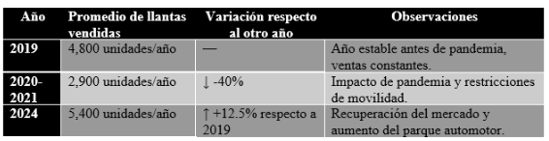

This table shows a general comparison of tire sales and inventory movements between 2019 (before the pandemic) and 2024. It highlights the total number of tires sold per year, the variation rate, and key observations about the market situation.

In 2019, sales were stable, reflecting normal business conditions. During 2020–2021, sales dropped sharply by around 40% due to the pandemic and mobility restrictions. However, by 2024, the market recovered, surpassing pre-pandemic levels with a 12.5% increase in total tire sales. This data emphasizes the importance of having a digital inventory management system to adapt quickly to market fluctuations.

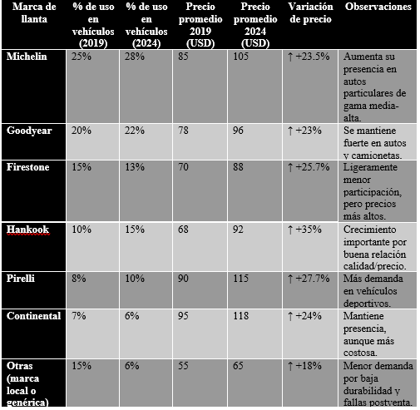

This table compares the market share (usage percentage) and average sale prices of major tire brands between 2019 and 2024. It also shows how prices have changed and provides brief comments about each brand’s position in the local market.

The data shows that premium brands such as Michelin, Goodyear, and Pirelli increased their market participation and prices, while lower-cost or generic brands lost market share due to durability and quality issues. Prices rose on average 20–30% due to inflation, raw material costs, and shipping fees after the pandemic.

This information is crucial for pricing control and strategic purchasing, helping store managers determine which brands bring the best profit margins and customer satisfaction.

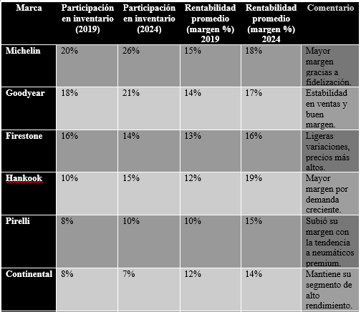

This table details each brand’s participation in the store’s total inventory and its average profitability margin in both 2019 and 2024. It shows how the distribution of stock has shifted and how profit margins have evolved over time.

Brands like Michelin and Hankook increased both their inventory share and profit margins, reflecting growing consumer trust and effective price management. On the other hand, generic or low-cost brands decreased their participation significantly as customers preferred more durable and reputable options.

This table demonstrates how implementing an automated control system for inventory and sales could help maintain ideal stock levels, update prices consistently, and improve profitability analysis for each brand.

**ANALYST COMPARISON**

Between 2019 and 2024, the tire market in Quito experienced significant changes that can be analyzed through a comparison similar to an analyst performance model. Each tire brand represents an investor starting with the same market opportunity, and its results depend on pricing strategy, inventory control, and demand. Michelin and Goodyear maintained solid growth, increasing both market share and profitability. Hankook showed the strongest improvement, achieving the highest efficiency and profitability among all brands. Pirelli and Firestone had moderate but steady progress, while Continental remained stable with minimal variation. In contrast, generic brands lost participation despite slight price increases, reflecting weak customer preference. Overall prices rose 20–30%, improving margins for recognized brands. The simulation shows that Hankook, Michelin, and Goodyear performed as top “investors,” while low-cost brands declined. This performance comparison reveals the importance of accurate price updates and automated inventory systems. By monitoring each brand’s evolution, the store can predict profitability trends and make smarter purchasing decisions.