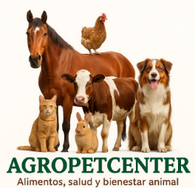
TEAM 3: ENCAPSULATED KNOWLEDGE

Features for Pet shop (AGROPETCENTER)
- Product registration
Allows you to add new products to inventory (name, category, price, quantity, tester, etc.).
- Control of entries and exits
Registration when new products enter (purchases) or leave (sales), automatically updating the available stock.
- Search and filtering of products
Make it easy to find products quickly by name, type (food, toy, medicine, etc.), or tester.
- Automatic inventory update
Every time a sale or purchase is made, the system adjusts the amounts automatically.
- Low stock alerts
Notify when a product has few units, to prevent it from running out of stock.
- Generation of reports
Create reports on best-selling products, products with low stock or movements of the month.
- Category management
It allows products to be classified by type (food, accessories, medicine, etc.) for more orderly control.
- Friendly interface
It has an easy-to-use design to register and consult products quickly and intuitively.

GitHub: https://github.com/bsgudino1416/T3-OOP-KNOWLEDGE-ENCAPSULATED.git

