# Architectural Layer Description

## Architecture Overview

The MAVS System architecture contains four layers:

1. Sensor Layer
2. Control Layer (Central Computer)
3. Camera Layer
4. Mobile Layer

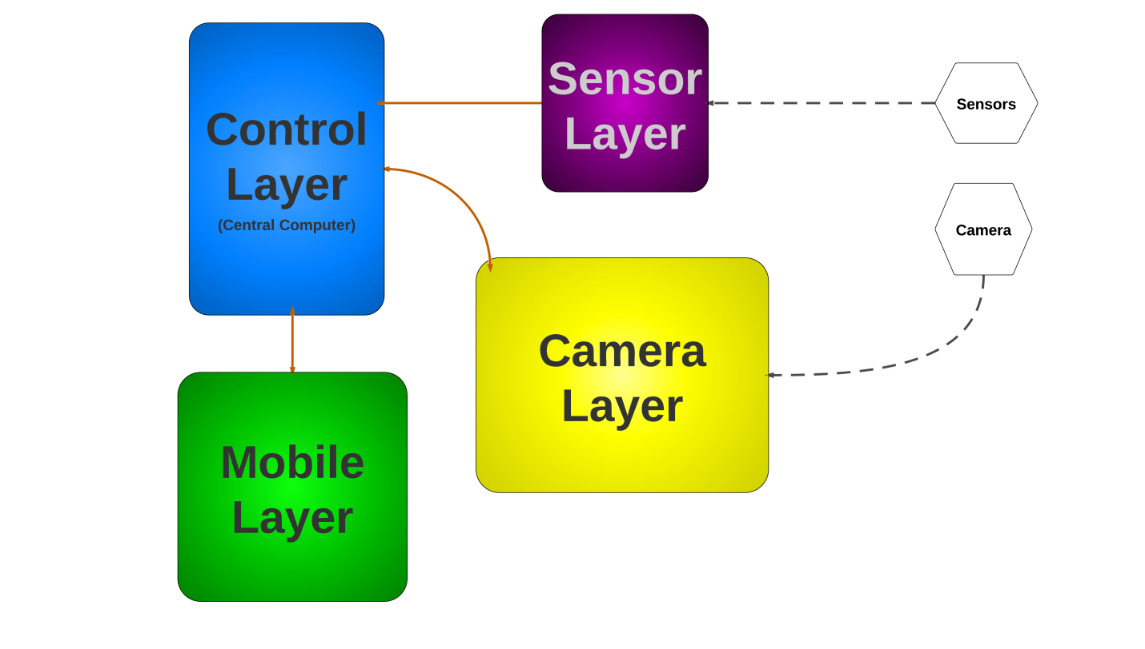

Figure 2 - Architectural Layer Overview

## Layer Name and Description

### Sensor Layer

The Sensor Layer interfaces with the sensors. Analog data is received from the sensors, converted to useful digital information, and transmitted to the central computer. The Sensor Layer maps to the Sensor Controller in Figure 1.

### Control Layer

The Control Layer interacts with the Sensor Layer, Mobile Layer, and Camera Layer, serving as the communications hub for all four layers as well as acting as the central processor. The Control Layer also provides an interface with the user. Data is received from the other three layers, processed, and can be stored within the Control Layer. The Control Layer transmits data to the Mobile Layer and the Camera Layer. The Control layer maps to the Central Computer in Figure 1.

### Camera Layer

The Camera Layer interfaces with the camera. It receives instructions from the Control Layer (or from the Mobile Layer via the Control Layer) and controls the movement of the camera. The Camera Layer is also responsible for processing the video and audio feeds from the camera before transmitting the streams to the Control Layer. The Camera Layer maps to the Camera in Figure 1.

### Mobile Layer

The Mobile Layer communicates directly with the Control Layer and interfaces with the user. The Mobile Layer can receive data from the Control Layer as well as transmit instructions and data back to the Control Layer. The Control Layer maps to the Mobile Device in Figure 1.

# Inter-Subsystem Dataflow

## Overview

The Inter-Subsystem Dataflow chapter describes the dataflow between the layers and between the subsystems. The description of the dataflow is in section 3.2. The MAVS System has four independent data flows.

1. A user can access the system directly through the Central Computer (denoted by data flow U1-A4).
2. A user can access the system via the Mobile Device (denoted by data flow U2-M3-M2-M1-M4).
3. The sensors transmit data to the system (denoted by data flow S1-S2-S3).
4. The camera transmits data to the system (denoted by data flow C1-8).

Note: User data flows are in dotted pink, other data flows are in blue; data from external sources are represented by dashed lines.

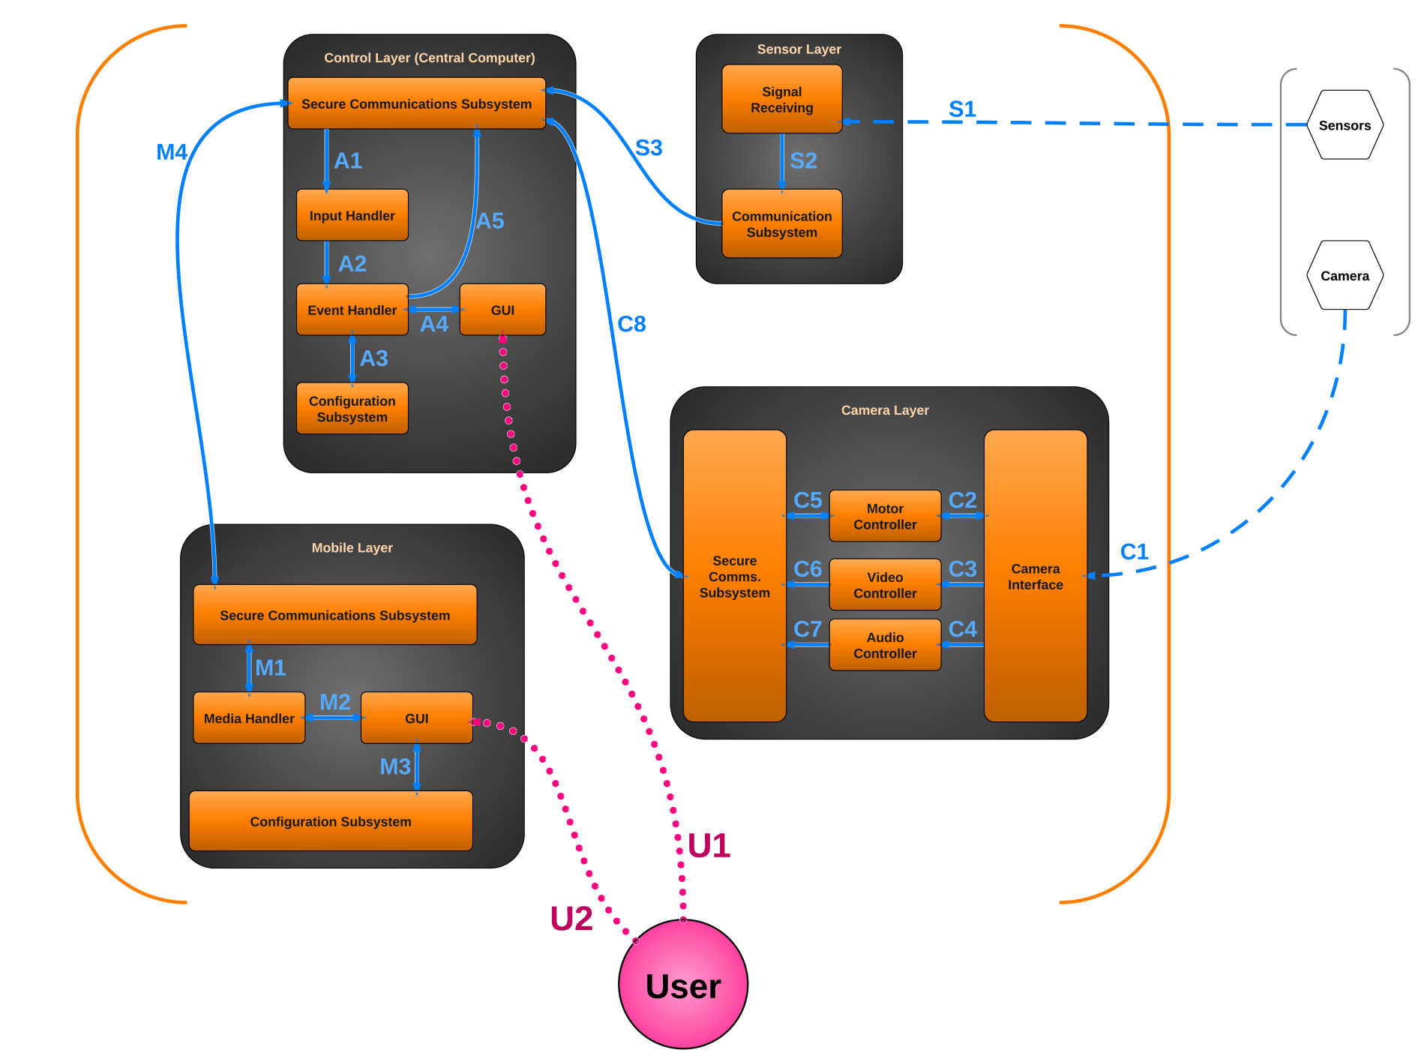

Figure 3 - Architectural Data Flow Diagram

## Data Flows

Table 2 - Inter-Subsystem Data Element Descriptions

*Note: An asterisk indicates no data flow, only interaction or contact.*

|  |  |
| --- | --- |
| Data Flow ID | Description of Data Flow |
| U1* | The User interacts with the GUI on the Central Computer.  The Central Computer GUI displays appropriate information to the User. |
| U2* | The User interacts with the GUI on the Mobile Device.  The Mobile Device GUI displays appropriate information to the User. |
| S1 | The sensors transmit analog signals to the Signal Receiving subsystem. |
| S2 | The Signal Receiving subsystem converts the analog data into digital data and sends the information to the Communication Subsystem. |
| S3 | The Communication Subsystem sends the converted signal data to the Control Layer’s Communication Subsystem. |
| C1 | The camera transmits video, audio, and configuration data to the Camera Interface.  The Camera Interface issues pan/tilt/zoom information to the camera. |
| C2 | The Camera Interface reports the camera’s orientation to the Motion Controller.  The Motion Controller sends pan/tilt/zoom instructions to the Camera Interface. |
| C3 | The Camera Interface sends the camera’s video stream to the Video Controller. |
| C4 | The Camera Interface sends the camera’s audio stream to the Audio Controller. |
| C5 | The Motion Controller reports the camera’s orientation to the Camera Layer’s Secure Communication Subsystem.  The Motion Controller receives pan/tilt/zoom instructions from the Camera Layer’s Secure Communication Subsystem. |
| C6 | The Video Controller processes the incoming video stream and sends it to the Camera Layer’s Secure Communication Subsystem. |
| C7 | The Audio Controller processes the incoming audio stream and sends it to the Camera Layer’s Secure Communications Subsystem. |
| Continued on next page… | |

|  |  |
| --- | --- |
| Data Flow ID | Description of Data Flow (Continued from previous page…) |
| C8 | The Camera Layer’s Secure Communication Subsystem transmits audio, video, and camera orientation data to the Control Layer’s Secure Communication Subsystem. Note that this is a secure channel.  The Control Layer’s Secure Communication Subsystem transmits pan/tilt/zoom instructions to the Camera Layer’s Secure Communication Subsystem. Note that this is a secure channel. |
| A1 | The Secure Communications Subsystem sends data to the Input Handler. The data could consist of video stream, audio stream, camera orientation, sensor data, or instructions from the Mobile Layer. |
| A2 | The Input Handler collects and processes all incoming data from the Secure Communications Subsystem before sending it to the Event Handler. |
| A3 | The Event Handler queries the Configuration Subsystem to help it perform logic operations on the date received from the Input Handler. It can also save new profile data in the Configuration Subsystem.  The Configuration Subsystem sends profile data for the Event Handler. |
| A4 | The Event Handler displays information in the GUI.  The GUI sends instructions to the Event Handler. |
| A5 | The Event Handler sends instructions, video stream, audio stream, or sensor information to the Secure Communications Subsystem to be transmitted to another layer. |
| M1 | The Secure Communications Subsystem sends video stream, audio stream, or sensor information to the Media Handler.  The Media Handler sends instructions to the Secure Communications Subsystem to be transmitted to another layer. |
| M2 | The Media Handler displays video, audio, notifications, or other information in the GUI.  The GUI sends instructions back to the Media Handler. |
| M3 | The GUI sends profile information to the Configuration Subsystem.  The Configuration Subsystem sends profile information to the GUI. |
| M4 | The Mobile Layer’s Secure Communications Subsystem transmits instructions to the Control Layer’s Secure Communications Subsystem. Note that this is a secure channel.  The Control Layer’s Secure Communications Subsystem transmits video stream, audio stream, camera orientation, sensor information, and notifications to the Mobile Layer’s Secure Communications Subsystem. Note that this is a secure channel. |

## Producer-Consumer Relationships

Product-consumer relationships define the relationships between subsystems. The following table shows dependencies between subsystems.

Table 3 - Producer-Consumer Relationships

|  |  |  |  |  |  |  |  |  |  |  |  |  |  |  |  |  |  |
| --- | --- | --- | --- | --- | --- | --- | --- | --- | --- | --- | --- | --- | --- | --- | --- | --- | --- |
|  |  | Consumer Subsystem | | | | | | | | | | | | | | | |
|  | **Signal Receiving (Sensor Layer)** | **Communication**  **(Sensor Layer)** | **Secure Communication  (Control Layer)** | **Input Handler**  **(Control Layer)** | **Event Handler**  **(Control Layer)** | **Configuration**  **(Control Layer)** | **GUI**  **(Control Layer)** | **Camera Interface**  **(Camera Layer)** | **Motion Controller**  **(Camera Layer)** | **Video Controller**  **(Camera Layer)** | **Audio Controller**  **(Camera Layer)** | **Secure Communication**  **(Camera Layer)** | **Secure Communication**  **(Mobile Layer)** | **Media Handler**  **(Mobile Layer)** | **GUI**  **(Mobile Layer)** | **Configuration**  **(Mobile Layer)** |
| Producer Subsystem | **Sensors** | **S1** |  |  |  |  |  |  |  |  |  |  |  |  |  |  |  |
| **Signal Receiving (Sensor Layer)** |  | **S2** |  |  |  |  |  |  |  |  |  |  |  |  |  |  |
| **Communication**  **(Sensor Layer)** |  |  | **S3** |  |  |  |  |  |  |  |  |  |  |  |  |  |
| **Secure Communication (Control Layer)** |  | **S3** |  | **A1** |  |  |  |  |  |  |  | **C8** | **M4** |  |  |  |
| **Input Handler**  **(Control Layer)** |  |  |  |  | **A2** |  |  |  |  |  |  |  |  |  |  |  |
| **Event Handler**  **(Control Layer)** |  |  | **A5** |  |  | **A3** | **A4** |  |  |  |  |  |  |  |  |  |
| **Configuration**  **(Control Layer)** |  |  |  |  | **A3** |  |  |  |  |  |  |  |  |  |  |  |
| **GUI**  **(Control Layer)** |  |  |  |  | **A4** |  |  |  |  |  |  |  |  |  |  |  |
| **Camera** |  |  |  |  |  |  |  | **C1** |  |  |  |  |  |  |  |  |
| **Camera Interface**  **(Camera Layer)** |  |  |  |  |  |  |  |  | **C2** | **C3** | **C4** |  |  |  |  |  |
| **Motion Controller**  **(Camera Layer)** |  |  |  |  |  |  |  | **C2** |  |  |  | **C5** |  |  |  |  |
| **Video Controller**  **(Camera Layer)** |  |  |  |  |  |  |  |  |  |  |  | **C6** |  |  |  |  |
| **Audio Controller**  **(Camera Layer)** |  |  |  |  |  |  |  |  |  |  |  | **C7** |  |  |  |  |
| **Secure Communication**  **(Camera Layer)** |  |  | **C8** |  |  |  |  |  | **C5** |  |  |  |  |  |  |  |
| **Secure Communication**  **(Mobile Layer)** |  |  | **M4** |  |  |  |  |  |  |  |  |  |  | **M1** |  |  |
| **Media Handler**  **(Mobile Layer)** |  |  |  |  |  |  |  |  |  |  |  |  | **M1** |  | **M2** |  |
| **GUI**  **(Mobile Layer)** |  |  |  |  |  |  |  |  |  |  |  |  |  | **M2** |  | **M3** |
| **Configuration**  **(Mobile Layer)** |  |  |  |  |  |  |  |  |  |  |  |  |  |  | **M3** |  |