**Department of Computer Science and Engineering  
The University of Texas at Arlington**

Maverick Audio Visual Security Systems

(MAVS Systems)



Team Members:

Charles Beran

Karl Feinauer

Hoang Tang

Brian Shef

Ivan Fan

**Late Updated: 15 August 2011 @ 02:00:00 AM**

**Copy Printed: 0 XXX 0000 @ 0:00:00 AM**

# Architecture Overview

Waiting on Ivan

# Architectural Layer Description

## Architecture Overview

The MAVS System architecture contains four layers:

1. Sensor Layer
2. Control Layer (Central Computer)
3. Camera Layer
4. Mobile Layer

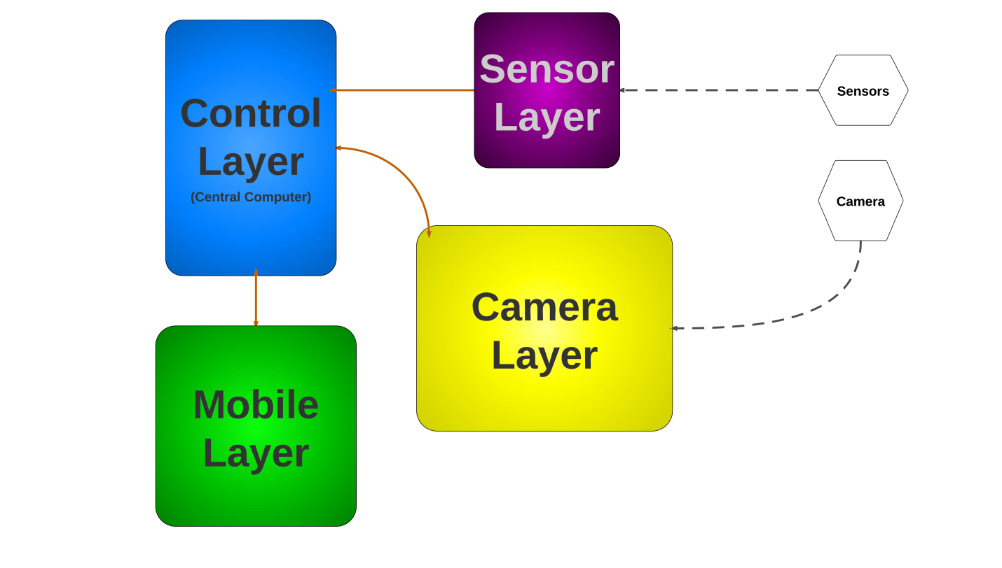

Figure 1 - Architectural Layer Overview

## Layer Name and Description

### Sensor Layer

The Sensor Layer interfaces with the sensors. Analog data is received from the sensors, converted to useful digital information, and transmitted to the central computer. The Sensor Layer maps to the Sensor Controller in Figure 1.

### Control Layer

The Control Layer interacts with the Sensor Layer, Mobile Layer, and Camera Layer, serving as the communications hub for all four layers as well as acting as the central processor. The Control Layer also provides an interface with the user. Data is received from the other three layers, processed, and can be stored within the Control Layer. The Control Layer transmits data to the Mobile Layer and the Camera Layer. The Control layer maps to the Central Computer in Figure 1.

### Camera Layer

The Camera Layer interfaces with the camera. It receives instructions from the Control Layer (or from the Mobile Layer via the Control Layer) and controls the movement of the camera. The Camera Layer is also responsible for processing the video and audio feeds from the camera before transmitting the streams to the Control Layer. The Camera Layer maps to the Camera in Figure 1.

### Mobile Layer

The Mobile Layer communicates directly with the Control Layer and interfaces with the user. The Mobile Layer can receive data from the Control Layer as well as transmit instructions and data back to the Control Layer. The Control Layer maps to the Mobile Device in Figure 1.

# Inter-Subsystem Dataflow

## Overview

The Inter-Subsystem Dataflow chapter describes the dataflow between the layers and between the subsystems. The description of the dataflow is in section 3.2. The MAVS System has four independent data flows.

1. A user can access the system directly through the Central Computer (denoted by data flow U1-A4).
2. A user can access the system via the Mobile Device (denoted by data flow U2-M3-M2-M1-M4).
3. The sensors transmit data to the system (denoted by data flow S1-S2-S3).
4. The camera transmits data to the system (denoted by data flow C1-8).

Note: User data flows are in dotted pink, other data flows are in blue; data from external sources are represented by dashed lines.

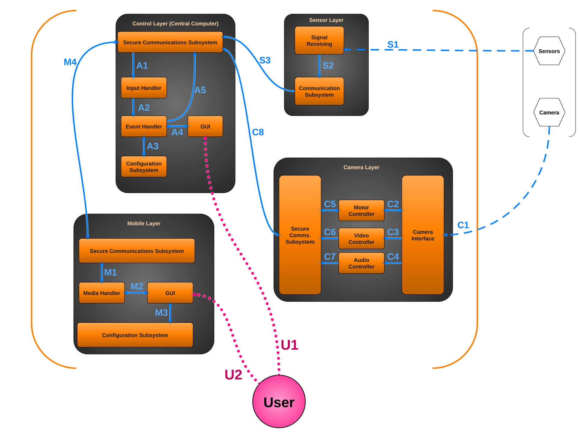

Figure 2 - Architectural Data Flow Diagram

## Data Flows

Table 1 - Inter-Subsystem Data Element Descriptions

*Note: An asterisk indicates no data flow, only interaction or contact.*

|  |  |
| --- | --- |
| Data Flow ID | Description of Data Flow |
| U1* | The User interacts with the GUI on the Central Computer.  The Central Computer GUI displays appropriate information to the User. |
| U2* | The User interacts with the GUI on the Mobile Device.  The Mobile Device GUI displays appropriate information to the User. |
| S1 | The sensors transmit analog signals to the Signal Receiving subsystem. |
| S2 | The Signal Receiving subsystem converts the analog data into digital data and sends the information to the Communication Subsystem. |
| S3 | The Communication Subsystem sends the converted signal data to the Control Layer’s Communication Subsystem. |
| C1 | The camera transmits video, audio, and configuration data to the Camera Interface.  The Camera Interface issues pan/tilt/zoom information to the camera. |
| C2 | The Camera Interface reports the camera’s orientation to the Motion Controller.  The Motion Controller sends pan/tilt/zoom instructions to the Camera Interface. |
| C3 | The Camera Interface sends the camera’s video stream to the Video Controller. |
| C4 | The Camera Interface sends the camera’s audio stream to the Audio Controller. |
| C5 | The Motion Controller reports the camera’s orientation to the Camera Layer’s Secure Communication Subsystem.  The Motion Controller receives pan/tilt/zoom instructions from the Camera Layer’s Secure Communication Subsystem. |
| C6 | The Video Controller processes the incoming video stream and sends it to the Camera Layer’s Secure Communication Subsystem. |
| C7 | The Audio Controller processes the incoming audio stream and sends it to the Camera Layer’s Secure Communications Subsystem. |
| Continued on next page… | |

|  |  |
| --- | --- |
| Data Flow ID | Description of Data Flow (Continued from previous page…) |
| C8 | The Camera Layer’s Secure Communication Subsystem transmits audio, video, and camera orientation data to the Control Layer’s Secure Communication Subsystem. Note that this is a secure channel.  The Control Layer’s Secure Communication Subsystem transmits pan/tilt/zoom instructions to the Camera Layer’s Secure Communication Subsystem. Note that this is a secure channel. |
| A1 | The Secure Communications Subsystem sends data to the Input Handler. The data could consist of video stream, audio stream, camera orientation, sensor data, or instructions from the Mobile Layer. |
| A2 | The Input Handler collects and processes all incoming data from the Secure Communications Subsystem before sending it to the Event Handler. |
| A3 | The Event Handler queries the Configuration Subsystem to help it perform logic operations on the date received from the Input Handler. It can also save new profile data in the Configuration Subsystem.  The Configuration Subsystem sends profile data for the Event Handler. |
| A4 | The Event Handler displays information in the GUI.  The GUI sends instructions to the Event Handler. |
| A5 | The Event Handler sends instructions, video stream, audio stream, or sensor information to the Secure Communications Subsystem to be transmitted to another layer. |
| M1 | The Secure Communications Subsystem sends video stream, audio stream, or sensor information to the Media Handler.  The Media Handler sends instructions to the Secure Communications Subsystem to be transmitted to another layer. |
| M2 | The Media Handler displays video, audio, notifications, or other information in the GUI.  The GUI sends instructions back to the Media Handler. |
| M3 | The GUI sends profile information to the Configuration Subsystem.  The Configuration Subsystem sends profile information to the GUI. |
| M4 | The Mobile Layer’s Secure Communications Subsystem transmits instructions to the Control Layer’s Secure Communications Subsystem. Note that this is a secure channel.  The Control Layer’s Secure Communications Subsystem transmits video stream, audio stream, camera orientation, sensor information, and notifications to the Mobile Layer’s Secure Communications Subsystem. Note that this is a secure channel. |

## Producer-Consumer Relationships

Product-consumer relationships define the relationships between subsystems. The following table shows dependencies between subsystems.

Table 2 - Producer-Consumer Relationships

|  |  |  |  |  |  |  |  |  |  |  |  |  |  |  |  |  |  |
| --- | --- | --- | --- | --- | --- | --- | --- | --- | --- | --- | --- | --- | --- | --- | --- | --- | --- |
|  |  | Consumer Subsystem | | | | | | | | | | | | | | | |
|  | **Signal Receiving (Sensor Layer)** | **Communication**  **(Sensor Layer)** | **Secure Communication  (Control Layer)** | **Input Handler**  **(Control Layer)** | **Event Handler**  **(Control Layer)** | **Configuration**  **(Control Layer)** | **GUI**  **(Control Layer)** | **Camera Interface**  **(Camera Layer)** | **Motion Controller**  **(Camera Layer)** | **Video Controller**  **(Camera Layer)** | **Audio Controller**  **(Camera Layer)** | **Secure Communication**  **(Camera Layer)** | **Secure Communication**  **(Mobile Layer)** | **Media Handler**  **(Mobile Layer)** | **GUI**  **(Mobile Layer)** | **Configuration**  **(Mobile Layer)** |
| Producer Subsystem | **Sensors** | **S1** |  |  |  |  |  |  |  |  |  |  |  |  |  |  |  |
| **Signal Receiving (Sensor Layer)** |  | **S2** |  |  |  |  |  |  |  |  |  |  |  |  |  |  |
| **Communication**  **(Sensor Layer)** |  |  | **S3** |  |  |  |  |  |  |  |  |  |  |  |  |  |
| **Secure Communication (Control Layer)** |  | **S3** |  | **A1** |  |  |  |  |  |  |  | **C8** | **M4** |  |  |  |
| **Input Handler**  **(Control Layer)** |  |  |  |  | **A2** |  |  |  |  |  |  |  |  |  |  |  |
| **Event Handler**  **(Control Layer)** |  |  | **A5** |  |  | **A3** | **A4** |  |  |  |  |  |  |  |  |  |
| **Configuration**  **(Control Layer)** |  |  |  |  | **A3** |  |  |  |  |  |  |  |  |  |  |  |
| **GUI**  **(Control Layer)** |  |  |  |  | **A4** |  |  |  |  |  |  |  |  |  |  |  |
| **Camera** |  |  |  |  |  |  |  | **C1** |  |  |  |  |  |  |  |  |
| **Camera Interface**  **(Camera Layer)** |  |  |  |  |  |  |  |  | **C2** | **C3** | **C4** |  |  |  |  |  |
| **Motion Controller**  **(Camera Layer)** |  |  |  |  |  |  |  | **C2** |  |  |  | **C5** |  |  |  |  |
| **Video Controller**  **(Camera Layer)** |  |  |  |  |  |  |  |  |  |  |  | **C6** |  |  |  |  |
| **Audio Controller**  **(Camera Layer)** |  |  |  |  |  |  |  |  |  |  |  | **C7** |  |  |  |  |
| **Secure Communication**  **(Camera Layer)** |  |  | **C8** |  |  |  |  |  | **C5** |  |  |  |  |  |  |  |
| **Secure Communication**  **(Mobile Layer)** |  |  | **M4** |  |  |  |  |  |  |  |  |  |  | **M1** |  |  |
| **Media Handler**  **(Mobile Layer)** |  |  |  |  |  |  |  |  |  |  |  |  | **M1** |  | **M2** |  |
| **GUI**  **(Mobile Layer)** |  |  |  |  |  |  |  |  |  |  |  |  |  | **M2** |  | **M3** |
| **Configuration**  **(Mobile Layer)** |  |  |  |  |  |  |  |  |  |  |  |  |  |  | **M3** |  |

# Control Layer

## General

The Control layer is the virtual hub for all the other layers. It receives and processes data from the Sensor and Camera layers according to the user profiles and stores and distributes them accordingly.

The control layer also includes a GUI subsystem to allow user to access cameras, sensors, alerts and log information locally on the central computer.

Furthermore, the Control layer also ensures that any remote communication must be done in a secure fashion.

Figure - Control Layer

## Subsystems

### Logic

#### General

The Logic is a subsystem within the Control layer and is responsible processing sensors and camera inputs data. After all the input data is received, the Logic subsystem will prioritize and distribute them to the log and communication subsystem. How the input data is prioritize and distributed is depend on the user configuration.

#### Assumptions

The Camera and Sensor layer must be working normally.

#### Responsibilities

The Logic subsystem is responsible for retrieving images or videos and camera position from the Camera layer. The Logic subsystem will also responsible for retrieving sensor data from the Sensor layer. All input data will be processed and distributed to the Log and Communication System.

#### Subsystem Public Interfaces

N/A

#### Inputs

Camera data: The Logic subsystem pulls the camera data from the Camera layer. Camera data include images or video stream and camera orientation.

Sensor data: The Logic subsystem pulls the camera data from the Sensor layer. Sensor data indicate whether a sensor was tripped and a string for extra information such as a weigh sensor will also sending how much weight was detected.

Configuration data: The Logic subsystem pulls the configuration data from the Configuration subsystem. This for example tells the system which profile is currently active or whether a certain sensor should be ignored.

#### Outputs

Camera data: The Logic subsystem supplies processed camera data to the Log and Communication subsystem. Camera data include images or video stream and camera orientation.

Alert: The Logic subsystem supplies alert to the Log and Communication subsystem.

### Configuration Subsystem

#### General

The Configuration subsystem is responsible for storing and retrieving user profile information.

#### Assumptions

The central computer is power up and running.

#### Responsibilities

The Configuration subsystem is responsible for storing and retrieving user profile information.

#### Subsystem Inter-layer Interfaces

N/A

#### Subsystem Public Interfaces

N/A

#### Inputs

New or Updated Configuration data: The Configuration subsystem receives new or updated configuration data from the Communication subsystem.

#### Outputs

Configuration data: The Configuration subsystem supplies configuration data to the Logic, Log and Communication subsystem.

### Communication

#### General

The Communication subsystem receives and supplies data to the local GUI. It will also supplies data properly authenticated remote subscribers.

Assumptions

N/A

#### Responsibilities

The Communication subsystem receives and supplies data to the local GUI. It wills also supply data to remote subscribers that are in the distribution list.

#### Subsystem Inter-layer Interfaces

N/A

#### Subsystem Public Interfaces

N/A

#### Inputs

Log data: The Communication subsystem receives log information from the Log subsystem.

Camera data: The Communication subsystem receives camera information from the Log layer.

Alert: The Communication subsystem receives alerts from the Log layer.

Configuration data: The Communication subsystem receives Configuration information from the Configuration and GUI layer.

#### Output

Camera Control Commands: The Communication subsystem supplies command to the Camera layer to control the camera.

Log data: The Communication subsystem supplies log information to the local GUI and any remote subscriber.

Sensor data: The Communication subsystem supplies sensor information to the local GUI and properly authenticated remote subscribers.

Camera data: The Communication subsystem supplies camera information to the local GUI and any remote subscriber.

Alert: The Communication subsystem supplies alert information to the local GUI and any remote subscriber.

### GUI

#### General

The GUI provides a way for the user to view the log, view or update configuration information, viewing camera feeds.

#### Assumptions

N/A

#### Responsibilities

The GUI provides a way for the user to view the log, view or update configuration information, viewing camera feeds.

#### Subsystem Inter-layer Interfaces

N/A

#### Subsystem Public Interfaces

N/A

#### Inputs

Configuration data: The GUI subsystem receives configuration data from the Communication subsystem.

Camera data: The GUI subsystem receives camera information from the Communication subsystem.

Alert: The GUI subsystem receives alert information from the Communication subsystem.

Log data: The GUI subsystem receives log information from the Communication subsystem.

#### Outputs

Information is displayed to the user via a text or graphical interface.

### Log

#### General

The Log subsystem store and retrieve log information.

#### Assumptions

N/A

#### Responsibilities

The Log subsystem store and retrieve log information. How the log is stored depend on the user configuration

#### Subsystem Inter-layer Interfaces

N/A

#### Subsystem Public Interfaces

N/A

#### Inputs

Camera data: The Log subsystem pulls the camera data from the Camera layer. Camera data include images or video stream and camera orientation.

Sensor data: The Log subsystem pulls the camera data from the Sensor layer. Sensor data indicate whether a sensor was tripped and a string for extra information such as a weigh sensor will also sending how much weight was detected.

Configuration data: The Log subsystem pulls the configuration data from the Configuration subsystem. This for example tells the system which profile is currently active or whether a certain sensor should be ignored.

#### Outputs

Log data: The Log supplies the log information to the Communication subsystem.

# Mobile Layer

## General

The mobile layer provides the user with a mobile interface with which to control the system. From within the Layer, which communicates with the control layer, the user will be able to manage the entire system. The mobile layer will communicate with the control layer/ Central Computer.

The Mobile Layer will contain a GUI through which the user can access the configuration subsystem to change settings or the media layer to view images. There will also be a media handler for displaying the images from the camera.

Alerts will be handled by the communication subsystem.

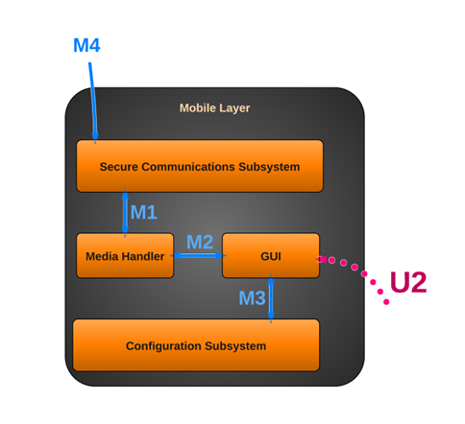

Figure – Mobile Layer

## Subsystems

### Communication Subsystem

#### General

The communication layer will be the subsystem within the mobile layer that handles all communication with the central computer, internet, or phone network.

#### Assumptions

The mobile device is connected to the internet via WiFi or another network (eg 2G, 3G, etc.). The mobile device is capable of making outgoing calls. The control subsystem is functioning properly.

#### Responsibilities

* Collecting alerts from the central computer
* Polling the central computer for connection status
* Collecting data (images/audio) from the central computer
* Accessing the dialer to make emergency calls
* Sending changes to configuration to the central computer
* Sending alert acknowledgements to the central computer
* Sending secured login information to central computer
* Sending camera commands to central computer

#### Subsystem Inter-Layer Interfaces

N/A

#### Subsystem Public Interfaces

N/A

#### Inputs

The communication layer will take the following inputs from the central computer.

* Video Data
* Audio Data
* Configuration Data
* System Status/Alerts
* Authentication Data

#### Outputs

The communication layer will have the following outputs

* Camera Commands to the central computer
* Audio Data to the central computer
* Configuration Data to the central computer
* Alert acknowledgement to the central computer
* Status ping to the central computer
* Emergency number to the phone’s dialer

### Media Handler Subsystem

#### General

The media handler will be responsible for processing audio/video and passing them to the GUI.

#### Assumptions

The mobile device has a screen capable of displaying images/video and speakers capable of playing sound.

#### Responsibilities

* Validate/process images/audio from the communications layer
* Render them for display in GUI
* Collecting data (images/audio) from the central computer for local storage

#### Subsystem Inter-Layer Interfaces

N/A

#### Subsystem Public Interfaces

N/A

#### Inputs

The media layer will take the following inputs:

* Video Data from communication subsystem
* Audio Data from communication subsystem
* Configuration Data from the communications subsystem

#### Outputs

The media layer will have the following outputs

* Audio Data to the communication subsystem
* Configuration Data to the central computer

### Configuration Subsystem

#### General

The configuration subsystem will hold all user setting for both the mobile device and the central computer. These settings will be modified through the GUI, stored locally and transmitted to the central computer.

#### Assumptions

N/A

#### Responsibilities

* Storing configuration settings
* Storing user data/profiles
* Updating changes to settings

#### Subsystem Inter-Layer Interfaces

N/A

#### Subsystem Public Interfaces

N/A

#### Inputs

The configuration layer will take the following inputs from the central computer.

* Configuration Data from the GUI
* Configuration Data from the communications subsystem

#### Outputs

The configuration layer will have the following outputs

* Configuration data to the GUI
* Configuration Data to the communications subsystem

### Mobile GUI Subsystem

#### General

The mobile GUI subsystem is where the user will be able to access or modify the system from the mobile device. It is a mobile front end.

#### Assumptions

The mobile device is capable of accepting touch screen input.

#### Responsibilities

* Allowing user to change configuration settings
* Allowing user to acknowledge alerts
* Allowing user to view camera
* Allowing user to listen to audio
* Displaying connection status to user
* Allowing user to access/transmit audio

#### Subsystem Inter-Layer Interfaces

N/A

#### Subsystem Public Interfaces

N/A

#### Inputs

The GUI layer will take the following inputs:

* Video Data from the media subsystem
* Audio Data from the media subsystem
* Configuration Data the configuration subsystem
* System Status/Alerts from the communication layer
* Authentication Data from the communication layer

#### Outputs

The GUI layer will have the following outputs

* Camera Commands to the communication layer
* Audio Data to the media layer
* Configuration Data to the configuration layer/communication layer
* Alert acknowledgement to the central computer
* Emergency dial to the communication layer

# Sensor Layer

## General

The Sensor Layer allows the system to communicate with the sensors. The installed sensors will provide information about triggered events to the central layer which will then pass the information on to the Control Layer, or central computer.

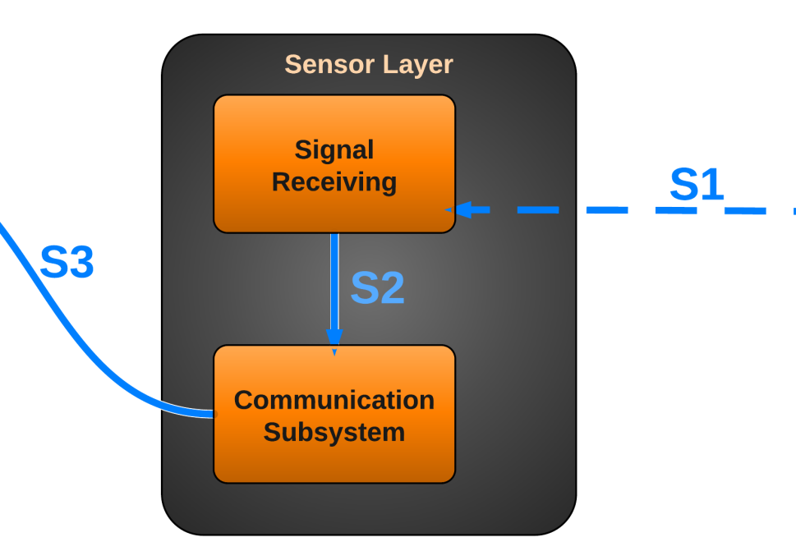

Figure - Sensor Layer

## Subsystems

### Signal Receiving

#### General

The Signal Receiving subsystem is software running on a microcontroller that receives status changes of the sensors. The subsystem will then simply pass on this information to the communication subsystem.

#### Assumptions

The microcontroller must be powered on and working properly.

#### Responsibilities

The Signal Receiving subsystem is responsible for detecting changes in the state of the sensors, indicating an event that must be passed on to the communication subsystem.

#### Subsystem Inter-layer Interfaces

N/A

#### Subsystem Public Interfaces

N/A

#### Inputs

Sensor Data: The current state of the sensors is continuously supplied to this subsystem. The subsystem does not do any significant calculation until a change in sensor state is noticed.

#### Outputs

Signal Status Changed: The Signal Receiving subsystem determines which of the sensors has been triggered by the usage of the microcontroller’s functionality.

### Communication Subsystem

#### General

The Communication Subsystem communicates with the Control Layer (Central Computer) through the usage of a serial communication line, informing the Control Layer of which sensor has been triggered.

#### Assumptions

All networking hardware is configured and working correctly.

#### Responsibilities

The Communication Subsystem receives which sensor has been triggered and sends this information along to the Control Layer via means of a serial communication line.

#### Subsystem Inter-layer Interfaces

N/A

#### Subsystem Public Interfaces

N/A

#### Inputs

Signal Status Changed: The specific sensor ID is passed in, indicating which sensor has been triggered.

#### Outputs

Signal Status Changed: The specific sensor ID representing which sensor has been changed is communicated to the Control Layer.

# Camera Layer

## General

The Camera Layer allows the system to communicate with the camera. The system will be able to retrieve the video and audio feeds from the camera, and send positioning commands (Pan/Tilt) to the camera. The Camera Layer will only accept communications from a secure, authenticated, and authorized source.

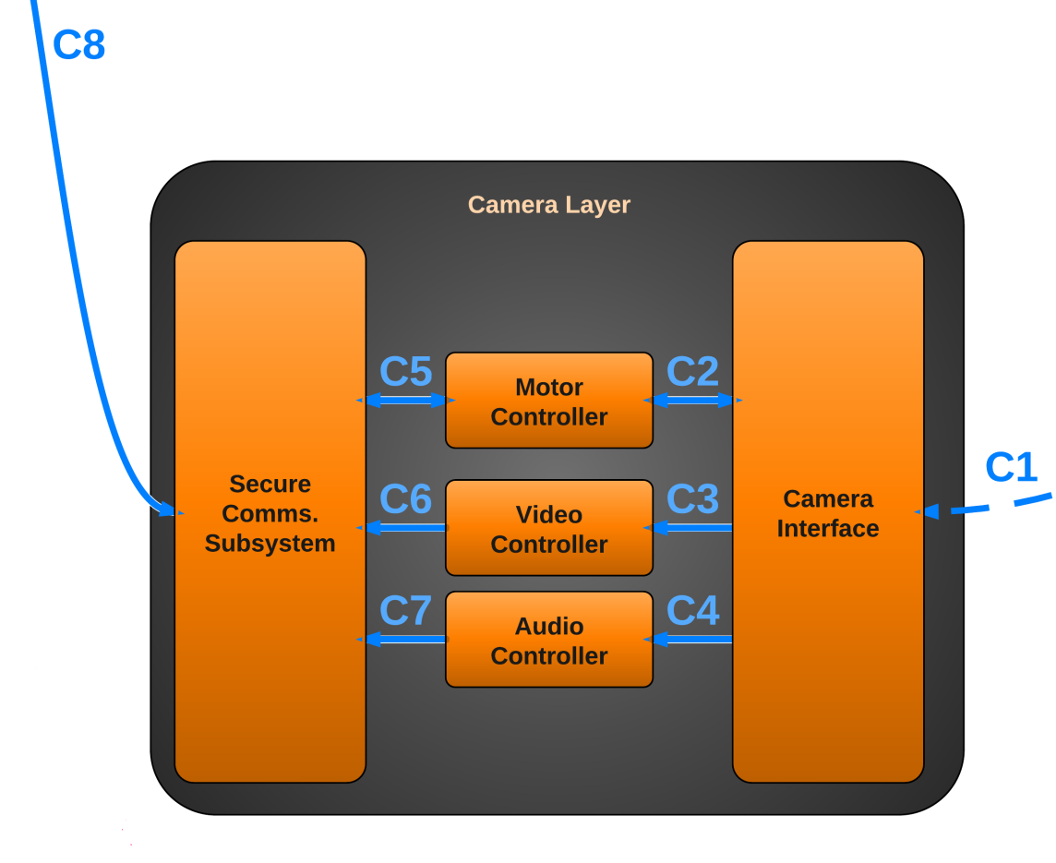

Figure 5 - Camera Layer

## Subsystems

### Camera Interface

#### General

The Camera Interface subsystem is software running on the Central Computer that actually communicates with the camera hardware. The subsystem will process all commands, such as those used to retrieve audio and video streams, and commands to control the position of the camera.

#### Assumptions

The Central Computer must be powered on, and the MAVS Systems software must be running on the computer.

#### Responsibilities

The Camera Interface subsystem is responsible for all communications between the camera hardware and the rest of the system. This allows the system to retrieve audio and video data, and instruct the camera to change its position.

#### Subsystem Inter-layer Interfaces

N/A

#### Subsystem Public Interfaces

N/A

#### Inputs

Camera Location/Orientation: The current location/orientation of the camera is supplied to the Camera Interface by the camera.

Video Data: The current video feed is supplied to the Camera Interface by the camera.

Audio Data: The current audio feed is supplied to the Camera Interface by the camera.

#### Outputs

Camera Location/Orientation: The Camera Interface subsystem provides the Motor Controller subsystem with the camera’s current position and orientation.

Video Data: The Camera Interface subsystem provides the Video Controller subsystem with the current video feed from the camera.

Audio Data: The Camera Interface subsystem provides the Audio Controller subsystem with the current audio feed from the camera.

### Motor Controller Subsystem

#### General

The Motor Controller Subsystem communicates with the Communication Subsystem to receive movement commands from the user for the camera. This allows the user to be able to instruct the camera to pan or tilt. Additionally, the Motor Controller Subsystem communicates with the Camera Interface to instruct the camera hardware to change its position and orientation.

#### Assumptions

All networking hardware is configured and working correctly. The Central Computer must be powered on, and the MAVS Systems software must be running on the computer. Additionally, the camera is powered on and working correctly.

#### Responsibilities

The Motor Control Subsystem is responsible for receiving movement commands from the Secure Comms. Subsystem and relaying those commands to the Camera Interface.

#### Subsystem Inter-layer Interfaces

N/A

#### Subsystem Public Interfaces

N/A

#### Inputs

Camera Position/Orientation: A new desired camera position/orientation is supplied to the Motor Controller Subsystem.

#### Outputs

Camera Position/Orientation: The desired camera position/orientation is passed to the Camera Interface, which can then instruct the camera hardware to move.

### Video Controller Subsystem

#### General

The Video Controller Subsystem communicates with the Secure Comms. Subsystem to return the current video stream of the camera to the user. Additionally, the Video Controller Subsystem communicates with the Camera Interface to instruct the camera to provide its video feed data. This subsystem also provides the capability to transform the video data into different formats based on current settings.

#### Assumptions

All networking hardware is configured and working correctly. The Central Computer must be powered on, and the MAVS Systems software must be running on the computer. Additionally, the camera is powered on and working correctly.

#### Responsibilities

The Video Controller Subsystem is responsible for retrieving the video feed data from the Camera Interface. Additionally, if necessary, the subsystem is responsible for transforming the video data into a different format as needed (for example, to a lower resolution).

#### Subsystem Inter-layer Interfaces

|  |  |  |  |
| --- | --- | --- | --- |
| *Method* | *Description* | *Information Required* | *Information Returned* |
| GetVideoFeed | The raw video data is received from the Camera Interface and is collected into a temporary buffer. | Video Feed Data | Raw Video Data buffer |
| TransformVideoFeed | The raw video data is converted into a format that the user desires. For example, the resolution may be lowered to conserve bandwidth. | Raw Video Data buffer, Video Format Settings | New Raw Video Data buffer |

#### Subsystem Public Interfaces

N/A

#### Inputs

Raw Video Data: The camera’s raw video data of the current feed is provided to the Video Controller Subsystem.

#### Outputs

Transformed Raw Video Data: The (optionally) transformed video data is provided to the Secure Comms. Subsystem.

### Audio Controller Subsystem

#### General

The Audio Controller Subsystem communicates with the Communication Subsystem to return the current audio stream of the camera to the user. Additionally, the Audio Controller Subsystem communicates with the Camera Interface to instruct the camera to provide its audio feed data.

#### Assumptions

All networking hardware is configured and working correctly. The Central Computer must be powered on, and the MAVS Systems software must be running on the computer. Additionally, the camera is powered on and working correctly. The camera is capable of recording audio data.

#### Responsibilities

The Audio Controller Subsystem is responsible for retrieving the audio feed data from the Camera Interface.

#### Subsystem Inter-layer Interfaces

N/A

#### Subsystem Public Interfaces

N/A

#### Inputs

Raw Audio Data: The camera’s raw audio data of the current feed is provided to the Audio Controller Subsystem.

#### Outputs

Raw Audio Data: The audio data is provided to the Communication Subsystem.

### Communication Subsystem

#### General

The Communication Subsystem communicates with the Communication Subsystem in the Control Layer to return the current audio and video streams of the camera to the user and to provide the current position/orientation of the camera. Additionally, the Communication Subsystem relays new position change requests to the Motor Controller Subsystem in order to move the camera.

#### Assumptions

All networking hardware is configured and working correctly. The Central Computer must be powered on, and the MAVS Systems software must be running on the computer. Additionally, the camera is powered on and working correctly.

#### Responsibilities

The Communication Subsystem is responsible for communicating with the Communication Subsystem of the Control Layer, providing it with the current audio and video streams and the current camera position and orientation.

#### Subsystem Inter-layer Interfaces

N/A

#### Subsystem Public Interfaces

N/A

#### Inputs

(Transformed) Raw Video Data: The camera’s (optionally) transformed raw video data of the current feed is provided to the subsystem.

Raw Audio Data: The camera’s raw audio data of the current feed is provided to the subsystem.

Camera Position/Orientation: The camera’s position and orientation is provided to the subsystem.

#### Outputs

(Transformed) Raw Video Data: The camera’s (optionally) transformed raw video data of the current feed is communicated to the Communication Subsystem of the Control Layer.

Raw Audio Data: The camera’s raw audio data of the current feed is communicated to the Communication Subsystem of the Control Layer.

Camera Position/Orientation: The camera’s position and orientation is communicated to the Communication Subsystem of the Control Layer.

# Testing Considerations

Waiting for Ivan