**Department of Computer Science and Engineering  
The University of Texas at Arlington**

Maverick Audio Visual Security Systems

(MAVS Systems)



Team Members:

Charles Beran

Karl Feinauer

Hoang Tang

Brian Shef

Ivan Fan

**Late Updated: 24 August 2011 @ 19:00:00 PM**

**Copy Printed: 0 XXX 0000 @ 0:00:00 AM**

Table of Contents

1 Architecture Overview 4

1.1 Overview 4

1.2 Outline 4

1.3 Purpose 4

1.4 Project Scope 4

1.5 System Requirements Mapping 5

1.6 Definitions, Acronyms and Abbreviations 6

2 Architectural Layer Description 7

2.1 Architecture Overview 7

2.2 Layer Name and Description 7

2.2.1 Sensor Layer 7

2.2.2 Control Layer 8

2.2.3 Camera Layer 8

2.2.4 Mobile Layer 8

3 Inter-Subsystem Dataflow 9

3.1 Overview 9

3.2 Data Flows 11

3.3 Producer-Consumer Relationships 14

4 Control Layer 15

4.1 General 15

4.2 Subsystems 15

4.2.1 Event Handler 15

4.2.2 Configuration Subsystem 16

4.2.3 Communication 17

4.2.4 GUI 17

5 Mobile Layer 19

5.1 General 19

5.2 Subsystems 20

5.2.1 Communication Subsystem 20

5.2.2 Media Handler Subsystem 21

5.2.3 Configuration Subsystem 22

5.2.4 Mobile GUI Subsystem 22

6 Sensor Layer 24

6.1 General 24

6.2 Subsystems 24

6.2.1 Signal Receiving 24

6.2.2 Communication Subsystem 25

7 Camera Layer 26

7.1 General 26

7.2 Subsystems 26

7.2.1 Camera Interface 26

7.2.2 Motor Controller Subsystem 27

7.2.3 Video Controller Subsystem 28

7.2.4 Audio Controller Subsystem 29

7.2.5 Communication Subsystem 30

8 Testing Considerations 32

8.1 General 32

8.2 Layer-level Interactions 32

8.2.1 Control Layer 32

8.2.2 Sensor Layer 32

8.2.3 Camera Layer 32

8.2.4 Mobile Layer 32

8.3 Assumptions 33

8.3.1 Subsystem pass/fail criteria 33

8.3.2 Test deliverables 33

8.3.3 Staffing and training needs 33

8.3.4 Debugging and Logging 33

8.4 Testing Considerations 33

8.4.1 Independence 33

8.4.2 Integrity 33

8.4.3 Interfaces 33

8.4.4 Implementability 33

# Architecture Overview

## Overview

The Architecture Design Specification (ADS) supplies high level descriptions of different layers to be implemented in the MAVS system and provides the relationship between the different layers. The ADS helps the stakeholders understand the MAVS system and its architecture at higher level. The ADS furnishes the architectural test considerations the MAVS team will be taking into account.

The ADS does not contain any details about the implementation of the product other than the high level description of the architectural planning.

## Outline

Architecture Layer (Chapter 2): Names the different layers implemented in the MAVS System along with the brief descriptions of those layers

Inter-Subsystem Dataflow (Chapter 3): Describes the dataflow between the subsystems

Individual Layers (Chapters 4 – 7): Breaks down each layer into different subsystems and describes each subsystem and its features

Testing Considerations (Chapter 8): Describes MAVS Team’s test standards and how each architectural layer of the MAVS System will be tested

## Purpose

The purpose of the ADS is to define the architecture specifications for the MAVS System. The ADS allows MAVS Team to further breakdown the components of the product into subcomponents to be completed throughout the life of the project. The ADS is the first step in the implementation of the product and will serve as a guideline.

The ADS does not describe individual components of the MAVS system nor does it explain how MAVS Team will implement the components. The ADS document sets up a foundation to initiate the implementation as the team moves to detail design phase.

## Project Scope

The MAVS System is a security system that gives the user total control and full capabilities concerning monitoring. The MAVS System is triggered primarily by sensors configured to the user’s specifications.  The user can access streaming video and audio from an on-site camera with their mobile device.  The user can also access these features from a central computer located on-site. The user can control the camera, configure the system settings, or instantly alert police to an emergency situation through a graphical interface from the mobile device. The MAVS System can be installed in homes, businesses, or any personal property with a secure point of entry.

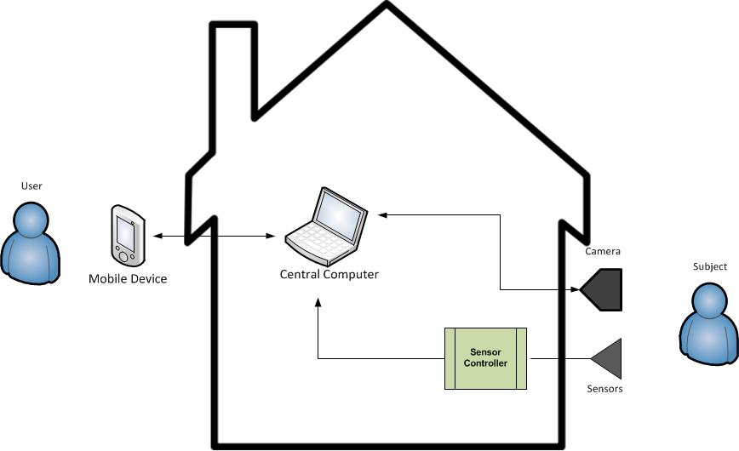

Figure 1 - Architectural Layer Overview

## System Requirements Mapping

Table 1 - Requirements Mapping

|  |  |  |  |  |  |
| --- | --- | --- | --- | --- | --- |
|  | **Customer Requirements** | **Control Layer** | **Sensor Layer** | **Camera Layer** | **Mobile Layer** |
| **4.2.1** | Mobile Device shall communicate with server |  |  |  |  |
| **4.2.2** | User is notified upon event (based on profile) |  |  |  |  |
| **4.2.3** | Authentication is necessary in order to access/control alarm |  |  |  |  |
| **4.2.4** | Camera and sensors are monitored by central server |  |  |  |  |
| **4.2.5** | User has the ability to control system status from Android device |  |  |  |  |
| **4.2.6** | Door/Window sensor must communicate with integrated circuit |  |  |  |  |
| **4.2.7** | System will handle user unavailability |  |  |  |  |
| **4.2.8** | System shall have an GUI for mobile device |  |  |  |  |
| **4.2.9** | Video streamed to mobile device |  |  |  |  |
| **4.2.10** | User can control camera from mobile device |  |  |  |  |
| **4.2.11** | User can dial 911 with one button |  |  |  |  |
| **4.2.12** | User is notified of connections status |  |  |  |  |
| **4.2.13** | User can view archived video |  |  |  |  |
| **4.2.14** | The user can set pre-defined camera "zones". |  |  |  |  |
| **4.2.15** | The system shall stream audio to the mobile device |  |  |  |  |
| **4.2.16** | User can set alert profile from mobile device |  |  |  |  |
| **4.2.17** | Detailed logs saved on server |  |  |  |  |
| **4.2.18** | Automatic lights on events |  |  |  |  |
| **4.2.19** | User can transmit voice to home |  |  |  |  |
| **4.2.20** | System deals with power outages |  |  |  |  |

## 

## Definitions, Acronyms and Abbreviations

ADS – Architectural Design Specification

CSE – Computer Science and Engineering

GUI – Graphical User Interface

IC - Integrated Circuit

MAVS System – Maverick Audio Visual Security System. Name of the product.

MAVS Team – Maverick Audio Visual Security Team. Name of the Team.

SC - Sensor Controller

User – Refers to the property owner, manager, or security personnel

UTA – University of Texas at Arlington.

Subject -- Refers to an entity capable of triggering the alarm.

Mobile Device -- Refers to any mobile device or tablet running Android 2.0 or greater

POE -- Point of Entry. Refers to a structural feature on a property through which persons or animals enter and exit the property, such as doors or windows.

# Architectural Layer Description

## Architecture Overview

The MAVS System architecture contains four layers:

1. Sensor Layer
2. Control Layer (Central Computer)
3. Camera Layer
4. Mobile Layer

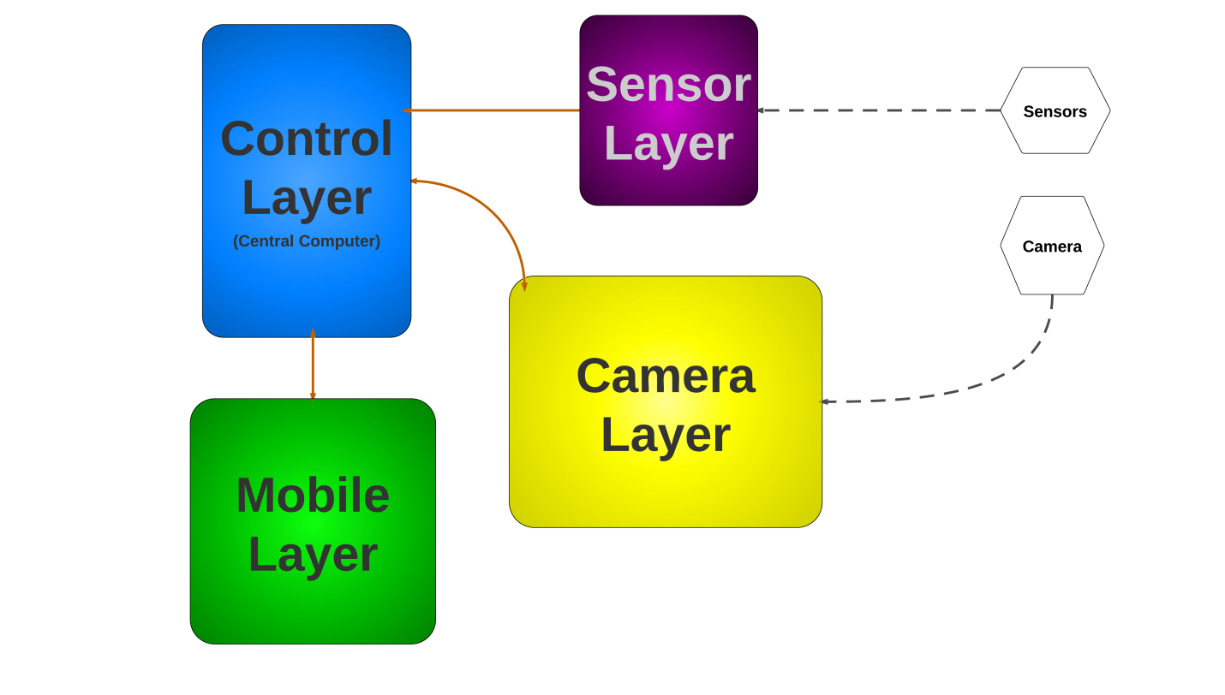

Figure 2 - Architectural Layer Overview

## Layer Name and Description

### Sensor Layer

The Sensor Layer interfaces with the sensors. Analog data is received from the sensors, converted to useful digital information, and transmitted to the central computer. The Sensor Layer maps to the Sensor Controller in Figure 1.

### Control Layer

The Control Layer interacts with the Sensor Layer, Mobile Layer, and Camera Layer, serving as the communications hub for all four layers as well as acting as the central processor. The Control Layer also provides an interface with the user. Data is received from the other three layers, processed, and can be stored within the Control Layer. The Control Layer transmits data to the Mobile Layer and the Camera Layer. The Control layer maps to the Central Computer in Figure 1.

### Camera Layer

The Camera Layer interfaces with the camera. It receives instructions from the Control Layer (or from the Mobile Layer via the Control Layer) and controls the movement of the camera. The Camera Layer is also responsible for processing the video and audio feeds from the camera before transmitting the streams to the Control Layer. The Camera Layer maps to the Camera in Figure 1.

### Mobile Layer

The Mobile Layer communicates directly with the Control Layer and interfaces with the user. The Mobile Layer can receive data from the Control Layer as well as transmit instructions and data back to the Control Layer. The Mobile Layer maps to the Mobile Device in Figure 1.

# Inter-Subsystem Dataflow

## Overview

The Inter-Subsystem Dataflow chapter describes the dataflow between the layers and between the subsystems. The description of the dataflow is in section 3.2. The MAVS System has four independent data flows.

1. A user can access the system directly through the Central Computer (denoted by data flow U1-A4).
2. A user can access the system via the Mobile Device (denoted by data flow U2-M4-M5).
3. The sensors transmit data to the system (denoted by data flow S1-S2-S3).
4. The camera transmits data to the system (denoted by data flow C1-C8).

Note: User data flows are in dotted pink, other data flows are in blue; data from external sources are represented by dashed lines.

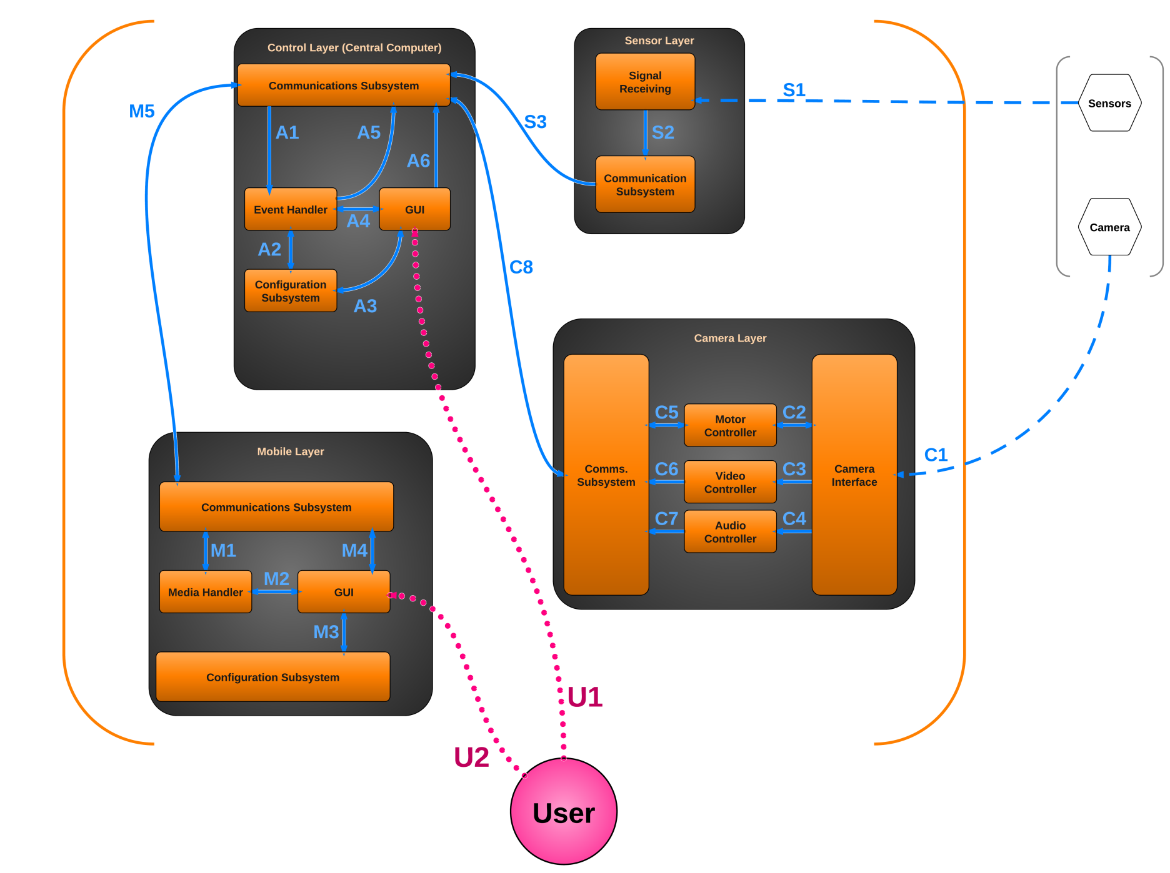Figure 2 - Architectural Data Flow Diagram

## Data Flows

Table 1 - Inter-Subsystem Data Element Descriptions

*Note: An asterisk indicates no data flow, only interaction or contact.*

|  |  |
| --- | --- |
| Data Flow ID | Description of Data Flow |
| U1* | The User interacts with the GUI on the Central Computer.  The Central Computer GUI displays appropriate information to the User. |
| U2* | The User interacts with the GUI on the Mobile Device.  The Mobile Device GUI displays appropriate information to the User. |
| S1 | The sensors transmit analog signals to the Signal Receiving subsystem. |
| S2 | The Signal Receiving subsystem converts the analog data into digital data and sends the information to the Communication Subsystem. |
| S3 | The Communication Subsystem sends the converted signal data to the Control Layer’s Communication Subsystem. |
| C1 | The camera transmits video, audio, and configuration data to the Camera Interface.  The Camera Interface issues pan/tilt/zoom information to the camera. |
| C2 | The Camera Interface reports the camera’s orientation to the Motion Controller.  The Motion Controller sends pan/tilt/zoom instructions to the Camera Interface. |
| C3 | The Camera Interface sends the camera’s video stream to the Video Controller. |
| C4 | The Camera Interface sends the camera’s audio stream to the Audio Controller. |
| C5 | The Motion Controller reports the camera’s orientation to the Camera Layer’s Communication Subsystem.  The Motion Controller receives pan/tilt/zoom instructions from the Camera Layer’s Communication Subsystem. |
| C6 | The Video Controller processes the incoming video stream and sends it to the Camera Layer’s Communication Subsystem. |
| C7 | The Audio Controller processes the incoming audio stream and sends it to the Camera Layer’s Communications Subsystem. |
| Continued on next page… | |
| Data Flow ID | Description of Data Flow (Continued from previous page…) |
| C8 | The Camera Layer’s Secure Communication Subsystem transmits audio, video, and camera orientation data to the Control Layer’s Secure Communication Subsystem. Note that this is a secure channel.  The Control Layer’s Secure Communication Subsystem transmits pan/tilt/zoom instructions to the Camera Layer’s Secure Communication Subsystem. Note that this is a secure channel. |
| A1 | The Communications Subsystem sends data to the Input Handler. The data could consist of video stream, audio stream, camera orientation, sensor data, or instructions from the Mobile Layer. |
| A2 | The Event Handler queries the Configuration Subsystem to help it perform logic operations on the date received from the Input Handler. It can also save new profile data in the Configuration Subsystem.  The Configuration Subsystem sends profile data for the Event Handler. |
| A3 | The GUI queries the Configuration Subsystem for configuration data.  The Configuration Subsystem sends configuration data to the GUI. |
| A4 | The Event Handler displays information in the GUI.  The GUI sends instructions to the Event Handler. |
| A5 | The Event Handler sends instructions, video stream, audio stream, or sensor information to the Communications Subsystem to be transmitted to another layer. |
| A6 | The GUI sends instructions to the Communications Subsystem to be transmitted to another layer. |
| Continued on next page… | |

|  |  |
| --- | --- |
| Data Flow ID | Description of Data Flow (Continued from previous page…) |
| M1 | The Communications Subsystem sends video stream, audio stream, or sensor information to the Media Handler.  The Media Handler sends instructions to the Communications Subsystem to be transmitted to another layer. |
| M2 | The Media Handler displays video, audio, notifications, or other information in the GUI.  The GUI sends instructions back to the Media Handler. |
| M3 | The GUI sends profile information to the Configuration Subsystem.  The Configuration Subsystem sends profile information to the GUI. |
| M4 | The GUI will transmit configuration information to the Communications Subsystem for relay to the Control Layer. Additionally, the GUI will transmit the command to the Communications Subsystem to initiate emergency call.  The Configuration settings and alerts will be relayed from the communications subsystem to the GUI. |
| M5 | The Mobile Layer’s Communications Subsystem transmits instructions to the Control Layer’s Communications Subsystem. Note that this is a secure channel.  The Control Layer’s Secure Communications Subsystem transmits video stream, audio stream, camera orientation, sensor information, and notifications to the Mobile Layer’s Communications Subsystem. Note that this is a secure channel. |

## Producer-Consumer Relationships

Product-consumer relationships define the relationships between subsystems. The following table shows dependencies between subsystems.

Table 2 - Producer-Consumer Relationships

|  |  |  |  |  |  |  |  |  |  |  |  |  |  |  |  |  |
| --- | --- | --- | --- | --- | --- | --- | --- | --- | --- | --- | --- | --- | --- | --- | --- | --- |
|  |  | Consumer Subsystem | | | | | | | | | | | | | | |
|  | **Signal Receiving (Sensor Layer)** | **Communication**  **(Sensor Layer)** | **Communication  (Control Layer)** | **Event Handler**  **(Control Layer)** | **Configuration**  **(Control Layer)** | **GUI**  **(Control Layer)** | **Camera Interface**  **(Camera Layer)** | **Motion Controller**  **(Camera Layer)** | **Video Controller**  **(Camera Layer)** | **Audio Controller**  **(Camera Layer)** | **Communication**  **(Camera Layer)** | **Communication**  **(Mobile Layer)** | **Media Handler**  **(Mobile Layer)** | **GUI**  **(Mobile Layer)** | **Configuration**  **(Mobile Layer)** | |
| Producer Subsystem | **Sensors** | **S1** |  |  |  |  |  |  |  |  |  |  |  |  |  |  | |
| **Signal Receiving (Sensor Layer)** |  | **S2** |  |  |  |  |  |  |  |  |  |  |  |  |  | |
| **Communication**  **(Sensor Layer)** |  |  | **S3** |  |  |  |  |  |  |  |  |  |  |  |  | |
| **Communication (Control Layer)** |  | **S3** |  | **A1** |  |  |  |  |  |  | **C8** | **M5** |  |  |  | |
| **Event Handler**  **(Control Layer)** |  |  | **A5** |  | **A2** | **A4** |  |  |  |  |  |  |  |  |  | |
| **Configuration**  **(Control Layer)** |  |  |  | **A2** |  | **A3** |  |  |  |  |  |  |  |  |  | |
| **GUI**  **(Control Layer)** |  |  | **A6** | **A4** | **A3** |  |  |  |  |  |  |  |  |  |  | |
| **Camera** |  |  |  |  |  |  | **C1** |  |  |  |  |  |  |  |  | |
| **Camera Interface**  **(Camera Layer)** |  |  |  |  |  |  |  | **C2** | **C3** | **C4** |  |  |  |  |  | |
| **Motion Controller**  **(Camera Layer)** |  |  |  |  |  |  | **C2** |  |  |  | **C5** |  |  |  |  | |
| **Video Controller**  **(Camera Layer)** |  |  |  |  |  |  |  |  |  |  | **C6** |  |  |  |  | |
| **Audio Controller**  **(Camera Layer)** |  |  |  |  |  |  |  |  |  |  | **C7** |  |  |  |  | |
| **Communication**  **(Camera Layer)** |  |  | **C8** |  |  |  |  | **C5** |  |  |  |  |  |  |  | |
| **Communication**  **(Mobile Layer)** |  |  | **M5** |  |  |  |  |  |  |  |  |  | **M1** | **M4** |  | |
| **Media Handler**  **(Mobile Layer)** |  |  |  |  |  |  |  |  |  |  |  | **M1** |  | **M2** |  | |
| **GUI**  **(Mobile Layer)** |  |  |  |  |  |  |  |  |  |  |  | **M4** | **M2** |  | **M3** | |
| **Configuration**  **(Mobile Layer)** |  |  |  |  |  |  |  |  |  |  |  |  |  | **M3** |  | |

# Control Layer

## General

The Control layer is the virtual hub for all the other layers. It receives and processes data from the Sensor and Camera layers according to the user profiles and stores and distributes them accordingly.

The control layer also includes a GUI subsystem to allow user to access cameras, sensors, alerts and log information locally on the central computer.

Furthermore, the Control layer also ensures that any remote communication must be done in a secure fashion.

Figure 3 - Control Layer

## Subsystems

### Event Handler

#### General

The Event Handler is responsible for routing messages received by the Communications Subsystem. Based on the message type, messages will be routed to the proper recipient(s) within the System.

#### Assumptions

The Camera and Sensor layer must be working normally.

#### Responsibilities

The Event Handler is responsible for routing and logging images, sensor, and configuration data received from the Communication Subsystem.

#### Subsystem Inter-layer Interfaces

N/A

#### Subsystem Public Interfaces

N/A

#### Inputs

The event handler will receive data from the following sources:

* Communication Subsystem – Images from the Camera Layer; Sensor data from the Sensor Layer; Configuration Data from the Mobile Layer
* Configuration Subsystem – Configuration Data
* GUI – Instructions

#### Outputs

Camera data: The Event Handler supplies processed camera data to the Communication subsystem. Camera data include images or video stream and camera orientation.

Alerts: The Event Handler supplies alerts to the GUI and Communication subsystem.

### Configuration Subsystem

#### General

The Configuration subsystem is responsible for storing and retrieving user profile information.

#### Assumptions

The central computer is powered up and running.

#### Responsibilities

The Configuration subsystem is responsible for storing and retrieving user profile information.

#### Subsystem Inter-layer Interfaces

N/A

#### Subsystem Public Interfaces

N/A

#### Inputs

New or Updated Configuration data: The Configuration subsystem receives new or updated configuration data from the Communication subsystem or from the GUI.

#### Outputs

Configuration data: The Configuration subsystem supplies configuration data to the Event Handler and to the GUI.

### Communication

#### General

The Communication subsystem receives instructions from the GUI. It also supplies alert and camera data to properly authenticated remote subscribers (Mobile Device). It sends incoming alert and camera data to the Event Handler.

#### Assumptions

N/A

#### Responsibilities

The Communication subsystem is responsible for receiving incoming alert and camera data, and for transmitting alert and camera data out to properly authenticated remote subscribers (Mobile Device).

#### Subsystem Inter-layer Interfaces

N/A

#### Subsystem Public Interfaces

N/A

#### Inputs

Camera data: The Communication subsystem receives camera information from the Camera Layer.

Alerts: The Communication subsystem receives sensor data from the Sensor Layer. It also receives routed alert data from the Event Handler.

Instructions: The Communication subsystem receives instructions from the GUI.

#### Output

Camera Control Commands: The Communication subsystem supplies commands to the Camera layer to control the camera.

Sensor data: The Communication subsystem supplies sensor information to the Event Handler.

Camera data: The Communication subsystem supplies camera information to the Event Handler and any remote subscriber.

Alert: The Communication subsystem supplies alert information to the local GUI and any remote subscriber.

### GUI

#### General

The GUI provides a way for the user to view or update configuration information and viewing camera feeds. The GUI allows the user to input instructions to the system.

#### Assumptions

N/A

#### Responsibilities

The GUI is responsible for interfacing with the User by displaying alerts, configuration information, and audio/video streams, as well as allowing the User to input instructions to the system.

#### Subsystem Inter-layer Interfaces

N/A

#### Subsystem Public Interfaces

N/A

#### Inputs

Configuration data: The GUI subsystem receives configuration data updates from the Event Handler, and current configuration data directly from the Configuration Subsystem.

Camera data: The GUI subsystem receives camera information from the Event Handler.

Alert: The GUI subsystem receives alert information from the Event Handler.

#### Outputs

Information is displayed to the user via a text or graphical interface.

Audio/video data is displayed within an embedded media player in the graphical interface.

# Mobile Layer

## General

The mobile layer provides the user with a mobile interface with which to control the system. From within the Layer, which communicates with the control layer, the user will be able to manage the entire system. The mobile layer will communicate with the control layer (Central Computer).

The Mobile Layer will contain a GUI through which the user can access the configuration subsystem to change settings or the media handler for displaying the images from the camera.

Alerts will be handled by the communication subsystem.

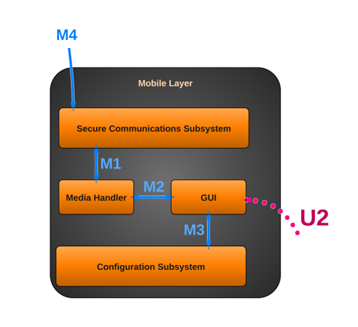

Figure 4 – Mobile Layer

## Subsystems

### Communication Subsystem

#### General

The communication layer will be the subsystem within the mobile layer that handles all communication with the central computer, internet, or phone network.

#### Assumptions

The mobile device is connected to the internet via WiFi or another network (eg 2G, 3G, etc.). The mobile device is capable of making outgoing calls. The Control Layer is functioning properly.

#### Responsibilities

* Receiving alerts from the Control Layer
* Polling the Control Layer for connection status
* Receiving data (images/audio) from the Control Layer
* Accessing the mobile device’s dialer to make emergency calls
* Sending configuration changes to the Control Layer
* Sending alert acknowledgements to the Control Layer
* Sending secured login information to Control Layer
* Sending camera commands to Control Layer

#### Subsystem Inter-Layer Interfaces

N/A

#### Subsystem Public Interfaces

N/A

#### Inputs

The communication layer will take the following inputs from the Control Layer.

* Video Data
* Audio Data
* Configuration Data
* System Status/Alerts
* Authentication Data

#### Outputs

The communication layer will have the following outputs

* Camera Commands to the Control Layer
* Audio Data to the Control Layer
* Configuration Data to the Control Layer
* Alert acknowledgement to the Control Layer
* Status ping to the Control Layer
* Alert notifications to the GUI

### Media Handler Subsystem

#### General

The media handler will be responsible for processing audio/video and passing them to the GUI.

#### Assumptions

The mobile device has a screen capable of displaying images/video and speakers capable of playing sound. There is sufficient bandwidth available to stream audio and video.

#### Responsibilities

* Validate/process images/audio from the communications layer
* Render them for display in GUI
* Collecting data (images/audio) from the Control Layer for local storage

#### Subsystem Inter-Layer Interfaces

N/A

#### Subsystem Public Interfaces

N/A

#### Inputs

The media handler will take the following inputs:

* Video Data from communication subsystem
* Audio Data from communication subsystem

#### Outputs

The media handler will have the following outputs

* Audio Data to the communication subsystem
* Video/Audio data to the GUI

### Configuration Subsystem

#### General

The configuration subsystem will hold all user settings for both the mobile device and the Control Layer. These settings will be modified through the GUI, stored locally and transmitted to the Control Layer.

#### Assumptions

N/A

#### Responsibilities

* Storing configuration settings
* Storing user data/profiles
* Updating changes to settings

#### Subsystem Inter-Layer Interfaces

N/A

#### Subsystem Public Interfaces

N/A

#### Inputs

The configuration layer will take the following inputs from within the Control Layer.

* Configuration Data from the GUI
* Configuration Data from the communications subsystem

#### Outputs

The configuration layer will have the following outputs

* Configuration Data to the GUI
* Configuration Data to the communications subsystem

### Mobile GUI Subsystem

#### General

The mobile GUI subsystem is where the user will be able to access or modify the system from the mobile device. It is a mobile front end.

#### Assumptions

The mobile device is capable of accepting touch screen input.

#### Responsibilities

* Allowing user to change configuration settings
* Allowing user to acknowledge alerts
* Allowing user to view camera
* Allowing user to listen to audio
* Displaying connection status to user
* Allowing user to access/transmit audio

#### Subsystem Inter-Layer Interfaces

N/A

#### Subsystem Public Interfaces

N/A

#### Inputs

The GUI layer will take the following inputs:

* Video Data from the media subsystem
* Audio Data from the media subsystem
* Configuration Data the configuration subsystem
* System Status/Alerts from the communication subsystem
* Authentication Data from the communication subsystem

#### Outputs

The GUI layer will have the following outputs

* Camera Commands to the communication layer
* Audio Data to the media layer
* Configuration Data to the configuration layer and communication subsystem
* Alert acknowledgement to the Control Layer via the Communication Subsystem

# Sensor Layer

## General

The Sensor Layer allows the system to communicate with the sensors. The installed sensors will provide information about triggered events to the central layer which will then pass the information on to the Control Layer, or central computer.

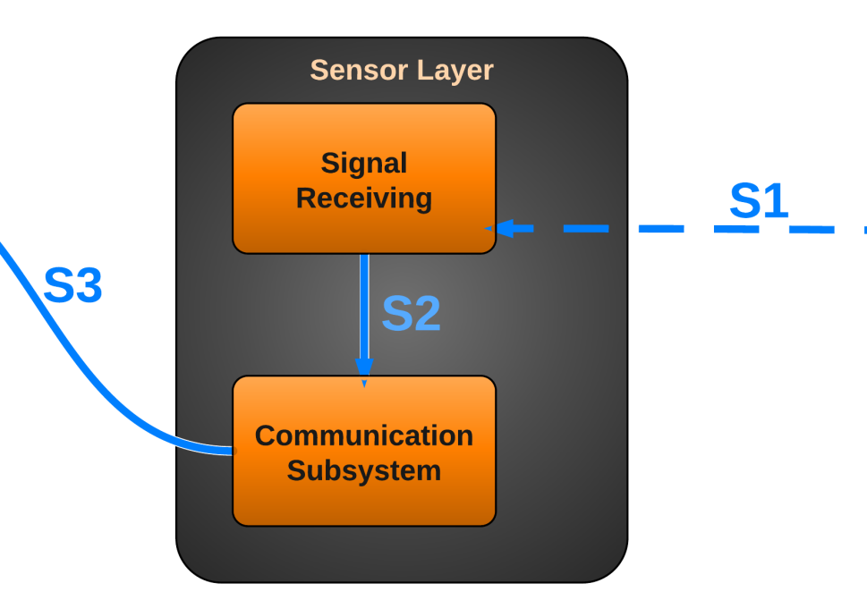

Figure 5 - Sensor Layer

## Subsystems

### Signal Receiving

#### General

The Signal Receiving subsystem is software running on a microcontroller that receives status changes of the sensors. The subsystem will then simply pass on this information to the communication subsystem.

#### Assumptions

The microcontroller must be powered on and working properly.

#### Responsibilities

The Signal Receiving subsystem is responsible for detecting changes in the state of the sensors, indicating an event that must be passed on to the communication subsystem.

#### Subsystem Inter-layer Interfaces

N/A

#### Subsystem Public Interfaces

N/A

#### Inputs

Sensor Data: The current state of the sensors is continuously supplied to this subsystem. The subsystem does not do any significant calculation until a change in sensor state is noticed.

#### Outputs

Signal Status Changed: The Signal Receiving subsystem determines which of the sensors has been triggered.

### Communication Subsystem

#### General

The Communication Subsystem communicates with the Control Layer (Central Computer) through the usage of a serial communication line, informing the Control Layer of which sensor has been triggered.

#### Assumptions

All networking hardware is configured and working correctly.

#### Responsibilities

The Communication Subsystem receives which sensor has been triggered and sends this information along to the Control Layer via means of a serial communication line.

#### Subsystem Inter-layer Interfaces

N/A

#### Subsystem Public Interfaces

N/A

#### Inputs

Signal Status Changed: The specific sensor ID is passed in, indicating which sensor has been triggered.

#### Outputs

Signal Status Changed: The specific sensor ID representing which sensor has been changed is communicated to the Control Layer via Communication Subsystem.

# Camera Layer

## General

The Camera Layer allows the system to communicate with the camera. The system will be able to retrieve the video and audio feeds from the camera, and send positioning commands (Pan/Tilt) to the camera. The Camera Layer will only accept communications from a secure, authenticated, and authorized source.

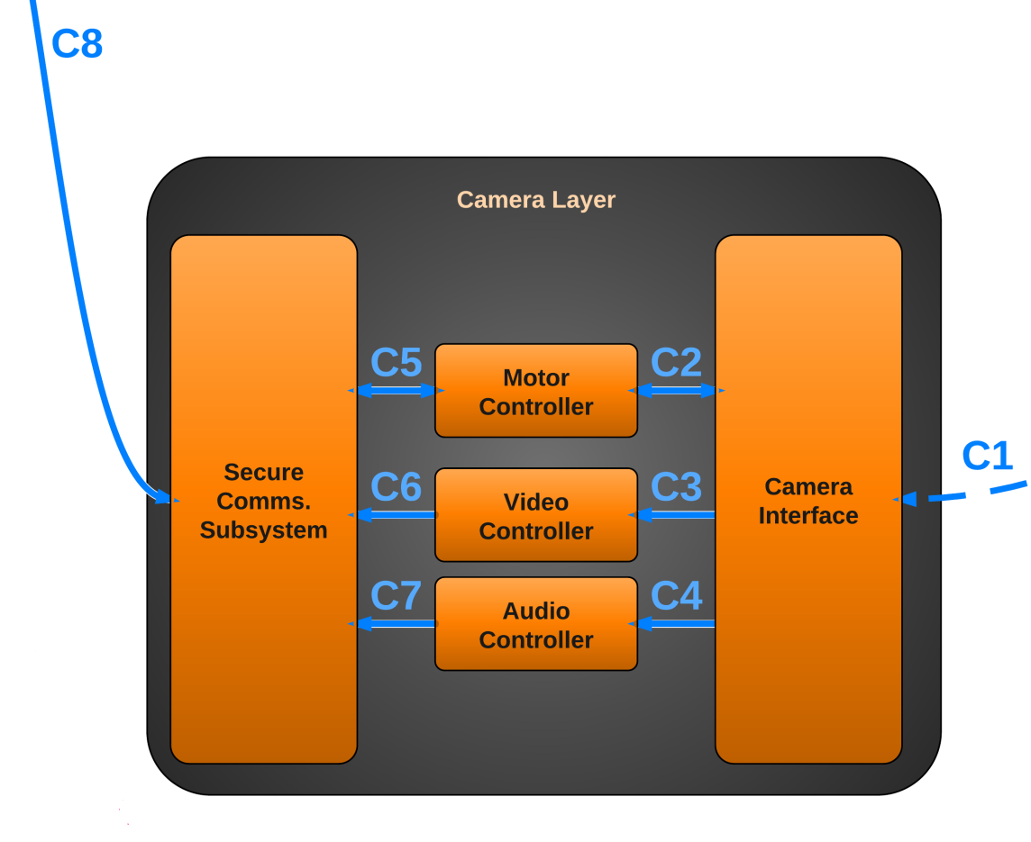

Figure 5 - Camera Layer

## Subsystems

### Camera Interface

#### General

The Camera Interface subsystem is software running on the Central Computer that actually communicates with the camera hardware. The subsystem will process all commands, such as those used to retrieve audio and video streams, and commands to control the position of the camera.

#### Assumptions

The Central Computer must be powered on, and the MAVS Systems software must be running on the computer.

#### Responsibilities

The Camera Interface subsystem is responsible for all communications between the camera hardware and the rest of the system. This allows the system to retrieve audio and video data, and instruct the camera to change its position.

#### Subsystem Inter-layer Interfaces

N/A

#### Subsystem Public Interfaces

N/A

#### Inputs

Camera Location/Orientation: The current location/orientation of the camera is supplied to the Camera Interface by the camera.

Video Data: The current video feed is supplied to the Camera Interface by the camera.

Audio Data: The current audio feed is supplied to the Camera Interface by the camera.

#### Outputs

Camera Location/Orientation: The Camera Interface subsystem provides the Motor Controller subsystem with the camera’s current position and orientation.

Video Data: The Camera Interface subsystem provides the Video Controller subsystem with the current video feed from the camera.

Audio Data: The Camera Interface subsystem provides the Audio Controller subsystem with the current audio feed from the camera.

### Motor Controller Subsystem

#### General

The Motor Controller Subsystem communicates with the Communication Subsystem to receive movement commands from the user for the camera. This allows the user to be able to instruct the camera to pan or tilt. Additionally, the Motor Controller Subsystem communicates with the Camera Interface to instruct the camera hardware to change its position and orientation.

#### Assumptions

All networking hardware is configured and working correctly. The Central Computer must be powered on, and the MAVS Systems software must be running on the computer. Additionally, the camera is powered on and working correctly.

#### Responsibilities

The Motor Control Subsystem is responsible for receiving movement commands from the Communication Subsystem and relaying those commands to the Camera Interface.

#### Subsystem Inter-layer Interfaces

N/A

#### Subsystem Public Interfaces

N/A

#### Inputs

Camera Position/Orientation: A new desired camera position/orientation is supplied to the Motor Controller Subsystem.

#### Outputs

Camera Position/Orientation: The desired camera position/orientation is passed to the Camera Interface, which can then instruct the camera hardware to move.

### Video Controller Subsystem

#### General

The Video Controller Subsystem communicates with the Communication Subsystem to send the current video stream from the camera to the user. Additionally, the Video Controller Subsystem communicates with the Camera Interface to instruct the camera to provide its video feed data. This subsystem also provides the capability to transform the video data into different formats based on current settings.

#### Assumptions

All networking hardware is configured and working correctly. The Central Computer must be powered on, and the MAVS Systems software must be running on the computer. Additionally, the camera is powered on and working correctly.

#### Responsibilities

The Video Controller Subsystem is responsible for retrieving the video feed data from the Camera Interface. Additionally, the subsystem is responsible for transforming the video data into a different format as needed (for example, to a lower resolution).

#### Subsystem Inter-layer Interfaces

|  |  |  |  |
| --- | --- | --- | --- |
| *Method* | *Description* | *Information Required* | *Information Returned* |
| GetVideoFeed | The raw video data is received from the Camera Interface and is collected into a temporary buffer. | Video Feed Data | Raw Video Data buffer |
| TransformVideoFeed | The raw video data is converted into a format that the user desires. For example, the resolution may be lowered to conserve bandwidth. | Raw Video Data buffer, Video Format Settings | New Raw Video Data buffer |

#### Subsystem Public Interfaces

N/A

#### Inputs

Raw Video Data: The camera’s raw video data of the current feed is provided to the Video Controller Subsystem.

#### Outputs

Transformed Raw Video Data: The transformed video data is provided to the Communications System.

### Audio Controller Subsystem

#### General

The Audio Controller Subsystem communicates with the Communication Subsystem to return the current audio stream of the camera to the user. Additionally, the Audio Controller Subsystem communicates with the Camera Interface to instruct the camera to provide its audio feed data.

#### Assumptions

All networking hardware is configured and working correctly. The Central Computer must be powered on, and the MAVS Systems software must be running on the computer. Additionally, the camera is powered on and working correctly. The camera is capable of recording audio data.

#### Responsibilities

The Audio Controller Subsystem is responsible for retrieving the audio feed data from the Camera Interface.

#### Subsystem Inter-layer Interfaces

N/A

#### Subsystem Public Interfaces

N/A

#### Inputs

Raw Audio Data: The camera’s raw audio data of the current feed is provided to the Audio Controller Subsystem.

#### Outputs

Raw Audio Data: The audio data is provided to the Communication Subsystem.

### Communication Subsystem

#### General

The Communication Subsystem communicates with the Communication Subsystem in the Control Layer to return the current audio and video streams of the camera to the user and to provide the current position/orientation of the camera. Additionally, the Communication Subsystem relays new position change requests to the Motor Controller Subsystem in order to move the camera.

#### Assumptions

All networking hardware is configured and working correctly. The Central Computer must be powered on, and the MAVS Systems software must be running on the computer. Additionally, the camera is powered on and working correctly.

#### Responsibilities

The Communication Subsystem is responsible for communicating with the Communication Subsystem of the Control Layer, providing it with the current audio and video streams and the current camera position and orientation.

#### Subsystem Inter-layer Interfaces

N/A

#### Subsystem Public Interfaces

N/A

#### Inputs

Transformed Video Data: The camera’s transformed video data of the current feed is provided to the subsystem.

Raw Audio Data: The camera’s raw audio data of the current feed is provided to the subsystem.

Camera Position/Orientation: The camera’s position and orientation is provided to the subsystem.

#### Outputs

Transformed Video Data: The camera’s transformed video data of the current feed is communicated to the Communication Subsystem of the Control Layer.

Raw Audio Data: The camera’s raw audio data of the current feed is communicated to the Communication Subsystem of the Control Layer.

Camera Position/Orientation: The camera’s position and orientation is communicated to the Communication Subsystem of the Control Layer.

# Testing Considerations

## General

Testing considerations cover the paths needed to test the MAVS System layers directly associated with the customer requirements. The testing procedures include unit testing, component testing, integration testing, and system verification testing.

* Unit testing consists of black box testing of each subsystem. Unit testing supplies subsystems with predetermined values designed to generate specific results to determine the usability of the subsystem.
* Integration testing is the process of verifying the interaction between the layers. Subsystems are assembled and tested in a group to verify performance and reliability of the system.
* System testing is the testing of a complete system after incorporation of the layers.

## Layer-level Interactions

The layers of the MAVS System are designed in modules and can be tested independently as well as together. The layer-level interactions clarify the standards of how testing is performed.

### Control Layer

* The Control Layer interacts with the Sensor Layer, Mobile Layer, and Camera Layer, serving as the communications hub for all four layers as well as acting as the central processor. The Control Layer also provides an interface with the user. Data is received from the other three layers, processed, and can be stored within the Control Layer. The Control Layer transmits data to the Mobile Layer and the Camera Layer.

### Sensor Layer

* The Sensor Layer interfaces with the sensors. Analog data is received from the sensors, converted to useful digital information, and transmitted to the central computer.

### Camera Layer

* The Camera Layer interfaces with the camera. It receives instructions from the Control Layer (or from the Mobile Layer via the Control Layer) and controls the movement of the camera. The Camera Layer is also responsible for processing the video and audio feeds from the camera before transmitting the streams to the Control Layer.

### Mobile Layer

* Mobile Layer communicates directly with the Control Layer and interfaces with the user. The Mobile Layer can receive data from the Control Layer as well as transmit instructions and data back to the Control Layer.

## Assumptions

### Subsystem pass/fail criteria

Subsystems will pass the testing phase after exhibiting the expected behavior.

### Test deliverables

The test results will be documented in accordance with the System Test Plan.

### Staffing and training needs

The System Test Plan will provide instructions for testing all features of the MAVS System. The MAVS Team members will be able to test entire system by following the System Test Plan.

### Debugging and Logging

The Mobile Interface and Control layers will record failures in their respective log files.

## Testing Considerations

### Independence

The independence of each layer will be accomplished by testing each layer independently.

### Integrity

The completeness of the architecture will be verified during system testing. The MAVS System will be assembled and tested as a whole system to verify the integrity of the system.

### Interfaces

After unit testing, the subsystems will be coupled together to verify the interfaces. Similarly, the layers will be assembled to verify the layer interfaces.

### Implementability

MAVS Team will use well documented software and hardware to maintain the implementability of the MAVS System.