Department of Computer Science and Engineering
The University of Texas at Arlington

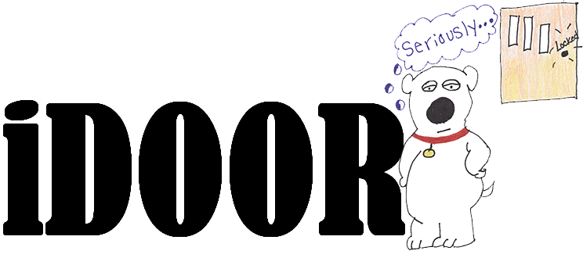
iDoor Automatic Pet Door
Architecture Design Specification

Team Members:
Jason Beere
Courtney Burkhart
Matthew Forsberg
Sandip Shrestha

Late Updated: d MMMM yyyy 40441.8590277778 h:mm:ss am/pm
Copy Printed: d MMMM yyyy 39204.4256944444 h:mm:ss am/pm
Table of Contents
1 Architecture Overview 1
1.1 Overview 1
1.2 Outline 1
1.3 Purpose 1
1.4 Project Scope 1
1.5 System Requirements Mapping 2
1.6 Definitions, Acronyms and Abbreviations 3
2 Architectural Layer Description 4
2.1 Architecture Overview 4
2.2 Layer-Name and Description 4
3 Inter-Subsystem Dataflow 6
3.1 Overview 6
3.2 Data Flows 7
3.3 Producer-Consumer Relationships 8
4 Web Interface 9
4.1 General 9
4.2 Subsystems 9
5 Control 12
5.1 General 12
5.2 Subsystems 12
6 Sensor 15
6.1 General 15
6.2 Subsystems 15
7 Lock Mechanism & Door 18
7.1 General 18
7.2 Subsystems 18
8 Testing Considerations 21
8.1 General 21
8.2 Layer-level Interactions 21
8.3 Assumptions 22

Architecture Overview

Overview
The Architecture Design Specification (ADS) supplies high level descriptions of different layers to be implemented in the iDoor and provides the relationship between the different layers. The ADS helps the stakeholders understand the iDoor system and its architecture at higher level. The ADS furnishes the architectural test considerations the iDoor team will be taking into account.
The ADS does not contain any details about the implementation of the product other than the high level description of the architectural planning.

Outline
Architecture Layer (Chapter 2): Names the different layers implemented in the iDoor along with the brief descriptions of those layers
Inter-Subsystem Dataflow (Chapter 3): Describes the dataflow between the subsystems
Individual Layers (Chapters 4 – 7): Breaks down each layer into different subsystems and describes each subsystem and its features
Testing Considerations (Chapter 8): Describes Team iDoor’s test standards and how each architectural layer of the iDoor will be tested

Purpose
The purpose of the ADS is to define the architecture specifications for the iDoor. The ADS allows Team iDoor to further breakdown the components of the product into mini-components to be completed throughout the life of the project. The ADS is the first step in the implementation of the product and will serve as a guideline.
The ADS does not describe individual components of the iDoor nor does it explain how Team iDoor will implement the components. The ADS document sets up a foundation to initiate the implementation as the team moves to detail design phase.

Project Scope
The iDoor is an automated pet door designed to give pet owners flexibility by controlling the door remotely. Unlike what is already on the market, the iDoor is operable through a network. A user is able to remotely set the schedule for the pets to enter or leave the house and has the ability to overwrite the schedule by accessing the remote server (see Figure 1 diagram of the iDoor product). Users shall have full control over the pet door remotely or at home.
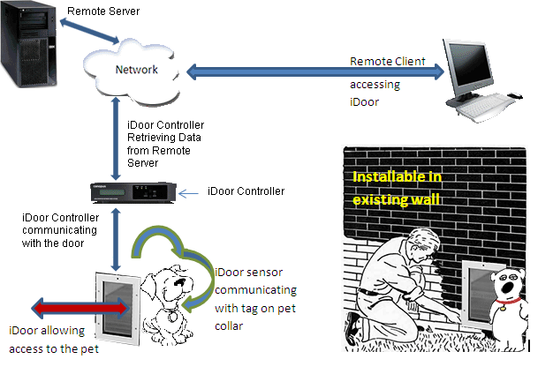
Figure 1 - Diagram of iDoor product
The iDoor Controller periodically connects to the Remote Server, to check if authorized pets are allowed enter or exit through the pet door.
The iDoor shall include a tag to attach to a pet’s collar and shall have a sensor device mounted to the pet door. The sensor recognizes the approaching pet and sends the information to the iDoor Controller. The iDoor Controller receives the signal, verifies the tag and schedule, and returns a signal to the iDoor locking mechanism to unlock the door, if permitted.

System Requirements Mapping

Table 1 - Requirements Mapping
 | Customer Requirements | Web Interface | Control | Sensor | Lock Mechanism & Door
4.2.1 | The iDoor product shall contain a pet door |  |  |  | X
4.2.2 | The pet door shall have a lock |  |  |  | X
4.2.3 | The iDoor shall sense the user’s pets |  |  | X
4.2.4 | The iDoor shall prohibit access for vermin and unwanted pets |  | X | X | X
4.2.5 | The iDoor shall notify pets when they may pass through the pet door |  |  |  | X
4.2.6 | The iDoor shall not crush the pets |  |  |  | X
4.2.7 | The iDoor shall operate on a schedule | X | X
4.2.8 | The iDoor shall have a schedule override feature | X | X
4.2.9 | The iDoor schedule and override feature shall be locally and remotely accessible | X
4.2.10 | Unauthorized users shall be prevented access to the schedule and override feature of the door | X
4.2.11 | If the iDoor has a guillotine-style door, the door shall automatically open and close after the pet is granted access |  |  |  | X
4.2.12 | The pet door component shall be mounted in a wall |  |  |  | X
4.2.13 | The iDoor shall contain removable pet tags |  |  | X
4.2.14 | The iDoor shall be installable in existing homes and new construction |  |  |  | X
4.2.15 | The iDoor shall use 120 volt alternating current electricity |  | X | X | X
4.2.16 | The iDoor shall be used for small to mid-size pets |  |  |  | X

Definitions, Acronyms and Abbreviations
ADS – Architecture Design Specification
GUI – Graphical User Interface
iDoor – Name of both the product and team name
Medium size pet – Medium sized pet is between 40-70 pounds
Pet – Refers to either a dog or cat
Tag – Device attached to the pet’s collar to identify the pet
User – Refers to the pet’s owner
Vermin – Squirrels, mice, rats, and raccoons

Architectural Layer Description

Architecture Overview
The iDoor architecture contains four layers:
- Web Interface
- Control
- Sensor
- Lock Mechanism & Door

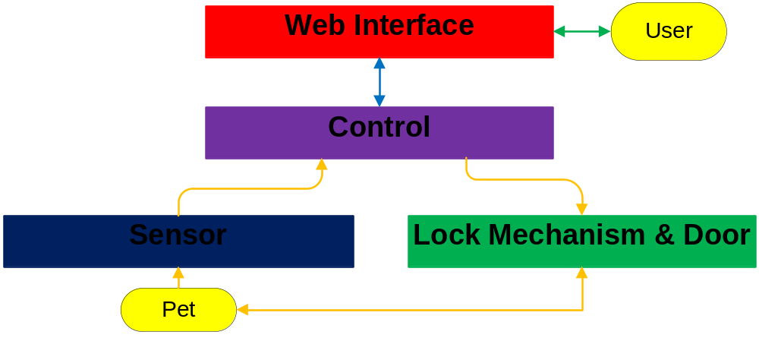
Figure 2 - Architectural Layer Overview

Layer-Name and Description

Web Interface
The Web Interface interacts with the users. The interface presents the current schedule of the iDoor and allows authorized users to change and override the schedule. The schedule data is stored in the Web Interface layer, providing the authorized user full access to the schedule data. The Web Interface layer maps to the Remote Server in Figure 1 - Diagram of iDoor product.

Control
The Control layer interacts with the Web Interface layer to access the schedule data. The Control layer receives data from the Sensor layer and controls the Lock Mechanism & Door layer. The Control layer maps to the iDoor Controller in Figure 1 - Diagram of iDoor product.

Sensor
The Sensor layer interfaces with the pet. The Sensor layer detects the pet, its position, and passes the information to the Control layer. The Sensor layer maps to the door in Figure 1.

Lock Mechanism & Door
The Control layer will control the Lock Mechanism & Door layer. The Control layer signals the Lock Mechanism & Door layer to lock and unlock the door. The door is attached to the wall. The pet pushes the door to walk though after being alerted. The Lock Mechanism & Door layer maps to the door in Figure 1.

Inter-Subsystem Dataflow

Overview
The Inter-Subsystem Dataflow chapter describes the dataflow between the layers and between the subsystems. The description of the dataflow is in section 3.2. The iDoor has three independent data flows.
- A user can access the schedule (denoted by data flow U1-U3). U is for User and the arrows are in green.
- The Controller periodically checks the schedule (denoted by S1-S2). S is for Schedule and the arrows are in blue.
- An authorized pet can walk through the door (denoted by P1-P12). P is for Pet and the arrows are in orange.
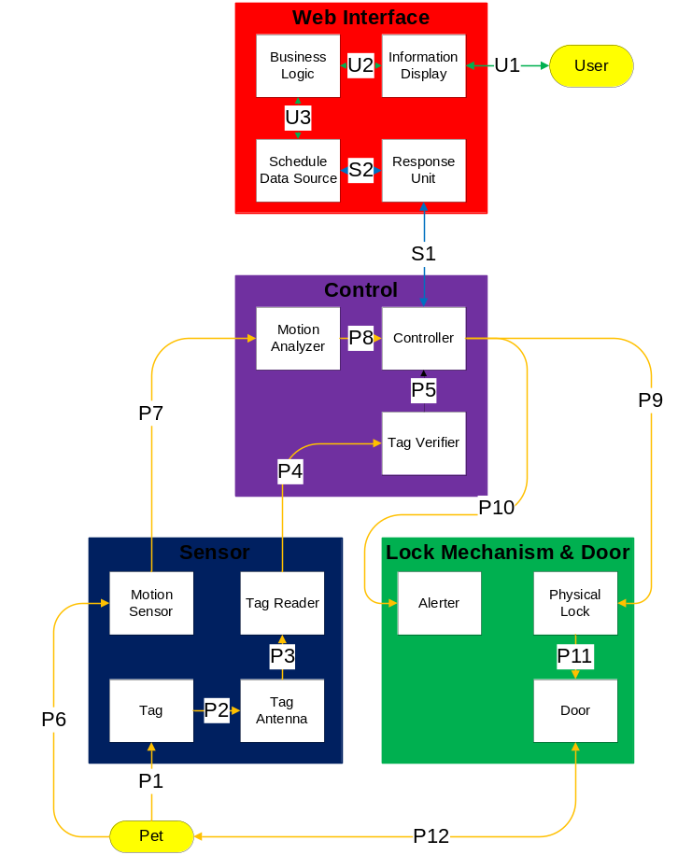
Figure 3 - Architectural Data Flow Diagram

Data Flows
Table 2 - Inter-Subsystem Data Element Descriptions
Note: * indicates no data flow, only interaction or contact
Data Element | Description of data element
U1* | Interaction between the user and the Information Display/GUI (graphical user interface) running in a browser
U2 | Network interface between web GUI in browser and Business Logic on server computer  Business Logic sends http data over the network to the Information Display, the GUI running in a browser on the user’s computer  Any requests by the remote user such as schedule updates and schedule overrides are transmitted from the UI to the Business Logic through a http connection
U3 | Internal computer interface between the Business Logic and Schedule Data Source on the remote server  Schedule Data Source sends schedule information to the Business Logic  Business Logic sends data to the Schedule Data Source if the user overrides the schedule or requests an update to the existing schedule
S1 | Network interface between the Control layer and Web Interface  The Controller subsystem sends location information to the Response Unit subsystem  The Response Unit sends back the current schedule information to the controller subsystem in Control Layer
S2 | Internal computer interface between Response Unit subsystem and Schedule Data Source file  The Response Unit subsystem sends iDoor location information to the Schedule Data Source (to identify the location)  Schedule Data Source subsystem sends schedule information to the Response Unit
P1* | Interaction between the pet collar and the Tag. The tag is worn on the collar
P2 | Interface between the Pet Tag and the Tag Antenna  Pet Tag broadcasts a signal and is received by the Tag Antenna
P3 | Signal interface between Tag Antenna and Reader  The Antenna sends signals over a wire to the Reader, so the signal can be read
P4 | Interface between the Sensor and Control layers  Data from the Tag Reader is passed to the Tag Verifier for verification purpose over a wired connection
P5 | Interface between Tag Verifier and Controller  The Tag Verifier programmatically verifies the tag signal and sends confirmation to the Controller over a digital connection
P6* | Interaction between the Pet and the Motion Sensor  Motion sensor converts the movement of the pet into a signal
P7 | Interface between the Motion Sensor and Motion Analyzer  Motion Sensor sends a signal to the Motion Analyzer to determine the position of the pet
P8 | Interface between Motion Analyzer and Controller within the Controller Layer within the Control Layer  The Motion Analyzer sends pet location information to the Controller over a digital connection
P9 | Interaction between the Controller Layer and Lock Mechanism & Door Layer. The Controller analyzes all the input data and sends a signal to Physical Lock to unlock the door if the lock is scheduled to be unlocked for authorized pets. The state of the lock is maintained for certain time before it locks
P10 | Interaction between the Controller Layer and Lock Mechanism & Door Layer. Controller analyzes all the input data and sends a signal to the Alerter to alert the pet if they are allowed to pass through the door at the time
P11* | Interaction between the physical door and the physical lock
P12* | Interaction between the pet and the iDoor

Producer-Consumer Relationships
Product-consumer relationships define the relationships between subsystems. The following table shows dependencies between subsystems.

Table 3 - Producer-Consumer Relationships
 |  | Consumer Subsystem
 |  | Business Logic | Information Display | Schedule Data Source | Response Unit | Tag Antenna | Tag Reader | Tag Verifier | Control | Motion Analyzer | Alerter | Physical Lock
Producer Subsystem | Business Logic |  | U2 | U3
Producer Subsystem | Information Display | U2
Producer Subsystem | Schedule Data Source | U3 |  |  | S2
Producer Subsystem | Response Unit |  |  | S2 |  |  |  |  | S1
Producer Subsystem | Tag |  |  |  |  | P2
Producer Subsystem | Tag Antenna |  |  |  |  |  | P3
Producer Subsystem | Tag Reader |  |  |  |  |  |  | P4
Producer Subsystem | Motion Sensor |  |  |  |  |  |  |  |  | P7
Producer Subsystem | Tag Verifier |  |  |  |  |  |  |  | P5
Producer Subsystem | Motion Analyzer |  |  |  |  |  |  |  | P8
Producer Subsystem | Control |  |  |  | S1 |  |  |  |  |  | P10 | P9

Web Interface

General
The Web Interface layer allows the user to access the iDoor schedule remotely. The functionality will be supported via the iDoor official website hosted at a secure location accessible using the internet. This layer allows users to set up the schedule for the pet door to operate. The Web Interface allows the user to override the schedule. The schedule override feature is given precedence over the schedule until the override is cleared. After the iDoor is installed, the user will primarily interact with the Web Interface.
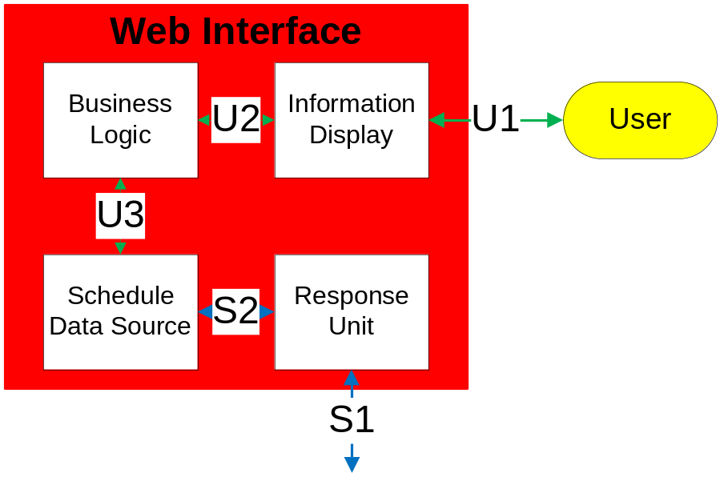
Figure 4 - Web Interface Layer

Subsystems

Business Logic

General
The Business Logic is software running on the remote server and is responsible for manipulating the Schedule Data Source. The Business Logic supplies the schedule information to the Information Display. The Business Logic processes requests from the Information Display to override or update the existing schedule in the Schedule Data Source.

Assumptions
The Web Interface must be powered on and working normally.

Responsibilities
The Business Logic subsystem is responsible for retrieving the schedule from the Schedule Data Source and sending it to the Information Display. The Business Logic processes schedule changes received from the Information Display and updates the Schedule Data Source.

Subsystem Inter-layer Interfaces
Method | Description | Information Required | Information Returned
SetUserData | Processes schedule changes received from the Information Display and updates the Schedule Data Source | None | Schedule
GetScheduleData | Retrieves schedule information from Schedule Data Source and sends to Information Display | Schedule | None

Subsystem Public Interfaces
N/A

Inputs
Schedule information: The Business Logic subsystem pulls the schedule information from the Schedule Data Source subsystem.
Updated schedule information: The Business Logic receives changes made by the user in the Information Display to the schedule information.

Outputs
Schedule data: The Business Logic supplies schedule data information to the Information Display.
Updated schedule: The Business Logic updates the Schedule Data Source with new schedule information.

Information Display

General
The Information Display builds a GUI consisting buttons and schedule controls, and uploads the GUI to the user’s browser. The Information Display receives requests from the user to update or override the schedule. The Information Display sends these changes to the Business Logic subsystem.

Assumptions
All networking hardware is configured correctly. The user is running Internet Explorer 8.

Responsibilities
The Information Display authenticates the user’s identity and builds a GUI for the user to interact. The Information Display uploads the GUI to the user’s browser and receives requests from the user to update or override the schedule. The Information Display sends these changes to the Business Logic subsystem.

Subsystem Inter-layer Interfaces
N/A

Subsystem Public Interfaces
N/A

Inputs
Schedule data: The Information Display receives schedule data information from the Business Logic.
Updated schedule data: The user updates the Information Display subsystem to change or override the schedule.

Outputs
GUI: A screen displaying the current schedule and override selections.
Updated schedule information: The Information Display sends schedule changes made by the user to the Business Logic.

Schedule Data Source

General
The Schedule Data Source subsystem consists of schedule data containing the schedule information and overrides.

Assumptions
N/A

Responsibilities
The Schedule Data Source holds the schedule information set by the user. The Schedule Data Source responds to the Business Logic and the Response Unit.

Subsystem Inter-layer Interfaces
N/A

Subsystem Public Interfaces
N/A

Inputs
Updated schedule: The Schedule Data Source receives updates from the Business Logic with new schedule information.
iDoor identity: The Response Unit supplies the unique serial number requesting the schedule information from the Schedule Data Source. The serial number identifies the specific iDoor unit.

Outputs
Schedule information: The Schedule Data Source sends the schedule information to the Business Logic.
Current schedule: The Schedule Data Source sends the schedule to the Response Unit.

Response Unit

General
The Response Unit receives requests from the Controller, pulls the schedule information, and uses the current time to determine the state of the lock for authorized pets. The Response Unit sends the result to the Controller.

Assumptions
The Web Interface layer is set to the correct time, is powered on, and is working normally.

Responsibilities
The Response Unit takes requests from the Controller and returns the desired state of the door lock for authorized pets. The Response Unit determines the correct state by using the current time and accessing the Schedule Data Source.

Subsystem Inter-layer Interfaces
Method | Description | Information Required | Information Returned
GetScheduledDoorState | Schedule information is retrieved from Schedule Data Source, processed, and the results sent to the Control layer | None | Door State

Subsystem Public Interfaces
N/A

Inputs
Current schedule: The Response Unit receives the current schedule from the Schedule Data Source.
iDoor identity: The Response Unit receives the unique serial number requesting the schedule information from the Controller. The serial number identifies the specific iDoor unit.

Outputs
iDoor identity: The Response Unit sends the unique serial number to the Schedule Data Source to obtain the schedule information for the particular iDoor.
Current state: The Response Unit sends information to the Controller to set the current state of the lock for authorized pets.

Control

General
The Control layer controls the iDoor. This layer periodically connects to the Web Interface and checks the schedule. The Control layer receives an alert for the presences of a pet; checks the location of the pet; checks the desired lock state for authorized pets; and opens the lock if necessary. The Control layer interfaces with all architectural layers of the iDoor, and does not contain any public interfaces.
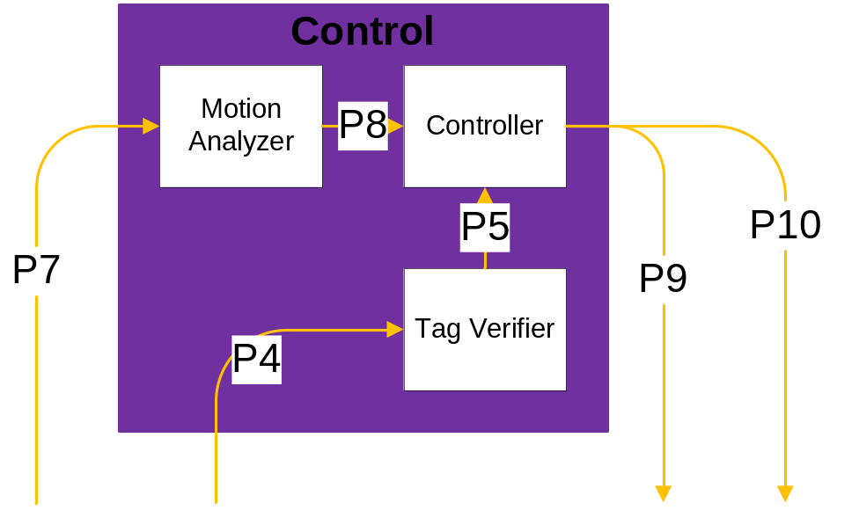
Figure 5 - Control Layer

Subsystems

Controller

General
The Controller subsystem regulates the locking mechanism and interfaces with the other layers in the iDoor. This subsystem is similar to a processing unit where the information from other subsystems is processed to produce the expected effect.

Assumptions
All the layers are connected to the Control layer. The Control layer is powered on and working properly.

Responsibilities
The Controller subsystem receives data from the Motion Analyzer, the Tag Verifier, and the Response Unit to control the locking mechanism of the iDoor.

Subsystem Inter-layer Interfaces
Method | Description | Information Required | Information Returned
GetSchedule | Retrieve schedule information from the Response Unit | None | Schedule
SetDoorState | Sends the new lock state to the physical lock | Schedule | New lock state
SetAlert | Sends alert signal to the Alerter subsystem | Schedule | Alert signal

Subsystem Public Interfaces
N/A

Inputs
Tag identity: The Controller receives tag identity information from the Tag Verifier.
Pet position: The Controller receives the position of the pet from the Motion Analyzer.
Schedule: The Controller will periodically receive schedule data from the Response Unit in the Web Interface Layer.

Outputs
New lock state: The controller blends all the inputs from the inputs to output the new lock state to the Physical Lock subsystem.
Alert signal: The controller blends all the inputs from the inputs to output the alert signal if the door is unlocked.

Motion Analyzer

General
The Motion Analyzer evaluates the signal to identify the position of the pet.

Assumptions
The Motion Sensor in the Sensor layer is functional.

Responsibilities
The Motion Analyzer subsystem receives data from Motion Sensor. The analyzer evaluates the signal to determine the position of the pet, and sends the information to the Controller.

Subsystem Inter-layer Interfaces
The Motion Analyzer interfaces with the Motion Sensor in the Sensor layer.
Method | Description | Information Required | Information Returned
AnalyzeMotion | Analyze the position of the pet | Motion Sensor data | Position

Subsystem Public Interfaces
N/A

Inputs
Motion data: Motion Sensor supplies motion data to the Motion Analyzer.

Outputs
Pet position: The Motion Analyzer supplies the pet position to the Controller subsystem.

Tag Verifier

General
The Tag Verifier subsystem receives the tag information from the Tag Reader and verifies the identity of pet before allowing access.

Assumptions
The Tag Reader is functional and tag information is sound.

Responsibilities
The Tag Verifier verifies the identity of the pet tag before allowing access to the door.

Subsystem Inter-layer Interfaces
The Tag Verifier interfaces with the Tag Reader in the Sensor layer.
Method | Description | Information Required | Information Returned
VerifyTAG | Verify the tag signal received from Tag Reader | Tag Signal | True/False

Subsystem Public Interfaces
N/A

Inputs
Tag information: The Tag Reader supplies the tag information to the Tag Verifier.

Outputs
Pet’s identity: The Tag Verifier verifies the identity of the pet tag and outputs the confirmation to the Controller.

Sensor

General
The Sensor layer is responsible for detecting the pet and notifying the Control layer. The Sensor layer shall detect the pet and the location (inside or outside) of the pet using the Motion Sensor.
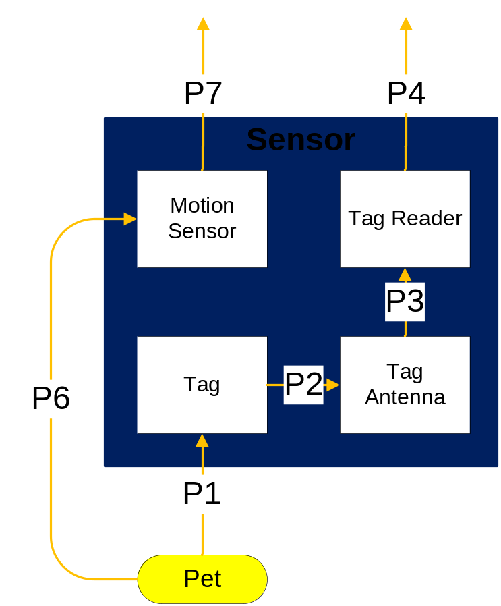
Figure 6 - Sensor Layer

Subsystems

Tag

General
The Tag subsystem is attached to the collar worn by the pet. The tag allows the pet to be identified by Control layer. Pets are required to wear the tag to be authorized to pass through the iDoor.

Assumptions
The Sensor layer must be powered on.

Responsibilities
The Tag subsystem passes information to the Tag Antenna subsystem. The Tag is responsible for identifying the pet to the iDoor.

Subsystem Inter-layer Interfaces
N/A

Subsystem Public Interfaces
The Tag subsystem attaches to the collar of the pet.

Inputs
N/A

Outputs
Tag signal: The Tag broadcasts a signal, received by the Tag Antenna.

Tag Antenna

General
The Tag Antenna subsystem is attached to the door, wall, or is embedded with the Tag Reader. The antenna receives data from the tag.

Assumptions
The Antenna subsystem is not attached to a metal object. The Sensor layer must be powered on. The antenna does not receive interference.

Responsibilities
The Tag Antenna receives an analog radio signal from the Tag subsystem and passes the information to the Tag Reader subsystem.

Subsystem Inter-layer Interfaces
N/A

Subsystem Public Interfaces
N/A

Inputs
Tag signal: The Tag Antenna receives the broadcast signal from the Tag.

Outputs
Tag information: The Tag Antenna sends the signal to the Tag Reader over a wired interface.

Tag Reader

General
The Tag Reader subsystem detects the tag and collects the data on the tag. The data is passed to the Tag Verifier subsystem to determine if the pet is allowed to use the pet door at this time.

Assumptions
The Sensor and Control layers must be powered on. The Tag Reader reads the data correctly.

Responsibilities
The Tag Reader subsystem receives analog information from the Tag Antenna subsystem and passes the information to the Control layer. The Tag Reader may convert the information to a digital signal if necessary.

Subsystem Inter-layer Interfaces
The Tag Reader subsystem connects to the Tag Verifier subsystem in the Control layer. The connection is over a wired interface.

Subsystem Public Interfaces
N/A

Inputs
Tag information: The Tag Reader receives the signal from the Tag Antenna over a wired interface.

Outputs
Pet’s identity: The Tag Reader sends the data to the Tag Verifier over a wired interface.

Motion Sensor

General
The Motion Sensor subsystem contains one or more sensors attached to the part of the iDoor located on the inside of the home. The Motion Sensor sends a signal to the Motion Analyzer if the pet is located inside the house.

Assumptions
The Motion Sensor subsystem is attached to the inside side of the iDoor. If an authorized pet approaches the iDoor and movement is detected on the inside, the pet is on the inside. If no movement is detected, the pet id is on the outside. The Sensor layer must be powered on. Movement is only detected on the inside of the door.

Responsibilities
After the pet is detected, the Motion Sensor subsystem looks for movement on the inside of the door. The Motion Sensor passes the information to the Control layer over a wired interface.

Subsystem Inter-layer Interfaces
The Motion Sensor subsystem connects to the Motion Analyzer subsystem in the Control layer. The connection is over a wired interface.

Subsystem Public Interfaces
The Motion Sensor subsystem interacts with the pet by using waves to detect motion.

Inputs
Movement: The Motion Sensor detects movement of the pet in an area.

Outputs
Motion data: The Motion Sensor sets the alarm pin to low when motion is detected. The alarm pin is connected to the Motion Sensor Analyzer over a wired interface.

Lock Mechanism & Door

General
The Lock Mechanism & Door layer contains the Physical Lock, physical Door, and Alerter. The layer interfaces with the Control layer and interacts with the pet. The interaction with the pet occurs when the pet touches the door to walk through.
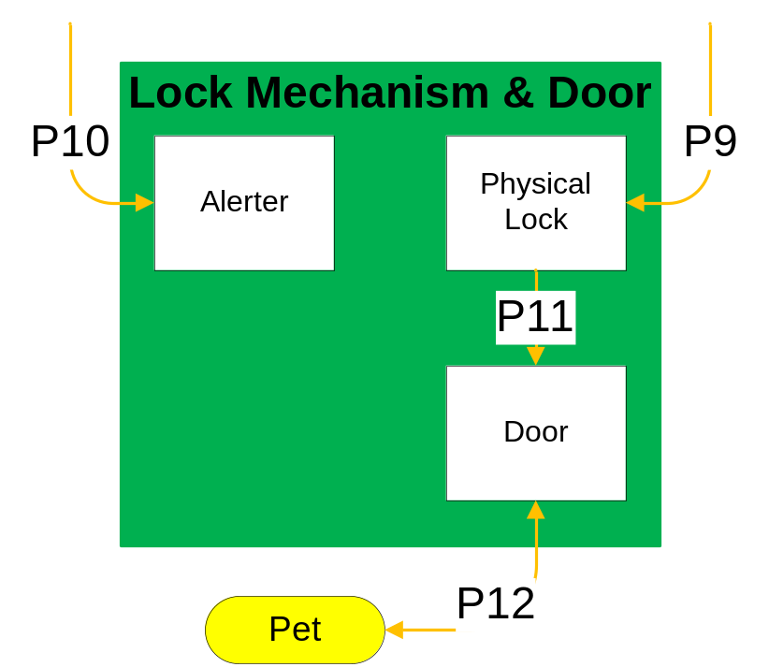
Figure 7 - Lock Mechanism & Door Layer

Subsystems

Physical Lock

General
There will be a physical lock on the door. This lock will be able to keep a pet or vermin from walking through the door. The Physical Lock will also prevent inclement weather from entering the user’s home.

Assumptions
The Physical Lock subsystem must be powered on.

Responsibilities
The Physical Lock subsystem will allow the door to be locked and unlocked. The lock will prevent inclement weather from entering in the user’s home.

Subsystem Inter-layer Interfaces
The Physical Lock subsystem will be controlled by the Controller subsystem in the Control layer. The interface between the two subsystems will be wired.

Subsystem Public Interfaces
N/A

Inputs
New lock state: The Physical Lock subsystem will receive a signal from the controller subsystem indicating on whether the door should be unlocked or locked.

Outputs
Door state: The Physical Lock subsystem will not send any outputs to any of the other subsystems or layers.

Door

General
The Door subsystem will be for a medium sized pet, installed in the wall of the user’s home. The door will have a physical lock installed. The door will be of a flap/ hinge style made of durable waterproof material.

Assumptions
The door will be large enough for a medium sized pet.

Responsibilities
The user’s pet can enter and exit the home through the Door subsystem. The door will keep out vermin as well as inclement weather.

Subsystem Inter-layer Interfaces
N/A

Subsystem Public Interfaces
The door will interact with the pet when the pet pushes the flap on the door while walking through.

Inputs
N/A

Outputs
N/A

Alerter

General
The Alerter subsystem will either display a light or sound a bell notifying the pet the door is unlocked. The pet can be trained by the user to respond to the notification.

Assumptions
The pet will respond to the light or sound.

Responsibilities
The Alerter will alert the pet after the door is unlocked. The pet will not be notified when the door is locked.

Subsystem Inter-layer Interfaces
The Alerter will interface with the Controller subsystem in the Control layer. The connection will be wired.

Subsystem Public Interfaces
The pet will see or hear the alert.

Inputs
Alert signal: The Alerter input will come from the Controller subsystem within the control layer. The Controller will send a signal to the Alerter alerting the pet the door is unlocked.

Outputs
Alert message: The Alerter subsystem outputs a sound or light notifying the pet the door is unlocked.

Testing Considerations

General
Testing considerations cover the paths needed to test the iDoor layers directly associated with the customer requirements. The testing procedures include unit testing, component testing, integration testing, and system verification testing.
- Unit testing consists of black box testing of each subsystem. Unit testing supplies subsystems with predetermined values designed to generate specific results to determine the usability of the subsystem.
- Integration testing is the process of verifying the interaction between the layers. Subsystems are assembled and tested in a group to verify performance and reliability of the system.
- System testing is the testing of a complete system after incorporation of the layers.

Layer-level Interactions
The layers of the iDoor are designed in modules and can be tested independently as well as together. The layer-level interactions clarify the standards of how testing is performed.

Web Interface
The Business Logic gets the information from the Schedule Data Source and serves the data to the Information Display. The Business Logic subsystem will be tested by setting break points and verifying the values expected at each breakpoint.
The Information Display builds a GUI for the user and gets the user input. This subsystem will be tested by verifying the changes and setting break points in the Business Logic to see if the expected values arrive.
The Response Unit handles the requests from the Controller and returns the lock state. This subsystem will be tested by setting break points and verifying the values expected at each breakpoint.

Control
The Tag Verifier verifies the tag id to identify the pet. The Motion Analyzer locates the pet and the Controller uses this information to control the lock. The Controller periodically requests the lock status from the Response Unit.
The testing of the Control layer will be performed after each subsystem is verified to be operational. The Controller will be tested by passing in valid and invalid states and observing the response.

Sensor
The Tag Antenna receives a signal from the tag and passes the information to the Tag Reader.
The Motion Sensor detects movement after the Tag Reader reads the tag to locate the pet.
Testing of both the tag subsystems and Motion Sensor subsystem will be black box testing.

Lock Mechanism & Door
The iDoor contains a physical lock built into the door. The physical lock is controlled by the Controller subsystem to lock and unlock the door.
The testing of the locking mechanism will start after installation of the lock into the door. The lock will be tested with the Controller using black box testing. This will verify the performance of the physical lock. The reliability of the testing will be based on the testing of the physical lock over various lock states (allow in, allow out, allow in and out, and locked both ways). The Alerter will be tested concurrently with the physical lock test.

Assumptions

Subsystem pass/fail criteria
Subsystems will pass the testing phase after exhibiting the expected behavior.

Test deliverables
The test results will be recorded.

Staffing and training needs
The System Test Plan will provide instructions for testing all features of the iDoor. The iDoor team members will be able to test entire system by following the System Test Plan.

Debugging and Logging
The Web Interface and Control layers will record failures in their respective log files.

Testing Considerations

Independence
The independence of each layer will be accomplished by testing each layer independently. Some of the testing will be black box testing.

Integrity
The completeness of the architecture will be verified during system testing. The iDoor will be assembled and tested as a whole system to verify the integrity of the system.

Interfaces
After unit testing, the subsystems will be coupled together to verify the interfaces. Similarly, the layers will be assembled to verify the layer interfaces.

Implementability
Team iDoor will use well documented software and hardware to maintain the implementability of the iDoor.

