Department of Computer Science and Engineering
The University of Texas at Arlington


iDoor Automatic Pet Door
Detailed Design Specification

Team Members:
Jason Beere
Courtney Burkhart
Matthew Forsberg
Sandip Shrestha

Late Updated: d MMMM yyyy 40484.7930555556 h:mm:ss am/pm
Copy Printed: d MMMM yyyy 39204.4673611111 h:mm:ss am/pm
Table of Contents
1 Introduction 1
1.1 Overview 1
1.2 Outline 1
1.3 Purpose 1
1.4 Project Scope 1
1.5 Definitions, Acronyms and Abbreviations 2
2 Architecture Overview 4
2.1 Architecture Overview 4
2.2 Layer-Name and Description 4
2.3 Module Decomposition Chart 6
3 Inter-Subsystem Dataflow 11
3.1 Overview 11
3.2 Data Flows 12
3.3 Producer-Consumer Relationships 13
4 Web Interface Layer Design 15
4.1 General 15
4.2 Business Logic Subsystem 15
4.3 Information Display Subsystem 21
4.4 Schedule Data Source Subsystem 25
4.5 Response Unit Subsystem 26
5 Control Layer Design 29
5.1 General 29
5.2 Controller Subsystem 29
5.3 Motion Analyzer Subsystem 31
5.4 Tag Verifier Subsystem 32
6 Sensor Layer Design 34
6.1 General 34
6.2 Tag Subsystem 34
6.3 Tag Antenna Subsystem 35
6.4 Tag Reader Subsystem 36
6.5 Motion Sensor Subsystem 36
7 Lock Mechanism & Door Layer Design 38
7.1 General 38
7.2 Physical Lock Subsystem 38
7.3 Door Subsystem 39
7.4 Alerter Subsystem 40
8 Quality Assurance 42
8.1 Test Plans and Procedures 42
8.2 Test Cases 45
9 Requirements Traceability Matrix 52
9.1 Requirements Traceability Matrix 52
10 Acceptance Plan 55
10.1 General 55
10.2 Packaging and Installation 55
10.3 Acceptance Testing 56
10.4 Acceptance Criteria 56
11 Appendices 58
11.1 Formulas and Algorithms Not Documented in the Software Requirements Document 58

Introduction

Overview
The Detailed Design Specification (DDS) is the further design of Architectural Design Specification and is to understand the system in a lower level of detail. This document clarifies the interface and the interaction between the subsystems at the modular level. The detailed specifications of the hardware and software components are described in this document. In brief, Detail Design Specification clarifies the aforementioned concepts defined in the architecture design specification.

Outline
The document is structured as follows:
- Introduction
- Architecture Overview
- Inter-Subsystem Dataflow
- Web Interface Layer Design
- Control Layer Design
- Sensor Layer Design
- Lock Mechanism & Door Layer Design
- Quality Assurance
- Requirements Traceability
- Acceptance Plan
- Appendices

Purpose
This Detailed Design Specification is to describe the system in detail at the modular level illustrating the subsystems and the subcomponents. This document facilitates the engineers and the designers with firm understanding of the system enabling them to modify or enhance the product.

Project Scope
The iDoor is an automated pet door designed to give pet owners flexibility by controlling the door remotely. Unlike what is already on the market, the iDoor is operable through a network. A user is able to remotely set the schedule for the pets to enter or leave the house and has the ability to overwrite the schedule by accessing the remote server (see Figure 1 diagram of the iDoor product). Users shall have full control over the pet door remotely or at home.
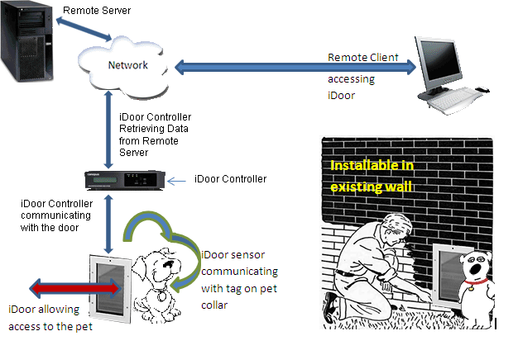
Figure 1 - Diagram of iDoor product
The iDoor Controller periodically connects to the Remote Server, to check if authorized pets are allowed enter or exit through the pet door.
The iDoor shall include a tag to attach to a pet’s collar and shall have a sensor device mounted to the pet door. The sensor recognizes the approaching pet and sends the information to the iDoor Controller. The iDoor Controller receives the signal, verifies the tag and schedule, and returns a signal to the iDoor locking mechanism to unlock the door, if permitted.

Definitions, Acronyms and Abbreviations
A/D Analog to Digital Converter
ATmega328 – Microcontroller made by Atmel
D/A Digital to Analog Converter
DDS – Derailed Design Specification
GUI – Graphical User Interface
ICSP – In-Circuit Serial Programming
iDoor – Name of both the product and team name
IP – Internet Protocol
IRED – Infrared emitting diode
IIS – Internet Information Services
iS – iDoorSchedule: Prefix used to shorten some function names listed in this document
MHz – Megahertz
Medium size pet – Medium sized pet is between 40-70 pounds
Pet – Refers to either a dog or cat
PSD – Position sensitive detector
PWM – Pulse Width Modulation
RFID – Radio-Frequency Identification
Tag – Device attached to the pet’s collar to identify the pet
User – Refers to the pet’s owner
Vermin – Squirrels, mice, rats, and raccoons

Architecture Overview

Architecture Overview
The iDoor architecture contains four layers:
- Web Interface
- Control
- Sensor
- Lock Mechanism & Door

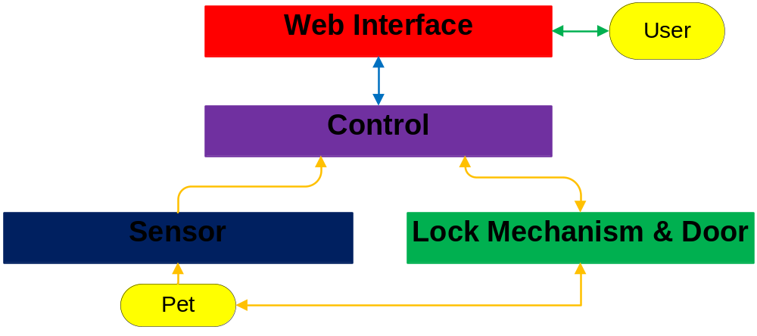
Figure 2 - Architectural Layer Overview

Layer-Name and Description

Web Interface
The Web Interface interacts with the users. The interface presents the current schedule of the iDoor and allows authorized users to change and override the schedule. The schedule data is stored in the Web Interface layer, providing the authorized user full access to the schedule data. The Web Interface layer maps to the Remote Server in Figure 2.

Control
The Control layer interacts with the Web Interface layer to access the schedule data. The Control layer receives data from the Sensor layer and controls the Lock Mechanism & Door layer. The Control layer maps to the iDoor Controller in Figure 2.

Sensor
The Sensor layer interfaces with the pet. The Sensor layer detects the pet, its position, and passes the information to the Control layer. The Sensor layer maps to the door in Figure 2.

Lock Mechanism & Door
The Control layer will control the Lock Mechanism & Door layer. The Control layer signals the Lock Mechanism & Door layer to lock and unlock the door. The door is attached to the wall. The pet pushes the door to walk though after being alerted. The Lock Mechanism & Door layer maps to the door in Figure 2.

Module Decomposition Chart
 |  | Modules
Web Interface Layer | Business Logic Subsystem | 1) iS.Page_Load | 2) iS. GetSchedule Information From Data Source | 3) iS.GetSchedule Override Information From Data Source | 4) iS.btnSubmit_Click
Web Interface Layer | Business Logic Subsystem | Function: Bind schedule to controls | Inputs: Schedule data source  Outputs: BindSchedules  Function: Retrieves schedule from data source | Inputs: Schedule data source  Outputs: BindSchedules  Function: Gets override information | Outputs: Schedule Data Source  Function: Creates new schedule from controls
Web Interface Layer | Business Logic Subsystem | 5) iS.MakeSchedule | 6) iS.BindSchedules | 7) iSWebUserControl. Repeater1_PreRender | 8) iDoor.ScheduleWeb UserControl.GetSchedule
Web Interface Layer | Business Logic Subsystem | Outputs: btnSubmit_Click  Function: Makes schedule from list of days | Inputs: GetScheduleInformation FromDataSource & GetScheduleOverride InformationFromDataSource  Outputs: ScheduleWebUserControl  Function: Binds schedule to controls | Inputs: ScheduleWebUserControl  Outputs: Datasource property of repeater  Function: Binds data source property to repeater | Inputs: WebUserControl.Repeater1_PreRender  Outputs: btmSubmit_Click  Function: Converts repeater to days
Web Interface Layer | Business Logic Subsystem | 9) iDoor.Day
Web Interface Layer | Business Logic Subsystem | Function: Contains schedule information for day for direction
Web Interface Layer | Information  Display | 1) Default.aspx | 2) Schedule.aspx | 3) Response.aspx | 4) ScheduleWebUser Control.ascx
Web Interface Layer | Information  Display | Inputs: ID & password  Outputs: HTML  Function: Login page | Inputs: bind_Schedule  Outputs: HTML  Function: Provide schedule page | Inputs: iDoor.Response. Page_Load  Function: Page with value for lock status | Inputs: iS.Page_Load  Function: Display table with hours of day
Web Interface Layer | Schedule  Data Source | 1) Schedule Data Source
Web Interface Layer | Schedule  Data Source | Function: Provides schedule data
Web Interface Layer | Response  Unit | 1) iDoor.Response. Page_Load
Web Interface Layer | Response  Unit | Inputs: Schedule data source  Outputs: Response.aspx  Function: Checks current status of lock

Figure 3 - Web Interface Layer Decomposition
Note: iS is an abbreviation for iDoorSchedule

 |  | Modules
Control | Controller | 1) Arduino
Control | Controller | Inputs: Motion Analyzer  Tag Verifier  Response.aspx  Outputs: Alerter  Lock Mechanism  Function: Control Lock and alert pet based on lock status, motion, and pet id
Control | Motion  Analyzer | 1) Motion Analyzer
Control | Motion  Analyzer | Inputs: Proximity Sensor  Outputs: Arduino  Function: Determine location and distance of pet
Control | Tag  Verifier | 1) Tag Verifier
Control | Tag  Verifier | Inputs: RFID Reader  Outputs: Arduino  Function: Determine identity of pet
Sensor | Tag | 1) RFID Pet Tag
Sensor | Tag | Outputs: RFID Antenna  Function: Broadcast RFID of pet
Sensor | Tag  Antenna | 1) RFID Antenna
Sensor | Tag  Antenna | Inputs: RFID Pet Tag  Outputs: RFID Reader  Function: Convert RFID signal from radio to wire
Sensor | Tag Reader | 1) RFID Reader
Sensor | Tag Reader | Inputs: RFID Antenna  Outputs: Tag Identifier  Function: Read RFID number and pass to Tag Identifier
Sensor | Motion  Sensor | 1) Proximity Sensor
Sensor | Motion  Sensor | Outputs: Motion Analyzer  Function: Detect location and distance of pet from door
Lock Mechanism & Door | Physical  Lock | 1) Lock | 2) Magnetic Alarm Contact
Lock Mechanism & Door | Physical  Lock | Inputs: Arduino  Function: Locks and unlocks door | Outputs: Arduino  Process: Controls entry and exit to home
Lock Mechanism & Door | Alerter | 1) Alerter
Lock Mechanism & Door | Alerter | Inputs: Arduino  Outputs: Sound  Function: Signals pet to enter door
Lock Mechanism & Door | Door | 1) Door
Lock Mechanism & Door | Door | Function: Controls entry and exit to home

Figure 4 – Control, Sensor, and Lock Mechanism & Door Layers Decomposition

iDoor.Schedule.Page_Load
iDoor.Schedule.Page_Load is an auto generated function allowing the system to execute custom code whenever the Schedule.aspx page is loaded. This function calls the iDoor.Schedule.BindSchedules function if the condition is not a postback.

iDoor.Schedule.GetScheduleInformationFromDataSource
iDoor.Schedule.GetScheduleInformationFromDataSource retrieves the schedule information from the data source using LINQ to XML.

iDoor.Schedule.GetScheduleOverrideInformationFromDataSource
iDoor.Schedule.GetScheduleOverrideInformationFromDataSource retrieves the schedule override information from the data source using LINQ to XML.

iDoor.Schedule.btnSubmit_Click
The iDoor.Schedule.btnSubmit_Click function is fired when the submit button is clicked on the Schedule.aspx page. This function gets the schedule and commits the schedule to the schedule file location.

iDoor.Schedule.MakeSchedule
Given a list of type iDoor.Day, the iDoor.Schedule.MakeSchedule function creates an XElement for the schedule in a given direction.

iDoor.Schedule BindSchedules
The iDoor.Schedule.BindSchedules function binds the schedule to the schedule web user controls and sets the override radio button on the Schedule.aspx page.

iDoor.ScheduleWebUserControl.Repeater1_PreRender
The Repeater1_PreRender function binds the DataSource property of the ScheduleWebUserControl to the DataSource of the repeater held within the function.

iDoor.ScheduleWebUserControl.GetSchedule
The iDoor.ScheduleWebUserControl.GetSchedule function retrieves the schedule information from the repeater held on the WebUserControl.ascx and returns a list of type iDoor.Day.

iDoor.Day
iDoor.Day is a class that holds the schedule for one day in one direction.

Default.aspx
Default.aspx is the default display page. This webpage contains one login control.

Schedule.aspx
Schedule.aspx is the page that holds the schedule and override information.

Response.aspx
The current state of the lock is written to the Response.aspx page. This page answers requests from the control subsystem.

ScheduleWebUserControl.ascx
ScheduleWebUserControl.ascx holds a repeater used to show the schedule for a set of days in one direction.

Schedule Data Source
The Schedule Data Source is a XML data file containing the schedule data.

iDoor.Response.Page_Load
The iDoor.Response.Page_Load function writes the current state to the Response.aspx page.

Arduino
The Arduino module is responsible for downloading schedule updates from the iDoor.Response.Page_Load module. The Arduino receives notifications from the Tag Verifier and Motion Analyzer about the presence and location of the user’s pet.

Motion Analyzer
Receives information from two Proximity Sensors and checks the location (inside or outside) and distance of the pet from door. If pet is close enough, Motion Analyzer triggers the unlock procedure.

Tag Verifier
The Tag Verifier module is responsible for receiving the RFID identification number information from the RFID Reader and determining the identification of the pet. If the pet is identified, the verifier notifies the Arduino about the presence of the owner’s pet.

RFID Pet Tag
The RFID Tag Module is responsible for broadcasting a number used to identify a user’s pet.

RFID Antenna
The RFID Antenna Module is responsible for receiving a number of the pet tag radio signal and passing the number to the RFID Reader over a wire.

RFID Reader
The RFID Reader Module is responsible for receiving a number from the antenna, reading the number, and passing the number digitally to the Tag Verifier.

Proximity Sensor
The Proximity Sensor Module is responsible for detecting the location of the pet and distance from the door. The sensor passes this information to the Motion Analyzer.

Lock Module
The Lock Module is responsible for locking and unlocking the door. The lock receives the locking information from the Arduino.

Magnetic Alarm Contact
The Magnetic Alarm Contact Module is responsible for making sure the door doesn’t lock while the door is still open. The alarm contact completes a circuit with the Arduino after the door is closed.

Alerter
The Alerter Module is responsible for notifying the pet when the door is unlocked, so the pet can pass through the door. The alerter receives the sound from the Arduino.

Door
The Door Module is responsible allowing the user’s pet to pass through the iDoor at the right time. The door keeps unauthorized pets, vermin, and children from passing through. The Door is the actual pet door.

Inter-Subsystem Dataflow

Overview
The Inter-Subsystem Dataflow chapter describes the dataflow between the layers and between the subsystems. The description of the dataflow is in section 3.2. The iDoor has three independent data flows.
- A user can access the schedule (denoted by data flow U1-U3). U is for User and the arrows are in green.
- The Controller periodically checks the schedule (denoted by S1-S2). S is for Schedule and the arrows are in blue.
- An authorized pet can walk through the door (denoted by P1-P12). P is for Pet and the arrows are in orange.
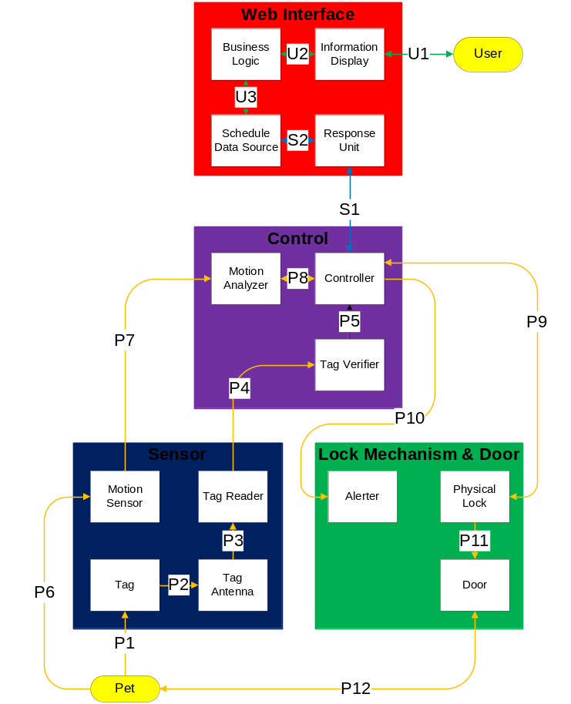
Figure 5 - Architectural Data Flow Diagram

Data Flows
Table 1 - Inter-Subsystem Data Element Descriptions
Note: * indicates no data flow, only interaction or contact
Data Element | Description of data element
U1* | Interaction between the user and the Information Display/GUI (graphical user interface) running in a browser
U2 | Network interface between web GUI in browser and Business Logic on server computer  Business Logic sends http data over the network to the Information Display, the GUI running in a browser on the user’s computer  Any requests by the remote user such as schedule updates and schedule overrides are transmitted from the UI to the Business Logic through a http connection
U3 | Internal computer interface between the Business Logic and Schedule Data Source on the remote server  Schedule Data Source sends schedule information to the Business Logic  Business Logic sends data to the Schedule Data Source if the user overrides the schedule or requests an update to the existing schedule
S1 | Network interface between the Control layer and Web Interface  The Controller subsystem sends location information to the Response Unit subsystem  The Response Unit sends back the current schedule information to the Controller subsystem in Control Layer
S2 | Internal computer interface between Response Unit subsystem and Schedule Data Source file  The Response Unit subsystem sends iDoor location information to the Schedule Data Source (to identify the location)  Schedule Data Source subsystem sends schedule information to the Response Unit
P1* | Interaction between the pet collar and the Tag. The tag is worn on the collar
P2 | Interface between the Pet Tag and the Tag Antenna  Pet Tag broadcasts a signal and is received by the Tag Antenna
P3 | Signal interface between Tag Antenna and Reader  The Antenna sends signals over a wire to the Reader, so the signal can be read
P4 | Interface between the Sensor and Control layers  Data from the Tag Reader is passed to the Tag Verifier for verification purpose over a wired connection
P5 | Interface between Tag Verifier and Controller  The Tag Verifier programmatically verifies the tag signal and sends confirmation to the Controller over a digital connection
P6* | Interaction between the Pet and the Motion Sensor  Motion sensor converts the movement of the pet into a signal
P7 | Interface between the Motion Sensor and Motion Analyzer  Motion Sensor sends a signal to the Motion Analyzer to determine the position of the pet
P8 | Interface between Motion Analyzer and Controller within the Controller Layer within the Control Layer  The Motion Analyzer sends pet location information to the Controller over a digital connection
P9 | Interaction between the Controller Layer and Lock Mechanism & Door Layer. The Controller analyzes all the input data and sends a signal to Physical Lock to unlock the door if the lock is scheduled to be unlocked for authorized pets. The state of the lock is maintained for certain time before it locks
P10 | Interaction between the Controller Layer and Lock Mechanism & Door Layer. Controller analyzes all the input data and sends a signal to the Alerter to alert the pet if they are allowed to pass through the door at the time
P11* | Interaction between the physical door and the physical lock
P12* | Interaction between the pet and the iDoor

Producer-Consumer Relationships
Product-consumer relationships define the relationships between modules. The following table shows dependencies between modules.

Table 2 – Producer - Consumer Relationships, not including Web Interface Layer
 |  | Consumer Subsystem
 |  | Response.aspx | RFID Antenna | RFID Reader | Tag Verifier | Arduino | Motion Analyzer | Alerter | Lock | Magnetic Alarm Contact
Producer Subsystem | Response.aspx |  |  |  |  | S1
Producer Subsystem | Tag Verifier |  |  |  |  | P8
Producer Subsystem | Motion Analyzer |  |  |  |  | P8
Producer Subsystem | Arduino | S1 |  |  |  |  |  | P9 | P9 | P9
Producer Subsystem | Proximity Sensor |  |  |  |  |  | P7
Producer Subsystem | RFID Tag |  | P2
Producer Subsystem | RFID Antenna |  |  | P3
Producer Subsystem | RFID Reader |  |  |  | P4
Producer Subsystem | Magnetic Alarm Contact |  |  |  |  | P9

Table 3 - Producer - Consumer Relationships, Web Interface Layer
Note: iS is an abbreviation for iDoorSchedule. I means the relationship is internal to the subsystem
 |  | Consumer Subsystem
 |  | iS.GetScheduleInformation FromDataSource | iS.GetScheduleOverride InformationFromDataSource | iS.btnSubmit_Click | iS.MakeSchedule | S.BindSchedules | iSWebUserControl. Repeater1_PreRender | iSWebUserControl.GetSchedule | Schedule.aspx | Response.aspx | ScheduleWebUserControl.ascx | Schedule Data Source | iDoor.Response.Page_Load
Producer Subsystem | iS.GetScheduleInformation FromDataSource |  |  |  |  | I
Producer Subsystem | iS.GetScheduleOverride InformationFromDataSource |  |  |  |  | I
Producer Subsystem | iS.btnSubmit_Click |  |  |  | I |  |  |  |  |  |  | U3
Producer Subsystem | iS.MakeSchedule |  |  | I
Producer Subsystem | iS.BindSchedules |  |  | I |  |  |  |  | I |  | U2
Producer Subsystem | iSWebUserControl. Repeater1_PreRender |  |  |  |  |  |  | I |  |  |  | U3
Producer Subsystem | iSWebUserControl.GetSchedule |  |  | I
Producer Subsystem | Default.aspx |  |  |  |  |  |  |  |  |  | U2
Producer Subsystem | ScheduleWebUserControl.ascx |  |  |  |  |  | U2 | U2
Producer Subsystem | Schedule Data Source | U3 | U3 |  |  | U3 |  |  |  |  |  |  | S2
Producer Subsystem | iDoor.Response.Page_Load |  |  |  |  |  |  |  |  | I

Web Interface Layer Design

General
The Web Interface layer communicates with the user and maintains the schedule. The Web Interface layer will be programmed in ASP.Net and C# with the .Net Framework 4.0. The Web Interface will run on a computer running IIS.
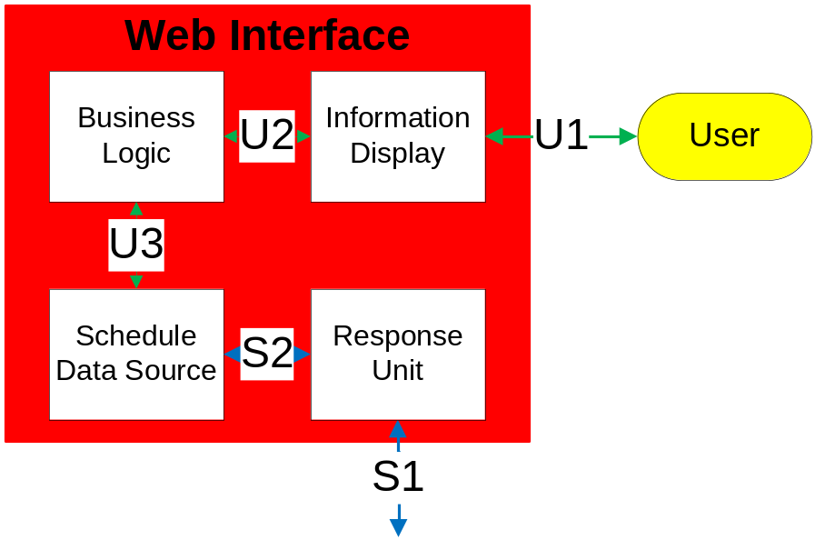
Figure 6 - Web Interface Layer

Business Logic Subsystem
The Business Logic subsystem will be a backend for the Information Display subsystem written in C# with the .Net Framework 4.0. The Business Logic subsystem is in charge of getting the schedule from the Schedule Data Source subsystem and binding the schedule to the controls in the Information Display subsystem. After the schedule is submitted from the Information Display subsystem, the Business Logic subsystem takes the value for the schedule and overwrites the Schedule Data Source subsystem with the new schedule. The Business Logic layer is in charge of verifying the username and password supplied by the Information Display subsystem with the database in the Schedule Data Source subsystem. The Business Logic system handles the Business Logic of the Schedule Web User Control. The Business Logic subsystem contains 3 classes:
iDoor.Schedule
iDoor.ScheduleWebUserControl
iDoor.Day

iDoor.Schedule.Page_Load

Module Prologue
protected void Page_Load(object sender, EventArgs e)
The Page_Load function is fired every time the page is loaded. This function binds the schedule to the Schedule Web User Controls the first time the page is loaded.

Interfaces (provider-consumer relationships with other modules)
N/A

N/A

Process
if (!IsPostBack)
{
BindSchedules();
}

iDooriDoor.Schedule.GetScheduleInformationFromDataSource

Module Prologue
private List<Day> GetScheduleInformationFromDataSource(string direction, string fileLocation)
The GetScheduleInformationFromDataSource function retrieves the schedule information from the XML data source for one week in a specific direction. This function returns a list of days.

Interfaces (provider-consumer relationships with other modules)
The list produced by the GetScheduleInformationFromDataSource function is consumed by the BindSchedules function. GetScheduleInformationFromDataSource consumes the schedule data source.

Physical data structure/data file descriptions
N/A

Process
List<Day> days = new List<Day>();
XDocument xDocument = XDocument.Load(Server.MapPath("~/Schedules.xml"));
XElement schedule = (from p in Document.Element("Schedules").Elements("Schedule") where p.Attribute("direction").Value == direction select p).Single();
foreach (XElement day in schedule.Elements("Day"))
{
Day d = new Day();
d.Name = day.Attribute("name").Value;
d.Hour0 = bool.Parse(day.Element("Hour0").Value);
d.Hour1 = bool.Parse(day.Element("Hour1").Value);
d.Hour2 = bool.Parse(day.Element("Hour2").Value);
……………
d.Hour23 = bool.Parse(day.Element("Hour23").Value);
days.Add(d);
}
return days;

iDoor.Schedule.GetScheduleOverrideInformationFromDataSource

Module Prologue
private int GetScheduleOverrideInformationFromDataSource(string fileLocation)
GetScheduleOverrideInformationFromDataSource gets the override information from the data source at the specified file location.

Interfaces (provider-consumer relationships with other modules)
The list produced by the GetScheduleOverrideInformationFromDataSource function is consumed by the BindSchedules function. GetScheduleOverrideInformationFromDataSource consumes the schedule data source.

Physical data structure/data file descriptions
N/A

Process
XDocument xDocument =
XDocument.Load(Server.MapPath(fileLocation));

string overridedirection =
(from p in xDocument.Element("Schedules").Elements("Override") select p.Attribute("direction").Value).Single();

if (overridedirection == "None")
{
return 0;
}
else if (overridedirection == "In")
{
return 1;
}
else if (overridedirection == "Out")
{
return 2;
}
else if (overridedirection == "Locked")
{
return 3;
}
else if (overridedirection == "Open")
{
return 4;
}
else
{
return 0;
}

iDoor.Schedule.btnSubmit_Click

Module Prologue
protected void btnSubmit_Click(object sender, EventArgs e)
The btnSubmit_Click function is fired every time the btnSubmit button is clicked. The btnSubmit_Click function is creates a schedule from the values of the controls on the asp page. Afterwards, the btnSubmit_Click function overwrites the Schedule Data Source.

Interfaces (provider-consumer relationships with other modules)
The btnSubmit_Click function creates a new schedule used to overwrite the Schedule Data Source.

Physical data structure/data file descriptions
N/A

Process
XDocument xDocument = new XDocument(new XElement("Schedules"));

XElement scheduleoverride =
new XElement("Override", new XAttribute("direction", rblOverride.SelectedValue));

xDocument.Element("Schedules").Add(scheduleoverride);

List<Day> daysIn = ScheduleWebUserControlIn.GetSchedule();

XElement scheduleIn = MakeSchedule(daysIn, "In");

xDocument.Element("Schedules").Add(scheduleIn);

List<Day> daysOut = ScheduleWebUserControlOut.GetSchedule();

XElement scheduleOut = MakeSchedule(daysOut, "Out");

xDocument.Element("Schedules").Add(scheduleOut);

xDocument.Save(Server.MapPath("~/Schedules.xml"));
BindSchedules();

iDoor.Schedule.MakeSchedule

Module Prologue
private XElement MakeSchedule(List<Day> days, string direction)
The MakeSchedule function makes a schedule from a list of Day elements for a given direction. The schedule is returned as a XElement to be incorporated in an XML document.

Interfaces (provider-consumer relationships with other modules)
The XElement returned by the MakeSchedule is consumed by the btnSubmitClick function.

Physical data structure/data file descriptions
N/A

Process
XElement schedule =
new XElement("Schedule", new XAttribute("direction", direction));

foreach (Day day in days)
{
schedule.Add(
new XElement("Day",
new XAttribute("name", day.Name),
new XElement("Hour0", day.Hour0),
new XElement("Hour1", day.Hour1),
new XElement("Hour2", day.Hour2),
……………………
new XElement("Hour23", day.Hour23)));
}
return schedule;

iDoor.Schedule.BindSchedules

Module Prologue
private void BindSchedules()
BindSchedules binds the schedule to the ScheduleWebUserControls and binds the override information to the radio button list, both on the Schedule.aspx page.

Interfaces (provider-consumer relationships with other modules)
The BindSchedules function consumes the list of type iDoor.Day from the GetScheduleInformationFromDataSource function. The BindSchedules function consumes the integer (between 1-4) returned from the GetScheduleOverrideInformationFromDataSource function. BindSchedules produces a list of type iDoor.Day for the ScheduleWebUserControls and an integer (between 1-4) for the radio button list.

Physical data structure/data file descriptions
N/A

Process
List<Day>
days = GetScheduleInformationFromDataSource("In", _ScheduleDataSource);
ScheduleWebUserControlIn.DataSource = days;
ScheduleWebUserControlIn.DataBind();
days = GetScheduleInformationFromDataSource("Out", _ScheduleDataSource);
ScheduleWebUserControlOut.DataSource = days;
ScheduleWebUserControlOut.DataBind ();

rblOverride.Items[GetScheduleOverrideInformationFromDataSource(_ScheduleDataSource)].Selected = true;

iDoor.ScheduleWebUserControl.Repeater1_PreRender

Module Prologue
protected void Repeater1_PreRender(object sender, EventArgs e)
The Repeater1_PreRender function is fired prior to rendering the ScheduleWebUserControl. The Repeater1_PreRender function binds the DataSource property of the ScheduleWebUserControl to the DataSource of the repeater held within the function.

Interfaces (provider-consumer relationships with other modules)
The Repeater1_PreRender function consumes the DataSource property of the ScheduleWebUserControl and produces the result to be consumed by the DataSource property of the repeater.

Physical data structure/data file descriptions
N/A

Process
Repeater1.DataSource = DataSource;
Repeater1.DataBind();

iDoor.ScheduleWebUserControl.GetSchedule

Module Prologue
The GetSchedule function returns a list of type iDoor.Day. The GetSchedule function takes each element of the repeater and turns the element into an iDoor.Day. GetSchedule puts all of the iDoor.Days in a list and returns the list.

Interfaces (provider-consumer relationships with other modules)
The GetSchedule function consumes the values from the repeater in ScheduleWebUserControl.ascx. The GetSchedule produces a list of type iDoor.Day for btnSubmit_Click.

Physical data structure/data file descriptions
N/A

Process

List<Day> days = new List<Day>();
foreach (RepeaterItem repeaterItem in Repeater1.Items)
{
Day day = new Day();
Label name = (Label)repeaterItem.FindControl("lblName");
day.Name = name.Text;
CheckBox cb = (CheckBox)repeaterItem.FindControl("cbHour0");
day.Hour0 = cb.Checked;
cb = (CheckBox)repeaterItem.FindControl("cbHour1");
day.Hour1 = cb.Checked;
cb = (CheckBox)repeaterItem.FindControl("cbHour2");
day.Hour2 = cb.Checked;
…
cb = (CheckBox)repeaterItem.FindControl("cbHour23");
day.Hour23 = cb.Checked;
days.Add(day);
}
return days;

iDoor.Day

Module Prologue
iDoor.Day is the class containing the schedule information for a given day in a given direction.

Interfaces (provider-consumer relationships with other modules)
N/A

Physical data structure/data file descriptions
public string Name { get; set; } // Name of the day
public bool Hour0 { get; set; } // True if pet is allowed in public bool Hour1 { get; set; } // direction of schedule
public bool Hour2 { get; set; }
…
public bool Hour23 { get; set; }

Process
N/A

Information Display Subsystem
The Information Display subsystem is in charge of displaying the web pages. The Information Display subsystem is mainly the visual aspect of the webpage, although the controls hold values accessible by the Business Logic layer. The Information Display is written in ASP.Net with Framework 4.0. The Information Display subsystem consists of 4 pages:
Default.aspx
Schedule.aspx
Response.aspx
ScheduleWebUserControl.ascx

Default.aspx

Module Prologue
The default page contains a login control for the user to login.

Interfaces (provider-consumer relationships with other modules)
N/A

Physical data structure/data file descriptions
N/A

Process
<%@ Page Language="C#" AutoEventWireup="true" CodeBehind="Default.aspx.cs" %>

<!DOCTYPE html PUBLIC "-//W3C//DTD XHTML 1.0 Transitional//EN" "http://www.w3.org/TR/xhtml1/DTD/xhtml1-transitional.dtd">

<html xmlns="http://www.w3.org/1999/xhtml" >
<head runat="server">
<title></title>
</head>
<body>
<form id="form1" runat="server">
<div>
<asp:Login ID="Login1" runat="server"
DestinationPageUrl="~/Schedule/Schedule.aspx" >
</asp:Login>

</div>
</form>
</body>
</html>

Schedule.aspx

Module Prologue
Schedule.aspx is the page holding the schedule and override information.

Interfaces (provider-consumer relationships with other modules)
N/A

Physical data structure/data file descriptions
N/A

Process
<%@ Page Language="C#" AutoEventWireup="true" CodeBehind="Schedule.aspx.cs" Inherits="iDoor.Schedule" EnableEventValidation="false" %>

<%@ Register src="~/Schedule/ScheduleWebUserControl.ascx" tagname="ScheduleWebUserControl" tagprefix="uc1" %>

<!DOCTYPE html PUBLIC "-//W3C//DTD XHTML 1.0 Transitional//EN" "http://www.w3.org/TR/xhtml1/DTD/xhtml1-transitional.dtd">

<html xmlns="http://www.w3.org/1999/xhtml" >
<head runat="server">
<title>iDoor Web Interface</title>
</head>
<body>
<form id="form1" runat="server">
<div>
<asp:RadioButtonList ID="rblOverride" runat="server" RepeatDirection="Horizontal">
<asp:ListItem>None</asp:ListItem>
<asp:ListItem>In</asp:ListItem>
<asp:ListItem>Out</asp:ListItem>
<asp:ListItem>Locked</asp:ListItem>
<asp:ListItem>Open</asp:ListItem>
</asp:RadioButtonList>
<br />In<br />
<uc1:ScheduleWebUserControl ID="ScheduleWebUserControlIn" runat="server" /><br />Out<br />
<uc1:ScheduleWebUserControl ID="ScheduleWebUserControlOut" runat="server" /><br />
<asp:Button ID="btnSubmit" runat="server" Text="Submit"
onclick="btnSubmit_Click" />
</div>
</form>
</body>
</html>

Response.aspx

Module Prologue
Response.aspx is a blank page with no html, with only the output of page load displayed.

Interfaces (provider-consumer relationships with other modules)
iDoor.Response.Page_Load produces the integer output on this page.

Physical data structure/data descriptors
N/A

Process (pseudo-code algorithm, PDL)
<%@ Page Language="C#" AutoEventWireup="true" CodeBehind="Response.aspx.cs" Inherits="iDoor.Response" %>

ScheduleWebUserControl.ascx
When bound to a list of iDoor.Day, ScheduleWebUserControl will display a table with the hours of the day as the header. A row of checkboxes will be displayed for each element in the list.

Module Prologue
ScheduleWebUserControl.ascx consists of a repeater control with the numbers 0 through 23 as the header representing the 24 hours in a day. In the item template are the name of the day and 24 checkboxes.

Interfaces (provider-consumer relationships with other modules)
ScheduleWebUserControl consumes a list of type iDoor.Day.

Physical data structure/data file descriptions
N/A

Process (pseudo-code algorithm, PDL)
<%@ Control Language="C#" AutoEventWireup="true" CodeBehind="ScheduleWebUserControl.ascx.cs" Inherits="iDoor.ScheduleWebUserControl" %>

<asp:Repeater ID="Repeater1" runat="server" onprerender="Repeater1_PreRender">
<HeaderTemplate>
<table>
<tr>
<th>Hour</th>
<th>0</th>
<th>1</th>
<th>2</th>
…
<th>23</th>
</tr>
</HeaderTemplate>

<ItemTemplate>
<tr>
<td>
<asp:Label ID="lblName" runat="server" Text='<%# Eval("Name") %>'></asp:Label>
</td>

<td>
<asp:CheckBox ID="cbHour0" runat="server" Checked='<%# Eval("Hour0") %>'/>
</td>

<td>
<asp:CheckBox ID="cbHour1" runat="server" Checked='<%# Eval("Hour1") %>'/>
</td>

<td>
<asp:CheckBox ID="cbHour2" runat="server" Checked='<%# Eval("Hour2") %>'/>
</td>

…

<td>
<asp:CheckBox ID="cbHour23" runat="server" Checked='<%# Eval("Hour23") %>'/>
</td>
</tr>
</ItemTemplate>

<FooterTemplate>
</table>
</FooterTemplate>
</asp:Repeater>

Schedule Data Source Subsystem
The Schedule Data Source subsystem holds the entire schedule and override information. The Schedule Data Source subsystem is an XML file residing on the server in the default directory.

Schedule Data Source

Module Prologue
The Schedule Data Source is a XML data file containing schedule data and schedule override data.

Interfaces (provider-consumer relationships with other modules)
The Schedule Data Source provides the schedule data to the Business Logic and Response subsystems. The Business Logic and Response subsystems both pull from the Schedule Data Source module.

Physical data structure/data file descriptions
<Schedules>
<Override direction="" />
<Schedule direction="In">
<Day name="Sunday">
<Hour0></Hour0>
…
<Hour23></Hour23>
</Day>
<Day name="Monday">
<Hour0></Hour0>
…
<Hour23></Hour23>
</Day>
<Day name="Tuesday">
<Hour0></Hour0>
…
<Hour23></Hour23>
</Day>
<Day name="Wednsday">
<Hour0></Hour0>
…
<Hour23></Hour23>
</Day>
<Day name="Thursday">
<Hour0></Hour0>
…
<Hour23></Hour23>
</Day>
<Day name="Friday">
<Hour0></Hour0>
…
<Hour23></Hour23>
</Day>
<Day name="Saturday">
<Hour0></Hour0>
…
<Hour23></Hour23>
</Day>
</Schedule>
<Schedule direction="Out">
<Day name="Sunday">
<Hour0></Hour0>
…
<Hour23></Hour23>
</Day>

…

<Day name="Saturday">
<Hour0></Hour0>
…
<Hour23></Hour23>
</Day>
</Schedule>
</Schedules>

Process (pseudo-code algorithm, PDL)
The Schedule Data Source module is an XML file with no executing code.

Response Unit Subsystem

iDoor.Response.Page_Load

Module Prologue
protected void Page_Load(object sender, EventArgs e)
The Page_Load function opens the Schedule Data Source and checks the override status. The Page_Load queries the current time, retrieves the schedule for the day of the week, and gets the schedule for the hour. Based on the schedule for the hour, the Page_Load function writes a value of 1 through 4 to the webpage: 1 is for in, 2 is for out, 3 is for locked, 4 is for open.

Interfaces (provider-consumer relationships with other modules)
The Page_Load function consumes the Schedule Data Source.

Physical data structure/data file descriptions
N/A

Process (pseudo-code algorithm, PDL)
bool hourIn = new bool();
bool hourOut = new bool();

DateTime now = DateTime.Now;

XDocument xDocument = XDocument.Load(Server.MapPath("~/Schedules.xml"));

string overridedirection = (from p in xDocument.Element("Schedules").Elements("Override") select p.Attribute("direction").Value).Single();

XElement scheduleIn = (from p in xDocument.Element("Schedules").Elements("Schedule") where p.Attribute("direction").Value == "In" select p).Single();

XElement scheduleOut = (from p in xDocument.Element("Schedules").Elements("Schedule") where p.Attribute("direction").Value == "Out" select p).Single();

XElement dayIn = (from p in scheduleIn.Elements("Day") where p.Attribute("name").Value == now.DayOfWeek.ToString() select p).Single();

XElement dayOut = (from p in scheduleOut.Elements("Day") where p.Attribute("name").Value == now.DayOfWeek.ToString() select p).Single();

switch (now.Hour)
{
case 0:
hourIn = bool.Parse(dayIn.Element("Hour0").Value);
hourOut = bool.Parse(dayOut.Element("Hour0").Value);
break;

case 1:
hourIn = bool.Parse(dayIn.Element("Hour1").Value);
hourOut = bool.Parse(dayOut.Element("Hour1").Value);
break;

case 2:
hourIn = bool.Parse(dayIn.Element("Hour2").Value);
hourOut = bool.Parse(dayOut.Element("Hour2").Value);
break;

case 3:
hourIn = bool.Parse(dayIn.Element("Hour3").Value);
hourOut = bool.Parse(dayOut.Element("Hour3").Value);
break;

…

case 23:
hourIn = bool.Parse(dayIn.Element("Hour23").Value);
hourOut = bool.Parse(dayOut.Element("Hour23").Value);
break;
}

if((hourIn==true&&hourOut==false)||overridedirection=="In")
{
Response.Write("1");
}
else
if((hourIn==false&&hourOut==true)||overridedirection=="Out")
{
Response.Write("2");
}
else if((hourIn==false&&hourOut==false)||overridedirection=="Locked")
{
Response.Write("3");
}
else
if((hourIn==true&&hourOut==true)||overridedirection=="Open")
{
Response.Write("4");

}

Control Layer Design

General
Control layer is the intelligence of the iDoor system. Each layer in the iDoor connects directly to the Control layer to accomplish their purpose. The Control layer is composed of hardware and software.
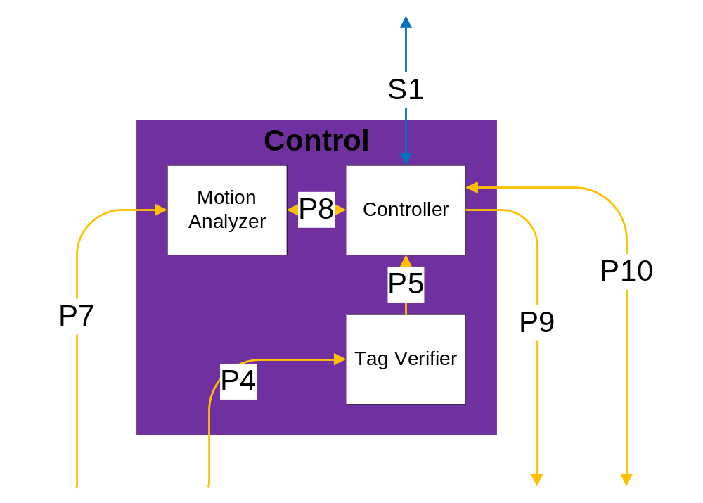
Figure 7 - Control Interface Layer

Controller Subsystem
The Controller subsystem contains one module, the Arduino module.

Arduino Module

Module Prologue
Arduino module consists of Arduino Duemilanove with the Ethernet Shield on top. The software is loaded in the memory available in an ATmega328 chip contained by the Arduino Duemilanove. The Controller subsystem uses the Arduino Ethernet Shield to interface with Web Interface layer.

Interfaces (provider-consumer relationships with other modules)
The Arduino Duemilanove has 14 digital input/output pins (of which 6 can be used as PWM outputs), 6 analog inputs, a 16 MHz crystal oscillator, a power jack, an ICSP (In-Circuit Serial Programming) header, and a reset button. The board contains everything needed to support the ATmega328 microcontroller. The Arduino uses digital & analog input & output pins to interface with different devices such as sensors and servos connected to the board.
Arduino Duemilanove connects to the internet using Arduinet Ethernet Shield. Arduinet Ethernet Shield contains a Wiznet W5100 ethernet chip, providing a network (IP) stack capable of both TCP (Transmission Control Protocol) and UDP (User Datagram Protocol).

Physical data structure/data file descriptions
The Arduino module connects to the server via internet using Wiznet W5100 chip. The module makes HTTP request to the server using serial communication via Ethernet. The schedule is retrieved periodically in the form of IP packets.
The Controller subsystem uses A/D and D/A converter in ATMega328 to process analog and digital signals from other subsystems.

Process (pseudo-code algorithm, PDL)
Initialize Ethernet
Main Loop ()
Establish Connection to the Server
Retrieve schedule
Set the timer
Start timer
Sub Loop ()
if (Tag_Verifier())
if (Motion_Analyzer())
Unlock the door
Send Analog Signal to the Alerter
Wait for door alignment
Lock the door
Count the timer
else
Count the timer
else
Count the timer

if (timer is out)
Break;

Motion Analyzer Subsystem
The Motion Analyzer subsystem contains one module, the Motion Analyzer module.

Motion Analyzer Module

Module Prologue
Two proximity sensors on either side of the door connect to this module. The Motion Analyzer application in the Controller subsystem accesses these sensors to determine the position of the pet.

Interfaces (provider-consumer relationships with other modules)
The analog voltage signals of range 0V to 2.5V produced by the sensors in Sensor Layer are consumed by the Motion Analyzer subsystem. Motion Analyzer consumes the schedule retrieved by Arduino to actuate the unlock procedure in the door. Thus, Arduino module consumes the output from the Motion Analyzer subsystem to control the door lock.

Physical data structure/data file descriptions
N/A

Process (pseudo-code algorithm, PDL)
Function Name: Motion_Analyzer
Input: schedule (int), sensor_reading_1 (int), sensor_reading_2 (int)
Output: Boolean signal
Pseudo-Code:
Switch (schedule)
{
Case ‘schedule to let the pet in”:
if (proximity sensor outside is active)
return true;
Break;
Case ‘schedule to let the pet out”:
if (proximity sensor inside is active)
return true;
Break;
Case ‘schedule to let the pet in or out”:
return true;

Default:
return false;
}

Tag Verifier Subsystem
The Tag Verifier subsystem contains one module, the Tag Verifier module.

Tag Verifier Module

Module Prologue
The Tag Verifier module is a combination of hardware and software. The Tag Verifier module uses an Arduino Duemilanove with a free RX/TX port to perform serial communication with RFID Reader module in Sensor layer. The value read will be compared with the value stored by the software implemented in the memory of the ATmega328 chip in the Arduino. If the value read is the same as the value stored, the Tag Verifier will alert the Arduino module about the presence of an authorized pet. If the Tag Verifier does not receive a value, the function returns false as output from the specific module.

Interfaces (provider-consumer relationships with other modules)
The Tag Verifier consumes outputs from RFID Reader module and Arduino module consumes the output from Tag Verifier.

Physical data structure/data file descriptions
The subsystem is dependent externally on Tag Reader subsystem in Sensor Layer and the Controller subsystem internally.

Process (pseudo-code algorithm, PDL)
Function Name: Tag_Verifier
Input: tag_reading (int)
Output: Boolean signal
Pseudo-Code:
Initialize preset_value
if (tag_reading == preset_value)
return true;
else
return false;

Sensor Layer Design

General
The Sensor layer consists of various sensors to sense the pet and its position. The layer consists of proximity sensors to determine the position of the pet and the tag along with an RFID reader to identify the pet. This layer has been subdivided into different components with respect the functionality and is described in detail below.
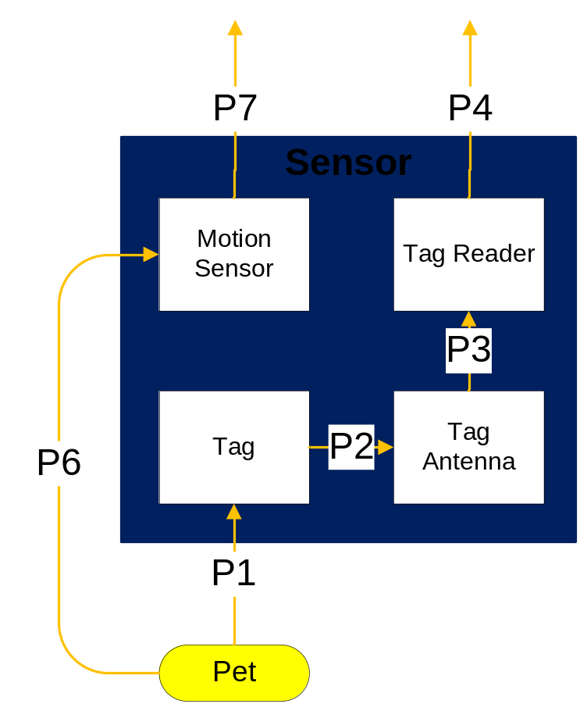
Figure 8 - Sensor Layer

Tag Subsystem
The Tag subsystem contains one module, the RFID Pet Tag.

RFID Pet Tag Module

Module Prologue
The RFID Pet Tag is a product manufactured by RFID Inc. The pet tag is an active RFID tag attached to the pet’s collar. The tag broadcasts an analog radio signal to the Tag Antenna Subsystem when the pet is near the iDoor. The radio signal contains a number used to identify the pet.

Interfaces (provider-consumer relationships with other modules)
The RFID Pet Tag provides 16 numbers broadcast over an analog signal with a frequency of 433MHz to the RFID Antenna module in the Tag Antenna subsystem. The RFID Pet Tag does not consume any data. The pet tag is powered by an internal battery.

Physical data structure/data file descriptions
The RFID Pet Tag contains 16 numbers identifying the tag. Each number is represented by an ASCII number corresponding to a hex digit.

Process (pseudo-code algorithm, PDL)
N/A

Tag Antenna Subsystem
The Tag Antenna subsystem contains one module, the RFID Antenna.

RFID Antenna Module

Module Prologue
The RFID Antenna is embedded with the RFID Reader in a product called RFID Inc 433 MHz Ext-Rd Starter's Kit. The antenna receives an analog radio signal from the RFID Pet Tag and transmits an analog signal over a wire to the RFID Reader. The analog signal contains a number used to identify the pet.

Interfaces (provider-consumer relationships with other modules)
The RFID Antenna consumes 16 numbers broadcast over an analog signal with a frequency of 433MHz from the RFID Pet Tag. The antenna provides an analog signal to the RFID Reader module in the Tag Reader subsystem. The analog signal is transmitted over a wire inside the RFID Inc 433 MHz Ext-Rd Starter's Kit.

Physical data structure/data file descriptions
The RFID Antenna contains 16 numbers identifying the tag. Each number is represented by an ASCII number corresponding to a hex digit. The number is received from the RFID Pet Tag module.

Process (pseudo-code algorithm, PDL)
N/A

Tag Reader Subsystem
The Tag Reader subsystem contains one module, the RFID Reader.

RFID Reader Module

Module Prologue
The RFID Reader is embedded with the RFID Antenna in a product called RFID Inc 433 MHz Ext-Rd Starter's Kit. The reader receives an analog signal from the RFID Antenna, reads the number contained in the signal, and sends the number to the Tag Verifier module in the Control Layer. The number sent is used to identify the pet.

Interfaces (provider-consumer relationships with other modules)
The RFID Reader consumes 16 numbers over an analog signal from the RFID Antenna. The reader provides a digital signal to the Tag Verifier module in the Control layer. The connection between the RFID Reader and Tag Verifier is over a RS232 cable.

Physical data structure/data file descriptions
The RFID Reader contains 16 numbers identifying the tag. Each number is represented by an ASCII number corresponding to a hex digit. The number is received from the RFID Antenna module.

Process (pseudo-code algorithm, PDL)
N/A

Motion Sensor Subsystem
The Motion Sensor subsystem contains one module, the Proximity Sensor.

Proximity Sensor Module

Module Prologue
The Proximity Sensor is a product called Sharp GP2Y0A02YK0F Distance Measuring Sensor Unit. Two proximity sensors are attached to the iDoor (one on each side). The proximity sensors detect the location and distance of the pet with respect to the door. Each sensor contains a PSD (position sensitive detector), IRED (infrared emitting diode), and signal processing circuit.

Interfaces (provider-consumer relationships with other modules)
The Proximity Sensor provides voltage corresponding to the detection distance to the Motion Analyzer subsystem in the Control Layer. The output voltage is between .25 to .55 volts.

Physical data structure/data file descriptions
The Proximity Sensor does not contain any physical data.

Process (pseudo-code algorithm, PDL)
N/A

Lock Mechanism & Door Layer Design

General
The Locking Mechanism & Door consists of three subsystems: Physical Lock, Door, and Alerter. These three subsystems will interface with the Control layer via producer and consumer relationships. The overall Detailed Design for this layer will be further broken down into modules described below.
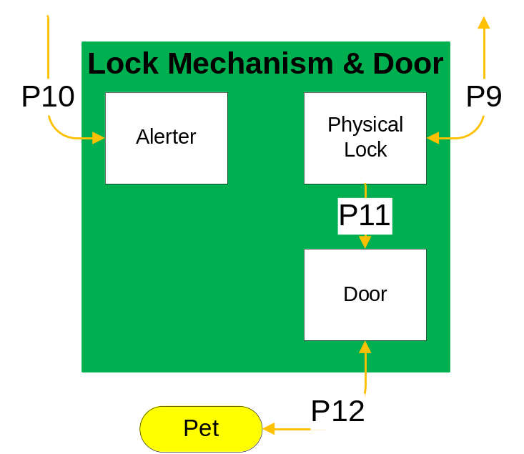
Figure 9 - Lock Mechanism & Door Layer

Physical Lock Subsystem
The Physical Lock subsystem contains two modules, the Lock module and the Magnetic Alarm Contact module.

Lock Module

Module Prologue
The Lock module is the physical lock on the door. The Lock will be wired to the Arduino via a relay circuit and will be powered using a wall plug. The Lock is projected to be a magnetic lock or a servo controlled lock.

Interfaces (provider-consumer relationships with other modules)
The Lock module will consume analog voltage from the Arduino module. The lock will be wired to the Arduino Duemilanove in which voltages will be sent ranging from 0V-5V. If a low voltage is received then the door will remain locked. If a high voltage is received then the door will be unlocked.

Physical data structure/data file descriptions
N/A

Process (pseudo-code algorithm, PDL)
N/A

Magnetic Alarm Contact Module

Module Prologue
The Magnetic Alarm Contact is the sensor on the physical door. The Magnetic Alarm Contact will be wired to the Arduino in a circuit and will ensure the door does not lock with the flap still open.

Interfaces (provider-consumer relationships with other modules)
The Magnetic Alarm Contact module will consume a digital signal from the Arduino module and pass the signal back to the Arduino.

Physical data structure/data file descriptions
The external data dependencies of the Magnetic Alarm Contact are dependent on the current voltages sent through the Arduino circuit. A voltage of 0V will indicate the circuit is broken. A voltage of 5V will indicate the circuit is closed and the door can be locked.

Process (pseudo-code algorithm, PDL)
N/A

Door Subsystem
The Door subsystem contains one module, the Door module.

Door Module

Module Prologue
The Door module is the physical door that is to be installed in the user’s home. The pet door Team iDoor will purchase is Ideal Pet 10 inch x 14 inch Large Premium Ultra Flex Door (see Figure 10). The door is the main portal for the pet to enter and exit the home when permitted.
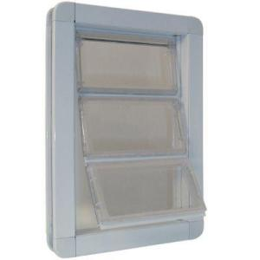
Figure 10 - Ideal Pet brand Door

Interfaces (provider-consumer relationships with other modules)
The door will interface with the lock on the door, as the two modules will touch but no data will be sent between the modules.
The door will interface with the user’s pet and will be the main portal in which the pet enters and exits the home. No data will be passed between the user’s pet and the door.

Physical data structure/data file descriptions
N/A

Process (pseudo-code algorithm, PDL)
N/A

Alerter Subsystem
The Alerter subsystem contains one module, the Alerter module.

Alerter Module

Module Prologue
The Alerter Subsystem will consist of a “bell” type sound that will notify the pet and the owner the door is open.

Interfaces (provider-consumer relationships with other modules)
The Alerter will interface with the Arduino in which to verify the schedule and make the “bell” sound.

Physical data structure/data file descriptions
N/A

Process (pseudo-code algorithm, PDL)
N/A

Quality Assurance

Test Plans and Procedures

General
The goal of the test plan is to ensure the iDoor is of the highest quality by minimizing the number of defects and bugs in the system. Specific testing information will be provided in the System Test Plan.

Module/Unit Test
The following modules will be unit tested:

iDoor.Schedule.Page_Load
To test the if statement, we will comment out the call to iDoor.Schedule.BindSchedules in iDoor.Schedule.btnSubmit_Click so that iDoor.Schedule.BindSchedules won’t be called on postback. We will see if the page loads correctly. If the page does load correctly, we will check to make sure we do not call iDoor.Schedule.BindSchedules on postback with a break point.

iDoor.Schedule.GetScheduleInformationFromDataSource
We will create a dummy schedule file since the real schedule file is constantly changing. We will pass the file in and check the results against the expected results. We will test to ensure we get the expected exception if a bad file location is passed in.

iDoor.Schedule.GetScheduleOverrideInformationFromDataSource
We will create a dummy schedule file since the real schedule file is constantly changing. We will pass the file in and check the results against the expected results. We will test to ensure we get the expected exception if a bad file location is passed in.

iDoor.Schedule.btnSubmit_Click
Testing iDoor.Schedule.btnSubmit_Click requires iDoor.Schedule.GetScheduleOverrideInformationFromDataSource, iDoor.Schedule.GetScheduleInformationFromDataSource, and Schedule.aspx are working. We will programmatically set ScheduleWebUserControlOut and ScheduleWebUserControlIn. We will run iDoor.Schedule.btnSubmit_Click and check the results with iDoor.Schedule.GetScheduleInformationFromDataSource and iDoor.Schedule.GetScheduleOverrideInformationFromDataSource.

iDoor.ScheduleMakeSchedule
A list of type iDoor.Day will be passed in. We will look at the resulting XElement to see if the response matches the expected result.

iDoor.ScheduleBindSchedules
We will execute the iDoor.Schedule.BindSchedules function and then compare the resulting Schedule.aspx page with the expected result.

iDoor.ScheduleWebUserControl.Repeater1_PreRender
iDoor.ScheduleWebUserControl.Repeater1_PreRender is not directly tested. Instead, the module is tested in the iDoor.Schedule.BindSchedules function.

iDoor.ScheduleWebUserControl.GetSchedule
We will set up a schedule and execute the iDoor.ScheduleWebUserControl.GetSchedule function and monitor the list that is returned.

iDoor.Day
We will create multiple Days using both of the constructors and test for equality.

Default.aspx
We will make sure that the login control accepts input.

Schedule.aspx
We will check to make sure each radio button and check box toggles correctly.

Response.aspx
We will test at various times to see if an integer between 1 and 4 inclusive, is displayed.

ScheduleWebUserControl.ascx

ScheduleWebUserControl.ascx will be tested when Schedule.aspx is tested.

Schedule Data Source
The Schedule Data Source is an xml file and will be tested by loading the file and ensuring no exceptions are thrown.

iDoor.Response.Page_Load
The testing will be done manually. We will alter the schedule and test one of the overrides or schedule options. Once done, we will proceed to check the remaining overrides and schedule options until all are tested.

Component Test
The following modules will be component tested:

RFID Reader, & RFID Antenna
The RFID Reader module and RFID Antenna module will be tested together. The two modules will be connected. The three red lights on the RFID Reader will be checked to verify the reader is working.

Proximity Sensor
The Proximity Sensors will be connected to a current and the voltage will be measured by a multimeter. Objects will be put in front of the proximity sensors at varying distances to check if the voltage changes.

Lock
The Lock will be connected to a 12V power source. A small current will be passed through the servo to check if the lock opens and closes.

Alerter
The Alerter will be connected to a 2.5mm audio jack, and sound will be generated. Testers will listen for the sound.

Magnetic Alarm Contact
The Magnetic Alarm Contact will be connected to a circuit. A current will be passed through the circuit with the magnetic contacts connected, and the voltage will be measured. The magnetic contacts will be disconnected, a current will be attempted, and the voltage will be measured.

Integration Test
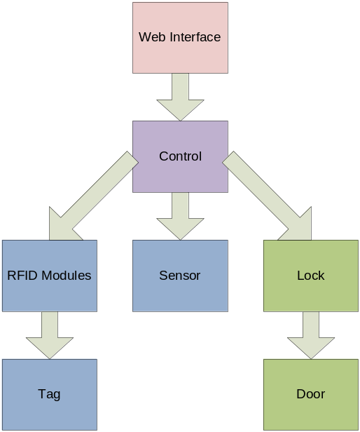
Figure 11 Integration Testing
1) Integration testing for the iDoor will start by testing all the modules in the Web Interface layer together.
2) The Control layer will be added to the Web Interface and the system will be tested.
3) The RFID modules will be added and the system will be tested.
4) An RFID Tag will be added and the system will be tested.
5) Two Proximity Sensors will be tested with the Web Interface and Control layers.
6) The Lock module will be tested with the Web Interface and Control layers.
7) The door will be added to the Web Interface, Control Interface, and Lock module. The system will be tested.

Web Interface
Web Interface layer will be tested using a browser to ensure schedule, override, and lock status function properly. The results can be measured by accessing Response.aspx.

Web Interface and Control
The Web Interface layer and Control layer will be tested together. The Arduino module will be connected to the Web Interface over a network. In addition, the Arduino will be connected to a PC over a USB connection. The Arduino will be tested to see if it connects to the Response subsystem.

Web Interface, Control, RFID Reader, & RFID Antenna
The Web Interface layer, Control layer, RFID Reader module, and RFID Antenna module will be tested together. The layers and modules will be connected and the Arduino board will be connected to a PC. The three red lights on the RFID Reader will be checked to verify the reader is working.

Web Interface, Control, & RFID Modules
The Web Interface layer, Control layer, and RFID modules will be tested together. The layers and modules will be connected and the Arduino board will be connected to a PC. The RFID Pet Tag will be brought near the RFID Reader. Results for the status of the lock will be viewed on the PC.

Web Interface, Control, & Sensor
The Web Interface layer, Control layer, and Proximity Sensor will be tested together. The layers and module will be connected and the Arduino board will be connected to a PC. Objects will be placed in front of the Proximity Sensors. Results for the status of the lock will be viewed on the PC.

Web Interface, Control, Lock, & Magnetic Alarm Contact
The Lock and Magnetic Alarm Contact modules will be tested with the Web Interface and Control layers to ensure the lock opens and closes correctly. The lock will be connected and powered, and a current will be passed through the Magnetic Alarm Contact to the servo lock. The tester will make sure the lock opens properly.

Web Interface, Control, Lock, Magnetic Alarm Contact, & Door
The Locking Mechanism & Door layer will be tested with the Web Interface and Control layers to ensure the lock opens and closes correctly, and the door does not attempt to lock while the door is open. The Locking Mechanism & Door subsystem will be connected and powered, and a current will be passed through the Magnetic Alarm Contact to the servo lock. The tester will make sure the lock opens properly. The tester will hold open the door flap, and will check to see if the lock locks. The tester will release the door flap, and check to see if the door locks.

System Verification Test
The entire iDoor will be tested using simulated animals and humans to ensure system is working as specified in the requirements.

Test Cases

The user accesses the schedule

General

Actors
User

Preconditions
The user has a network connection.

Description
The user navigates to the user interface accessing the empty or existing schedule.

Post Conditions Applying to All Paths
None

Primary Path

Summary
The user opens the user interface and connects to the local iDoor server over the network. The user navigates to the empty or existing schedule.

Post Conditions
None

Alternate paths
The user opens the user interface in the local network directly and navigates to the empty or existing schedule.

The user modifies the schedule

General

Actors
User

Preconditions
The user is accessing the schedule.

Description
The user sets a new schedule or modifies the existing schedule.

Post Conditions Applying to All Paths
None

Primary Path

Summary
The user sets a new schedule as they prefer and saves the schedule.

Post Conditions
The new schedule takes effect.

Alternate paths

Summary
The user modifies the existing schedule as they prefer and saves the schedule.

Post Conditions
The modified schedule takes effect.

The user overrides the schedule

General

Actors
User

Preconditions
The user is accessing the schedule.

Description
The user overrides the current schedule.

Post Conditions Applying to All Paths
None

Primary Path

Summary
The user overrides the existing schedule.

Post Conditions
The schedule override takes effect.

Alternate paths
None

User’s pet approaches the iDoor and access is granted

General
Actors
User’s pet
Preconditions
The pet is wearing the pet tag. The door is scheduled to allow the pet to enter or exit the iDoor.
Description
The pet approaches the iDoor; the pet is notified to enter or exit; and access is granted.
Post Conditions Applying to All Paths
None

Primary Path
Summary
The user’s pet approaches the iDoor from the inside. The pet tag is identified by the sensor. The pet will be notified and allowed to exit.
Post Conditions
The pet is outside.

Alternate paths
Summary
The user’s pet approaches the iDoor from the outside. The pet tag is identified by the sensor. The pet will be notified and allowed to enter.
Post Conditions
The pet is inside.

User’s pet approaches the iDoor and access is denied

General
Actors
User’s pet
Preconditions
The pet is wearing the pet tag. The door is not scheduled to allow the pet to enter or exit the iDoor.
Description
The pet approaches the iDoor to enter or exit and access is denied.
Post Conditions Applying to All Paths
None

Primary Path
Summary
The user’s pet approaches the iDoor from the inside. The pet tag is identified by the sensor. The pet will not be allowed to exit.
Post Conditions
The pet remains inside.

Alternate paths
Summary
The user’s pet approaches the iDoor from the outside. The pet tag is identified by the sensor. The pet will not be allowed to enter.
Post Conditions
The pet remains outside.

User’s pet approaches the iDoor and access is granted due to schedule override

General
Actors
User’s pet
Preconditions
The pet is wearing the pet tag. The door is not scheduled to allow the pet to enter or exit the iDoor; however the schedule has been overridden to allow access.
Description
The pet approaches the iDoor to enter or exit and access is granted.
Post Conditions Applying to All Paths
None

Primary Path
Summary
The user’s pet approaches the iDoor from the inside. The pet tag is identified by the sensor. The pet will be notified and allowed to exit because the schedule has been overridden.
Post Conditions
The pet is outside.

Alternate paths
Summary
The user’s pet approaches the iDoor from the outside. The pet tag is identified by the sensor. The pet will be notified and allowed to enter because the schedule has been overridden.
Post Conditions
The pet is inside.

User’s pet approaches the iDoor and access is denied due to schedule override

General
Actors
User’s pet
Preconditions
The pet is wearing the pet tag. The door is scheduled to allow the pet to enter or exit the iDoor; however the schedule has been overridden to deny access.
Description
The pet approaches the iDoor to enter or exit and access is denied.
Post Conditions Applying to All Paths
None

Primary Path
Summary
The user’s pet approaches the iDoor from the inside. The pet tag is identified by the sensor. The pet will not be allowed to exit because the schedule has been overridden.
Post Conditions
The pet remains inside.

Alternate paths
Summary
The user’s pet approaches the iDoor from the outside. The pet tag is identified by the sensor. The pet will not be allowed to enter because the schedule has been overridden.
Post Conditions
The pet remains outside.

Neighbor’s pet or vermin approaches the iDoor and access is denied

General
Actors
Neighbor’s pet or vermin
Preconditions
The neighbor’s pet or vermin are not wearing a pet tag. The user’s pet is not in the area.
Description
The neighbor’s pet or vermin approaches the iDoor to enter and access is denied.
Post Conditions Applying to All Paths
None

Primary Path
Summary
The neighbor’s pet or vermin approaches the iDoor from the outside. The neighbor’s pet or vermin are not identified by the sensor. The iDoor will not respond.
Post Conditions
The neighbor’s pet or vermin remains outside.

Alternate paths
None

A child approaches the iDoor and access is denied

General
Actors
Child
Preconditions
The child is not holding a pet tag. The user’s pet is not in the area.
Description
The child approaches the iDoor to enter or exit and access is denied.
Post Conditions Applying to All Paths
None

Primary Path
Summary
The child approaches the iDoor from the inside. The child is not identified by the sensor. The iDoor will not respond.
Post Conditions
The child remains inside.

Alternate paths
None

Requirements Traceability Matrix

Requirements Traceability Matrix
The requirements listed in Table 1 are all the Customer Requirements and are defined in chapter 4 in the System Requirements Document. The requirements are mapped to the components defined in the DDS.
Table 4 - Requirements Mapping, excluding Web Interface
 | Customer Requirements | Response.aspx | iDoor.Response.Page_Load | Arduino | Motion Analyzer | Tag Verifier | Proximity Sensor | RFID Tag | RFID Antenna | RFID Reader | Alerter | Lock | Magnetic Alarm Contact | Door
4.2.1 | The iDoor product shall contain a pet door |  |  |  |  |  |  |  |  |  |  |  |  | X
4.2.2 | The pet door shall have a lock |  |  |  |  |  |  |  |  |  |  | X
4.2.3 | The iDoor shall sense the user’s pets |  |  |  | X |  | X | X | X | X
4.2.4 | The iDoor shall prohibit access for vermin and unwanted pets |  |  | X |  | X |  | X | X | X |  | X |  | X
4.2.5 | The iDoor shall notify pets when they may pass through the pet door |  |  |  |  |  |  |  |  |  | X
4.2.6 | The iDoor shall not crush the pets |  |  |  |  |  |  |  |  |  |  |  | X | X
4.2.7 | The iDoor shall operate on a schedule | X | X | X
4.2.8 | The iDoor shall have a schedule override feature | X | X | X
4.2.11 | If the iDoor has a guillotine-style door, the door shall automatically open and close after the pet is granted access |  |  |  |  |  |  |  |  |  |  |  |  | X
4.2.12 | The pet door component shall be mounted in a wall |  |  |  |  |  |  |  |  |  |  |  |  | X
4.2.13 | The iDoor shall contain removable pet tags |  |  |  |  |  |  | X
4.2.14 | The iDoor shall be installable in existing homes and new construction |  |  |  |  |  |  |  |  |  |  |  |  | X
4.2.15 | The iDoor shall use 120 volt alternating current electricity |  |  | X |  |  |  |  |  | X |  | X
4.2.16 | The iDoor shall be used for small to mid-size pets |  |  |  |  |  |  |  |  |  |  |  |  | X

Table 5 - Requirements Mapping, Web Interface
Note: iS stands for iDoorSchedule
 | Customer Requirements | iS.Page_Load | iS. GetScheduleInformation FromDataSource | iS. GetScheduleOverride InformationFromDataSource | iS.btnSubmit_Click | iS.MakeSchedule | iS.BindSchedules | iS.Repeater1_PreRender | iSWebUserControl.GetSchedule | iDoor.Day | Default.aspx | Schedule.aspx | Response.aspx | ScheduleWebUserControl.ascx | Schedule Data Source | iDoor.Response.Page_Load
4.2.7 | The iDoor shall operate on a schedule | X | X |  | X | X | X | X | X | X |  | X | X | X | X | X
4.2.8 | The iDoor shall have a schedule override feature | X |  | X | X |  | X |  |  |  |  | X | X |  | X | X
4.2.9 | The iDoor schedule and override feature shall be locally and remotely accessible | X | X | X | X | X | X | X | X | X | X | X |  | X
4.2.10 | Unauthorized users shall be prevented access to the schedule and override feature of the door |  |  |  |  |  |  |  |  |  | X |  |  |  | X

Acceptance Plan

General
Team iDoor will use the following Acceptance Plan in order for the iDoor prototype to be accepted by all stakeholders. The Acceptance Plan is in place to ensure the quality, system requirements acceptance, and feasibility of the development of the overall prototype. Team iDoor will follow the outlined Acceptance Plan as meticulously as possible and will notify all stakeholders if any of the high priority requirements cannot be developed. Team iDoor will notify all stakeholders of any changes as well as communicate overall progress during the implementation stage. This Acceptance Plan will allow Team iDoor to develop the prototype to the highest standards achievable.

Packaging and Installation
The final iDoor prototype will be no larger than 3’ x 3’ x 3’. The prototype will be presented in a mock wall that will be built by Team iDoor.

Packaging
See Figure 12 - Encasement of Door in Mock Wall
1) Blue Square indicates placement of Arduino
2) Red Square Indicates placement of RFID Reader and antenna
3) Pink Circle indicates placement of motion sensor which will be infrared
4) Yellow Circle indicates physical lock on the door
5) Orange Rectangle indicate magnetic alarm contact
5) Teal Lines indicates wiring to and from each of the hardware components
6) Lime Green Lines indicate Plexiglass allowing transparency
7) Black Lines indicate 2’ x 4’blocks of wood that will represent a portion of a wall
(Note: All hardware placements are subject to change as implementation begins or future enhancements are made)
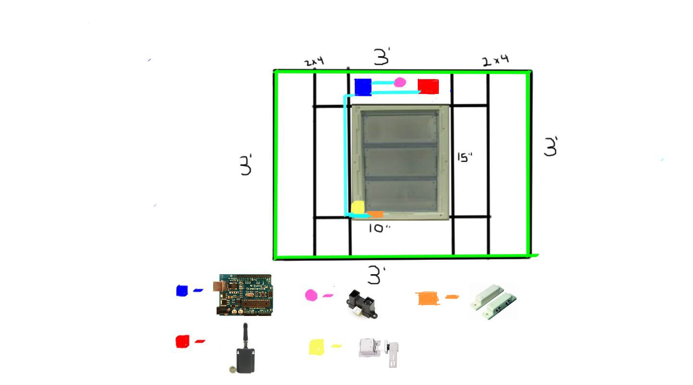
Figure 12 - Encasement of Door in Mock Wall

Installation Guidelines
There will be a set of instillation guidelines presented in the final document of the prototype. These instructions will guide a certified installed to install the iDoor. The instructions will be a rough guideline pending future development of the product.

Acceptance Testing
The Acceptance testing will coincide with the system test plan. The iDoor will undergo rigorous unit testing. After unit tests are passed, testing will move into component testing, integration testing, and eventually into a full system test. The Acceptance testing allows Team iDoor to document when and how each system requirement is satisfied.

Acceptance Criteria
The following list of System Requirements is the minimal functionality required to be implemented in order for the iDoor to be accepted by all stakeholders. The following System Requirements are in reference to section 4 in Team iDoor’s System Requirements Document.

The iDoor product shall contain a pet door

The pet door shall have a lock

The iDoor shall sense the user’s pets

The iDoor shall prohibit access for vermin and unwanted pets

The iDoor shall not crush the pets

The iDoor shall operate on a schedule

The iDoor shall have a schedule override feature

The iDoor schedule and override feature shall be locally and remotely accessible

If the iDoor has a guillotine-style door, the door shall automatically open and close after the pet is granted access

The pet door component shall be mounted in a wall

Appendices

Formulas and Algorithms Not Documented in the Software Requirements Document
Sharp GP2Y0A02YK0F Distance Measuring Sensor Unit:

Omni-Directional Reader Model EXR1 – RS232/485, Wiegand:
ATMega328 Data sheet:
http://www.atmel.com/dyn/resources/prod_documents/doc8271.pdf

Arduino:
http://www.nongnu.org/avr-libc/user-manual/index.html
http://www.nongnu.org/avr-libc/user-manual/index.html

