Department of Computer Science and Engineering
The University of Texas at Arlington


iDoor Automatic Pet Door
System Test Plan
Team Members:
Jason Beere
Courtney Burkhart
Matthew Forsberg
Sandip Shrestha

Late Updated: d MMMM yyyy 40512.7375 h:mm:ss am/pm
Copy Printed: d MMMM yyyy 39204.4256944444 h:mm:ss am/pm
Table of Contents
1 Introduction 1
1.1 Overview 1
1.2 Outline 1
1.3 Purpose 1
1.4 Project Scope 1
1.5 Definitions, Acronyms and Abbreviations 2
2 References Overview 4
2.1 Overview 4
2.2 System Requirements Document 4
2.3 Detailed Design Specification 6
2.4 Architecture Design Specification 8
3 Test Items 9
3.1 Overview 9
3.2 Relational Diagram 10
3.3 Unit Tests 11
3.4 Integration Tests 12
3.5 System Verification Tests 13
3.6 Non-functional Tests 13
4 Risks 14
5 Testable Features 15
5.1 General 15
5.2 Features 15
6 Non-Testable Features 19
6.1 General 19
6.2 Non-Testable Requirements 19
6.3 Non-Testable Hardware Components 19
7 Testing Strategy & Deliverables 20
7.1 General 20
7.2 Testing Strategy Diagram 20
7.3 Reintegration & Regression 23
8 Item Pass/Fail Criteria 25
8.1 Test Plans and Procedures 25
9 Test Deliverables 26
9.1 System Test Plan 26
9.2 Test Cases 26
9.3 Test Results 26
9.4 Bugs and Defects 26
9.5 Test Code 27
10 Test Schedule 28
11 Approvals 29

Introduction

Overview
The System Test Plan is devised to test the functionality of the product. The document consists of various techniques and test cases to be analyzed for verification of the functionality and the accuracy of the system.

Outline
The document is structured as follows:
- Introduction
- Reference Overview
- Test Items
- Risk
- Testable Features
- Non Testable features
- Testing Strategy
- Item Pass or Fail Criteria
- Test Deliverables
- Test Schedules
- Approvals
- Appendices

Purpose
Implementation is major part of the system design and expected to be cumbersome and hectic. The purpose of test plan is to schedule tasks among team members during the implementation phase. The plan avoids unsystematic and inappropriate implementation and testing of the system. Backup plans are included in case circumstances change.

Project Scope
The iDoor is an automated pet door designed to give pet owners flexibility by controlling the door remotely. Unlike what is already on the market, the iDoor is operable through a network. A user is able to remotely set the schedule for the pets to enter or leave the house and has the ability to overwrite the schedule by accessing the remote server (see Figure 1 diagram of the iDoor product). Users shall have full control over the pet door remotely or at home.
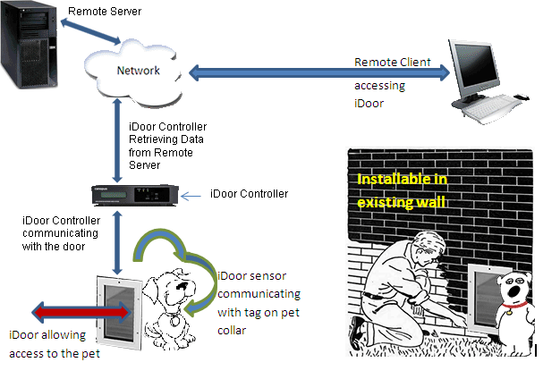
Figure 1 - Diagram of iDoor product
The iDoor Controller periodically connects to the Remote Server, to check if authorized pets are allowed enter or exit through the pet door.
The iDoor shall include a tag to attach to a pet’s collar and shall have a sensor device mounted to the pet door. The sensor recognizes the approaching pet and sends the information to the iDoor Controller. The iDoor Controller receives the signal, verifies the tag and schedule, and returns a signal to the iDoor locking mechanism to unlock the door, if permitted.

Definitions, Acronyms and Abbreviations
A/D Analog to Digital Converter
D/A Digital to Analog Converter
DDS – Derailed Design Specification
GUI – Graphical User Interface
iDoor – Name of both the product and team name
IRED – Infrared emitting diode
IIS – Internet Information Services
iS – iDoorSchedule: Prefix used to shorten some function names listed in this document
MHz – Megahertz
Medium size pet – Medium sized pet is between 40-70 pounds
Pet – Refers to either a dog or cat
PSD – Position sensitive detector
RFID – Radio-Frequency Identification
Tag – Device attached to the pet’s collar to identify the pet
User – Refers to the pet’s owner
Vermin – Squirrels, mice, rats, and raccoons

References Overview

Overview
The Reference Overview refers to items taken from team iDoor’s System Requirements Document, Detailed Design Specification, and Architecture Design Specification. These previous documents facilitate the individual and integrated components needing to be tested. The figures in this section act as guidelines for Team iDoor to ensure the test plan correlates to the customer requirements, architecture and detailed design.

System Requirements Document

Customer Requirements

The iDoor product shall contain a pet door

The pet door shall have a lock

The iDoor shall sense the user’s pets

The iDoor shall prohibit access for vermin and unwanted pets

The iDoor shall notify pets when they may pass through the pet door

The iDoor shall not crush the pets

The iDoor shall operate on a schedule

The iDoor shall have a schedule override feature

The iDoor schedule and override feature shall be locally and remotely accessible

Unauthorized users shall be prevented access to the schedule and override feature of the iDoor

If the iDoor has a guillotine-style door, the door shall automatically open and close after the pet is granted access

The pet door component shall be mounted in a wall

The iDoor shall contain removable pet tags

The iDoor shall be installable in existing homes and new construction

The iDoor shall use 120 volt alternating current electricity

The iDoor shall be used for small to mid-size pets

Detailed Design Specification
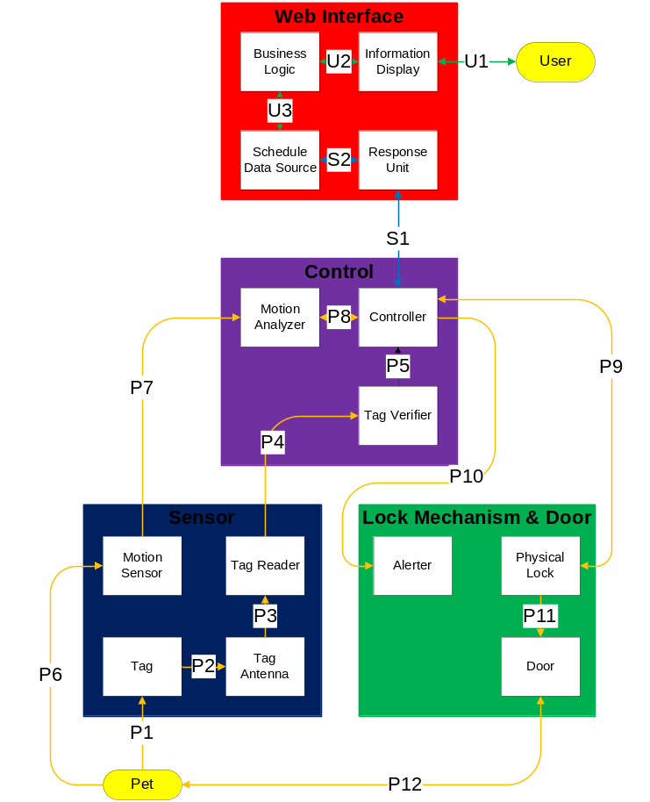
- A user can access the schedule (denoted by data flow U1-U3). U is for User and the arrows are in green.
- The Controller periodically checks the schedule (denoted by S1-S2). S is for Schedule and the arrows are in blue.
- An authorized pet can walk through the door (denoted by P1-P12). P is for Pet and the arrows are in orange.

Data Flows
Table 1 - Inter-Subsystem Data Element Descriptions
Note: * indicates no data flow, only interaction or contact
Data Element | Description of data element
U1* | Interaction between the user and the Information Display/GUI (graphical user interface) running in a browser
U2 | Network interface between web GUI in browser and Business Logic on server computer  Business Logic sends http data over the network to the Information Display, the GUI running in a browser on the user’s computer  Any requests by the remote user such as schedule updates and schedule overrides are transmitted from the UI to the Business Logic through a http connection
U3 | Internal computer interface between the Business Logic and Schedule Data Source on the remote server  Schedule Data Source sends schedule information to the Business Logic  Business Logic sends data to the Schedule Data Source if the user overrides the schedule or requests an update to the existing schedule
S1 | Network interface between the Control layer and Web Interface  The Controller subsystem sends location information to the Response Unit subsystem  The Response Unit sends back the current schedule information to the Controller subsystem in Control Layer
S2 | Internal computer interface between Response Unit subsystem and Schedule Data Source file  The Response Unit subsystem sends iDoor location information to the Schedule Data Source (to identify the location)  Schedule Data Source subsystem sends schedule information to the Response Unit
P1* | Interaction between the pet collar and the Tag. The tag is worn on the collar
P2 | Interface between the Pet Tag and the Tag Antenna  Pet Tag broadcasts a signal and is received by the Tag Antenna
P3 | Signal interface between Tag Antenna and Reader  The Antenna sends signals over a wire to the Reader, so the signal can be read
P4 | Interface between the Sensor and Control layers  Data from the Tag Reader is passed to the Tag Verifier for verification purpose over a wired connection
P5 | Interface between Tag Verifier and Controller  The Tag Verifier programmatically verifies the tag signal and sends confirmation to the Controller over a digital connection
P6* | Interaction between the Pet and the Motion Sensor  Motion sensor converts the movement of the pet into a signal
P7 | Interface between the Motion Sensor and Motion Analyzer  Motion Sensor sends a signal to the Motion Analyzer to determine the position of the pet
P8 | Interface between Motion Analyzer and Controller within the Controller Layer within the Control Layer  The Motion Analyzer sends pet location information to the Controller over a digital connection
P9 | Interaction between the Controller Layer and Lock Mechanism & Door Layer. The Controller analyzes all the input data and sends a signal to Physical Lock to unlock the door if the lock is scheduled to be unlocked for authorized pets. The state of the lock is maintained for certain time before it locks
P10 | Interaction between the Controller Layer and Lock Mechanism & Door Layer. Controller analyzes all the input data and sends a signal to the Alerter to alert the pet if they are allowed to pass through the door at the time
P11* | Interaction between the physical door and the physical lock
P12* | Interaction between the pet and the iDoor

Architecture Design Specification

System Requirement Mapping
See section 1.5 in the Architecture Design Specification

Test Items

Overview
The Test Items chapter gives an overview of the testing done in the Unit tests, Integration tests, and System Verification tests. The chapter describes the non-functional tests. The relational diagram shows how the tests relate to each other and the order of the tests.
Section 3.3, 3.4, and 3.5 give inputs and expected outputs for the tests and assign a risk level. A risk level of low means testing has been executed and is working correctly. A risk level of medium denotes the test has been executed, doesn’t work perfectly, but a workaround has been found. A risk level of very high denotes a test has not been executed at present.

Relational Diagram
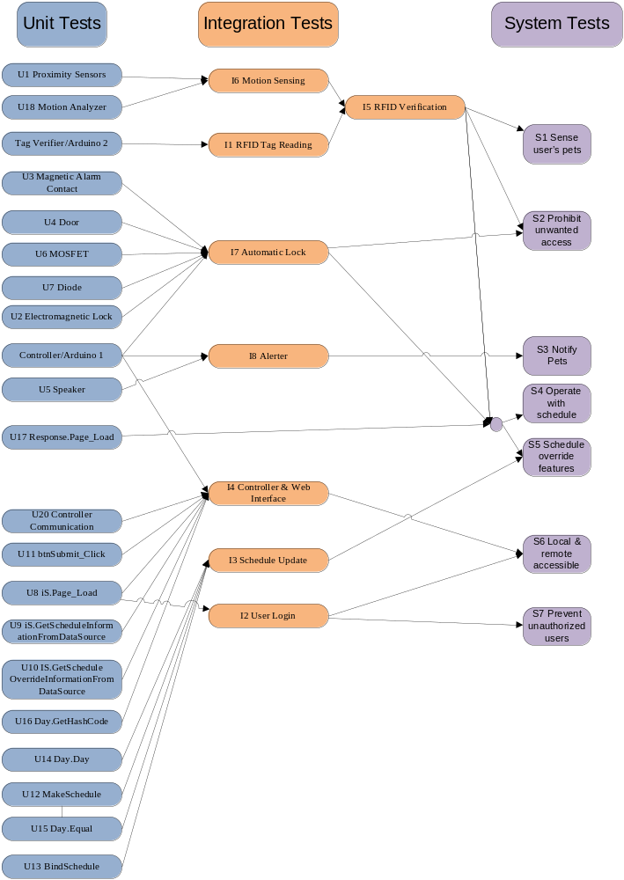
Figure 2 Relational Diagram

Unit Tests

Hardware Unit Tests
Test ID | Features | Inputs |  | Expected Output | Risk Severity | Tools & Required Components
U1 | Proximity Sensor | Motion |  | Varying voltage in specific pattern | Low | Multimeter, Power Supply
U2 | Electromagnetic Lock | 0V or 12V |  | Unlock & Lock state | Very High | Power Supply
U3 | Magnetic Alarm Contact | Contact/No Contact |  | Sound | Low | Multimeter
U4 | Door | Stuffed Animal |  | Stuffed Animal | Low | Stuffed Animal
U5 | Speaker | Voltage Signal |  | Sound | Low | Voltage Supply
U6 | MOSFET | Voltage Signal [0V & 5V] |  | Lights on/off | Low | External Source LEDs
U7 | Diode | Current through Multimeter | Current to Multimeter |  | Low | Multimeter

Software Unit Tests – Web Interface
Test ID | Features | Inputs | Expected Output | Risk Severity
U8 | iDoor.Schedule.Page_Load | None | Schedule an override output to page | Very Low
U9 | iDoor.Schedule.GetScheduleInformationFromDataSource | Direction {in, out} Location of xml file | List<Day> | Low
U10 | iDoor.Schedule.GetScheduleOverrideInformationFromDataSource | Location of xml file | Int {0 to 4} | Low
U11 | btnSubmit_Click | None | Changed XML file | Low
U12 | MakeSchedule | List<Day> direction{in,out} | XElement | Low
U13 | BindSchedule | None | Changed schedule on page | Low
U14 | Day.Day | String and 24 bools | Day | Low
U15 | Day.Equal | Day | bool | Low
U16 | Day.GetHashCode | Day | Int | Low
U17 | Response.Page_Load | None | Int {1 to 4} | Low

Software Unit –Controller
Test ID | Features | Inputs | Expected Output | Risk Severity
U18 | Motion_Analyzer | Schedule as char {1, 2, 3, 4}; 2 Sensors readings as int {1-700} | Boolean Value | Low
U19 | Unlock_Door | Current time in seconds as int {0-15} | New time in seconds as int | Low
U20 | Controller Communication | Static url as http request | http response as packets | Low

Integration Tests
Test ID | Features | Integrated Components | Inputs | Expected Output | Risk Severity
I1 | RFID Tag Reading | RFID Tag, Reader, Antenna, & Tag Verifier | RFID Tag | 16 ASCII bytes read by RFID Reader projected in serial monitor using tag verifier | Medium
I2 | User Login | Information Display & Data Source | User ID & password | Schedule Webpage | Low
I3 | Schedule Update | Business Logic & Schedule Data Source | Schedule Change | New Schedule in XML file | Low
I4 | Controller & Web Interface | Response Unit & Controller | http request from controller [schedule request] | Current lock status(1-4) as http response projected in a serial monitor as expected | Low
I5 | RFID Verification | RFID Tag, Reader, Antenna, & Tag Verifier | RFID Tag | Verification message in LCD monitor | Medium
I6 | Motion Sensing | Proximity Sensor & Motion Analyzer | Motion | Light intensity as displayed by controller signifying distance | Low
I7 | Automated Lock | Physical Lock, MOSFET, 12V Power Supply, Diode, & Controller | 0V & 5V | Unlocked & Locked State | Very High
I8 | Alerter | Controller & Speaker | Voltage to pins | Sound | Low

System Verification Tests
Test ID | Features | Inputs | Expected Output | Risk Severity
S1 | The iDoor shall sense the user’s pets | RFID Tag | LCD test display will say detected | Medium
S2 | The iDoor shall prohibit access for vermin and unwanted pets | RFID Tag | LCD test display will not change | Low
S3 | The iDoor shall notify pets when they may pass through the pet door | RFID Tag & schedule override set to Open | Sound from speaker | Low
S4 | The iDoor shall operate on a schedule | RFID Tag | Door responding as specified by user schedule | Low
S5 | The iDoor shall have a schedule override feature | RFID Tag | Door responding as specified by schedule override | Low
S6 | The iDoor schedule and override feature shall be locally and remotely accessible | URL in a browser, user name, & password | Information Display Page with Schedule | Low
S7 | Unauthorized users shall be prevented access to the schedule and override feature of the iDoor | URL in a browser, unauthorized user name, & password | Display page notifying user access denied | Low

Non-functional Tests
Test ID | Features
N1 | The iDoor contains a pet door
N2 | The iDoor contains a lock
N3 | The iDoor does not crush pets
N4 | The iDoor is mounted in a wall
N5 | The iDoor contains removable pet tags
N6 | The iDoor shall use 120 volt alternating current electricity

Risks
Risk | Means of control | Strategy | Severity
Test misses bug in code | We will thoroughly test our product with an emphasis on “good enough” | Accept | High
Dependencies for tests forms a cycle | Find another way to test the components | Research | Medium
Goldplating while fixing bugs | Features will not be added unless required to fix a bug | Monitor | Low
Can’t finish all the tests | Prioritize tests | Monitor | Low
Critical tests missed | Tests will not be added without change process being followed | Avoid | Low
Module depends on another module | Test modules together | Accept | Medium
Stuffed animal does not mimic real animal closely enough | Get the most lifelike stuffed animal possible within budget | Accept | Low

Testable Features

General
Testable features are individual unit tests and integration tests. These features of the iDoor prototype will be tested according to this System Test Plan. Most or all of these features will be tested as time permits. See Section 8 for the criteria to determine if a feature passes or fails a given test.
Risk level is assigned by our confidence the test will pass. A risk level of low means testing has been executed and is working correctly. A risk level of medium denotes the test has been executed, doesn’t work perfectly, but a workaround has been found. A risk level of very high denotes a test has not been executed at present.

Features

Electromagnetic Lock
Risk level: Very High
Description: This tests the physical lock on the door in the locked and unlocked states.
User’s Path: Power is applied to the lock and the magnetic aperture is placed on the lock. The aperture will be stuck to the magnetic lock. Power is disconnected from the lock and the aperture will be removed from the lock.

Automated Lock
Risk Level: Very High
Description: This refers to the Arduino interacting with the physical lock. Changing the schedule for the door will test this feature, making sure the corresponding lights are on at the appropriate time.
User’s Path: The Arduino will change the state of the door if needed to either unlocked or locked after the stuffed pet approaches the door. If power is off, the controller will not be on and the door will remain unlocked.

RFID Tag Reading
Risk Level: Medium
Description: The RFID Reading test checks to see if the RFID Tag is being read correctly by the RFID Reader and Antenna. The RFID Tag is brought near the reader, and the reader is checked to see if the correct 16 ASCII bytes are output.
User’s Path: The user will not fully interact with this module. The stuffed pet will only have to approach the door with the appropriate RFID tag.

RFID Tag Verification
Risk Level: Medium
Description: The RFID Tag Verification test checks to see if the RFID Tag is being verified correctly by the Arduino controller. An LCD monitor is attached to the controller. Authorized and unauthorized RFID Tags are brought near the reader, and the LCD monitor is checked for tag verification by the controller.
User’s Path: The user will approach the door with the appropriate RFID tag.

Motion Analyzer
Risk Level: Low
Description: The Motion Analyzer receives the data from the Proximity Sensors and alerts the Controller if the motion is detected within a certain range. Test cases will be sent to this function and the expected output will be analyzed. This module will pass after a reasonable amount of test cases return the correct expected output.
User’s Path: The user will send numbers between 1-700 representing distance and an integer from 1-4 representing the schedule. The analyzer will return a Boolean representing lock or unlock.

User Login
Risk Level: Low
Description: The User Login test relates to the Web Interface of the iDoor. The expected output will be the schedule page for valid user names & passwords; and login page with an error message for invalid user names & passwords.
User’s Path: The owner will go to a computer and type in the valid website address then they will enter in a username and password.

Proximity Sensor
Risk Level: Low
Description: The Proximity Sensors detect the motion and distance of an object. The result will be a voltage specifying the distance from an object.
User’s Path: An object will be moved in front of the proximity sensor. The object will come closer and further from the sensor. The voltage will be read. A stationary object will be placed in front of the sensor and voltage will be read.

Motion Sensing
Risk Level: Low
Description: Motion Sensing tests the controller and proximity sensors for correct voltages sent indicating motion and distance. If the RFID is correctly verified and the proximity sensor sends correct voltages the door will unlock or lock. If the sensor sends incorrect voltages then the door will remain in its last valid state.
User’s Path: The user pet approaches the door allowing a motion to be sensed by the proximity sensor.

Alerter
Risk Level: Low
Description: The Alerter tests the speaker indicating a “beeping” type noise when the controller verifies the pet is allowed to enter or exit the home.
User’s Path: The user approaches the door and, if permitted, the controller sends a signal to the speaker to make the appropriate sound notifying the user the door is unlocked.

Magnetic Alarm Contact
Risk Level: Low
Description: The Magnetic Alarm Contact test verifies a current is passed through the contact only when the contacts are very close.
User’s Path: The contacts are brought very close to each other and a current is passed through the contacts with a multimeter. The multimeter should beep. The multimeter should not beep when the contacts are placed slightly further from each other.

Speaker
Risk Level: Low
Description: The Speaker test verifies the ability for a speaker to make a sound when a voltage signal is passed through.
User’s Path: The speaker is attached to a voltage supply. A sound will come from the speaker. The sound will end after the voltage is stopped.

MOSFET
Risk Level: Low
Description: The MOSFET test checks control of the MOSFET by using a voltage signal to turn on and off the MOSFET.
User’s Path: The MOSFET is attached to a voltage signal and some LED lights. 5 volts are passed through and the light from the LEDs are verified. 0 volts are passed through and the absence of light from the LEDs are verified.

Diode
Risk Level: Low
Description: This Diode test verifies current is passed only one way through the diode.
User’s Path: The diode will be connected to a multimeter with current passed through and measured. The diode will be reversed and a current will be passed through. The current will be measured. The diode will only receive a large percentage of current for one of the tests.

Unlock_Door
Risk Level: Low
Description: Unlock Door test verifies the timer is working to check the schedule every 15 seconds.
User’s Path: An integer between 0 and 15 is passed into the function. An integer representing the new time in seconds is output.

Controller Communication
Risk Level: Low
Description: The Controller Communication test verifies the controller can send http requests to a url and receive back an http response. The communication allows the controller to receive lock status updates from the Web Interface.
User’s Path: The controller sends an http request to a static url. The controller should receive an http response.

Schedule Update
Risk Level: Low
Description: The Schedule Update test verifies a new XML file is written after a schedule change.
User’s Path: The iDoor schedule is changed. The new XML file with the new schedule should overwrite the existing XML file.

Controller & Web Interface
Risk Level: Low
Description: The Controller & Web Interface test verifies the controller is receiving the current lock status from the Web Interface. The Controller sends an http request to the Web Interface and receives back an http response with the current lock status.
User’s Path: The Controller sends an http request to a special url on the Web Interface. The Controller should receive an http response with a number between 1 and 4 indicating the current lock status.

Door
Risk Level: Low
Description: The Door test verifies the stuffed pet is successfully able to navigate through the door.
User’s Path: The stuffed pet is placed through the door, simulating a real pet.

Non-Testable Features

General
Non-Testable Features cannot or will not be tested. Such features are either assumed to be functioning properly with very low risk severity or could not be tested in the given circumstances.

Non-Testable Requirements

Pet door components shall be mounted in the wall
The prototype is pre-mounted in a wall built for the iDoor. This requirement will not be tested further. This requirement bears a very low risk severity of system failure. Team iDoor assumes the door can be mounted in a wall.

iDoor shall be installed in existing home and new construction
The prototype already installed in a wall built for the iDoor. The wall simulates a wall in an existing home and new construction. Team iDoor assumes the wall is an accurate representation of a wall in a home. The iDoor prototype will not be installed in a home for testing purposes. The corresponding requirement bears very low risk severity of system failure.

iDoor shall be used for small to medium size pets
The iDoor will be tested with stuffed animals. Team iDoor assumes stuffed animals will accurately represent live pets. The prototype will not be tested with the real animals.

Non-Testable Hardware Components

RFID Tag, Antenna, & Reader
The unit testing for RFID Tag, Antenna, and Reader is not feasible in the given circumstance with the current testing equipment. The integration testing will be performed to verify the system is working.

Testing Strategy & Deliverables

General
This section consists of overall test strategy for Team iDoor. Each member is in charge of testing specific units and the integrated system. The plans to deal with the identified defects will be discussed along with the reintegration and regression. The results of each testing will be reported and recorded as progressed. Any special requirements for testing will be identified and an adjustment will be made.

Testing Strategy Diagram

Hardware Testing Strategy 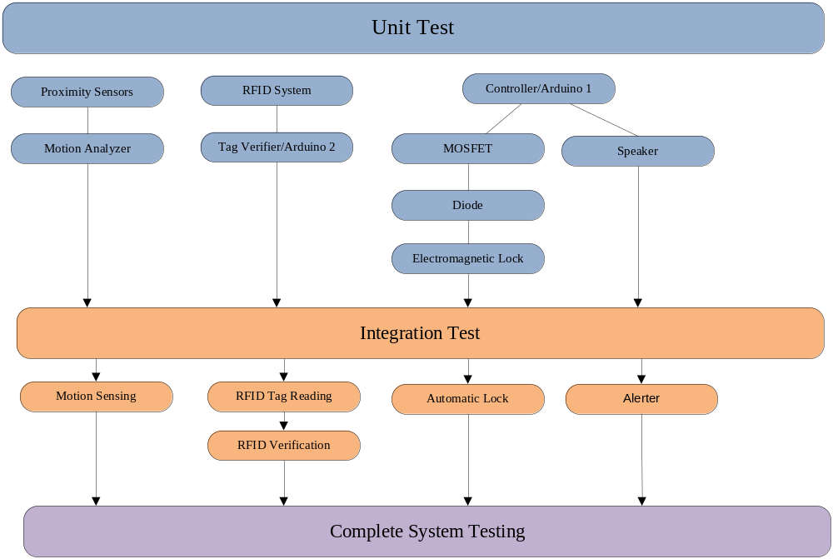
The hardware contains three external inputs to the system:
- RFID Tag (authorized , unauthorized tag, no tag)
- Inside motion sensor (detected or not detected)
- Outside motion sensor (detected or not detected)
During Complete System Testing, twelve tests need to be run to test all possible inputs to the hardware. All twelve tests will be run.

Web Interface Testing Strategy
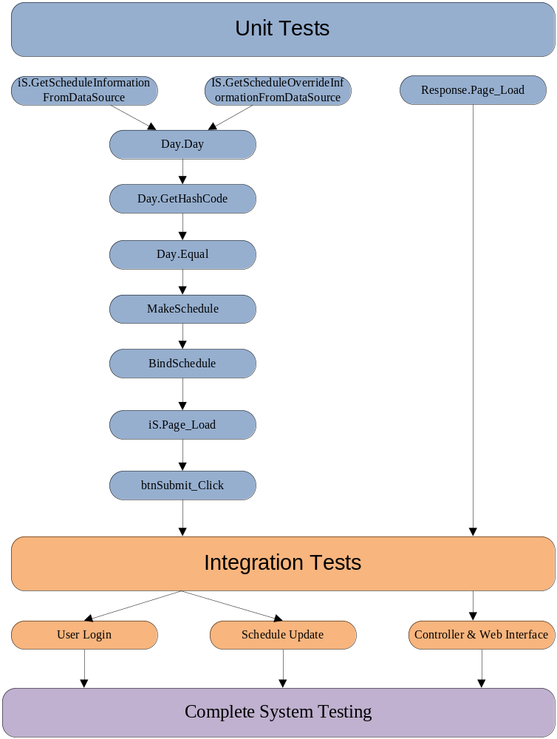
The Web Interface contains 28 external inputs to the system:
- Login (authorized & unauthorized)
- Schedule override (none, in, out, locked, & open)
- 24 check boxes for times of day
- Time of day (hours, minutes, seconds)
For Complete System Testing, 1.5 trillion tests need to be run to test all possible inputs to the software. 163 tests will be selected from the 1.5 trillion:
- All 4 login options (valid/invalid username & password)
- All 5 schedule overrides (none, in, out, locked, & open)
- 4 configurations for current hour
- 4 configurations for following hour
- Tests will be conducted during current hour and following hour.

Complete System Testing Strategy
The complete system tests will include all the System Verification Tests, all the Non-functional tests, and subset of the tests using the external inputs. The subset of tests using the external inputs will be:
- 4 lock statuses - authorized pet allowed in, out, locked, and open
- 2 motion detection options – in and out

Requirements Traceability
# | Customer Requirements | Tests required to satisfy requirement
# | Customer Requirements | System Verification | Non-functional | Integration | Unit
4.2.1 | The iDoor product shall contain a pet door |  | N1
4.2.2 | The pet door shall have a lock |  | N2
4.2.3 | The iDoor shall sense the user’s pets | S1 |  | I1, I5, I6 | U1, U18, Tag Verifier
4.2.4 | The iDoor shall prohibit access for vermin and unwanted pets | S2 |  | I1, I5, I6, I7 | U1, U2, U3, U4, U6, U7, U18, Tag Verifier
4.2.5 | The iDoor shall notify pets when they may pass through the pet door | S3 |  | I8 | U5, Controller
4.2.6 | The iDoor shall not crush the pets |  | N3
4.2.7 | The iDoor shall operate on a schedule | S4 |  | I1, I5, I6, I7 | U1, U2, U3, U4, U6, U7, U17, U18, Tag Verifier
4.2.8 | The iDoor shall have a schedule override feature | S5 |  | I1, I3, I5, I6, I7 | U1, U2, U3, U4, U6, U7, U12, U13, U14, U15, U17, U18, Tag Verifier
4.2.9 | The iDoor schedule and override feature shall be locally and remotely accessible | S6 |  | I2, I4 | U8, U9, U10, U11, U16, U20
4.2.10 | Unauthorized users shall be prevented access to the schedule and override feature of the iDoor | S7 |  | I2 | U8
4.2.11 | If the iDoor has a guillotine-style door, the door shall automatically open and close after the pet is granted access
4.2.12 | The pet door component shall be mounted in a wall |  | N4
4.2.13 | The iDoor shall contain removable pet tags |  | N5
4.2.14 | The iDoor shall be installable in existing homes and new construction
4.2.15 | The iDoor shall use 120 volt alternating current electricity |  | N6
4.2.16 | The iDoor shall be used for small to mid-size pets

Reintegration & Regression
Testing will start with Unit Testing, followed by Integration Testing and System Testing. The following information will be recorded for each of the hardware tests conducted:
- Test Name
- Date
- Tester’s Name
- Module being tested
- Input
- Expected Output
- Actual Output
- Results Of Test [Pass/Fail]
- Notes
Web interface testing will be done in Visual Studio. The Visual Studio testing handles all inputs and outputs. The tool returns a pass/fail result. The following information will be recorded for each of the software tests conducted.
- Test Method Name
- Date
- Tester’s Name
- Module being tested
- Results Of Test [Pass/Fail]
- Notes
Failure to obtain expected results for Integration Testing will require retesting of the Units required for the integration test. Upon successful re-unit testing, reintegration testing will be performed. The reintegration testing will follow the regression testing of the system to ensure the changes do not affect features that are not supposed to be affected.
Failure to obtain expected results for System Verification Testing will require retesting of the Units required for the verification test. Upon successful re-unit testing, reintegration testing will be performed on the required integration tests. The System Verification Test will be re-run to ensure the iDoor is working as designed.
Any defects or bugs detected during this phase will be recorded as follows:
- Test Name
- Date Opened
- Date Closed
- Tester’s Name
- Status
- Severity (1, 2, 3, or 4)
- Module being tested
- Bug description
- Notes
Defect severity will be rated as follows:
Sev 1: iDoor can’t be used
Sev 2: iDoor can be used but major functions of iDoor can’t be used
Sev 3: iDoor can be used but minor functions of iDoor can’t be used
Sev 4: iDoor can be used, but minor functions of iDoor are affected or unavailable; however, a workaround exists

Item Pass/Fail Criteria

Test Plans and Procedures

General
The goal of the test plan is to ensure the iDoor is of the highest quality by minimizing the number of defects and bugs in the system. Specific testing information will be provided in the System Test Plan.

Unit Tests
Pass: All unit tests expected to return valid return expected output. All unit test expected to return invalid return expected errors.
Fail: The unit test fails at meeting the expected output during any attempt at unit testing.

Integration Tests
Pass: The module works as described in the ADS and DDS.
Fail: Any part of the module fails to work as specified in the ADS and DDS.

Hardware Tests
Pass: The hardware demonstrates expected behavior in response to the change.
Fail: The hardware fails to demonstrate expected behavior in response to the change.

System Verification Tests
Pass: The system works as described in the SRD.
Fail: Any part of the system fails to work as specified in the SRD.

Test Deliverables
Team iDoor will deliver several testing collateral items:

System Test Plan
The System Test Plan (this document) provides a guide and overview to the tests for the iDoor.

Test Cases
Test cases will give the input and expected output of all tests on the iDoor.

Test Results
For the hardware, the test cases will be run and each test result will be recorded as follows:
- Test Name
- Date
- Tester’s Name
- Module being tested
- Input
- Expected Output
- Actual Output
- Results Of Test [Pass/Fail]
- Notes
Test cases will be generated using the expected input parameters in chapter 3 and chapter 5.

Bugs and Defects
All bugs and defects found during testing will be recorded as follows:
- Test Name
- Date Opened
- Date Closed
- Tester’s Name
- Status
- Severity (1, 2, 3, or 4)
- Module being tested
- Bug description
- Notes

Test Code
Code in the Web Interface will be tested using a software testing tool in Visual Studio. The testing code written for will be saved to a CD and delivered with the prototype.

Test Schedule
The test schedule starts on October 19th, 2010 and ends on December 7th, 2010. This testing schedule is a summary from the iDoor project plan.

Test | Start Date | End Date | Time | Resource
Hardware Unit | 10/19/10 | 11/15/10 | 10 hrs | Sandip
Software Unit –Web Interface | 10/19/10 | 11/21/10 | 15 hrs | Courtney, Jason, & Matt
Software Unit –Controller | 10/19/10 | 11/17/10 | 15 hrs | Sandip
Integration | 11/22/10 | 11/28/10 | 10 hrs | Courtney, Jason, Matt, & Sandip
System | 11/28/10 | 12/07/10 | 44 hrs | Courtney, Jason, Matt, & Sandip

Approvals
Marcus Oladell: ________________________________________________________

Jason Beere: ___________________________________________________________

Sandip Shrestha: ________________________________________________________

Courtney Burkhart: ______________________________________________________

Matt Forsberg: _________________________________________________________

