CPS209 Assignment 2:

Linked List Simulator

Due Date: April 7 11:59pm

Objective: To practice using Linked Lists, recursion, inheritance, frames, listeners, and standard documentation.

General Application: Simulate linked lists graphically.

Instructions:

Write a graphical application for drawing and linking cars (or any other complex shaped object). The interface for the simulation should look something like the following:

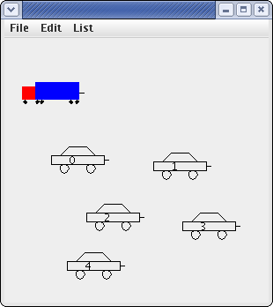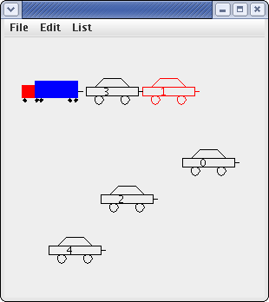
Figure 1: The figure on the left shows the panel after the user has pressed the mouse in six locations to first create the truck, and then the five cars shown. The figure on the right shows the panel after car 3 has been hitched to the
truck and after car 1 has been selected and hitched to car 3. Note the line used to visually depict a vehicle’s trailer “hitch”.
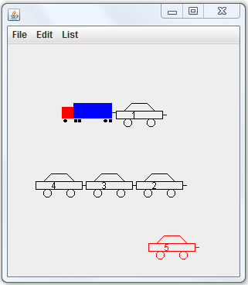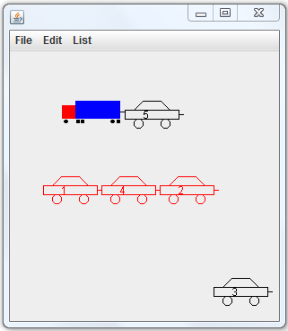

Figure 2: In the left figure, car 3 has been selected and hitched to car 4 and then car 2 has been selected and hitched to car 3. Car 5 is currently selected (indicated by the color red). In the right figure, cars 1, 4, and 2 have been linked and then car 1 has been selected. This causes the trailer of car 1 (car 4) and the trailer of car 4 (car 2) to also be selected. The user can now move cars 1, 4, 2 as a single unit.

Terminology:

• Vehicle: Abstract class which is a superclass of classes Car and Truck. This class should contain variables and methods that are common to Car and Truck. The methods supply default behavior and may be overridden in Car and Truck.

• trailer: This is not a class, but rather just a term that refers to a car attached to the hitch of another vehicle. So, in figure 1 on the right, car 3 is a trailer for the truck, and car 1 is a trailer for car 3. Class Vehicle should have an instance variable trailer of type Vehicle. This variable is set to refer to the towed vehicle object or is set to null (indicating there is no towed vehicle).

Functionality:

- You cannot use the mouse to select a towed vehicle. Only the lead vehicle can be selected. When a lead vehicle is selected, the vehicle and its trailer (and the trailer’s trailer etc.) move as a single unit. We will refer to a trailer car, and the trailer’s trailer etc. as the “linked cars” .

- When you draw a vehicle, you must recursively draw its trailer (which will cause the trailer's trailer to be drawn, etc.).

Basic mouse operations are as follows:

• Press: Initially the panel is blank. The user can then press the mouse button and the truck is created at the mouse position. Then, wherever they press the mouse button a car is created at that location. After five cars have been created in this manner, then pressing the mouse does not create any more cars. At this point, pressing the mouse on a car selects the car (and any linked cars) and changes its (and any linked cars) color to red.

• Drag: If the user presses and holds the mouse button and drags the mouse on a car which has been selected, then the car (and any linked cars) moves with the mouse. You can look up MouseMotionListener in the java API to implement dragging.

• Release: When you release the mouse button, if the bounding box of the selected car intersects the bounding box of another vehicle (car or truck) which does not already have a trailer, then the selected car (and any linked cars) becomes the trailer for that vehicle.

The File menu lets the user do the following:

• New: Start the simulation.
• Exit: Exit from the application.

The List menu lets the user do the following:

• Add First: Link the selected car (along with any linked cars) to the truck as the first one in the chain of vehicles towed by the truck.

• Add Last: Link the selected car (along with any linked cars) to the last car in the chain of vehicles towed by the truck.

• Remove First : Remove the first car from the chain of cars linked to the truck. The other cars remain attached to the truck.

• Remove Last : Remove the last car from the chain of cars attached to the truck.

The Edit menu lets the user do the following:

• Move: The Move menu lets you do the following
• Left : Move truck to the left.
• Right : Move truck to the right.
• Up: Move truck up.
• Down : Move truck down.
• Randomize: Move truck to the random position.

Note: “truck” in this (Edit menu) context means the truck and all cars linked to it

Sample files that may be useful to extend and modify:
Car.java (From BigJava)
Truck.java

Sample files that may be useful as an example or guide:
FontViewer.java (From Chapter 19 of BigJava)
FontFrame.java (From Chapter 19 of BigJava)

Details:

- For a maximum of 6 marks do all of the above except no mouse functionality. Automatically create the truck and the five cars and place them randomly in the panel. Also, the menu items Add First and Add Last add a randomly selected car.
- For a maximum of 7 marks, add the mouse press functionality.
- For a maximum of 8 marks, add the mouse drag functionality.
- For a maximum of 10 marks, add the mouse release functionality.
- Note that 10% of your mark is for program structure, style and documentation. You must use inheritance. You must use javadoc style documentation, have proper indentation, meaningful variable names, class names starting with uppercase, variable names starting with lower case, constants all capitals.
- Submit your java files on Blackboard by Apr. 7

Copying or letting your work be copied results in a zero as well as other repercussions.

