**Interstellar**

Introduction :

Interstellar is a computer game build in Python on top of OpenGL Graphics Library.

The game gives the user a 3-D experience of roaming in “space”.

The user can navigate his/her Space shuttle to explore whatever he/she wants in the space.

Game Play :

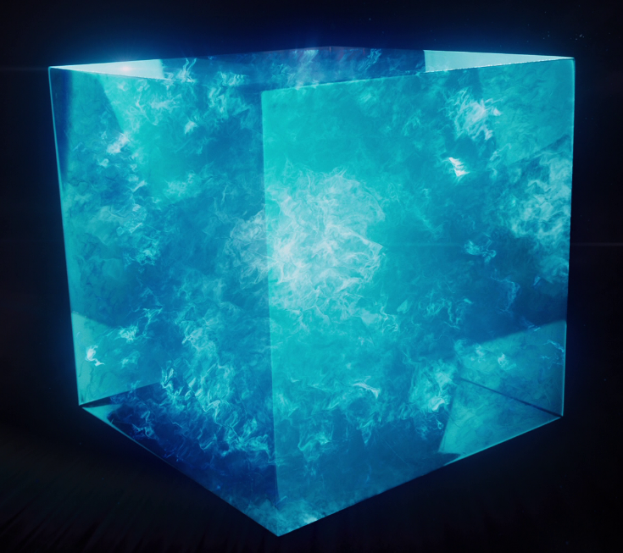The space is considered as a “Black Universe” consisting of high energy condensates in the form of “Tesseract-A 4-D Cube”

User will face a lot of Tesseracts through his/her journey and after sometime user will be get a real feeling of being in space.

The user can navigate his/her Space shuttle to explore whatever he/she wants in the space.

Technical Details :

Platform : Windows (64-bit)

Python 3.4.3 (32-bit)

PyOpenGL-3.1.1a1-cp34-none-win32.whl

Pygame-1.9.2a0-cp34-none-win32.whl

Submitted by :

Shikhar Bansal - cse1200132

Shweta Katheria – cse120013