Modeling Fuel Efficiency Using Linear, Polynomial, Piecewise, and Machine Learning Regression Techniques

Authors
Bhalchandra Shinde, Shantanu Wankhare, Josh (Fall 2025)
Master of Science in Artificial Intelligence, Northeastern University Silicon Valley

Introduction
Fuel efficiency (measured in Miles Per Gallon, MPG) is a critical measure of automotive performance. It impacts consumer vehicle choices, environmental sustainability, and automotive engineering decisions. Understanding the relationship between vehicle characteristics and fuel economy is essential for designing cleaner and more efficient vehicles.
The Auto MPG dataset provides real-world measurements of fuel consumption and several automobile attributes. The goal of this project is to model and predict MPG using a variety of regression approaches, and to compare the performance of linear and nonlinear modeling techniques. This study explores both univariate (horsepower → MPG) and multivariate models using engineered features and advanced algorithms such as polynomial regression, piecewise linear regression (PWLF), and Random Forests.
The project demonstrates how data cleaning, feature engineering, and algorithm selection influence predictive accuracy, and identifies the most effective model for MPG prediction.

Dataset
We use the Auto MPG dataset from the UCI Machine Learning Repository, containing 398 vehicles with the following features:
- mpg (target)
- cylinders
- displacement
- horsepower
- weight
- acceleration
- model_year
- origin

Data Characteristics
- Contains missing values (especially in horsepower).
- Several variables have nonlinear relationships with MPG.
- Strong multicollinearity exists among displacement, horsepower, and weight.
- Origin is a categorical variable requiring encoding.

Why this dataset?
- Widely used for regression benchmarking.
- Contains real-world automotive measurements.
- Exhibits nonlinearities and multi-factor dependencies suitable for testing different regression models.

Data Cleaning & Feature Engineering

Missing Values
- Horsepower contained missing entries encoded as "?"
- Converted to NaN and imputed using the median horsepower for robustness

Outlier Inspection
- Used boxplots to detect extreme values in MPG, horsepower, and displacement
- Removed obviously erroneous entries (e.g., mpg > 50)

Type Fixing
Converted categorical fields into the correct format:
- cylinders, origin, model_year → categorical

Feature Engineering
We engineered several new features to improve model expressiveness:
(1) Horsepower-to-Weight Ratio
$$hp_to_weight=\frac{horsepower}{weight}$$Captures vehicle power efficiency better than horsepower alone.
(2) Car Age
$$car_age=82-model_year$$Reflects improvements in engine technology across years.
(3) One-Hot Encoding
Encoded origin as:
- origin_2
- origin_3
(4) Scaling
Standardized continuous variables:
- horsepower
- weight
- displacement
- acceleration
- hp_to_weight
- car_age

Methods
This project evaluates six models across two categories.

Univariate Models (MPG ~ horsepower)

Linear Regression –
Linear regression models the relationship between input features and the target as a straight-line combination of the predictors
A simple linear model of the form:
$$mpg=β_{0}+β_{1}(horsepower)$$Polynomial Regression (Degree 2)
Polynomial regression extends linear regression by including polynomial terms of the features, allowing the model to capture curved, nonlinear relationships
Adds quadratic curvature:
$$mpg=β_{0}+β_{1}x+β_{2}x^{2}$$Piecewise Linear Regression (PWLF)
PWLF models the relationship between features by fitting several connected linear segments. Unlike traditional regression, PWLF automatically learns the optimal breakpoints the locations where the slope of the line changes by minimizing overall prediction error. This allows the model to adapt to different trends in different ranges of the input feature, capturing nonlinear patterns while remaining interpretable and computationally efficient.

Multivariate Models (All engineered features)

Multiple Linear Regression
Multiple Linear Regression models MPG as a linear combination of several predictors simultaneously, allowing the model to capture the combined contributions of horsepower, weight, displacement, and other engineered features. By using multiple inputs, it significantly improves predictive accuracy over univariate models and provides interpretable coefficients for each feature.

Polynomial Regression (Degree 2)
Multivariate Polynomial Regression extends linear regression by adding squared and interaction terms across all features, enabling the model to capture smooth nonlinear relationships between predictors and MPG. This expanded feature space improves flexibility and predictive accuracy compared to standard linear models, especially when the underlying relationships are curved or non-additive.

Random Forest Regression
An ensemble of decision trees that:
- Models nonlinearities automatically
- Captures feature interactions
- Avoids multicollinearity issues
- Provides the best predictive accuracy in this study

Evaluation Metrics
We measure all models using:
- R² and Adjusted R²
- MSE (Mean Squared Error) and RMSE (Root Mean Squared Error)
- MAE (Mean Absolute Error)
Adjusted R² accounts for the number of predictors:
$$R_{adj}^{2}=1-(1-R^{2})⋅\frac{n-1}{n-p-1}$$

Results

Univariate Model Visualization (MPG vs Horsepower)
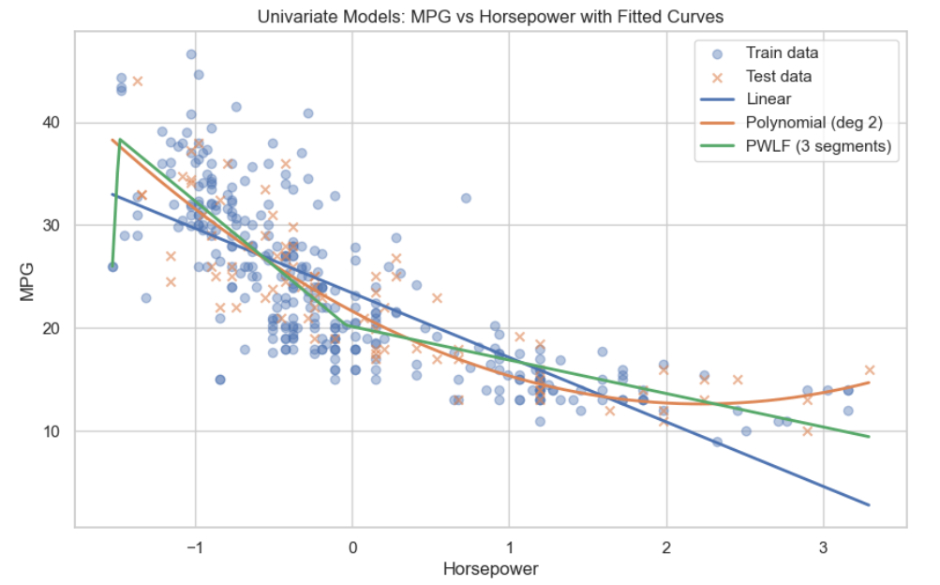
- Linear regression captures the broad negative trend but misses curvature.
- Polynomial regression provides the best univariate fit.
- PWLF adapts slopes across regions but still lacks explanatory power since MPG is multi-factor.

Model Comparison Table
Your table results:
Model | R² | RMSE | MAE
Random Forest | 0.923 | 2.02 | 1.57
Polynomial Regression (multi) | 0.898 | 2.34 | 1.72
Linear Regression (multi) | 0.855 | 2.79 | 2.22
Polynomial Regression (hp) | 0.741 | 3.73 | 2.92
PWLF (hp) | 0.721 | 3.87 | 3.00
Linear Regression (hp) | 0.639 | 4.40 | 3.50

Dashboard Insights
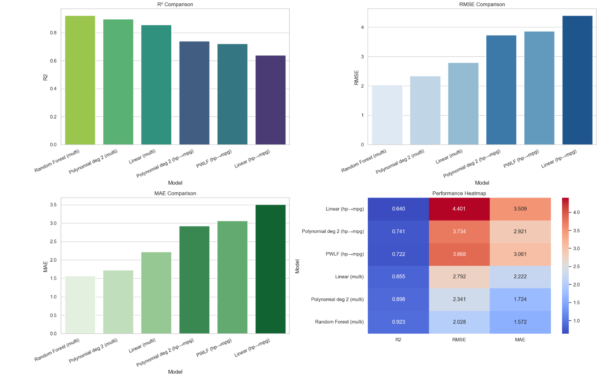
This 4-panel dashboard (R², RMSE, MAE, heatmap) shows:
- Random Forest consistently leads across all metrics.
- Polynomial (multivariate) is a strong interpretable alternative.
- Multivariate models drastically outperform univariate models.
- Horsepower alone is insufficient to predict MPG.

Discussion

Why Random Forest performs best
- Captures complex nonlinear interactions among weight, horsepower, and displacement.
- Naturally handles mixed feature types and feature importance.
- Resistant to overfitting due to averaging across many trees.

Why Polynomial Regression performs well
- Captures smooth nonlinear curvature across multiple correlated features.
- Adds interaction terms that improve expressiveness.

Why Univariate Models Fail
- MPG is influenced by multiple factors simultaneously.
- Horsepower alone cannot explain the observed variance in MPG.

Role of Feature Engineering
hp-to-weight and car_age improved predictive power significantly:
- Both features ranked high in feature importance for Random Forest.
- Multicollinearity effects were reduced.

Related Work

Work 1: Regression Benchmarking for Fuel Efficiency (2024)
Found that nonlinear models, particularly Random Forests, outperform linear models in vehicle MPG prediction. Our findings corroborate this trend.

Work 2: Piecewise Regression in Energy Modeling (2024)
Showed that automatic breakpoint detection improves interpretability. This motivated our use of PWLF.

What We Learned
- MPG prediction is highly nonlinear.
- Feature engineering (hp-to-weight, car_age) is crucial.
- Multivariate nonlinear models dramatically improve accuracy.
- Random Forest performed best due to its flexibility and robustness.
- Polynomial multivariate regression is a strong interpretable choice.

Conclusion
- Random Forest is the best-performing model for MPG prediction on this dataset.
- Polynomial multivariate regression provides strong, interpretable results.
- Feature engineering and data cleaning significantly improved outcomes.
- Future work may include hyperparameter tuning, SVR, and neural networks (MLP).

References
Dataset - https://www.kaggle.com/datasets/uciml/autompg-dataset/data
PWLR Paper link - https://arxiv.org/html/2510.10639v1

Appendix
- GitHub link - TBD
- Additional plots and dashboards as below

Predicted vs Actual for each model
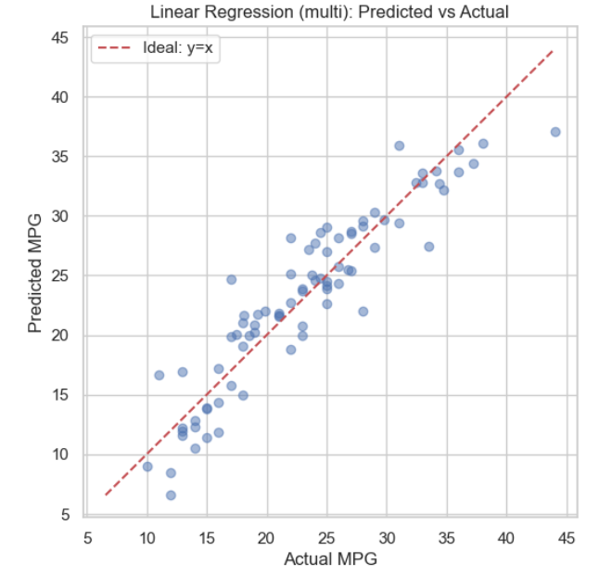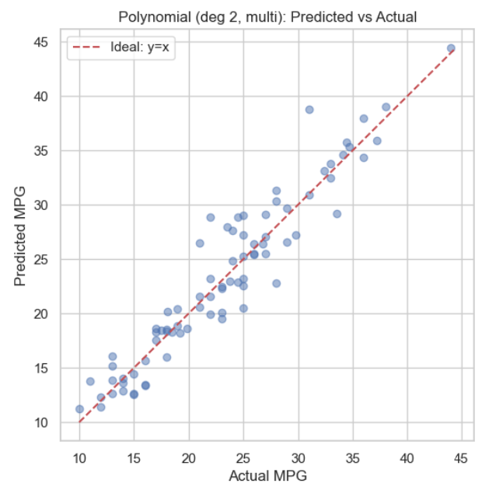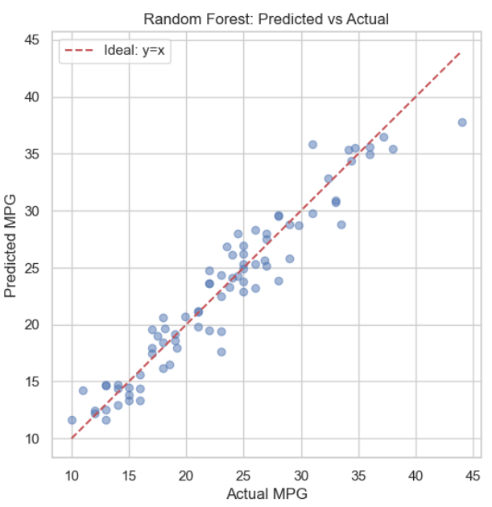

Feature importance chart
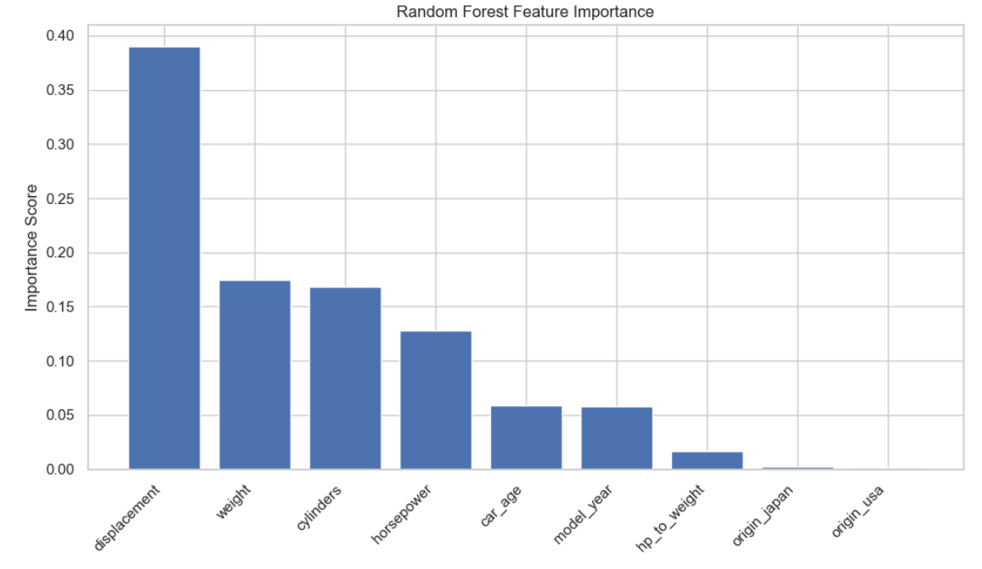

Partial Dependence Plots
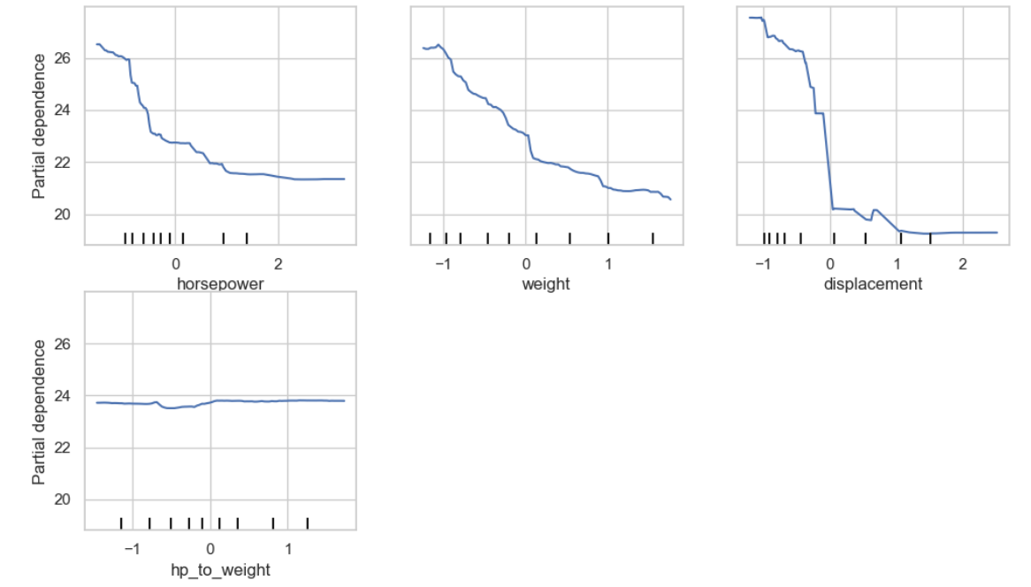

Random Forest Residual Plot
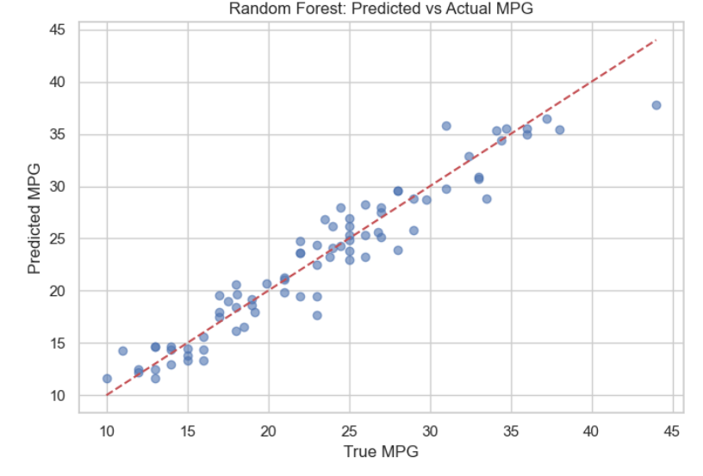

Residual Distribution Plot
