Analyzing Hallucination Patterns in Retrieval-Augmented Financial Question Answering: A Preliminary Study
Bhalchandra Shinde
Piyush Daga
Anish Kelkar
Rituraj Singh
Retrieval-augmented generation (RAG) grounds large language models (LLMs) in external documents, yet models still produce claims that contradict or exceed the retrieved evidence—a failure mode with acute consequences in finance, where a single wrong figure misleads. We study when and how RAG systems hallucinate on financial QA using the open-source subset of FinanceBench (150 annotated questions over 84 SEC filings). This preliminary report contributes: (i) an expanded literature review situating our work across RAG methods, hallucination evaluation, and financial NLP; (ii) an exploratory analysis showing that FinanceBench answers are overwhelmingly abstractive—only 2% appear verbatim in the cited evidence—over long, table-heavy 10-K filings, precisely the regime where grounded generation is hard; and (iii) a simple baseline pipeline (BM25 + GPT-3.5-turbo) evaluated with RAGAS faithfulness and token-level F1/Exact Match. Our results establish a working end-to-end system and quantify the retrieval bottleneck that drives both abstention and the “grounded-but-wrong” errors we will taxonomize in the final paper.

Introduction
Retrieval-augmented generation (Lewis et al. 2020) has become the dominant recipe for grounding LLM outputs in verifiable external knowledge. Yet a growing body of work shows that even with relevant context in the prompt, models generate statements that are unsupported by—or contradict—the retrieved passages (Ji et al. 2023; Huang et al. 2023). In financial question answering this is especially costly: answers are exact numeric values drawn from dense regulatory filings, and a single fabricated or misattributed figure produces a confidently wrong answer.
We investigate three research questions:
- RQ1. How frequently do different RAG pipeline configurations hallucinate on financial QA?
- RQ2. Which hallucination types dominate in finance—numerical, entity, reasoning, or unsupported extrapolation?
- RQ3. Do larger / instruction-tuned LLMs hallucinate less given the same retrieved context?
This report establishes the foundation for answering them: a literature review (Section 2), an exploratory analysis of FinanceBench that motivates the difficulty (Section 3), and a working baseline pipeline with preliminary faithfulness and accuracy metrics (Section 4). We close with the roadblocks this early evidence surfaces (Section 5).
Contributions. Bhalchandra Shinde: repository/infrastructure, environment, data pipeline, exploratory data analysis, and literature-review notes for Lewis et al. (2020) and Islam et al. (2023). Anish Kelkar: document chunking, baseline RAG pipeline, evaluation harness (RAGAS + F1/EM), and results tabulation. Piyush Daga and Rituraj Singh: remaining related-work papers and paper writing. All members contributed to the final draft.

Related Work
We organize related work into three themes: RAG methods and retrieval, hallucination detection and evaluation, and financial NLP/QA.
RAG methods and retrieval. RAG was introduced by Lewis et al. (2020), coupling a DPR retriever with a BART generator and framing knowledge as parametric (model weights) versus non-parametric (an editable document index) memory; it is the architectural baseline our pipelines instantiate. Two of its findings bear directly on our setting. First, RAG answers correctly even when the gold answer appears in no retrieved passage verbatim (11.8% of Natural Questions cases), where a purely extractive reader scores zero—the same abstractive regime we observe in FinanceBench, where only 2% of gold answers are verbatim in the evidence (Section 3). Second, swapping the document index updates the model’s world knowledge with no retraining, underscoring that retrieval quality—not generator memory—governs what a RAG system can ground, which is precisely the bottleneck our results expose. The two retrieval families we compare are defined by BM25 (Robertson and Zaragoza 2009), a probabilistic term-matching function that is our baseline retriever, and DPR (Karpukhin et al. 2020), which learns dense question/passage encoders and beats BM25 on most open-domain QA—motivating our planned dense pipeline. That dense pipeline embeds chunks with Sentence-BERT (Reimers and Gurevych 2019), a siamese-BERT model that produces semantically comparable sentence vectors, the encoder behind our MiniLM index. REALM (Guu et al. 2020) pre-trains the retriever jointly with a masked LM, and Fusion-in-Decoder (Izacard and Grave 2021) instead fuses many retrieved passages in the decoder; both integrate retrieval more deeply than our prompt-based setup and mark upgrade paths we may explore. Self-RAG (Asai et al. 2024) trains a model to decide when to retrieve and to critique its own generations with reflection tokens—directly relevant to cutting the unsupported answers we aim to reduce. Query rewriting (Ma et al. 2023) expands or reformulates the query before retrieval and is exactly the mechanism of our planned “enhanced” pipeline. The recent survey of Gao et al. (2023) organizes these advances and motivates our controlled comparison of retrieval strategies.
Hallucination detection and evaluation. Ji et al. (2023) and Huang et al. (2023) survey hallucination in NLG and LLMs respectively and provide the vocabulary (intrinsic vs. extrinsic, faithfulness vs. factuality) our taxonomy refines for finance. For measurement, RAGAS (Es et al. 2024) supplies reference-free metrics—faithfulness, answer relevancy, context precision—that we adopt as our primary hallucination signal. SelfCheckGPT (Manakul, Liusie, and Gales 2023) detects hallucination without external resources by sampling several responses and measuring their mutual consistency, while FActScore (Min et al. 2023) decomposes a generation into atomic facts and scores each against a source—two complementary detection lenses we consider for the final error analysis. RAGTruth (Niu et al. 2024) contributes a word-level hallucination corpus and taxonomy that we will use as supervision for the (optional) automatic classifier, and the RGB benchmark (J. Chen et al. 2024) evaluates LLM robustness to noisy retrieval—the “wrong context” condition our full-corpus retriever deliberately induces. We additionally report token-level F1/EM following the SQuAD protocol (Rajpurkar et al. 2016) to capture correctness that faithfulness alone misses, and note RAGBench (Friel, Belyi, and Sanyal 2024) as a cross-domain resource for future comparison.
Financial NLP and QA. FinanceBench (Islam et al. 2023) is our primary benchmark: 10,231 open-book questions over 361 real 10-K/10-Q/8-K/earnings filings from 40 US companies, of which a human-reviewed 150-question subset (the open-source release) is our evaluation set. Its own experiments motivate our study in three ways. (i) 66% of its questions require numerical reasoning rather than extraction—our EDA independently recovers this numeric skew (Section 3). (ii) Even the best realistic configuration (GPT-4-Turbo, long context) reaches only ~79% accuracy against an 85% oracle ceiling, and confident hallucination is a named failure theme—the phenomenon we set out to quantify and taxonomize. (iii) They report that stronger models tend to refuse when uncertain while weaker ones answer wrong; our GPT-3.5 baseline likewise abstains rather than fabricate (Section 4), and they find placing context before the question is critical—a design choice our prompt template adopts. Prior financial QA datasets establish that numerical reasoning over hybrid table/text is the core difficulty our EDA also finds: FinQA (Z. Chen et al. 2021) pairs expert-written questions with executable reasoning programs over earnings-report tables; ConvFinQA (Z. Chen et al. 2022) extends this to multi-turn conversational chains; and TAT-QA (Zhu et al. 2021) targets questions that jointly span a table and its surrounding text—exactly the table+prose evidence our chunker must preserve. On the model side, BloombergGPT (Wu et al. 2023), a 50B model pre-trained on a large financial corpus, and FinGPT (Yang, Liu, and Wang 2023), an open finance-LLM framework, show the appetite for finance-specialized models but evaluate generation quality rather than isolating RAG hallucination, which is our focus. Our open-source generator comparison will use Mistral-7B-Instruct (Jiang et al. 2023), a strong 7B open model, as the RQ3 counterpart to GPT-3.5.

Data and Exploratory Analysis
Dataset. We use the open-source subset of FinanceBench (Islam et al. 2023): 150 QA pairs spanning 32 companies and 84 source filings (fiscal years 2015–2024) across 9 GICS sectors. Question types are balanced by design (50 metrics-generated, 50 domain-relevant, 50 novel-generated). Each record carries a gold answer and an evidence span, letting us judge groundedness directly.
Findings. Figure 1 summarizes the analysis (full notebook and 22 figures in the repository). Four properties make this a stress test for grounded generation: (1) Long, tabular context—source filings have a median of 128 pages and evidence spans are 69% table-heavy, so retrieval operates over large, noisy documents. (2) Short, numeric answers—the median gold answer is 9 words and 84% are numeric, so a single wrong figure flips a correct answer to wrong. (3) Abstractive answers—only 2% of gold answers appear verbatim in the evidence (mean extractability 0.27); the model must synthesize a value, not copy it, which is the core hallucination risk. (4) Modest lexical overlap—median question–evidence cosine similarity is 0.47, so retrievers must bridge a vocabulary gap, and 46% of questions require numerical computation or aggregation. These observations justify measuring faithfulness (RAGAS) alongside F1/EM and motivate our four-category hallucination taxonomy.
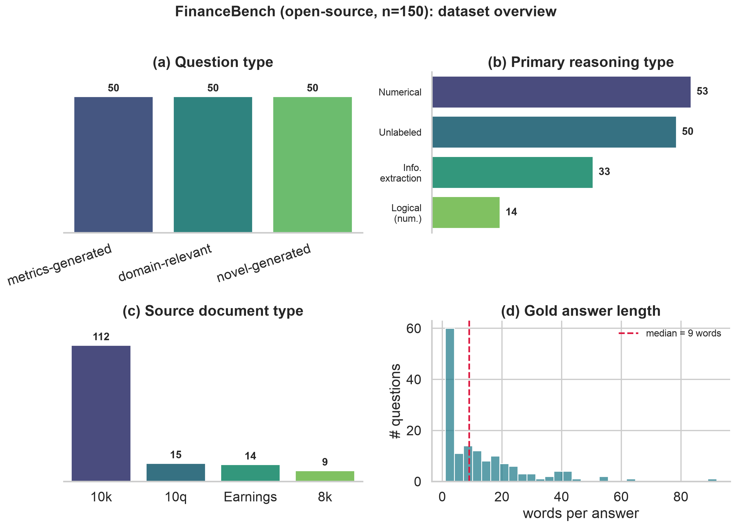
FinanceBench (open-source, n=150) overview: (a) balanced question types, (b) numeric reasoning dominates, (c) 10-K filings dominate the corpus, (d) gold answers are short.

Preliminary Method and Results
Pipelines. All configurations share the same GPT-3.5-turbo generator (temperature 0), prompt, 512-token chunks, and top-3 retrieval; only retrieval changes, which isolates its effect. We compare Baseline (BM25 sparse retrieval over the entire 84-filing corpus), Dense (FAISS over MiniLM embeddings), and Enhanced (an LLM rewrites the query before dense retrieval), plus a known-document upper bound (Single-doc: retrieval restricted to the question’s own filing). We index the full corpus on purpose—a retriever that can surface the wrong filing among 84 is exactly where hallucination appears. The prompt instructs the model to answer only from context and to say “I don’t know” when the answer is absent, so a wrong answer is a grounding failure rather than a memory guess. A fixed output schema lets one harness score every pipeline.
Evaluation. We report RAGAS (Es et al. 2024) faithfulness, answer relevancy, and context precision (LLM judge: GPT-4o-mini; local sentence-transformer embeddings), plus SQuAD-style token F1 and Exact Match (Rajpurkar et al. 2016). Because gold answers are short numbers formatted many ways ($1,577 vs. 1577.00 vs. 1.577 billion), strict EM is near zero, so we also report a numeric-tolerant EM (right value within 1%, ignoring format) and faithfulness on the answered subset. Retr@3 = share of questions whose top-3 retrieval reached the correct filing.
Pipeline | Retr@3 | Faithful. | Faith(ans) | Ans. Rel. | Ctx. Prec. | Answered | F1 | EM (num)
Baseline (BM25) | 43% | 0.104 | 0.408 | 0.234 | 0.240 | 47/150 | 0.083 | 0.120
Dense (FAISS) | 64% | 0.197 | 0.352 | 0.414 | 0.417 | 82/150 | 0.116 | 0.180
Enhanced (rewrite) | 69% | 0.209 | 0.353 | 0.432 | 0.462 | 87/150 | 0.121 | 0.207
Dense, single-doc | 100% | 0.300 | 0.572 | 0.424 | 0.435 | 96/150 | 0.139 | 0.267
Results. Every metric improves as retrieval improves. The correct filing reaches the top-3 for 43% → 64% → 69% of questions (BM25 → dense → rewrite); because the model answers only from context, coverage rises in lockstep (47 → 82 → 87 of 150), and so do context precision (0.24 → 0.42 → 0.46), faithfulness (0.10 → 0.20 → 0.21), token F1 (0.083 → 0.116 → 0.121), and numeric-tolerant EM (0.12 → 0.18 → 0.21). Since only retrieval changed, this isolates retrieval as the dominant lever (RQ1). Strict EM ~0 understates accuracy: the numeric-tolerant EM shows 33–42% of answered questions are actually correct—the model was penalized for formatting, not errors. Faithfulness is low overall, but that is dominated by abstentions (an “I don’t know” has nothing to ground); on the answered subset it is moderate (0.35–0.57), i.e. when the model commits to an answer it is partly—not fully—grounded, which is precisely the hallucination we study. The known-document upper bound makes the ceiling explicit: restricting retrieval to the correct filing lifts Retr@3 to 100%, coverage to 96/150, F1 to 0.139, and answered-faithfulness to 0.57—yet a third of questions still go unanswered, so finding the right filing is necessary but not sufficient. Those answered-but-unsupported cases are exactly what our error analysis will taxonomize.

Roadblocks and Next Steps
The preliminary run isolates the key bottleneck: sparse full-corpus retrieval often fails to surface the correct filing, so the model either abstains or answers from wrong context. This directly shapes our plan: (1) dense retrieval (FAISS + sentence embeddings) and query rewriting to raise retrieval recall (RQ1); (2) an open-source generator (Mistral-7B (Jiang et al. 2023)) under the same retrieval config to test RQ3; and (3) manual annotation of 50 failure cases into our four-type taxonomy (numerical, entity, reasoning, unsupported extrapolation) to answer RQ2. The main risks are OpenAI API cost control (run once at temperature 0) and the fidelity of PDF table extraction, which flattens tables into linear text and is a known limitation we will quantify.

References
Asai, Akari, Zeqiu Wu, Yizhong Wang, Avirup Sil, and Hannaneh Hajishirzi. 2024. “Self-RAG: Learning to Retrieve, Generate, and Critique Through Self-Reflection.” In Proceedings of ICLR.
Chen, Jiawei, Hongyu Lin, Xianpei Han, and Le Sun. 2024. “Benchmarking Large Language Models in Retrieval-Augmented Generation.” In Proceedings of AAAI.
Chen, Zhiyu, Wenhu Chen, Charese Smiley, Sameena Shah, Iana Borova, Dylan Langdon, Reema Moussa, et al. 2021. “FinQA: A Dataset of Numerical Reasoning over Financial Data.” In Proceedings of EMNLP.
Chen, Zhiyu, Shiyang Li, Charese Smiley, Zhiqiang Ma, Sameena Shah, and William Yang Wang. 2022. “ConvFinQA: Exploring the Chain of Numerical Reasoning in Conversational Finance Question Answering.” In Proceedings of EMNLP.
Es, Shahul, Jithin James, Luis Espinosa-Anke, and Steven Schockaert. 2024. “RAGAS: Automated Evaluation of Retrieval Augmented Generation.” In Proceedings of EACL: System Demonstrations.
Friel, Robert, Masha Belyi, and Atindriyo Sanyal. 2024. “RAGBench: Explainable Benchmark for Retrieval-Augmented Generation Systems.” arXiv Preprint arXiv:2407.11005.
Gao, Yunfan, Yun Xiong, Xinyu Gao, Kangxiang Jia, Jinliu Pan, Yuxi Bi, Yi Dai, Jiawei Sun, and Haofen Wang. 2023. “Retrieval-Augmented Generation for Large Language Models: A Survey.” arXiv Preprint arXiv:2312.10997.
Guu, Kelvin, Kenton Lee, Zora Tung, Panupong Pasupat, and Ming-Wei Chang. 2020. “REALM: Retrieval-Augmented Language Model Pre-Training.” In Proceedings of ICML.
Huang, Lei, Weijiang Yu, Weitao Ma, Weihong Zhong, Zhangyin Feng, Haotian Wang, Qianglong Chen, et al. 2023. “A Survey on Hallucination in Large Language Models: Principles, Taxonomy, Challenges, and Open Questions.” arXiv Preprint arXiv:2311.05232.
Islam, Pranab, Anand Kannappan, Douwe Kiela, Rebecca Qian, Nino Scherrer, and Bertie Vidgen. 2023. “FinanceBench: A New Benchmark for Financial Question Answering.” arXiv Preprint arXiv:2311.11944.
Izacard, Gautier, and Edouard Grave. 2021. “Leveraging Passage Retrieval with Generative Models for Open Domain Question Answering.” In Proceedings of EACL.
Ji, Ziwei, Nayeon Lee, Rita Frieske, Tiezheng Yu, Dan Su, Yan Xu, Etsuko Ishii, Ye Jin Bang, Andrea Madotto, and Pascale Fung. 2023. “Survey of Hallucination in Natural Language Generation.” ACM Computing Surveys 55 (12): 1–38.
Jiang, Albert Q., Alexandre Sablayrolles, Arthur Mensch, Chris Bamford, Devendra Singh Chaplot, Diego de las Casas, Florian Bressand, et al. 2023. “Mistral 7B.” arXiv Preprint arXiv:2310.06825.
Karpukhin, Vladimir, Barlas Oğuz, Sewon Min, Patrick Lewis, Ledell Wu, Sergey Edunov, Danqi Chen, and Wen-tau Yih. 2020. “Dense Passage Retrieval for Open-Domain Question Answering.” In Proceedings of EMNLP.
Lewis, Patrick, Ethan Perez, Aleksandra Piktus, Fabio Petroni, Vladimir Karpukhin, Naman Goyal, Heinrich Küttler, et al. 2020. “Retrieval-Augmented Generation for Knowledge-Intensive NLP Tasks.” In Advances in Neural Information Processing Systems (NeurIPS).
Ma, Xinbei, Yeyun Gong, Pengcheng He, Hai Zhao, and Nan Duan. 2023. “Query Rewriting for Retrieval-Augmented Large Language Models.” In Proceedings of EMNLP.
Manakul, Potsawee, Adian Liusie, and Mark J. F. Gales. 2023. “SelfCheckGPT: Zero-Resource Black-Box Hallucination Detection for Generative Large Language Models.” In Proceedings of EMNLP.
Min, Sewon, Kalpesh Krishna, Xinxi Lyu, Mike Lewis, Wen-tau Yih, Pang Wei Koh, Mohit Iyyer, Luke Zettlemoyer, and Hannaneh Hajishirzi. 2023. “FActScore: Fine-Grained Atomic Evaluation of Factual Precision in Long Form Text Generation.” In Proceedings of EMNLP.
Niu, Cheng, Yuanhao Wu, Juno Zhu, Siliang Xu, Kashun Shum, Randy Zhong, Juntong Song, and Tong Zhang. 2024. “RAGTruth: A Hallucination Corpus for Developing Trustworthy Retrieval-Augmented Language Models.” In Proceedings of ACL.
Rajpurkar, Pranav, Jian Zhang, Konstantin Lopyrev, and Percy Liang. 2016. “SQuAD: 100,000+ Questions for Machine Comprehension of Text.” In Proceedings of EMNLP.
Reimers, Nils, and Iryna Gurevych. 2019. “Sentence-BERT: Sentence Embeddings Using Siamese BERT-Networks.” In Proceedings of EMNLP.
Robertson, Stephen, and Hugo Zaragoza. 2009. “The Probabilistic Relevance Framework: Bm25 and Beyond.” Foundations and Trends in Information Retrieval 3 (4): 333–89.
Wu, Shijie, Ozan Irsoy, Steven Lu, Vadim Dabravolski, Mark Dredze, Sebastian Gehrmann, Prabhanjan Kambadur, David Rosenberg, and Gideon Mann. 2023. “BloombergGPT: A Large Language Model for Finance.” arXiv Preprint arXiv:2303.17564.
Yang, Hongyang, Xiao-Yang Liu, and Christina Dan Wang. 2023. “FinGPT: Open-Source Financial Large Language Models.” arXiv Preprint arXiv:2306.06031.
Zhu, Fengbin, Wenqiang Lei, Youcheng Huang, Chao Wang, Shuo Zhang, Jiancheng Lv, Fuli Feng, and Tat-Seng Chua. 2021. “TAT-QA: A Question Answering Benchmark on a Hybrid of Tabular and Textual Content in Finance.” In Proceedings of ACL.

