**SysconJobScheduler Help**

1. **Running the program**

Double click the JobSchedulerUI.exe in the program folder to run the application. It might ask for admin privilege if the security settings are enabled in Windows 7.

1. **Viewing the existing jobs**

The scheduled jobs datagrid shows the available jobs.

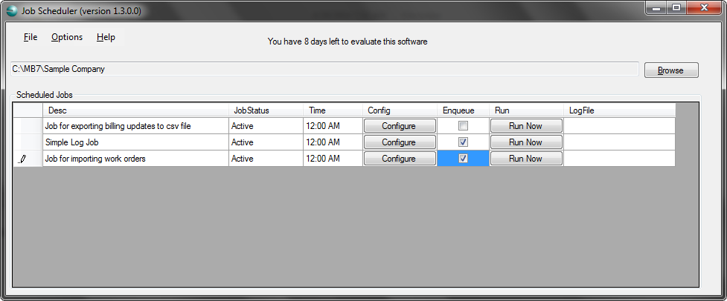

1. **Scheduling a job to the windows scheduled task**

Configure the job first before sending it to windows scheduler. Click the configure button for the job to be scheduled and fill the necessary details.

Check the “Enqueue” checkbox in the datagrid. A dialog for setting the schedule time will pop up. Do the settings in the dialog and click the Ok button. A message box will display the confirmation and the job will get added to the windows task scheduler.

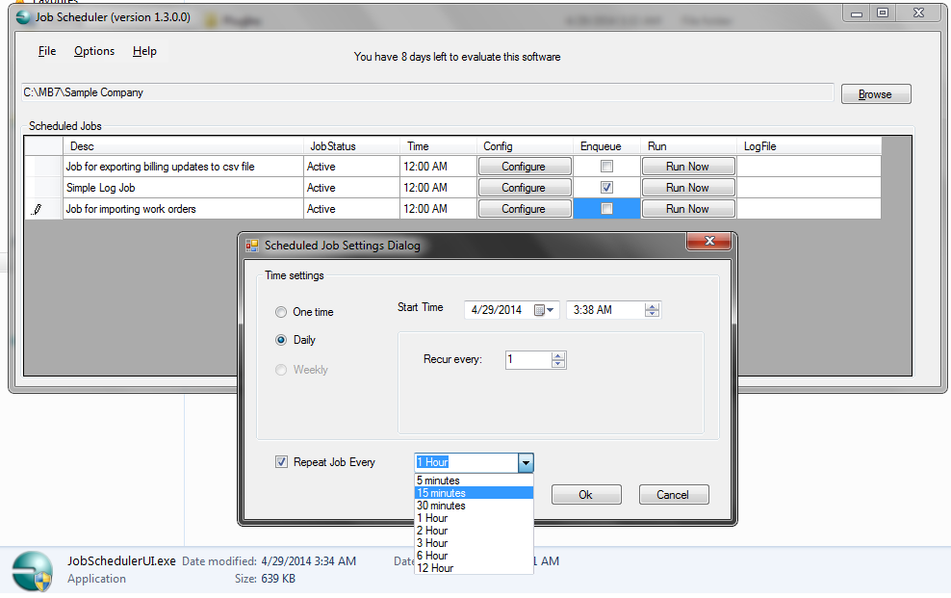

**Viewing and editing the jobs in Windows Task Scheduler**

The jobs get scheduled in the windows task scheduler root folder. Here in the below image the **SimpleLogjob** is scheduled in the windows task scheduler. To open the windows task scheduler type “Task Scheduler” in the search box of windows start menu.

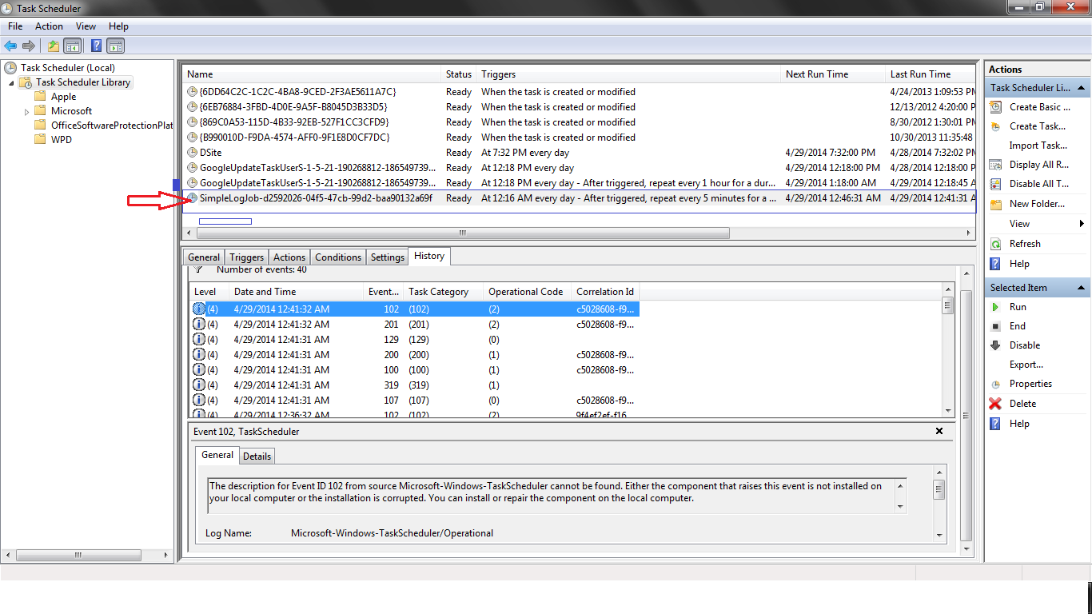

On double clicking the task in task scheduler window the following dialog will appear

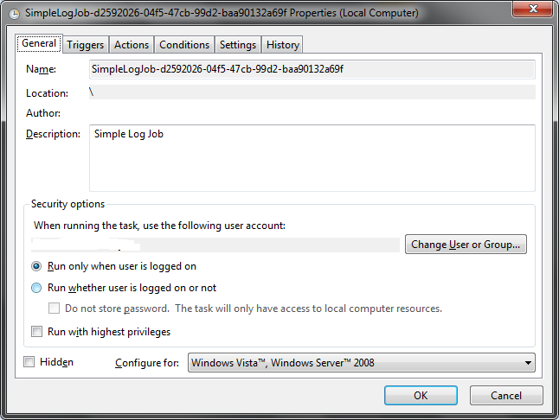

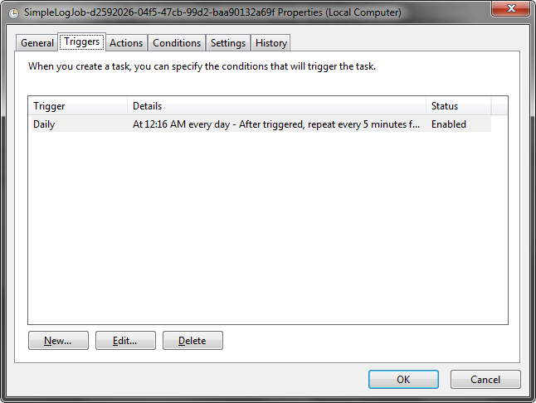

The user can either add one more trigger here by clicking the “New” button or edit the existing one by clicking the “Edit” button. On clicking the edit button the following dialog will appear

The user can edit the scheduled time in the following dialog which provides advanced settings. The changed settings will remain for next time.

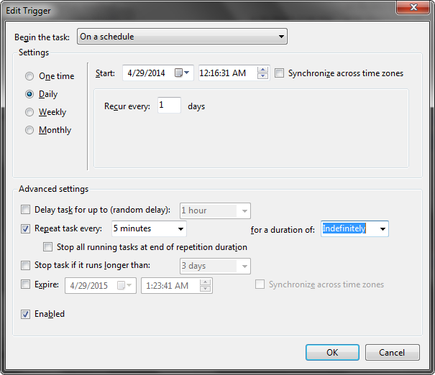

The third tab is the “Actions” tab. It shows the scheduled action to be performed for this task. Please don’t change any parameter here otherwise the program might not perform as expected.

