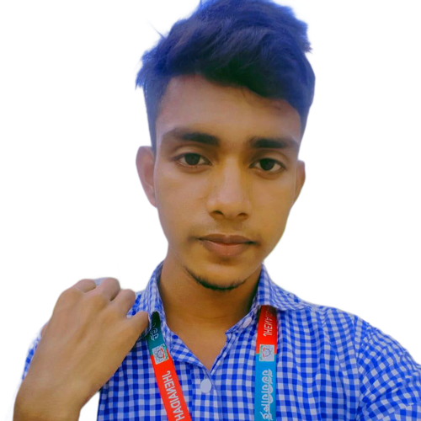

Hello, I Am Asikur, Full-Stack Web Developer MERN.

in 3years + Experienced. I Am Also A Good Designer ..

I Am Node js Developer, I Love Coding, Its My Best Hobby.

**Web Design**

**Front end Developer**

**2024**

**Full-Stack Web Development,MERN**

**Junior Developer**

**2023**

**Jhenaidah polytechnic institute**

**ComputerTechnology**

**2020-2023**

**Duet,Bsc In Computer**

**Bachelor in Information Technology**

**2024-2028**

Reading

Writing

Music

Photography

kaliganj,Jhenaidah,Bd

https://asikurdualweb.vercel.app

asikurrahaman997@gmail.com

**EXPERIENCE**

**EDUCATION**

**HOBBIES**

**CONTACT**

**PROFILE**

**Md Asikur**

CURICULUM VITAE

391-mail4.png

067-phone.png

+8801893585782/whastapp or call

001-home.png

202-sphere.png

032-book.png016-camera.png

006-pencil.png018-music.png

Recreated by:

**Technomaniac Dude**

https://www.youtube.com/channel/UCLN9JBy6gCvAWkg5DUInKKA

Please **Subcribe**

Visit

Freepik.com

For more designs

(All design credits goes to freepik.com)

Link: https://www.freepik.com/free-vector/curriculum-vitae-template_992045.htm

Fonts used:

For Texts: Calibri (Body)

For Symbols: https://www.icomoon.io/