1. If you have not used Tilemill before, go to Start > Programs > Tilemill. Complete all parts of the [Crashcourse](https://www.mapbox.com/tilemill/docs/crashcourse/introduction/):

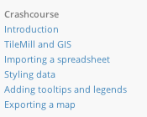

(Note: in the final step, you can upload directly to your Mapbox account instead of uploading).

1. If you exported without uploading, upload your map (MBtiles) to your Mapbox account: [help!](https://www.mapbox.com/help/upload-mbtiles-file/)
2. Start a new map project. Uncheck “Include world layer styles”, as we will not need them for this exercise.
3. Choose one of the shapefiles from your course folder and follow the instructions on [adding a shapefile layer](https://www.mapbox.com/tilemill/docs/guides/add-shapefile/) to Tilemill.
4. Press the  button in the upper left corner. Enter the following settings and press **Save**:

|  |  |
| --- | --- |
|  | Zoom: 12 to 15  Center: -122.4454,37.7566,12  Bounds:  -122.5219,37.7069,-122.3458, 37.8356 |

1. The text in the right panel is CartoCSS. It controls the styling of the census blocks on your map. The default is green borders (#594) and green fill (#ae8). Change the colors by clicking the color boxes in the bottom border

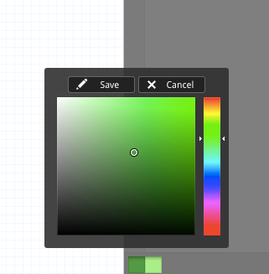

1. Now open the shapefile in QGIS or ArcGIS, whichever you are more comfortable with, and play with the break types. If you need help with this stage, wave the instructor over! Once you have a favorite data break type, copy it here:

____ ____ ____ ____ ____ Break type:

1. Go back to Tilemill. Press the layers button in the lower left corner, then press the features table button. All of your attribute data is here.
2. Go to <http://colorbrewer2.org/> to create a color ramp for your map. Be sure to select the correct number of data classes and a sequential color scheme.
3. Apply what you learned about conditional styles from the Crashcourse to creating your choropleth styles here. The only difference is that instead of varying marker-width, you are varying polygon-fill.
4. Change the line-color and line-width to improve the graphical style.
5. Create a legend to show your data classification by copying and modifying the HTML/CSS in the [Advanced Legend Guide](https://www.mapbox.com/tilemill/docs/guides/advanced-legends/).
6. Add a **tooltip** and **teaser** that clearly and concisely provide the map user with relevant contextual information about the values associated with each census block. Ask for help designing this if you are uncertain.
7. Export your map and upload it to your Mapbox account.
8. Take a look at each of your projects with a WIMP and a touchscreen interface. Do they look great? If not, iterate!