# ABSTRACT

Growing a tomato is skill, knowledge and experience demanding job. A healthy plant has to endure plethora of problems varying from bacteria, fungi and viruses to the environmental conditions. An expertise in this field can only provide his/her adroitness to grow a plant. If proper care is not taken in this area, it may lead to serious effects on plants and adversely affects the productivity and quality. To detect, the plant diseases we need a fast automatic way. The main approach adopted in practice for detection and identification of plant diseases is naked eye observation through experts. So this method is time consuming and less efficient. Here, a project is proposed with an idea of detecting tomato plant diseases using image processing. Image processing in Python is to be used for measuring affected area of disease and Machine Learning to determine the immediate solution. This concept can be extended to detect the symptoms of any type of plant diseases that is affected on different horticulture crops.

# TABLE OF CONTENTS

ABSTRACT i

TABLE OF CONTENTS ii

LIST OF FIGURES iii

Chapter 1: INTRODUCTION 1

1.1 Background 1

1.2 Problem Statement 2

1.3 Objectives 2

Chapter 2: LITERATURE REVIEW 3

Chapter 3: FEASIBILITY STUDY 5

3.1 Economic Feasibility: 5

3.2 Resource Feasibility: 5

3.3 Technical Feasibility: 5

Chapter 4: PROJECT METHODOLOGY 6

4.1 Block Diagram of proposed system 6

4.2 Development model 7

Chapter 5:IMPLEMENTATION PLAN 8

5.1 Schedule (Gantt chart) 8

5.2 Software Requirements 8

Chapter 6: Expected Outcomes 9

REFERENCES 10

# LIST OF FIGURES

Figure 1 Block Diagram……………..………………………………………….6

Figure 2 Development Model…………….………………………….…......……7

Figure 3 Gantt Chart…………………………………………………..….……...8

# Chapter 1: INTRODUCTION

## 1.1 Background

Agriculture is the most important occupation of our nation. It has played a key role in the development of human civilization. The agricultural production system is an outcome of a complex interaction of soil, seed and agro chemicals including fertilizers. Therefore, judicious management of all the inputs is essential for the sustainability of a complex system. The focus on enhancing the productivity, without considering the ecological impacts has resulted in environmental degradation. As diseases of the plants are inevitable, detecting disease plays a major role in the field of agriculture. Plant pathogens consist of fungi, organism, bacteria, viruses, phytoplasmas, viroids etc., three components are absolutely necessary for diseases to occur in any plant system and which may infect all types of plant tissues including leaves, shoots, stems, crowns, roots, tuber, fruits, seeds, and vascular tissues. Therefore, detection and classification of diseases is an important and urgent task. The naked eye observation of experts is the main approach adopted in practice for detection and identification of plant diseases. However, this requires continuous monitoring of experts which might be prohibitively expensive in large farms. Further, in some developing countries, farmers may have to go long distances to contact experts, this makes consulting experts too expensive and time consuming. When crops suffered disease, if the symptoms are not obvious or more complex, it will be very difficult to distinguish the characteristics so that delays the effective control of crop diseases seriously. We can analyze the image of disease leaves by using computer image processing technology and extract the features of disease spot according to color, texture and other characteristics from a quantitative point of view.

There will be great significance for the green production safety through using the computer image processing technology to monitor crop and pest diagnosis, in order to achieve artificial intelligence prevention. Traditionally farmers identify the diseases by naked eye observation method. In this method disease is visually detected by the experts, who have the ability to detect subtle changes in leaf color. This method is very laborious, time consuming and impractical for large fields. So a fast and accurate approach to identify the plant diseases is needed. Some researchers have used image processing techniques for fast and accurate detection of plant diseases. The steps followed by these researchers in detection of leaf diseases are image acquisition, image pre-processing, disease spot segmentation, feature extraction and disease classification. The accuracy of result depends on methods used for disease spot detection.

## 1.2 Problem Statement

* Farmers don’t know about the diseases that arise in the plant.
* Farmers can’t provide proper care to the plant.

## 1.3 Objectives

* To detect the disease that is caused in the tomato plant using image processing and artificial intelligence and provide a remedy and cure to the disease found.

# Chapter 2: LITERATURE REVIEW

Vijai Singh et.al proposed a new approach for classifying different plant leaf diseases. Image segmentation, which is an important aspect for disease detection in plant leaf disease, is done by using genetic algorithm. Image segmentation is the process of separating or grouping an image into different parts. Genetic algorithms belong to the evolutionary algorithms which generate solutions for optimization problems. The algorithm begins with a set of solutions called a population. Solutions from one population are chosen and then used to form a new population. This is done with the anticipation, that the new population will be enhanced than the old one. Using very less computational efforts the optimum results were obtained, which also shows the efficiency of Genetic algorithm in recognition and classification of the leaf diseases Another advantage of using this method is that the plant diseases can be identified at early stage or the initial stage. Also this type of classifier algorithm is less complex to understand and easy to implement [1].

Savita N. Ghaiwat and Parul Arora examined the different classiﬁcation techniques that can be used for plant leaf disease classiﬁcation. For given test example, k-nearest-neighbor (KNN) method is seems to be suitable as well as the simplest of all algorithms for class prediction. If the training data is not linearly separable, then it is difficult to determine optimal parameters in SVM, which appears as one of its drawbacks and SVM is more complex to understand and implement. The main disadvantage of KNN algorithm is that it is a slow learner and also it is not robust to noisy data [2].

S. Arivazhagan et.al proposed a software solution for automatic detection and classiﬁcation of plant leaf diseases. The proposed algorithms efficiency can successfully detect and classify the examined diseases with an accuracy of 94 percentages. Experimental results on a database of about 500 plant leaves conﬁrm the robustness of the proposed approach. The classification is first done using Minimum Distance Criterion (MDC). A comparative study on different species of plant leaves were done based on their disease detection accuracy [3].

The detection of agricultural plant Leaf diseases using Image Processing was proposed by Prof. Sanjay B. Dhaygude and Mr. Nitin P. Kumbhar. There are mainly four steps in developed processing scheme, out of which, ﬁrst one is, for the input RGB image, a color transformation structure is created, because this RGB is used for color generation and transformed or converted image to RGB, that is, HSI is used for color descriptor. In the second step, by using threshold value, green pixels are masked and removed. In the third, by using threshold level, removing of green pixels and masking is done for the useful segments that are extracted ﬁrst in this step, while the image is segmented. And in last or fourth main step the segmentation is done [4].

The Mrunalini R. Badnakhe and Prashant R. Deshmukh present the technique to classify and identify the different disease through which plants are affected. In Indian Economy a Machine learning based recognition system will proves to be very useful as it saves efforts, money and time too. The approach given in this for feature set extraction is the Color Co-occurrence Method. For automatic detection of diseases in leaves, neural networks are used. The approach proposed can significantly support an accurate detection of leaf, and seems to be important approach, in case of steam, and root diseases, putting fewer efforts in computation [5].

Anand H. Kulkarni et al. presents a methodology for early and accurately plant diseases detection, using artificial neural network (ANN) and diverse image processing techniques. As the proposed approach is based on ANN classifier for classification and Gabor filter for feature extraction, it gives better results with a recognition rate of up to 91%. An ANN based classifier classifies different plant diseases and uses the combination of textures, color and features to recognize those diseases [6].

# Chapter 3: FEASIBILITY STUDY

## 3.1 Economic Feasibility:

It is software based system, so it is economically feasible.

## 3.2 Resource Feasibility:

All the resources such as data’s which will be needed in this project can be collected and generated accordingly.

## 3.3 Technical Feasibility:

All the technical resources needed in this project are available. Common programming languages will be used.

# Chapter 4: PROJECT METHODOLOGY

## 4.1 Block Diagram of proposed system

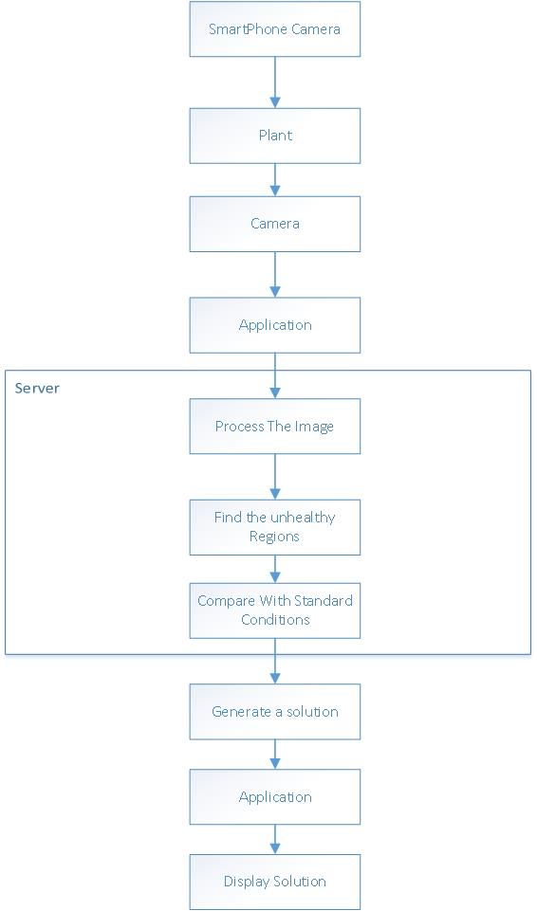

Figure 1: Block Diagram of proposed system

## 4.2 Development model

The development model that we are going to use is a Prototyping model. The Prototyping Model is a systems development method (SDM) in which a prototype (an early approximation of a final system or product) is built, tested, and then reworked as necessary until an acceptable prototype is finally achieved from which the complete system or product can now be developed. This model works best in scenarios where not all of the project requirements are known in detail ahead of time. It is an iterative, trial-and-error process that takes place between the developers and the users.

Quick Design

Building Prototype

Customer Evaluation

Refining Prototype

Requirement Gathering

Engineer Product

Requirement Gathering

Engineer Product

Figure 2: Prototype Model

# Chapter 5:IMPLEMENTATION PLAN

## 5.1 Schedule (Gantt chart)

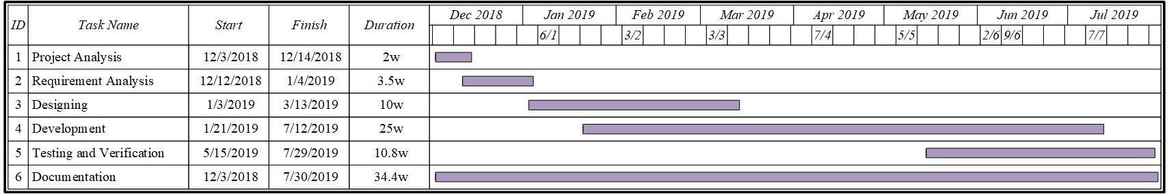

Figure 3:Gantt Chart

## 5.2 Software Requirements

* Android Studio
* MySql workbench
* Python
* JavaScript

# Chapter 6: Expected Outcomes

* Recognition of diseases in the plant.
* Recommendation of solution to the diseases by providing medicine and proper fertilizer to the plant.

# REFERENCES

[1] Savita N. Ghaiwat, Parul Arora “Detection and Classification of Plant Leaf Diseases Using Image processing Techniques: A Review”, International Journal of Recent Advances in Engineering & Technology, ISSN (Online): 2347 - 2812, Volume-2, Issue - 3, 2014

[2] S. Arivazhagan, R. Newlin Shebiah, S. Ananthi, S. Vishnu Varthini “Detection of unhealthy region of plant leaves and classification of plant leaf diseases using texture features” Agric Eng Int: CIGR Journal, 15(1): 211ˉ217 2013

[3] Prof Sanjay B. Dhaygude Mr. Nitin P. Kumbhar ”Agricultural plant Leaf Disease Detection Using Image Processing” International Journal of Advanced Research in Electrical Electronics and Instrumentation Engineering vol. 2 no. 1 January 2013.

[4] Smita Naikwadi, Niket Amoda” ADVANCES IN IMAGE PROCESSING FOR DETECTION OF PLANT DISEASES” , International Journal of Application or Innovation in Engineering & Management , Volume 2, Issue 11, November 2013

[5] Sanjay B. Patil et al. “LEAF DISEASE SEVERITY MEASUREMENT USING IMAGE PROCESSING”, International Journal of Engineering and Technology Vol.3 (5), 2011, 297-301

[6] B. Bhanu, J. Peng. “Adaptive integrated image segmentation and object recognition”, In IEEE Transactions on Systems, Man and Cy- bernetics, Part C, volume 30, pages 427–441, November 2000.