# ABSTRACT

Travelling is an integral part life. Every new itineraries incorporates new emotions from a traveller. People travel to relax and rejuvenate whereas sometimes to forget the past or to kill the recent mishaps or even sometimes to learn from a new realm. Travelling is requisite for living. Nevertheless, single travelling single or alone is an expensive endeavour. Passionate travellers with keen interests crave to congregate and desire to locomote together to explore the world which eventually furnishes more vigour during the travel and yield notable savings in their travel budget. This project ‘**Sahayaatri’** proposes a mobile application where a traveller is able to find the travellers with same sentiments and mentality like him or herself. Machine Learning based recommendation is to be used in this project which will be effectively suggesting the keen companions to a traveller to travel with. This Machine Learning powered project will be able to predict the next travelling destination based on the recent itineraries of that traveller. Backend of this web system is to be constructed with Java Spring MVC. MySQL will be the database to store the data generated by the travellers.

# TABLE OF CONTENTS

ABSTRACT i

TABLE OF CONTENTS ii

LIST OF FIGURES iii

Chapter 1: INTRODUCTION 1

1.1 Background 1

1.2 Problem Statement 2

1.3 Objectives 2

Chapter 2: LITERATURE REVIEW 3

Chapter 3: FEASIBILITY STUDY 5

3.1 Economic Feasibility: 5

3.2 Resource Feasibility: 5

3.3 Technical Feasibility: 5

Chapter 4: PROJECT METHODOLOGY 6

4.1 Block Diagram of proposed system 6

4.2 Development model 7

Chapter 5:IMPLEMENTATION PLAN 8

5.1 Schedule (Gantt chart) 8

5.2 Software Requirements 8

Chapter 6: Expected Outcomes 9

REFERENCES 10

# LIST OF FIGURES

Figure 1 Block Diagram……………..………………………………………….6

Figure 2 Development Model…………….………………………….…......……7

Figure 3 Gantt Chart…………………………………………………..….……...8

# Chapter 1: INTRODUCTION

## 1.1 Background

Amalgamation of Artificial Intelligence with the tourism industry can have colossal prospect. Unnoticed realm of the tourism sector are revealing due to the marvels of Artificial Intelligence. Tourism industry is contributing 10.4% to the world economy in 2018 and projected to grow to an estimated 3.6% average every year over the next decade (World Travel and Tourism Council, 2018). The number of tourists worldwide has increased rapidly. Over the same 10-year period, Southeast Asia is expected to be the fastest-growing region regarding travel and tourism’s contribution to a country’s or a region’s Gross Domestic Product (GDP). Nepal has huge possibilities of tourism development as we are rich in biodiversity, natural beauty, culture and hospitality.

With the boom in tourism over the last decade, information sources play an important role for tourists when making decisions and selecting destinations. The Internet is now considered to be the tourist’s main information source for information on products and services. However, the sheer volume of data on the Internet has made it difficult for tourists to process information, whether in pre-trip planning or when making choices during travel. The travel-planning problem is highly complex, time-consuming, and dynamic as there are many factors involved in the decision-making process. Some of the factors involved in travel-planning include travel budget, number of nights one intends to stay at a given destination, food quality, the number of individuals travelling, transport mode, leisure activities, weather etc.

Recently, tourism has benefited substantially from Information and Communications Technology (ICT), and especially from Internet technology and its applications. Decision support tools, also known as Recommendation Systems (RSs), have been developed to address these concerns. In the tourism field, they are referred to as Tourism Recommendation Systems (TRSs). Tourists and tourism providers can search, select, compare and make decisions almost instantly, and more efficiently than ever. Due to the enormous amount of heterogeneous information available on the Internet and through other information sources, TRSs can act as information filters. Selecting appropriate tourist services to match user preferences is one of the most complex tasks a tourist faces when planning a visit to an unfamiliar city. Even though search engines provide lists of tourism services, tourists are still overwhelmed with the information on offer. TRSs can be utilised extensively as a means of reducing information overload for tourists. Finding an appropriate group for the trip is also a major problem. TRS can be utilized to solve these issues also.

TRSs can help assist tourists to travel independently to an unfamiliar city, especially as regards searching, selecting and comparing tourism services. Not only can TRSs help travellers when planning their trip, but also during and after a trip, thanks to mobile and wireless communication. A well-developed TRS can suggest appropriate tourism services to tourists without interfering with their privacy and suggest other travel-related products to them.

## 1.2 Problem Statement

* Finding people who want to travel with the like-minded people is cumbersome.
* Some travel to relax and rejuvenate whereas some travel to forget the past or to escape some tragedy. However, searching people having same sentiments and emotions to travel with is strenuous.
* Getting a credible, secured and reliable mediator to create respective group is not possible.

## 

## 1.3 Objectives

* To create a web system that finds the travel companions for a traveller who is willing to travel with like-minded people as him/herself.
* To provide a mobile platform (app), based on recent activity of a traveller, which predicts the next destination that a traveller may travel and suggesting the complete itinerary to that specific user(traveller).
* To create a system where a traveller can easily find the Travel Agencies that deliver the same packages (destinations, days of stay, locomotion ways) in which a traveller(user) is interested.

# Chapter 2: LITERATURE REVIEW

Vijai Singh et.al proposed a new approach for classifying different plant leaf diseases. Image segmentation, which is an important aspect for disease detection in plant leaf disease, is done by using genetic algorithm. Image segmentation is the process of separating or grouping an image into different parts. Genetic algorithms belong to the evolutionary algorithms which generate solutions for optimization problems. The algorithm begins with a set of solutions called a population. Solutions from one population are chosen and then used to form a new population. This is done with the anticipation, that the new population will be enhanced than the old one. Using very less computational efforts the optimum results were obtained, which also shows the efficiency of Genetic algorithm in recognition and classification of the leaf diseases Another advantage of using this method is that the plant diseases can be identified at early stage or the initial stage. Also this type of classifier algorithm is less complex to understand and easy to implement [1].

Savita N. Ghaiwat and Parul Arora examined the different classiﬁcation techniques that can be used for plant leaf disease classiﬁcation. For given test example, k-nearest-neighbor (KNN) method is seems to be suitable as well as the simplest of all algorithms for class prediction. If the training data is not linearly separable, then it is difficult to determine optimal parameters in SVM, which appears as one of its drawbacks and SVM is more complex to understand and implement. The main disadvantage of KNN algorithm is that it is a slow learner and also it is not robust to noisy data [2].

S. Arivazhagan et.al proposed a software solution for automatic detection and classiﬁcation of plant leaf diseases. The proposed algorithms efficiency can successfully detect and classify the examined diseases with an accuracy of 94 percentages. Experimental results on a database of about 500 plant leaves conﬁrm the robustness of the proposed approach. The classification is first done using Minimum Distance Criterion (MDC). A comparative study on different species of plant leaves were done based on their disease detection accuracy [3].

The detection of agricultural plant Leaf diseases using Image Processing was proposed by Prof. Sanjay B. Dhaygude and Mr. Nitin P. Kumbhar. There are mainly four steps in developed processing scheme, out of which, ﬁrst one is, for the input RGB image, a color transformation structure is created, because this RGB is used for color generation and transformed or converted image to RGB, that is, HSI is used for color descriptor. In the second step, by using threshold value, green pixels are masked and removed. In the third, by using threshold level, removing of green pixels and masking is done for the useful segments that are extracted ﬁrst in this step, while the image is segmented. And in last or fourth main step the segmentation is done [4].

The Mrunalini R. Badnakhe and Prashant R. Deshmukh present the technique to classify and identify the different disease through which plants are affected. In Indian Economy a Machine learning based recognition system will proves to be very useful as it saves efforts, money and time too. The approach given in this for feature set extraction is the Color Co-occurrence Method. For automatic detection of diseases in leaves, neural networks are used. The approach proposed can significantly support an accurate detection of leaf, and seems to be important approach, in case of steam, and root diseases, putting fewer efforts in computation [5].

Anand H. Kulkarni et al. presents a methodology for early and accurately plant diseases detection, using artificial neural network (ANN) and diverse image processing techniques. As the proposed approach is based on ANN classifier for classification and Gabor filter for feature extraction, it gives better results with a recognition rate of up to 91%. An ANN based classifier classifies different plant diseases and uses the combination of textures, color and features to recognize those diseases [6].

# Chapter 3: FEASIBILITY STUDY

## 3.1 Economic Feasibility:

This project requires the online money payment system. From the technical grounds in Nepal, digital payment companies like Khalti and eSewa are such providers who have the price of quotations of Rs 25,000 and Rs 20,000 respectively to get their authenticated API token or simply to call their API’s from any web-app.

## 3.2 Resource Feasibility:

## It can be said that almost all people travel in some points of their life. Tourism Ministry of Nepal published the statistical report showing total of 9,40,218 tourists travelled to Nepal staying 12.6 days on average in 2017. It manifests that collecting a travellers data and their would-be companions data is feasible in our system.

## 3.3 Technical Feasibility:

Even major functionalities like web-scrapping and machine learning based recommendations can be developed to perfection with common technologies. The libraries, frameworks and the databases to be used in this project are open-sourced, whose entire features are free to use. Therefore this project is considered to be technically feasible.

# Chapter 4: PROJECT METHODOLOGY

## 4.1 Block Diagram of proposed system

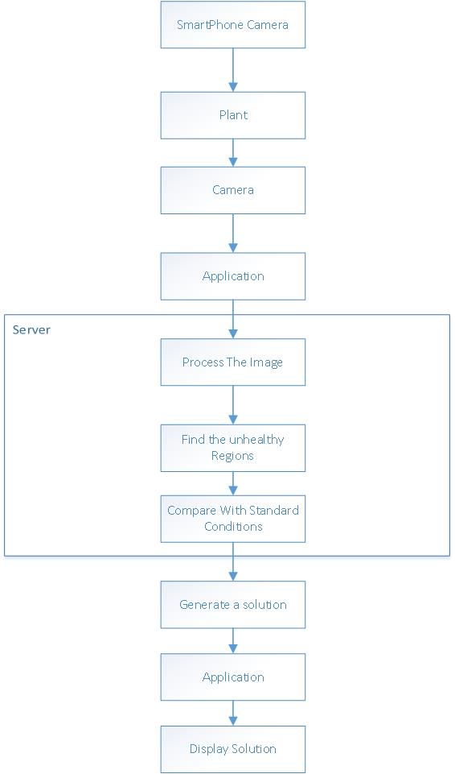

Figure 1: Block Diagram of proposed system

## 4.2 Development model

The development model that we are going to use is a Prototyping model. The Prototyping Model is a systems development method (SDM) in which a prototype (an early approximation of a final system or product) is built, tested, and then reworked as necessary until an acceptable prototype is finally achieved from which the complete system or product can now be developed. This model works best in scenarios where not all of the project requirements are known in detail ahead of time. It is an iterative, trial-and-error process that takes place between the developers and the users.

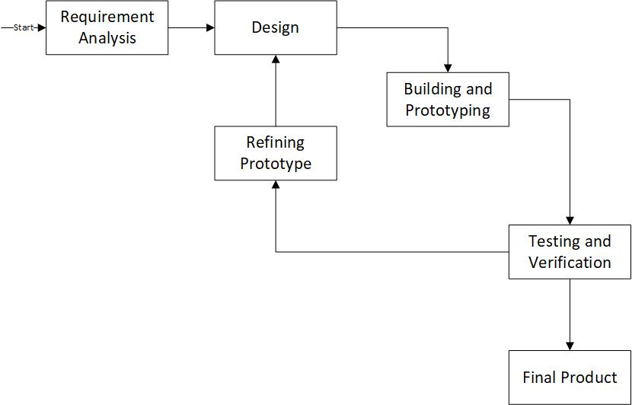

Figure 2: Prototype Model

# Chapter 5:IMPLEMENTATION PLAN

## 5.1 Schedule (Gantt chart)

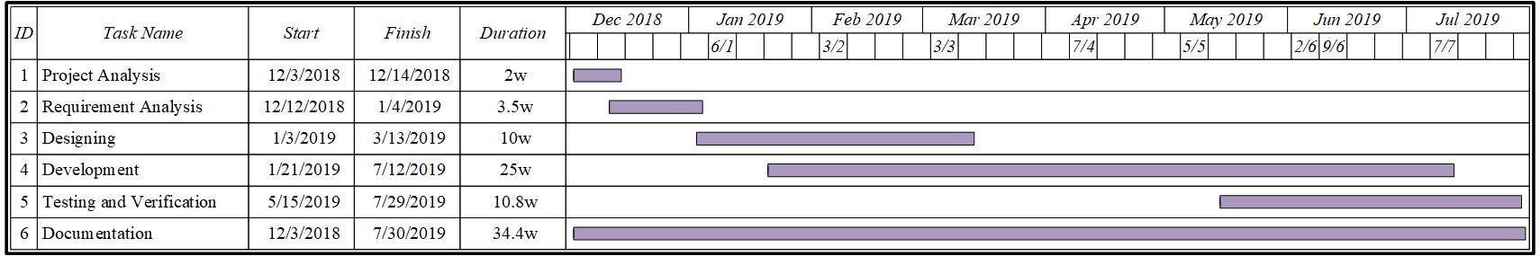

Figure 3:Gantt Chart

## 5.2 Software Requirements

* Java Spring
* MySql workbench
* Python
* JavaScript

# Chapter 6: Expected Outcomes

* Web system that finds the travel companions for a traveller who is willing to travel with like-minded people as him/herself.
* Based on recent activity of a traveller, which predicts the next destination that a traveller may travel and suggesting the complete itinerary to that specific user(traveller).
* A system where a traveller easily finds the Travel Agencies that deliver the same packages (destinations, days of stay, locomotion ways) in which a traveller(user) is interested.

# REFERENCES

[1] Savita N. Ghaiwat, Parul Arora “Detection and Classification of Plant Leaf Diseases Using Image processing Techniques: A Review”, International Journal of Recent Advances in Engineering & Technology, ISSN (Online): 2347 - 2812, Volume-2, Issue - 3, 2014

[2] S. Arivazhagan, R. Newlin Shebiah, S. Ananthi, S. Vishnu Varthini “Detection of unhealthy region of plant leaves and classification of plant leaf diseases using texture features” Agric Eng Int: CIGR Journal, 15(1): 211ˉ217 2013

[3] Prof Sanjay B. Dhaygude Mr. Nitin P. Kumbhar ”Agricultural plant Leaf Disease Detection Using Image Processing” International Journal of Advanced Research in Electrical Electronics and Instrumentation Engineering vol. 2 no. 1 January 2013.

[4] Smita Naikwadi, Niket Amoda” ADVANCES IN IMAGE PROCESSING FOR DETECTION OF PLANT DISEASES” , International Journal of Application or Innovation in Engineering & Management , Volume 2, Issue 11, November 2013

[5] Sanjay B. Patil et al. “LEAF DISEASE SEVERITY MEASUREMENT USING IMAGE PROCESSING”, International Journal of Engineering and Technology Vol.3 (5), 2011, 297-301

[6] B. Bhanu, J. Peng. “Adaptive integrated image segmentation and object recognition”, In IEEE Transactions on Systems, Man and Cy- bernetics, Part C, volume 30, pages 427–441, November 2000.