Part A

What will the following commands do?

1. echo "Hello, World!"

Answer - These Command will give output as “Hello, World!” to a user.

1. name="Productive"

Answer -

1. touch file.txt

Answer - These Command will create a file (file.txt)

1. ls –a

Answer - These command will list all the files

1. rm file.txt

Answer - It will remove the file.txt

1. cp file1.txt file2.txt

Answer - It will Copy the file1.txt in new file2.txt

1. mv file.txt /path/to/directory/

Answer - These command will move the file.txt to the another directory

1. chmod 755 script.sh

Answer - It will read and execute the file

1. grep "pattern" file.txt

Answer - It will show the pattern in file.txt

1. kill PID

Answer - These command is used to Kills single process at time with given PID

1. ls -l | grep ".txt"

Answer – These command pass the list of files in the current directory to grep which will remove all file names that have a .txt

1. cat file1.txt file2.txt | sort | uniq

Answer - These command combines the content of file1.txt and file2.txt sort the file records and uniq words will shown

1. s -l | grep "^d"

Answer - It will lists only directories in the current directory

1. chmod 644 file.txt

Answer - Gives the permission to owner to read and write file

1. echo $PATH

Answer - It will show current value of $PATH variable

Part B

Q1) ls is used to list files and directories in a directory.

Answer - True

Q2) mv is used to move files and directories.

Answer - True

Q3) cd is used to copy files and directories.

Answer - False

Q4) pwd stands for "print working directory" and displays the current directory.

Answer - True

Q5) grep is used to search for patterns in files.

Answer - True

Q6) chmod 755 file.txt gives read, write, and execute permissions to the owner, and read and execute permissions to group and others.

Answer - True

Q7) mkdir -p directory1/directory2 creates nested directories, creating directory2 inside directory1 if directory1 does not exist.

Answer - True

Q8) rm -rf file.txt deletes a file forcefully without confirmation.

Answer - True

Identify the Incorrect Commands:

1. chmodx is used to change file permissions.

2. cpy is used to copy files and directories.

3. mkfile is used to create a new file.

4. catx is used to concatenate files.

5. rn is used to rename files.

Answer - 3. mkfile is used to create a new file.

Part C

1. Write a shell script that prints "Hello, World!" to the terminal.

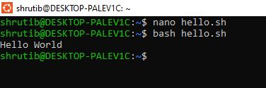

1. Declare a variable named "name" and assign the value "CDAC Mumbai" to it. Print the value of the variable.

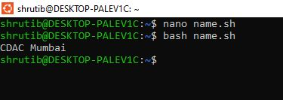

Q3) Write a shell script that takes a number as input from the user and prints it.

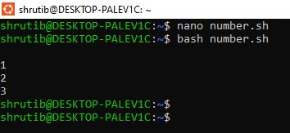

Q4) Write a shell script that performs addition of two numbers (e.g., 5 and 3) and prints the result.

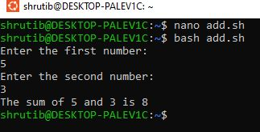

Q5) Write a shell script that takes a number as input and prints "Even" if it is even, otherwise prints"Odd”.

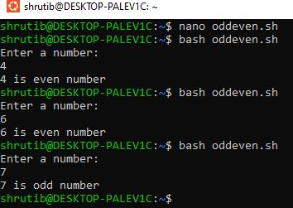

Q6) Write a shell script that uses a for loop to print numbers from 1 to 5.

