# SCTR’s Pune Institute of Computer Technology Dhankawadi, Pune

**A.Y. 2022-23**

# WADL MINI PROJECT REPORT ON

“Blood Donation Management System”

## Submitted By

Samarth Badadhe – 33209 Shubham Bangar – 33210 Tushar Bansod – 33211 Sarvadnyaa Barate – 33212

## Under the guidance of

Mrs. R. A. Karnavat



**DEPARTMENT OF INFORMATION TECHNOLOGY ACADEMIC YEAR 2022-23**

# ABSTRACT

This report outlines the development of a web-based platform designed to streamline blood donation management processes. Harnessing the capabilities of web technology, the platform serves as a central hub for organizing blood donation activities, promoting community engagement, and delivering essential information on donation procedures and eligibility criteria. Key functionalities include user authentication, interactive communication features like chat and comments, and educational materials to raise awareness about the significance of blood donation. Additionally, the platform facilitates the scheduling and coordination of donation drives, fostering seamless collaboration among donors, recipients, and healthcare institutions. By leveraging web technology, this initiative aims to address the complexities of blood donation management, ultimately contributing to improved healthcare services and life-saving outcomes.

## INTRODUCTION

Blood donation stands as a cornerstone of healthcare systems globally, providing critical support to patients in moments of medical need, be it emergencies, surgeries, or chronic conditions. Despite its paramount importance, blood donation management often grapples with logistical hurdles such as coordination complexities, low awareness, and infrastructural inadequacies. Addressing these challenges and optimizing the efficiency of blood donation processes necessitates the integration of web technology—a promising avenue for improvement.

Delving into the conceptualization and execution of a web-based platform aimed at revolutionizing blood donation management, our focus is on leveraging the capabilities inherent in web technology. The platform endeavours to centralize donation efforts, elevate community engagement, and disseminate easily accessible information pertaining to donation procedures and eligibility criteria. By incorporating interactive elements like user authentication, real-time communication avenues, and educational resources, the platform seeks to empower donors and recipients alike, cultivating a culture of informed and active involvement in blood donation endeavours.

Furthermore, serving as a facilitator for the scheduling and coordination of donation drives, the platform provides a streamlined mechanism for organizing and mobilizing blood donation initiatives. Through the strategic utilization of web technology, this initiative aspires to surmount barriers hindering blood donation, ultimately contributing to the enhancement of healthcare services and the preservation of countless lives.

## LITERATURE SURVEY

Red Cross Blood Donation Website Review: https:/[/www.redcrossblood.or](http://www.redcrossblood.org/)g[/](http://www.redcrossblood.org/)

The Red Cross Blood Donation website offers a user-friendly interface with clear navigation menus and intuitive layout, allowing users to easily access information about donation centers, upcoming drives, and eligibility criteria. Adopting a professional theme consistent with the Red Cross brand, the website utilizes cards and hyperlinks to organize content, providing users with additional resources such as blogs, magazines, and educational materials. However, the abundance of content and sections on the homepage may overwhelm users, and the interface appears somewhat crowded. Simplifying the layout and streamlining navigation could enhance user experience and engagement.

Eraktkosh Blood Donation Website Review: https:/[/www.eraktkosh.in/](http://www.eraktkosh.in/BLDAHIMS/bloodbank/transactions/bbpublicindex.html)B[LDAHIMS/bloodbank/transactions/bbpublicindex.html](http://www.eraktkosh.in/BLDAHIMS/bloodbank/transactions/bbpublicindex.html)

The Eraktkosh Blood Donation website presents users with a platform to engage in blood donation activities, featuring a unique theme and various functionalities. The website adopts a professional and functional theme, with a focus on usability and accessibility. The design is clean and minimalistic, allowing users to focus on essential information and actions related to blood donation. Eraktkosh integrates blogs and location-based features, providing users with relevant information and resources tailored to their geographical location. However, unnecessary animations may detract from overall user experience. Streamlining animations and focusing on functional elements could improve the user experience and performance.

Vitalant Blood Donation Website Review:

https:/[/www.vit](http://www.vitalant.org/)a[lant.org/](http://www.vitalant.org/)

The Vitalant Blood Donation website presents users with a comprehensive platform to engage in blood donation activities, featuring a themed design and a range of user-friendly functionalities. The website offers an easy-to-use interface that is both intuitive and friendly, with clear navigation menus and prominent call-to-action buttons guiding users through the donation process. Content is presented in a structured manner for easy consumption, with concise and informative text providing users with all the necessary information about blood donation procedures, eligibility criteria, and safety measures. Additionally, Vitalant provides information about support programs and initiatives aimed at donors, fostering a sense of community and appreciation for their contributions.

## WEB TECHNOLOGIES USED

### Frontend development

React, React-dom:

React is a popular JavaScript library for building user interfaces, while react-dom provides the necessary DOM-specific methods for rendering React components in the browser. These libraries form the foundation of the blood donation management project's frontend development, allowing for the creation of interactive and dynamic user interfaces. React's component-based architecture and declarative syntax simplify the development process and promote code reusability, while react-dom ensures efficient rendering of React components in the browser environment.

React-hot-toast, react-toastify:

These libraries are used for displaying toast notifications in the blood donation management project. react-hot-toast and react-toastify offer customizable and user-friendly notification components that provide feedback to users for actions such as successful form submissions, error messages, or important updates. Toast notifications enhance the user experience by providing timely and non-intrusive feedback, improving usability and accessibility across the platform.

React-player:

React-player is a React component for playing various media formats, including videos and audio files. In the blood donation management project, react-player is utilized to embed educational videos or promotional content related to blood donation within the platform. This library enables seamless playback of multimedia content directly within the application, enhancing user engagement and providing additional educational resources for users.

React-router-dom:

React-router-dom is a routing library for React applications, enabling navigation and rendering of different components based on the URL. In the blood donation management project, react-router-dom is used to implement client-side routing, allowing users to navigate between different pages and sections of the application without full-page reloads. This library enables the creation of a single-page application (SPA) architecture, improving performance and providing a smoother user experience.

### Backend development

Firebase:

Firebase is a powerful platform for building web and mobile applications, offering a suite of tools and services for backend infrastructure, data storage, authentication, and more. In the blood donation management project, Firebase is utilized for backend services such as user authentication, data storage, and real-time database functionality. It enables secure user authentication, stores user profiles and donation records, and facilitates real-time updates for chat functionality and donation scheduling.

### Features

Login and Signup:

Users can create accounts or log in to the platform to access personalized features, such as scheduling donations, participating in community discussions, and accessing their donation history.

Find Nearby Donor Centre:

The platform provides a feature to locate nearby donor centers or blood donation drives based on the user's location. Users can search for donation centers, view their details, and get directions to the nearest facility.

Blogs:

The platform hosts a collection of informative articles, news updates, and personal stories related to blood donation. Users can browse through the blog posts to stay informed about blood donation practices, success stories, and upcoming events.

Ability to Host Drive:

Organizations or individuals can host blood donation drives through the platform. They can create events, specify details such as location, date, and time, and invite participants to donate blood. This feature facilitates the organization and promotion of blood donation campaigns.

Check Blood Stock Availability:

Users can check the availability of different blood types at donor centers or blood banks in real-time. This feature provides transparency regarding blood supply levels and helps users make informed decisions about when and where to donate.

Community Posts and Comment Section:

Users can engage with the community through posts and comments on various topics related to blood donation. They can share their experiences, ask questions, or provide insights, fostering a supportive and interactive community within the platform.

Blood Types and Info about Complementary Blood Types:

The platform offers comprehensive information about different blood types and their compatibility. Users can learn about the characteristics of each blood type, understand compatibility with other types, and gain insights into the importance of matching blood types during transfusions.

### Integretion

Frontend and backend components are integrated through RESTful API endpoints, allowing frontend components to communicate with the backend server and retrieve or manipulate data as needed.

User authentication tokens may be used to authorize access to protected routes and resources on the backend. When a user logs in or signs up on the frontend, Firebase Authentication generates a token that is sent with subsequent requests to authenticate the user on the backend.

Real-time communication between frontend and backend components is facilitated through WebSocket technology or Firebase Realtime Database. This enables features such as real-time chat functionality, live updates on donation availability, and dynamic content rendering based on database changes.

## OUTPUT

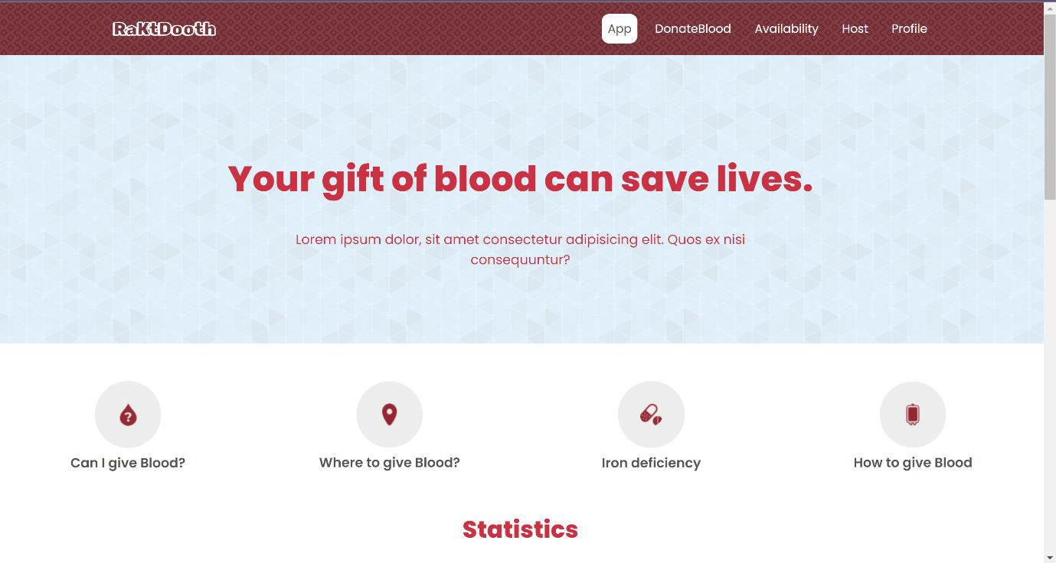

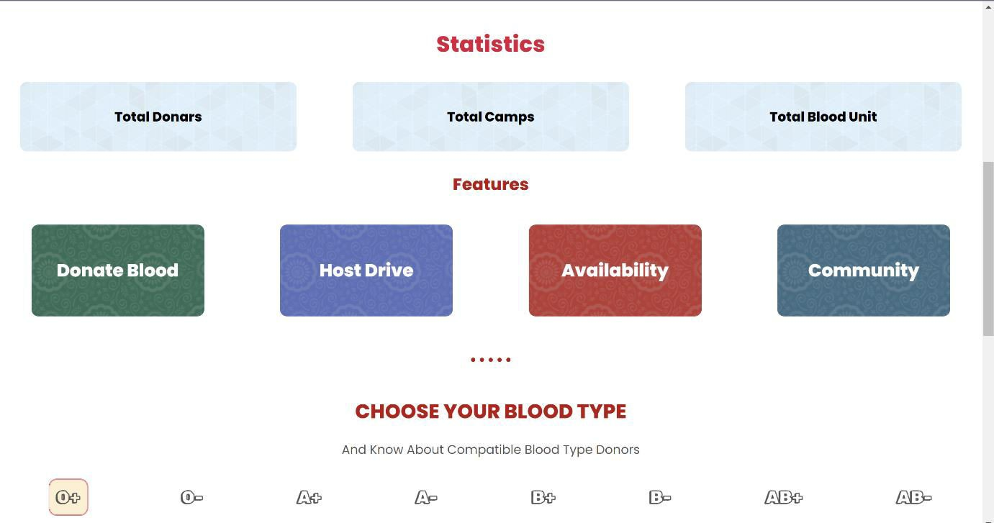

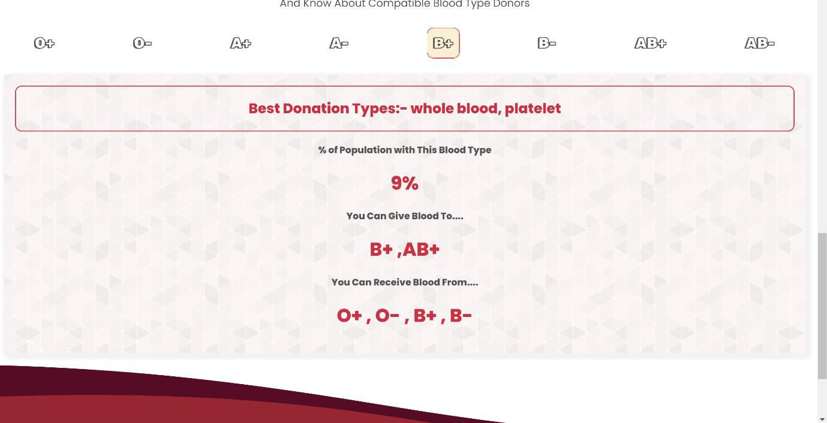

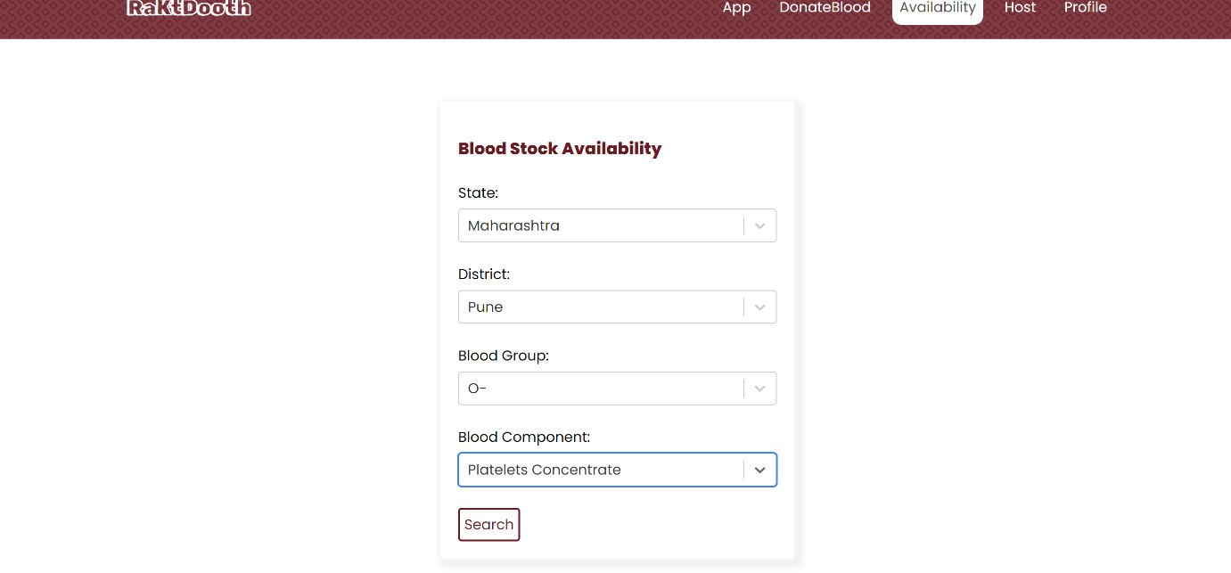

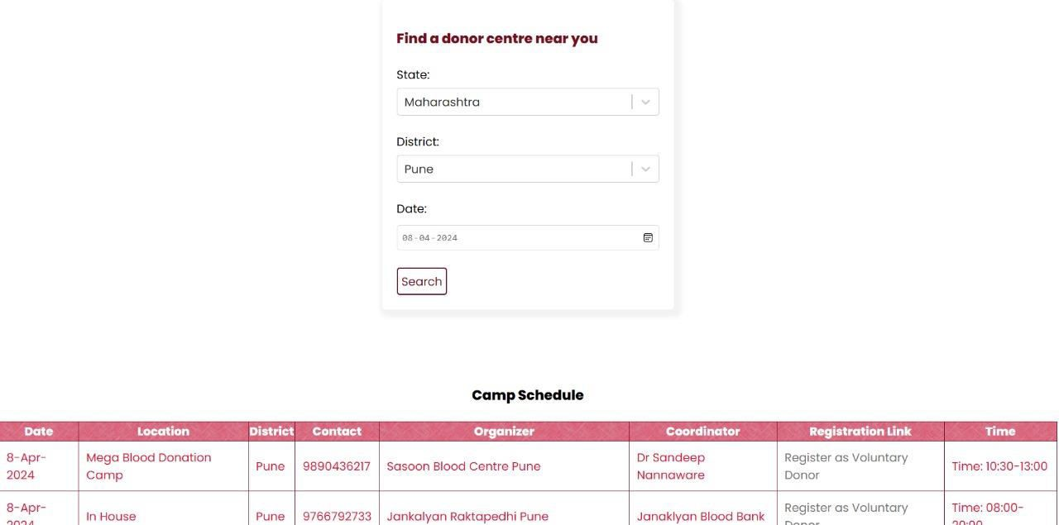

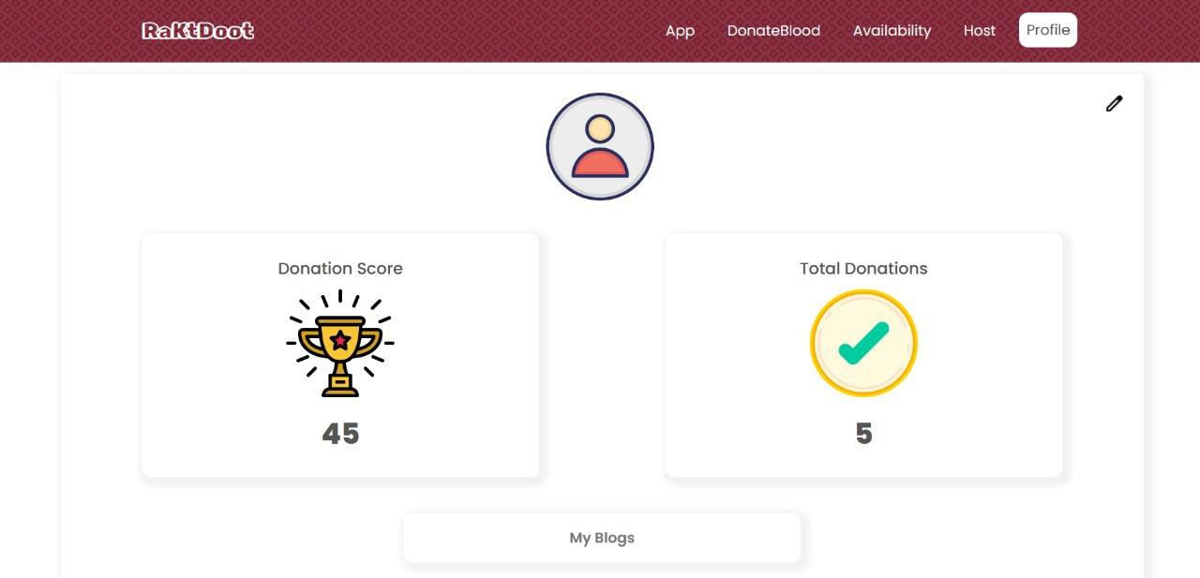

**CONCLUSION**

In conclusion, the development and implementation of the web-based blood donation management platform represent a significant step towards enhancing the efficiency and effectiveness of blood donation processes. Through the strategic integration of frontend and backend technologies, the platform offers a user-friendly interface, robust functionality, and seamless communication channels, empowering both donors and recipients to participate actively in blood donation initiatives.

The utilization of modern web technologies such as HTML5, CSS3, JavaScript, React.js, Node.js, Express.js, and MongoDB has enabled the creation of a dynamic and scalable platform capable of accommodating diverse user needs and organizational requirements. By centralizing donation efforts, elevating community engagement, and disseminating essential information on donation procedures and eligibility criteria, the platform serves as a valuable resource for promoting and facilitating blood donation activities.

As we look to the future, continued advancements in web technology, coupled with ongoing community engagement and awareness initiatives, hold the potential to further optimize blood donation management processes and expand access to life-saving blood products. By leveraging the capabilities of web technology and fostering a culture of altruism and solidarity, we can collectively contribute to the improvement of healthcare services and the preservation of countless lives through blood donation.

## REFERENCES

#### For literature survey

https:/[/www.redcrossblood.or](http://www.redcrossblood.org/)g[/](http://www.redcrossblood.org/) https:/[/www.eraktkosh.in/](http://www.eraktkosh.in/BLDAHIMS/bloodbank/transactions/bbpublicindex.html)B[LDAHIMS/bloodbank/transactions/bbpublicindex.html](http://www.eraktkosh.in/BLDAHIMS/bloodbank/transactions/bbpublicindex.html) <https://www.vitalant.org/>

#### For development

https://react.dev/

https://firebase.google.com/docs

https://restfulapi.net/