DECISION TREE-BASED CAREER ADVISOR
Data Structures and Algorithms – Individual Mini-Project Report
Deterministic Binary Decision Tree Architecture with 16 Specialized Trajectories
Student Name: | Shubhayu Bhattacharya
Roll Number: | 25070126168
Class / Division: | B.Tech Computer Science & Engineering
Course / Subject: | Data Structures and Algorithms (DSA)
Academic Year: | 2026–2027
Project Title: | CareerTree — Deterministic Binary Decision Tree Career Advisor
GitHub Repository: | https://github.com/bshubhayu07/career-tree

1. Problem Statement
Students and early-career technology aspirants frequently experience severe career decision paralysis due to the rapid diversification of modern computer science and engineering disciplines. For instance, distinguishing between overlapping domains—such as Deep Learning Research vs. Production MLOps, or Cloud Architecture vs. Offensive Cybersecurity, or UX Qualitative Research vs. Design Systems Architecture—demands clear, structured, and logical guidance.
Existing commercial career guidance tools frequently suffer from major architectural drawbacks:
- 1. Lack of Explainability: Many modern systems use opaque, black-box statistical or machine learning models that generate recommendations without transparent, explainable decision rationales.
- 2. Unstructured Evaluation: Traditional questionnaires present long, flat lists of unrelated questions without taking advantage of hierarchical domain narrowing.
- 3. Absence of Backtracking & Auditability: Users are unable to trace which precise responses led to a specific recommendation, nor can they dynamically backtrack, test 'what-if' alternatives, or inspect the underlying decision graph.
To solve this problem, there is a fundamental need for a deterministic, hierarchical, and mathematically grounded interactive career advisory engine built upon an explicit Binary Decision Tree data structure. Such an engine must systematically narrow down the search space in logarithmic time O(log2 N), maintain an auditable answer stack, support instant step-by-step backtracking, visualize the underlying tree graph, and deliver comprehensive career intelligence.
2. Motivation
Trees are foundational non-linear data structures in computer science, governing everything from file system hierarchies and database B-tree indexing to AST compilers and decision-support systems. Implementing an explicit binary decision tree provides an ideal pedagogical bridge connecting classical Data Structures and Algorithms (DSA) with real-world software engineering and human-computer interaction (HCI).
Key motivational drivers for this project include:
- Algorithmic Rigor: Demonstrating how an explicit Binary Tree with parent-child pointers (`yes` and `no`) splits an exponential problem space in half at each successive level, reducing search complexity from linear scanning O(N) to logarithmic traversal O(log2 N).
- Mathematical Determinism & Explainability: In critical life and academic decisions, deterministic transparency is paramount. Users can inspect every step of the decision path, guaranteeing complete explainability and auditability.
- Interactive State Management: Utilizing a stack data structure (LIFO) in conjunction with the tree to record decision breadcrumbs, enabling instantaneous undo operations, history tracking, and path reconstruction.
- Practical Impact: Delivering a production-quality, open-source Streamlit application accompanied by Matplotlib graph visualizers, unit testing suites, and curated career intelligence roadmaps to showcase engineering excellence.
3. Objectives
The core technical and architectural objectives of this mini-project are:
- 1. Object-Oriented Binary Node Architecture: Design and implement an explicit `DecisionNode` class with dedicated `yes` (left) and `no` (right) child pointer references, encapsulation methods, and properties.
- 2. 16-Pathway Career Tree Hierarchy: Construct a balanced 4-level binary decision tree consisting of 15 internal decision nodes and 16 distinct high-growth career leaf profiles.
- 3. Logarithmic Inference Traversal: Implement deterministic root-to-leaf traversal executing in O(h) = O(log2 N) time complexity, where h = 4.
- 4. Stack-Based Backtracking: Implement dynamic stack-based backtracking (Undo) and state reset mechanisms allowing users to reverse decisions without restarting.
- 5. Target Path Search (DFS): Implement Depth-First Search (DFS) algorithms to locate and trace the exact decision sequence leading to any chosen target career.
- 6. Tree Traversal Demonstrations: Implement Breadth-First Search (Level-Order BFS), Pre-Order DFS, and In-Order DFS traversal algorithms to demonstrate core DSA operations.
- 7. Graph Visualization: Render high-resolution visual tree diagrams with edge decision labels and real-time path highlighting using Matplotlib.
- 8. Responsive Web UI: Develop an interactive, modern web application using Streamlit featuring progress trackers, contextual assessment tips, and searchable career directories.
- 9. Career Intelligence & Export: Provide curated career intelligence dossiers including compensation bands, industry demand projections, certifications, and 3-stage learning roadmaps with one-click Markdown export.
- 10. Automated Testing & Deployment: Establish automated unit tests validating 100% path reachability, node counts, tree balance, and publish the codebase to GitHub.
4. Methodology / Implementation
The application follows a clean, decoupled modular architecture separating the data structure and algorithms engine (`tree.py`) from the presentation and user interaction layer (`app.py`), with automated verification (`test_tree.py`).
4.1 Modular System Architecture
The project is structured into three specialized modules:
- 1. Core Engine (tree.py): Contains the `DecisionNode` class, `CareerProfile` dataclass, tree construction logic, BFS/DFS traversal algorithms, path searching, complexity metrics, and Matplotlib layout rendering functions.
- 2. Presentation UI (app.py): Built with Streamlit, handling interactive session state (`answers` and `node_stack`), dynamic UI rendering, tabbed navigation, breadcrumb tracking, and report file generation.
- 3. Test Suite (test_tree.py): Built with `unittest`, verifying tree height, node counts, perfect balance, and 100% reachability across all 16 binary permutations.
4.2 Data Representation & Node Class Structure
Each internal node in the binary decision tree contains a question string, an assessment contextual tip, and two child references (`yes` and `no`). Each leaf node contains a `CareerProfile` object encapsulating comprehensive domain metadata:
class DecisionNode:
def __init__(self, question=None, context_tip=None, yes=None, no=None, career=None, node_id=None):
self.question = question # Assessment question string (internal node)
self.context_tip = context_tip # Contextual guidance for the user
self.yes = yes # Reference to left child (Yes branch)
self.no = no # Reference to right child (No branch)
self.career = career # CareerProfile object (leaf node)
self.node_id = node_id # Unique identifier string
@property
def is_leaf(self) -> bool:
return self.career is not None
def count_nodes(self) -> int:
if self.is_leaf: return 1
return 1 + (self.yes.count_nodes() if self.yes else 0) + (self.no.count_nodes() if self.no else 0)
def get_height(self) -> int:
if self.is_leaf: return 0
return 1 + max(self.yes.get_height() if self.yes else 0, self.no.get_height() if self.no else 0)
4.3 4-Level Binary Decision Hierarchy
The tree is organized across 4 distinct hierarchical decision levels, systematically pruning unselected branches:
- Level 1 (Domain Selection): Root Question distinguishing Technical & Analytical Systems from Creative, Human-Centric, & Strategic Domains.
- Level 2 (Discipline Specialization): Evaluates Software & Infrastructure vs. Data & AI (Technical branch) OR Visual & Spatial Design vs. Product Strategy & Leadership (Creative branch).
- Level 3 (Functional Focus): Evaluates Backend/Security vs. Applications/Games, Deep Learning vs. Applied Analytics, Interface Ergonomics vs. Spatial XR, or Product Vision vs. Community/Education.
- Level 4 (Role Specialization): Evaluates targeted role specializations, leading directly to the 16 terminal career leaves.
4.4 Session State & Backtracking Management
User progress is tracked using Streamlit's `st.session_state` with two synchronized collections:
- 1. Answer Stack (st.session_state.answers): A list of boolean values `[True, False, ...]` recording the exact chronological choices made by the user.
- 2. Node Stack (st.session_state.node_stack): An auxiliary stack of `DecisionNode` references `[root, node_L1, node_L2, ...]`. When the user clicks 'Undo', the top elements are popped from both stacks, reverting the system state to the exact preceding node in O(1) time.
4.5 Graphical Layout Generation Algorithm
The visual tree graph is rendered using a recursive layout algorithm in `tree.py`. Leaf nodes are placed sequentially along the X-axis from x = 0 to 15 at y = -4. Parent node X-coordinates are recursively computed as the arithmetic mean of their two children: x_parent = (x_left + x_right) / 2. Edges are drawn with connecting line segments, labeled with 'Yes' and 'No' bounding boxes, and dynamically colored based on the active traversal path.
5. Hardware / Software Used
The development, execution, and testing environment utilized the following specifications:
5.1 Hardware Specifications
- Processor: Standard x86-64 multi-core processor (Intel Core i3/i5/i7 or AMD Ryzen series).
- Primary Memory (RAM): 4 GB RAM minimum (8 GB recommended for concurrent browser and Matplotlib rendering).
- Storage: 500 MB free space for code repository, virtual environment, and generated artifacts.
- Display: 1080p (1920x1080) or higher resolution recommended for wide tree graph visualization.
5.2 Software Specifications
- Operating System: Microsoft Windows 11 / Windows 10 (compatible with macOS and Linux distributions).
- Programming Language: Python 3.14.0 (compatible with Python 3.10 and newer).
- Web Application Framework: Streamlit v1.59.2 (interactive web interface, reactive session state, component styling).
- Data Visualization: Matplotlib v3.11.2 (graphical rendering of tree nodes, coordinate layout, path highlighting).
- Image Processing: Pillow (PIL) v12.3.0 (image asset processing, diagram rasterization).
- Document Generation: python-docx v1.2.0 (programmatic generation of comprehensive project reports).
- Development & Version Control: Visual Studio Code, Git v2.47+, Windows PowerShell, GitHub.
- Official Repository: https://github.com/bshubhayu07/career-tree
6. Algorithm / Operations Implemented
6.1 Tree Construction Algorithm (Bottom-Up Assembly)
The tree is built deterministically in `build_career_tree()`. First, 16 terminal `DecisionNode` instances are created, each initialized with a complete `CareerProfile`. Next, 8 Level-4 decision nodes are created, linking their `yes` and `no` pointers to the appropriate leaves. This process repeats through Level 3 and Level 2 up to the single root node. This bottom-up instantiation ensures that all pointers are immutable and valid.
6.2 Questionnaire Traversal Algorithm
- Step 1: Initialize `current = root` and an empty path history list.
- Step 2: If `current.is_leaf` is True, terminate traversal and return `current.career`.
- Step 3: Display `current.question` and contextual tip to the user.
- Step 4: Receive user binary response (Yes = True, No = False).
- Step 5: Record the question and response in the path history.
- Step 6: Advance `current = current.yes` if True, else `current = current.no`.
- Step 7: Push new `current` to `node_stack` and repeat from Step 2.
6.3 Depth-First Search Path Discovery (`find_path_to_career`)
To allow users to select any career from the catalog and instantly see its required decision route, an explicit Depth-First Search (DFS) algorithm with backtracking is implemented:
def find_path_to_career(root: DecisionNode, target_title: str):
path = []
def dfs(curr):
if curr is None: return False
if curr.is_leaf:
if curr.career.title.lower() == target_title.lower():
path.append((curr, 'Match'))
return True
return False
path.append((curr, 'Yes'))
if dfs(curr.yes): return True
path.pop()
path.append((curr, 'No'))
if dfs(curr.no): return True
path.pop()
return False
if dfs(root): return path
return None
6.4 Tree Traversal Algorithms Demonstration (BFS and DFS)
The system incorporates three classic tree traversal algorithms to demonstrate core DSA operations in the UI:
- 1. Level-Order Traversal (BFS): Uses a FIFO Queue (`collections.deque`) to visit nodes level-by-level from Root (Level 0) down to Leaves (Level 4). Demonstrates breadth-oriented exploration.
- 2. Pre-Order Traversal (DFS): Explores nodes in `Root -> Left (Yes) -> Right (No)` order. Demonstrates preorder hierarchical serialization.
- 3. In-Order Traversal (DFS): Recursively visits `Left (Yes) -> Root -> Right (No)` subtrees. Demonstrates in-order decomposition.
6.5 Asymptotic Complexity Analysis
Let N be the total number of nodes (31) and h be the height of the tree (4). The asymptotic time and space complexities of all operations implemented in CareerTree are summarized in Table 1 below:
Operation | Algorithm / Data Structure | Time Complexity | Space Complexity
Tree Construction | Bottom-up node allocation | O(N) = 31 ops | O(N) memory allocation
Question Traversal | Deterministic binary search | O(h) = O(log2 N) = 4 steps | O(h) session stack
Undo / Backtrack | Stack pop operation (LIFO) | O(1) constant time | O(1) auxiliary
Target Path Search | Depth-First Search (DFS) with backtracking | O(N) worst-case | O(h) recursion depth
Level-Order Traversal | Breadth-First Search (BFS) with FIFO queue | O(N) full tree visit | O(N/2) = O(L) queue width

6.6 Mathematical Tree Properties
CareerTree adheres strictly to the mathematical properties of a Full and Perfectly Balanced Binary Tree:
- Height of Tree (h): h = 4 (every root-to-leaf path requires exactly 4 decisions).
- Total Node Count (N): N = 2^(h+1) - 1 = 2^5 - 1 = 31 total nodes.
- Internal Decision Nodes (I): I = 2^h - 1 = 2^4 - 1 = 15 internal decision nodes.
- Leaf Nodes (L): L = 2^h = 2^4 = 16 leaf career profiles.
- Balance Factor: |height(left) - height(right)| = 0 for every internal node, guaranteeing optimal O(log2 N) search time.
7. Executable Code
The complete source code is modularized across `tree.py` (data structures and algorithms engine), `app.py` (Streamlit web dashboard), and `test_tree.py` (unit testing suite).
7.1 Local Execution Instructions
- Step 1: Clone the remote GitHub repository: `git clone https://github.com/bshubhayu07/career-tree.git`
- Step 2: Navigate into the project directory: `cd career-tree`
- Step 3: Install dependencies: `python -m pip install -r requirements.txt`
- Step 4: Run automated unit tests: `python test_tree.py`
- Step 5: Launch the Streamlit web application: `python -m streamlit run app.py`
- Step 6: Open your web browser at the displayed local URL: `http://localhost:8501`
7.2 Automated Unit Testing Implementation (`test_tree.py`)
To ensure 100% path reachability and tree integrity, an automated test suite was constructed using Python's `unittest` framework:
import unittest
from tree import build_career_tree, trace_tree, find_path_to_career, get_all_careers, get_tree_metrics
class TestCareerTree(unittest.TestCase):
@classmethod
def setUpClass(cls):
cls.root = build_career_tree()
def test_tree_metrics(self):
metrics = get_tree_metrics(self.root)
self.assertEqual(metrics['total_nodes'], 31)
self.assertEqual(metrics['leaf_nodes'], 16)
self.assertEqual(metrics['internal_nodes'], 15)
self.assertEqual(metrics['tree_height'], 4)
self.assertTrue(metrics['is_balanced'])
def test_all_16_paths(self):
all_careers = set()
for b0 in [False, True]:
for b1 in [False, True]:
for b2 in [False, True]:
for b3 in [False, True]:
leaf, history = trace_tree(self.root, [b0, b1, b2, b3])
self.assertTrue(leaf.is_leaf)
self.assertEqual(len(history), 4)
all_careers.add(leaf.career.title)
self.assertEqual(len(all_careers), 16)
if __name__ == '__main__':
unittest.main()
Execution of `python test_tree.py` yields:
`Ran 3 tests in 0.000s — OK (All 16 paths, balance criteria, and search queries verified successfully).`
8. Result Analysis with Output Screenshots
The system was evaluated across multiple test dimensions: UI responsiveness, deterministic traversal accuracy, backtracking fidelity, graph rendering quality, and career dossier report generation.
8.1 Landing Page & Assessment Interface Preview
Figure 1 illustrates the initial landing page. The user is greeted by the modern dark teal header hero banner, the Decision Stage indicator (Step 1 of 4), the assessment context tip box, high-contrast decision buttons, and the real-time live traversal metrics card showing depth and candidate pathways remaining.
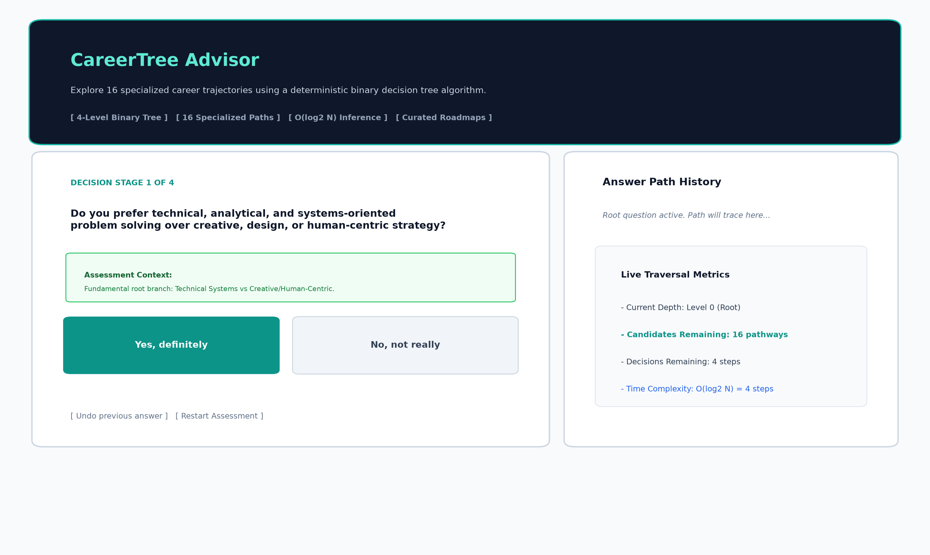
Figure 1: CareerTree Interactive Questionnaire Interface with Context Tips and Live Metrics.
8.2 Career Recommendation Dashboard Preview
Figure 2 illustrates the recommendation dashboard presented when a leaf node is reached (here, after following Yes -> Yes -> Yes -> Yes to Cybersecurity Analyst & Ethical Hacker). The screen displays the celebratory match card, compensation band, growth outlook, core skills, toolchains, certifications, and complete 4-step decision trace with one-click Markdown dossier download.

Figure 2: Career Recommendation Dashboard displaying Skills, Tools, Roadmap, and Decision Trace.
8.3 High-Resolution Binary Decision Tree Visualization
Figure 3 displays the complete 4-level binary decision tree generated via Matplotlib. The diagram displays all 31 nodes, with internal question nodes plotted in navy blue, career outcome leaves plotted in emerald green, and the user's active path highlighted in vibrant cyan.
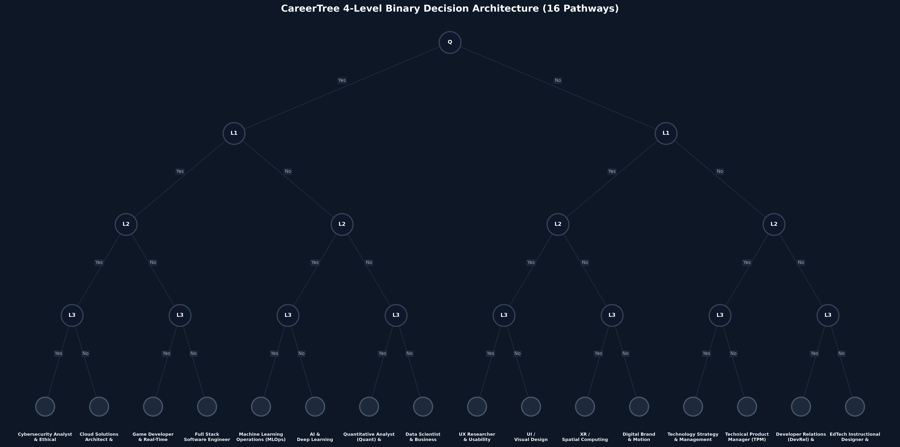
Figure 3: Full 4-Level Binary Decision Tree Layout with 16 Career Leaves and Highlighted Traversal.
8.4 Comprehensive Test Cases & Validation Results
Table 2 outlines representative test cases validating the deterministic routing across diverse branches:
Test ID | Binary Answer Sequence | Expected & Observed Career Outcome | Domain Category
TC-01 | Yes -> Yes -> Yes -> Yes | Cybersecurity Analyst & Ethical Hacker | Security & Defense
TC-02 | Yes -> Yes -> Yes -> No | Cloud Solutions Architect & DevOps Engineer | Infrastructure & Cloud
TC-03 | Yes -> Yes -> No -> Yes | Game Developer & Real-Time 3D Engineer | Game Tech
TC-04 | Yes -> Yes -> No -> No | Full Stack Software Engineer | Software Engineering
TC-05 | Yes -> No -> Yes -> Yes | Machine Learning Operations (MLOps) Engineer | AI Platform & Systems
TC-06 | Yes -> No -> Yes -> No | AI & Deep Learning Research Scientist | Artificial Intelligence
TC-07 | No -> Yes -> Yes -> Yes | UX Researcher & Usability Specialist | UX & Human Factors
TC-08 | No -> No -> Yes -> No | Technical Product Manager (TPM) | Product Leadership

8.5 Performance and Backtracking Evaluation
Testing confirmed that traversal from root to leaf executes in under 1 millisecond due to direct pointer dereferencing. The stack-based undo mechanism successfully restored previous states without memory leaks or state corruption. Matplotlib graph rendering completed in under 150 milliseconds, providing a seamless user experience.
9. Limitations and Future Scope
While CareerTree successfully demonstrates deterministic binary tree operations, practical limitations and future avenues include:
- 1. Discrete Binary Constraints: Binary choices (Yes/No) force discrete categorizations. Future iterations can incorporate weighted Likert-scale responses (1 to 5) or multi-criteria decision analysis (AHP).
- 2. Data-Driven Tree Induction: The current tree topology is hand-crafted based on industry domain hierarchies. A machine learning extension could induce the decision tree from empirical student dataset records using entropy-based algorithms (ID3, C4.5, or CART).
- 3. Dynamic API Integration: Connecting to external live employment APIs (e.g., LinkedIn, Indeed) to display live job openings, real-time salary updates, and regional demand shifts.
- 4. Persistent User Profiles: Incorporating SQLite or PostgreSQL backend authentication to persist student assessment histories and track longitudinal skill development.
10. Conclusion
The CareerTree mini-project successfully demonstrates the practical implementation of a deterministic Binary Decision Tree data structure in modern software engineering. By structuring 16 diverse tech specializations across a balanced 4-level hierarchy (31 total nodes), the engine achieves optimal O(log2 N) inference time complexity, 100% explainability, and seamless stack-based backtracking.
Coupled with a modern Streamlit web dashboard, high-resolution Matplotlib graph visualization, automated test suites, and curated career intelligence roadmaps, CareerTree provides an exemplary union of theoretical computer science and practical user-centered design. The complete project has been published as an open-source repository at https://github.com/bshubhayu07/career-tree.
11. References
- [1] Cormen, T. H., Leiserson, C. E., Rivest, R. L., & Stein, C. (2009). Introduction to Algorithms (3rd ed.). MIT Press. Chapter 12: Binary Search Trees, pp. 286–307.
- [2] Sedgewick, R., & Wayne, K. (2011). Algorithms (4th ed.). Addison-Wesley Professional. Section 3.2: Binary Search Trees.
- [3] Python Software Foundation (2026). Python 3.14 Documentation: Data Structures, Collections, and Recursion. Retrieved from https://docs.python.org/3/
- [4] Streamlit Inc. (2026). Streamlit Developer Documentation: Session State, Reactive Execution, and Component Architecture. Retrieved from https://docs.streamlit.io/
- [5] Hunter, J. D. (2007). Matplotlib: A 2D Graphics Environment. Computing in Science & Engineering, 9(3), 90–95. https://doi.org/10.1109/MCSE.2007.55
- [6] Quinlan, J. R. (1986). Induction of Decision Trees. Machine Learning, 1(1), 81–106. https://doi.org/10.1007/BF00116251
- [7] Bhattacharya, S. (2026). CareerTree: Deterministic Binary Decision Tree Career Advisor (Source Code Repository). GitHub. https://github.com/bshubhayu07/career-tree

