**Share Your Moral Views and Compare with Other People's Views**

Before diving in, feel free to enjoy the brief video below to inform next steps.

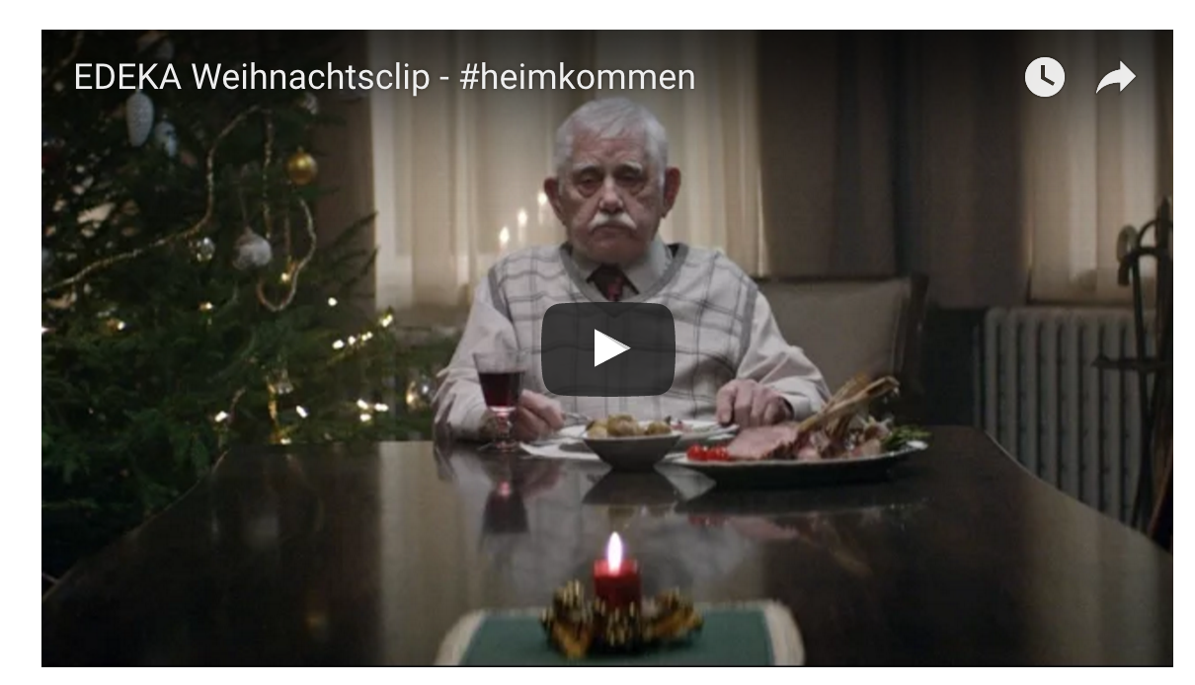

Now feel free to take our anonymous, 3-minute survey. Your responses will dynamically update data visualizations below.

You can find your similarities and/or differences with not only recent respondents of our survey but respondents to other relevant surveys, which are incorporated in data visualizations below.

* [Duke University's "Measuring Morality" survey conducted by GfK](http://kenan.ethics.duke.edu/attitudes/resources/measuring-morality/GfK)
* [Pew Research Center's "Global Restrictions on Religion Data” survey](http://www.thearda.com/Archive/Files/Descriptions/GRELREST.asp)

**Go to survey**

**Thank you for participating!** Your anonymous responses dynamically updated the data visualizations below!

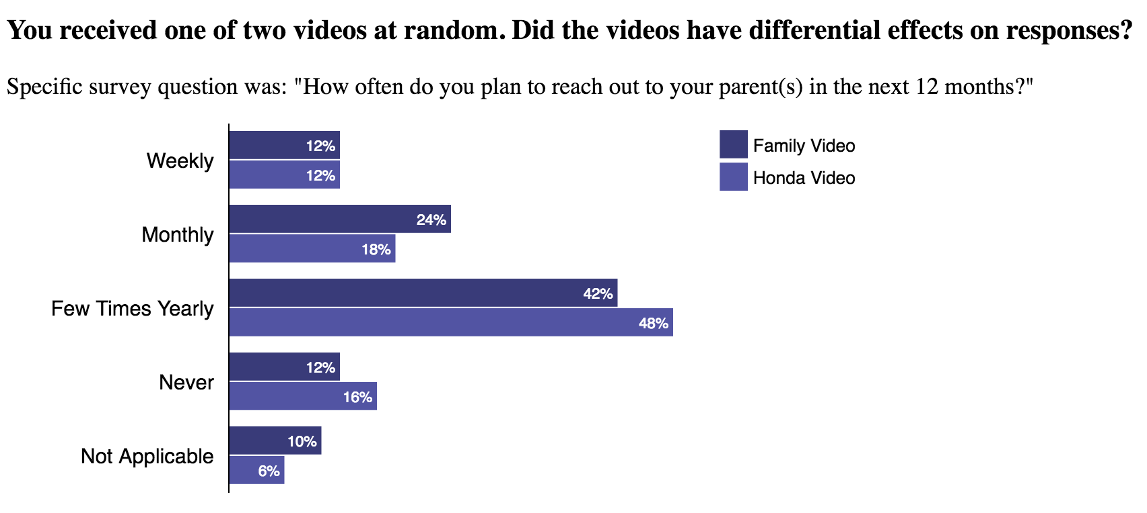

Compare your agreement/disagreement with other people in your state and other states. The interactive data incorporates respondent data from Duke University’s “Measuring Morality” survey, too.

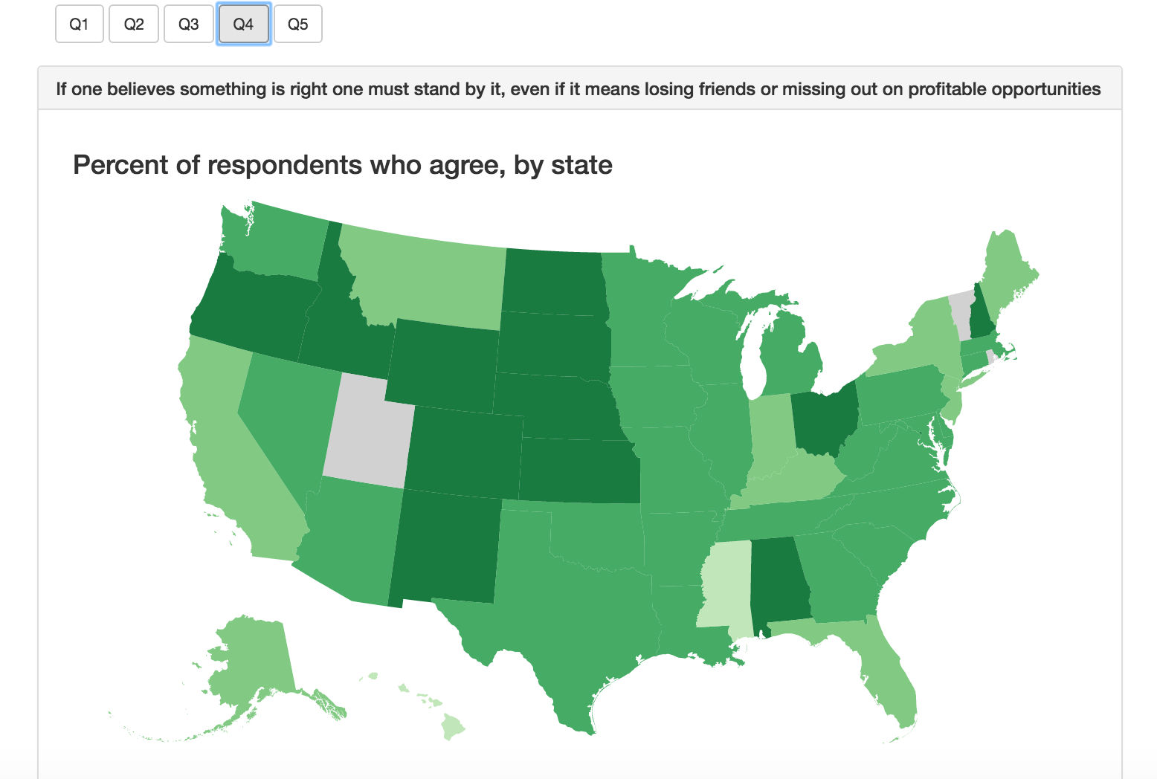

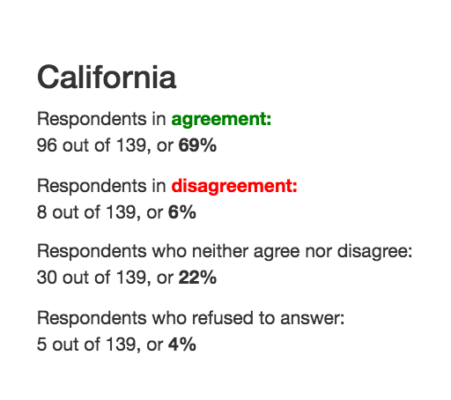

Drill down further to see whether regional patterns exist, by interactively selecting different demographics of interest.

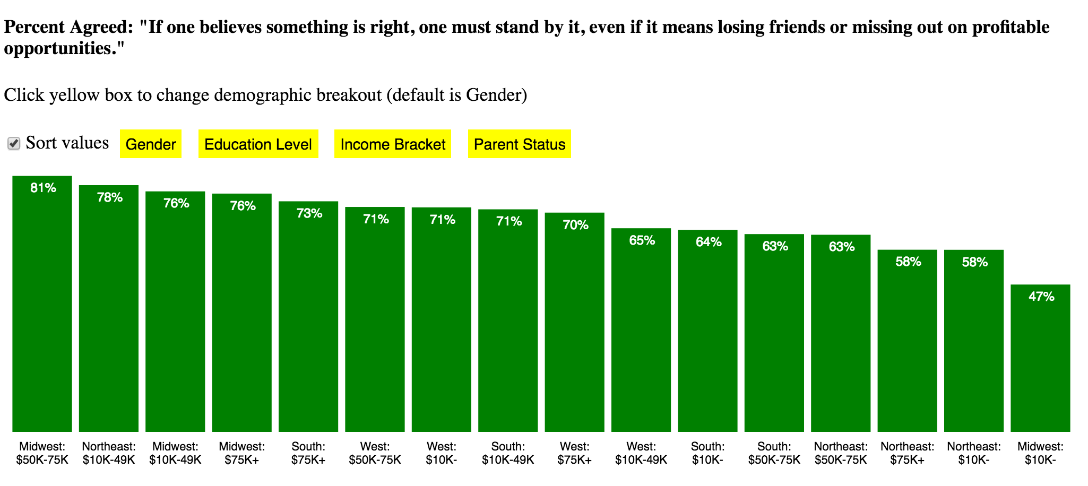

How can each of us improve interpersonal relations among people close to us and elevate harmony in the broader world?

* To jumpstart the effort, the data visualizations below are derived from a respondent data of [Pew Research Center's "Global Restrictions on Religion Data” survey](http://www.thearda.com/Archive/Files/Descriptions/GRELREST.asp), and reveal some trends on violence in the world over the past 9 years.

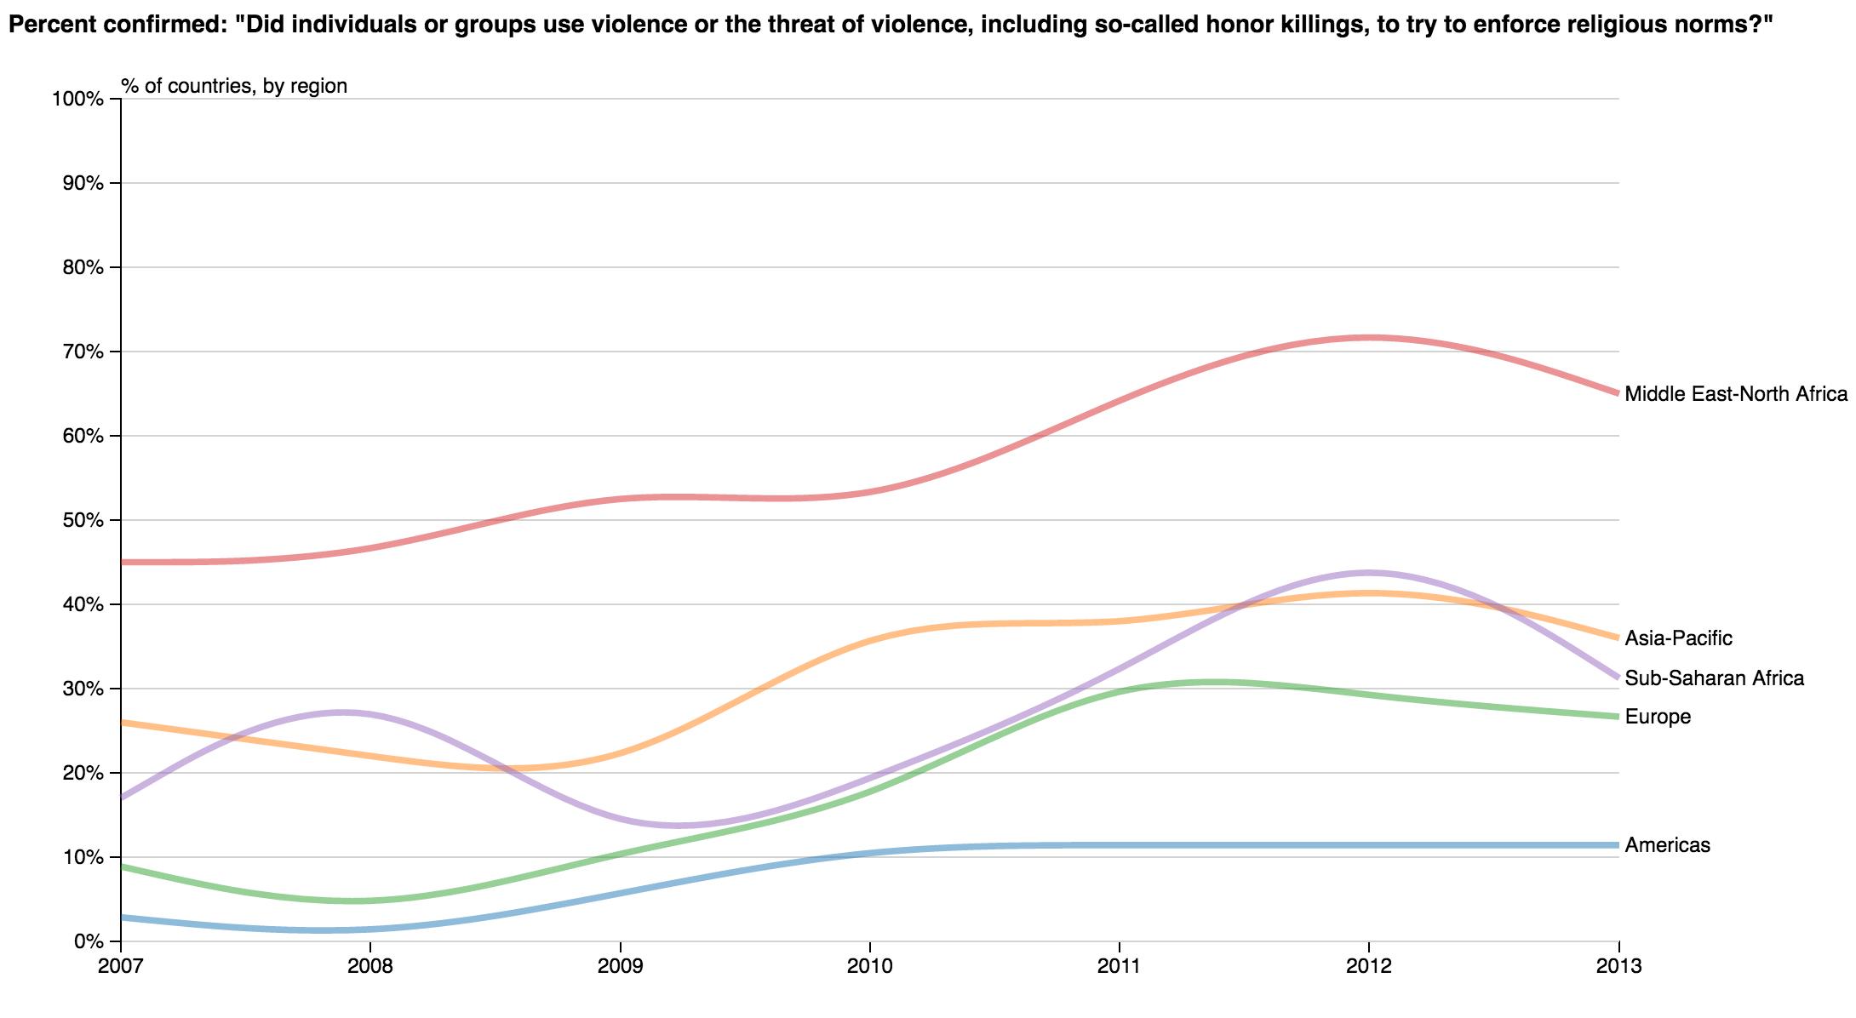

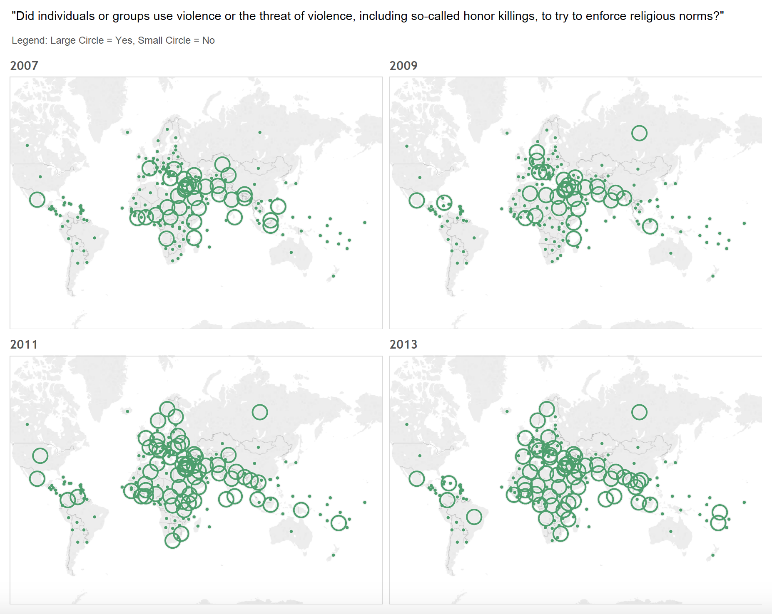

Hopefully, these visualizations have engaged reflection on your moral views and/or others’ views, and will support better relationships in society. Thank you again for visiting! Now let’s improve the world collectively!