# TOPICS :- CHARITY MANAGEMENT SYSTEM

## ER-DIAGRAM

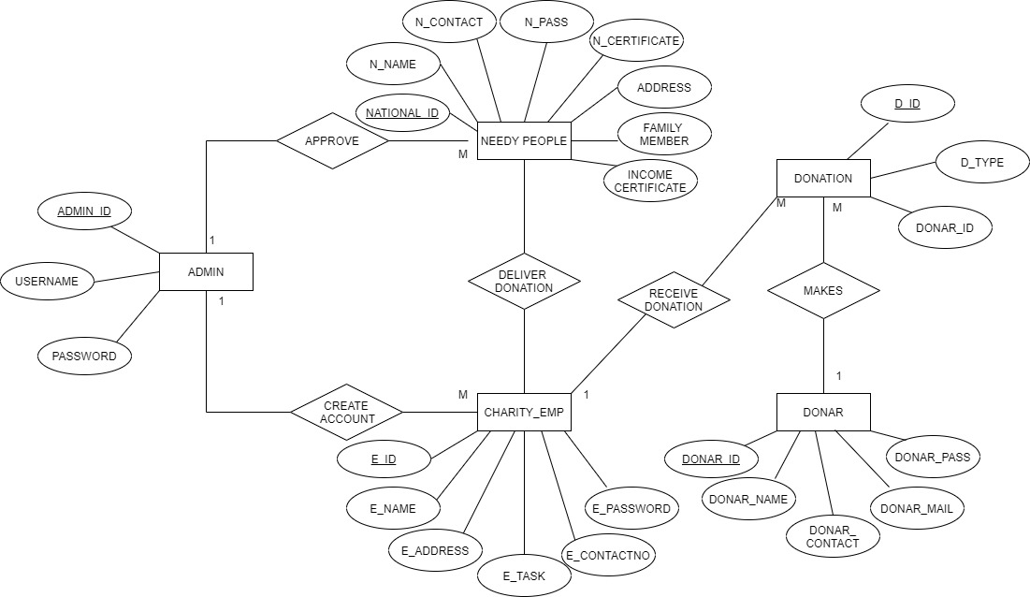

## DFD DIAGRAM

