For my final project I plan to create an application for the card game “Dominion.” There will be a class to hold the frame in which the game is played, with buttons for each card that can be bought by a player. The current player’s hand will appear at the bottom of the screen as buttons. Those buttons can be pressed to perform their action and a player can press the buttons on the board to buy them. There will be a player class, that contains the players name, deck, and current hand. A card class, holding the cards attributes, such as its action, cost, and value (for spending). There will be interfaces for each type of card, Action, Treasure, and Victory.

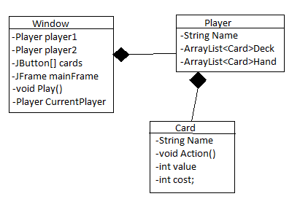UML:

Use cases:

|  |  |
| --- | --- |
| User Action | System Response |
| Program opens |  |
|  | Displays frame with game board and a start button |
| User clicks start |  |
|  | Dialog opens prompting user for player’s name |
| User enters names |  |
|  | Names are entered, first player’s hand is displayed |
| Players clicks a card on the board |  |
|  | Card is added to deck if players is capable of buying it |
| Player clicks card |  |
|  | Card’s action is played if capable |
| Player ends turn |  |
|  | Current player is switched to other player and their hand is displayed |
| Last province is bought |  |
|  | Game ends |