Thyroid Cancer Recurrence Prediction
Problem statement:
To predict the recurrence of thyroid cancer. This prediction can help in taking necessary precautions and proactive steps to prevent thyroid cancer from recurring among cancer survivors.
Dataset:
The Differentiated Thyroid cancer dataset has 17 columns and 383 rows.
Source:
https://www.kaggle.com/datasets/shamimhasan8/differentiated-thyroid-cancer-recurrence-dataset
Columns:
Age
Gender
Smoking
HxSmoking
HxRadiotherapy
Thyroid function
Physical Examination
Adenopathy
Pathology
Focality
Risk
T
N
M
Stage
Response
Recurred
Data Preprocessing:
The dataset doesn’t have missing values or outliers. Cleaned the format to maintain a uniform format throughout all the values. This cleaned dataset is used for further analysis and model creation. Except Age all other columns are categorical features.
Univariate & Bivariate analysis:
As age is the only numerical feature and all other variables are categorical variables, Univariate analysis is done for Age column.
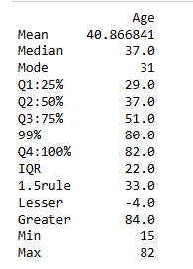
The correlation Matrix is as below. 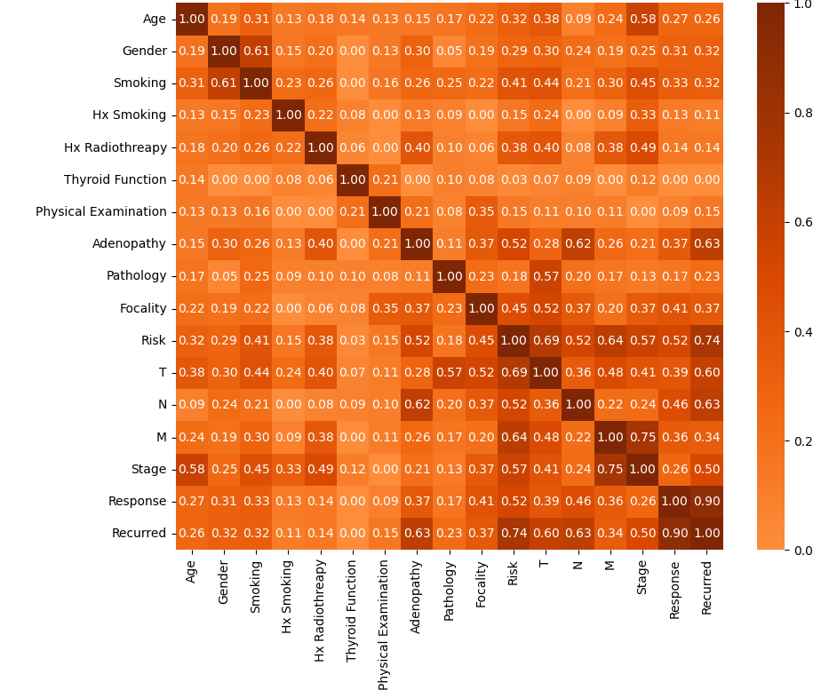
The features like Adenopathy,Risk,T,N, Stage and Response have correlation coefficient more than 0.5. A Tableau dashboard is created to view the impact of these features on recurrence of thyroid cancer.
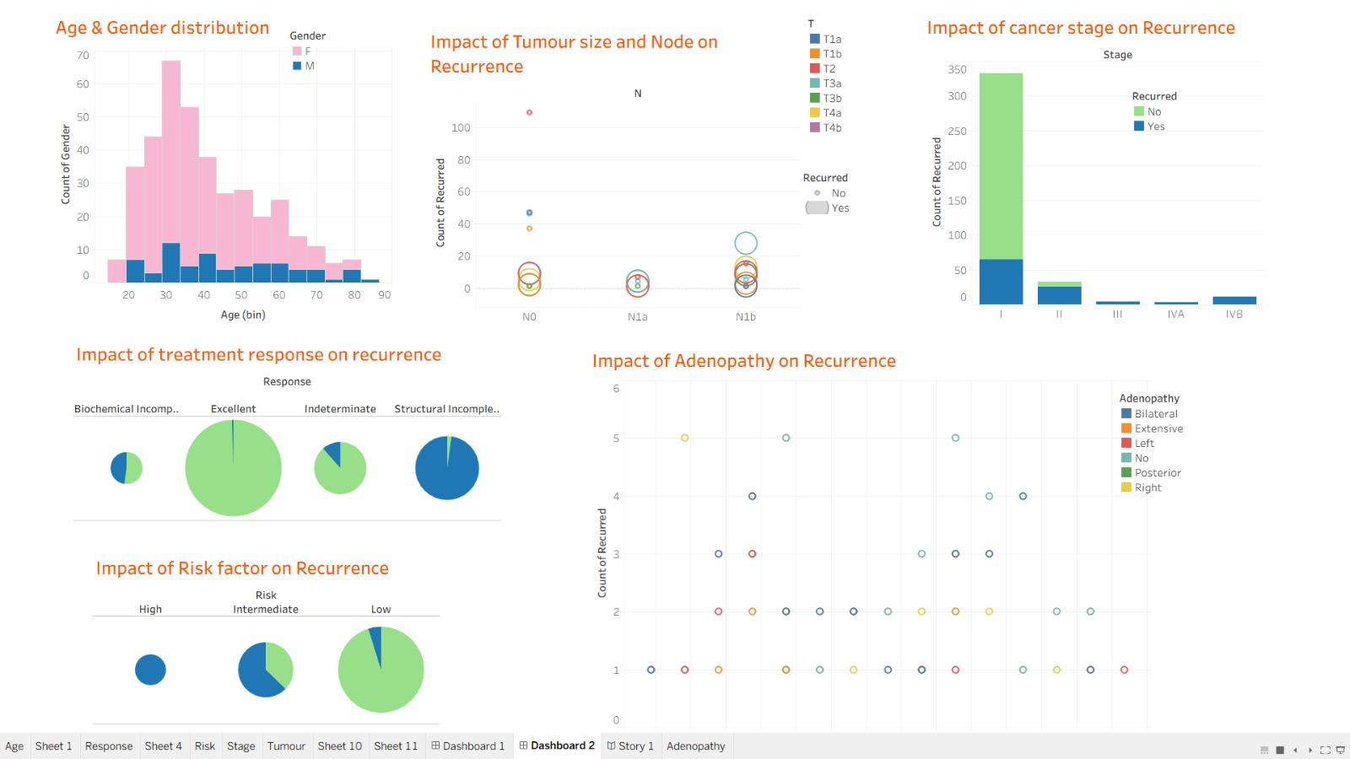

Feature Selection
SelectKbest algorithm has been used to select the important features for prediction model. The getdummies() method is used for one hot encoding. Below are the results for number of features varying from 1 to 10. The best Chi square value is 95.8% when number of features is 5 and Logistic regression is used.
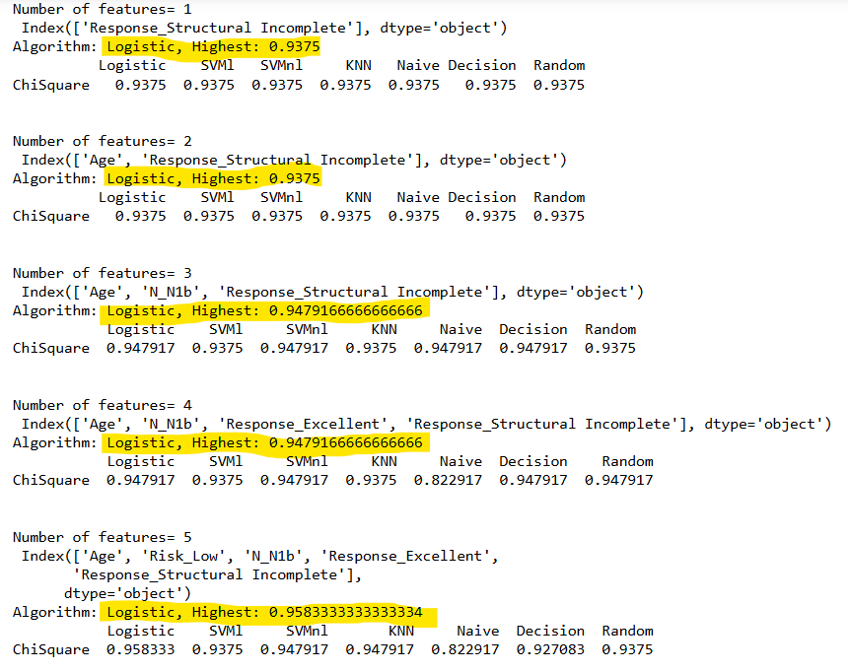
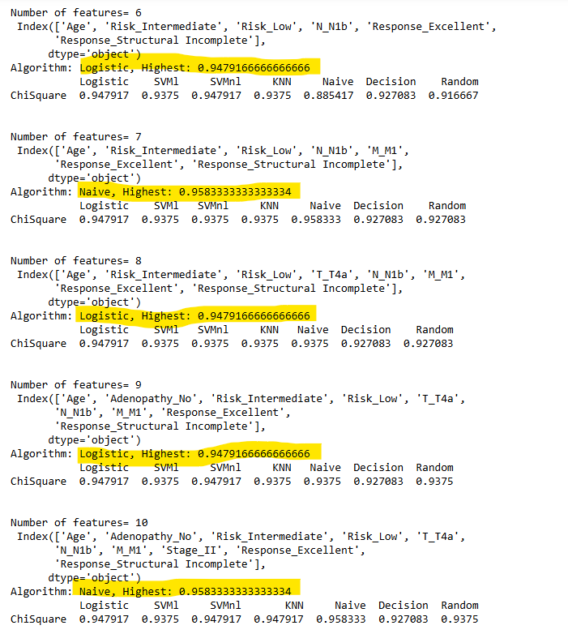
Model Creation
While creating the model using Logistic Regression and hyperparameter tuning method, it came out that using 6 parameters gives better accuracy than using 5 parameters.
When the features are 'Age', 'Risk_Intermediate', 'Risk_Low', 'N_N1b', 'Response_Excellent', 'Response_Structural Incomplete', The accuracy is 97%.
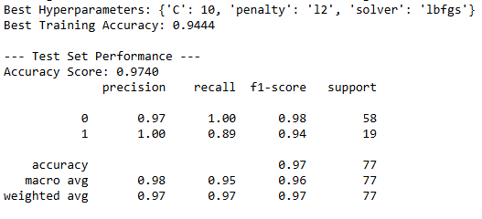
When the features are 'Age', 'Risk_Low', 'N_N1b', 'Response_Excellent', 'Response_Structural Incomplete', the accuracy is 95%.
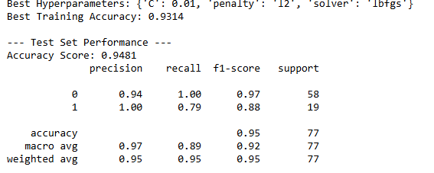
So, the final model is created using 6 features.

