1. Predict insurance charges based on the given dataset.
2. Dataset

Variables: Age, Sex, BMI, Children, Smoker, Charges

Number of records: 1338

1. Sex and Smoker are nominal data variables. Getdummies method can be used to convert them to numeric value.
2. Random Forest algorithm gives the best score as 0.867
3. A. MLR

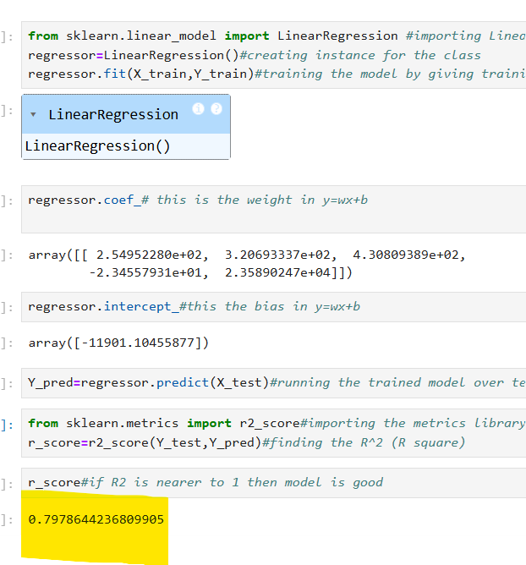

B. SVM

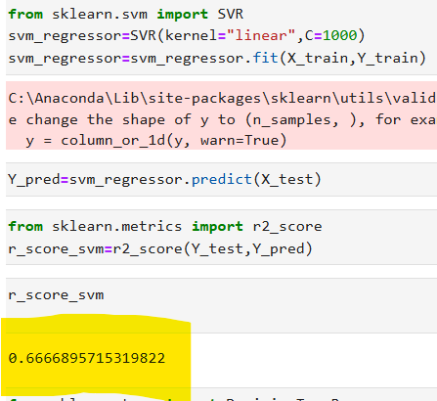

C. Decision Tree

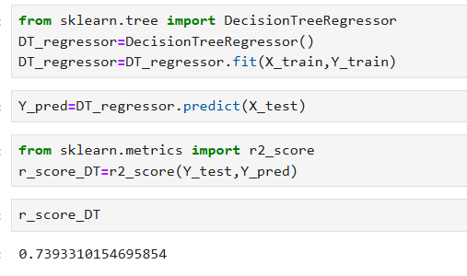

D. Random Forest

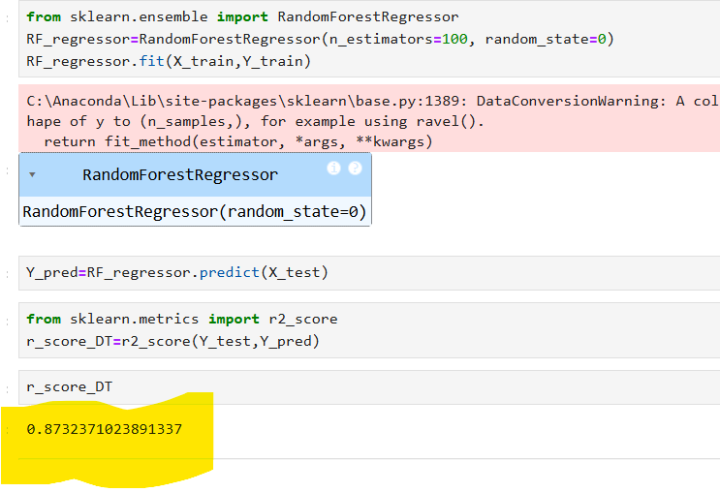

1. Random Forest method is chosen because it gives 87.3% accuracy in prediction.