- To predict Chronic Kidney Disease which may help in preventing the disease or start early treatment
- 25 columns and 399 rows.
- Columns 'rbc', 'pc', 'pcc', 'ba', 'htn', 'dm', 'cad', 'appet', 'pe', 'ane', 'classification' are nominal data. Getdummies function is used to convert them to numeric values.
- Random forest model with Grid search option was tried
- A)
Test size:30% Random forest

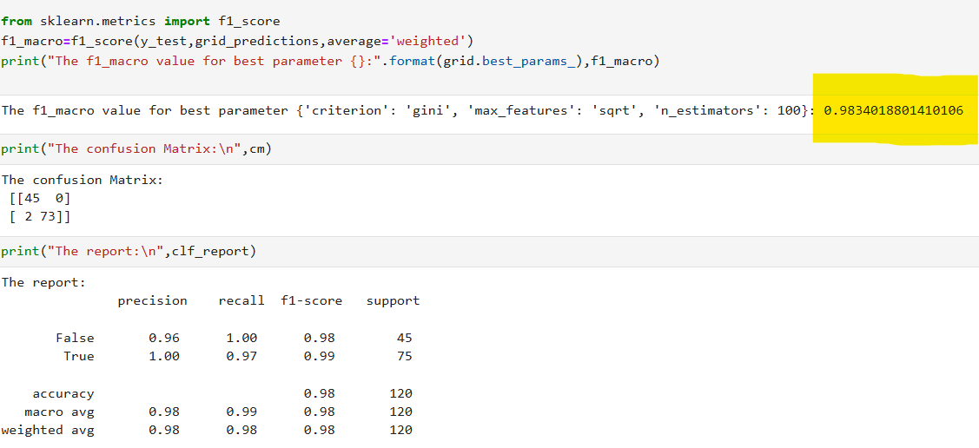

B)
Test size: 20% Random forest
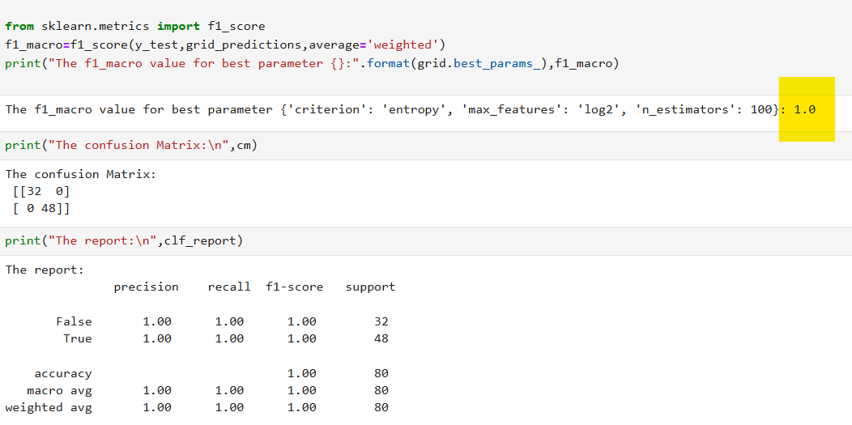

- Random forest model with below parameters and Train size as 80%.
{'criterion': 'entropy', 'max_features': 'log2', 'n_estimators': 100}

