Supabase Images Import Workflow (DBeaver)
Open DBeaver.
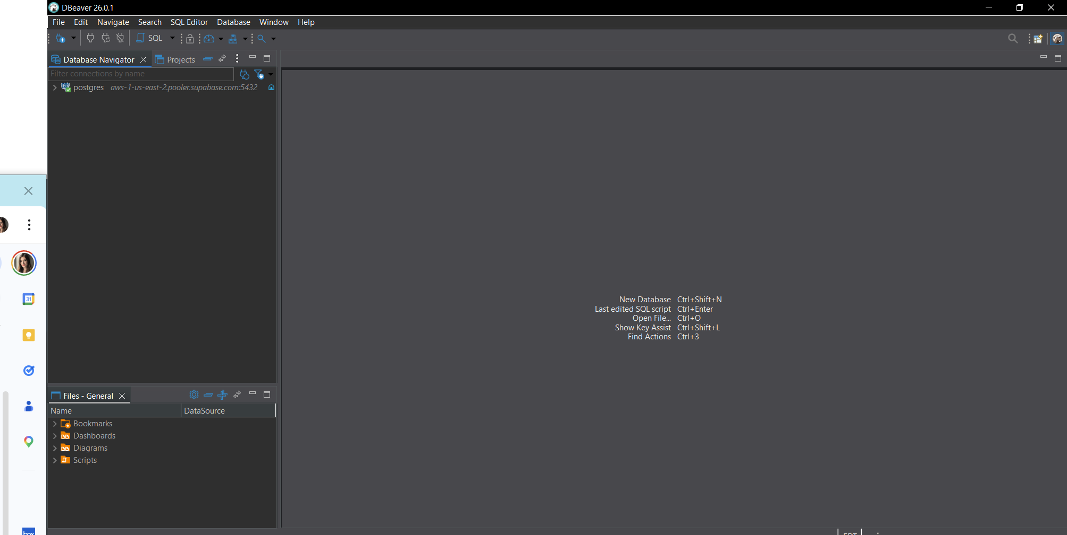
In the left panel, expand: postgres → Schemas → public → Tables.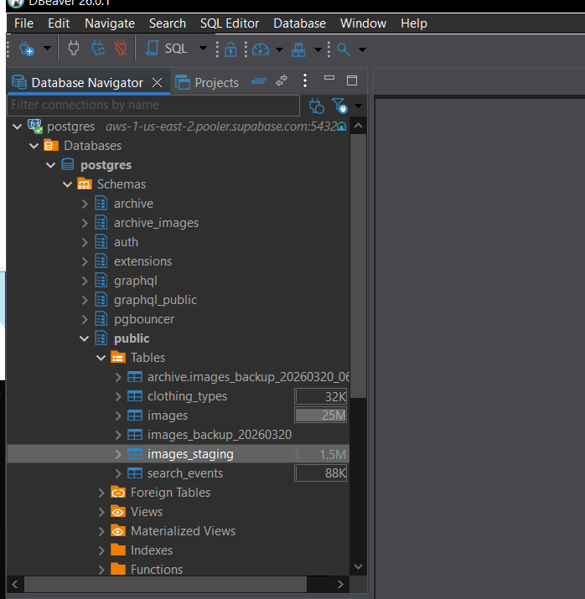
Right-click images_staging → View Data.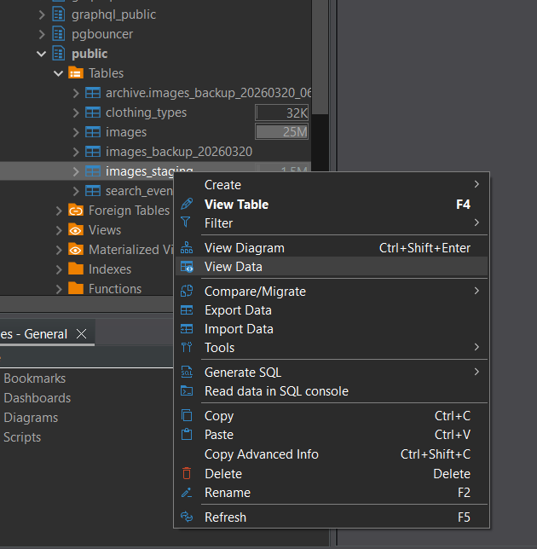
Right-click images_staging → Import Data.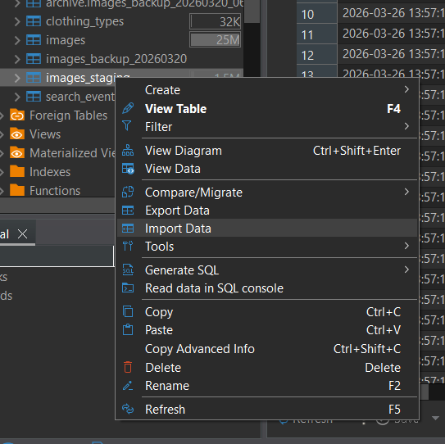
In Data Transfer window: Click Browse → select CSV → Open.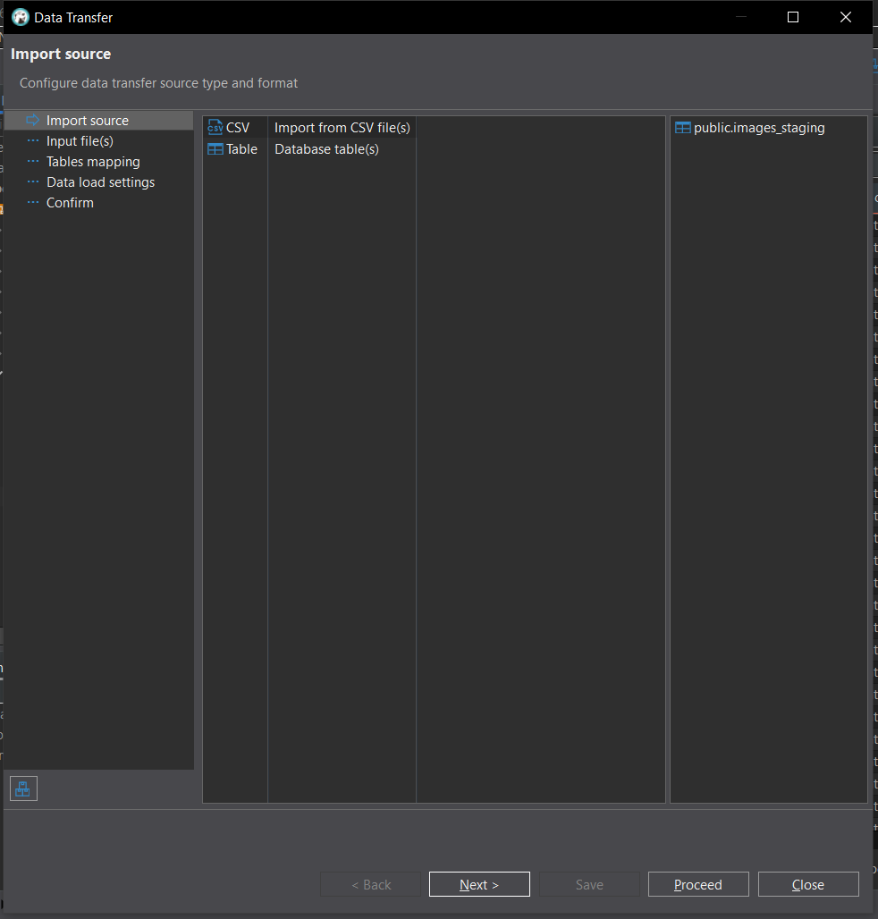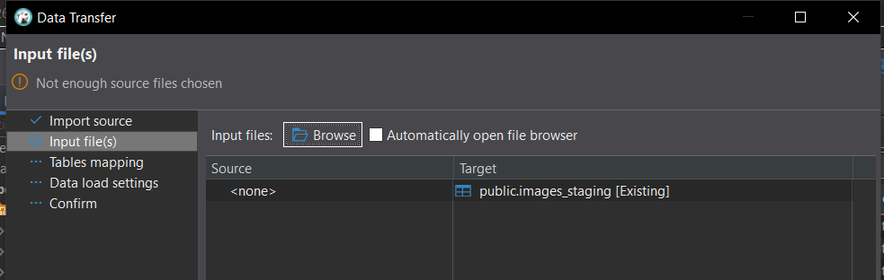
Click Next.
On mapping screen: select top row → press Space to map to images_staging.
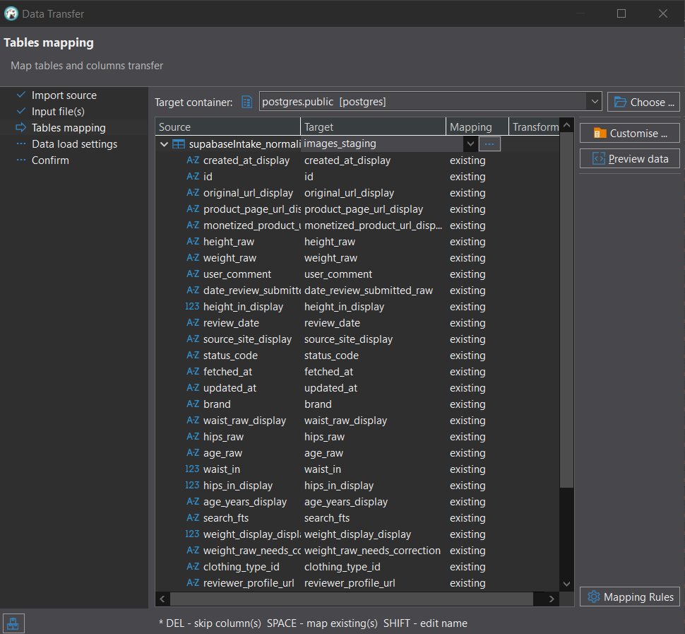
Set created_at_display to [skip].
Set id to [skip].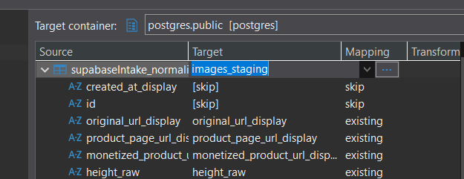
Ensure all other columns are mapped.
Click Next.
Check Disable batches.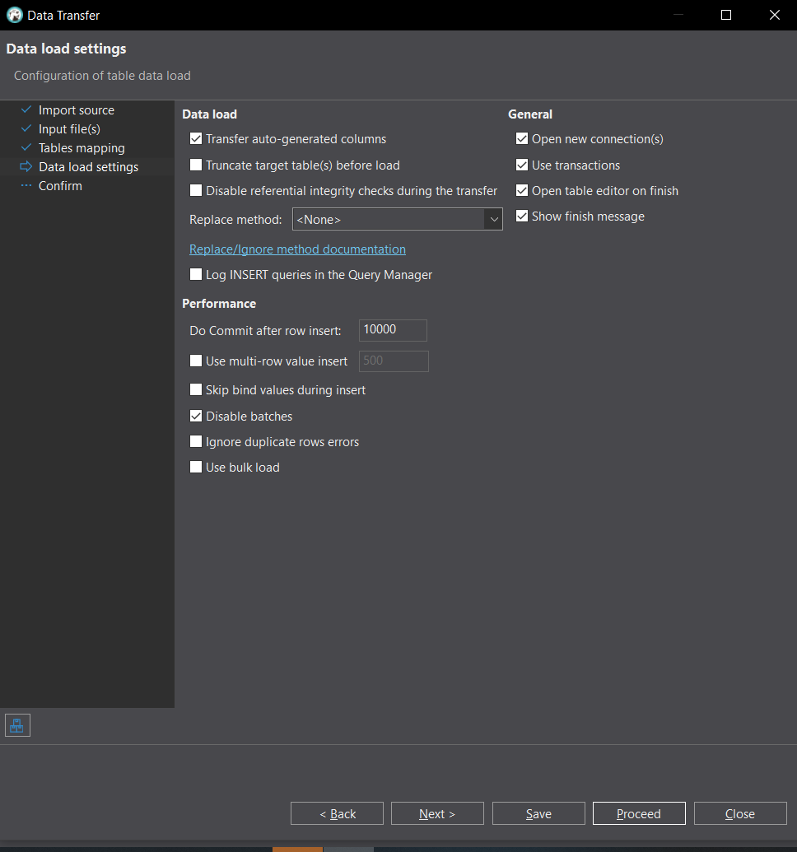
Click Next → Proceed.
If errors appear → click Skip all.
After import, verify rows in images_staging.
Open Scripts panel → run images_staging_cleanup.sql (Ctrl + Enter).
Run: select count(*) from public.images_staging;
Run: insert into public.images select * from public.images_staging;
Run: select count(*) from public.images;

