Marketing texts for Tabi Android app
Nazwa: Tabi – Polish license plates
Krótki opis: Search for Polish license plates
Pełny opis:
Every license plate in Poland is connected to district a car comes from. This car with „DOL” licence plate, do you where it is from? Or this big city – Krakow – what license plates are used in there?

Tabi will help you answer this questions.

<b>Main features:</b>
- Search through large database of license plates from Poland
- Find any town or village in Poland
- Find out more about found place
- Discover new license plates every time you enter the app

Find license plates from whole Poland
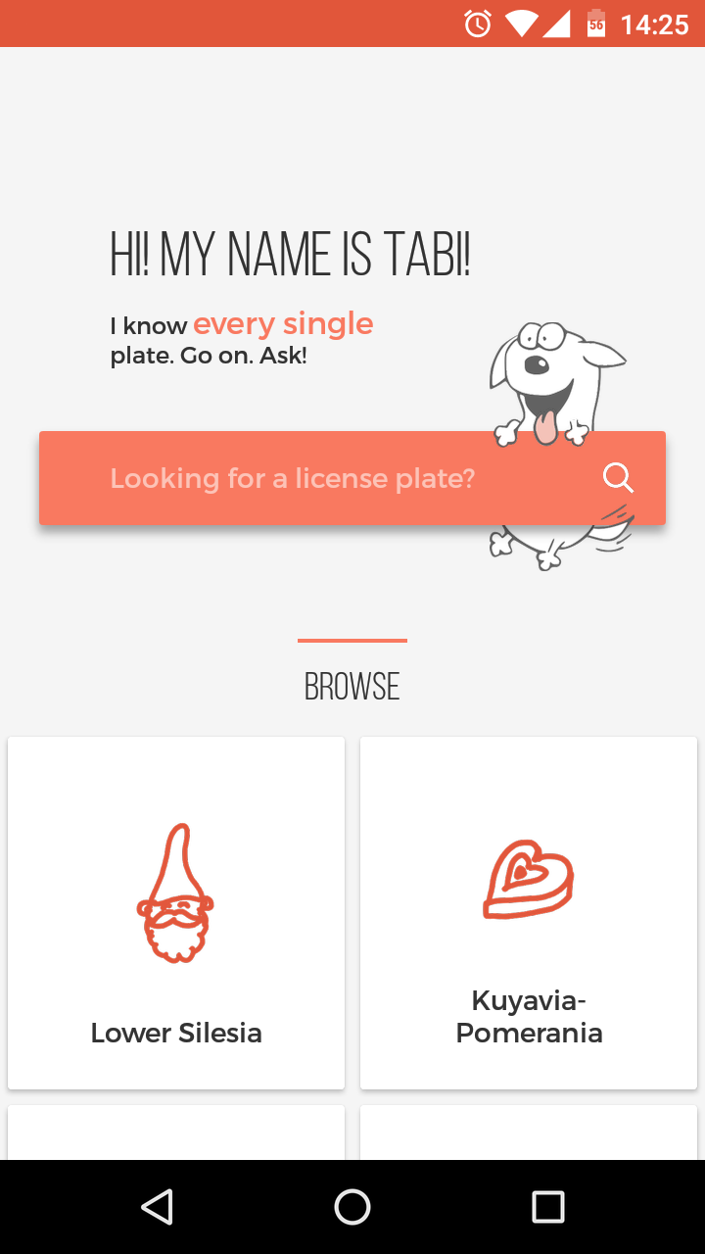
Large database of towns and villages
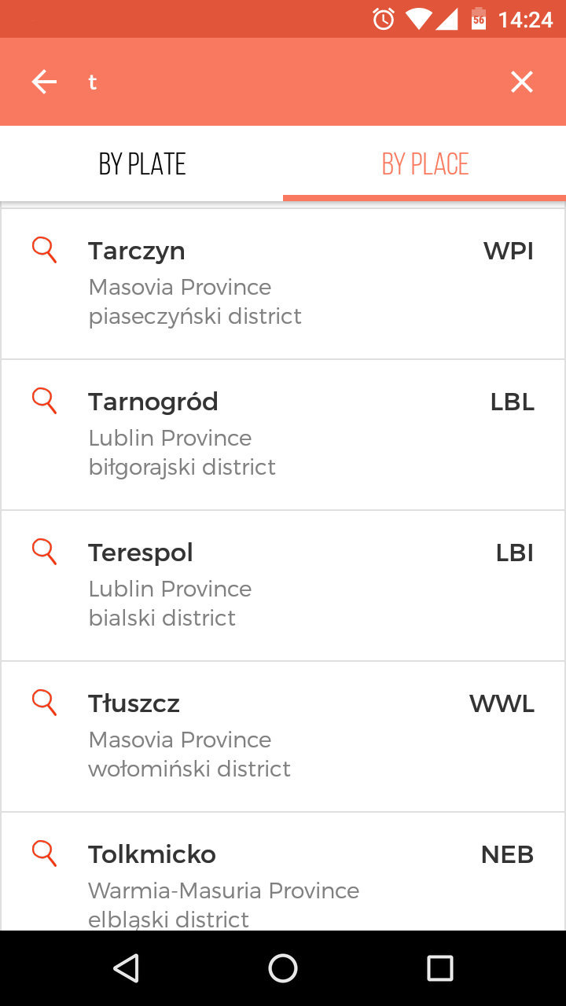
Find out more about town you have found
