Revision History
Date | Version | Description | Author
17.10.2021 | 1.1 | All fields filled. | Başak Balcı
17.10.2021 | 1.2 | UML Diagram added. | Başak Balcı
17.10.2021 | 1.3 | Flow Charts added. | Başak Balcı

TABLE OF CONTENTS

Revision History 1
1 Identification 3
1.1 Document overview 3
1.2 Abbreviations 3
1.2.1 Abbreviations 3
2 Software Development Activities 3
2.1 Software development process 3
2.1.1 Overview of process phases 3
2.1.2 Technical documentation 3
2.1.3 Deliverables 3
2.2 Software development tools 3
2.2.1 Workstation 3
2.2.2 Requirements management and documentation 4
2.2.3 Software Design 4
2.2.4 Coding and automated tests 4
2.2.5 Configuration management 4
2.3 Software development rules and standards 4
3 Responsibilities 6
3.1 Activities and responsibilities 6
4 Risk Assessment 6
4.1 Risk Analysis 6
4.2 Risk Planning 6

Identification

Document overview

This document contains the software development plan of software DFASimulator.

This project simulates the behavior of a DFA. It takes an file as an input and returns an file as an output. In the input file there are information about the DFA: number of states, number
of variables, number of goal states, states, goal state, variables, transition function and the strings to be computes. In the output file there are information about if the given strings are accepted or not and the route taken. The algorithm computes the behavior of the defined DFA.

Abbreviations

Abbreviations

DFA: Deterministic Finite Automata

Software Development Activities

The section lists and describes the software development activities of DFASimulator software development project.

Software development process

This is a course project, which adopts the waterfall model as the software development process.

Overview of process phases

The software development process for the project will be composed of the following phases:
- Design
- Implementation
These phases will follow each other sequentially, where each phase starts just after the completion of the previous one.

Technical documentation

Only this documentation will be produced
- Software Development Plan: SDP

Deliverables

The following items will be delivered at the end of the process:
- Technical documentation as outlined in Section 2.1.2
- Software and its configuration files

Software development tools

Workstation

- Developers Computer:
  - CPU: Intel(R) Core(TM) i5-6200U CPU @ 2.30GHz 2.40 GHz
  - GPU: AMD RADEON R7 M360
  - RAM: 8,00 GB

Requirements management and documentation

- Microsoft Word 16

Software Design

- Draw IO 9.7.3

Coding and automated tests

- IntellijIDEA 2020.3.1

Configuration management
GitHub , in private, will be used for software configuration management and tracking issues regarding the software development. A public repository will be created for this purpose.

Software development rules and standards
UML will be used for software design documentation.

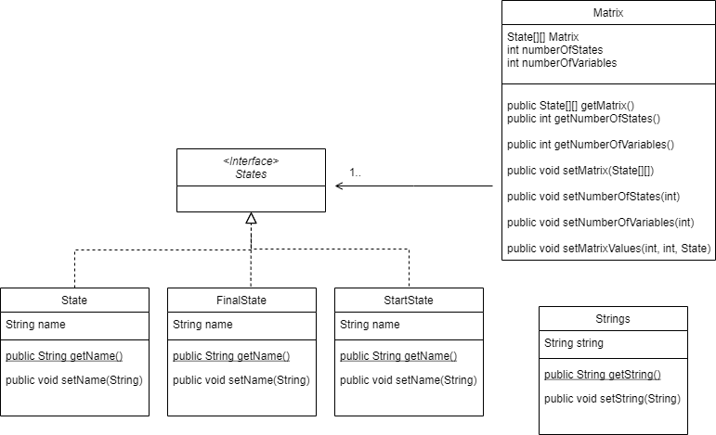
Figure 1 UML Diagram
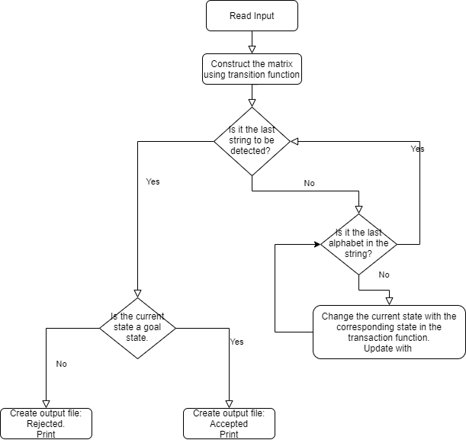
Figure 2 Algorithm Flow Diagram

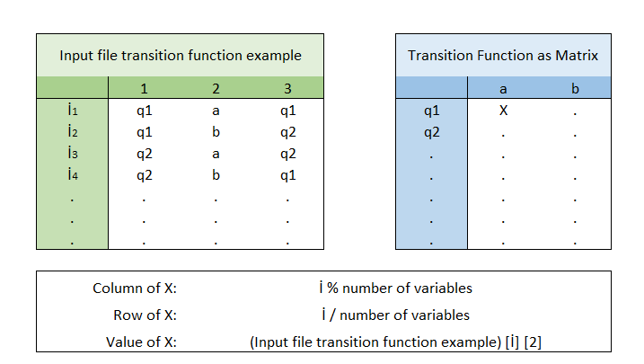
Figure 3 Calculation of the Transition Function Matrix

Responsibilities

Activities and responsibilities

Activity | Responsibility | Comment
Project management | Başak Balcı
Configuration tools management | Başak Balcı
Setting up the Development tools | Başak Balcı

Risk Assessment

Risk Analysis

Risk Type | Possible Risk
Tools | Software tools cannot work together in an integrated way.
Requirements | Changes to requirements that require major design rework are proposed.
Estimation | The time required to develop the software is underestimated.  The rate of defect repair is underestimated.  The size of the software is underestimated.

Risk Planning

Risk | Probability | Effects
Software tools cannot be integrated | High | Tolerable
Changes to requirements that require major design rework are proposed. | Moderate | Tolerable
The time required to develop the software is  underestimated | High | Serious
The rate of defect repair is underestimated | Moderate | Tolerable
The size of the software is underestimated | High | Tolerable

Risk | Strategy
Tools | In the beginning of the project all tool integration will be done and in possible failure support will be requested.
Requirements | All the requirements will be listed as will be closely followed.
Estimation | Design will be planned very detailed to reduce this risk.

http://www.github.com
http://www.uml.org/

