Project 4 Analysis

For reference:

For all of the screenshots in this document, the program on the left is solution A, using child processes, and the program on the right the solution B, using threads.

The information printed by the reporter is detailed as such:

System time: current system time
SIGUSR1: count for the current reporting interval
SIGUSR2: count for the current reporting interval
S1 avg time: average time of reception for SIGUSR1 during this interval
S2 avg time: average time of reception for SIGUSR2 during this interval
S1 total: total count of signals received by the handlers
S2 total: total count of signals by the handlers
S1 avg total: average of signal reception throughout the entire run
S2 avg total: average of signal reception throughout the entire run
Reports: number of times the reporter received 10 signals
SIGUSR1 sent: count of SIGUSR1 signals sent by the generators
SIGUSR2 sent: count of SIGUSR2 signals sent by the generators

Results

At first I ran the one instance of each solution at the same time to compare the results. The results were very similar with the solution using threads sending slightly more signals. Both solutions received about twice as many signals as were sent. Since there were 4 signal handlers receiving the signals, this gives about a 50% signal loss. I think most of this loss was caused by receiving the same signal twice while in the signal handling thread. I found no way to improve this so this is the only explanation that I could find. Solution B’s reporter was slightly more efficient.

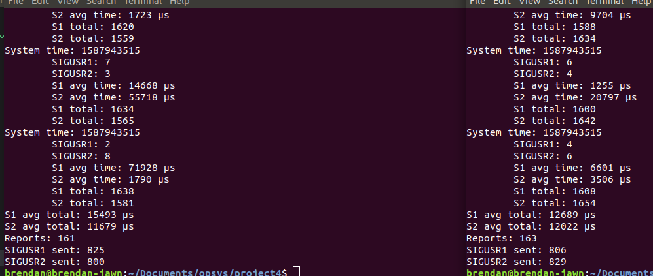
30 second runs:
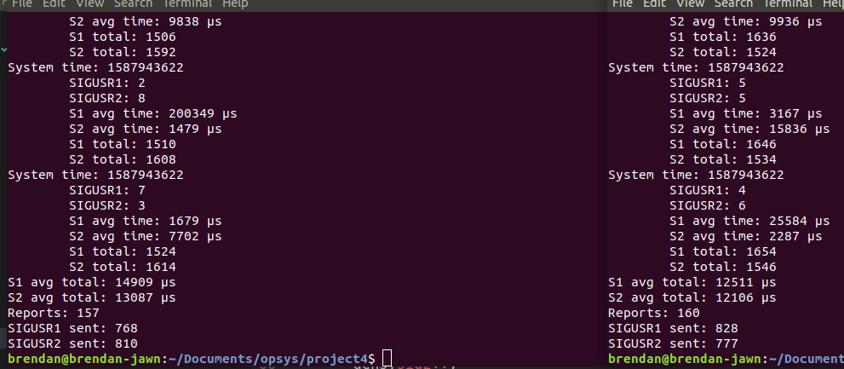
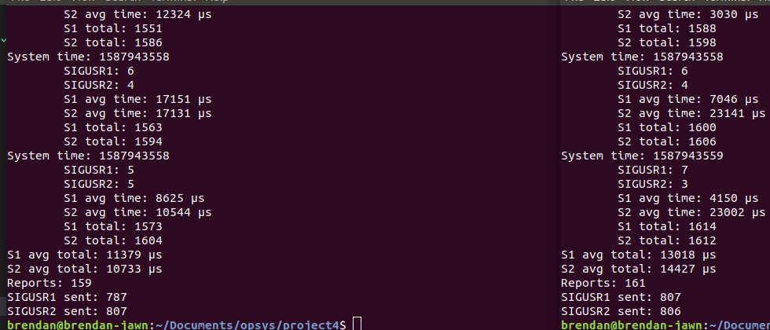

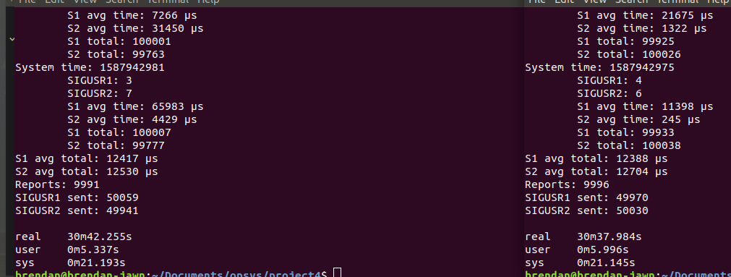
100,000 signal run

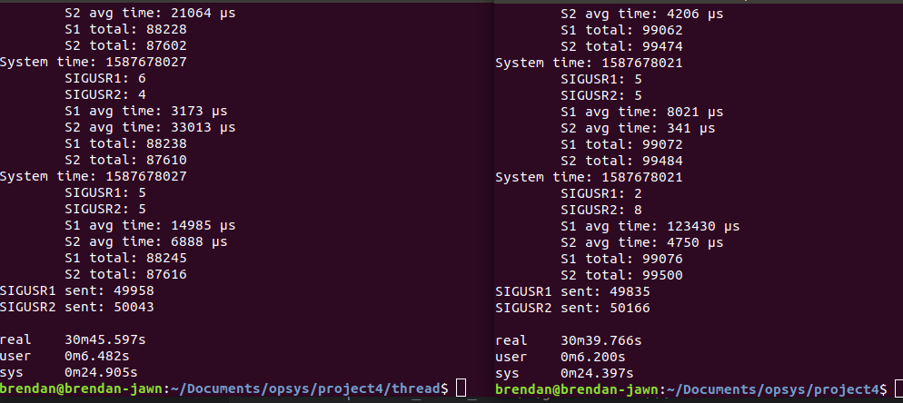
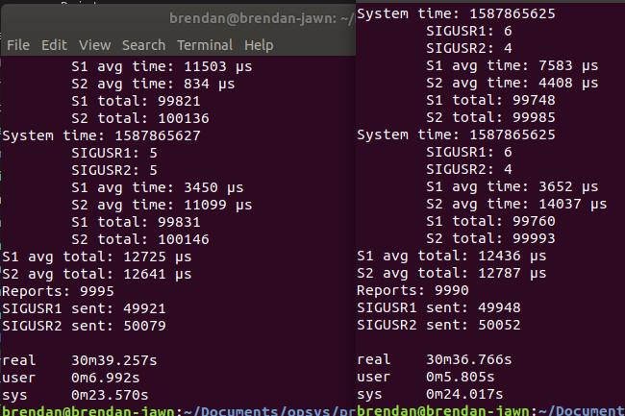

When running, multiple instances of the solutions at the same time, I found that solution A was able to send and receive more signals within 30 seconds and finish sending 100,000 signals in about half the time as solution B. I found this very interesting and could not find a good explanation for this. I first thought it was due to using the same file for the shared memory key, but when I changed the program, to take different key files, the results were the same. Despite being able to generate and handle more signals, the reporter was actually reporting less. Again, I could find no explanation for this.

30 second runs

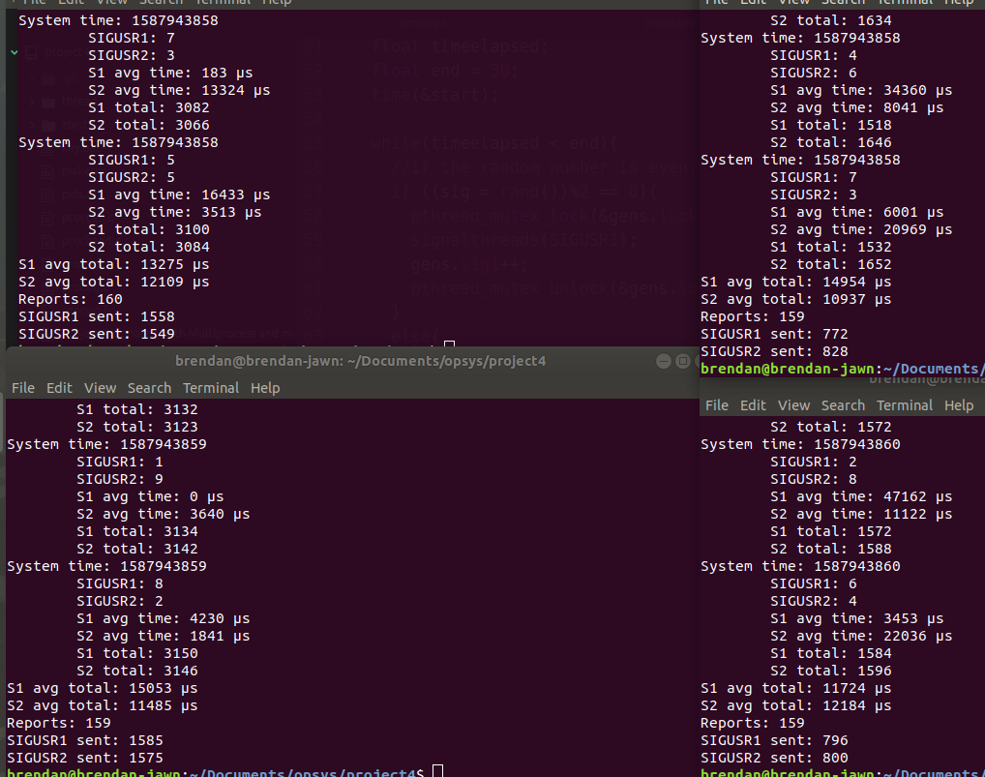

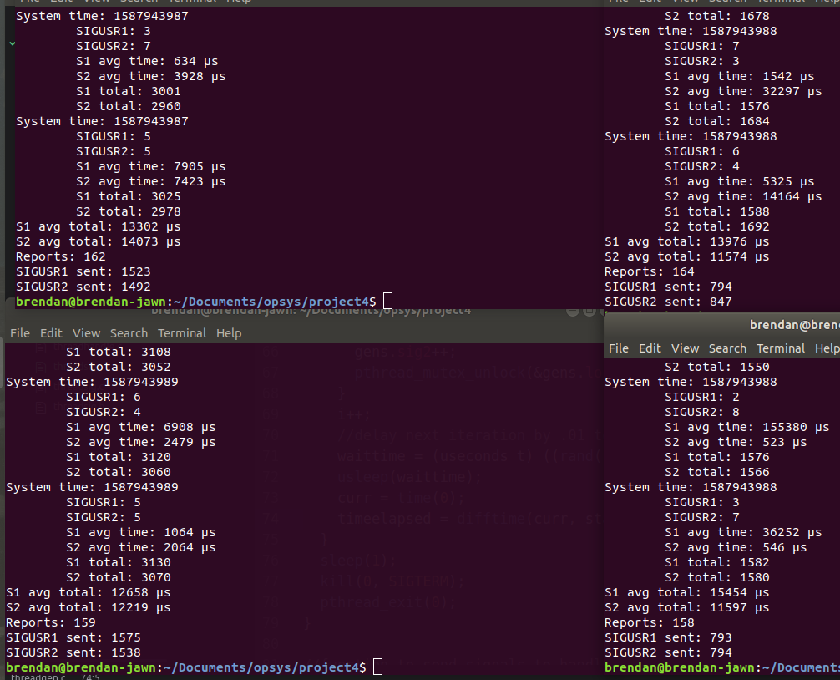

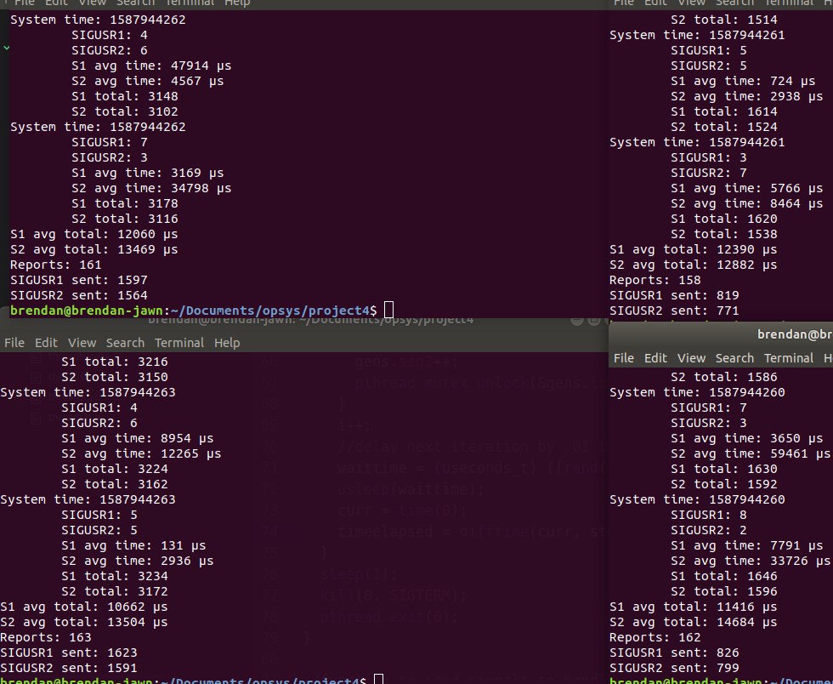

100,000 signals

