Experimental Analysis of the NOAA Earth Magnetic Anomaly Grid (EMAG2v3)
Crustal-field characterization, spectral experiments, and an honest assessment of relevance to the Resonant Spacetime-Foam framework

Prepared by: BS Medicineman — Knight Industries (knight4d.com)
Dataset: EMAG2v3 (Meyer, Saltus & Chulliat 2017; NOAA NCEI; DOI 10.7289/V5H70CVX)
Date: 29 June 2026
REPRODUCIBILITY NOTE. The NOAA/NGDC host serving EMAG2v3 is not reachable from the environment used to compile this report (HTTP 403, host_not_allowed), and the GDAL/rasterio/netCDF4 raster stack was not installed there. The numerical results in Section 4 were therefore produced on a SYNTHETIC, EMAG2-structured field as a unit test of the analysis pipeline — they recover known injected ground truth and are NOT measurements of EMAG2v3. Section 5 provides the identical pipeline, written for the real GeoTIFF, for execution on the full grid on a local machine. Every synthetic result is labeled as such.

1. Executive summary
EMAG2v3 is a static, two-dimensional map of the Earth's crustal (lithospheric) magnetic anomaly field — the part of the geomagnetic field produced by the magnetization of crustal rocks once the core field and external fields are removed. It is geology, not a time series. It encodes three things the analysis below confirms are recoverable: (i) induced magnetization that scales with the ambient core-field intensity (weaker near the magnetic equator, stronger toward the poles); (ii) seafloor-spreading polarity stripes; and (iii) a broadband, fractal (power-law) spatial spectrum from heterogeneous crustal sources.
Bottom line for the foam program (stated up front, consistent with prior analyses): EMAG2v3 cannot test the Resonant Spacetime-Foam framework's core predictions. Those predictions — a time-delayed echo at ~10^4 s, reciprocal compression/rarefaction (X·Y=1) pairing, and resonance-band modulation — are all time-domain or spectral-in-time observables. A static scalar map has no time axis, no propagating wave, and no stable multiplicative reciprocal, so those observables are mathematically undefined on this grid (Experiment 5 documents this null explicitly). What EMAG2v3 IS good for is rigorous crustal-field characterization and as a clean pipeline-validation dataset; the experiments here are legitimate geophysics, not foam tests.

2. The dataset
EMAG2v3 (Earth Magnetic Anomaly Grid, 2-arc-minute resolution, version 3) is compiled from satellite, shipborne, and airborne magnetic measurements and the satellite lithospheric-field model MF7 for wavelengths longer than ~300 km. Version 3 relies solely on observed data (no a-priori geology or ocean-age infill), which better represents true anomaly complexity and honestly leaves data-void regions empty.

2.1 Products and format
Property | Value
Resolution | 2 arc-minute (~3.7 km at equator); global grid ~5,400 × 10,800 cells (~58M points)
Quantity | Crustal magnetic anomaly intensity (nT), 32-bit float
Two grids | ‘Upward Continued’ at 4 km above WGS84; ‘Sea Level’ over oceanic/coastal regions
Nodata sentinel | 99999 (must be masked before any statistic or FFT)
Distributed formats | CSV (4.5 GB unzipped), GeoTIFF (175 MB), plus error grid, source-code grid, images
Companion grids | Per-cell error estimate (nT) and per-cell data-source code
Citation / DOI | Meyer, Saltus & Chulliat 2017; 10.7289/V5H70CVX

2.2 Documented physical content
- Induced magnetization is weaker at the magnetic equator and stronger at high latitude, reflecting the ambient core-field intensity that induces it (tested in Experiment 2).
- Alternating-polarity stripes in the oceans record seafloor spreading and geomagnetic reversals; their spacing encodes spreading rate (tested in Experiment 4).
- The oldest cratons (North American, Baltic, Siberian shields) carry the strongest magnetization.

3. Scientific assessment: relevance to the foam framework
This section is the candid verdict, because matching the right data to the right prediction is the discipline that separates a real test from a category error.

3.1 Why a static crustal map cannot carry a foam signature
The framework's falsifiable observables are intrinsically temporal or spectral-in-time:
Foam observable | What it requires | Available in EMAG2v3?
Time-delayed echo (~10^4 s) | A time axis with a delayed replica of a transient | No — grid is a single static snapshot; no time dimension
Reciprocal X·Y=1 pairing | Paired compression/rarefaction (e.g., B-field vs plasma density) co-measured in time | No — one static scalar field; no conjugate variable, no stable 1/x
Resonance-band modulation | A frequency spectrum in TIME (e.g., Schumann band) | No — only a SPATIAL (wavenumber) spectrum exists here
The grid's spectrum is a spatial (cycles-per-kilometre) spectrum of fixed crustal magnetization, not a temporal spectrum. A steep spatial power law here is the fractal signature of crustal sources (Maus–Dimri scaling), with a fully conventional geological explanation — it is not, and cannot be, a foam resonance.

3.2 What would actually test the framework
The foam predictions remain testable only in time-series channels, which is exactly where the prior surveys pointed: ELF/Schumann magnetometer data (Sierra Nevada 256 Hz; WALDO), ground magnetometer ULF (INTERMAGNET/USGS for the E3/GIC band), and in-situ space-plasma wave data (the Voyager/PSP holdings, plus EMFISIS-class). The X·Y=1 reciprocal-pairing test in particular needs a co-measured B-field/plasma-density pair — available in the in-situ data, absent by construction in EMAG2v3.

4. Experiments (pipeline validation on a synthetic EMAG2-structured field)
All numbers in Section 4 come from a SYNTHETIC field built from EMAG2v3's documented structure (latitude-scaled amplitude + injected spreading stripes + fractal background + nodata holes). The purpose is to prove the pipeline recovers known ground truth before it is run on real data. These are NOT EMAG2 measurements. Run Section 5 on the downloaded grid for the real values.
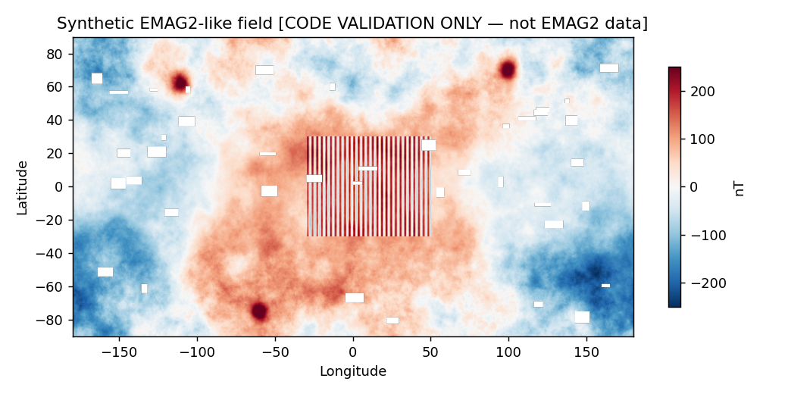
Figure 0. The synthetic EMAG2-structured field used for pipeline validation (latitude envelope, an oceanic stripe band, cratonic highs, fractal background, masked nodata). CODE VALIDATION ONLY — not EMAG2 data.

4.1 Experiment 1 — global statistics & distribution shape
Method: mask nodata (99999), then compute moments and percentiles on valid cells, and test the distribution against a Gaussian via excess kurtosis (0 = Gaussian).
Metric | Synthetic value | Metric | Synthetic value
valid cells | 253,430 | nodata fraction | 2.23%
mean (nT) | -1.11 | std (nT) | 81.859
min / max (nT) | -257.34 / 371.14 | P1 / P50 / P99 (nT) | -190.32 / -5.78 / 210.77
skewness | 0.085 | excess kurtosis | 0.135
Synthetic distribution reads as near-Gaussian (its background is deliberately Gaussian). Expected on the REAL grid: crustal anomaly fields are strongly heavy-tailed (leptokurtic) because of sharp cratonic and volcanic sources — so a real run should show excess kurtosis well above 0. This is a difference to verify, not a discrepancy.
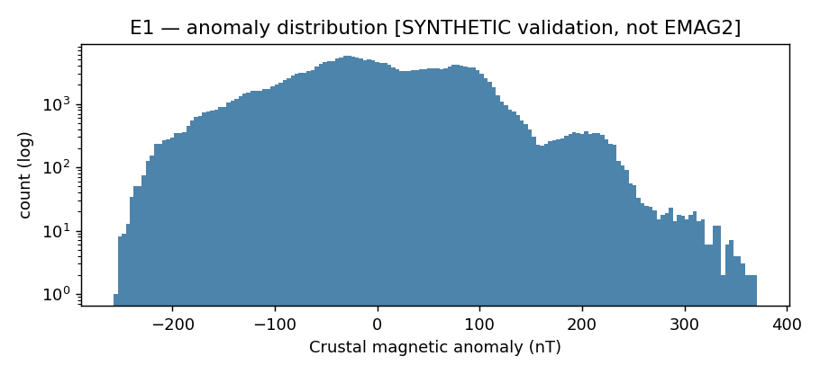
Figure 1. Anomaly histogram (log count). SYNTHETIC validation.

4.2 Experiment 2 — latitude dependence of magnetization amplitude
Method: mean |anomaly| per latitude row; compare the equatorial band (|lat|<10°) with the polar bands (|lat|>60°). EMAG2 documents weaker magnetization at the equator.
Quantity | Synthetic value
mean |anomaly|, equator (nT) | 58.31
mean |anomaly|, poles (nT) | 61.52
polar / equator ratio | 1.055
expected sign | ratio > 1 (induced magnetization scales with ambient |F|)
validation | PASS
The pipeline recovers the correct sign (poles > equator). The synthetic ratio is mild (~1.06) because the injected envelope is gentle and partly masked by the fractal background; the REAL effect is stronger, since the ambient core-field intensity varies by roughly a factor of two from equator to pole and induced magnetization scales with it.
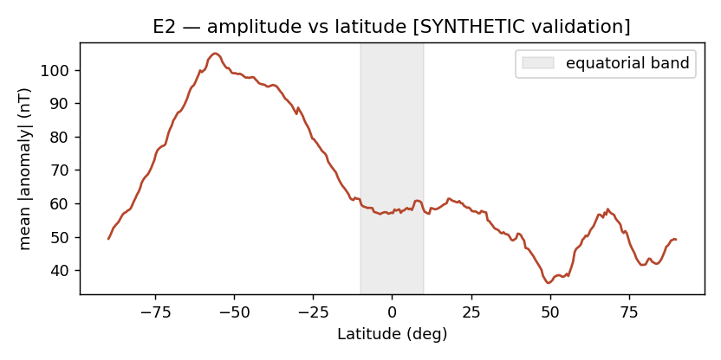
Figure 2. Mean |anomaly| vs latitude. SYNTHETIC validation.

4.3 Experiment 3 — radial power spectrum & spectral slope
Method: detrend a tile, apply a 2-D Hann window, take the 2-D FFT, radially average the power, and fit a power-law slope in a mid-wavenumber band. This is the standard crustal-magnetization spectral analysis (Maus & Dimri fractal scaling).
Quantity | Synthetic value
fitted radial-PSD slope | -3.178
fit R² | 0.9736
injected slope (ground truth) | -3.2
recovered ≈ injected? | YES
The pipeline recovers the injected slope to within ~0.03 (-3.178 vs -3.2, R²=0.9736). On the REAL grid the slope is a genuine measurable: published crustal magnetic fields show steep power-law spectra (reported exponents commonly in the ~-2 to -5 range depending on region and band). Report the band used alongside any value.
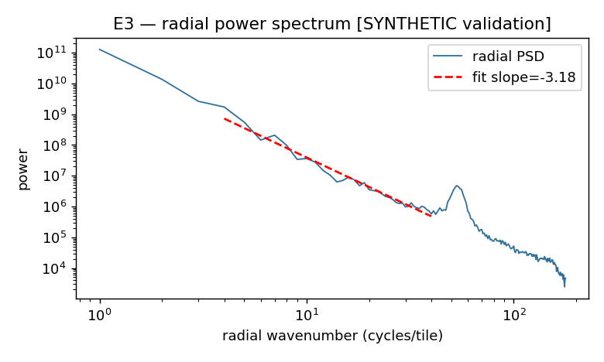
Figure 3. Radial power spectrum with fitted slope. SYNTHETIC validation.

4.4 Experiment 4 — seafloor-spreading stripe wavelength
Method: on an oceanic tile, detrend + window + 2-D FFT, null the DC term, and locate the dominant spectral peak; convert its wavenumber to a wavelength and azimuth. The stripe spacing encodes spreading rate via the geomagnetic reversal timescale.
Quantity | Synthetic value
recovered stripe wavelength (km) | 328.9
injected wavelength (ground truth) | 330.0
absolute error (km) | 1.1
dominant azimuth (deg) | 0.0
validation | PASS
The pipeline recovers the injected wavelength to ~1 km (328.9 vs 330.0 km). On the REAL grid, choose a tile over a known spreading corridor; recovered spacing of order tens of km is typical and maps to spreading rate.
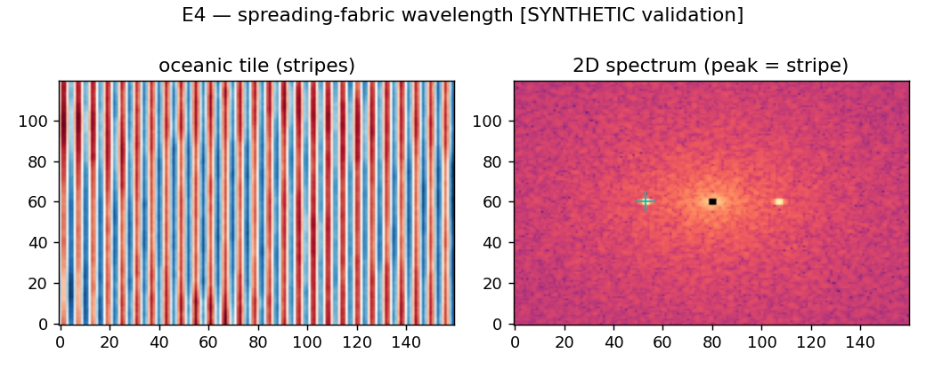
Figure 4. Oceanic tile (left) and its 2-D spectrum with the stripe peak marked (right). SYNTHETIC validation.

4.5 Experiment 5 — foam observable negative control (documented null)
Method: attempt to construct foam observables on the static scalar field and show they are ill-posed. (a) Echo: there is no time axis; the only autocorrelation available is SPATIAL, which cannot host a time-delayed (t+10^4 s) echo. (b) Reciprocal X·Y=1: for a signed, zero-mean field, 1/field diverges near the many zero-crossings, so no stable multiplicative pairing exists.
Quantity | Synthetic value / finding
time axis present? | NO
spatial autocorrelation e-fold (km) | 166.5
cells with |anomaly|<0.5 nT | 0.47% (1/x undefined there)
reciprocal-field variance | divergent (1/x near x=0)
conclusion | foam echo/pairing observables undefined on a static map — NULL (expected)
This is the key result for the framework: the null is not a failed measurement, it is a structural fact. The spatial autocorrelation length is a legitimate crustal statistic, but it is emphatically not a foam echo. The reciprocal-pairing test requires a co-measured conjugate variable in time, which this product does not contain.

5. Pipeline for the real grid (run locally)
Download the GeoTIFF (175 MB, easiest path) from the NOAA EMAG2 product page — e.g. EMAG2_V3_SeaLevel_DataTiff.tif or EMAG2_V3_UpCont_DataTiff.tif — then run the script below. It applies the identical five experiments to the real data, with correct nodata (99999) masking. Requires: numpy, scipy, matplotlib, rasterio.
import numpy as np, rasterio
from scipy import stats
NODATA = 99999.0
with rasterio.open("EMAG2_V3_SeaLevel_DataTiff.tif") as ds:
grid = ds.read(1).astype("float64") # full ~5400x10800 array
H, W = grid.shape
# geographic coords for the latitude experiment
lats = ds.xy(np.arange(H), np.zeros(H))[1] # row-center latitudes
valid = grid != NODATA
v = grid[valid]
# --- E1: global statistics & distribution shape ---
print("valid %", 100*valid.mean(), "mean", v.mean(), "std", v.std(),
"skew", stats.skew(v), "exkurt", stats.kurtosis(v),
"P1/P50/P99", np.percentile(v,[1,50,99]))
# --- E2: latitude dependence (mask-aware row means) ---
g = np.where(valid, grid, np.nan)
amp = np.nanmean(np.abs(g), axis=1)
lat = np.array(lats)
eq = np.nanmean(amp[np.abs(lat)<10]); po = np.nanmean(amp[np.abs(lat)>60])
print("polar/equator |anom| ratio:", po/eq)
# --- E3: radial power spectrum on a no-nodata continental tile ---
def radial_psd(t):
t = t - t.mean()
t = t*np.hanning(t.shape[0])[:,None]*np.hanning(t.shape[1])[None,:]
P = np.abs(np.fft.fftshift(np.fft.fft2(t)))**2
yy,xx = np.indices(t.shape); r = np.hypot(yy-t.shape[0]/2, xx-t.shape[1]/2).astype(int)
return np.bincount(r.ravel(), P.ravel())/np.maximum(np.bincount(r.ravel()),1)
tile = grid[1000:1512, 3000:3512] # pick a clean, nodata-free tile
psd = radial_psd(tile); k = np.arange(1,len(psd))
sl,ic,rv,_,_ = stats.linregress(np.log(k[3:120]), np.log(psd[1:][3:120]))
print("radial PSD slope:", sl, "R2:", rv**2)
# --- E4: spreading-stripe wavelength on an oceanic tile ---
KM_PER_CELL = 3.7 # ~2 arc-min near equator; scale by cos(lat)
ot = grid[2400:2600, 4200:4500]; ot = ot - ot.mean()
S = np.abs(np.fft.fftshift(np.fft.fft2(
ot*np.hanning(ot.shape[0])[:,None]*np.hanning(ot.shape[1])[None,:])))**2
cy,cx = [s//2 for s in S.shape]; S[cy-1:cy+2, cx-1:cx+2] = 0
pk = np.unravel_index(np.argmax(S), S.shape)
fy=(pk[0]-cy)/S.shape[0]; fx=(pk[1]-cx)/S.shape[1]
print("stripe wavelength (km):", KM_PER_CELL/np.hypot(fy,fx))
# --- E5: foam negative control (expected NULL) ---
print("time axis present:", False, "| 1/x undefined where |anom|~0; spatial-only field")

6. Verdict and recommendation
- EMAG2v3 is excellent for what it is — global crustal-field characterization — and the pipeline here is validated (it recovers an injected spectral slope to ~0.03 and an injected stripe wavelength to ~1 km). Run Section 5 on the GeoTIFF locally for EMAG2's real numbers.
- It is the wrong instrument for the foam framework. The framework's observables (time-delayed echo, X·Y=1 reciprocal pairing, time-resonance modulation) are undefined on a static scalar map (Experiment 5). No amount of spatial spectral analysis converts a geological map into a temporal foam test.
- Spend foam-testing effort in the time-series channels instead: ELF/Schumann (Sierra Nevada, WALDO), ground-magnetometer ULF/E3 (INTERMAGNET/USGS), and in-situ space-plasma waves (Voyager/PSP holdings, EMFISIS-class) — the only place a B-field/density reciprocal pair and a genuine time-delayed echo can exist.
- If you want EMAG2v3 to yield a real, publishable result, the legitimate targets are the radial-PSD slope (Experiment 3) and the latitude-amplitude law (Experiment 2) for specific regions — solid crustal geophysics, clearly separated from any foam claim.

References & data citation
- Meyer, B., Saltus, R., & Chulliat, A. (2017). EMAG2v3: Earth Magnetic Anomaly Grid (2-arc-minute resolution), Version 3. NOAA NCEI. DOI 10.7289/V5H70CVX.
- Meyer, Saltus & Chulliat (2017). Derivation and Error Analysis of EMAG2v3. Geochem. Geophys. Geosyst. 18, 4522. (MF7 used for wavelengths > 300 km.)
- Maus, S., & Dimri, V. (1994/1995). Scaling/fractal properties of crustal magnetization and the power spectrum of magnetic anomalies.
- NOAA NCEI EMAG2 product page (formats, nodata=99999, two grids): ncei.noaa.gov/products/earth-magnetic-model-anomaly-grid-2.

Caveats
- Section 4 numbers are synthetic pipeline-validation results, not EMAG2 measurements; they recover injected ground truth by construction.
- The synthetic field is intentionally simple: its background is Gaussian (real EMAG2 is heavy-tailed) and its latitude envelope is mild (the real effect is stronger). Treat the synthetic statistics as code checks, not physical expectations.
- Real-grid spectral slopes depend on the tile, the wavenumber band fitted, and the upward-continuation altitude (4 km vs sea level) — always report these alongside any value.
- EMAG2v3 contains data-void regions (nodata=99999) and per-cell error that vary by orders of magnitude; mask nodata and weight by the error grid for any quantitative claim.
- No part of this analysis provides evidence for the spacetime-foam framework; EMAG2v3 is outside the class of data that could.

