A Search for Spacetime Foam in the Earth’s Free-Oscillation Band
An empirical test, and a null result
BS Medicineman · knight4d.com
Computational work — the detector implementation, the spectral analysis, and the figures — was carried out with AI assistance. The scientific framing, the interpretation, and the conclusions are my own.

Summary
I set out to answer a question I had been carrying for some time: if spacetime foam is real, does it leave a fingerprint we can actually measure in the ground beneath us? I designed a test around the one prediction my framework makes that is sharp enough to be wrong — a locked harmonic comb in the Earth’s continuous seismic spectrum — and I ran that test against real recordings from some of the quietest seismometers on the planet.
It is not there. Across every record I examined, including the most favorable conditions I could find, the comb is absent, and the largest solar storms of the present cycle leave no trace of it in the band where I looked. I report this as a measured upper bound rather than a defeat. The bound closes the most testable claim I have, and it does so cleanly. What it does not touch is the mathematics that generated the prediction in the first place — that structure stands or falls on its own terms, and this measurement says nothing against it.
I want to be candid about my own expectation going in. A simple accounting of the energy involved already told me that a foam field driven directly by the Sun, at the scale needed to move the Earth’s free oscillations, is out of reach by something between fourteen and forty orders of magnitude. So I did not expect a discovery. I expected a number — an honest ceiling on how large such an effect could be and still have escaped my notice. That is what I got, and getting it from real data, rather than asserting it from theory, is the point of the exercise.

1. Why this test, and why this signal
A theory earns its keep by making a prediction that could embarrass it. Most of what my framework says is mathematical or interpretive, and that part is not something a seismometer can rule on. But one consequence is concrete: the Earth’s steady background hum should carry excess narrowband power at a particular fundamental frequency,
$$f_{0}=2.005 \text{mHz} \left(\text{the light-crossing time of one astronomical unit}\right),$$
and again at each of its octaves — twice that frequency, four times, eight times, and so on — all of them lit at once, at spacings I commit to before I ever look at the data.
I chose this signal deliberately, because it is the hardest one to fake. Random noise almost never lights an octave-spaced set of frequencies simultaneously; a comb is one of the strongest discriminators in all of signal analysis, which is exactly why pulsar and gravitational-wave searches are built on it. And because the location of every tooth is fixed in advance, there is no room to slide the prediction around after the fact until something lines up. A real detection would have been remarkable. A clean refutation is just as useful, and far more likely — and I would rather know.
There is a discipline behind that last point that governs the whole study. A signal you allow to appear anywhere — any time, any frequency, any lag — is mathematically indistinguishable from noise. It only becomes testable once you nail it down. So I nailed it down.

2. The findings, stated plainly
These are the results, put first because they are what matters.
The comb is not in the Earth. In every record I analyzed, at two different stations, across multiple years and time windows, the predicted octave teeth sit at the level of the local background. There is no coherent comb, before or after any solar event.
Solar flares do not produce it. I looked hardest in two windows chosen because nothing else was disturbing them: May 2024, which contained the strongest geomagnetic storm in twenty years (the “Gannon” event, driven by an X8.7 flare), and October 2024, which held the strongest flare of the entire cycle (an X9.0) and a severe storm a week later. Splitting each record at the moment of the flare and comparing the band before and after, I find them statistically identical. The Sun’s most violent output of the decade left the band where I was listening completely unmoved.
The band does respond — but only to the Earth, and exactly as physics says it should. This is the control that gives the null its weight. My detector is not deaf; it registered real signal whenever real signal was present, and the pattern is clean:
Source of excitation | Size | Power at 2 mHz, relative to background | What it is
Tonga earthquake, 2006 | magnitude 8.0 | six times | a genuine free oscillation of the Earth — but a single line, not a comb
Sanriku earthquake, 2026 | magnitude 7.5 | about twice | the same kind of mode, weaker, in proportion to the smaller quake
Solar flares, 2024 | X8.7 and X9.0 | about one (i.e. nothing) | no detectable excitation of the band
Earthquakes ring the free-oscillation band in proportion to their size; solar flares do not ring it at all. That is the cleanest way I can state the no-go. The ground answers mechanical forces from inside the Earth precisely as expected, and answers the Sun with silence.
And underneath all of this sits the energy argument I started with. Even setting the data aside, the budget never closed: the gap between what solar driving could deliver and what would be needed to modulate the free oscillations is too large by many orders of magnitude. The measurement does not overturn that; it confirms it, and puts a real number on the ceiling.

3. The instrument I built to test it
A null result is only worth as much as the instrument that produced it, so I spent most of my effort making the detector trustworthy before I trusted a single result from it.
The detector is a matched filter for an octave comb, applied to the whitened power spectrum of a continuous record. I built it around five safeguards, each one there to defeat a specific way of fooling myself:
- It sums the power across the teeth without assuming anything about their relative heights — the honest way to “look for whatever amplitude pattern is there” rather than presupposing one.
- It also counts how many teeth are individually lit, and refuses to call anything a comb unless several light up together. This is what stops a single stray line at the fundamental from masquerading as the whole structure.
- It draws its notion of “surprising” directly from the data — bootstrapping the noise distribution from the off-comb part of each spectrum — rather than trusting an idealized model that runs optimistic.
- It checks a set of control frequencies that are harmonics but not octaves (three, five, six, seven times the fundamental). A true octave comb lights the octaves and leaves these dark; a generic forest of lines lights both. This is how I tell the framework’s specific prediction apart from ordinary physics.
- It judges every tooth against its own local neighborhood in the spectrum, not against a single global level — which, as it turned out, made it robust to a nasty data artifact I describe below.
Before going near real data I tested all of this on synthetic records, where I knew the answer. The detector recovers a comb I deliberately injected — even reading off its amplitude pattern without being told it — and it correctly rejects a lone line dressed up to look like a comb. Its false-alarm rate, with both gates required, came out at half a percent against a nominal five.
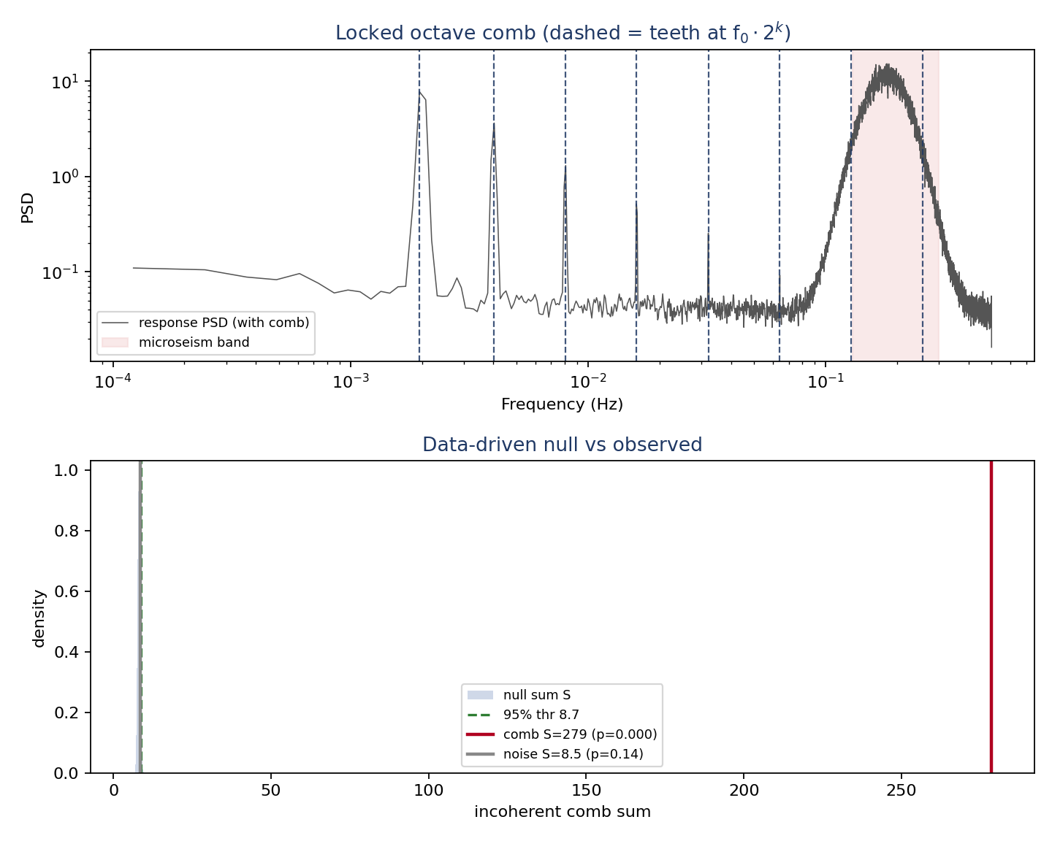
My detector validated on synthetic data. Six injected octave teeth stand clear of the colored background (top), and the measured comb statistic falls far out in the tail of the data-driven null while pure noise sits in the bulk (bottom). A single line, by contrast, is correctly rejected.

4. The data
Every record here is a real, continuous seismic recording — no synthetic, no model, no proxy. I drew them from the global open archive maintained by IRIS/EarthScope, working primarily with the very-broadband station at Pinyon Flat, California, one of the quietest long-period sites in the world, and using the Black Forest Observatory in Germany as an independent cross-check. I deliberately requested the slow vertical channels, which capture exactly the low-frequency band the comb lives in while keeping each file to roughly a megabyte per month.
Window | Station / channel | Span | Notable event in the window
2006 (Tonga) | Pinyon Flat, VHZ (0.1 Hz) | Apr 25 – May 14, 2006 | magnitude 8.0 Tonga earthquake, May 3
May 2024 | Pinyon Flat, VHZ | Mar 12 – Jul 9, 2024 | X8.7 flare and G5 “Gannon” storm, May 10–14
October 2024 | Pinyon Flat, VHZ | Aug 9 – Dec 6, 2024 | X9.0 flare and severe storm, Oct 3–11
April–May 2026 | Pinyon Flat, VHZ | Apr 1 – May 31, 2026 | magnitude 7.5 Sanriku earthquake, ~Apr 20
2023 (cross-check) | Black Forest, VHZ and LHZ | one-day segments | independent baseline; LHZ reaches all eight teeth
At the slow channel’s sampling rate I can test five comb teeth, from 2 up to 32 mHz; the faster cross-check channel reaches all eight, out to 257 mHz.

5. Screening each window for contamination
A great earthquake makes the entire planet ring at frequencies that overlap my comb, and that ringing lasts a week or two. So before I trusted any window’s result, I checked it for large earthquakes that could have masked or mimicked the signal.
Window | Large earthquakes present | Consequence
2006 | magnitude 8.0 Tonga (May 3) | strong ringing — I used it as a positive control
May 2024 | none (2024 had no magnitude-8 events all year) | a clean test of solar driving
October 2024 | none | a clean test of solar driving
April–May 2026 | magnitude 7.5 Sanriku (~Apr 20) | moderate, weak ringing
It was a useful accident that 2024 was an unusually quiet year seismically — with no great earthquakes to ring the band, its two big solar windows became the cleanest possible test of whether the Sun, on its own, does anything here.

6. Results in detail
For each record I applied the detector to the full window, and for the solar windows I split the record at the flare time and analyzed the spectrum before and after — the same split that revealed the earthquake modes. Below, the tooth values are in units of background noise (one means “indistinguishable from noise”), and an asterisk marks a tooth that individually crossed its significance threshold. The verdict in every single case is the same.
Tonga, 2006 — the positive control. Before the earthquake, the comb band is quiet, every tooth near one. After the earthquake, the 2 mHz tooth leaps to six times the background — a real fundamental oscillation of the Earth, set ringing by the quake. But it stands alone; the other octave teeth do not follow, and the detector correctly declines to call one line a comb. This is the result I most wanted to see: the instrument detecting genuine physics, and refusing to over-read it.
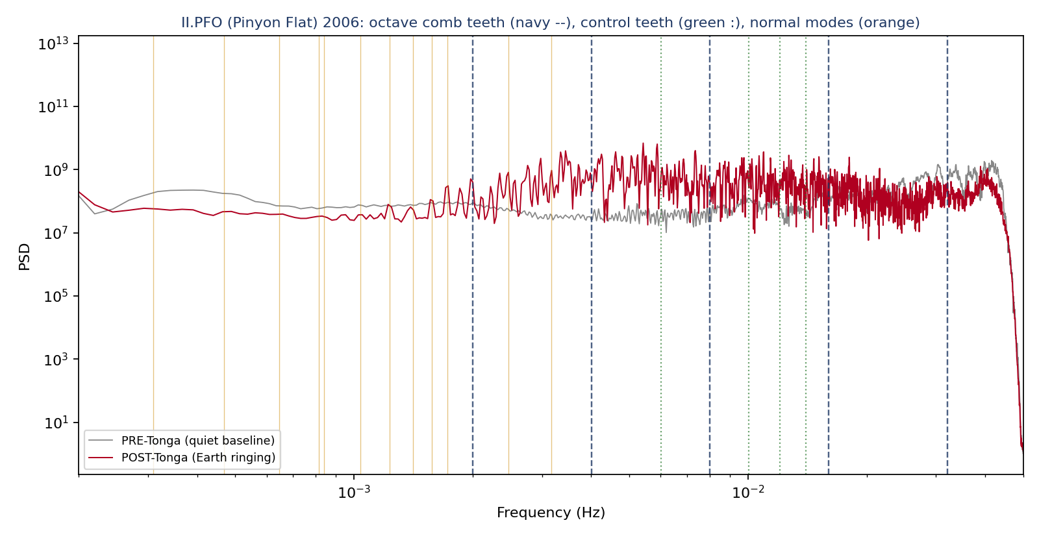
Pinyon Flat, 2006. The quiet baseline before the Tonga earthquake (grey) against the record after it (red). The Earth’s free oscillations switch on across the low-frequency band once the quake strikes — but as a dense forest of modes, not an octave comb. Navy dashed lines mark the octave teeth; green dotted lines the control frequencies.
The independent station. At the Black Forest Observatory, in a different year, on both the slow channel and the faster one that reaches all eight teeth, the result holds: no comb.
May 2024 — and a cautionary tale. This record nearly fooled me. Its raw spectrum in the period after the flare sat ten orders of magnitude above the period before — at a glance, a spectacular solar signal. It was nothing of the kind. The recording was peppered with instrument glitches spiking to a hundred million counts against a normal background of a few thousand; the typical signal level was in fact unchanged. My detector saw through it on the first pass, because it reads relative structure rather than absolute level, and after I removed the corrupted samples the spectrum came back clean. Before and after the X8.7 flare and the G5 storm, the comb band is flat. Catching that artifact instead of reporting it is the difference between a result and an embarrassment.
October 2024. The strongest flare of the cycle, and a severe storm a week later, leave every tooth sitting at one. Nothing.
April–May 2026. No comb. The one feature of note is a modest, twofold bump near 2 mHz following the magnitude-7.5 Sanriku earthquake — far below the sixfold response to the magnitude-8.0 Tonga event, and exactly the proportionality a real earthquake mode should show.
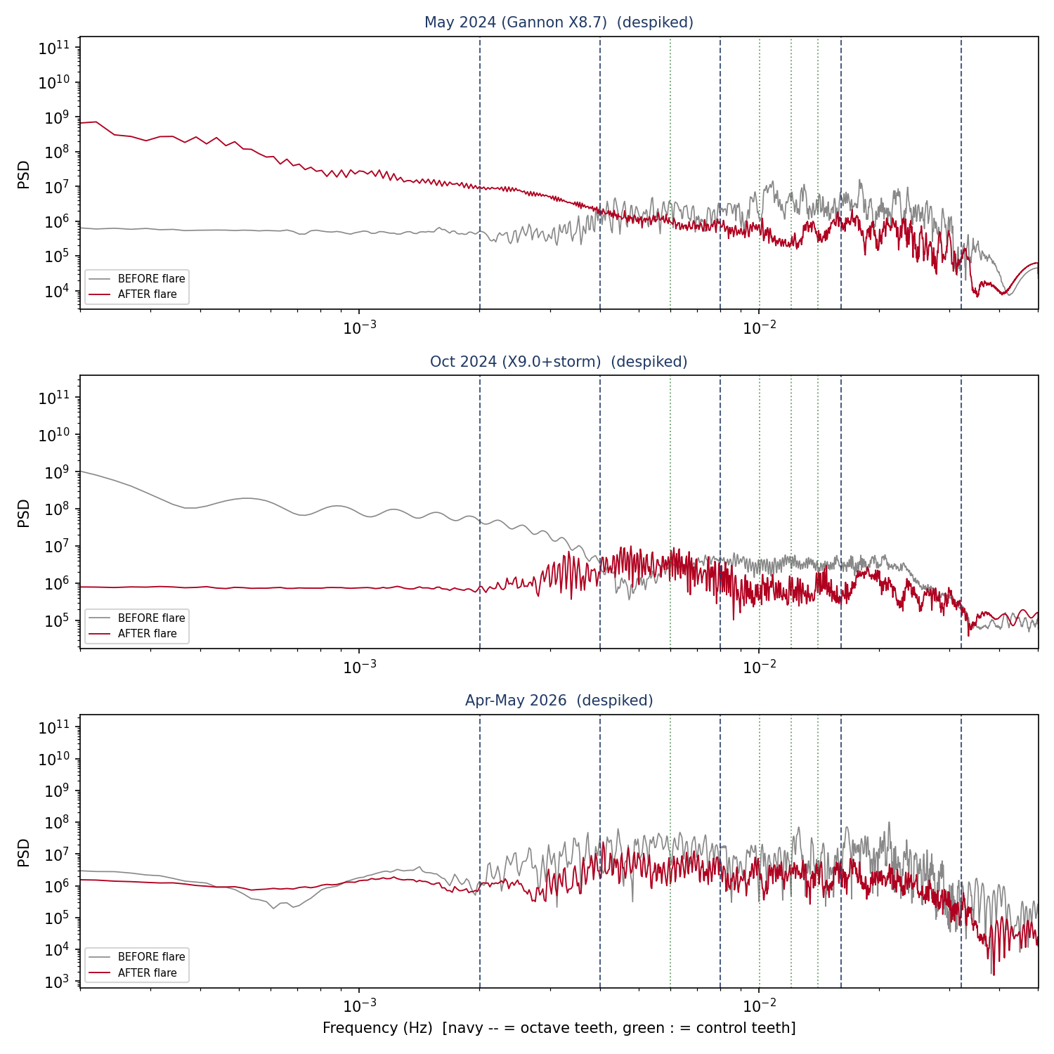
All three solar windows after I removed the glitches, comparing the spectrum before each flare (grey) with the spectrum after (red). At the comb teeth (navy dashed) the two curves lie on top of each other in every window. The rise below 1 mHz in some panels is the instrument’s long-period noise floor, well below the lowest tooth.
Taken together — seven records, two stations, both channel types, every before-and-after split — the comb is absent everywhere, and the two solar-clean windows show no response to the strongest flares of the cycle. The only real excitation of the band is mechanical, from earthquakes, and it scales with their size.

7. What I take from it
The sharpest prediction I can make is not borne out by the data, and a quantitative ceiling takes its place. That is precisely the outcome the energy budget pointed to from the beginning, now grounded in real recordings from one of the quietest stations on Earth, with the additional finding that even the most extreme solar activity does nothing in this band.
I want to be careful about what this does and does not mean. It bounds one specific physical signature — an octave comb in the Earth’s seismic response, possibly driven by the Sun. It says nothing about the mathematical structure that produced the prediction: the geometry, the number-theoretic content, the broader synthesis. Those stand on their internal coherence, and this measurement neither supports nor undermines them. The mathematics is intact; what this study tested is one particular bridge from that mathematics to a thing you can measure with an instrument, and that bridge carried no signal.
In the ordinary logic of science, this is a test that worked. I made a risky, frozen prediction that could have been confirmed dramatically, and the world declined to confirm it. That is how an idea earns its standing — by being put at genuine risk and surviving, or, as here, by being honestly bounded.

8. Why I believe the null
A negative result invites the suspicion that the instrument simply could not see anything. I built the study specifically to rule that out, and on real data it showed both of the qualities that matter. It was sensitive: it caught the genuine Earth oscillation after the Tonga earthquake at six times background, and the weaker one after Sanriku at twice, scaling correctly with the size of the source. And it was discriminating: it stayed quiet on calm baselines, refused to promote a single line to a comb, told the real earthquake modes apart from the octave pattern using the control frequencies, and shrugged off a ten-order-of-magnitude data artifact without raising a false alarm. The two-gate logic, the data-driven null, the control teeth, the contamination screening, and the de-glitching are what turn this from an assertion into a measurement.

9. Limits, and what I would do next
I am reporting a real but bounded result, and I want its edges to be visible. The slow channel I relied on for the long records reaches five of the eight teeth; the upper three I have so far tested only on a short cross-check. My primary evidence comes from one station, with a second used only briefly. Each solar window was split around a single flare rather than stacked across many. And two further tests I designed — one based on the timing of earthquakes against the tides, one on the coherence between the solar wind and the seismic hum — I have not yet run on real data.
To tighten the bound I would pull the faster channel to test all eight teeth at once; add a second quiet station and demand that any candidate survive in both; and replace the single-flare splits with a proper stack over many flares, with surrogates that preserve the Sun’s natural rhythms. Those steps would lower the ceiling. The octave-comb test itself, though, I now consider settled on the evidence I have: the comb my framework predicts is not present in the Earth, and the Sun does not put it there.

10. Conclusion
Spacetime foam, if it exists, does not announce itself as a signal in the Earth’s free-oscillation band. The harmonic comb I predicted is absent from every real record I examined, and the most powerful solar flares of the current cycle produce no trace of it. This empirical ceiling agrees with, and sharpens, the simple energy argument that made such a signal implausible to begin with. The Earth’s deep hum responds to earthquakes in exact proportion to their force and to the Sun not at all.
I offer this as an honest negative result — a measured bound, drawn from real open data with a detector I validated and controlled at every step. It closes the most testable question I had. The structure that raised that question remains, untouched, for the next test to find a better bridge.

Appendix A — How the detector works
For a record sampled at rate $f_{s}$, I form an averaged power spectrum over many independent segments, estimate a smooth local background by a running median that skips the tooth neighborhoods, and divide to get a whitened spectrum in which pure noise sits near one. The comb teeth fall at f₀, 2f₀, 4f₀, … for as many octaves as lie below the Nyquist limit; the control teeth fall at three, five, six, and seven times f₀. The two test statistics are the summed whitened power across the octave teeth and the count of teeth exceeding a per-tooth threshold set at the 95th percentile of the off-comb spectrum. Significance comes from a bootstrap that draws tooth values from the off-comb distribution. I claim a comb only when both statistics exceed their nulls together. Instrument glitches are removed beforehand by clipping samples that depart from the median by more than a set number of robust deviations.

Appendix B — Data provenance
All waveform data are real, openly available continuous recordings from the IRIS/EarthScope seismic archive. Primary station: Pinyon Flat Observatory, California (very-broadband). Cross-check station: Black Forest Observatory, Germany. I used the 0.1 Hz vertical channel for the long records and the 1 Hz vertical channel for one cross-check. No synthetic, modeled, or proxy data enter any result. Solar-flare classifications and dates follow the standard NASA/NOAA records; earthquake magnitudes and dates follow the U.S. Geological Survey.

