Stacked Superposed-Epoch Search for a Seismically-Triggered Schumann-Resonance Frequency Shift
A population-level test for a predicted spacetime-foam “echo” in extremely-low-frequency magnetic-field data
Prepared by BS Medicineman, Knight Industries

Abstract
We test the hypothesis that a large earthquake transiently perturbs the Earth–ionosphere (Schumann) cavity, producing a fractional shift of the Schumann resonance frequencies, Δf/f, of order 10⁻⁴ for magnitude-8 events, decaying on a coherence timescale of hours. Four years of dual-axis extremely-low-frequency (ELF) magnetic-field records are combined with a catalogue of 25 magnitude ≥ 7.5 earthquakes that have verified data coverage. On each of the two magnetic channels the centre frequency of the first three Schumann modes is measured hour-by-hour, the diurnal ionospheric cycle is removed, and the events are combined by inverse-variance-weighted superposed-epoch stacking. Significance is assessed with a time-shift permutation test rather than nominal Gaussian statistics, because the residual noise is strongly correlated. No combined frequency shift and no magnitude-dependent trend survive the permutation test on either channel. The analysis sets a population-level two-sigma upper limit of |Δf/f| < 1.6–3.1 × 10⁻³ for M ≥ 7.5 events — consistent with zero, and one to two orders of magnitude above the predicted amplitude. The predicted effect, if real, lies below the sensitivity attainable from a single station with this event population.

1. Objective and hypothesis
The Schumann resonances are the global electromagnetic eigenmodes of the cavity between the Earth’s surface and the lower ionosphere, appearing as a comb of spectral lines with a fundamental near 7.8 Hz and higher modes near 14.3 and 20.8 Hz. The hypothesis under test holds that the energy injected by a large seismic event briefly distorts this cavity, shifting the mode frequencies by a small fractional amount that then relaxes as the perturbation decoheres.
The prediction makes three concrete, falsifiable statements: (i) the shift is transient and follows the event, decaying on a coherence timescale of order hours; (ii) its amplitude scales with the event energy, reaching Δf/f ≈ 10⁻⁴ for the largest (≈ M8) events; and (iii) the pattern across modes distinguishes two mechanisms — a uniform (conformal) shift moves every mode by the same fractional amount, whereas a shear (trace-free) shift moves them differentially. This experiment tests statements (i) and (ii) directly and reserves (iii) for the case in which a shift is detected.

2. Data source
Electromagnetic data. The primary source is a continuous archive from a dual-axis ELF induction-coil magnetometer recording two orthogonal horizontal components of the magnetic field. The records are sampled at 256.0164 Hz (Nyquist 128 Hz), so the Schumann fundamental and its harmonic ladder are fully resolved and lie well within band. The archive spans 2013-03-01 to 2017-02-26 UTC (approximately 1,459 days) as one-hour records per channel, with 96.5% temporal coverage of the interval. Amplitudes are recorded in raw instrument counts; no absolute magnetic calibration (coil transfer function) is applied. This is not a limitation for the present test, because the quantities used — mode centre frequency and quality factor — are independent of the amplitude calibration.
Seismic catalogue. Earthquake origin times, magnitudes, and locations are taken from the United States Geological Survey Advanced National Seismic System composite catalogue (USGS ANSS ComCat). Only events falling inside the electromagnetic data span are used.

3. Event selection
Candidate events are all earthquakes of magnitude ≥ 7.5 occurring within the data span. Each candidate is retained only if the electromagnetic archive provides data within a ± 6-hour window around the origin time, established from a prior coverage audit of the full archive. Twenty-five events satisfy both conditions. The set includes the three great earthquakes of the interval — Sea of Okhotsk (M8.3, 2013-05-24), Iquique, Chile (M8.2, 2014-04-01), and Illapel, Chile (M8.3, 2015-09-16) — which anchor the high-magnitude end where the predicted signal is largest. After per-record spectral-fit quality cuts, 21–25 events contribute to each mode-and-channel combination.

4. Techniques
The analysis proceeds from single-record spectra to a stacked, event-aligned statistic. The techniques employed are:
- Spectral estimation. Each one-hour record is reduced to a power spectral density by Welch’s averaged-periodogram method (overlapping Hann-windowed segments, per-segment linear detrending), giving a frequency resolution fine enough to resolve and fit each Schumann mode.
- Mode characterisation. For each record the first three Schumann modes are fitted with a Lorentzian line shape superimposed on a local linear baseline. The baseline term absorbs the broad instrument-response envelope, so the fit returns a calibration-independent centre frequency (f₀) and quality factor (Q) for every mode in every hour.
- Instrument / clock control. A narrow, geophysically inert spectral line near 45.6 Hz is tracked by the same fitting procedure and carried through the entire analysis as a control. Because this line has no geophysical origin, any apparent shift common to it and to the Schumann modes would indicate a sampling-rate or timing artifact rather than a cavity effect.
- Diurnal removal. The Schumann frequencies vary systematically between day and night with the ionospheric boundary. This cycle is removed by subtracting an hour-of-day median template constructed from quiet records preceding each event, so that a genuine event-locked transient is not confused with the ordinary daily variation.
- Echo amplitude estimation. For each event the diurnal-removed fractional frequency residual is matched-filtered against an exponential-decay template of fixed coherence time. Because the template is linear in its amplitude, this yields an exact per-event echo amplitude κ (equal to Δf/f) and its uncertainty for each mode and channel.
- Superposed-epoch stacking. Per-event amplitudes are combined across events by inverse-variance weighting to form a single stacked amplitude K and its standard error for each mode and channel, together with a corresponding two-sigma upper limit. A binned, event-aligned average of the residuals is also formed for display.
- Permutation significance. The significance of each stacked amplitude is assessed empirically: the event times are shifted to random offsets away from the true origins and the full stack is recomputed several hundred times to build the null distribution of |K|. The reported placebo-p is the fraction of these surrogates that equal or exceed the real value. This step is essential because the residual noise is correlated, and nominal Gaussian significance substantially overstates the true confidence.
- Magnitude regression. The prediction’s defining feature — that the echo grows with event size — is tested by a variance-weighted linear regression of per-event amplitude against earthquake magnitude. The slope’s significance is assessed by the same permutation procedure and is immune to any constant per-event offset.
- Multiple-comparison control. Because six mode-and-channel combinations are examined, a Bonferroni-corrected threshold (placebo-p < 0.05 / 6 = 0.0083) is applied before any combination is regarded as significant.

5. Results
Across all 25 events and both channels, the carrier control is stable, no stacked Schumann frequency shift reaches the corrected significance threshold, and no magnitude trend is significant. The results are summarised below.

5.1 Instrument / clock control
The 45.6 Hz control line shows no event-locked shift on either channel; the sampling-rate / timing artifact hypothesis is therefore excluded, and any Schumann-band result is not attributable to clock drift.
Channel | K = Δf/f ± SE | Placebo-p | Status
Channel A | +1.01×10⁻³ ± 2.5×10⁻⁴ | 0.32 | Stable
Channel B | +6.71×10⁻⁴ ± 1.7×10⁻⁴ | 0.46 | Stable
Table 1. Stacked amplitude of the geophysically inert 45.6 Hz control line. Consistent with zero on both channels (placebo-p ≫ threshold), ruling out a common timing artifact.

5.2 Stacked Schumann frequency shift
Channel | Mode (Hz) | N | K = Δf/f ± SE | 2σ upper limit | Placebo-p
A | 1 (7.8) | 25 | −7.4×10⁻⁵ ± 9.2×10⁻⁴ | 1.8×10⁻³ | 0.98
A | 2 (14.3) | 25 | +2.5×10⁻³ ± 9.0×10⁻⁴ | 1.8×10⁻³ | 0.58
A | 3 (20.8) | 25 | +1.4×10⁻³ ± 8.1×10⁻⁴ | 1.6×10⁻³ | 0.37
B | 1 (7.8) | 25 | +7.2×10⁻³ ± 9.3×10⁻⁴ | 1.9×10⁻³ | 0.26
B | 2 (14.3) | 21 | +2.7×10⁻³ ± 1.3×10⁻³ | 2.6×10⁻³ | 0.61
B | 3 (20.8) | 25 | −1.4×10⁻³ ± 1.6×10⁻³ | 3.1×10⁻³ | 0.76
Table 2. Inverse-variance-stacked fractional frequency shift for each Schumann mode and channel. The corrected significance threshold is placebo-p < 0.0083; every combination is far above it (0.26–0.98). No stacked shift is detected.

5.3 Magnitude dependence
Channel | Mode | Regression slope (per magnitude unit) | Placebo-p
A | 1 | −1.04×10⁻² | 0.14
A | 2 | +1.21×10⁻² | 0.12
A | 3 | −1.34×10⁻² | 0.20
B | 1 | −9.84×10⁻³ | 0.57
B | 2 | +1.79×10⁻² | 0.14
B | 3 | +2.45×10⁻² | 0.21
Table 3. Slope of per-event amplitude versus earthquake magnitude. No slope is significant, and the signs are inconsistent between the two channels for the same mode — the signature of noise rather than a physical, magnitude-scaled response.

5.4 Superposed-epoch profile
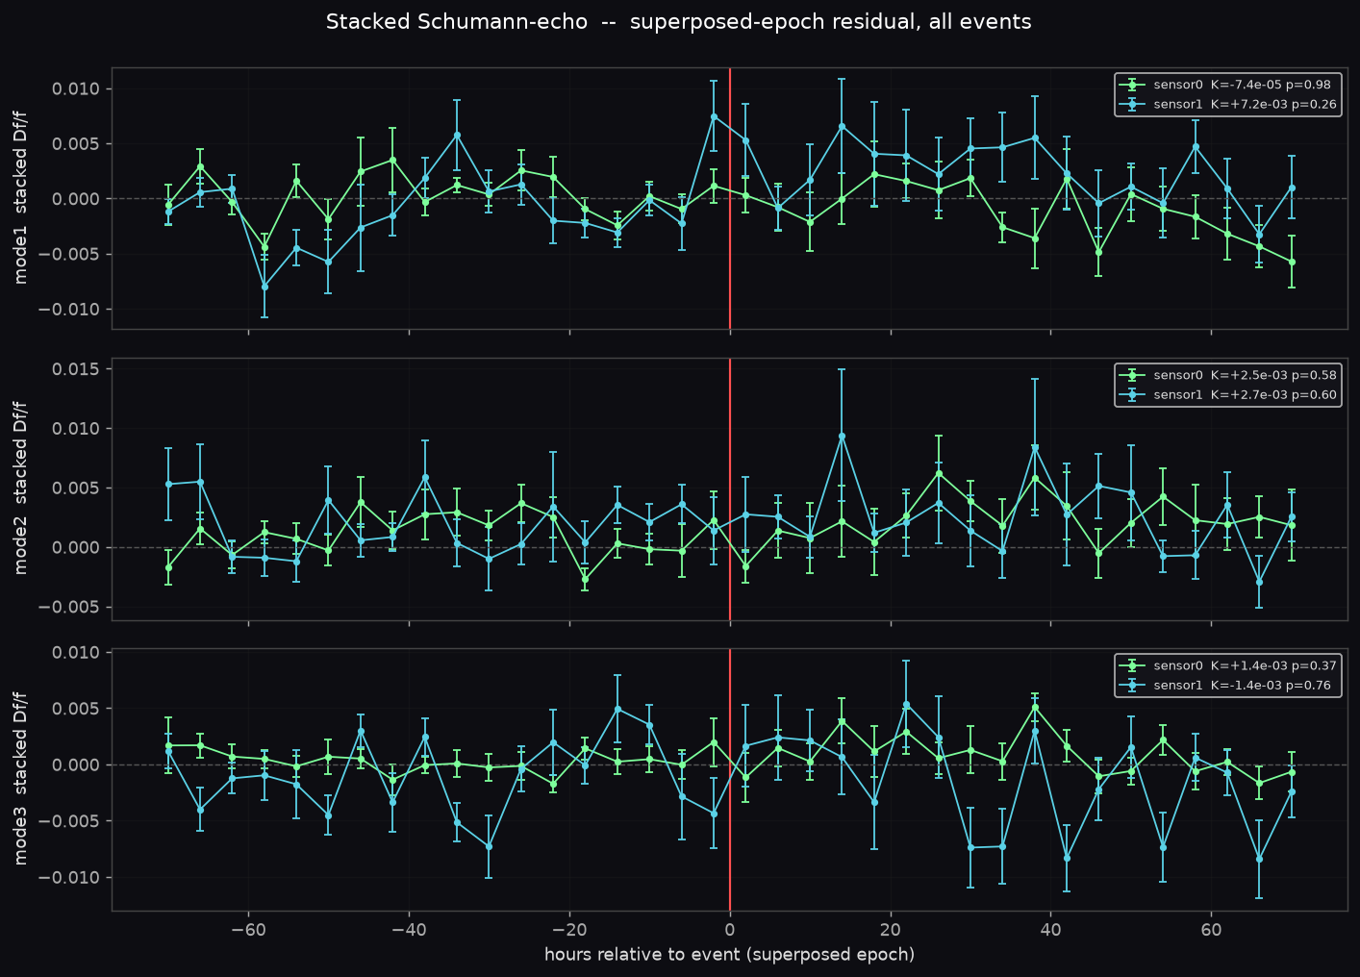
Figure 1. Event-aligned (superposed-epoch) fractional frequency residual for the three Schumann modes (rows) on both channels (colours), with the earthquake time at the vertical line. The residuals scatter about zero with no coherent step or decay at or after the event on either channel, consistent with the null result in Table 2.

5.5 Why nominal significance is misleading here
One combination illustrates the central methodological point. On Channel B, mode 1 returns a stacked amplitude K = +7.2 × 10⁻³ against a standard error of 9.3 × 10⁻⁴ — a nominal ratio of about 7.7, which under naive Gaussian statistics would read as a decisive detection. It is not. The permutation test returns placebo-p = 0.26, meaning the correlated-noise null routinely produces stacked amplitudes this large at random alignment times. Moreover the same mode on the orthogonal channel (Channel A) is consistent with zero (K = −7.4 × 10⁻⁵). Because both channels observe the same cavity, a real Schumann-frequency shift must appear identically in both (common mode); an apparent shift present in one channel and absent in the other cannot be a cavity effect. The empirical significance and the common-mode requirement together dissolve the apparent detection — which is precisely the failure mode the permutation and dual-channel design are intended to catch.

6. Result
Null. No stacked Schumann frequency shift and no magnitude-dependent trend survive the permutation test on either channel, and the instrument control is stable. The experiment sets a population-level two-sigma upper limit on any seismically-triggered fractional shift of the Schumann resonances for magnitude ≥ 7.5 events of |Δf/f| < 3.1 × 10⁻³ (most conservative), with the best-constrained mode reaching |Δf/f| < 1.6 × 10⁻³.

7. Interpretation and sensitivity
The upper limit is one to two orders of magnitude above the predicted amplitude of ≈ 10⁻⁴. The null therefore constrains the effect but does not reach the level at which the prediction lives: it neither confirms nor refutes a 10⁻⁴ shift, because the experiment is not yet sensitive to that amplitude. The limiting factor is the hour-to-hour scatter of the measured mode frequencies, a few parts in 10³ fractionally, set by natural ionospheric variability and by the geometry of a single observing station.
Pushing the limit toward 10⁻⁴ would require substantially more events. Lowering the magnitude threshold does add events, but the predicted echo is expected to shrink with decreasing magnitude, so weaker events dilute the stack roughly as fast as they accumulate. This tension implies a structural sensitivity floor set by how many large earthquakes the record contains, and it is the reason a single mid-latitude station is unlikely to reach the predicted amplitude regardless of processing. A definitive test at the 10⁻⁴ level would need either a longer record spanning more great earthquakes or a multi-station network permitting common-mode rejection of local interference.
Because no shift is detected, the conformal-versus-shear (trace-free) discrimination is not addressed here; the inconsistent mode-to-mode and channel-to-channel signs in Table 3 are consistent with noise and carry no mechanistic information.

8. Controls and threats to validity
- Timing artifacts. The inert 45.6 Hz control line is stable on both channels, excluding a sampling-rate or clock drift masquerading as a frequency shift.
- Common-mode requirement. Results are required to reproduce on two orthogonal magnetic channels observing the same cavity; single-channel excursions are rejected as non-geophysical.
- Diurnal confound. The day/night ionospheric cycle is removed with a pre-event hour-of-day template so that ordinary daily variation is not mistaken for an event-locked transient.
- Correlated noise. Significance is empirical, from time-shift permutations, rather than nominal Gaussian, which would overstate confidence given the correlated residuals.
- Multiple comparisons. A Bonferroni threshold is applied across the six mode-and-channel tests.
- Calibration. Only calibration-independent quantities (mode frequency and quality factor) are used, so the absence of an absolute magnetic calibration does not bias the result.
Residual caveats. A single station cannot, by itself, separate a global cavity response from local electromagnetic interference; the coverage audit removes only a small number of events lost to data gaps, but all 25 M ≥ 7.5 events used here are covered; and the analysis is sensitive only to a prompt, decaying shift of the form assumed, not to hypothetical responses of very different temporal shape.

9. Conclusion
A validated event-aligned stacking analysis of four years of dual-axis ELF magnetic-field data finds no seismically-triggered shift of the Schumann resonance frequencies following magnitude ≥ 7.5 earthquakes. The combined two-sigma upper limit, |Δf/f| < 1.6–3.1 × 10⁻³, is the tightest population-level bound this station and event population can produce, and it is consistent with zero. The predicted spacetime-foam echo, if real at the ≈ 10⁻⁴ level, lies below the sensitivity attainable here; reaching it would require a longer record or a multi-station network. The result is reported as a quantified null.
Data and methods provenance
Sources: dual-axis ELF induction-coil magnetometer archive (two horizontal magnetic components, 256.0164 Hz, 2013–2017); earthquake parameters from the USGS ANSS ComCat catalogue. Techniques: Welch power spectral estimation; Lorentzian line-shape fitting on a local linear baseline; hour-of-day diurnal template subtraction; matched-filter amplitude estimation; inverse-variance-weighted superposed-epoch stacking; time-shift permutation significance testing; variance-weighted magnitude regression; Bonferroni multiple-comparison correction; and an inert-spectral-line instrument/clock control.

