*Muribaculaceae* genomes assembled from metagenomes suggest genetic drivers of differential response to acarbose treatment in mice

Byron J. Smith1

Richard A. Miller2

Thomas M. Schmidt3,*

1Gladstone Institutes, San Francisco, CA, USA  
2Department of Pathology and Geriatrics Center, University of Michigan, Ann Arbor, MI, USA  
3Department of Internal Medicine, University of Michigan, Ann Arbor, MI, USA

*Corresponding Author: [schmidti@umich.edu](mailto:schmidti@umich.edu)

# Heading 1

## Heading 2

### Heading 3

First Paragraph

Body Text

Block text (whatever that means).

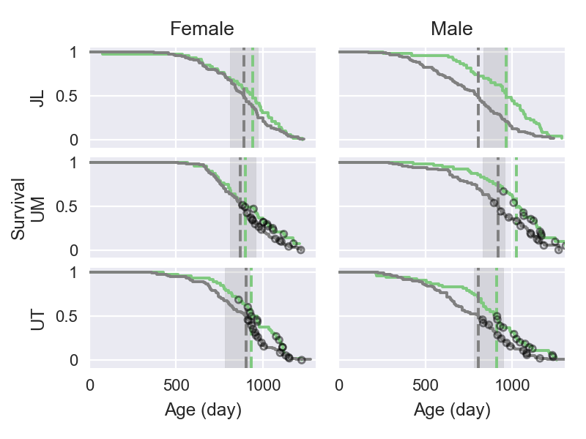

**Figure** **bolded_figure_name**: Image Caption

**Table bolded_table_name**: Table Caption

|  |  |  |  |
| --- | --- | --- | --- |
| Table Heading (“Compact”) | % control (IQR) | % ACA (IQR) | ACA : Control |
| S24-7 | 31.0 (21.5, 43.3) | 48.3** (35.3, 61.8) | 2.7** |
| Lachnospiraceae | 26.6 (16.0, 41.6) | 24.0 (9.5, 37.5) | 1.8 |
| Ruminococcaceae | 14.0 (8.9, 18.6) | 11.6* (6.3, 15.3) | 1.4 |
| Lactobacillaceae | 9.4 (1.2, 16.9) | 2.6* (1.0, 8.2) | 0.41 |
| Erysipelotrichaceae | 1.3 (0.3, 6.2) | 0.5* (0.2, 2.2) | 0.58 |

# Heading 1

Bibliography: Lagkouvardos, Ilias, Rüdiger Pukall, Birte Abt, Bärbel U Foesel, Jan P Meier-Kolthoff, Neeraj Kumar, Anne Bresciani, et al. 2016. “The Mouse Intestinal Bacterial Collection (miBC) provides host-specific insight into cultured diversity and functional potential of the gut microbiota.” *Nature Microbiology* 1 (August). Nature Publishing Group: 16131. doi:[10.1038/nmicrobiol.2016.131](http://doi.org/10.1038/nmicrobiol.2016.131) (Hyperlink).