Changes in the gut microbiota and fermentation products associated with enhanced longevity in acarbose-treated mice.

Byron J. Smith

Richard A. Miller

Aaron C. Ericsson

Randy Strong

David E. Harrison

Thomas M. Schmidt

# Results

## Description of the study population

The mice included in this study were randomly selected from the surviving members of larger cohorts of mice at each study site. Fecal pellets were collected from mice between 109 and 137 weeks of age, with a single mouse randomly sampled from each cage. (see **Figure survival_sample**). Visual inspection of the overall survival curves confirms that pellets were collected from a representative sample of the mice surviving to the age of collection.

144 samples were chosen for collection, from 12 male and 12 female mice, from each of three sites, and from both control and ACA treatment groups. One sample from an ACA female at JL was dropped entirely (neither sequence data nor metabolite data obtained), In addition, metabolite data was not collected for a second ACA female at JL, an ACA female at UM, and a control male at UT. Associated survival data was collected for all 96 samples from UT and UM, but not JL.

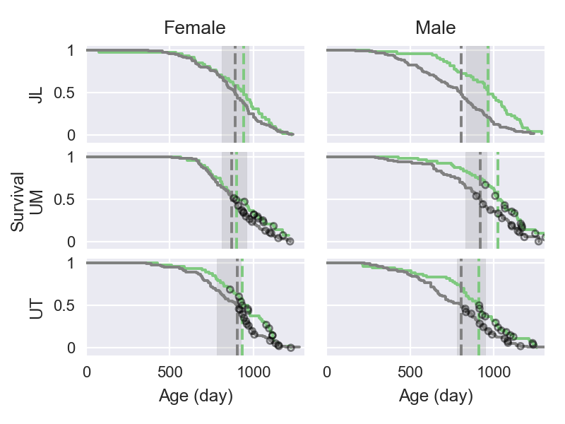

**Figure survival_sample**: Mouse survival curves for replicate cohorts from which fecal samples were collected. 48 samples each were collected from each of three sites, with a balanced factorial design over sex and treatment group: mice fed a control diet (grey lines), or mice fed the same diet amended with 1000 ppm ACA (green lines). Median longevity for each group of mice is indicated by a vertical line. Mice were collected from 111 to 137 weeks of age. The shaded region on each panel indicates the range of ages at collection for that site and sex. The age at death of sampled mice for which matching longevity data is available are indicated on the survival curves (black circles). All sampled mice were dead at the time of analysis.

Table **aca_family**: (IQR: Interquartile Range, *: p < 0.05, **: p < 0.001 via Mann Whitney U test)

|  |  |  |  |
| --- | --- | --- | --- |
| family | % control (IQR) | % ACA (IQR) | ACA : Control |
| S24-7 | 31.0 (21.5, 43.3) | 48.3** (35.3, 61.8) | 2.7** |
| Lachnospiraceae | 26.6 (16.0, 41.6) | 24.0 (9.5, 37.5) | 1.8 |
| Ruminococcaceae | 14.0 (8.9, 18.6) | 11.6* (6.3, 15.3) | 1.4 |
| Lactobacillaceae | 9.4 (1.2, 16.9) | 2.6* (1.0, 8.2) | 0.41 |
| Erysipelotrichaceae | 1.3 (0.3, 6.2) | 0.5* (0.2, 2.2) | 0.58 |

# Citations

Lagkouvardos, Ilias, Rüdiger Pukall, Birte Abt, Bärbel U Foesel, Jan P Meier-Kolthoff, Neeraj Kumar, Anne Bresciani, et al. 2016. “The Mouse Intestinal Bacterial Collection (miBC) provides host-specific insight into cultured diversity and functional potential of the gut microbiota.” *Nature Microbiology* 1 (August). Nature Publishing Group: 16131. doi:[10.1038/nmicrobiol.2016.131](http://doi.org/10.1038/nmicrobiol.2016.131).