Title titles title title tiles

Byron J. Smith1

Test A. Test*

1Gladstone Institutes, San Francisco, CA, USA

*Corresponding Author: [test@test.com](mailto:test@test.com)

# Heading 1

## Heading 2

### Heading 3

#### Heading 4

First Paragraph First Paragraph First Paragraph First Paragraph First Paragraph First Paragraph First Paragraph First Paragraph First Paragraph First Paragraph First Paragraph First Paragraph First Paragraph First Paragraph First Paragraph First Paragraph First Paragraph

Body Text Body Text Body Text Body Text Body Text Body Text Body Text Body Text Body Text Body Text Body Text Body Text Body Text Body Text Body Text Body Text Body Text Body Text Body Text Body Text Body Text Body Text Body Text Body Text Body Text Body Text

Block text (whatever that means).

SupplementaryTablesS1-8.xlsx

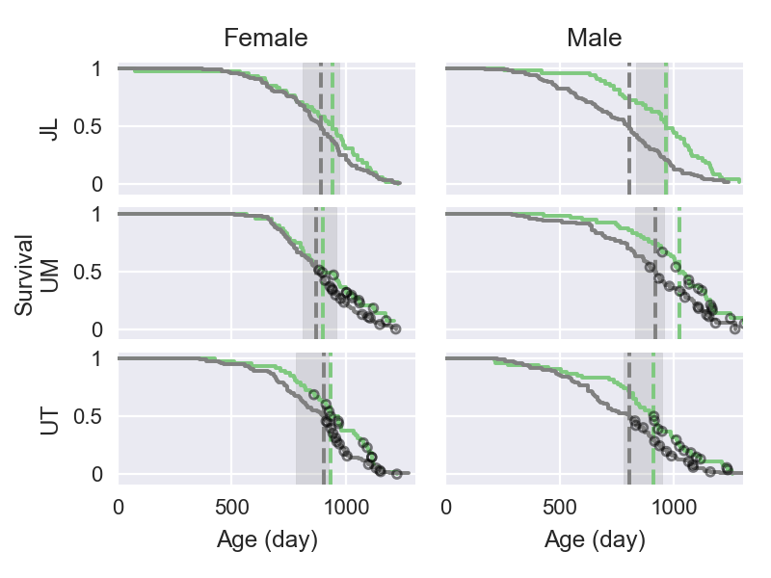

Figure bolded_figure_name: Image Caption

Table bolded_table_name: Table Caption

|  |  |  |  |
| --- | --- | --- | --- |
| Table Heading (“Compact”) | % control (IQR) | % ACA (IQR) | ACA : Control |
| S24-7 | 31.0 (21.5, 43.3) | 48.3** (35.3, 61.8) | 2.7** |
| Lachnospiraceae | 26.6 (16.0, 41.6) | 24.0 (9.5, 37.5) | 1.8 |
| Ruminococcaceae | 14.0 (8.9, 18.6) | 11.6* (6.3, 15.3) | 1.4 |
| Lactobacillaceae | 9.4 (1.2, 16.9) | 2.6* (1.0, 8.2) | 0.41 |
| Erysipelotrichaceae | 1.3 (0.3, 6.2) | 0.5* (0.2, 2.2) | 0.58 |

# Heading 1

Bibliography: Lagkouvardos, Ilias, Rüdiger Pukall, Birte Abt, Bärbel U Foesel, Jan P Meier-Kolthoff, Neeraj Kumar, Anne Bresciani, et al. 2016. “The Mouse Intestinal Bacterial Collection (miBC) provides host-specific insight into cultured diversity and functional potential of the gut microbiota.” *Nature Microbiology* 1 (August). Nature Publishing Group: 16131. doi:[10.1038/nmicrobiol.2016.131](http://doi.org/10.1038/nmicrobiol.2016.131) (Hyperlink).