Optimizing Ad Campaigns: A Neural Network Approach to Customer Response Prediction
- ABSTRACT
This project focuses on building a neural network model to predict customer responses to shop advertisement campaigns. By understanding which ads are likely to catch customer interest, this model can help businesses improve their marketing strategies. The model uses 37 features about customers, such as their demographics and shopping behavior. Categorical data is processed using one-hot encoding, while numerical data is normalized to ensure efficient learning. The neural network has an input layer, a hidden layer, and an output layer with six neurons, each representing a possible customer response. Key techniques include using the sigmoid activation function for predicting outcomes, backpropagation to adjust the model's accuracy, and gradient descent for optimization. Early stopping was applied to prevent overfitting and improve performance on new data. The model achieved a validation accuracy of 93.35% and a test accuracy of 92.41%, providing valuable insights for businesses to make better-targeted marketing decisions.

- INTRODUCTION
Predicting customer response to advertisements is important to business as it enables marketers to tailor their campaigns in maximizing their marketing strategies. In today’s competitive landscape, understanding consumer behavior can provide significant advantages in targeting the right audience and maximizing the return on investment for advertising campaigns. However, traditional methods of evaluating customer response, such as surveys or past purchase behavior analysis come with sets of limitations. They often fall short in capturing complex patterns in consumer data. This has made the application of artificial intelligence (AI), particularly neural networks, an exciting and promising approach to solving this problem.

Several studies and traditional methods have aimed to solve the problem of predicting consumer behavior. Early techniques relied on statistical approaches such as regression analysis, which provided useful but limited insights into linear relationships between variables. As computational power increased, machine learning algorithms like decision trees, random forests, and support vector machines were introduced, allowing for more flexibility and accuracy in consumer behavior predictions [1]. However, these models still faced limitations when tasked with capturing more intricate, non-linear relationships that are typical of real-world data. Researchers began turning to neural networks for their ability to learn from large datasets and discover patterns that would be difficult for traditional algorithms to recognize.

AI-driven approaches, including neural networks, have been employed in a wide array of marketing applications, such as customer churn prediction, personalized recommendations, and market segmentation [3]. These methods have shown great promise in improving the accuracy of predictions and automating marketing processes. However, challenges like overfitting, difficulty in generalizing to new or unseen data, and the computational cost of processing large datasets remain obstacles to their broader adoption. As a result, while neural networks offer significant potential, they are not without their drawbacks, especially when scalability and model robustness are important factors.

Case studies from companies that have successfully integrated AI and neural networks into their marketing strategies offer insights into the real-world impact of these technologies. For example, Netflix has utilized an AI-powered recommendation engine that analyzes user behavior to suggest personalized content, significantly enhancing user engagement and retention. By leveraging neural networks, Netflix can offer highly tailored recommendations that traditional methods would struggle to provide. On the other hand, Nielsen, a global leader in market research, continues to rely on traditional methods such as surveys and face-to-face interviews to gain a deeper understanding of consumer preferences [2]. Despite AI's rise, Nielsen’s long-standing methods are still valued for their ability to capture the human element of decision-making.

In this project, a neural network model is designed to predict customer responses to a shop’s advertisement campaign. The model takes a variety of input features, including customer demographics, purchase behavior, and past interactions to predict their responses to various marketing campaigns. The input features include attributes like age, education, income, and purchase history, while the output consists of whether the customer accepted certain campaigns and their general responsiveness to advertisements. The neural network was trained using a backpropagation algorithm with gradient descent to minimize the error between the predicted and actual customer responses. To ensure robust performance, the datasets are split into training, validation, and test sets and employed early stopping to prevent overfitting.

TODO: rewrite after doing results
The results of the neural network demonstrate its ability to effectively predict customer responses to advertisements. With a validation accuracy of 93.35% and a test accuracy of 92.41%, the model shows strong performance in forecasting customer behavior. This neural network provides a robust tool for businesses to better understand their customers and tailor their marketing strategies, accordingly, improving the chances of success in future campaigns.

- OBJECTIVES
The primary objective of this project is to develop and implement a neural network model that accurately predicts customer responses to a shop’s advertisement campaigns. This model aims to assist businesses in optimizing their marketing strategies by providing insights into which advertisements are likely to engage customers effectively.
To achieve this general objective, several specific goals have been set. First, the project focuses on designing and training a neural network that processes 37 input features, including customer demographics and purchasing behavior, to predict the likelihood of customers accepting or responding to specific advertisements. Second, the performance of the neural network will be evaluated using key metrics such as accuracy and loss, ensuring that the model performs well on both validation and test datasets. Lastly, early stopping will be incorporated into the training process to prevent overfitting and enhance the model’s ability to generalize to new, unseen data.

- METHODOLOGY
1. Specification
The neural network model for predicting the results of shop advertisements was implemented using Python. The primary libraries used in the development of the model include NumPy for numerical computations, pandas for data manipulation and processing, and scikit-learn for splitting the dataset. NumPy was chosen for its efficiency in handling matrix operations and mathematical functions, while pandas provided powerful tools for data preprocessing and manipulation. Scikit-learn’s train_test_split function was utilized to partition the dataset into training, validation, and test sets, allowing for proper evaluation of the model’s performance. These libraries were selected due to their robustness, extensive documentation, and compatibility with the data processing and machine learning tasks required.

2. Data Encoding
The data encoding process was crucial for preparing the raw dataset for neural network training. This process involved handling categorical variables and normalizing numerical features to ensure the data was suitable for input into the neural network.
- One-Hot Encoding: Categorical variables, such as Education, Marital_Status, Kidhome, and Teenhome, were transformed into one-hot encoded variables. This method creates binary columns for each category, which allows the neural network to process these features effectively without assuming any ordinal relationship. For example, the Education column was converted into multiple binary columns representing each educational level, and similar transformations were applied to other categorical variables.
- Normalization and Scaling: To standardize numerical features and enhance model performance, normalization was applied to most features. This process scaled the feature values to a range between 0 and 1, which helps accelerate the convergence of the neural network during training. Features (X) such as Dt_Customer were converted to Unix timestamps and then normalized to ensure consistent data representation. Normalization is essential for neural networks because it ensures that all input features contribute equally to the model's learning process, preventing features with larger ranges from dominating the training process.
- Data Splitting: The processed data was divided into training, validation, and test sets. Initially, 70% of the data was allocated to the training set, while the remaining 30% was split equally into validation and test sets. This approach allows the model to be trained on a substantial portion of the data while reserving separate sets for validating and testing its performance, thus ensuring that the model’s generalization ability is properly evaluated.

3. The Neural Network
The neural network was designed to predict the outcomes of advertisement campaigns based on 37 input features. The architecture and training process of the neural network involved several key components:
- Architecture: The neural network consisted of an input layer with 37 neurons corresponding to the input features, a hidden layer with a balanced number of neurons, and an output layer with 6 neurons to predict various campaign responses.
- Activation Function – Sigmoid: The sigmoid activation function was employed in both the hidden and output layers. The sigmoid function, defined as $σ\left(x\right)=\frac{1}{1+e^{-x}}$​, maps input values to a range between 0 and 1, introducing non-linearity into the model. This non-linearity is essential for the network to learn complex patterns and relationships in the data. The sigmoid function was chosen because it provides a smooth gradient, which helps in the optimization process during training.
- Backpropagation: This algorithm was employed to update the model’s weights and biases based on the error between predicted and actual outputs. By computing gradients of the loss function with respect to each parameter, backpropagation adjusted the weights to minimize prediction error. This method was chosen for its effectiveness in training neural networks by systematically improving the model’s accuracy through iterative updates.
- Gradient Descent: Gradient descent was used to optimize the neural network’s parameters. It iteratively adjusted the weights and biases by minimizing the loss function. The learning rate controlled the size of these adjustments, balancing convergence speed with stability. This technique was selected for its proven effectiveness in optimizing neural network parameters and improving model performance.
- Early Stopping: To prevent overfitting and enhance the model’s ability to generalize, early stopping was implemented. Training was halted when validation loss no longer improved, ensuring that the model did not become too tailored to the training data. Early stopping helps maintain the model’s performance on new, unseen data by preventing excessive training that can lead to overfitting.
- Error Calculation – Mean Squared Error (MSE): The loss function used for evaluating the performance of the model was Mean Squared Error (MSE), calculated as $MSE= \frac{1}{n}\sum{{(y- ŷ)}^{2}}$, where y is the expected output and $ŷ$ is the predicted output. MSE measures the average squared difference between the predicted and actual values, providing a quantitative metric for assessing model accuracy. MSE was chosen due to its straightforward interpretation and its sensitivity to large errors, which helps in identifying areas where the model needs improvement.
These methodologies were carefully chosen to align with the specific objectives of developing an accurate predictive model and ensuring reliable performance evaluation. The use of the sigmoid function, backpropagation, gradient descent, early stopping, and MSE reflects best practices in neural network training, as learned from course principles and concepts.

- RESULTS AND DISCUSSION
The neural network model was designed to predict customer responses to a shop’s advertisement campaigns based on various input features. The following section outlines the results obtained from training and testing the model and discusses the implications of these findings.

Training Performance
The training process was conducted with a maximum of 1000 epochs, but early stopping occurred at epoch 101 based on the validation loss. This method was applied to prevent overfitting and to ensure the model could generalize well to unseen data.
The validation accuracy was consistently logged throughout training, starting at epoch 10 with a value of 93.35%. This accuracy remained stable across all subsequent epochs. Additionally, the validation loss started at 0.0701 by epoch 10 and gradually decreased to 0.0608 by epoch 100. The early stopping was triggered once it became apparent that further training would yield little to no improvement.
Validation Accuracy Over Epochs
As seen in Figure 1, the validation accuracy curve shows that the model quickly reached its maximum accuracy by the 10th epoch, remaining steady at 93.35%. This quick convergence demonstrates the efficiency of the model's learning process.
To further illustrate the initial learning phase, a close-up view of the validation accuracy from epoch 1 to epoch 10 is shown in Figure 2. This close-up highlights how the accuracy surged to its final value, reaching stability by the 10th epoch.
Include Figures:
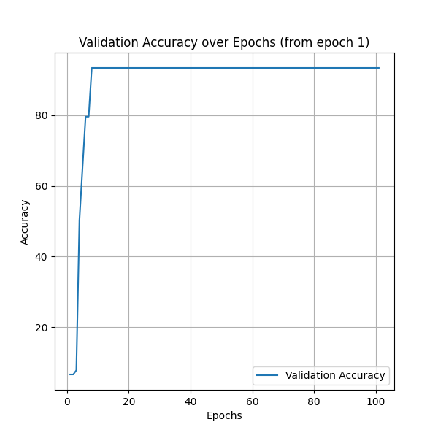
- Figure 1: Validation Accuracy Over All Epochs

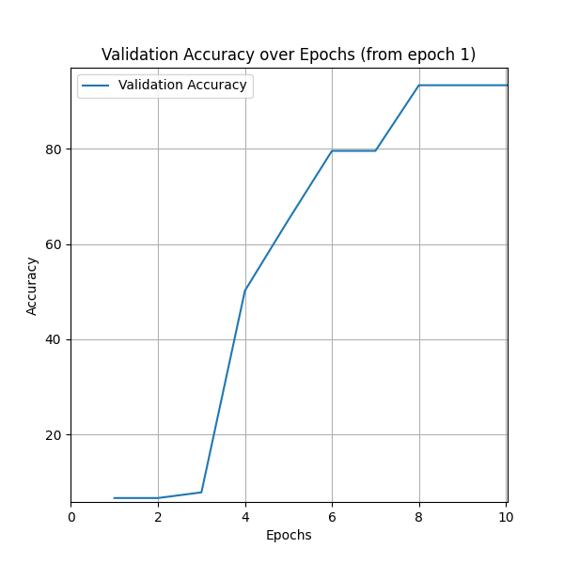
- Figure 2: Close-Up of Validation Accuracy (Epochs 1-10)

Validation Loss Over Epochs
The validation loss curve, depicted in Figure 3, shows a steady decrease from 0.0701 at epoch 10 to 0.0608 at epoch 100. This decline in validation loss suggests that the model was minimizing error over time without any signs of overfitting.
To better observe the early improvements in loss reduction, Figure 4 provides a close-up view of the validation loss from epoch 1 to epoch 10. This figure clearly illustrates the early phase where significant improvements were made as the loss dropped from its initial values.
Include Figures:
- Figure 3: Validation Loss Over All Epochs
- Figure 4: Close-Up of Validation Loss (Epochs 1-10)

Test Performance
After training was complete, the model achieved a test accuracy of 92.41% on unseen data. The small difference between the validation accuracy (93.35%) and test accuracy (92.41%) indicates that the model generalized well and did not overfit to the training data. This is a positive indicator of the model's reliability for practical applications.
Discussion
The results demonstrate that the model converged quickly and maintained high accuracy with minimal fluctuations. The validation accuracy, which stabilized early in the training process, suggests that the model efficiently learned patterns in the data. The validation loss, while decreasing steadily, reached a plateau, indicating that the model had maximized its learning potential by epoch 100.
The close-up views of the first 10 epochs provide additional insight into the early learning dynamics of the model. The rapid improvements in both accuracy and loss during this phase indicate that the model learned key features quickly.

- CONCLUSION
This project developed a neural network model to predict customer responses to advertisement campaigns. The goal was to help businesses optimize their marketing strategies by identifying which advertisements are more likely to engage customers. Using 37 input features, including demographics and purchasing behavior, the model was trained to classify customers based on their likelihood of responding to specific advertisements.
The results showed that the model achieved a validation accuracy of 93.35%, which remained stable from epoch 10 onwards. Additionally, the validation loss decreased gradually from 0.0701 at epoch 10 to 0.0608 at epoch 100, indicating steady improvement. Early stopping was applied, allowing the training process to halt when further improvements became minimal, thus preventing overfitting and enhancing the model’s ability to generalize to new data.
The final test accuracy of 92.41% suggests that the model performs well on unseen data, making it a reliable tool for predicting customer engagement in real-world settings. This level of accuracy indicates that the model can effectively assist businesses in understanding which advertisements resonate more with their audience, potentially leading to better-targeted marketing efforts.
Future improvements could involve experimenting with different neural network architectures or adding more features to capture other aspects of customer behavior. By refining the model further, it could become even more accurate and provide deeper insights into customer engagement. Overall, this project demonstrates the potential of neural networks in supporting business decisions related to advertising and customer engagement.

- REFERENCES
- [1] J. Xiong, “An introduction to statistical machine learning,” Jun. 30, 2023. Available: https://www.datacamp.com/tutorial/unveiling-the-magic-of-statistical-machine-learning

- [2] I. Von Aulock, “AI vs. Traditional Methods: A Comprehensive Comparison for Audience Behavior Analysis in 2024,” Penfriend.ai, Jun. 28, 2024. https://penfriend.ai/blog/ai-vs-traditional-methods#:~:text=Artificial%20Intelligence%2C%20with%20its%20precision,in%20strategizing%20their%20efforts%20wisely.
- [3] A. Haleem, M. Javaid, M. A. Qadri, R. P. Singh, and R. Suman, “Artificial intelligence (AI) applications for marketing: A literature-based study,” International Journal of Intelligent Networks, vol. 3, pp. 119–132, Jan. 2022, doi: 10.1016/j.ijin.2022.08.005. Available: https://www.sciencedirect.com/science/article/pii/S2666603022000136

- APPENDIX

