Project for the Degree of B.Sc. Engineering

KNOWLEDGE SHARING

Md. Murad Hossain

Student ID : 20151201034

Supervised by

Maimuna Begum Kali

Lecturer

Department Of Computer Science and Engineering

Bangabandhu Sheikh Mujibur Rahman Science
and Technology University, Gopalganj-8100

Submission Date : 27.01.2019

Project Approval

Md. Murad Hossain
Student ID : 20151201034

KNOWLEDGE SHARING

We the undersigned, recommend that the project completed by the student listed above, in partial fulfillment of B.Sc. Engineering degree requirements, be accepted by the Department of Computer Science and Engineering, Bangabandhu Sheikh Mujibur Rahman Science and Technology University for deposit.

Supervisor Approval

……………………………………

Maimuna Begum Kali

Lecturer

Department of Computer Science and Engineering

Bangabandhu Sheikh Mujibur Rahman Science and Technology University, Gopalganj-8100

Dedicated to
Maimuna Begum Kali
Lecturer
Department of computer Science and Engineering

Bangabandhu Sheikh Mujibur Rahman Science and Technology University, Gopalganj-8100

Abstract

Knowledge Sharing is a web based application which shares your problems and gets your problem’s solution. Basically it is a one kind management project which will be many users, the question of these users and answers of these users whose replies. With recent development in Internet Technology and its wider acceptance and popularity, there are many gather knowledge using web technologies. This project helps our departmental courses, any different kinds of problem face, so ask your questions and if you know so you will give the answer. So it’s a better problem and these solution sharing management for enlarging our knowledge.

iv
Acknowledgement

It is very special moment; first and foremost, I would like to express my heartiest gratitude to the almighty Allah for allowing me to accomplish this project successfully. This is my third academic project and I tried my best to make an impressive project. However I faced some problems to complete my project, although it is completed and I am really thankful and would like to express my deepest appreciation to my friends who have contribute a lot to finish my project. I also thankful to my senior brothers who also helped me to find my project ideas and support me to finish the project. And especially I am grateful to my respected teacher Maimuna Begum Kali for inspiring me a lot in my project.

Md. Murad Hossain
ID : 20151201034

v
Table of Contents

PAGE NO.
ABSTRACT iii
ACKNOWLEDGEMENT v

CAHPTER 1: INTRODUCTION 8
1.1 Introduction 8
1.2 Objectives 8
1.3 Motivation 8

CAHPTER 2: RELATED WORKS 9-10
2.1 Introduction 9
2.1.1 Quora 9
2.1.2 Stack Overflow 10
2.1.3 Programabad 11

CAHPTER 3: METHEDOLOGY 10-15
3.1 E-R Diagram 10

CAHPTER 4: IMPLEMENTATION 12-18
4.1 Required Tools 12
4.1.1 PhpStorm 12
4.1.2 Google Chrome 12
4.2 Working Language 13
4.2.1 Object Oriented Programming PHP 13
4.2.2 MySql 14
4.3 Fundamental Concept 14
4.4 Page Representation 14
4.4.1 Home Page 14
4.4.2 Details Page 15
4.4.3 Login Page 16
4.4.4 Register Page 17
4.4.5 Question Page 18
CAHPTER 5: LIMITATIONS OF WORKS 19
5.1 Limitation 19 5.2 Future Work 19

CAHPTER 6: CONCLIUSION 20
6.1 Conclusion 20
REFERENCES 21

List of Figure

1.1 – Home Page 15
1.2 – Details Page 16
1.3 – Login Page 16
1.4 – Register Page 17
1.5 – Question Page 18
1.6- E-R Diagram 11

Chapter 1: Introduction

1.1 Introduction
Knowledge Sharing is a web based application using object oriented programming php language. It is such a process of creating, sharing, using and managing the knowledge and information of our departmental course related problems. It refers to a multidisciplinary approach to achieving objectives by making the best use of knowledge. If anyone faces the departmental course related problems, share your questions easily. Anyone reply to the answer of sharing the question but must registered user of these applications. The whole concept of this websites is based on the opportunity to exchange the content within a community.
1.2 Objectives
To share your knowledge easily with your friends, seniors, juniors in your department. To help the getting real answer according to the questions. To get a huge information specific a topics of our departmental courses.
1.3 Motivation
Knowing about Programabad, Quora, Stack Overflow. This application works Question-Answer, works huge amount of Information and also many categories. So I motivated by the application but only my departmental course related topics. Anyone can question-answer English and also Bengali language which is best help our newcomers of our department.

8
Chapter 2: Related Works

2.1 Introduction
This application works question and answer but user registration must needed. Here huge amount of category, so anyone asks the questions any topics, any categories but Knowledge Sharing Application only works our departmental course related problems. There are many web based application like Knowledge Sharing. Some of examples are given below
- Quora
- Stack OverFlow
- Programabad
2.1.1 Quora
Quora is a question-answer website where questions are asked, answered, edited, and organized by its community of users in the form of opinions. Its publisher, Quora is based in Mountain View, California. The company was founded in June 2009, and the website was made available to the public for the first time on June 21, 2010. Users can collaborate by editing questions and suggesting edits to answers that have been submitted by other users.
Quora requires users to register with the complete form of their real names rather than the screen name although verification of names is not required, false names can be reported by the community. This was done with the ostensible intent of adding credibility to answers. Users with a certain amount of activity on the website have the option to write their answers anonymously but not by default. Visitors unwilling to log in or use cookies have had to resort to workarounds to use the site. Users may also log in with their Google and Facebook accounts by using the OpenID protocol. They can upvote or downvote answers and suggest edits to extant answers provided by other users. The Quora community includes some well-known people such as Jimmy Wales, Richard A. Muller, Justin Trudeau, Barack Obama, Hillary Clinton as well as many current and former professional athletic personalities.
Quora allows users to create user profiles with visible real names, photos, site use statistics etc which users can set to private. In August 2012 blogger Ivan Kirigin pointed out that acquaintances and followers could see his activity, including which
9
questions he had looked at. In response, Quora stopped showing question views in feeds later that month. By default, Quora exposes its users' profiles, including theirreal names, to search engines. Users can disable this feature.
2.1.2 Stack Overflow
Stack Overflow is a question and answer site for professional and enthusiast programmers. It is a privately held website, the flagship site of the Stack Exchange Network. The website serves as a platform for users to ask and answer questions and through membership and active participation, to vote questions and answers up or down and edit questions and answers in a fashion similar to a Digg. Users of Stack Overflow can earn reputation points and badges, for example, a person is awarded 10 reputation points for receiving an "up" vote on an answer given to a question and 5 points for the "up" vote of a question, and can receive badges for their valued contributions which represents a kind of gamification of the traditional Question-Answer site. Users unlock new privileges with an increase in reputation like the ability to vote, comment, and even edit other people's posts. All user-generated content is licensed under a Creative Commons Attribute-ShareAlike license.
2.1.1 Programabad
This website is also Question-Answer website but Programming based website in Bengali Language.

10
Chapter 3: METHEDOLOGY

3.1 E-R Diagram

QUESTION
Id
Title
Category
Content
Author

ANSWER
Id
Question_no
Name
Ans_content

USER
Id
Name
Email
Password
District

11
Chapter 4 : Implementation Details

4.1 Required Tools
The tools required to develop the program are given below:
- PhpStorm (Editor)
- Google Chrome
4.1.1 PhpStorm
JetBrains PhpStorm is a commercial, cross-platform IDE (integrated development environment) for PHP built on JetBrains IntelliJ IDEA platform.
PhpStorm provides an editor for PHP, HTML and JavaScript with on-the-fly code analysis, error prevention and automated refactorings for PHP and JavaScript code. PhpStorm's code completion supports PHP 5.3, 5.4, 5.5, 5.6, 7.0, 7.1, and 7.2(modern and legacy projects), including generators, coroutines, the finally keyword, list in foreach, namespaces,closures, traitsand short array syntax. It includes a full-fledged SQL editor with editable query results.
PhpStorm is built on IntelliJ IDEA, which is written in Java. Users can extend the IDE by installing plugins created for the IntelliJ Platform or write their own plugins.
All features available in WebStorm are included in PhpStorm, which adds support for PHP and databases. WebStorm ships with pre-installed JavaScript plugins (such as for Node.js).
4.1.2 Google Chrome
Google Chrome (commonly known simply as Chrome) is a cross-platform web browser developed by Google. It was first released in 2008 for Microsoft Windows, and was later ported to Linux, macOS, IOS, and Android. The browser is also the main component of Chrome OS, where it serves as the platform for web apps.
Most of Chrome's source code comes from Google's open-source Chromium project, but Chrome is licensed as proprietary freeware. WebKit was the original rendering engine, but Google eventually forked it to create the Blink engine; all Chrome variants except iOS now use Blink.
As of 2018, StatCounter estimates that Chrome has a 61% worldwide browser market share across all platforms. Because of this success, Google has expanded the "Chrome" brand name to other products: Chrome OS, Chromecast, Chromebook, Chromebit, Chromebox and Chromebase.

12
4.2 Working Language
- Object Oriented Programming PHP
- MySql
4.2.1 Object Oriented Programming PHP
Object-oriented programming (OOP) is a programming paradigm based on the concept of “objects” which may contain data, in the form of fields, often known as attributes; and code, in the form of procedures, often known as methods. A feature of objects is that an object's procedures can access and often modify the data fields of the object with which they are associated (objects have a notion of “this” or "self"). In OOP, computer programs are designed by making them out of objects that interact with one another. There is significant diversity of OOP languages, but the most popular ones are class-based, meaning that objects are instances of classes, which typically also determine their type.
Many of the most widely used programming languages (such as C++, Object Pascal, Java, Python etc.) are multi-paradigm programming languages that support object-oriented programming to a greater or lesser degree, typically in combination with imperative, procedural programming. Significant object-oriented languages include Java, C++, C#, Python, PHP, JavaScript, Ruby, Perl, Object Pascal, Objective-C, Dart, Swift, Scala, Common Lisp and Smalltalk.
Hypertext Preprocessor (or simply PHP) is a server-side scripting language designed for web development. It was originally created by Rasmus Lerdorf in 1994; the PHP reference implementation is now produced by The PHP Group. PHP originally stood for Personal Home Page but it now stands for the recursive initialism PHP: Hypertext Preprocessor.
PHP code may be embedded into HTML code, or it can be used in combination with various web template systems, web content management systems, and web frameworks. PHP code is usually processed by a PHP interpreter implemented as a module in the web server or as a Common gateway Interface (CGI) executable. The web server combines the results of the interpreted and executed PHP code, which may be any type of data, including images, with the generated web page. PHP code may also be executed with a command-line interface (CLI) and can be used to implement standalone graphical applications.
The standard PHP interpreter, powered by the Zend Engine, is free softwar released under the PHP License. PHP has been widely ported and can be deployed on most web servers on almost every operating system and platform, free of charge.
The PHP language evolved without a written formal specification or standard until 2014, with the original implementation acting as the de facto standard which other implementations aimed to follow. Since 2014 work has gone on to create a formal PHP specification.

13
4.2.2 MySql
MySQL is an open source relational database management system (RDBMS). Its name is a combination of "My", the name of co-founder Michael Widenius’s daughter, and "SQL", the abbreviation for Structured Query Language.
MySQL is free and open-source software under the terms of the GNU General Public License, and is also available under a variety of proprietary licenses. MySQL was owned and sponsored by the Swedish company MySql AB, which was bought by Sun Microsystems (now Oracle Corporation). In 2010, when Oracle acquired Sun, Widenius forked the open-source MySQL project to create MariaDB.
MySQL is a component of the LAMP web application software stack which is an acronym for Linux,Apache, MySQL, Per/Perl/Python. MySQL is used by many database-driven web applications, including Drupal, Joomla, phpBB, and Wordpress. MySQL is also used by many popular website, including Google (though not for searches), facebook, Twitter, Flickr and YouTube.
4.3 Fundamental Concept
Knowledge Sharing is based on the fundamental concept that one of the most valuable assets of the getting easily solution according to the problem. When a question is asked, experienced users will answer based on their authority and knowledge. Furthermore, users can collaborate on answers to ensure the best possible responses are posted. This high level of quality is also established through the “real names” policy, which requires users to sign-up and post using, you guessed it, their actual names. There’s no hiding behind anonymous screen names, meaning all users are accountable for what they post. It’s a great resource to turn to when conducting research for the writing projects.
4.4 Page Representation
It contains many page of representation of my project output.
4.4.1 Home Page
It contains the total information which contains login, register, question page and showing all questions and link-up with details page.

14
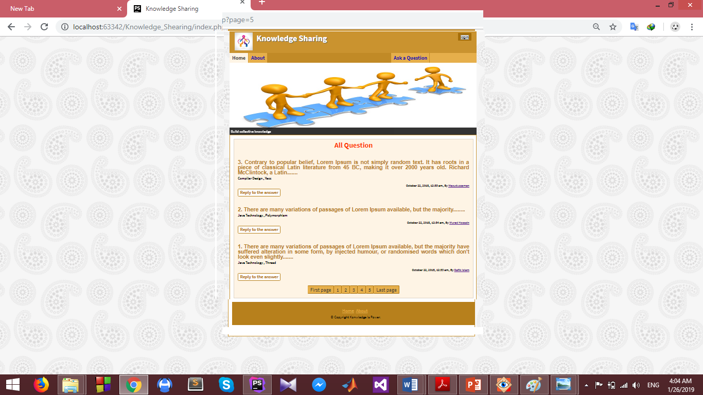
Figure-4.1 Home Page

4.4.2 Details Page
When click to reply to the answer, displaying the total information in a particular question. Containing multiple answer and get the form for replying the questions and answer more and more.

15
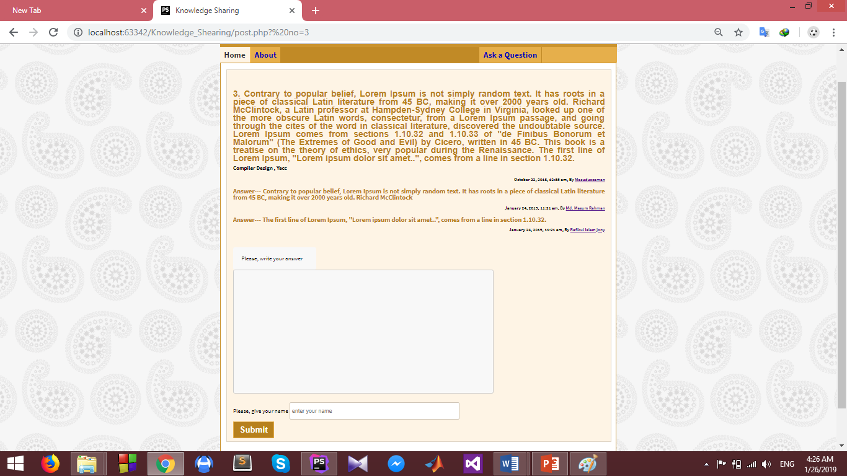
Figure 3.2 Details Page
4.4.3 Login Page
Reply to the answer before must be logged in. Login Page contains the information for login which is connected to the database.
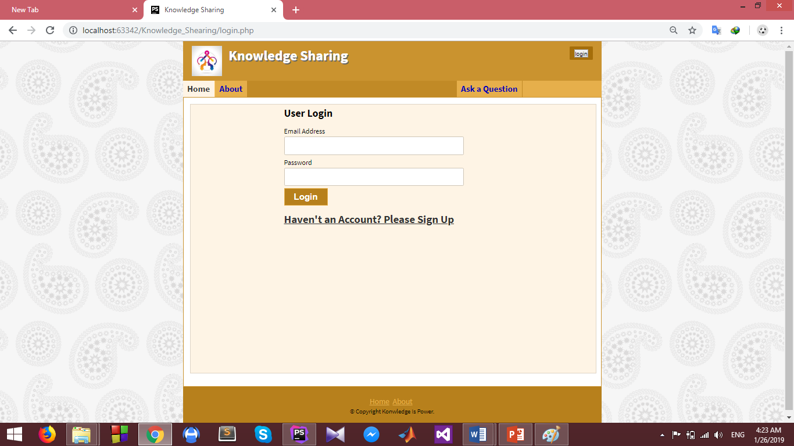
Figure 4.3 Login Page

16
4.4.4 Register Page
It contains the user register information.
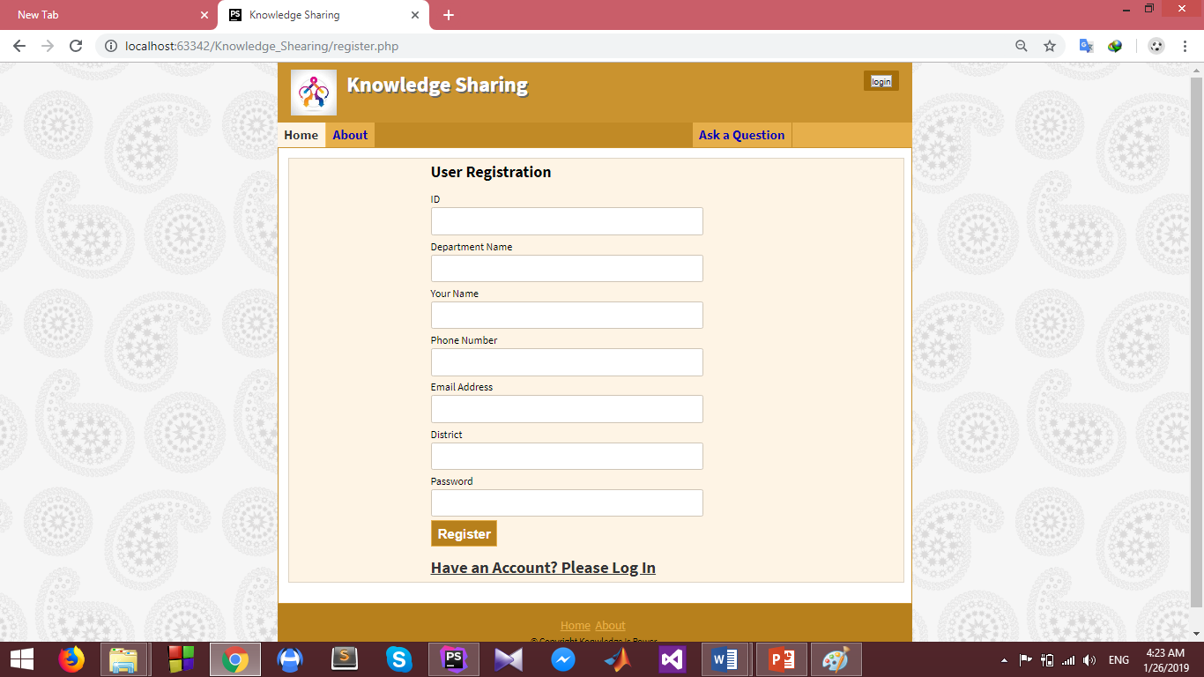
Figure 4.4 Register Page

17
4.4.5 Question Page
When anyone want to ask question, Question Page helps us.
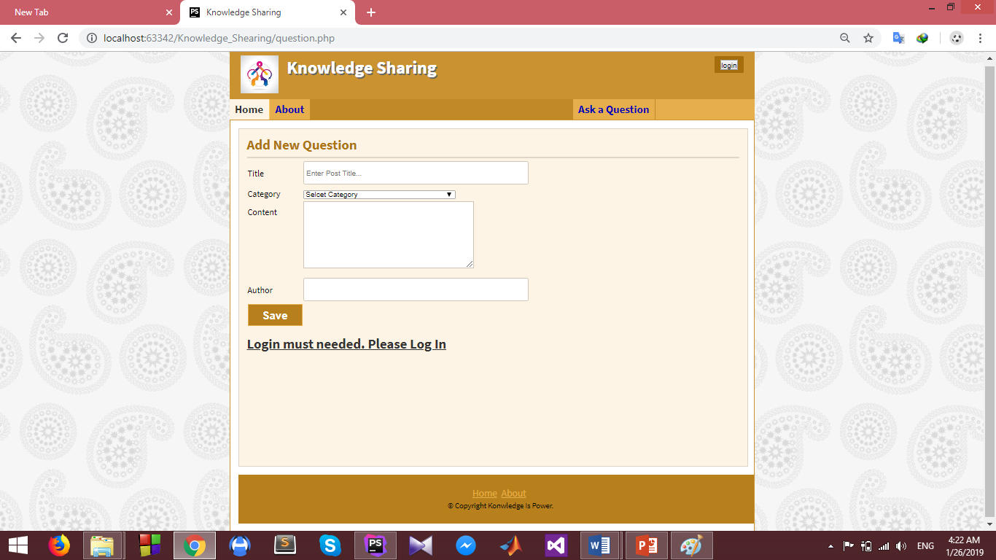
Figure 4.5 Question Page

18
Chapter 5 : Limitations of works

5.1 Limitation
Admin does not maintain the user’s registration. Admin who edit, delete the user’s question and answer’s but does not work in this project.
5.2 Future Scope
Not only our departmental courses but also include all departmental courses in our campus. Different different a great topics included there. Not only a web platform, also included an Android and IOS platform.

19
Chapter 6: Conclusion

6.1 Conclusion
Knowledge Sharing Application specially a great helps our new comers students in cause huge information can get by this. Here, there are many topics can describe in Bengali Language, so it’s a helpful ours.

20
References
- Training with live project
Link- http://www.trainingwithliveproject.com/p/php-tutorials.html
- W3 Schools
Link- https://www.w3schools.com/php/default.asp

21

