**Task 1–**

Program 1

Install Jupyter notebook and run the first program and share the screenshot of the output.Output :-

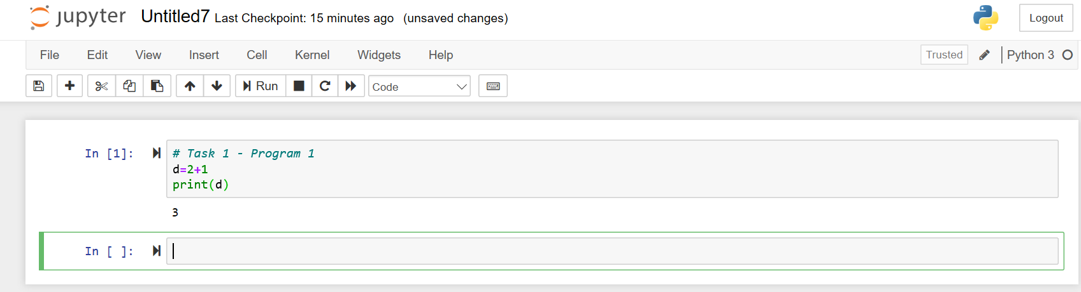

Program – 2

Write a program which will find all such numbers which are divisible by 7 but are not a multiple of 5, between 2000 and 3200 (both included). The numbers obtained should be printed in a comma-separated sequence on a single line.

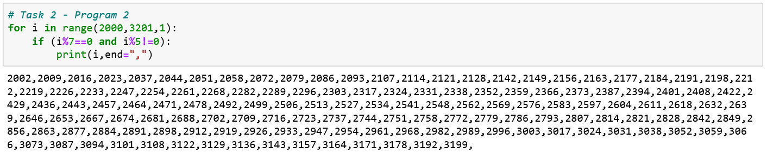

Program – 3

Write a Python program to accept the user's first and last name and then getting them printed in

The reverse order with a space between first name and last name.

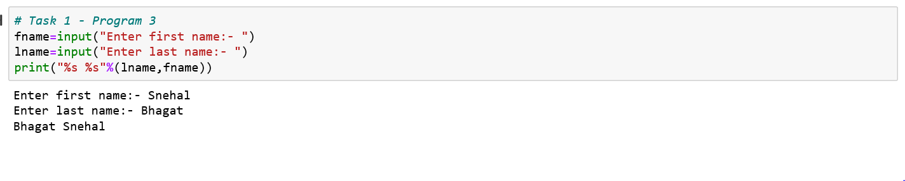

Program -4

Write a Python program to find the volume of a sphere with diameter 12 cm.

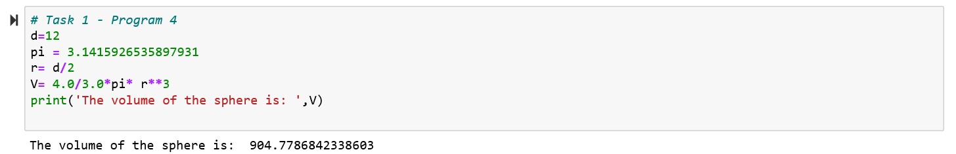

**Task 2**

Program 1 :-

Write a program which accepts a sequence of comma-separated numbers from console and generate a list.

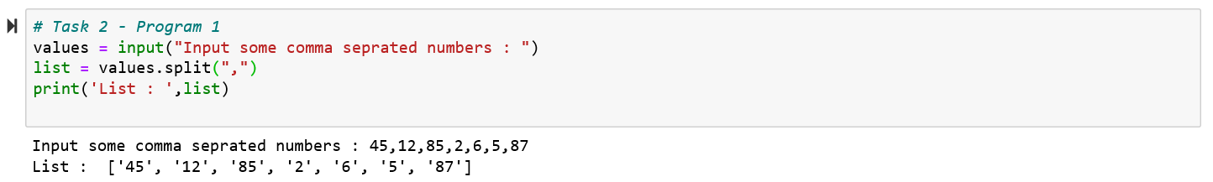

Program 2 :-

Create the below pattern using nested for loop in Python.

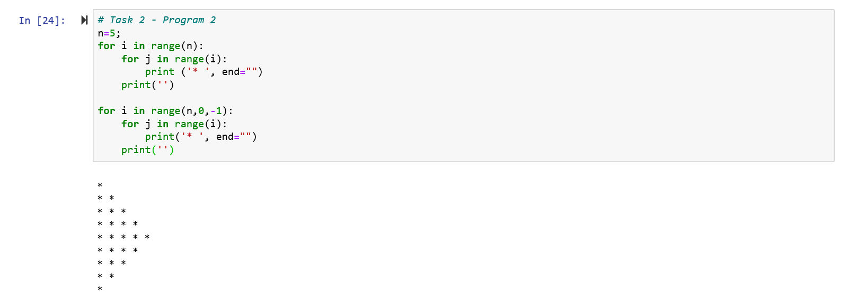

Program 3 :-

Write a Python program to reverse a word after accepting the input from the user.

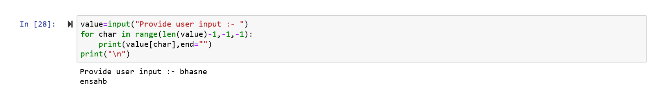

Program 4:-

