Design Document – Quality Assurance – CISC 327

Scripts:

Daily script –

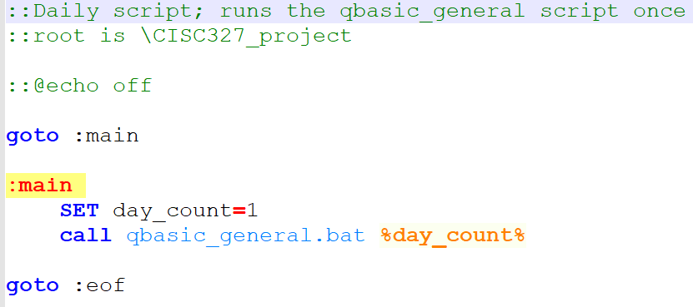

Weekly script –

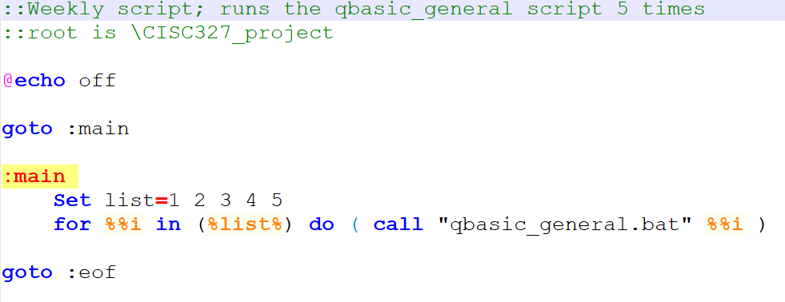

Qbasic_general:

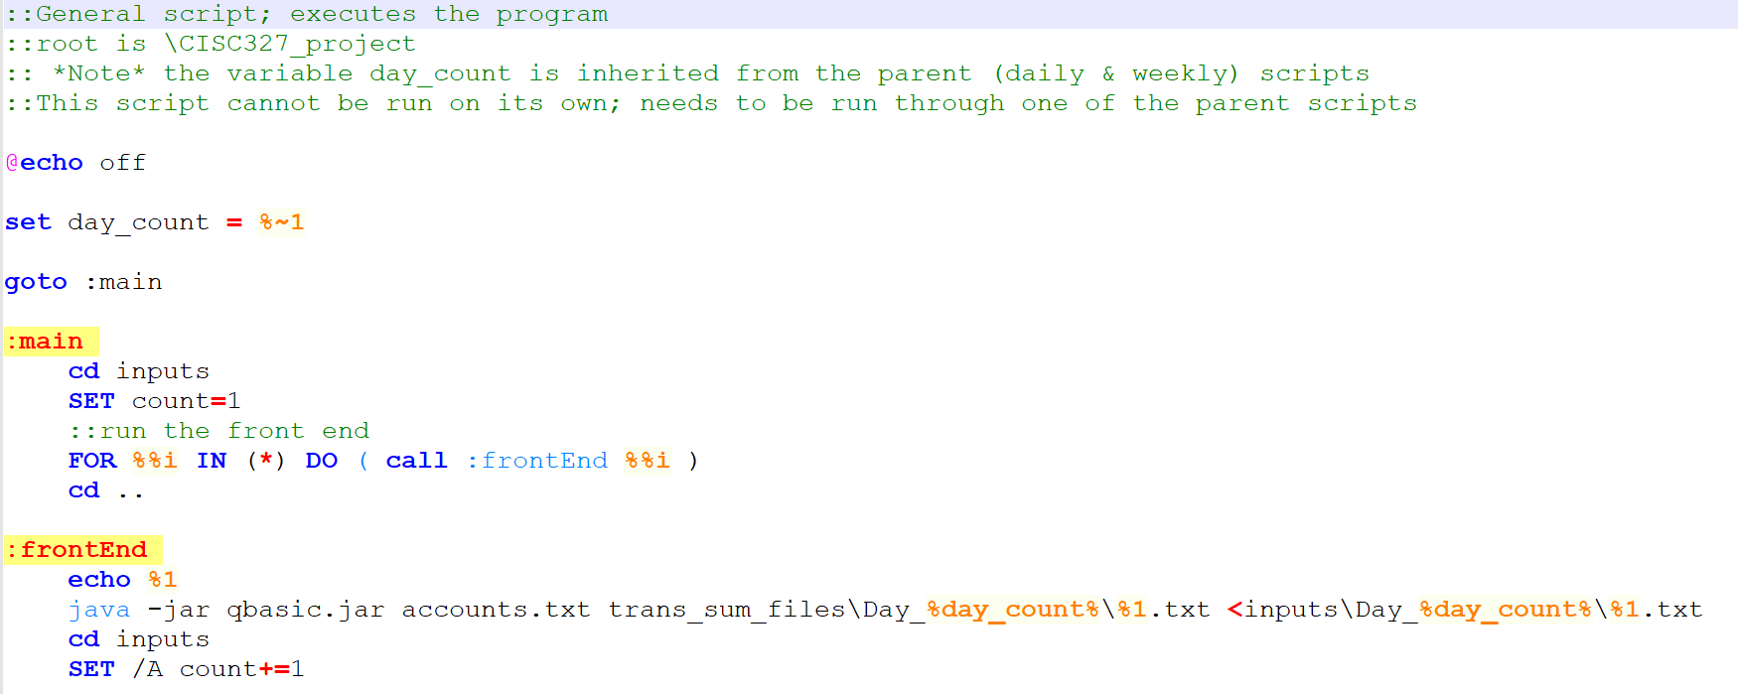

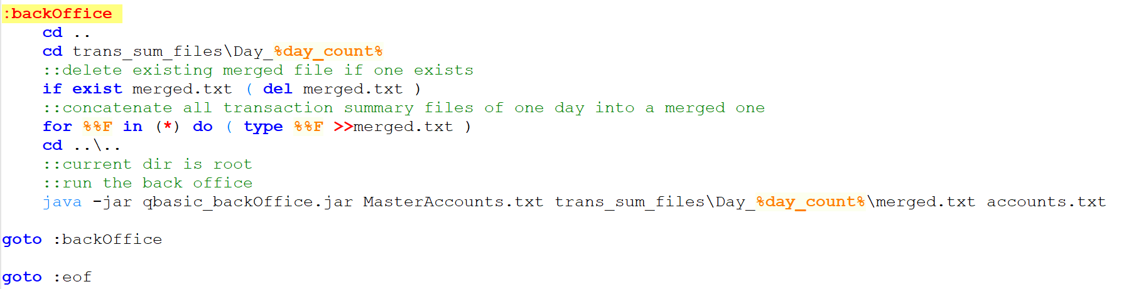

Transaction session inputs – Day 1:

Transaction1:

login

agent

createacct 1234567 test1

createacct 7654321 test2

createacct 9021069 test3

logout

Transaction2:

login

machine

deposit 1234567 50000

deposit 7654321 100000

logout

Transaction3:

login

agent

withdraw 1234567 5000

transfer 7654321 1234567 10000

deleteacct 9021069 test3

logout

Transaction summary file of day1:

TODO

Master Account File:

Day 1: