TestPolyLineMover

**Helps you test an agent moving along a road network.**

## CASE 1

Tests …

**Coordinates:**

C1 (0/0)

C2 (10/0)

C3 (10/15)

C4 (5/15)

C5 (5/20)

**Lines**

l1 : (0/0) -> (10/0) -> (10/15)

l2 : (5/20) -> (5/15) -> (10/15)

Entry Coordinate (4/0)

**Target Coordinate** (6/15)

**Step length:** 5.0

**Results**:

(4/0) -> (9/0) -> (10/4) -> (10/9) -> (10/14) -> (6/15) -> (5/19)

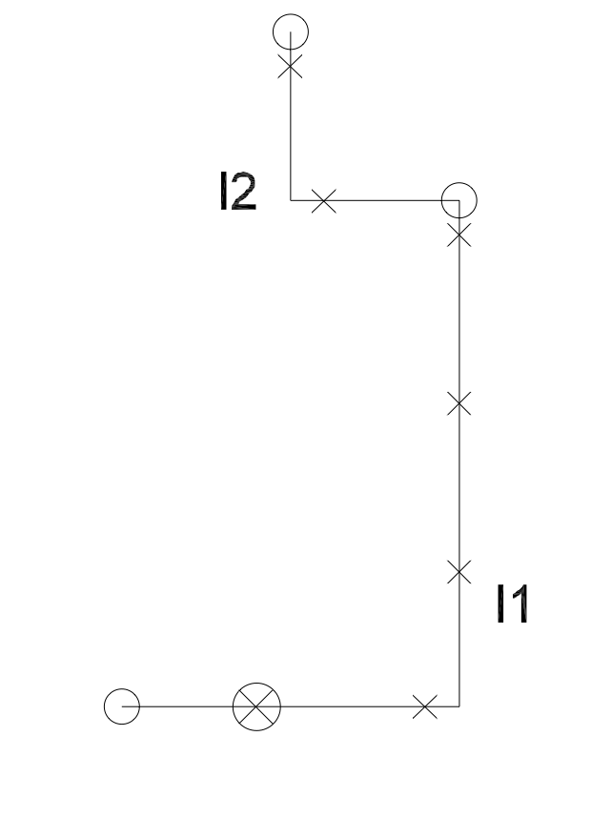

## CASE 2

**Lines**

l1 : (0/0) -> (10/0)

l2 : (10/0) -> (10/2)

l3 : (10/2) -> (10/3)

l4: (10/3) -> (10/4)

l5: (10/15) -> (10/4)

l6: (10/15) -> (5/15) -> (5/20)

**Entry Coordinate:** (4/-2)

**Target Coordinate** (6/15)

**Step Length :** 5.0

**Results**:

(4/0)

(9/0)

(10/4)

(10/9)

(10/14)

(6/15)

## CASE 3

**Testing**

First touchdown after snap on line on segment

**Entry Coordinate:** (4/-2)

First Coordinate on PL (4/0)

**Target Coordinate** (9/10)

Results

(4/0)

(9/0)

(9/5)

(9/10)