**Tensor-based MRSI GUI: Matlab based Graphical User-Interface for Residual Water Suppression and tissue type differentiation in MRSI signals**

Bharath Halandur Nagaraja, Diana Sima, Sabine Van Huffel

December 2018

**Contents:**

1. Introduction ---------------------------------------------------------------------- 2
2. “Tensor-based MRSI GUI’’ folder contents ------------------------------- 2
3. GUI description ------------------------------------------------------------------ 3
   1. Load ---------------------------------------------------------------------------- 3
   2. Load img ----------------------------------------------------------------------- 3
   3. Plot in -------------------------------------------------------------------------- 3
   4. Show ---------------------------------------------------------------------------- 3
   5. Crop ----------------------------------------------------------------------------- 4
   6. Water Suppression ---------------------------------------------------------- 4
      1. HLSVD --------------------------------------------------------------------- 4
      2. Hankel ---------------------------------------------------------------------- 5
      3. Löwner --------------------------------------------------------------------- 5
   7. Tissue type differentiation ----------------------------------------------- 6
      1. NCPD ---------------------------------------------------------------------- 6
      2. NCPD Results ------------------------------------------------------------ 7
      3. Save Fig ------------------------------------------------------------------- 7
   8. Save ---------------------------------------------------------------------------- 7
   9. Other GUI functions -------------------------------------------------------- 8
4. Acknowledgment --------------------------------------------------------------- 9
5. References ------------------------------------------------------------------------ 9

**Introduction:**

This document is the user manual of the MATLAB based graphical user interface (GUI) for residual water suppression and tissue type differentiation in Magnetic Resonance Spectroscopic Imaging (MRSI) signals. The algorithms for residual water suppression and tissue type differentiation are described in [1] and [2], respectively.

This GUI requires two additional MATLAB toolboxes: Tensorlab [3] and Simple Matlab Solver for L1-regularized Least Squares Problems [4]. Before starting, make sure that these toolboxes are installed in MATLAB. In this GUI, all tensor-based analysis is done using “Tensorlab 3.0” package [3].

**Folder contents:**

“Tensor-based MRSI GUI’’ contains the following files

1. All required MATLAB code for using the GUI.
2. User manual named “MRSI_GUI_user_manual” for the GUI
3. One example MRSI dataset named “CSI_spectro_35_SENSE_11_2_raw_act”
4. One background MRI image (for representation only) named “aa_rep_img”.
5. Software License Agreement file. Note that the license specifying the conditions under which this code is distributed admits academic use only. If used for commercial purposes, contact Sabine Van Huffel.



**Load:** To Load the MRSI data

Supported Format:

* {'.spar','.sdat','.SPAR','.SDAT'} 🡪 philips data
* '.mat' 🡪 SPID format

Other formats can be loaded by installing SPID software toolbox [5] [6].

* {'.rda','.RDA'} 🡪siemens data
* {'.ima','.IMA','.dcm'} 🡪 siemens DICOM data
* {'.txt'} 🡪 jMRUI or 3DiCSI data

 **Load img:** To load one slice of background MRI image.

Supported Format:

* ‘.mat’ 🡪 Matlab data matrix
* ‘.jpg’ 🡪 JPEG images
* ‘.png’ 🡪 portable network graphics

Note: Here the loaded MRI image slice is assumed to be co-registered and aligned with the MRSI voxel grid. No co-registration or alignment is performed by this GUI

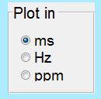

To plot time domain FID in milliseconds

To plot frequency domain Spectrum in Hertz

To plot frequency domain Spectrum in ppm



To plot real part of the signal

To plot imaginary part of the signal

To plot absolute value of the signal

**Residual Water Suppression:**

* To Crop the outer edge voxels from the MRSI grid
* Specify number of voxels to remove from left, right, top and bottom
* To undo cropping
* Total number of signals in MRSI

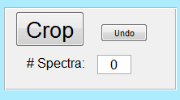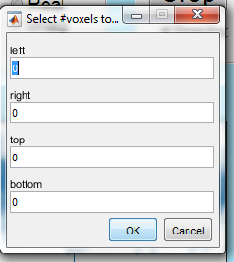

MRSI signals contain information for estimating metabolite concentrations from in-vivo in a non-invasive fashion. Along with clinically relevant components MRSI signals also contain unwanted components such as water, baseline etc. In general, residual water is suppressed before doing any analysis in a pre-processing step. This GUI provides three methods to suppress residual water in MRSI: HLSVD, Hankel-tensor and Löwner-tensor. For details of the water suppression algorithm the user is referred to [1].

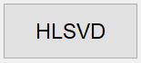**HLSVD:** To suppress residual water using Hankel Lanczos singular value decomposition (HLSVD) method. The HLSVD implementation is part of the SPID software toolbox [5] [6] which is based on [7].

Input required by HLSVD method:

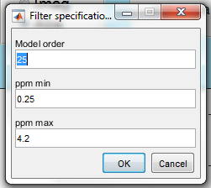

* Model order: Number of sources required to model water and metabolite signals in each voxel of the grid (i.e. order of Hankel expansion of each MRSI signal)
  + Default 🡪50
* ‘ppm’min and ‘ppm max’:
  + Range of frequency in ppm in which the metabolite signal has to be retained.
  + Default 🡪 0.25 – 4.2 ppm



**Hankel:** To suppress residual water using Hankel-tensor method.

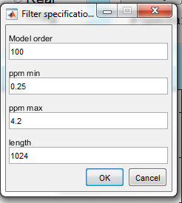

* Model order: Number of sources required to model water and metabolite signals over all voxels in the grid (i.e. order of MLSVD of tensor comprising all Hankel expansions of each MRSI signal as slices)
  + Default 🡪100
* ‘ppm’min and ‘ppm max’:
  + Range of frequency in ppm in which the metabolite signal has to be retained.
  + Default 🡪 0.25 – 4.2 ppm
* length:
  + length of FID in samples used to construct Hankel matrix. Remaining samples longer than “length” are discarded.

Input required by Hankel-tensor method:



**Löwner:** To suppress residual water using Löwner-tensor method.

Input required by Löwner -tensor method:

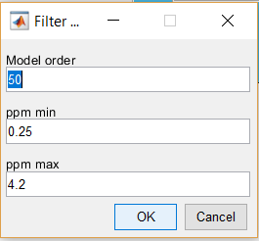

* Model order: Number of sources required to model water and metabolite signals in each voxel of the grid (i.e. the number of first-order rational functions). Additionally, 4 baseline sources modelling a 4-th order polynomial are also included.
  + Default 🡪50
* ‘ppm’min and ‘ppm max’:
  + Range of frequency in ppm in which the metabolite signal has to be retained.
  + Default 🡪 0.25 – 4.2 ppm

**Tissue type differentiation using non-negative canonical polyadic decomposition (NCPD):**

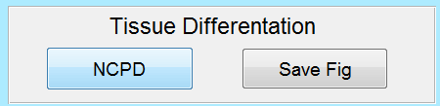Magnetic resonance spectroscopic imaging (MRSI) reveals chemical information that characterizes different tissue types, e.g. in brain tumors. This GUI implements a Non-negative canonical polyadic decomposition (NCPD) based algorithm to differentiate various tissue types and to extract the tissue-specific profiles and their corresponding distribution. For details of the algorithm, the user is referred to [2].

**NCPD:** To perform tissue type differentiation.

Input required by NCPD algorithm:

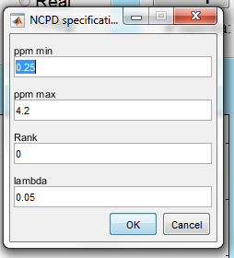

* ‘ppm’min and ‘ppm max’:
  + Range of frequency in ppm in which the metabolite signal of interest is retained.
  + Only this region is used for analysis
  + Default 🡪 0.25 – 4.2 ppm
* Rank:
  + Number of tissue sources.
  + R < 1, number of sources is estimated automatically.
* lambda
  + L1- regularization weight applied on abundancies.
  + Default 🡪 0.05

**NCPD Results:**

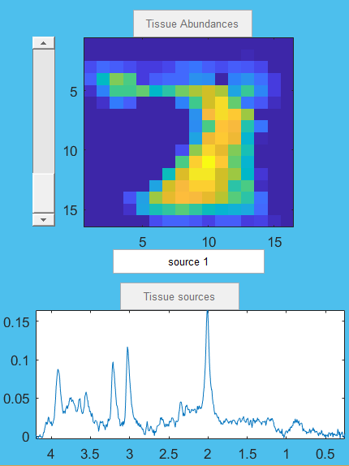

* Source label, can be modified by user.
* Distribution map of each source.
* Spectrum of each source.
* Slider to see different sources.



To save the figure of abundance map and spectrum of individual sources obtained from NCPD algorithm.



To save the processed signals. Will be saved in ‘.mat’ format, can be loaded again to view the results. The results of NCPD algorithm are saved in process_info.abundances and process_info.sources.

Note: Save option will save only processed signals and original signals are not saved. Therefore, undo operations of the processed signals are not possible after loading again.

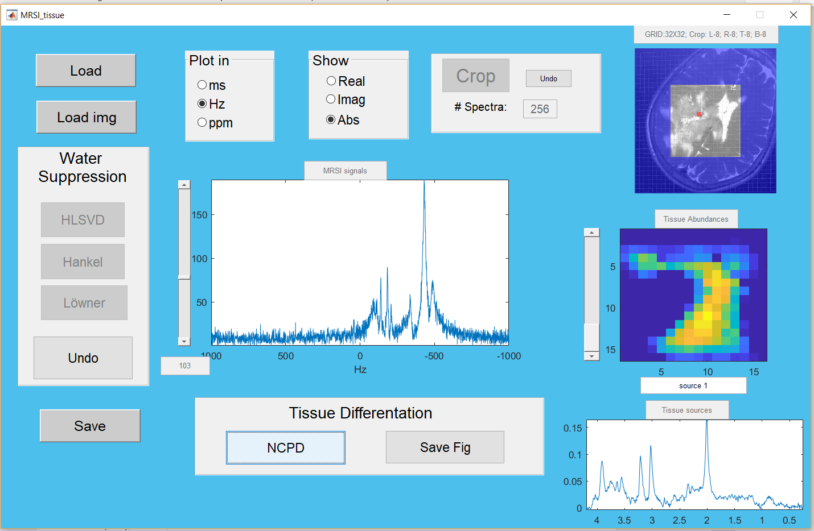

Voxels in MRSI grid:

blue: Cropped voxels, red: Voxel that is displayed.

Slider to view different voxels in the GRID

**Acknowledgment:**

The research leading to these results has received funding from the European Research Council under the European Union’s Seventh Framework Programme (FP7/2007-2013) / ERC Advanced Grant: BIOTENSORS (no. 339804). This paper reflects only the authors’ views and the Union is not liable for any use that may be made of the contained information.

**References:**

[1] Bharath, H. N., Debals, O., Sima, D. M., Himmelreich, U., De Lathauwer, L., and Van Huffel, S. Tensor based method for residual water suppression in 1H magnetic resonance spectroscopic imaging. IEEE Transactions on Biomedical Engineering, vol. 66, no. 2 (Feb. 2019), pp. 584-594. DOI: [10.1109/TBME.2018.2850911](https://doi.org/10.1109/TBME.2018.2850911)

[2] Bharath, H. N., Sima, D. M., Sauwen, N., Himmelreich, U., De Lathauwer, L., and Van Huffel, S. Nonnegative canonical polyadic decomposition for tissue-type differentiation in gliomas*.* IEEE Journal of Biomedical and Health Informatics 21, 4 (July 2017), 1124–1132.

[3] Vervliet, N., Debals, O., Sorber, L., Van Barel, M., and De Lathauwer, L. Tensorlab 3.0. https://www.tensorlab.net, 2016.

[4] Koh, K., Kim, S., and Boyd, S. l1_ls: A Matlab Solver for Large-Scale L1-Regularized Least Squares Problems. http://web.stanford.edu/~boyd/l1_ls/, 2008.

[5] SPID software toolbox available from https://www.esat.kuleuven.be/stadius/software.php

[6] J. B. Poullet, “Quantification and classification of magnetic resonance spectroscopic data for brain tumor diagnosis,” Ph.D. dissertation, Katholieke Universiteit Leuven, Leuven, Belgium, 2008.

[7] T. Laudadio and N. Mastronardi and L. Vanhamme and P. Van Hecke and S. Van Huffel, “Improved Lanczos algorithms for blackbox MRS data quantitation”, Journal of Magnetic Resonance, Volume 157, pages 292-297, 2002