**Washout**

**User Manual and Reference**

Version 0.4.0

Release date: January 6th, 2020

Developed by:

**Brian J. Soher, Ph.D.**

© 2014 Brian J Soher, All Rights Reserved

Table of Contents

Overview of the Washout Package 3

Installation 3

Using Washout – A User Manual 4

1. Overview – How to Launch Washout 4

2. Typical Workflows 5

2.1 Loading New Data, Fitting, Saving Data and Results 5

2.2 Saving Fitting Results 6

2.3 Loading Saved Timeseries Data Sets 6

3. Images and Plots in the Washout Tab 7

3.1 Mouse Events in the Image Windows 7

3.2 Mouse Events in Plots 8

4. Setting Fitting Parameters 8

4.1 Fitting Settings 8

4.2 Strip Output – Chop Settings 9

Overview of the Washout Package

Washout is a Python based application that fits a model to the 'wash-in' and 'wash-out' phases of gas-dynamics in the lung measured using perfluorinated gasses and 19F MR imaging.

Washout is written in Python and has be packaged using PyInstaller to run as an executable file on Windows. That means that you don’t have to install Python to use Washout, and if Python is already installed on your computer, it won’t interfere with the way Washout runs.

Washout has been tested to run on the following systems: Windows 7 and 10. However, it should run on any system that supports Python and wxpython.

Installation

1. Copy the washout.zip file to the directory in which you want to install the program.
2. Unzip the file and a directory named washout will appear.
3. (optional) Create an alias on your desktop. Point the ‘Target’ value to the washout.exe file that is inside the washout directory.

Using Washout – A User Manual

*This section assumes Washout has been installed. See the Washout Installation guide above.*

In the following, screenshots are based on running Washout on the Windows OS, but aside from starting the program, the basic commands are the same on all platforms.

1. Overview – How to Launch Washout

* Double click on the washout.exe file in the washout directory. The Washout GUI should appear within a few seconds.
* (optional) Create an alias on your desktop. Point the ‘Target’ value to the washout.exe file that is inside the washout directory.

This is the Washout main window as it appears on first opening. No actual Washout data tabs are open, only the ‘Welcome’ banner is displayed.

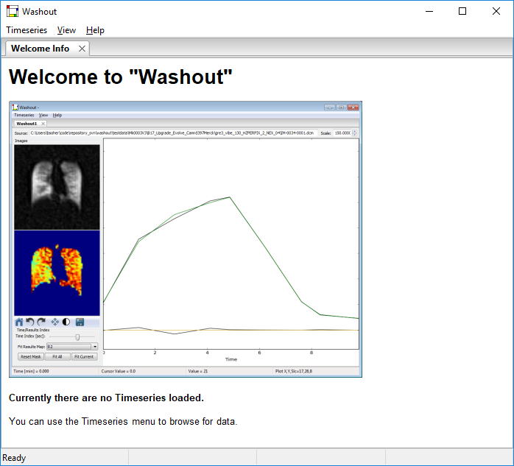

2. Typical Workflows

2.1 Loading New Data, Fitting, Saving Data and Results

Loading 19F MRI Data – Use the **Timeseries → Import Time Data from DICOM** menu item to open DICOM MRI series data into a tab. The menu drop down and directory select dialog are shown below.

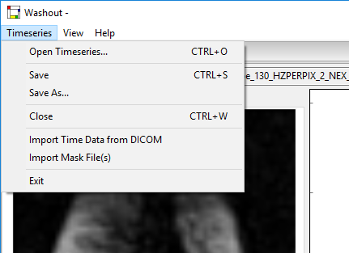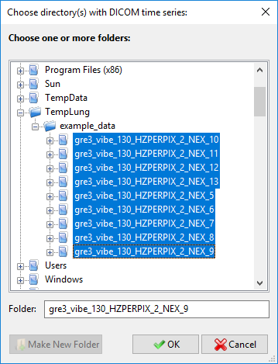

Select all the series directories that contain MRI data that is part of the timeseries data. Directory names do not have to be in alpha-numerical order (although they can be if you want). The actual DICOM headers are used to sort all the images into x,y,z,time order as they are read.

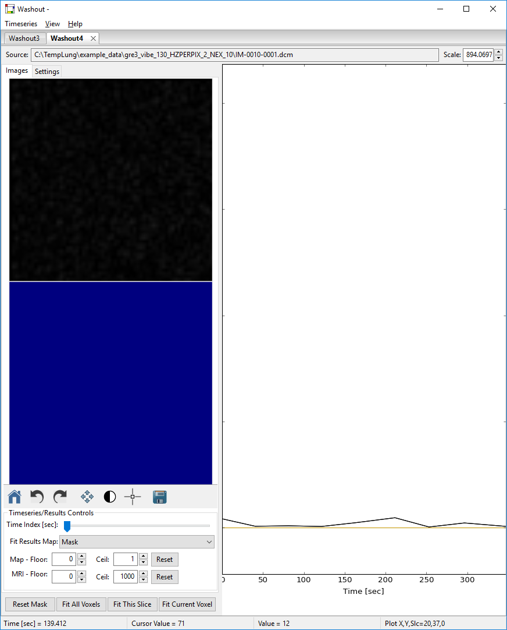The new Timeseries data tab should look like this since voxel 0,0,0 (which is outside the head) is initially displayed and there are no fitting results to display either.

Fitting Timeseries Data – At this point, you can hit the **Fit All Voxels** button and the data will be processed. BUT, you may want to set the processing parameters to different values first. This will be covered in a later section.

Saving Washout Session – When fitting is finished, use the **Save** button to save the entire Washout tab to an XML file. Select a descriptive filename and location you will remember. This will save the current ‘state’ of the active tab so that it can be read back in later exactly as it is now. This output may take a few seconds since it has to save. This XML file saves the data, fitting parameters and results and serves as data provenance for the fitted data set. Once saved, you can use the **Save As…** button to save to a new filename.

2.2 Saving Fitting Results

Fitting results can be saved in a variety of format from the View menu.

1. **View → Output Images** – output masks, fitting parameter maps, or MRI images to either mosaic or strip format. A variety of image formats can be selected from the Save File dialog including: EPS, PNG, PDF, PS, bitmap, or vector graphics.
2. **View → Output Plots** – output the plot displayed in the canvas on the right side of the GUI to an image. A variety of image formats can be selected including: PNG, SVG, PDF, and EPS.
3. **View → Output Results → to CSV File by Slice** – outputs fitting parameter map values to a text file in comma separated value format. This option outputs results to two files in the directory containing the MRI series using default filenames:   
    <base>_Left_Masked_XYZV.csv and <base>_Right_Masked_XYZV.csv  
   where <base> is the DICOM series default value. Parameter map values are organized by x,y values in each row. There are separate columns for each slice in the data set. And each parameter (Mask, Peak, R1, R2, Delay1, Delay2, Base, ChiSquare, and BadFit) is annotated with the slice number, ie. Mask_1, Mask_2 … Mask_16. All voxels are output whether they are fitted or now.
4. **View → Output Results → to CSV File by Slice** – outputs fitting parameter map values to a text file in comma separated value format. User is prompted for a filename. Parameter map values are organized by x,y,z values in the first three columns , then Mask, Peak, R1, R2, Delay1, Delay2, Base, ChiSquare, and BadFit values are in subsequent columns. There is one line of values representing one voxel in the data set. All voxels are output whether they are fitted or now.
5. **View → Output Results → to DICOM by Slice** – outputs fitting parameter map values as DICOM images, one image per parameter map slice. This option writes files to a standard location, the directory that contains the MRI series. If there are 16 slices in the data set, then 16 DICOM files are created for each parameter map. Subdirectories are created to sort each set of DICOM files. Subdirectory names are: washout_01_mask, washout_02_peak, washout_03_r1, etc. The number in the name helps sort the subdirectories in a reasonable order. DICOM header IDs are updated using the sequential, quasi-random method suggested by Clunie and should render as independent series within the original Study without a problem.

2.3 Loading Saved Timeseries Data Sets

Use the **Timeseries → Open Timeseries** menu to open saved timeseries data into a tab. User is prompted to select an XML file for the saved Washout timeseries data to load.

3. Images and Plots in the Washout Tab

This is a view of the main Washout user interface window with two timeseries data sets loaded into two Washout tabs. You can select either tab to work in. You can also arrange them to display side by side if you wish, just grab the tab and move it to a side and release the mouse.

Each tab has two image windows on the left and a plot canvas on the right. Additional display widgets are at the bottom right. The top image window displays the 19F MRI images. The bottom image window displays the parametric map images. Hover the mouse over either image and roll the ball (center button) and you can move through the z-plane (MRI slices). The MRI image and parametric map image change at the same time. The **Time Index** slider bar at bottom left selects the stack of MRI slices in the top image based on the location along the time axis in the timeseries. The **Fit Results Map** drop menu at the lower left changes the parametric map displayed in the lower image. The **Floor** and **Ceil** widgets can help you better adjust the colormap levels in each image window.

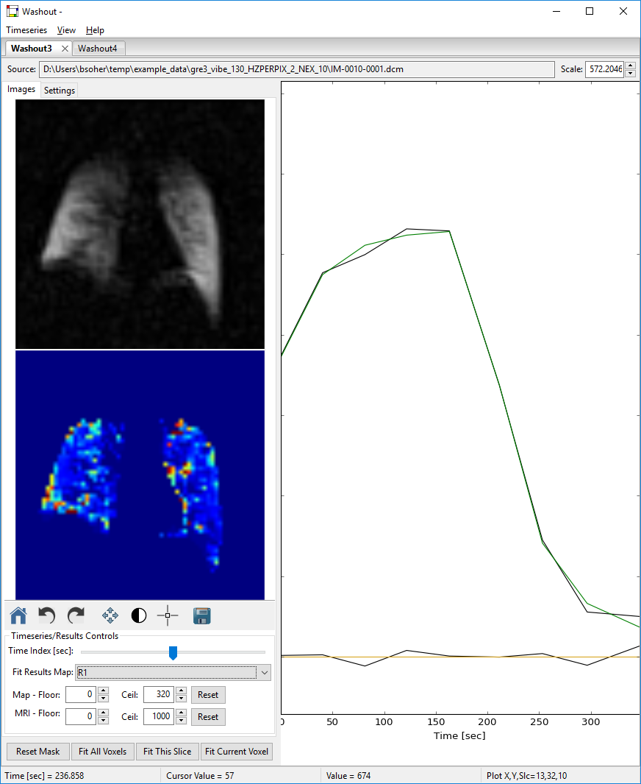 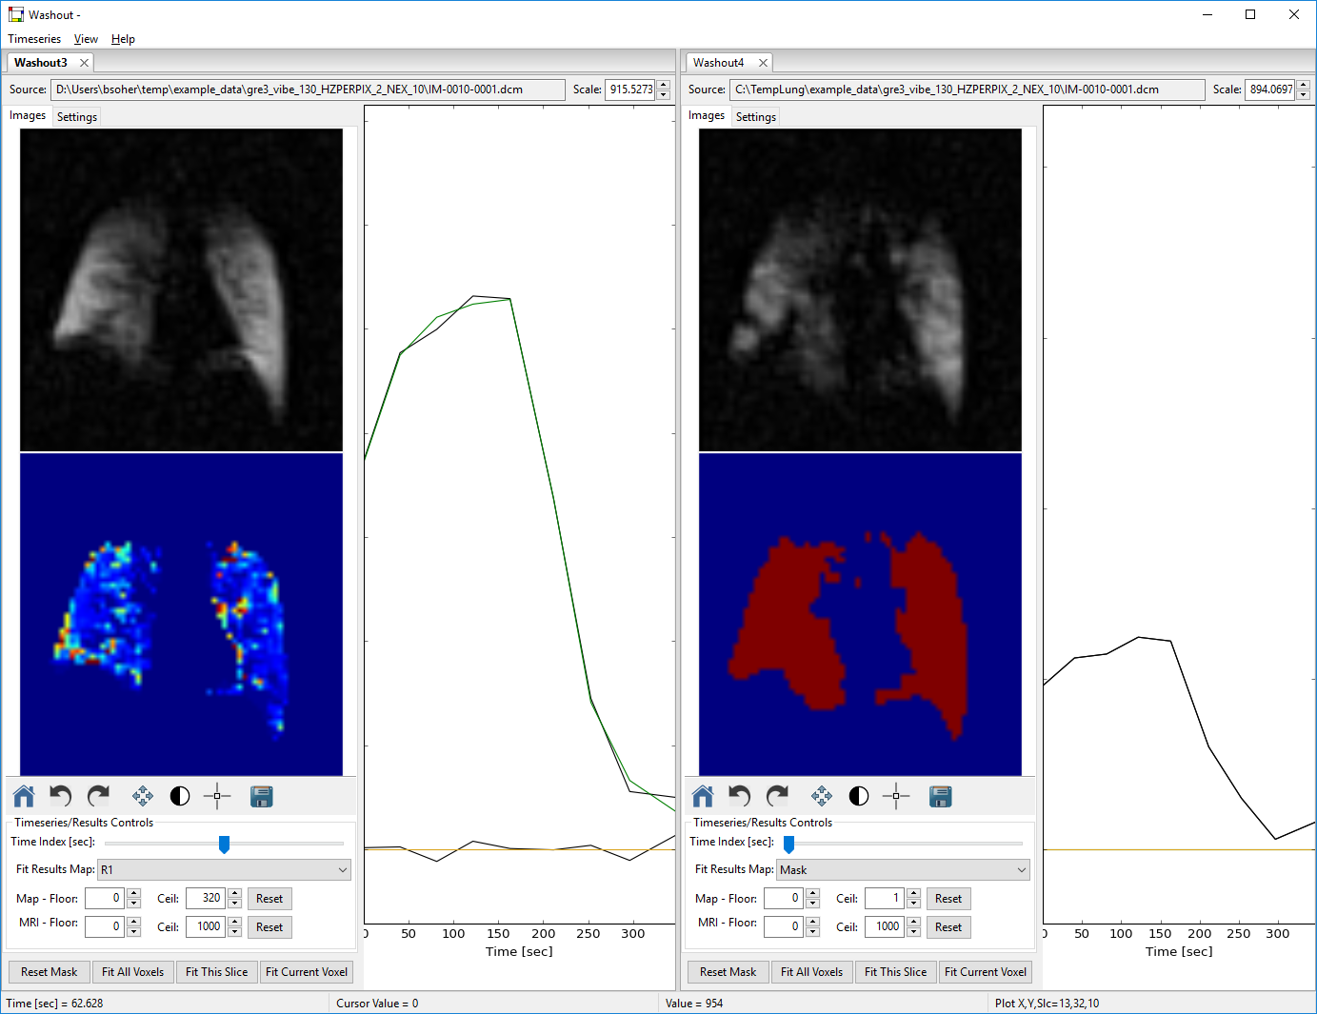

3.1 Mouse Events in the Image Windows

If no Action buttons are on in the image manipulation bar, clicking either the left or right mouse button will change the plot to the left to the data in the x,y,z position of the cursor when clicked. Note. Rolling the roller ball while over an image will change the z-value/slice displayed.

The image manipulation bar below the bottom image window allows you to perform the following actions on both windows at the same time: Home, Undo, Redo, Pan/Zoom, Level, Crosshairs, Save. Home, Undo and Redo all assume that you have done a Pan and/or a Level action already. Only Pan OR Level actions can be active at one time. Crosshairs can be on, but will be ignored if Pan or Level are also active.

* Pan/Zoom – affects both image windows at the same time. Turn this on and left button pans, and right button zooms.
* Level/Width – affects only the image the mouse is over. Turn this on and right mouse up/down or left/right to change width and level, respectively.
* Save – outputs an image of the whole Figure, ie both image windows, to a file and format of the users choice. This is an alternative to using the **View → Output Plots** menu item.

3.2 Mouse Events in Plots

The plot in the right window can be modified using the mouse.

* Left click in place – resets the x and y display scales.
* Roller ball up/down – changes the y scale interactively.
* Left click and drag – draws a zoom box that is displayed upon release.

4. Setting Fitting Parameters

There are two sub-tabs on the left side of each Washout tab labelled Images and Settings. You can change fitting and display settings on this second tab. See red box in figure below. These values are maintained as long as the tab is open and you don’t change them again. When you save the tab to an XML file, these values are saved as well and will be used to set the widgets appropriately when you next load it in.

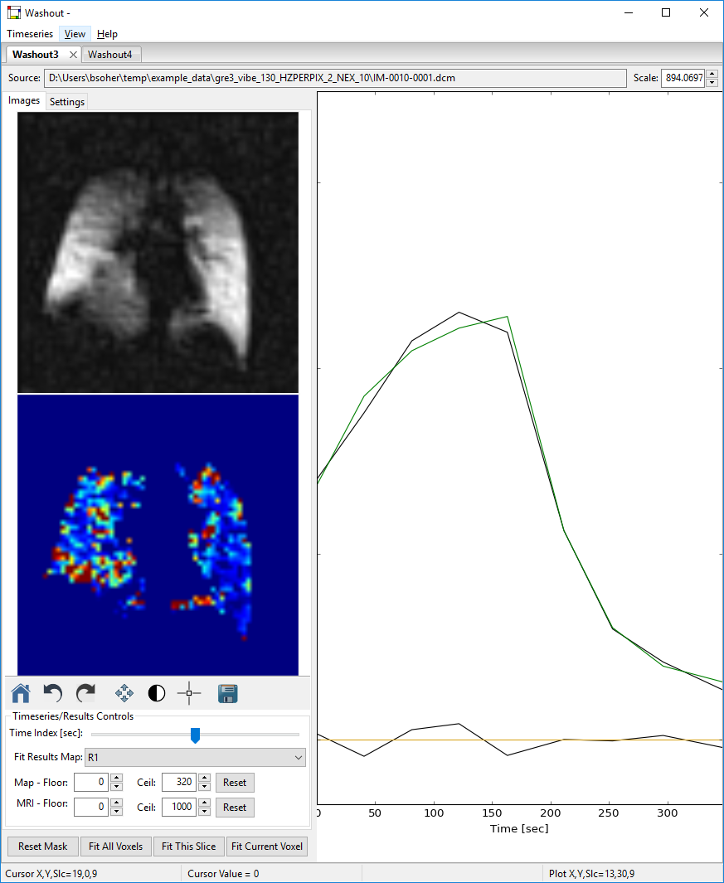 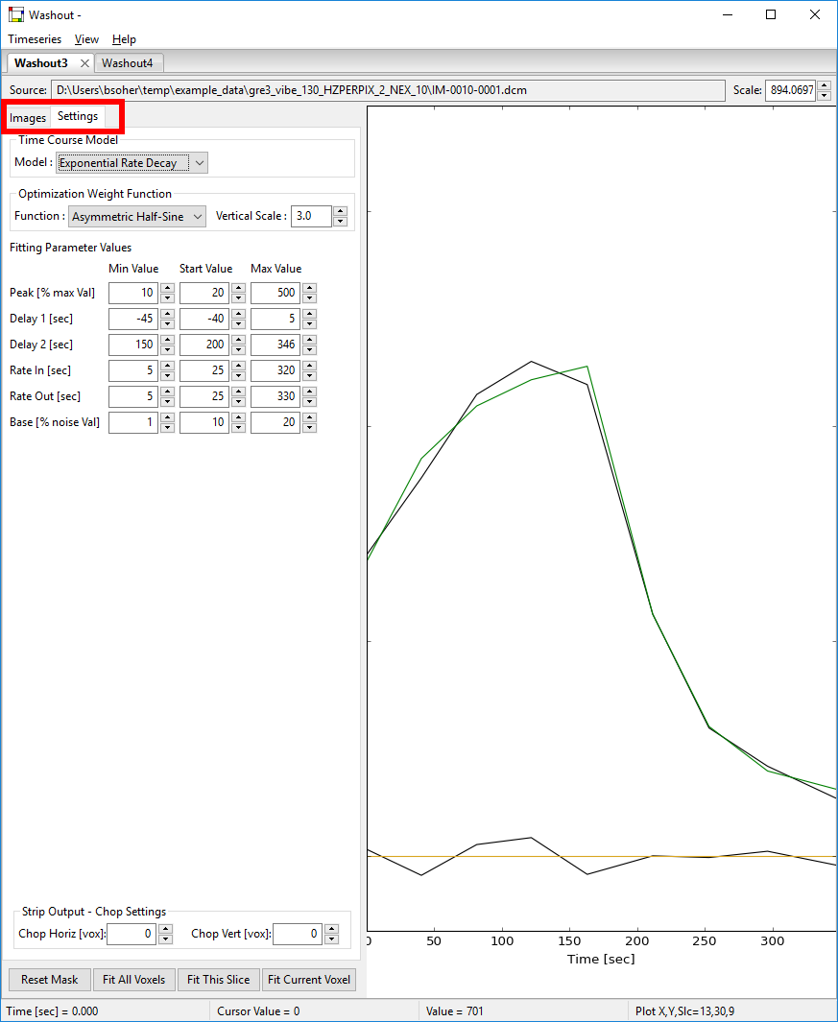

4.1 Fitting Settings

The **Model** can be selected as **Exponential Rate Decay** or **Exponential** **Washin** **Only** to fit either wash-in/wash-out or wash-in only timeseries.

The **Optimization** **Weight Function** can be set to **Even** or **Asymmetric Half Sine** to give even weights across all time points or to weight the wash-in and initial wash-out time period a bit more heavily.

**Fitting Parameter Value** settings. All parameters have widgets you can use to set Constrains (min and max values) and default start values. Units are indicated on the left label.

* **Peak** – in % max Val, a max MRI value is calculated for voxel data being fitted. This parameter is used to set the min/max/default fitting values as a percentage of this max.
* **Delay 1 / Delay 2** – in seconds, sets the min/max/default values to the exact values in the widgets. Note, Delay 2 values should be later than Delay 1 generally.
* **Rate In / Rate Out** – in seconds, sets the min/max/default values to the exact values in the widgets. Note, these values are rate constants.
* **Base** – in % max Value, a max MRI value is calculated for voxel data being fitted. This parameter is used to set the min/max/default fitting values as a percentage of this max.

Note. The default values set in the program code have served to create reasonable results for the test data sets used in creating the Washout program. Data taken differently than the original test data may require different fitting settings to achieve optimal results.

4.2 Strip Output – Chop Settings

The images created using the **View → Output Images** option create Mosaic or ‘Strip’ arrangements of multiple MRI or map slices. Cropping out the top/bottom and left/right edge voxels that are outside of the lung can make the resultant Strip/Mosaic more visible. Adjust these **Horiz** and **Vert** widget values to get the best results.