**Matlab UI: Menu Items and Screen Shots**

Top Level menu

* Master Parameters
* RF Pulses
* Optimal Control
* Special
* Figures

Master Parameters -->

* Master Parms

RF Pulses -->

* SLR Pulse Generation
* Filtering, Scaling
* Bloch Equations
* Pulse Import

Optimal Control -->

* OC Non-Selective, B1-Immune
* OC Selective, B1-Immune
* Contour Plot of B1-Immunity

Special -->

* Grad Refocus
* Relaxation
* Bloch Equa w Flow
* Test Pulses
* Root Reflect
* Pulse Re-Map
* Concatenate
* Siemens Save
* SMIS Save

Figures -->

* Close all but 1st 1
* Retain 1st 2 figs
* Retain 1st 3 figs
* Retain 1st 4 figs
* Close Selected

Matpulse - Main Window

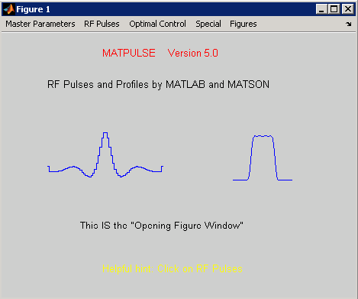

Master Parameters 🡪 Master Parms

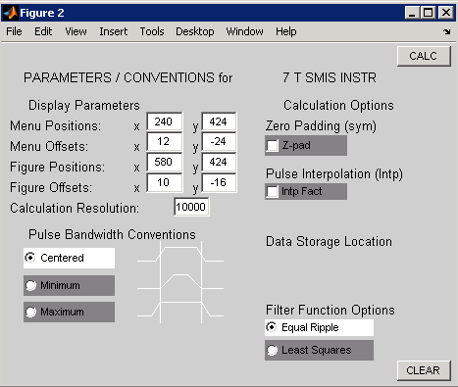

RF Pulses 🡪 SLR Pulse Generation

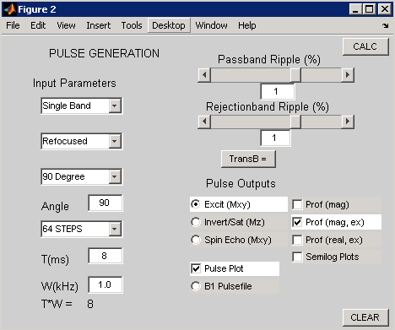

RF Pulses 🡪 Filtering, Scaling

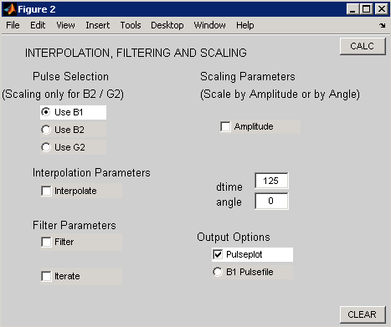

RF Pulses 🡪 Filtering, Scaling (expanded)

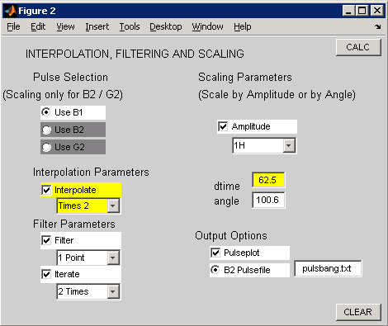

RF Pulses 🡪 Bloch Equations

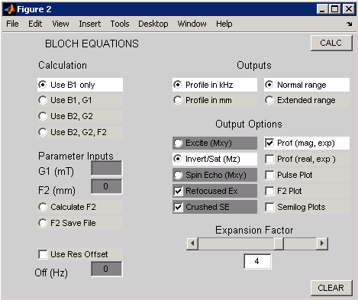

RF Pulses 🡪 Pulse Import

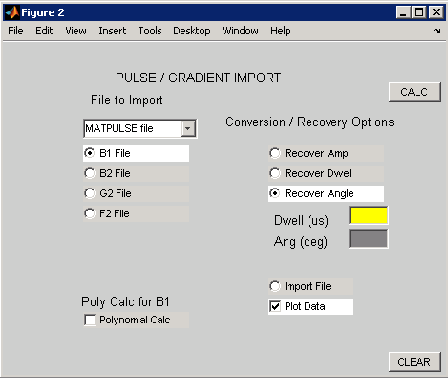

Optimal Control 🡪 OC Non-Selective, B1-Immune

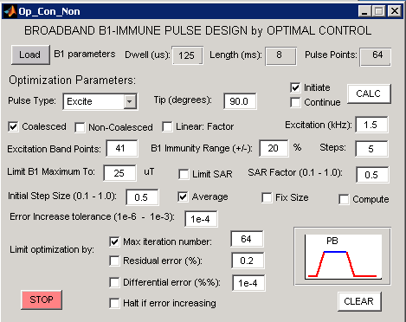

Optimal Control 🡪 OC Non-Selective, B1-Immune (Saturate pulse) # fyi -Non-Selective

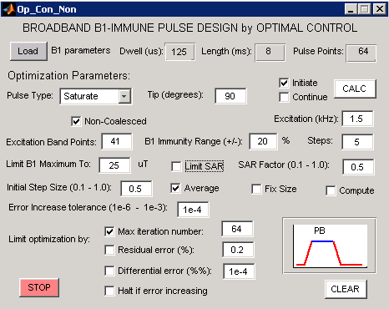

Optimal Control 🡪 OC Selective, B1-Immune

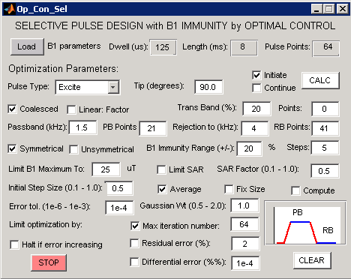

Optimal Control 🡪 Contour Plot of B1-Immunity

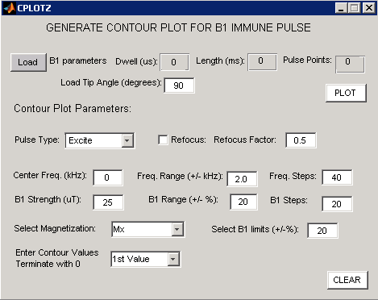

Optimal Control 🡪 Contour Plot of B1-Immunity (for Saturate pulse and with 2nd Value)

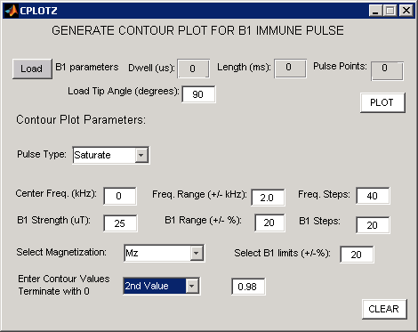

Special 🡪 Grad Refocus

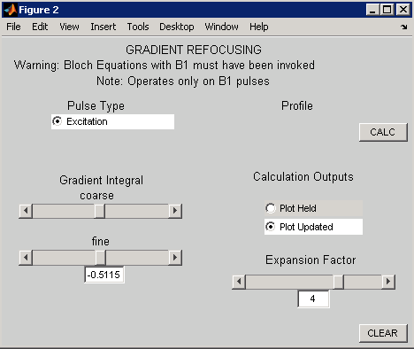

Special 🡪 Relaxation

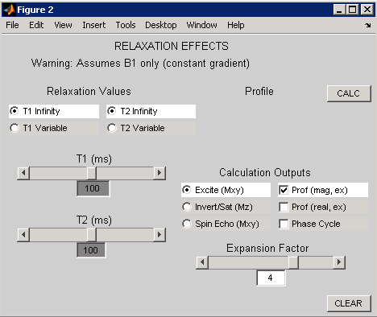

Special 🡪 Bloch Equa w Flow (Bloch Equations with Flow)

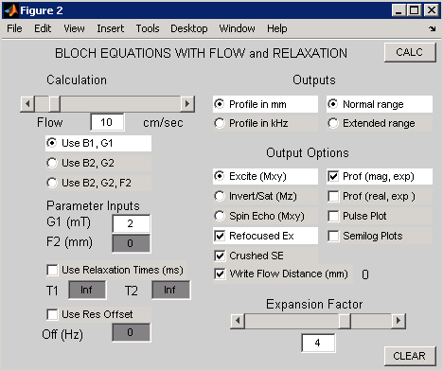

Special 🡪 Test Pulses

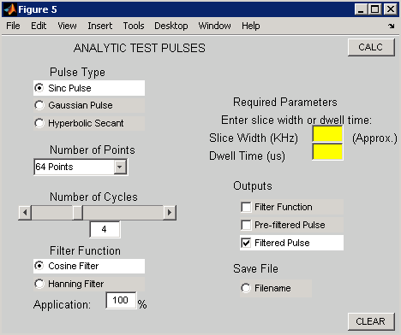

Special 🡪Test Pulses (Hyperbolic Secant)

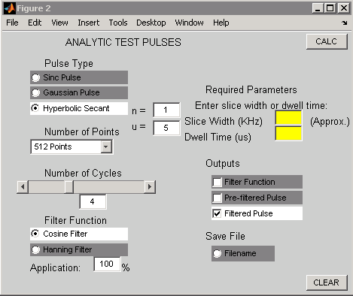

Special 🡪 Root Reflect

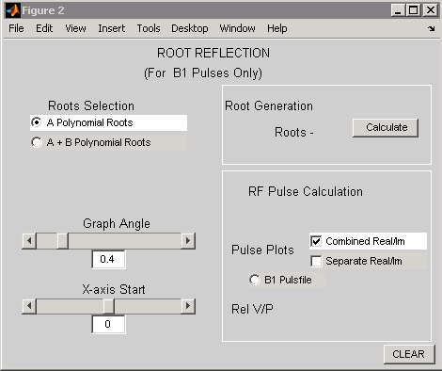

Special 🡪 Pulse Re-Map

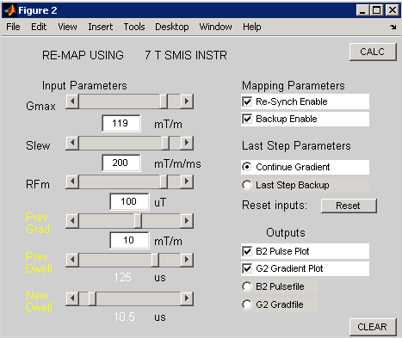

Special 🡪 Concatenate

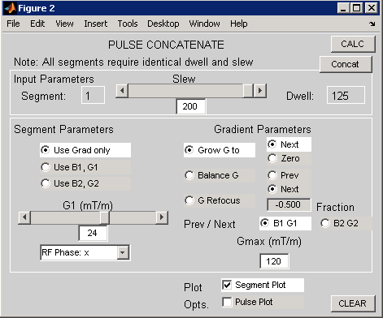

Special 🡪 Siemens Save

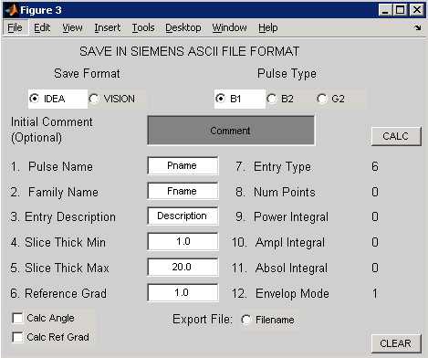

Special 🡪 SMIS Save

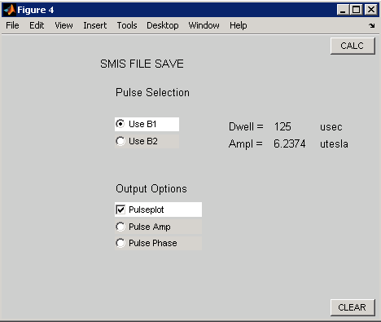

NOTE: No panels to show for the “Figures” menu.