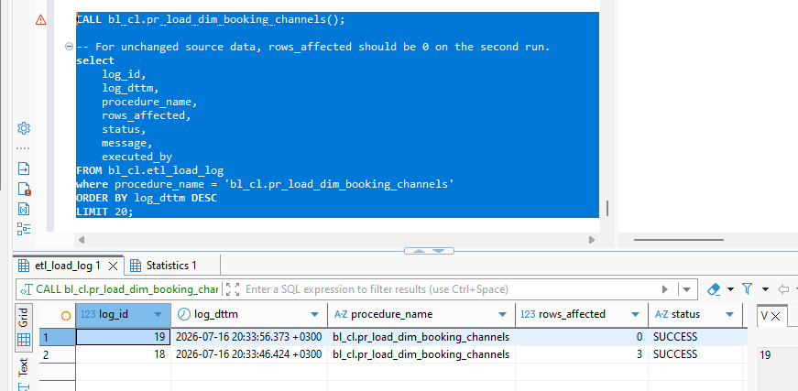

The screenshot showcasing the data inserted into the DM layer

DIM_BOOKING_CHANNELS
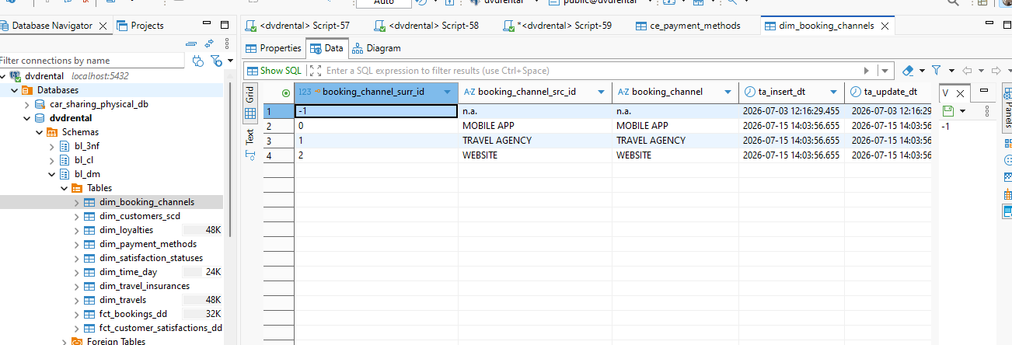

DIM_PAYMENT_METHODS
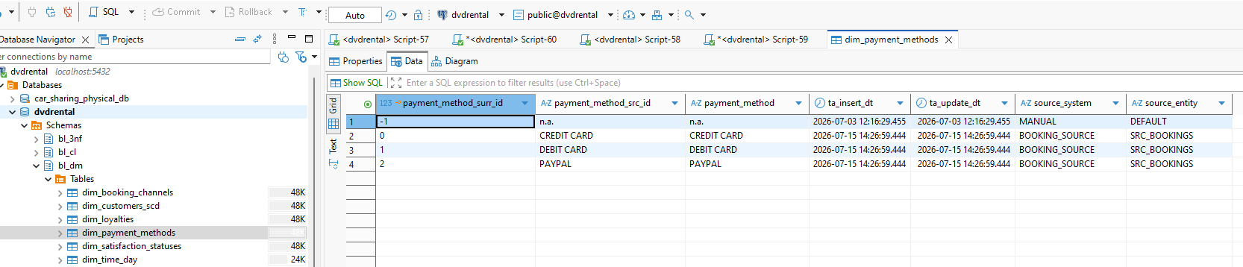

DIM_LOYALITIES
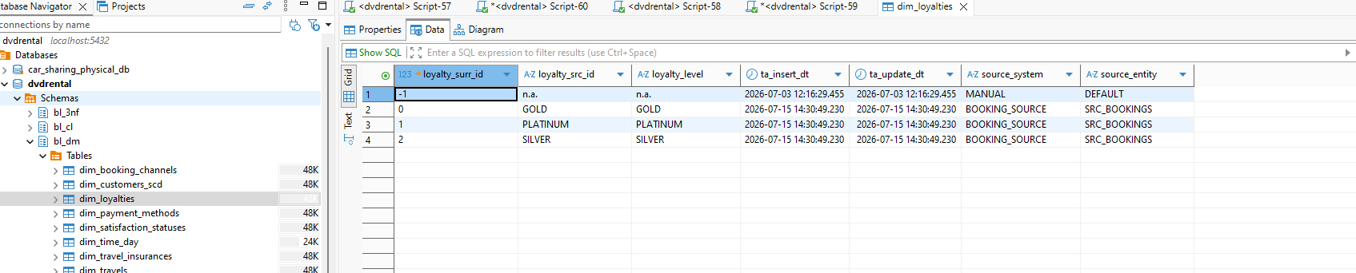

DIM_TRAVEL_INSURANCES
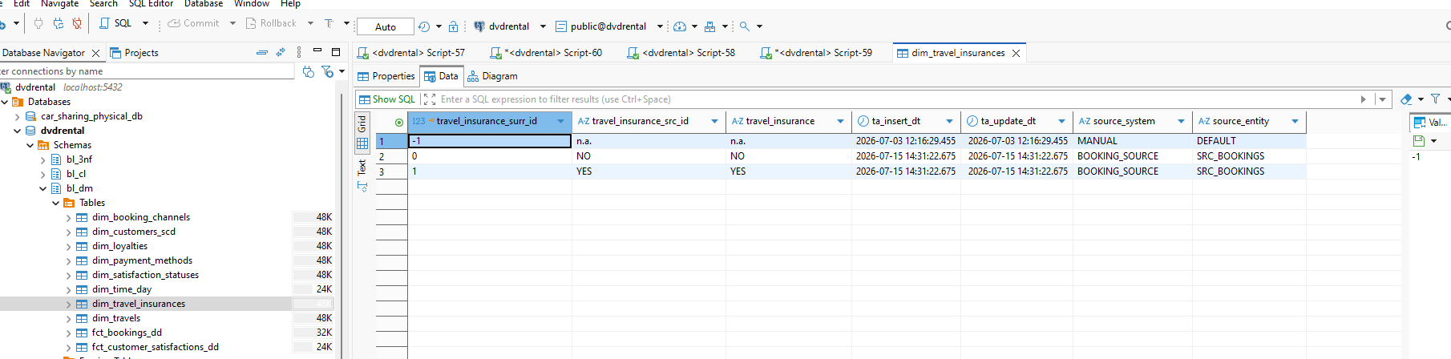
DIM_SATISFACTION_STATUSES
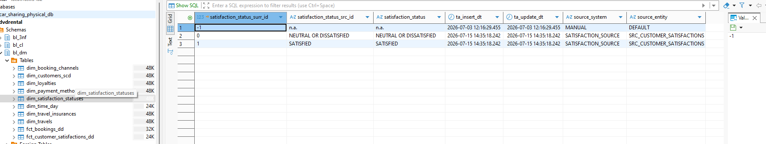

DIM_TRAVELS
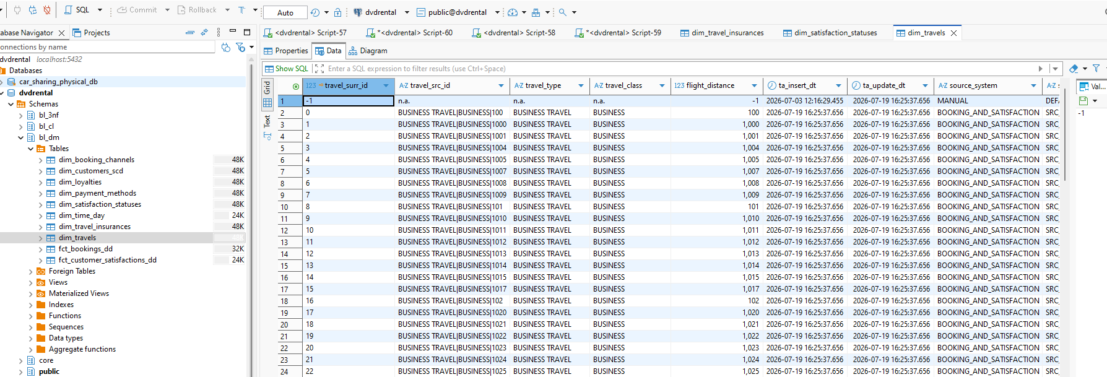

DIM_CUSTOMER_SCD
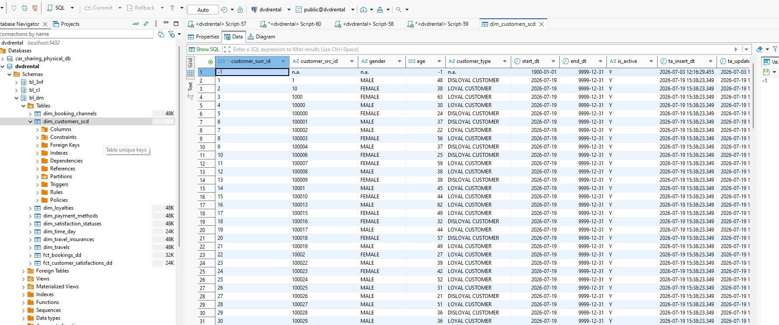

DIM_TIME_DAY
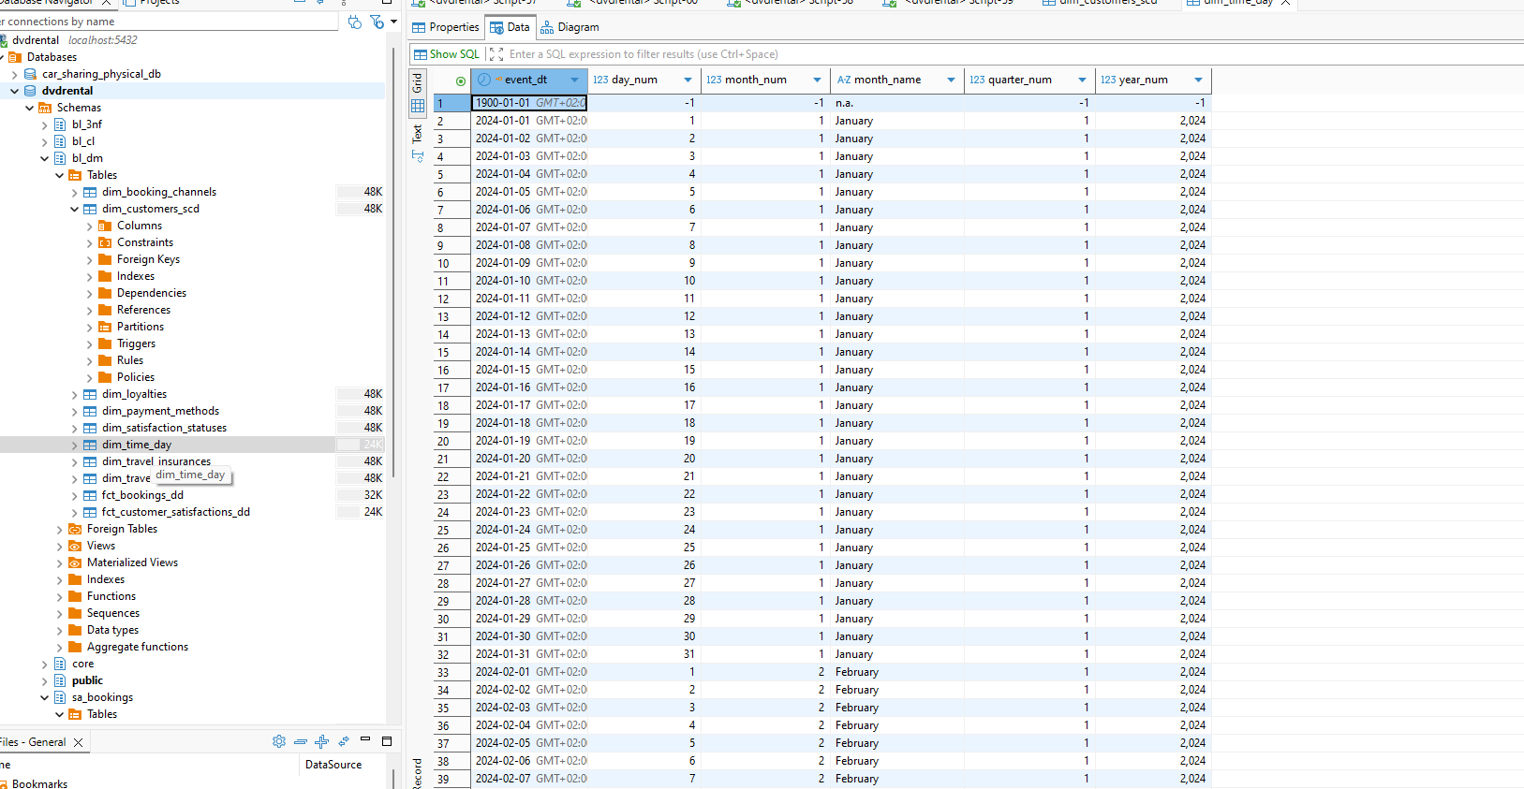

screenshot showcasing that procedure can be executed repeatedly
Because there is no new data added to table after the initial load – the affected rows are zero.

pr_load_dim_payment_methods
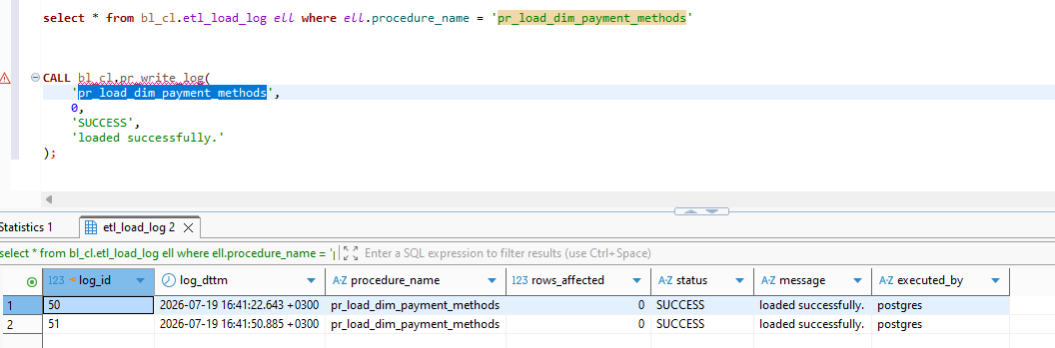

pr_load_dim_loyalties

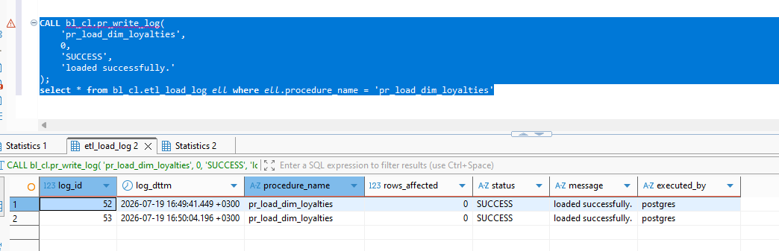
pr_load_dim_travel_insurances
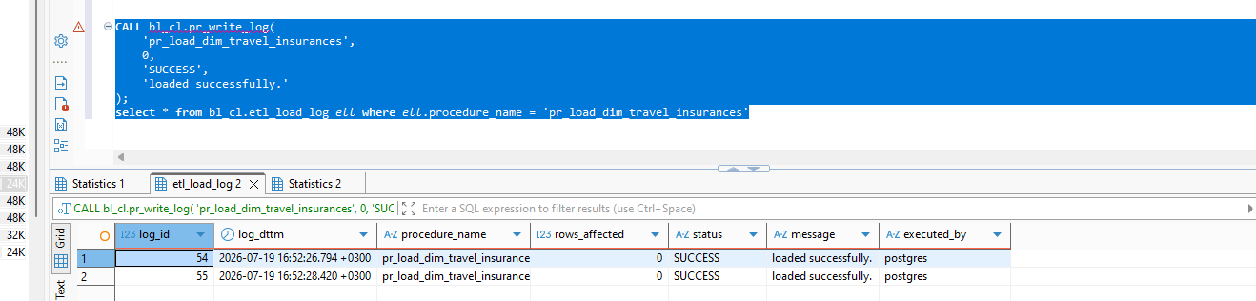

pr_load_dim_satisfaction_statuses
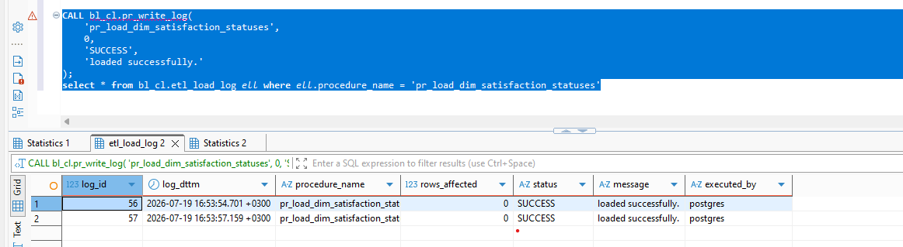

pr_load_dim_travels
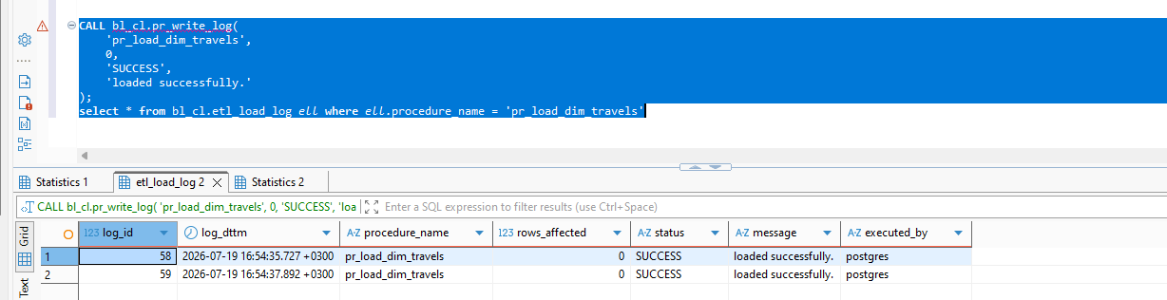

pr_load_dim_customers_scd
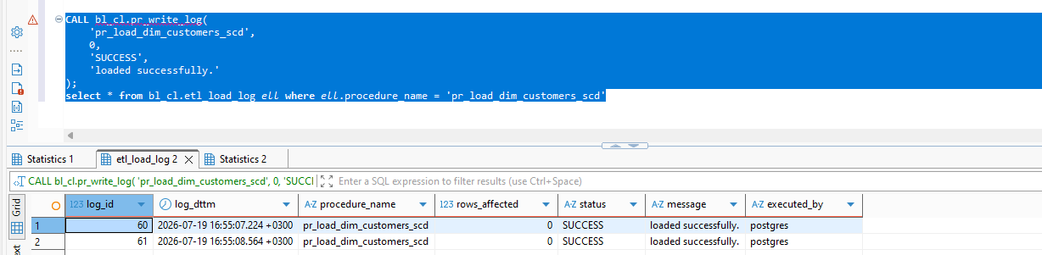

pr_load_dim_time_day
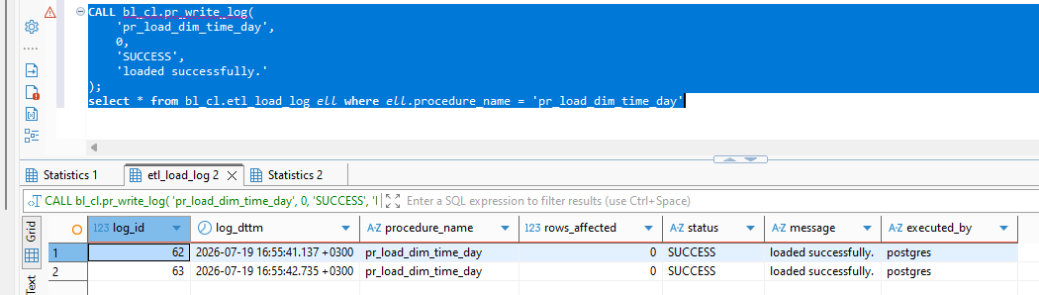

screenshots of the established procedures for each dimension

-- ============================================================
-- BL_CL FUNCTIONS AND BL_3NF LOAD PROCEDURES
-- Corrected for the table structures shown in the screenshots.
-- ============================================================

CREATE SCHEMA IF NOT EXISTS bl_cl;

-- ============================================================
-- 1. LOGGING
-- ============================================================

CREATE TABLE IF NOT EXISTS bl_cl.etl_load_log
(
log_id BIGINT GENERATED ALWAYS AS IDENTITY PRIMARY KEY,
log_dttm TIMESTAMPTZ NOT NULL DEFAULT clock_timestamp(),
procedure_name TEXT NOT NULL,
rows_affected BIGINT NOT NULL DEFAULT 0,
status VARCHAR(20) NOT NULL,
message TEXT,
executed_by TEXT NOT NULL DEFAULT session_user
);

CREATE OR REPLACE PROCEDURE bl_cl.pr_write_log
(
p_procedure_name TEXT,
p_rows_affected BIGINT,
p_status TEXT,
p_message TEXT
)
LANGUAGE plpgsql
AS $$
BEGIN
INSERT INTO bl_cl.etl_load_log
(
procedure_name,
rows_affected,
status,
message
)
VALUES
(
p_procedure_name,
COALESCE(p_rows_affected, 0),
p_status,
p_message
);
EXCEPTION
WHEN OTHERS THEN
RAISE WARNING
'Unable to write ETL log. SQLSTATE=%, message=%',
SQLSTATE,
SQLERRM;
END;
$$;

-- ============================================================
-- 2. CLEANSING FUNCTIONS
-- ============================================================

CREATE OR REPLACE FUNCTION bl_cl.fn_norm_text(p_value TEXT)
RETURNS TEXT
LANGUAGE sql
IMMUTABLE
AS $$
SELECT UPPER(NULLIF(BTRIM(p_value), ''));
$$;

CREATE OR REPLACE FUNCTION bl_cl.fn_to_int(p_value TEXT)
RETURNS INTEGER
LANGUAGE plpgsql
IMMUTABLE
AS $$
DECLARE
v_value TEXT;
BEGIN
v_value := NULLIF(BTRIM(p_value), '');

IF v_value IS NULL
OR v_value !~ '^[+-]?[0-9]+$'
THEN
RETURN NULL;
END IF;

RETURN v_value::INTEGER;
EXCEPTION
WHEN OTHERS THEN
RETURN NULL;
END;
$$;

CREATE OR REPLACE FUNCTION bl_cl.fn_to_numeric(p_value TEXT)
RETURNS NUMERIC
LANGUAGE plpgsql
IMMUTABLE
AS $$
DECLARE
v_value TEXT;
BEGIN
v_value := REPLACE(NULLIF(BTRIM(p_value), ''), ',', '.');

IF v_value IS NULL
OR v_value !~ '^[+-]?([0-9]+([.][0-9]*)?|[.][0-9]+)$'
THEN
RETURN NULL;
END IF;

RETURN v_value::NUMERIC;
EXCEPTION
WHEN OTHERS THEN
RETURN NULL;
END;
$$;

CREATE OR REPLACE FUNCTION bl_cl.fn_to_date
(
p_date_value TEXT,
p_date_key TEXT
)
RETURNS DATE
LANGUAGE plpgsql
STABLE
AS $$
DECLARE
v_value TEXT;
v_date DATE;
BEGIN
v_value := NULLIF(BTRIM(p_date_value), '');

IF v_value ~ '^[0-9]{4}-[0-9]{2}-[0-9]{2}$' THEN
BEGIN
RETURN v_value::DATE;
EXCEPTION
WHEN OTHERS THEN
NULL;
END;
END IF;

IF v_value ~ '^[0-9]{8}$' THEN
BEGIN
v_date := TO_DATE(v_value, 'YYYYMMDD');

IF TO_CHAR(v_date, 'YYYYMMDD') = v_value THEN
RETURN v_date;
END IF;
EXCEPTION
WHEN OTHERS THEN
NULL;
END;
END IF;

v_value := NULLIF(BTRIM(p_date_key), '');

IF v_value ~ '^[0-9]{8}$' THEN
BEGIN
v_date := TO_DATE(v_value, 'YYYYMMDD');

IF TO_CHAR(v_date, 'YYYYMMDD') = v_value THEN
RETURN v_date;
END IF;
EXCEPTION
WHEN OTHERS THEN
NULL;
END;
END IF;

RETURN NULL;
END;
$$;

-- ============================================================
-- 3. SOURCE FUNCTIONS
-- ============================================================

CREATE OR REPLACE FUNCTION bl_cl.fn_booking_source()
RETURNS TABLE
(
booking_src_id TEXT,
customer_src_id TEXT,
gender TEXT,
age INTEGER,
travel_type TEXT,
travel_class TEXT,
flight_distance NUMERIC,
booking_channel TEXT,
payment_method TEXT,
ticket_price NUMERIC,
loyalty_level TEXT,
travel_insurance TEXT,
booking_date DATE,
airport_fee NUMERIC,
promotion_discount NUMERIC,
operating_cost NUMERIC,
profit NUMERIC
)
LANGUAGE sql
STABLE
AS $$
SELECT
bl_cl.fn_norm_text(b.booking_id),
bl_cl.fn_norm_text(b.customer_id),
COALESCE(bl_cl.fn_norm_text(b.gender), 'UNKNOWN'),
bl_cl.fn_to_int(b.age),
COALESCE(bl_cl.fn_norm_text(b.travel_type), 'UNKNOWN'),
COALESCE(bl_cl.fn_norm_text(b.travel_class), 'UNKNOWN'),
COALESCE(bl_cl.fn_to_numeric(b.flight_distance), 0),
COALESCE(bl_cl.fn_norm_text(b.booking_channel), 'UNKNOWN'),
COALESCE(bl_cl.fn_norm_text(b.payment_method), 'UNKNOWN'),
bl_cl.fn_to_numeric(b.ticket_price),
COALESCE(bl_cl.fn_norm_text(b.loyalty_level), 'UNKNOWN'),
COALESCE(bl_cl.fn_norm_text(b.travel_insurance), 'UNKNOWN'),
bl_cl.fn_to_date(b.booking_date, b.date_key),
bl_cl.fn_to_numeric(b.airport_fee),
bl_cl.fn_to_numeric(b.promotion_discount),
bl_cl.fn_to_numeric(b.operating_cost),
bl_cl.fn_to_numeric(b.profit)
FROM sa_bookings.src_bookings b;
$$;

CREATE OR REPLACE FUNCTION bl_cl.fn_satisfaction_source()
RETURNS TABLE
(
survey_src_id TEXT,
customer_src_id TEXT,
gender TEXT,
customer_type TEXT,
age INTEGER,
travel_type TEXT,
travel_class TEXT,
flight_distance NUMERIC,
satisfaction_status TEXT,
survey_date DATE,
inflight_wifi_service INTEGER,
departure_arrival_time_convenient INTEGER,
ease_of_online_booking INTEGER,
gate_location INTEGER,
food_and_drink INTEGER,
online_boarding INTEGER,
seat_comfort INTEGER,
inflight_entertainment INTEGER,
on_board_service INTEGER,
leg_room_service INTEGER,
baggage_handling INTEGER,
checkin_service INTEGER,
inflight_service INTEGER,
cleanliness INTEGER,
departure_delay_in_minutes NUMERIC,
arrival_delay_in_minutes NUMERIC
)
LANGUAGE sql
STABLE
AS $$
SELECT
bl_cl.fn_norm_text(s.survey_id),
bl_cl.fn_norm_text(s.customer_id),
COALESCE(bl_cl.fn_norm_text(s.gender), 'UNKNOWN'),
COALESCE(bl_cl.fn_norm_text(s.customer_type), 'UNKNOWN'),
bl_cl.fn_to_int(s.age),
COALESCE(bl_cl.fn_norm_text(s.travel_type), 'UNKNOWN'),
COALESCE(bl_cl.fn_norm_text(s.travel_class), 'UNKNOWN'),
COALESCE(bl_cl.fn_to_numeric(s.flight_distance), 0),
COALESCE(bl_cl.fn_norm_text(s.satisfaction), 'UNKNOWN'),
bl_cl.fn_to_date(s.survey_date, s.date_key),
bl_cl.fn_to_int(s.inflight_wifi_service),
bl_cl.fn_to_int(s.departure_arrival_time_convenient),
bl_cl.fn_to_int(s.ease_of_online_booking),
bl_cl.fn_to_int(s.gate_location),
bl_cl.fn_to_int(s.food_and_drink),
bl_cl.fn_to_int(s.online_boarding),
bl_cl.fn_to_int(s.seat_comfort),
bl_cl.fn_to_int(s.inflight_entertainment),
bl_cl.fn_to_int(s.on_board_service),
bl_cl.fn_to_int(s.leg_room_service),
bl_cl.fn_to_int(s.baggage_handling),
bl_cl.fn_to_int(s.checkin_service),
bl_cl.fn_to_int(s.inflight_service),
bl_cl.fn_to_int(s.cleanliness),
bl_cl.fn_to_numeric(s.departure_delay_minutes),
bl_cl.fn_to_numeric(s.arrival_delay_minutes)
FROM sa_customer_satisfactions.src_customer_satisfactions s;
$$;

-- ============================================================
-- 4. LOOKUP LOAD PROCEDURES
-- ============================================================

CREATE OR REPLACE PROCEDURE bl_cl.pr_load_ce_booking_channels()
LANGUAGE plpgsql
AS $$
DECLARE
v_rows BIGINT := 0;
v_msg TEXT;
v_state TEXT;
BEGIN
WITH src AS
(
SELECT DISTINCT booking_channel
FROM bl_cl.fn_booking_source()
WHERE booking_channel IS NOT NULL
),
new_rows AS
(
SELECT
COALESCE((SELECT MAX(booking_channel_id)
FROM bl_3nf.ce_booking_channels), 0)
+ ROW_NUMBER() OVER (ORDER BY booking_channel) AS booking_channel_id,
booking_channel
FROM src
WHERE NOT EXISTS
(
SELECT 1
FROM bl_3nf.ce_booking_channels t
WHERE t.booking_channel_src_id = src.booking_channel
)
)
INSERT INTO bl_3nf.ce_booking_channels
(
booking_channel_id,
booking_channel_src_id,
booking_channel,
insert_dt,
update_dt,
source_system,
source_entity
)
SELECT
booking_channel_id,
booking_channel,
booking_channel,
CURRENT_TIMESTAMP,
CURRENT_TIMESTAMP,
'BOOKING_SOURCE',
'SRC_BOOKINGS'
FROM new_rows;

GET DIAGNOSTICS v_rows = ROW_COUNT;

CALL bl_cl.pr_write_log(
'pr_load_ce_booking_channels', v_rows, 'SUCCESS',
'CE_BOOKING_CHANNELS loaded successfully.'
);
EXCEPTION
WHEN OTHERS THEN
GET STACKED DIAGNOSTICS
v_msg = MESSAGE_TEXT,
v_state = RETURNED_SQLSTATE;

CALL bl_cl.pr_write_log(
'pr_load_ce_booking_channels', 0, 'ERROR',
'SQLSTATE=' || v_state || '; ' || v_msg
);

RAISE WARNING
'pr_load_ce_booking_channels failed. SQLSTATE=%, message=%',
v_state, v_msg;
END;
$$;

CREATE OR REPLACE PROCEDURE bl_cl.pr_load_ce_payment_methods()
LANGUAGE plpgsql
AS $$
DECLARE
v_rows BIGINT := 0;
v_msg TEXT;
v_state TEXT;
BEGIN
WITH src AS
(
SELECT DISTINCT payment_method
FROM bl_cl.fn_booking_source()
WHERE payment_method IS NOT NULL
),
new_rows AS
(
SELECT
COALESCE((SELECT MAX(payment_method_id)
FROM bl_3nf.ce_payment_methods), 0)
+ ROW_NUMBER() OVER (ORDER BY payment_method) AS payment_method_id,
payment_method
FROM src
WHERE NOT EXISTS
(
SELECT 1
FROM bl_3nf.ce_payment_methods t
WHERE t.payment_method_src_id = src.payment_method
)
)
INSERT INTO bl_3nf.ce_payment_methods
(
payment_method_id,
payment_method_src_id,
payment_method,
insert_dt,
update_dt,
source_system,
source_entity
)
SELECT
payment_method_id,
payment_method,
payment_method,
CURRENT_TIMESTAMP,
CURRENT_TIMESTAMP,
'BOOKING_SOURCE',
'SRC_BOOKINGS'
FROM new_rows;

GET DIAGNOSTICS v_rows = ROW_COUNT;

CALL bl_cl.pr_write_log(
'pr_load_ce_payment_methods', v_rows, 'SUCCESS',
'CE_PAYMENT_METHODS loaded successfully.'
);
EXCEPTION
WHEN OTHERS THEN
GET STACKED DIAGNOSTICS
v_msg = MESSAGE_TEXT,
v_state = RETURNED_SQLSTATE;

CALL bl_cl.pr_write_log(
'pr_load_ce_payment_methods', 0, 'ERROR',
'SQLSTATE=' || v_state || '; ' || v_msg
);

RAISE WARNING
'pr_load_ce_payment_methods failed. SQLSTATE=%, message=%',
v_state, v_msg;
END;
$$;

CREATE OR REPLACE PROCEDURE bl_cl.pr_load_ce_loyalties()
LANGUAGE plpgsql
AS $$
DECLARE
v_rows BIGINT := 0;
v_msg TEXT;
v_state TEXT;
BEGIN
WITH src AS
(
SELECT DISTINCT loyalty_level
FROM bl_cl.fn_booking_source()
WHERE loyalty_level IS NOT NULL
),
new_rows AS
(
SELECT
COALESCE((SELECT MAX(loyalty_id)
FROM bl_3nf.ce_loyalties), 0)
+ ROW_NUMBER() OVER (ORDER BY loyalty_level) AS loyalty_id,
loyalty_level
FROM src
WHERE NOT EXISTS
(
SELECT 1
FROM bl_3nf.ce_loyalties t
WHERE t.loyalty_src_id = src.loyalty_level
)
)
INSERT INTO bl_3nf.ce_loyalties
(
loyalty_id,
loyalty_src_id,
loyalty_level,
insert_dt,
update_dt,
source_system,
source_entity
)
SELECT
loyalty_id,
loyalty_level,
loyalty_level,
CURRENT_TIMESTAMP,
CURRENT_TIMESTAMP,
'BOOKING_SOURCE',
'SRC_BOOKINGS'
FROM new_rows;

GET DIAGNOSTICS v_rows = ROW_COUNT;

CALL bl_cl.pr_write_log(
'pr_load_ce_loyalties', v_rows, 'SUCCESS',
'CE_LOYALTIES loaded successfully.'
);
EXCEPTION
WHEN OTHERS THEN
GET STACKED DIAGNOSTICS
v_msg = MESSAGE_TEXT,
v_state = RETURNED_SQLSTATE;

CALL bl_cl.pr_write_log(
'pr_load_ce_loyalties', 0, 'ERROR',
'SQLSTATE=' || v_state || '; ' || v_msg
);

RAISE WARNING
'pr_load_ce_loyalties failed. SQLSTATE=%, message=%',
v_state, v_msg;
END;
$$;

CREATE OR REPLACE PROCEDURE bl_cl.pr_load_ce_travel_insurances()
LANGUAGE plpgsql
AS $$
DECLARE
v_rows BIGINT := 0;
v_msg TEXT;
v_state TEXT;
BEGIN
WITH src AS
(
SELECT DISTINCT travel_insurance
FROM bl_cl.fn_booking_source()
WHERE travel_insurance IS NOT NULL
),
new_rows AS
(
SELECT
COALESCE((SELECT MAX(travel_insurance_id)
FROM bl_3nf.ce_travel_insurances), 0)
+ ROW_NUMBER() OVER (ORDER BY travel_insurance) AS travel_insurance_id,
travel_insurance
FROM src
WHERE NOT EXISTS
(
SELECT 1
FROM bl_3nf.ce_travel_insurances t
WHERE t.travel_insurance_src_id = src.travel_insurance
)
)
INSERT INTO bl_3nf.ce_travel_insurances
(
travel_insurance_id,
travel_insurance_src_id,
travel_insurance,
insert_dt,
update_dt,
source_system,
source_entity
)
SELECT
travel_insurance_id,
travel_insurance,
travel_insurance,
CURRENT_TIMESTAMP,
CURRENT_TIMESTAMP,
'BOOKING_SOURCE',
'SRC_BOOKINGS'
FROM new_rows;

GET DIAGNOSTICS v_rows = ROW_COUNT;

CALL bl_cl.pr_write_log(
'pr_load_ce_travel_insurances', v_rows, 'SUCCESS',
'CE_TRAVEL_INSURANCES loaded successfully.'
);
EXCEPTION
WHEN OTHERS THEN
GET STACKED DIAGNOSTICS
v_msg = MESSAGE_TEXT,
v_state = RETURNED_SQLSTATE;

CALL bl_cl.pr_write_log(
'pr_load_ce_travel_insurances', 0, 'ERROR',
'SQLSTATE=' || v_state || '; ' || v_msg
);

RAISE WARNING
'pr_load_ce_travel_insurances failed. SQLSTATE=%, message=%',
v_state, v_msg;
END;
$$;

CREATE OR REPLACE PROCEDURE bl_cl.pr_load_ce_satisfaction_statuses()
LANGUAGE plpgsql
AS $$
DECLARE
v_rows BIGINT := 0;
v_msg TEXT;
v_state TEXT;
BEGIN
WITH src AS
(
SELECT DISTINCT satisfaction_status
FROM bl_cl.fn_satisfaction_source()
WHERE satisfaction_status IS NOT NULL
),
new_rows AS
(
SELECT
COALESCE((SELECT MAX(satisfaction_status_id)
FROM bl_3nf.ce_satisfaction_statuses), 0)
+ ROW_NUMBER() OVER (ORDER BY satisfaction_status)
AS satisfaction_status_id,
satisfaction_status
FROM src
WHERE NOT EXISTS
(
SELECT 1
FROM bl_3nf.ce_satisfaction_statuses t
WHERE t.satisfaction_status_src_id = src.satisfaction_status
)
)
INSERT INTO bl_3nf.ce_satisfaction_statuses
(
satisfaction_status_id,
satisfaction_status_src_id,
satisfaction_status,
insert_dt,
update_dt,
source_system,
source_entity
)
SELECT
satisfaction_status_id,
satisfaction_status,
satisfaction_status,
CURRENT_TIMESTAMP,
CURRENT_TIMESTAMP,
'SATISFACTION_SOURCE',
'SRC_CUSTOMER_SATISFACTIONS'
FROM new_rows;

GET DIAGNOSTICS v_rows = ROW_COUNT;

CALL bl_cl.pr_write_log(
'pr_load_ce_satisfaction_statuses', v_rows, 'SUCCESS',
'CE_SATISFACTION_STATUSES loaded successfully.'
);
EXCEPTION
WHEN OTHERS THEN
GET STACKED DIAGNOSTICS
v_msg = MESSAGE_TEXT,
v_state = RETURNED_SQLSTATE;

CALL bl_cl.pr_write_log(
'pr_load_ce_satisfaction_statuses', 0, 'ERROR',
'SQLSTATE=' || v_state || '; ' || v_msg
);

RAISE WARNING
'pr_load_ce_satisfaction_statuses failed. SQLSTATE=%, message=%',
v_state, v_msg;
END;
$$;

-- ============================================================
-- 5. CE_TRAVELS
-- ============================================================

CREATE OR REPLACE PROCEDURE bl_cl.pr_load_ce_travels()
LANGUAGE plpgsql
AS $$
DECLARE
v_rows BIGINT := 0;
v_msg TEXT;
v_state TEXT;
BEGIN
WITH src AS
(
SELECT DISTINCT
travel_type,
travel_class,
flight_distance
FROM
(
SELECT travel_type, travel_class, flight_distance
FROM bl_cl.fn_booking_source()

UNION

SELECT travel_type, travel_class, flight_distance
FROM bl_cl.fn_satisfaction_source()
) s
),
prepared AS
(
SELECT
travel_type || '|' ||
travel_class || '|' ||
flight_distance::TEXT AS travel_src_id,
travel_type,
travel_class,
flight_distance
FROM src
),
new_rows AS
(
SELECT
COALESCE((SELECT MAX(travel_id)
FROM bl_3nf.ce_travels), 0)
+ ROW_NUMBER() OVER (ORDER BY travel_src_id) AS travel_id,
*
FROM prepared p
WHERE NOT EXISTS
(
SELECT 1
FROM bl_3nf.ce_travels t
WHERE t.travel_src_id = p.travel_src_id
)
)
INSERT INTO bl_3nf.ce_travels
(
travel_id,
travel_src_id,
travel_type,
travel_class,
flight_distance,
insert_dt,
update_dt,
source_system,
source_entity
)
SELECT
travel_id,
travel_src_id,
travel_type,
travel_class,
flight_distance,
CURRENT_TIMESTAMP,
CURRENT_TIMESTAMP,
'BOOKING_AND_SATISFACTION',
'SRC_BOOKINGS_AND_SRC_CUSTOMER_SATISFACTIONS'
FROM new_rows;

GET DIAGNOSTICS v_rows = ROW_COUNT;

CALL bl_cl.pr_write_log(
'pr_load_ce_travels', v_rows, 'SUCCESS',
'CE_TRAVELS loaded successfully.'
);
EXCEPTION
WHEN OTHERS THEN
GET STACKED DIAGNOSTICS
v_msg = MESSAGE_TEXT,
v_state = RETURNED_SQLSTATE;

CALL bl_cl.pr_write_log(
'pr_load_ce_travels', 0, 'ERROR',
'SQLSTATE=' || v_state || '; ' || v_msg
);

RAISE WARNING
'pr_load_ce_travels failed. SQLSTATE=%, message=%',
v_state, v_msg;
END;
$$;

-- ============================================================
-- 6. CE_CUSTOMERS_SCD
-- ============================================================

CREATE OR REPLACE PROCEDURE bl_cl.pr_load_ce_customers_scd()
LANGUAGE plpgsql
AS $$
DECLARE
r RECORD;
v_old bl_3nf.ce_customers_scd%ROWTYPE;
v_customer_id NUMERIC;
v_rows BIGINT := 0;
v_msg TEXT;
v_state TEXT;
BEGIN
FOR r IN
WITH customer_candidates AS
(
SELECT
customer_src_id,
COALESCE(gender, 'UNKNOWN') AS gender,
COALESCE(customer_type, 'UNKNOWN') AS customer_type,
age,
survey_date AS event_date,
'SATISFACTION_SOURCE' AS source_system,
'SRC_CUSTOMER_SATISFACTIONS' AS source_entity,
1 AS source_priority
FROM bl_cl.fn_satisfaction_source()

UNION ALL

SELECT
customer_src_id,
COALESCE(gender, 'UNKNOWN') AS gender,
'UNKNOWN' AS customer_type,
age,
booking_date AS event_date,
'BOOKING_SOURCE' AS source_system,
'SRC_BOOKINGS' AS source_entity,
2 AS source_priority
FROM bl_cl.fn_booking_source()
)
SELECT DISTINCT ON (customer_src_id)
customer_src_id,
gender,
age,
customer_type,
source_system,
source_entity
FROM customer_candidates
WHERE customer_src_id IS NOT NULL
ORDER BY
customer_src_id,
source_priority,
event_date DESC NULLS LAST
LOOP
SELECT *
INTO v_old
FROM bl_3nf.ce_customers_scd
WHERE customer_src_id = r.customer_src_id
AND is_active = 'Y'
ORDER BY start_dt DESC
LIMIT 1;

IF NOT FOUND THEN
SELECT COALESCE(MAX(customer_id), 0) + 1
INTO v_customer_id
FROM bl_3nf.ce_customers_scd;

INSERT INTO bl_3nf.ce_customers_scd
(
customer_id,
customer_src_id,
gender,
age,
customer_type,
start_dt,
end_dt,
is_active,
insert_dt,
source_system,
source_entity
)
VALUES
(
v_customer_id,
r.customer_src_id,
r.gender,
r.age,
r.customer_type,
CURRENT_DATE,
DATE '9999-12-31',
'Y',
CURRENT_TIMESTAMP,
r.source_system,
r.source_entity
);

v_rows := v_rows + 1;

ELSIF v_old.gender IS DISTINCT FROM r.gender
OR v_old.age IS DISTINCT FROM r.age
OR v_old.customer_type IS DISTINCT FROM r.customer_type
THEN
IF v_old.start_dt = CURRENT_DATE THEN
UPDATE bl_3nf.ce_customers_scd
SET
gender = r.gender,
age = r.age,
customer_type = r.customer_type,
source_system = r.source_system,
source_entity = r.source_entity
WHERE customer_id = v_old.customer_id;

v_rows := v_rows + 1;
ELSE
UPDATE bl_3nf.ce_customers_scd
SET
end_dt = CURRENT_DATE - 1,
is_active = 'N'
WHERE customer_id = v_old.customer_id;

SELECT COALESCE(MAX(customer_id), 0) + 1
INTO v_customer_id
FROM bl_3nf.ce_customers_scd;

INSERT INTO bl_3nf.ce_customers_scd
(
customer_id,
customer_src_id,
gender,
age,
customer_type,
start_dt,
end_dt,
is_active,
insert_dt,
source_system,
source_entity
)
VALUES
(
v_customer_id,
r.customer_src_id,
r.gender,
r.age,
r.customer_type,
CURRENT_DATE,
DATE '9999-12-31',
'Y',
CURRENT_TIMESTAMP,
r.source_system,
r.source_entity
);

v_rows := v_rows + 2;
END IF;
END IF;
END LOOP;

CALL bl_cl.pr_write_log(
'pr_load_ce_customers_scd', v_rows, 'SUCCESS',
'CE_CUSTOMERS_SCD loaded successfully.'
);
EXCEPTION
WHEN OTHERS THEN
GET STACKED DIAGNOSTICS
v_msg = MESSAGE_TEXT,
v_state = RETURNED_SQLSTATE;

CALL bl_cl.pr_write_log(
'pr_load_ce_customers_scd', 0, 'ERROR',
'SQLSTATE=' || v_state || '; ' || v_msg
);

RAISE WARNING
'pr_load_ce_customers_scd failed. SQLSTATE=%, message=%',
v_state, v_msg;
END;
$$;

-- ============================================================
-- 7. CE_BOOKINGS
-- booking_id is used as the source booking identifier because
-- CE_BOOKINGS does not contain a booking_src_id column.
-- ============================================================

CREATE OR REPLACE PROCEDURE bl_cl.pr_load_ce_bookings()
LANGUAGE plpgsql
AS $$
DECLARE
v_rows BIGINT := 0;
v_msg TEXT;
v_state TEXT;
BEGIN
INSERT INTO bl_3nf.ce_bookings AS tgt
(
booking_id,
customer_id,
travel_id,
booking_channel_id,
payment_method_id,
loyalty_id,
travel_insurance_id,
booking_dt,
ticket_price,
operating_cost,
airport_fee,
promotion_discount,
profit,
insert_dt,
update_dt,
source_system,
source_entity
)
SELECT
/* Convert BK1 to 1, BK10 to 10, etc. */
REGEXP_REPLACE(src.booking_id, '[^0-9]', '', 'g')::BIGINT
AS booking_id,

COALESCE(c.customer_id, -1)
AS customer_id,

COALESCE(t.travel_id, -1)
AS travel_id,

COALESCE(ch.booking_channel_id, -1)
AS booking_channel_id,

COALESCE(pm.payment_method_id, -1)
AS payment_method_id,

COALESCE(l.loyalty_id, -1)
AS loyalty_id,

COALESCE(i.travel_insurance_id, -1)
AS travel_insurance_id,

COALESCE(NULLIF(src.booking_date, '')::DATE, DATE '1900-01-01') AS booking_dt,

src.ticket_price::NUMERIC,
src.operating_cost::NUMERIC,
src.airport_fee::NUMERIC,
src.promotion_discount::NUMERIC,
src.profit::NUMERIC,

CURRENT_TIMESTAMP,
CURRENT_TIMESTAMP,
'BOOKING_SOURCE',
'SRC_BOOKINGS'

FROM
(
SELECT DISTINCT ON (b.booking_id)
b.*
FROM sa_bookings.src_bookings AS b
WHERE b.booking_id IS NOT NULL
AND NULLIF(
REGEXP_REPLACE(b.booking_id, '[^0-9]', '', 'g'),
''
) IS NOT NULL
ORDER BY
b.booking_id,
b.booking_date DESC NULLS LAST
) AS src

LEFT JOIN bl_3nf.ce_customers_scd AS c
ON c.customer_src_id = src.customer_id::TEXT
AND c.is_active = 'Y'

LEFT JOIN bl_3nf.ce_travels AS t
ON t.travel_type = src.travel_type
AND t.travel_class = src.travel_class
AND t.flight_distance = src.flight_distance::NUMERIC

LEFT JOIN bl_3nf.ce_booking_channels AS ch
ON ch.booking_channel_src_id = src.booking_channel

LEFT JOIN bl_3nf.ce_payment_methods AS pm
ON pm.payment_method_src_id = src.payment_method

LEFT JOIN bl_3nf.ce_loyalties AS l
ON l.loyalty_src_id = src.loyalty_level

LEFT JOIN bl_3nf.ce_travel_insurances AS i
ON i.travel_insurance_src_id = src.travel_insurance

ON CONFLICT (booking_id)
DO UPDATE
SET
customer_id = EXCLUDED.customer_id,
travel_id = EXCLUDED.travel_id,
booking_channel_id = EXCLUDED.booking_channel_id,
payment_method_id = EXCLUDED.payment_method_id,
loyalty_id = EXCLUDED.loyalty_id,
travel_insurance_id = EXCLUDED.travel_insurance_id,
booking_dt = EXCLUDED.booking_dt,
ticket_price = EXCLUDED.ticket_price,
operating_cost = EXCLUDED.operating_cost,
airport_fee = EXCLUDED.airport_fee,
promotion_discount = EXCLUDED.promotion_discount,
profit = EXCLUDED.profit,
update_dt = CURRENT_TIMESTAMP,
source_system = EXCLUDED.source_system,
source_entity = EXCLUDED.source_entity

WHERE ROW
(
tgt.customer_id,
tgt.travel_id,
tgt.booking_channel_id,
tgt.payment_method_id,
tgt.loyalty_id,
tgt.travel_insurance_id,
tgt.booking_dt,
tgt.ticket_price,
tgt.operating_cost,
tgt.airport_fee,
tgt.promotion_discount,
tgt.profit
)
IS DISTINCT FROM
ROW
(
EXCLUDED.customer_id,
EXCLUDED.travel_id,
EXCLUDED.booking_channel_id,
EXCLUDED.payment_method_id,
EXCLUDED.loyalty_id,
EXCLUDED.travel_insurance_id,
EXCLUDED.booking_dt,
EXCLUDED.ticket_price,
EXCLUDED.operating_cost,
EXCLUDED.airport_fee,
EXCLUDED.promotion_discount,
EXCLUDED.profit
);

GET DIAGNOSTICS v_rows = ROW_COUNT;

CALL bl_cl.pr_write_log(
'pr_load_ce_bookings',
v_rows,
'SUCCESS',
'CE_BOOKINGS loaded successfully.'
);

RAISE NOTICE
'pr_load_ce_bookings completed. Rows inserted or updated: %',
v_rows;

EXCEPTION
WHEN OTHERS THEN
GET STACKED DIAGNOSTICS
v_msg = MESSAGE_TEXT,
v_state = RETURNED_SQLSTATE;

RAISE WARNING
'pr_load_ce_bookings failed. SQLSTATE=%, message=%',
v_state,
v_msg;
END;
$$;

-- ============================================================
-- 8. CE_CUSTOMER_SATISFACTIONS
-- ============================================================

CREATE OR REPLACE PROCEDURE bl_cl.pr_load_ce_customer_satisfactions()
LANGUAGE plpgsql
AS $$
DECLARE
v_rows BIGINT := 0;
v_msg TEXT;
v_state TEXT;
BEGIN
INSERT INTO bl_3nf.ce_customer_satisfactions AS tgt
(
customer_satisfaction_id,
customer_id,
travel_id,
satisfaction_status_id,
customer_satisfaction_src_id,
survey_dt,
inflight_wifi_service,
departure_arrival_time_convenient,
ease_of_online_booking,
gate_location,
food_and_drink,
online_boarding,
seat_comfort,
inflight_entertainment,
on_board_service,
leg_room_service,
baggage_handling,
checkin_service,
inflight_service,
cleanliness,
departure_delay_in_minutes,
arrival_delay_in_minutes,
insert_dt,
update_dt,
source_system,
source_entity
)
SELECT
COALESCE(
existing.customer_satisfaction_id,
base.max_id + ROW_NUMBER() OVER
(
PARTITION BY (existing.customer_satisfaction_id IS NULL)
ORDER BY src.survey_src_id
)
) AS customer_satisfaction_id,
COALESCE(c.customer_id, -1),
COALESCE(t.travel_id, -1),
COALESCE(ss.satisfaction_status_id, -1),
src.survey_src_id,
COALESCE(src.survey_date, DATE '1900-01-01'),
src.inflight_wifi_service,
src.departure_arrival_time_convenient,
src.ease_of_online_booking,
src.gate_location,
src.food_and_drink,
src.online_boarding,
src.seat_comfort,
src.inflight_entertainment,
src.on_board_service,
src.leg_room_service,
src.baggage_handling,
src.checkin_service,
src.inflight_service,
src.cleanliness,
src.departure_delay_in_minutes,
src.arrival_delay_in_minutes,
COALESCE(existing.insert_dt, CURRENT_TIMESTAMP),
CURRENT_TIMESTAMP,
'SATISFACTION_SOURCE',
'SRC_CUSTOMER_SATISFACTIONS'
FROM
(
SELECT DISTINCT ON (survey_src_id) *
FROM bl_cl.fn_satisfaction_source()
WHERE survey_src_id IS NOT NULL
ORDER BY survey_src_id, survey_date DESC NULLS LAST
) src
CROSS JOIN
(
SELECT COALESCE(MAX(customer_satisfaction_id), 0) AS max_id
FROM bl_3nf.ce_customer_satisfactions
) base
LEFT JOIN bl_3nf.ce_customer_satisfactions existing
ON existing.customer_satisfaction_src_id = src.survey_src_id
LEFT JOIN bl_3nf.ce_customers_scd c
ON c.customer_src_id = src.customer_src_id
AND c.is_active = 'Y'
LEFT JOIN bl_3nf.ce_travels t
ON t.travel_type = src.travel_type
AND t.travel_class = src.travel_class
AND t.flight_distance = src.flight_distance
LEFT JOIN bl_3nf.ce_satisfaction_statuses ss
ON ss.satisfaction_status_src_id = src.satisfaction_status

ON CONFLICT (customer_satisfaction_src_id)
DO UPDATE
SET
customer_id = EXCLUDED.customer_id,
travel_id = EXCLUDED.travel_id,
satisfaction_status_id = EXCLUDED.satisfaction_status_id,
survey_dt = EXCLUDED.survey_dt,
inflight_wifi_service = EXCLUDED.inflight_wifi_service,
departure_arrival_time_convenient =
EXCLUDED.departure_arrival_time_convenient,
ease_of_online_booking = EXCLUDED.ease_of_online_booking,
gate_location = EXCLUDED.gate_location,
food_and_drink = EXCLUDED.food_and_drink,
online_boarding = EXCLUDED.online_boarding,
seat_comfort = EXCLUDED.seat_comfort,
inflight_entertainment = EXCLUDED.inflight_entertainment,
on_board_service = EXCLUDED.on_board_service,
leg_room_service = EXCLUDED.leg_room_service,
baggage_handling = EXCLUDED.baggage_handling,
checkin_service = EXCLUDED.checkin_service,
inflight_service = EXCLUDED.inflight_service,
cleanliness = EXCLUDED.cleanliness,
departure_delay_in_minutes =
EXCLUDED.departure_delay_in_minutes,
arrival_delay_in_minutes =
EXCLUDED.arrival_delay_in_minutes,
update_dt = CURRENT_TIMESTAMP,
source_system = EXCLUDED.source_system,
source_entity = EXCLUDED.source_entity
WHERE ROW
(
tgt.customer_id,
tgt.travel_id,
tgt.satisfaction_status_id,
tgt.survey_dt,
tgt.inflight_wifi_service,
tgt.departure_arrival_time_convenient,
tgt.ease_of_online_booking,
tgt.gate_location,
tgt.food_and_drink,
tgt.online_boarding,
tgt.seat_comfort,
tgt.inflight_entertainment,
tgt.on_board_service,
tgt.leg_room_service,
tgt.baggage_handling,
tgt.checkin_service,
tgt.inflight_service,
tgt.cleanliness,
tgt.departure_delay_in_minutes,
tgt.arrival_delay_in_minutes
)
IS DISTINCT FROM
ROW
(
EXCLUDED.customer_id,
EXCLUDED.travel_id,
EXCLUDED.satisfaction_status_id,
EXCLUDED.survey_dt,
EXCLUDED.inflight_wifi_service,
EXCLUDED.departure_arrival_time_convenient,
EXCLUDED.ease_of_online_booking,
EXCLUDED.gate_location,
EXCLUDED.food_and_drink,
EXCLUDED.online_boarding,
EXCLUDED.seat_comfort,
EXCLUDED.inflight_entertainment,
EXCLUDED.on_board_service,
EXCLUDED.leg_room_service,
EXCLUDED.baggage_handling,
EXCLUDED.checkin_service,
EXCLUDED.inflight_service,
EXCLUDED.cleanliness,
EXCLUDED.departure_delay_in_minutes,
EXCLUDED.arrival_delay_in_minutes
);

GET DIAGNOSTICS v_rows = ROW_COUNT;

CALL bl_cl.pr_write_log(
'pr_load_ce_customer_satisfactions', v_rows, 'SUCCESS',
'CE_CUSTOMER_SATISFACTIONS loaded successfully.'
);
EXCEPTION
WHEN OTHERS THEN
GET STACKED DIAGNOSTICS
v_msg = MESSAGE_TEXT,
v_state = RETURNED_SQLSTATE;

CALL bl_cl.pr_write_log(
'pr_load_ce_customer_satisfactions', 0, 'ERROR',
'SQLSTATE=' || v_state || '; ' || v_msg
);

RAISE WARNING
'pr_load_ce_customer_satisfactions failed. SQLSTATE=%, message=%',
v_state, v_msg;
END;
$$;

-- ============================================================
-- 9. REQUIRED UNIQUE CONSTRAINTS FOR ON CONFLICT
-- Run only if equivalent unique constraints do not already exist.
-- ============================================================

CREATE UNIQUE INDEX IF NOT EXISTS ux_ce_bookings_booking_id
ON bl_3nf.ce_bookings (booking_id);

CREATE UNIQUE INDEX IF NOT EXISTS ux_ce_customer_satisfactions_src_id
ON bl_3nf.ce_customer_satisfactions
(customer_satisfaction_src_id);

CREATE UNIQUE INDEX IF NOT EXISTS ux_ce_customers_active_src
ON bl_3nf.ce_customers_scd (customer_src_id)
WHERE is_active = 'Y';

-- ============================================================
-- 10. RUN IN THE REQUIRED ORDER
-- ============================================================

CALL bl_cl.pr_load_ce_booking_channels();
CALL bl_cl.pr_load_ce_payment_methods();
CALL bl_cl.pr_load_ce_loyalties();
CALL bl_cl.pr_load_ce_travel_insurances();
CALL bl_cl.pr_load_ce_satisfaction_statuses();
CALL bl_cl.pr_load_ce_travels();
CALL bl_cl.pr_load_ce_customers_scd();
CALL bl_cl.pr_load_ce_bookings();
CALL bl_cl.pr_load_ce_customer_satisfactions();

