Add screenshot showcasing the data inserted into fact tables on DM layers.
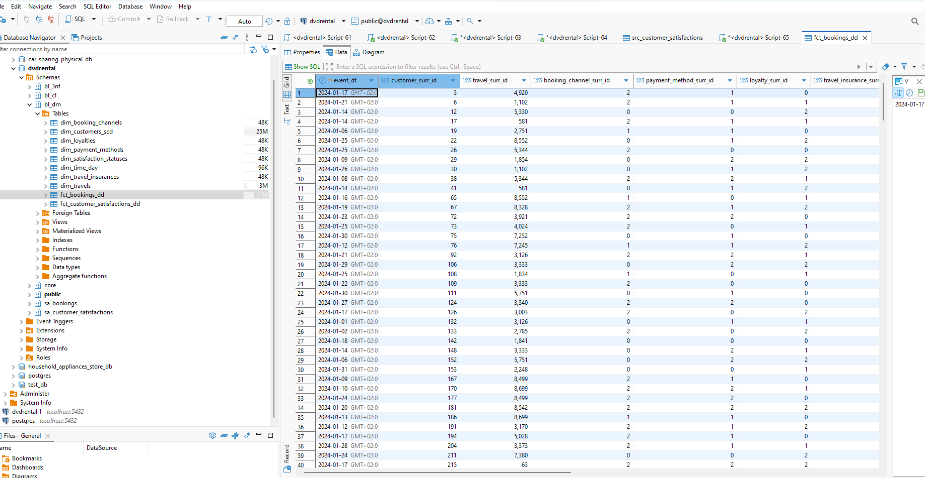
fct_bookings_dd
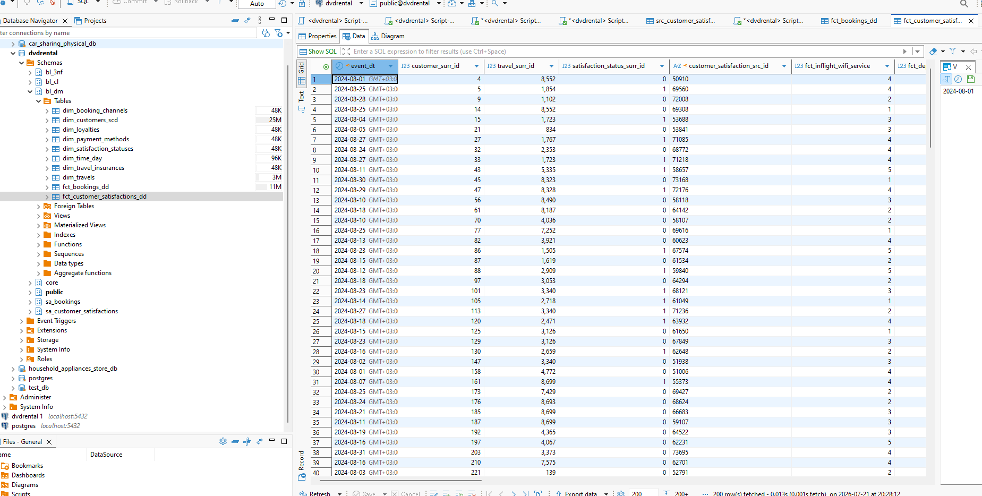
fct_customer_satisfactions_dd

Add screenshot showcasing that procedure can be executed repeatedly with explanation in case ‘Number of rows affected’ is not 0

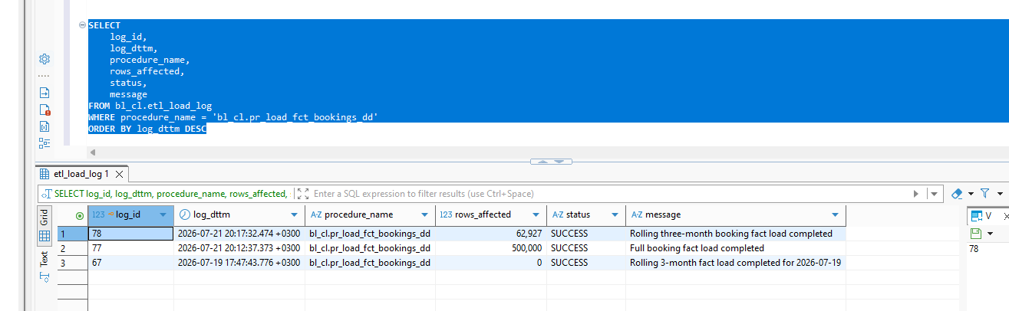
500000 is loaded on first call of procedure, on second call the number is 62927 as Rolling three-month booking fact load completed

CALL bl_cl.pr_load_fct_bookings_dd
(
'2024-10-06'::date,
FALSE
);
Second parameter defines the logic of load for either full or rolling window period (2-3 months).
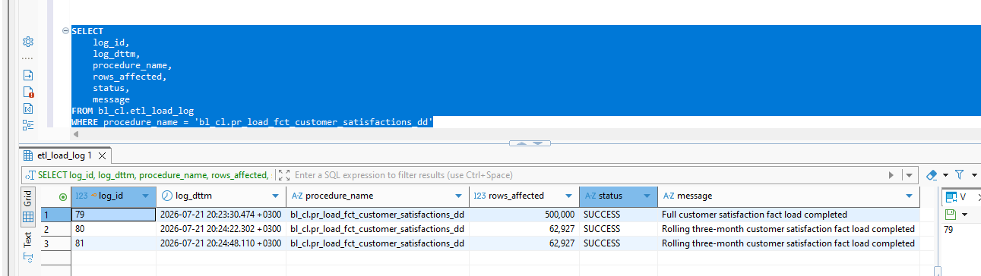

Add screenshot showcasing that all your objects are loaded correctly, without duplicates

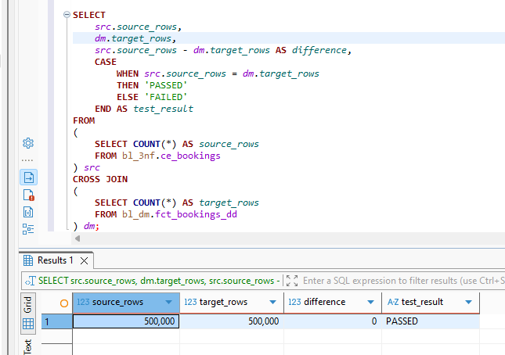
loaded correctly because number of rows in the source table is the same as in fact table
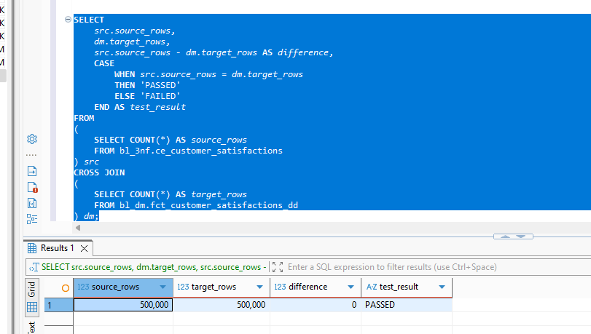

SQL scripts- screenshots of the established procedures

CREATE OR REPLACE PROCEDURE bl_cl.pr_load_fct_bookings_dd
(
p_load_date DATE DEFAULT CURRENT_DATE,
p_full_load BOOLEAN DEFAULT FALSE
)
LANGUAGE plpgsql
AS $$
DECLARE
v_first_month DATE;
v_last_month DATE;
v_month_start DATE;
v_month_end DATE;

v_partition_name TEXT;
v_stage_name TEXT;

v_month_rows BIGINT := 0;
v_total_rows BIGINT := 0;
BEGIN
IF p_full_load THEN
SELECT
DATE_TRUNC('month', MIN(booking_dt))::DATE,
DATE_TRUNC('month', MAX(booking_dt))::DATE
INTO
v_first_month,
v_last_month
FROM bl_3nf.ce_bookings;
ELSE
v_first_month :=
(
DATE_TRUNC('month', p_load_date)
- INTERVAL '2 months'
)::DATE;

v_last_month :=
DATE_TRUNC('month', p_load_date)::DATE;
END IF;

IF v_first_month IS NULL
OR v_last_month IS NULL
THEN
CALL bl_cl.pr_write_log
(
'bl_cl.pr_load_fct_bookings_dd',
0,
'SUCCESS',
'No source booking data found'
);

RETURN;
END IF;

v_month_start := v_first_month;

WHILE v_month_start <= v_last_month
LOOP
v_month_end :=
(
v_month_start + INTERVAL '1 month'
)::DATE;

v_partition_name :=
FORMAT(
'fct_bookings_dd_%s',
TO_CHAR(v_month_start, 'YYYYMM')
);

v_stage_name :=
FORMAT(
'fct_bookings_dd_stage_%s',
TO_CHAR(v_month_start, 'YYYYMM')
);

EXECUTE FORMAT(
'DROP TABLE IF EXISTS bl_dm.%I',
v_stage_name
);

EXECUTE FORMAT(
'CREATE TABLE bl_dm.%I
(
LIKE bl_dm.fct_bookings_dd
INCLUDING DEFAULTS
INCLUDING CONSTRAINTS
INCLUDING INDEXES
)',
v_stage_name
);

EXECUTE FORMAT(
'ALTER TABLE bl_dm.%I
ADD CONSTRAINT %I
CHECK
(
event_dt >= DATE %L
AND event_dt < DATE %L
)',
v_stage_name,
v_stage_name || '_date_chk',
v_month_start,
v_month_end
);

EXECUTE FORMAT(
$sql$
INSERT INTO bl_dm.%I
(
event_dt,
customer_surr_id,
travel_surr_id,
booking_channel_surr_id,
payment_method_surr_id,
loyalty_surr_id,
travel_insurance_surr_id,
booking_src_id,
fct_ticket_price,
fct_operating_cost,
fct_airport_fee,
fct_promotion_discount,
fct_profit,
ta_insert_dt,
ta_update_dt
)
SELECT
b.booking_dt,

dc.customer_surr_id,
dt.travel_surr_id,
dbc.booking_channel_surr_id,
dpm.payment_method_surr_id,
dl.loyalty_surr_id,
dti.travel_insurance_surr_id,

b.booking_id::VARCHAR(255),

b.ticket_price::NUMERIC(18, 4),
b.operating_cost::NUMERIC(18, 4),
b.airport_fee::NUMERIC(18, 4),
b.promotion_discount::NUMERIC(18, 4),
b.profit::NUMERIC(18, 4),

CURRENT_TIMESTAMP,
CURRENT_TIMESTAMP

FROM bl_3nf.ce_bookings b

INNER JOIN bl_3nf.ce_customers_scd c3
ON c3.customer_id = b.customer_id

INNER JOIN bl_dm.dim_customers_scd dc
ON dc.customer_src_id::TEXT =
c3.customer_src_id::TEXT

INNER JOIN bl_3nf.ce_travels t3
ON t3.travel_id = b.travel_id

INNER JOIN bl_dm.dim_travels dt
ON dt.travel_src_id::TEXT =
t3.travel_src_id::TEXT

INNER JOIN bl_3nf.ce_booking_channels bc3
ON bc3.booking_channel_id =
b.booking_channel_id

INNER JOIN bl_dm.dim_booking_channels dbc
ON dbc.booking_channel_src_id::TEXT =
bc3.booking_channel_src_id::TEXT

INNER JOIN bl_3nf.ce_payment_methods pm3
ON pm3.payment_method_id =
b.payment_method_id

INNER JOIN bl_dm.dim_payment_methods dpm
ON dpm.payment_method_src_id::TEXT =
pm3.payment_method_src_id::TEXT

INNER JOIN bl_3nf.ce_loyalties l3
ON l3.loyalty_id =
b.loyalty_id

INNER JOIN bl_dm.dim_loyalties dl
ON dl.loyalty_src_id::TEXT =
l3.loyalty_src_id::TEXT

INNER JOIN bl_3nf.ce_travel_insurances ti3
ON ti3.travel_insurance_id =
b.travel_insurance_id

INNER JOIN bl_dm.dim_travel_insurances dti
ON dti.travel_insurance_src_id::TEXT =
ti3.travel_insurance_src_id::TEXT

WHERE b.booking_dt >= DATE %L
AND b.booking_dt < DATE %L
AND b.booking_id IS NOT NULL
$sql$,
v_stage_name,
v_month_start,
v_month_end
);

EXECUTE FORMAT(
'SELECT COUNT(*)
FROM bl_dm.%I',
v_stage_name
)
INTO v_month_rows;

v_total_rows :=
v_total_rows + v_month_rows;

IF TO_REGCLASS(
FORMAT(
'bl_dm.%I',
v_partition_name
)
) IS NOT NULL
THEN
EXECUTE FORMAT(
'ALTER TABLE bl_dm.fct_bookings_dd
DETACH PARTITION bl_dm.%I',
v_partition_name
);

EXECUTE FORMAT(
'DROP TABLE bl_dm.%I',
v_partition_name
);
END IF;

EXECUTE FORMAT(
'ALTER TABLE bl_dm.%I
RENAME TO %I',
v_stage_name,
v_partition_name
);

EXECUTE FORMAT(
'ALTER TABLE bl_dm.fct_bookings_dd
ATTACH PARTITION bl_dm.%I
FOR VALUES FROM (%L) TO (%L)',
v_partition_name,
v_month_start,
v_month_end
);

v_month_start :=
(
v_month_start + INTERVAL '1 month'
)::DATE;
END LOOP;

CALL bl_cl.pr_write_log
(
'bl_cl.pr_load_fct_bookings_dd',
v_total_rows,
'SUCCESS',
CASE
WHEN p_full_load
THEN 'Full booking fact load completed'
ELSE 'Rolling three-month booking fact load completed'
END
);

EXCEPTION
WHEN OTHERS THEN
CALL bl_cl.pr_write_log
(
'bl_cl.pr_load_fct_bookings_dd',
0,
'FAILED',
SQLSTATE || ': ' || SQLERRM
);

RAISE;
END;
$$;

CREATE OR REPLACE PROCEDURE bl_cl.pr_load_fct_customer_satisfactions_dd
(
p_load_date DATE DEFAULT CURRENT_DATE,
p_full_load BOOLEAN DEFAULT FALSE
)
LANGUAGE plpgsql
AS $$
DECLARE
v_first_month DATE;
v_last_month DATE;
v_month_start DATE;
v_month_end DATE;

v_partition_name TEXT;
v_stage_name TEXT;

v_month_rows BIGINT := 0;
v_total_rows BIGINT := 0;
BEGIN
/*
* Full load:
* process all months available in the 3NF source.
*
* Incremental load:
* process the selected month and two previous months.
*/
IF p_full_load THEN
SELECT
DATE_TRUNC('month', MIN(survey_dt))::DATE,
DATE_TRUNC('month', MAX(survey_dt))::DATE
INTO
v_first_month,
v_last_month
FROM bl_3nf.ce_customer_satisfactions;
ELSE
v_first_month :=
(
DATE_TRUNC('month', p_load_date)
- INTERVAL '2 months'
)::DATE;

v_last_month :=
DATE_TRUNC('month', p_load_date)::DATE;
END IF;

IF v_first_month IS NULL
OR v_last_month IS NULL
THEN
CALL bl_cl.pr_write_log
(
'bl_cl.pr_load_fct_customer_satisfactions_dd',
0,
'SUCCESS',
'No source customer satisfaction data found'
);

RETURN;
END IF;

v_month_start := v_first_month;

/*
* Process each required month separately.
*/
WHILE v_month_start <= v_last_month
LOOP
v_month_end :=
(
v_month_start + INTERVAL '1 month'
)::DATE;

v_partition_name :=
FORMAT
(
'fct_customer_satisfactions_dd_%s',
TO_CHAR(v_month_start, 'YYYYMM')
);

v_stage_name :=
FORMAT
(
'fct_customer_satisfactions_dd_stage_%s',
TO_CHAR(v_month_start, 'YYYYMM')
);

EXECUTE FORMAT
(
'DROP TABLE IF EXISTS bl_dm.%I',
v_stage_name
);

/*
* Create a standalone monthly table.
* It will later be attached as a partition.
*/
EXECUTE FORMAT
(
'CREATE TABLE bl_dm.%I
(
LIKE bl_dm.fct_customer_satisfactions_dd
INCLUDING DEFAULTS
INCLUDING CONSTRAINTS
INCLUDING INDEXES
)',
v_stage_name
);

/*
* Add the monthly date-range constraint.
*/
EXECUTE FORMAT
(
'ALTER TABLE bl_dm.%I
ADD CONSTRAINT %I
CHECK
(
event_dt >= DATE %L
AND event_dt < DATE %L
)',
v_stage_name,
v_stage_name || '_date_chk',
v_month_start,
v_month_end
);

EXECUTE FORMAT
(
$sql$
INSERT INTO bl_dm.%I
(
event_dt,
customer_surr_id,
travel_surr_id,
satisfaction_status_surr_id,
customer_satisfaction_src_id,

fct_inflight_wifi_service,
fct_departure_arrival_time_convenient,
fct_ease_of_online_booking,
fct_gate_location,
fct_food_and_drink,
fct_online_boarding,
fct_seat_comfort,
fct_inflight_entertainment,
fct_on_board_service,
fct_leg_room_service,
fct_baggage_handling,
fct_checkin_service,
fct_inflight_service,
fct_cleanliness,
fct_departure_delay_in_minutes,
fct_arrival_delay_in_minutes,

ta_insert_dt,
ta_update_dt
)
SELECT
s.survey_dt,

dc.customer_surr_id,
dt.travel_surr_id,
dss.satisfaction_status_surr_id,

s.customer_satisfaction_id::VARCHAR(255),

s.inflight_wifi_service::NUMERIC(5, 2),
s.departure_arrival_time_convenient::NUMERIC(5, 2),
s.ease_of_online_booking::NUMERIC(5, 2),
s.gate_location::NUMERIC(5, 2),
s.food_and_drink::NUMERIC(5, 2),
s.online_boarding::NUMERIC(5, 2),
s.seat_comfort::NUMERIC(5, 2),
s.inflight_entertainment::NUMERIC(5, 2),
s.on_board_service::NUMERIC(5, 2),
s.leg_room_service::NUMERIC(5, 2),
s.baggage_handling::NUMERIC(5, 2),
s.checkin_service::NUMERIC(5, 2),
s.inflight_service::NUMERIC(5, 2),
s.cleanliness::NUMERIC(5, 2),
s.departure_delay_in_minutes::NUMERIC(10, 2),
s.arrival_delay_in_minutes::NUMERIC(10, 2),

CURRENT_TIMESTAMP,
CURRENT_TIMESTAMP

FROM bl_3nf.ce_customer_satisfactions s

INNER JOIN bl_3nf.ce_customers_scd c3
ON c3.customer_id = s.customer_id

INNER JOIN bl_dm.dim_customers_scd dc
ON dc.customer_src_id::TEXT =
c3.customer_src_id::TEXT

INNER JOIN bl_3nf.ce_travels t3
ON t3.travel_id = s.travel_id

INNER JOIN bl_dm.dim_travels dt
ON dt.travel_src_id::TEXT =
t3.travel_src_id::TEXT

INNER JOIN bl_3nf.ce_satisfaction_statuses ss3
ON ss3.satisfaction_status_id =
s.satisfaction_status_id

INNER JOIN bl_dm.dim_satisfaction_statuses dss
ON dss.satisfaction_status_src_id::TEXT =
ss3.satisfaction_status_src_id::TEXT

WHERE s.survey_dt >= DATE %L
AND s.survey_dt < DATE %L
AND s.customer_satisfaction_id IS NOT NULL
$sql$,
v_stage_name,
v_month_start,
v_month_end
);

EXECUTE FORMAT
(
'SELECT COUNT(*)
FROM bl_dm.%I',
v_stage_name
)
INTO v_month_rows;

v_total_rows :=
v_total_rows + v_month_rows;

/*
* Replace the existing monthly partition.
*/
IF TO_REGCLASS
(
FORMAT
(
'bl_dm.%I',
v_partition_name
)
) IS NOT NULL
THEN
EXECUTE FORMAT
(
'ALTER TABLE bl_dm.fct_customer_satisfactions_dd
DETACH PARTITION bl_dm.%I',
v_partition_name
);

EXECUTE FORMAT
(
'DROP TABLE bl_dm.%I',
v_partition_name
);
END IF;

EXECUTE FORMAT
(
'ALTER TABLE bl_dm.%I
RENAME TO %I',
v_stage_name,
v_partition_name
);

/*
* Attach the newly loaded monthly partition.
*/
EXECUTE FORMAT
(
'ALTER TABLE bl_dm.fct_customer_satisfactions_dd
ATTACH PARTITION bl_dm.%I
FOR VALUES FROM (%L) TO (%L)',
v_partition_name,
v_month_start,
v_month_end
);

v_month_start :=
(
v_month_start + INTERVAL '1 month'
)::DATE;
END LOOP;

CALL bl_cl.pr_write_log
(
'bl_cl.pr_load_fct_customer_satisfactions_dd',
v_total_rows,
'SUCCESS',
CASE
WHEN p_full_load
THEN 'Full customer satisfaction fact load completed'
ELSE 'Rolling three-month customer satisfaction fact load completed'
END
);

EXCEPTION
WHEN OTHERS THEN
CALL bl_cl.pr_write_log
(
'bl_cl.pr_load_fct_customer_satisfactions_dd',
0,
'FAILED',
SQLSTATE || ': ' || SQLERRM
);

RAISE;
END;
$$;

