Prerequisite
SELECT current_database();
SELECT current_schema();

SHOW search_path;
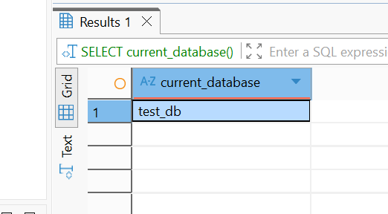

DROP TABLE IF EXISTS labs.person;

CREATE TABLE labs.person (
id integer NOT NULL,
name varchar(15)
);
INSERT INTO labs.person VALUES (1, 'Bob');
INSERT INTO labs.person VALUES (2, 'Alice');
INSERT INTO labs.person VALUES (3, 'Robert');
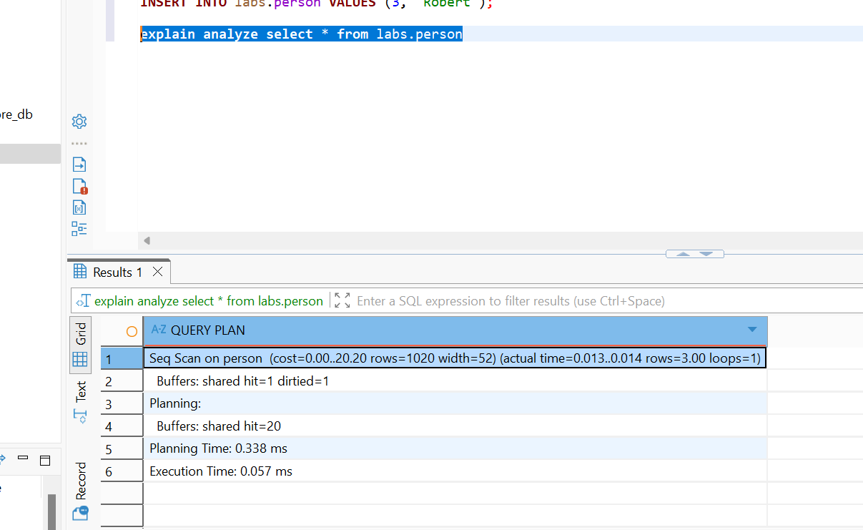

TASK 1
DROP TABLE IF EXISTS labs.test_simple;

CREATE TABLE labs.test_simple (
a int,
b int
);

Perform insert and check how much time it takes:
EXPLAIN ANALYZE
INSERT INTO labs.test_simple(a)
SELECT generate_series(1, 1000000);

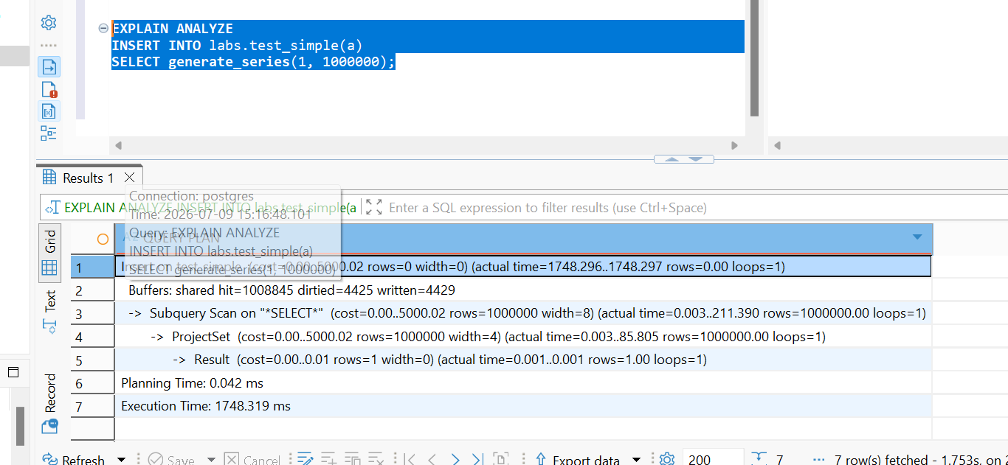
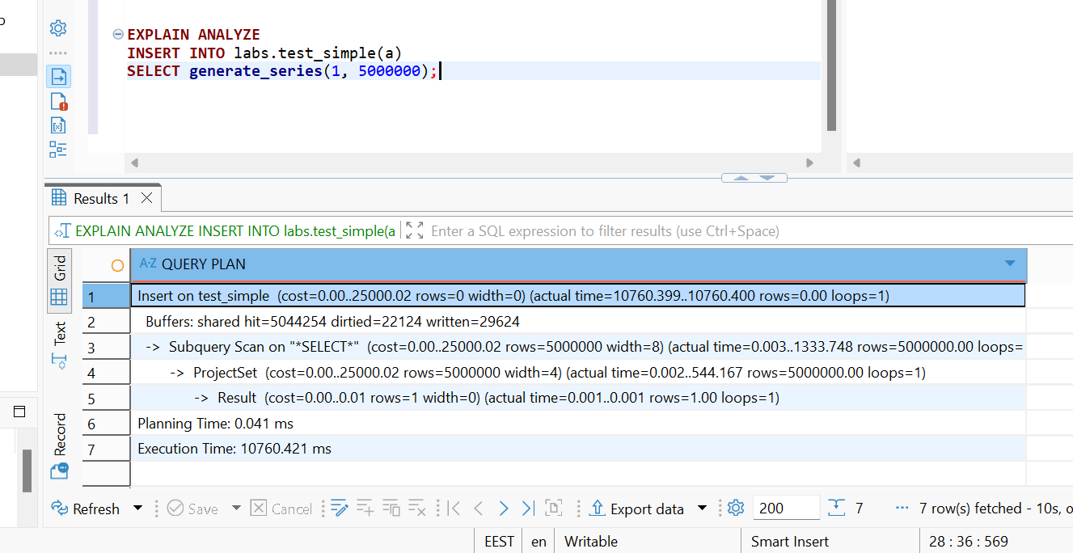
Create UNLOGGED table
DROP TABLE IF EXISTS labs.test_unlogged;

CREATE UNLOGGED TABLE labs.test_unlogged (
a int,
b int
);

Perform insert and check how much time it takes:
EXPLAIN ANALYZE

INSERT INTO labs.test_unlogged(a)
SELECT generate_series(1, 1000000);

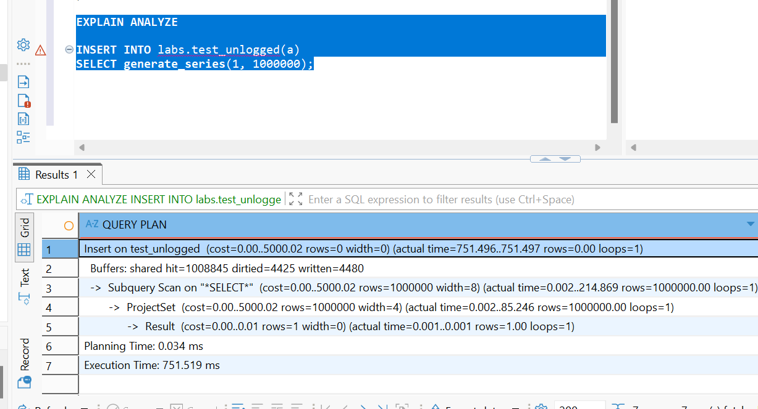
EXPLAIN ANALYZE
INSERT INTO labs.test_unlogged(a)
SELECT generate_series(1, 5000000);

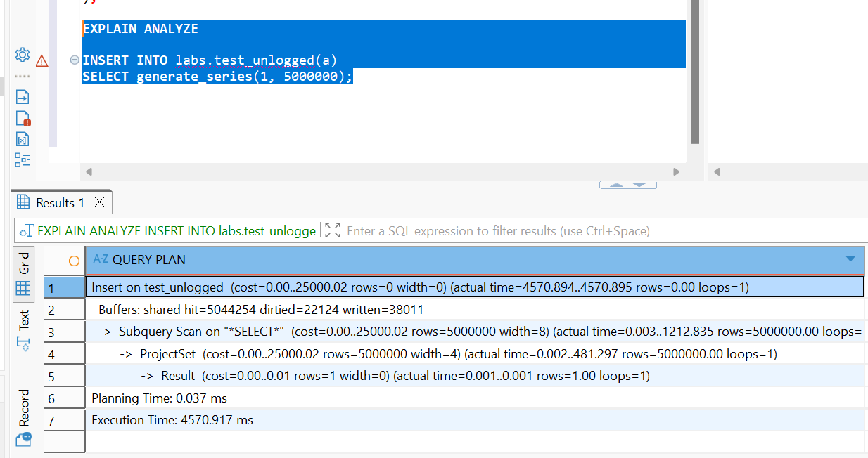
Conclusion: Increasing the dataset size from 1 million to 5 million rows increased execution time from 751 ms to 4571 ms

Task 2
Create inherited table for person:
CREATE TABLE labs.users(user_id INT GENERATED BY DEFAULT AS IDENTITY PRIMARY KEY, login VARCHAR(30)) INHERITS (person);
INSERT INTO users VALUES (1, 'new Bob', 'NewLogin');
INSERT INTO users VALUES (999, 'TestUser', 'TestLogin');

Perform selects:
SELECT * FROM users;

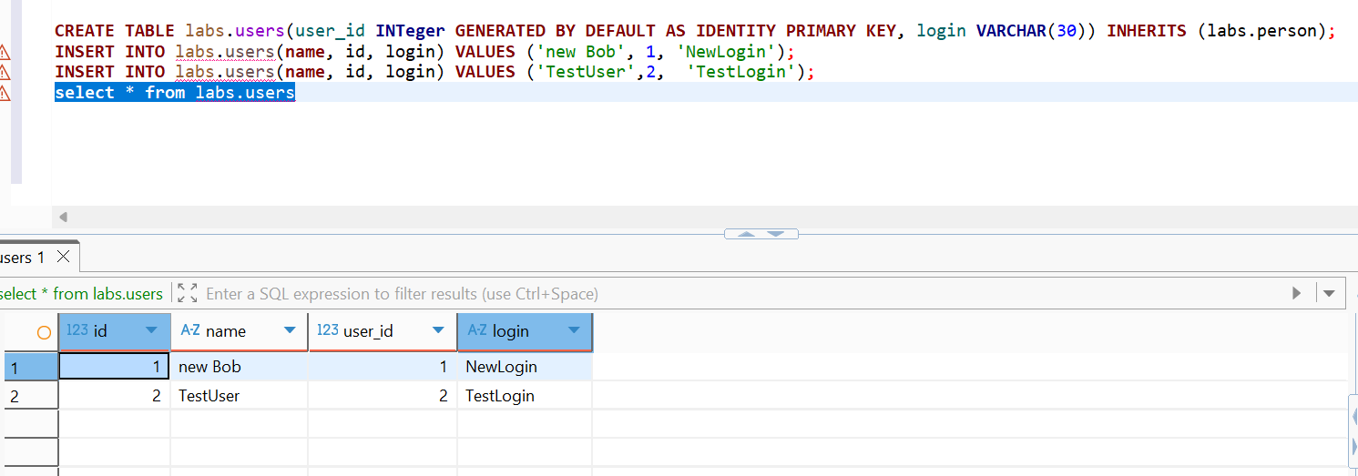
SELECT * FROM person;

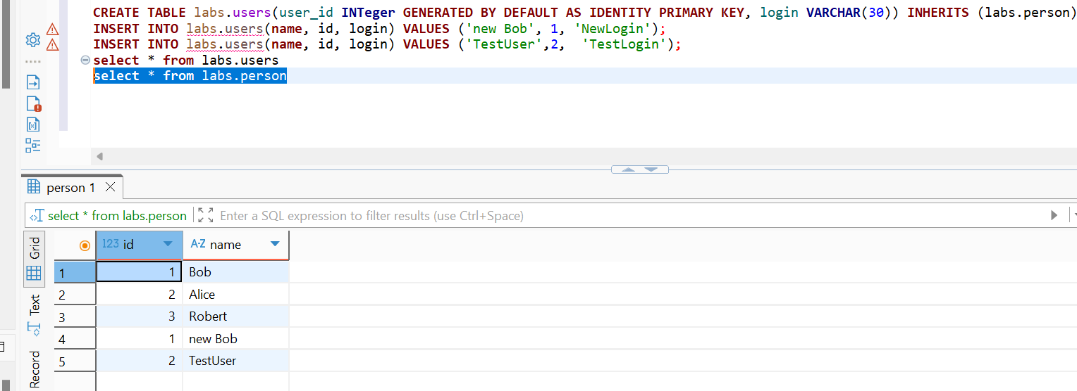
SELECT * FROM ONLY person;

Modify data in person table, check result:
UPDATE person SET name = 'not Bob' where id = 1;
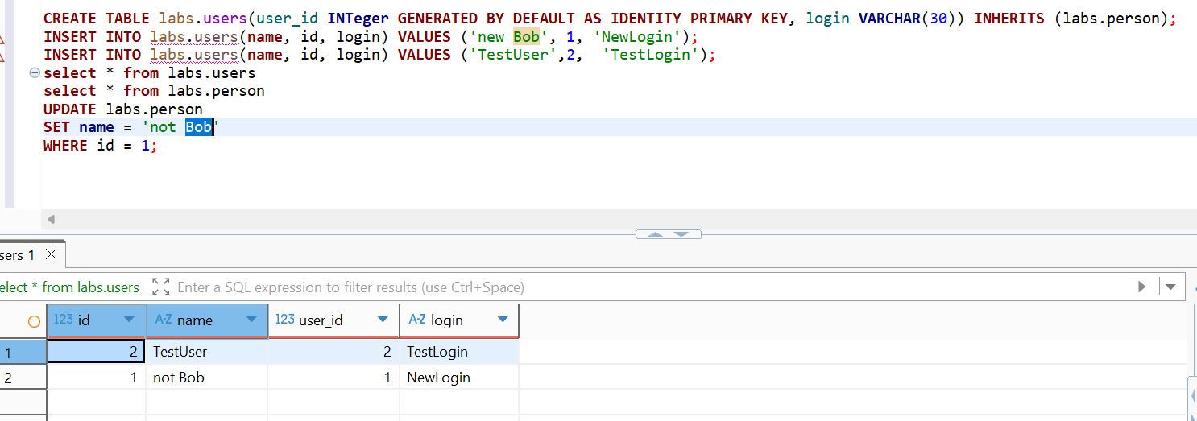
Alter person table and check structure and constraints on both users and person tables:
ALTER TABLE person ADD COLUMN status integer DEFAULT 0;
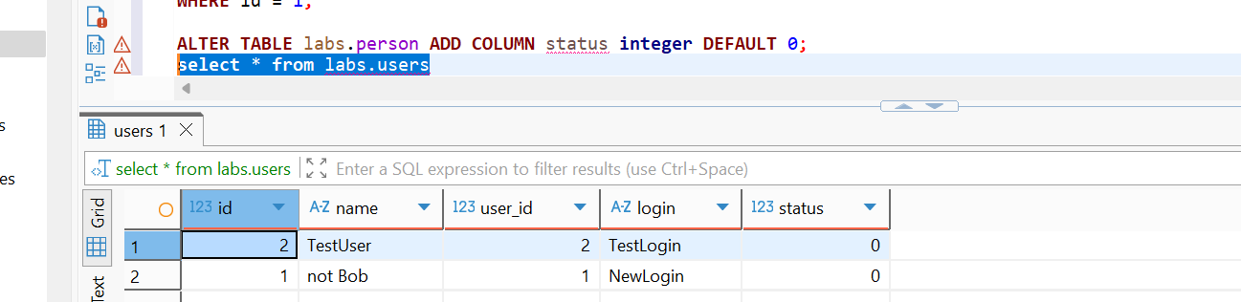
ALTER TABLE labs.person
ADD CONSTRAINT status CHECK (status IN (0, 1)) NO INHERIT;

ALTER TABLE person ADD CONSTRAINT id UNIQUE (id, name);
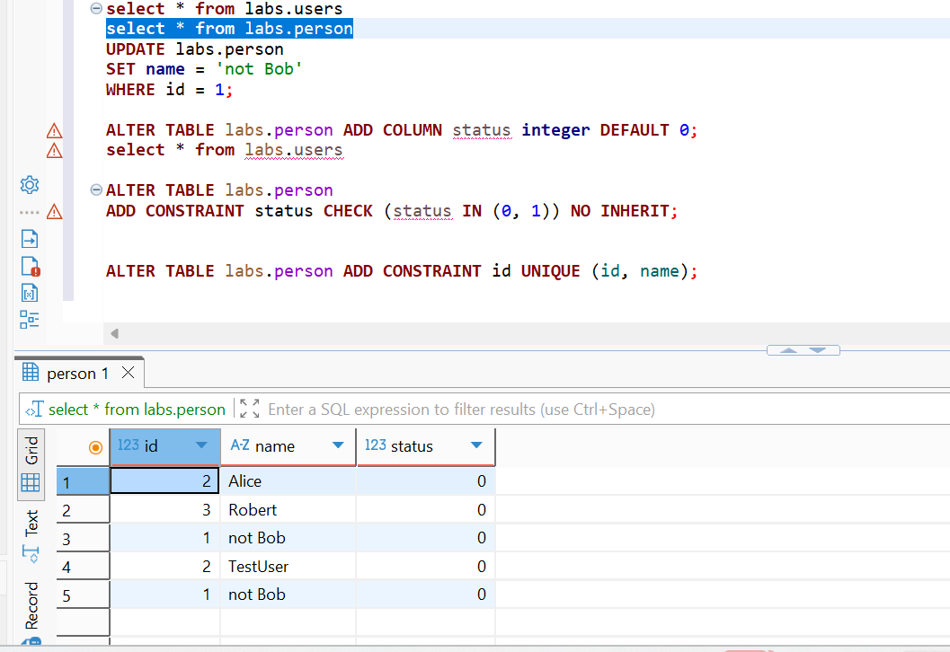

Check data
SELECT *
FROM labs.users;

Conclusions: child table users inherited all structural and data modification changes from table person.

TASK 3 - BRIN VS B-TREE
Create table test_index:
CREATE TABLE labs.test_index ( num float NOT NULL, load_date timestamptz NOT NULL );

Check table structure
SELECT
table_schema,
table_name,
column_name,
data_type
FROM information_schema.columns
WHERE table_schema = 'labs'
AND table_name = 'test_index'
ORDER BY ordinal_position;

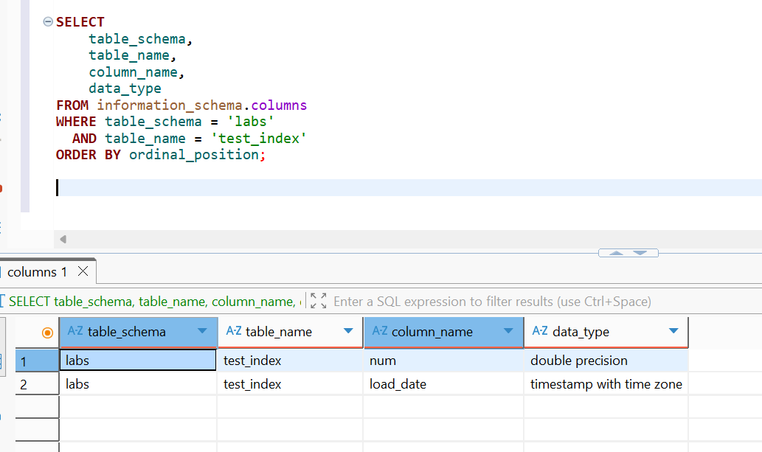
Fill the table with a lot of test data:
INSERT INTO labs.test_index(num, load_date)
SELECT random(), x
FROM generate_series(
'2017-01-01 0:00'::timestamptz,
'2021-12-31 23:59:59'::timestamptz,
'10 seconds'::interval
) x;

Check the table size:
SELECT pg_size_pretty(pg_relation_size('test_index'));
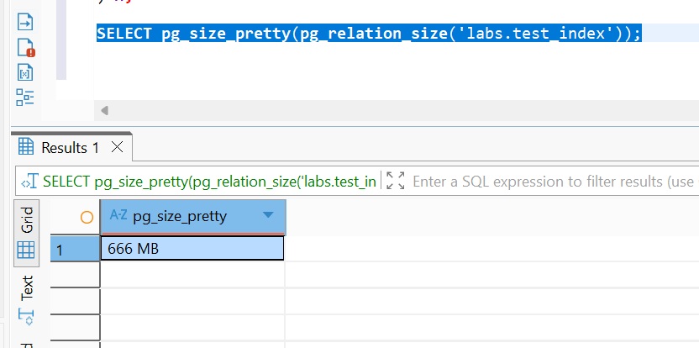
Perform select and check how much time it takes:
EXPLAIN ANALYZE
SELECT date_trunc('year', load_date), max(num)
FROM labs.test_index
WHERE load_date BETWEEN '2021-09-01 0:00' AND '2021-10-31 11:59:59'
GROUP BY 1
ORDER BY 1;

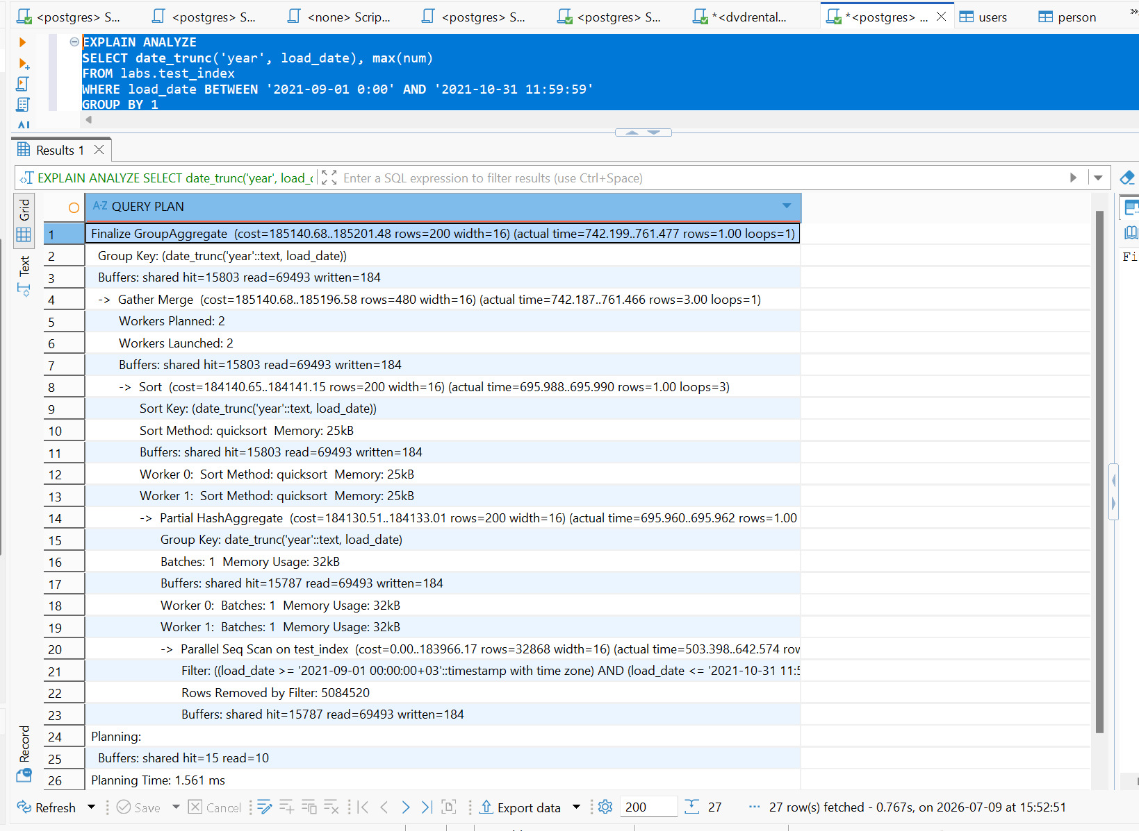
Create B-Tree index on load_date:
CREATE INDEX test_index_load_date_btree_idx
ON labs.test_index USING btree (load_date);

check the execution time
ANALYZE labs.test_index;
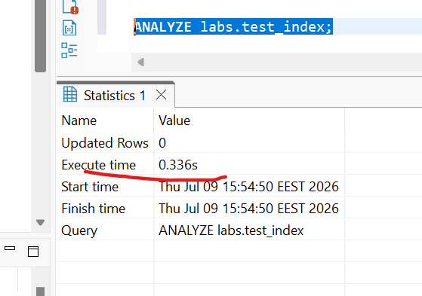
Check B-Tree index size:
SELECT pg_size_pretty(
pg_relation_size('labs.test_index_load_date_btree_idx')
) AS btree_index_size;
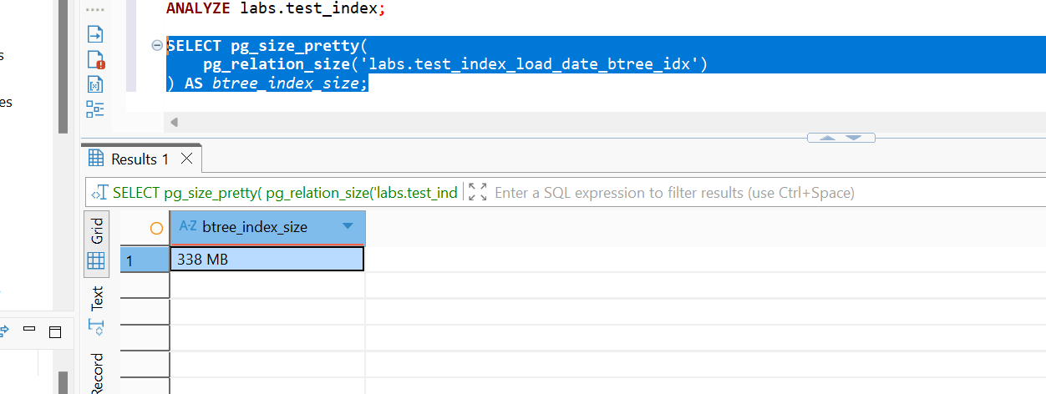

EXPLAIN ANALYZE
SELECT date_trunc('year', load_date), max(num)
FROM labs.test_index
WHERE load_date BETWEEN '2021-09-01 0:00' AND '2021-10-31 11:59:59'
GROUP BY 1
ORDER BY 1;
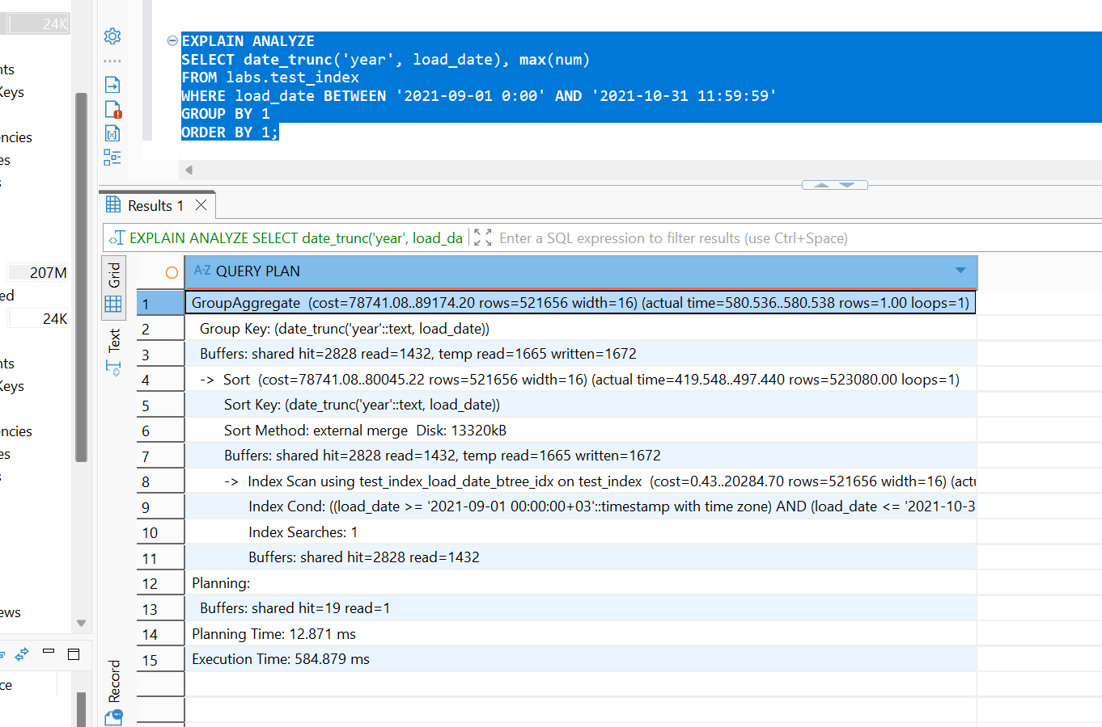

DROP INDEX labs.test_index_load_date_btree_idx;

Create BRIN index on load_date:
CREATE INDEX test_index_load_date_brin_idx
ON labs.test_index USING brin (load_date);

Check execution plan
ANALYZE labs.test_index;
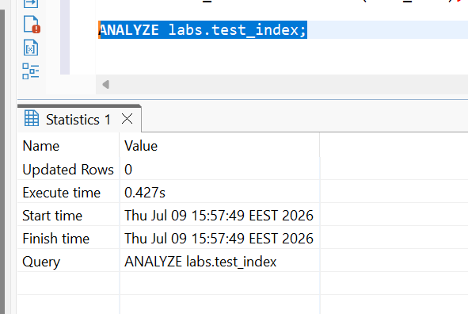
Check BRIN index size:
SELECT pg_size_pretty(
pg_relation_size('labs.test_index_load_date_brin_idx')
) AS brin_index_size;
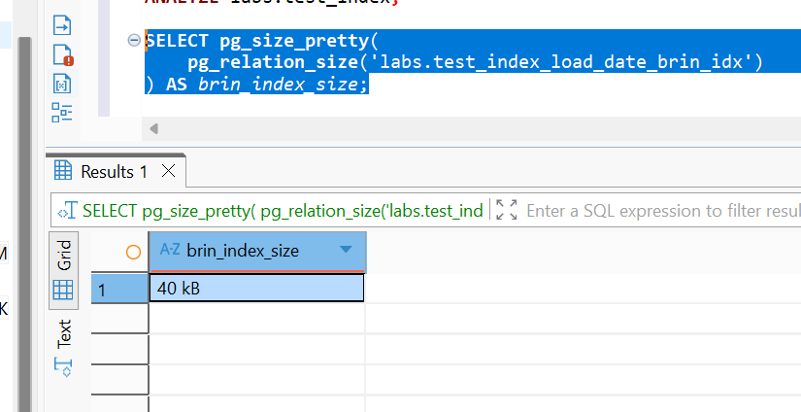
SELECT with BRIN index
EXPLAIN ANALYZE
SELECT date_trunc('year', load_date), max(num)
FROM labs.test_index
WHERE load_date BETWEEN '2021-09-01 0:00' AND '2021-10-31 11:59:59'
GROUP BY 1
ORDER BY 1;
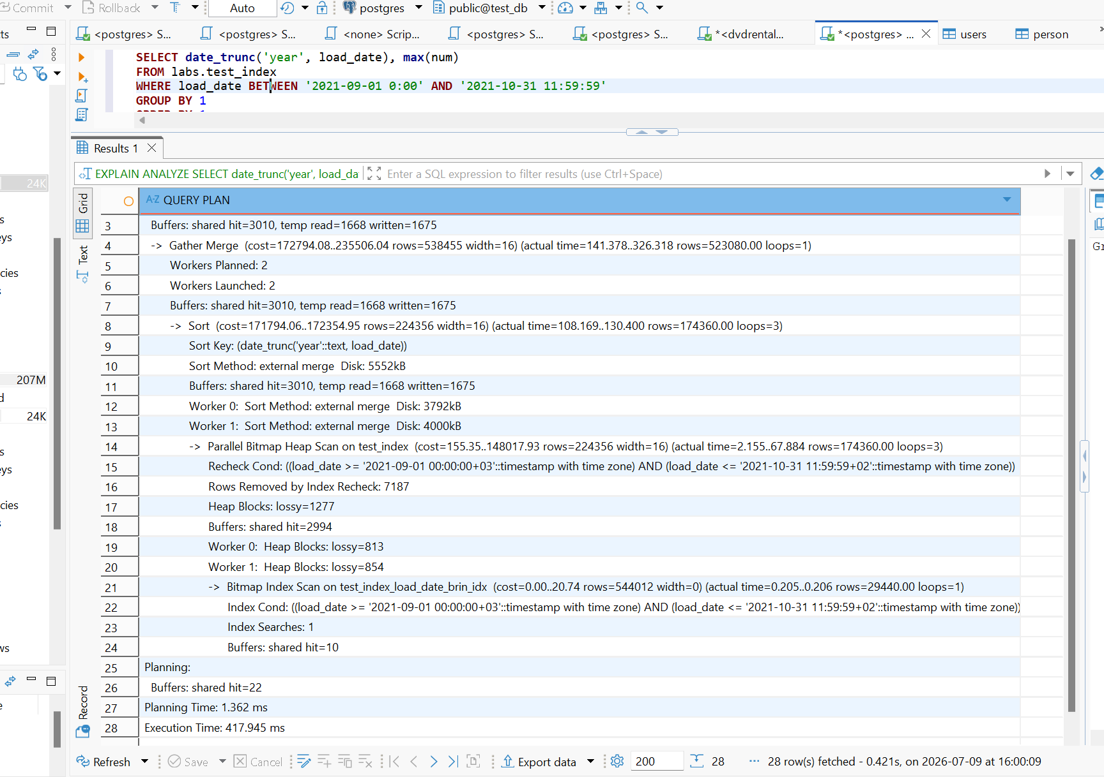
BRIN means Block Range Index.
A BRIN index does not store every value like B-Tree. Instead, it stores summary information for groups of table pages.
Drop BRIN Index
DROP INDEX labs.test_index_load_date_brin_idx;
Results
Test | Query time | Index size | Plan
Without index | 0.450 | — | Seq Scan / Parallel Seq Scan
B-Tree index | 0.336 | 338Mb | Bitmap Index Scan / Index Scan
BRIN index | 0.427 | 40kb | Bitmap Index Scan with recheck
Conclusion: The B-Tree index provided the best query performance (0.336 ms) at the cost of significant storage (338 MB), while the BRIN index achieved comparable performance with minimal storage usage (40 KB), making it a highly space-efficient alternative for large datasets.

TASK 4 - GIN VS GIST
Create a table and fill with test data:
CREATE TABLE test_index AS SELECT id, md5(id::text) as t_hash FROM generate_series(1, 10000000) AS id;

Check the table size:
SELECT pg_size_pretty(pg_relation_size('test_index'));
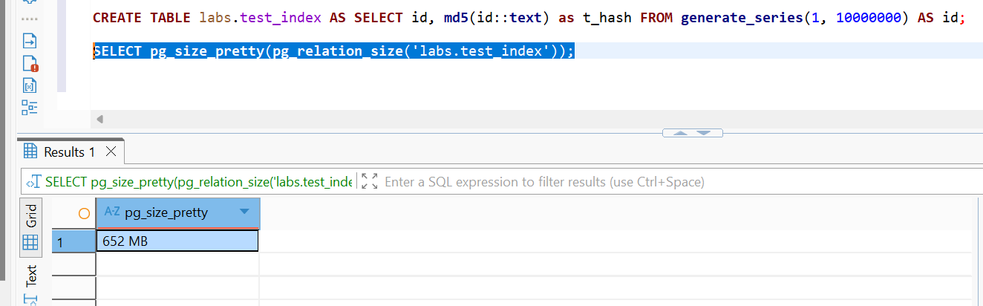
Perform select and check how much time it takes:
EXPLAIN ANALYZE
SELECT * FROM test_index WHERE t_hash LIKE '%ceea167a5a%';
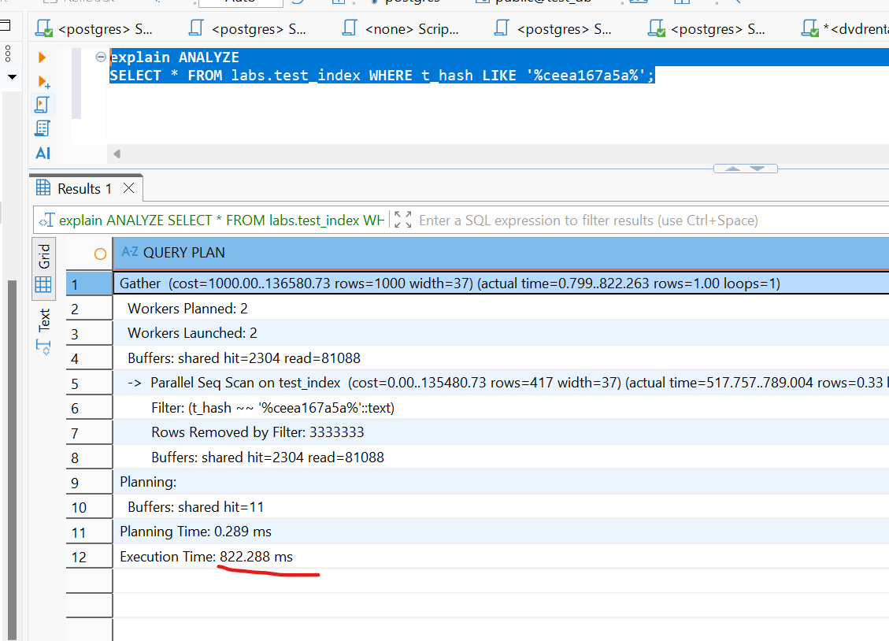
Create GIST Index on test_index table for t_hash column.
CREATE EXTENSION IF NOT EXISTS pg_trgm;
CREATE INDEX idx_text_index_gist ON test_index USING gist(t_hash gist_trgm_ops);
Perform select and check how much time it takes:
EXPLAIN ANALYZE
SELECT *
FROM labs.test_index
WHERE t_hash LIKE '%ceea167a5a%';
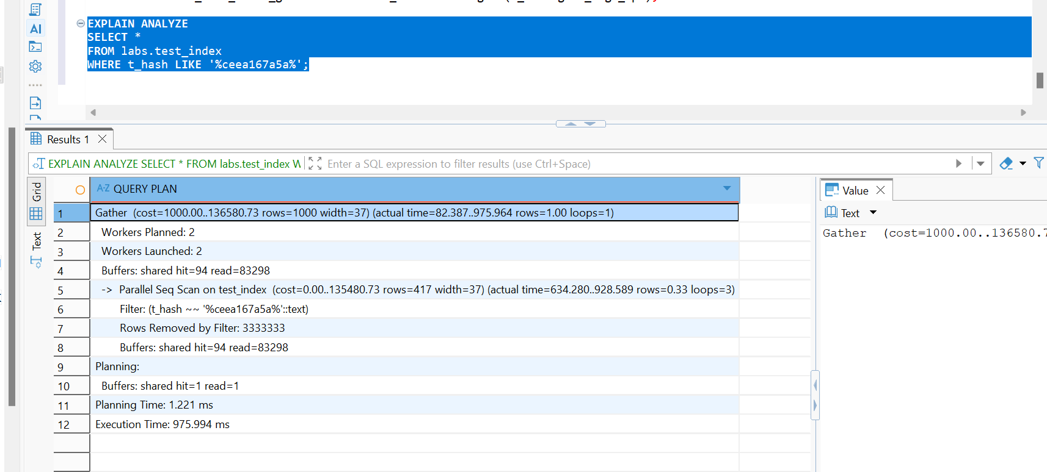
Drop GIST index
DROP INDEX labs.idx_text_index_gist;

Create GIN Index on test_index table for t_hash column.
CREATE INDEX idx_text_index_gin ON test_index USING gin (t_hash gin_trgm_ops);

Perform select and check how much time it takes:
EXPLAIN ANALYZE
SELECT *
FROM labs.test_index
WHERE t_hash LIKE '%ceea167a5a%';
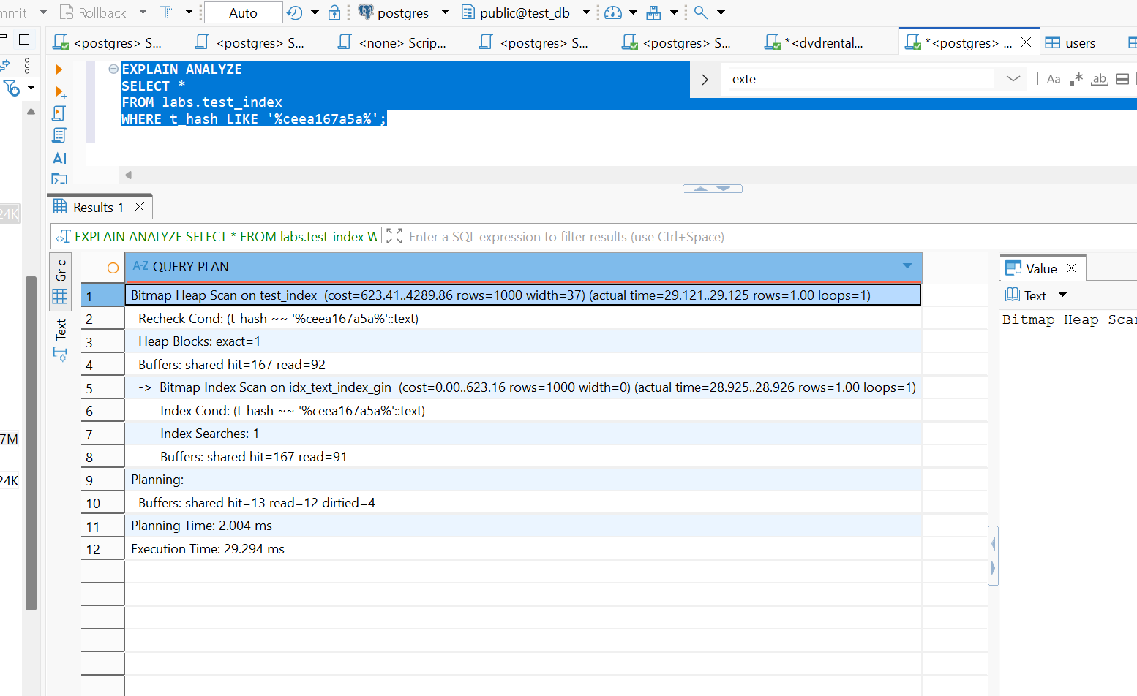
Drop GIN index
DROP INDEX labs.idx_text_index_gin;

Conclusions:
Test | Query time | Execution plan
Without index | 822.228ms | Seq Scan / Parallel Seq Scan
GIST trigram index | 975.997ms | Bitmap Index Scan using idx_text_index_gist
GIN trigram index | 29.294ms | Bitmap Index Scan using idx_text_index_gin
Conclusion: The GIN trigram index delivered the best performance, reducing query execution time from 822.228 ms to 29.294 ms

TASK 5 – CSV FILE AS A TABLE
Install file_fdw extension to database and create the SERVER to use, every FOREIGN TABLE requires a server:
CREATE EXTENSION file_fdw; CREATE SERVER test_import FOREIGN DATA WRAPPER file_fdw;

Create the foreign table to connect to the CSV file
CREATE FOREIGN TABLE labs.test_foreign_table
(
LatD INT,
LatM INT,
LatS INT,
NS TEXT,
LonD INT,
LonM INT,
LonS INT,
EW TEXT,
City TEXT,
State TEXT
)
SERVER test_import
OPTIONS
(
filename 'C:/temp/cities_list.csv',
format 'csv',
header 'true',
delimiter ','
);

Select data from the foreign table and count of rows.
SELECT * FROM test_foreign_table;
SELECT count(*) FROM test_foreign_table;
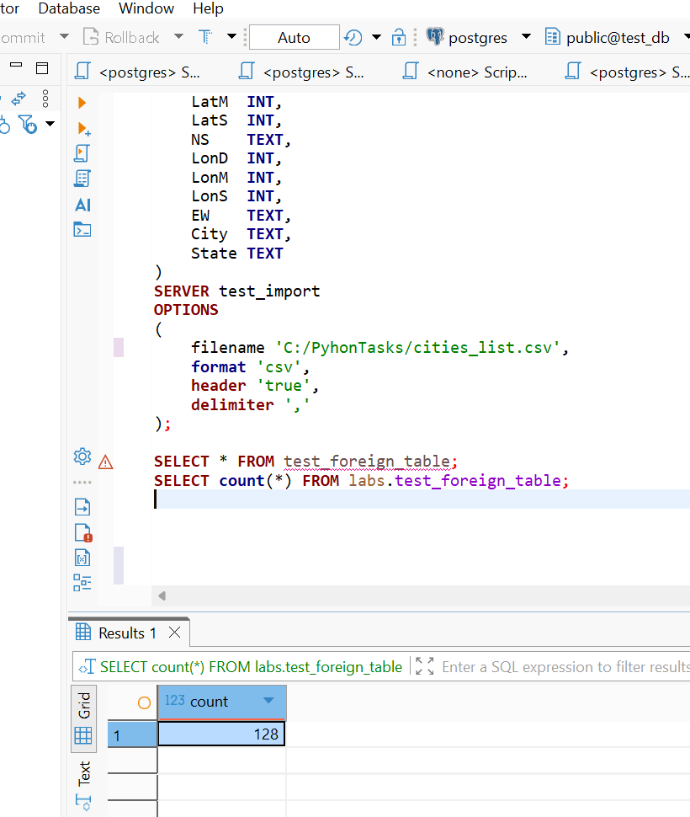
Create Materialized view to select from this foreign table. Select from MView.
CREATE MATERIALIZED VIEW labs.test_foreign_mview AS
SELECT *
FROM labs.test_foreign_table;
select count(*) from mview
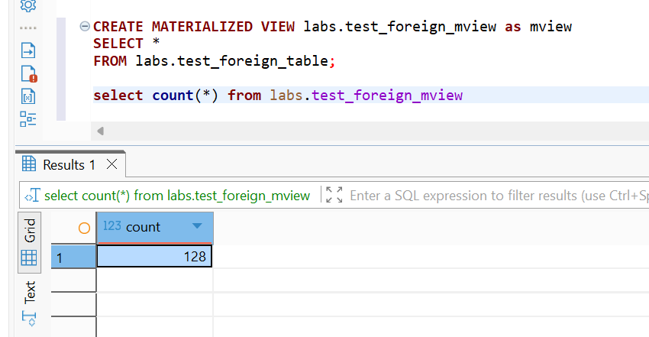
Delete from file some rows. Select count again.
SELECT COUNT(*)
FROM labs.test_foreign_table;
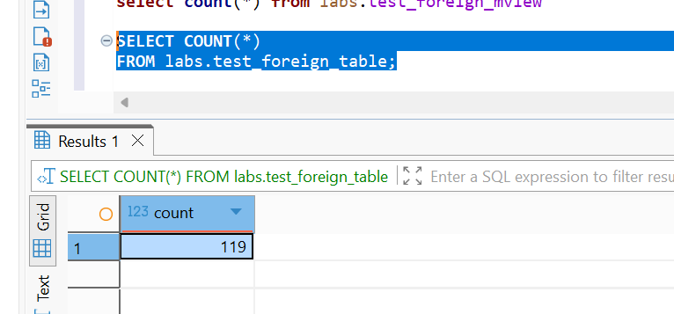
Refresh MView to update count of rows.
REFRESH MATERIALIZED VIEW labs.test_foreign_mview;

SELECT COUNT(*)
FROM labs.test_foreign_table;
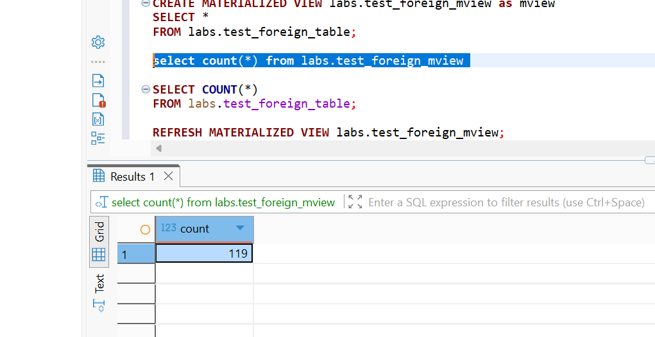

Conclusion: after rows are deleted from csv file the numbers of row doesn’t change in materialized view, it changes only after the REFRESH MATERIALIZED VIEW command.
In table the value of row value refreshes immediately after row value change.

