TASK 1 – TABLE WITHOUT INDEX
Create table test_index:
CREATE TABLE labs.test_index_plan ( num float NOT NULL, load_date timestamptz NOT NULL );

Fill the table with a lot of test data:
INSERT INTO labs.test_index(num, load_date) SELECT random(), x FROM generate_series('2017-01-01 0:00'::timestamptz, '2021-12-31 23:59:59'::timestamptz, '10 seconds'::interval) x;

Disable the parallel query planning
SET max_parallel_workers_per_gather = 0;

EXPLAIN (Cost-Based Estimation Only)
EXPLAIN
SELECT *
FROM labs.test_index_plan
WHERE load_date BETWEEN '2021-09-01 0:00' AND '2021-10-31 23:59:59'
ORDER BY 1;
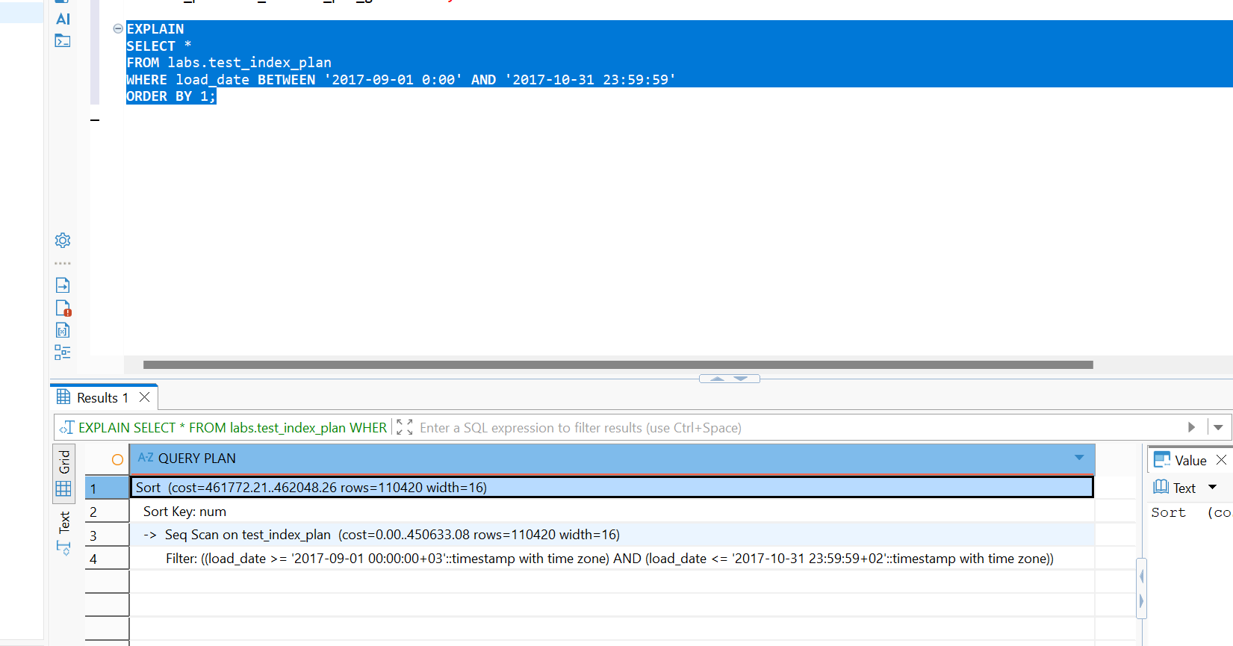
Conclusions:
Seq Scan (Sequential Scan) happened because there are no indexes on the load_date column.
Filter represents the CPU evaluation of WHERE clause applied to every scanned row.
Cost is estimated because EXPLAIN on its own does not execute the query. It only asks the planner to estimate costs based on internal system statistics (pg_statistic).

TASK 2 – ADDING INDEX
Create B-Tree Index on test_index_plan table for load_date column.
CREATE INDEX idx_test_index_plan_load_date
ON labs.test_index_plan (load_date);

B-Tree Index scans the entire table and builds a balanced tree structure mapping each load_date timestamp to its physical storage location (Tuple ID / TID) in the heap table.
Disable the parallel query planning
SET max_parallel_workers_per_gather = 0;

EXPLAIN (Cost-Based Estimation Only)
EXPLAIN
SELECT *
FROM labs.test_index_plan
WHERE load_date BETWEEN '2021-09-01 0:00' AND '2021-10-31 23:59:59'
ORDER BY 1;

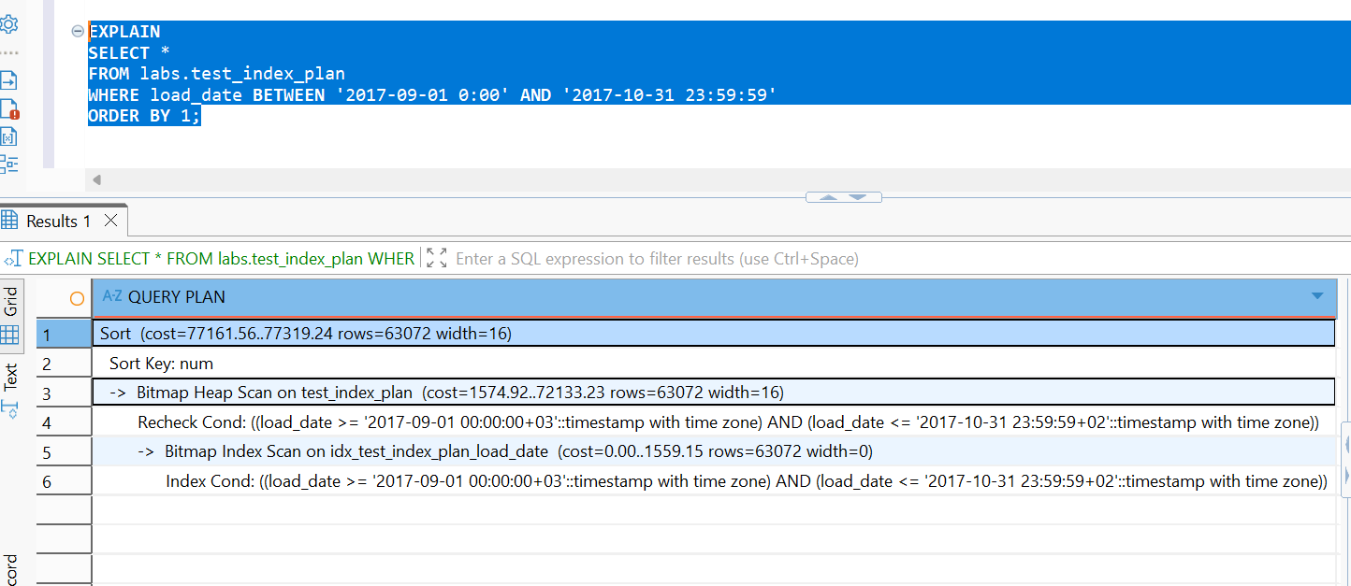
Bitmap Index Scan reads the index, builds a bitmap of matching physical pages in memory, sorts these page addresses.
Bitmap Heap Scan reads the actual physical pages sequentially. This minimizes head movement on traditional spinning disks and avoids reading the same page multiple times.
The planner uses a bitmap because the volume of matching data is too large for a standard direct index lookup, but too small to justify scanning the entire table sequentially (Seq Scan).
EXPLAIN (ANALYZE, BUFFERS)
EXPLAIN (ANALYZE, BUFFERS)
SELECT *
FROM labs.test_index_plan
WHERE load_date BETWEEN '2021-09-01 0:00' AND '2021-10-31 11:59:59'
ORDER BY 1;

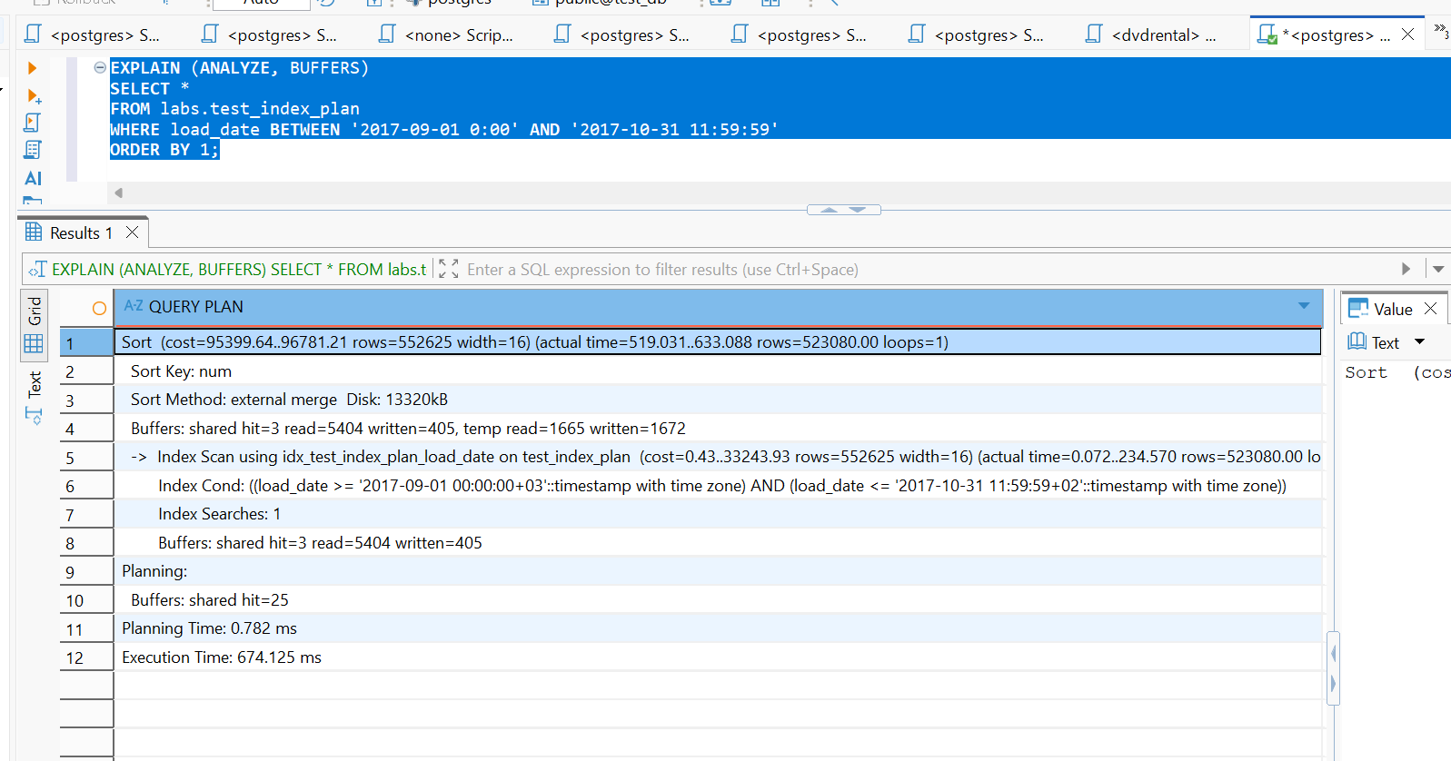
3. What can be done to use INDEX ONLY SCAN?
Create a composite (covering) index:

CREATE INDEX idx_covering_test_index
ON labs.test_index_plan (load_date) INCLUDE (num);

-- Clean the table to update the Visibility Map
VACUUM ANALYZE labs.test_index_plan;

EXPLAIN (ANALYZE, BUFFERS)
EXPLAIN (ANALYZE, BUFFERS)
SELECT load_date, num
FROM labs.test_index_plan
WHERE load_date BETWEEN '2021-09-01 0:00' AND '2021-10-31 11:59:59';

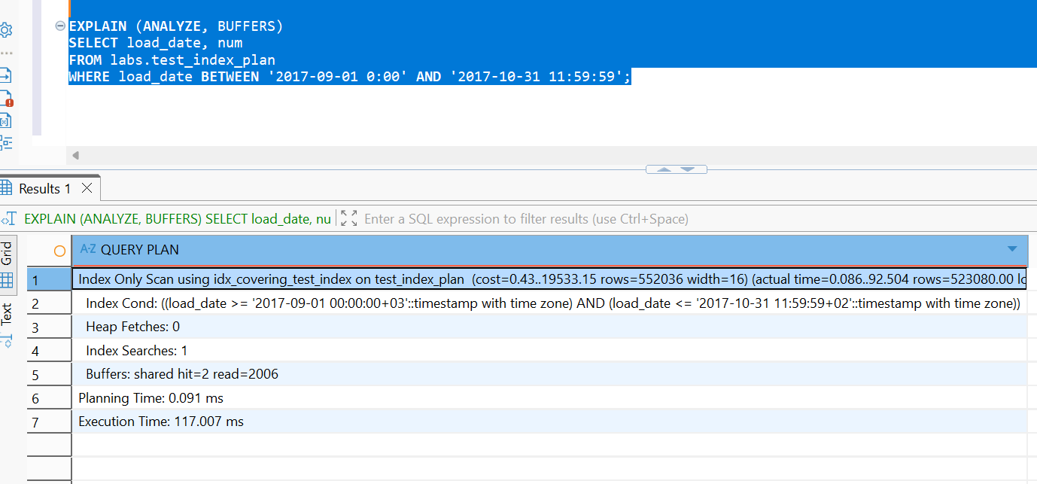
Drop B-Tree and Create BRIN Index
DROP INDEX labs.idx_test_index_plan_load_date;

Create BRIN Index
CREATE INDEX idx_brin_test_index_plan
ON labs.test_index_plan USING BRIN (load_date);

Check the BRIN Plan – 1st time
EXPLAIN (ANALYZE, BUFFERS)
SELECT *
FROM labs.test_index_plan
WHERE load_date BETWEEN '2021-09-01 0:00' AND '2021-10-31 11:59:59'
ORDER BY 1;
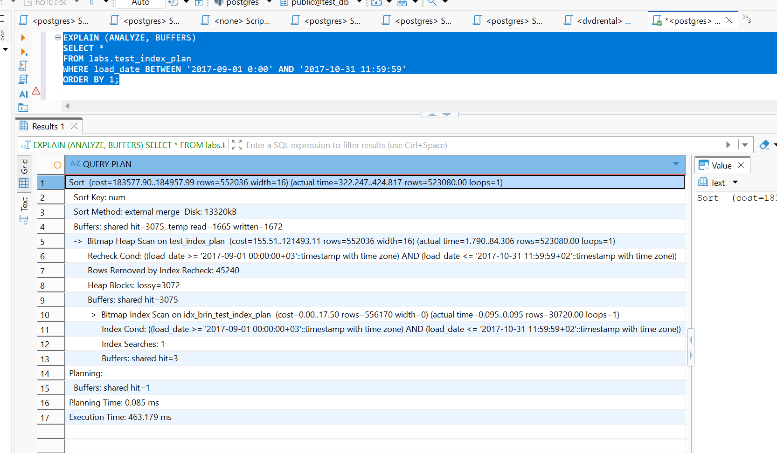
Check the BRIN Plan – 2nd time
EXPLAIN (ANALYZE, BUFFERS)
SELECT *
FROM labs.test_index_plan
WHERE load_date BETWEEN '2021-09-01 0:00' AND '2021-10-31 11:59:59'
ORDER BY 1;
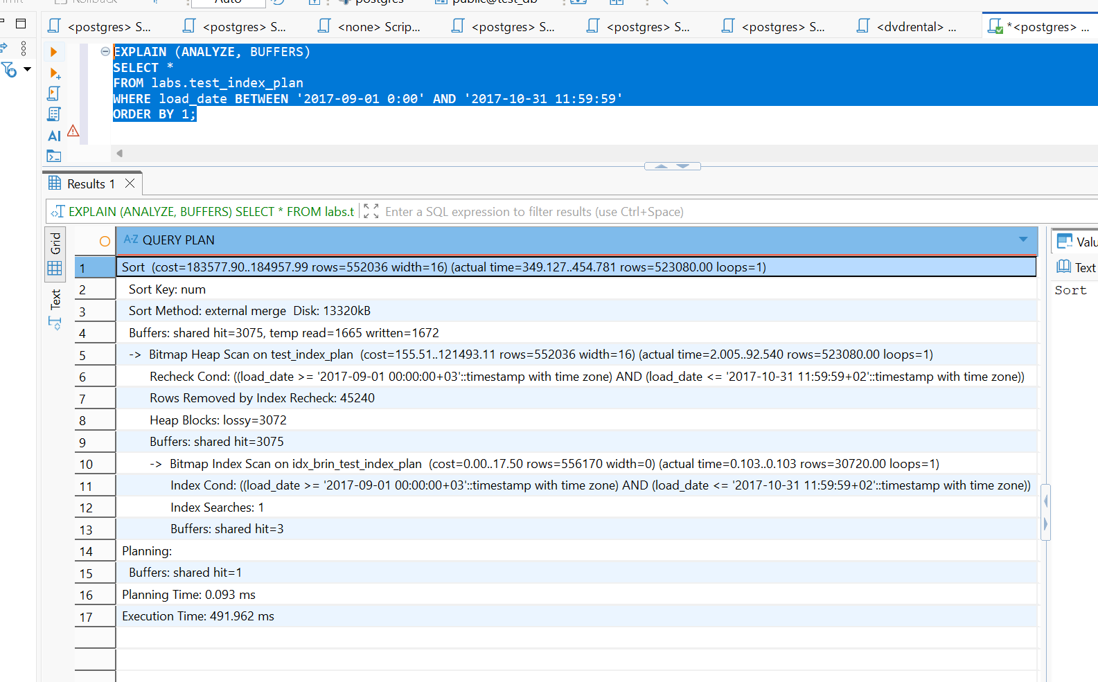
Comparison:
Both executions used the same BRIN plan, but the second run was about 6% faster due to data being cached in memory, while most execution time was spent on heap scanning and sorting rather than index access.
TASK 3 BULK INSERT
Create new table:
CREATE TABLE labs.test_inserts ( num float NOT NULL, load_date timestamptz NOT NULL );

Add B-Tree index on the table test_inserts on load_date column.
CREATE INDEX idx_test_inserts_load_date
ON labs.test_inserts (load_date);

INSERT into test_inserts by using:
EXPLAIN (ANALYZE, BUFFERS)
INSERT INTO labs.test_inserts (num, load_date)
SELECT num, load_date
FROM labs.test_index_plan;
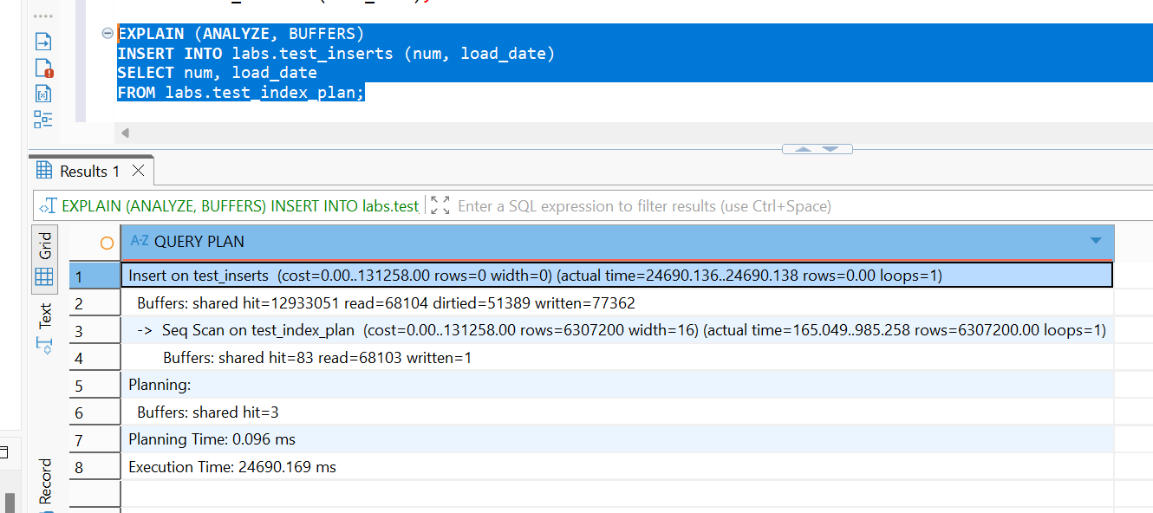
The plan shows that PostgreSQL inserted 6,307,200 rows into labs.test_inserts using a sequential scan of labs.test_index_plan.
The sequential scan itself took about 985 ms, while the total execution took 24.69 seconds, meaning most of the time was spent writing the new rows and maintaining storage rather than reading the source table.

Create new table
CREATE TABLE emp ( empno NUMERIC(4) NOT NULL CONSTRAINT emp_pk PRIMARY KEY, ename VARCHAR(10) UNIQUE, job VARCHAR(9), mgr NUMERIC(4), hiredate DATE );

Rewrite INSERT statements to more efficient way, run it:
INSERT INTO emp (empno, ename, job, mgr, hiredate) VALUES
(1, 'SMITH', 'CLERK', 13, '1980-12-17'),
(2, 'ALLEN', 'SALESMAN', 6, '1981-02-20'),
(3, 'WARD', 'SALESMAN', 6, '1981-02-22'),
(4, 'JONES', 'MANAGER', 9, '1981-04-02'),
(5, 'MARTIN', 'SALESMAN', 6, '1981-09-28'),
(6, 'BLAKE', 'MANAGER', 9, '1981-05-01'),
(7, 'CLARK', 'MANAGER', 9, '1981-06-09'),
(8, 'SCOTT', 'ANALYST', 4, '1987-04-19'),
(9, 'KING', 'PRESIDENT', NULL, '1981-11-17'),
(10,'TURNER', 'SALESMAN', 6, '1981-09-08'),
(11,'ADAMS', 'CLERK', 8, '1987-05-23'),
(12,'JAMES', 'CLERK', 6, '1981-12-03'),
(13,'FORD', 'ANALYST', 4, '1981-12-03'),
(14,'MILLER', 'CLERK', 7, '1982-01-23');
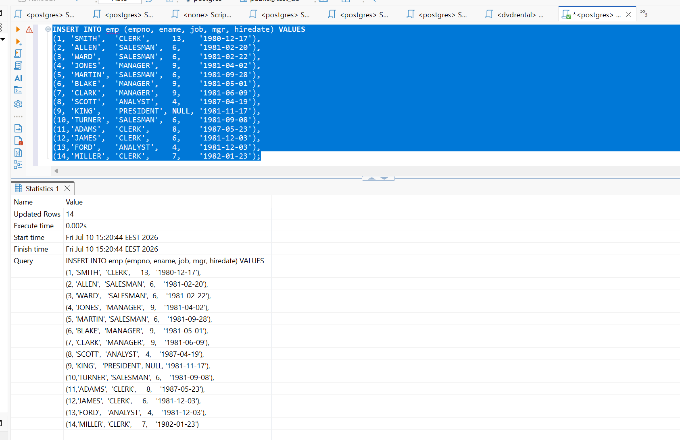
The rewritten method more efficient because PostgreSQL executes a single multi-row INSERT statement in a single implicit transaction. This means the engine only has to commit and flush WAL (Write-Ahead Log) data to disk once instead of 14 times.

TASK 4 COPY COMMAND
Use COPY Command to export test_index_plan table into csv file:
COPY labs.test_index_plan
TO '/tmp/test_index_plan.csv'
WITH (
FORMAT CSV,
DELIMITER ',',
HEADER true,
FORCE QUOTE load_date
);
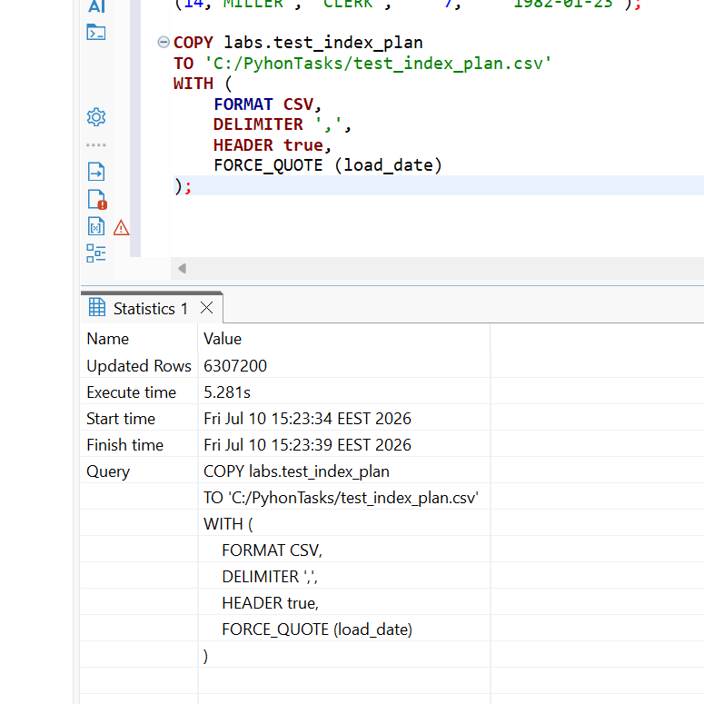
Use COPY to export data from test_index_plan table into csv file ‘test_index_plan_short.csv’ where load_date between '2021-09-01 0:00' AND '2021-09-01 11:59:59'
COPY (
SELECT *
FROM labs.test_index_plan
WHERE load_date BETWEEN '2021-09-01 00:00:00' AND '2021-09-01 11:59:59'
)
TO '/tmp/test_index_plan_short.csv'
WITH (
FORMAT CSV,
DELIMITER ',',
HEADER true
);
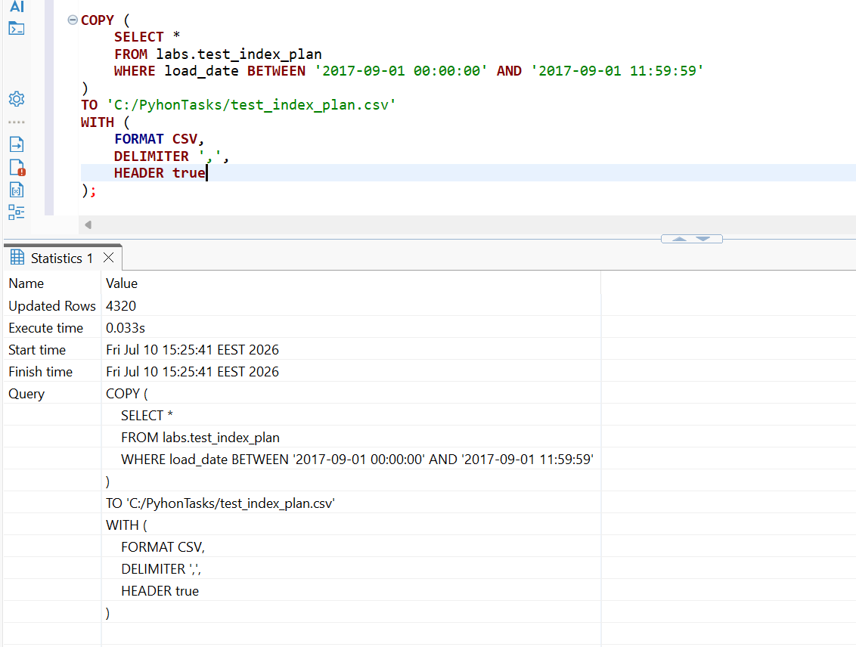
Create new table:
CREATE TABLE labs.test_copy ( num float NOT NULL, load_date timestamptz NOT NULL );

Add B-Tree index on the table test_inserts on load_date column.
CREATE INDEX idx_test_copy_load_date
ON labs.test_copy (load_date);

COPY into test_copy by using test_index_plan.csv file.
COPY labs.test_copy (num, load_date)
FROM '/tmp/test_index_plan.csv'
WITH (
FORMAT CSV,
DELIMITER ',',
HEADER true
);
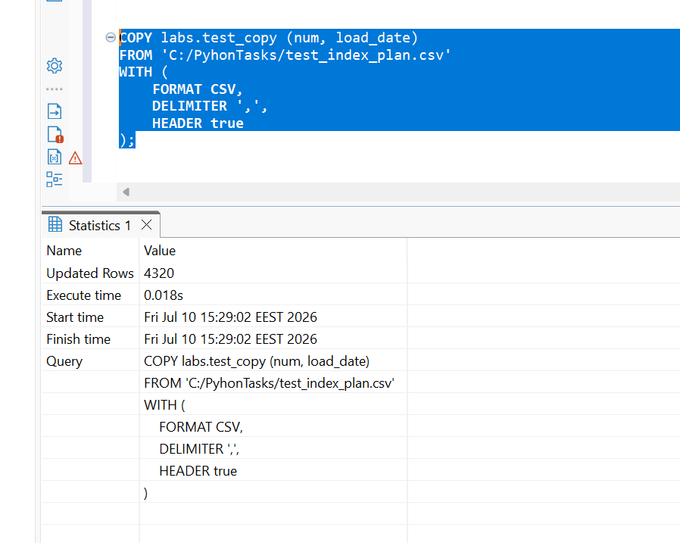
Export execution time – 0.033ms, import time – 0.018ms .
The load_date index did not improve the COPY execution time; indexes are used for query lookups, while COPY performance is mainly determined by file I/O and row insertion operations.

TASK 5 UPSERT
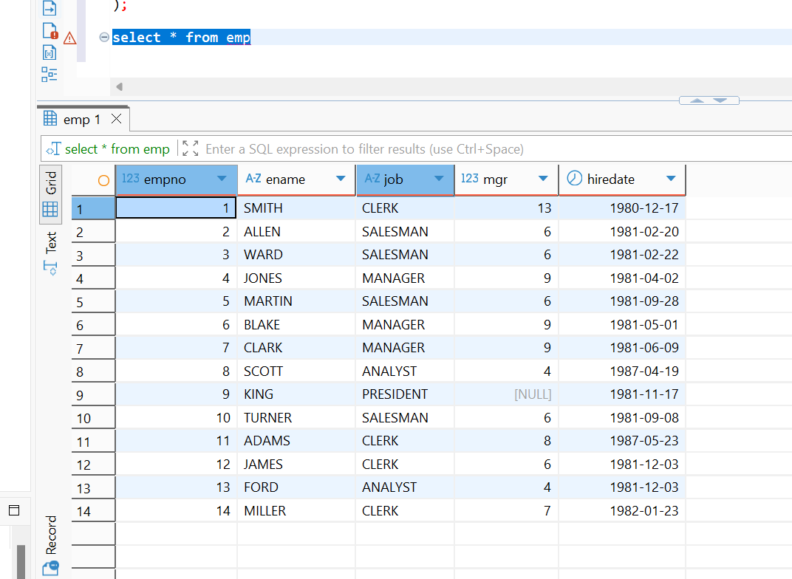
Raw data analysis:
Based on the raw data strings, the rows are structured:
Row 1:
empno: 1 (Exists)
ename: SMITH (Exists)
New Data: job = 'MANAGER', mgr = 13, hiredate = '2021-12-01'
Expectation: Conflict on empno (1) and ename ('SMITH'). We must update job and hiredate.
Row 2:
empno: 2
ename: KELLY
New Data: job = 'CLERK', mgr = 1, hiredate = '2021-12-01'
Expectation: Conflict on empno (1) and ename (‘KELLY’). We must update name,job,mgr and hiredate.
SQL
INSERT INTO emp (empno, ename, job, mgr, hiredate)
VALUES
(1, 'SMITH', 'MANAGER', 13, '2021-12-01'),
(14, 'KELLY', 'CLERK', 1, '2021-12-01'),
(15, 'HANNAH', 'CLERK', 1, '2021-12-01'),
(11, 'ADAMS', 'SALESMAN',8, '2021-12-01'),
(4, 'JONES', 'ANALYST', 9, '2021-12-01')
ON CONFLICT (empno)
DO UPDATE SET
ename = EXCLUDED.ename,
job = EXCLUDED.job,
mgr = EXCLUDED.mgr,
hiredate = EXCLUDED.hiredate;

