- Create test tables and populate them with test data:
DROP TABLE IF EXISTS test_joins_a;
DROP TABLE IF EXISTS test_joins_b;

CREATE TABLE test_joins_a
(
id1 int,
id2 int
);

CREATE TABLE test_joins_b
(
id1 int,
id2 int
);

INSERT INTO test_joins_a (id1, id2)
SELECT generate_series(1, 10000), 3;

INSERT INTO test_joins_b (id1, id2)
SELECT generate_series(1, 10000), 3;

ANALYZE test_joins_a;
ANALYZE test_joins_b;

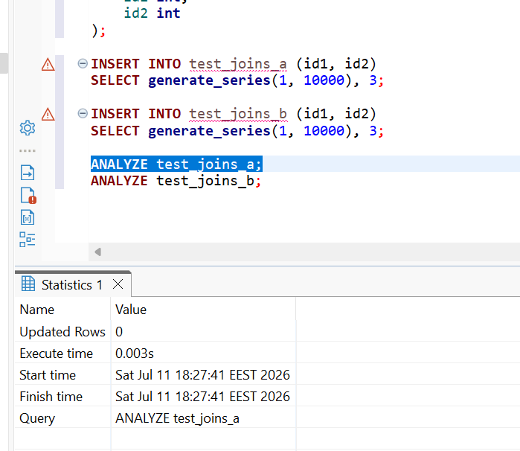
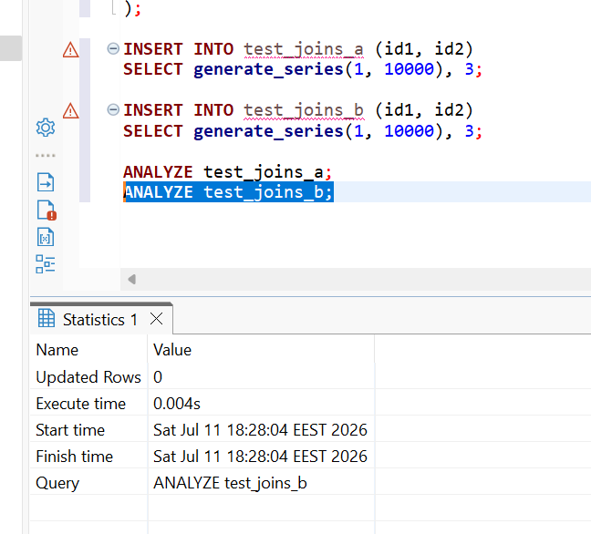

2. Check how NESTED LOOP JOIN method is used in below queries. Why?
EXPLAIN
SELECT *
FROM test_joins_a a
JOIN test_joins_b b
ON a.id1 > b.id1;
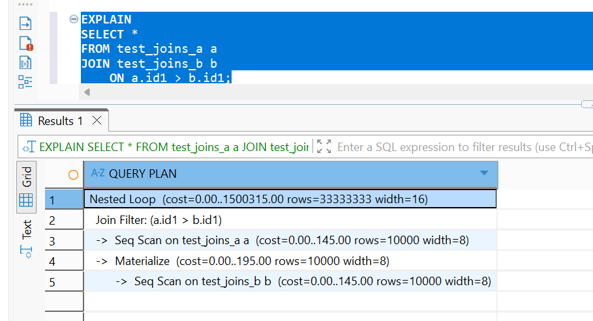
PostgreSQL reads rows from test_joins_a and compares each row with rows from test_joins_b. The condition:
a.id1 > b.id1
is checked as a join filter.

Conclusion
The Nested Loop was selected because the join uses a non-equality condition, requiring PostgreSQL to compare rows from one table against rows from the other table.

Cross join:
EXPLAIN
SELECT *
FROM test_joins_a a
CROSS JOIN test_joins_b b;
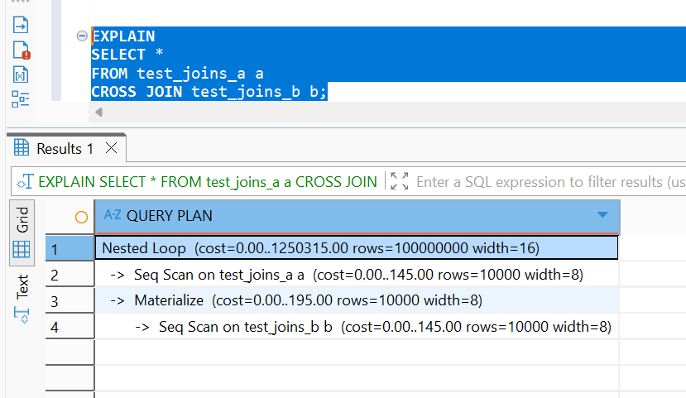

A CROSS JOIN produces every possible combination of rows from both tables.
Because each table has 10,000 rows, the result contains:
10,000 × 10,000 = 100,000,000 rows

Conclusion
The Nested Loop was used for the CROSS JOIN because PostgreSQL must generate every possible pair of rows, producing 100 million result rows.

TASK 2: HASH JOIN

Rewrite SELECT to instruct the planner to use HASH JOIN method

EXPLAIN (ANALYZE, BUFFERS)
SELECT *
FROM test_joins_a a
JOIN test_joins_b b
ON a.id1 = b.id1;

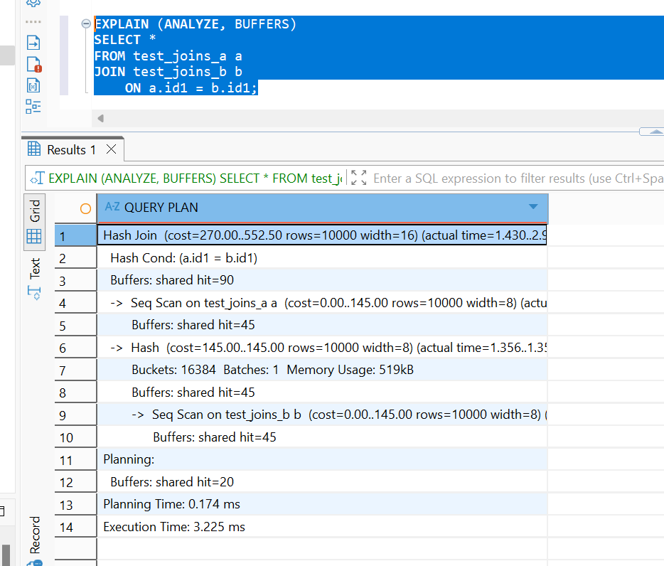
PostgreSQL scans one table and builds an in-memory hash table using id1. It then scans the other table and searches the hash table for rows with the same id1.
Conclusion: The original inequality join cannot use Hash Join; after changing the condition to equality, PostgreSQL can build a hash table and efficiently match rows.
Create query with SEMI JOIN between tables to get HASH SEMI JOIN in the plan.
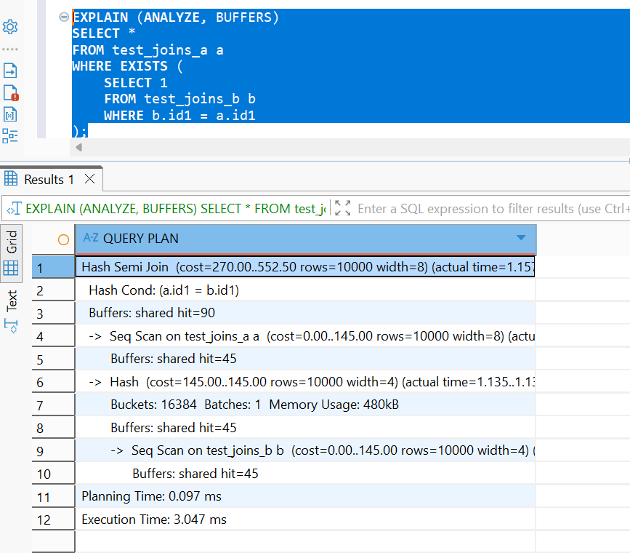
PostgreSQL creates a hash table from test_joins_b.id1. For each row in test_joins_a, it checks whether a matching key exists.
Conclusion: PostgreSQL uses Hash Semi Join because the query checks for the existence of matching id1 values using an equality condition.

- Set enable_hashjoin to off and recheck plan. Switch on enable_hashjoin.
EXPLAIN (ANALYZE, BUFFERS)
SELECT *
FROM test_joins_a a
JOIN test_joins_b b
ON a.id1 = b.id1;
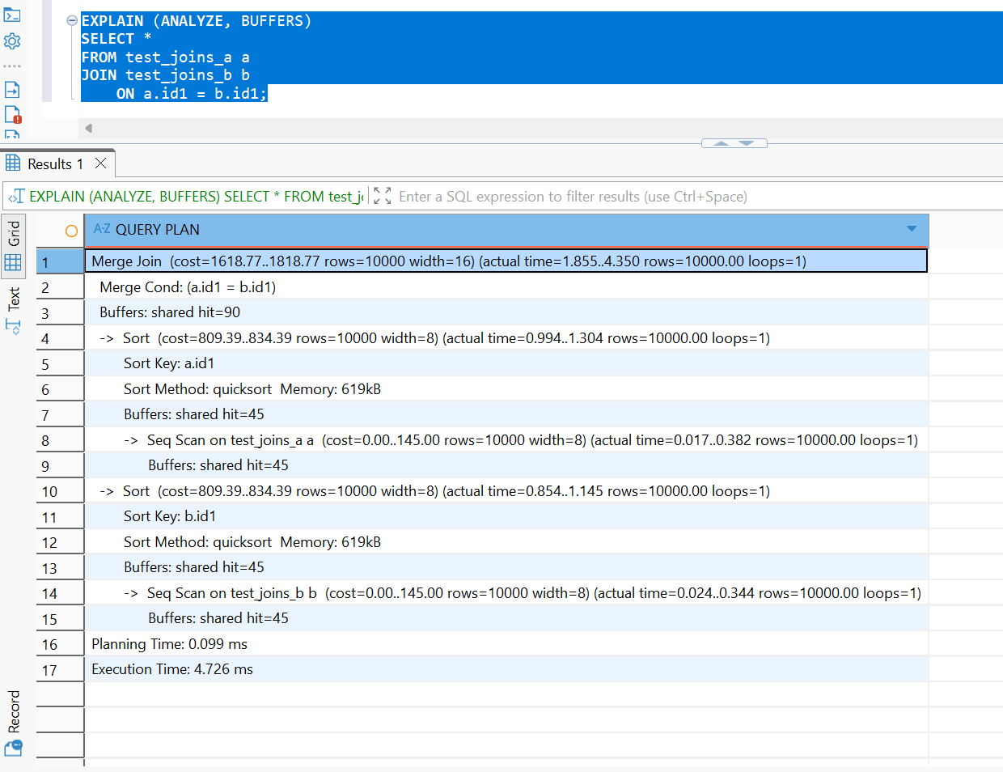
SET enable_hashjoin = on;
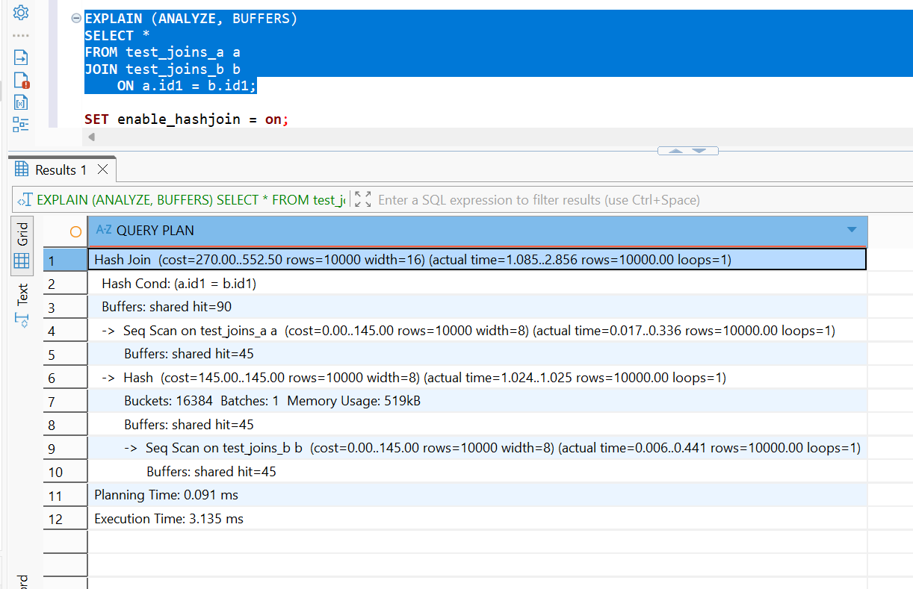

Conclusion
With Hash Join enabled, PostgreSQL can match equality keys using an in-memory hash table; after disabling it, the planner selects an alternative such as Merge Join, which may require sorting or repeated row comparisons.
TASK 3: MERGE JOIN
Using tables test_joins_a and test_joins_b create a query which is use MERGE JOIN as a join method.

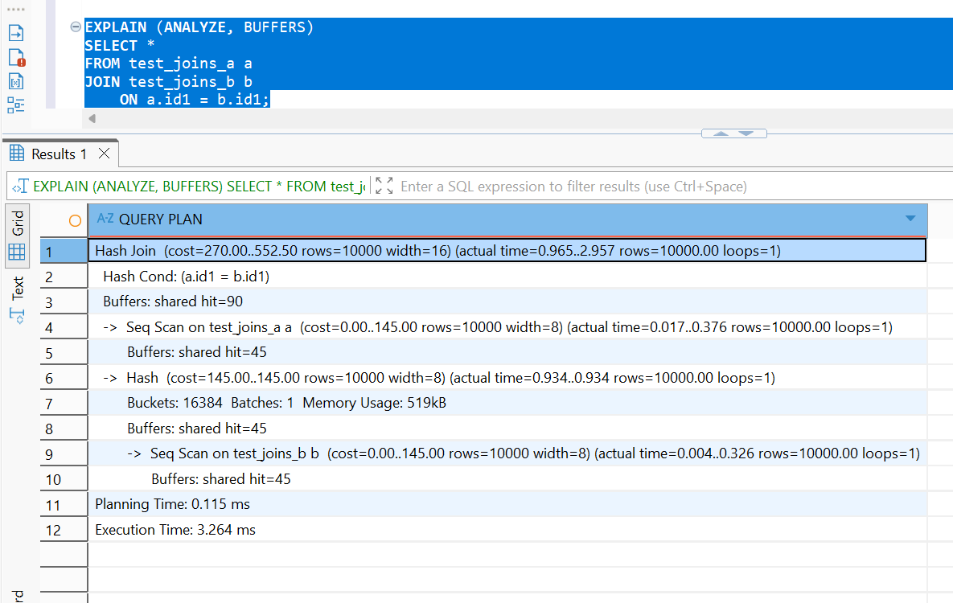
CREATE INDEX idx_test_joins_a_id1
ON test_joins_a (id1);

CREATE INDEX idx_test_joins_b_id1
ON test_joins_b (id1);

ANALYZE test_joins_a;
ANALYZE test_joins_b;

EXPLAIN (ANALYZE, BUFFERS)
SELECT *
FROM test_joins_a a
JOIN test_joins_b b
ON a.id1 = b.id1
ORDER BY a.id1;

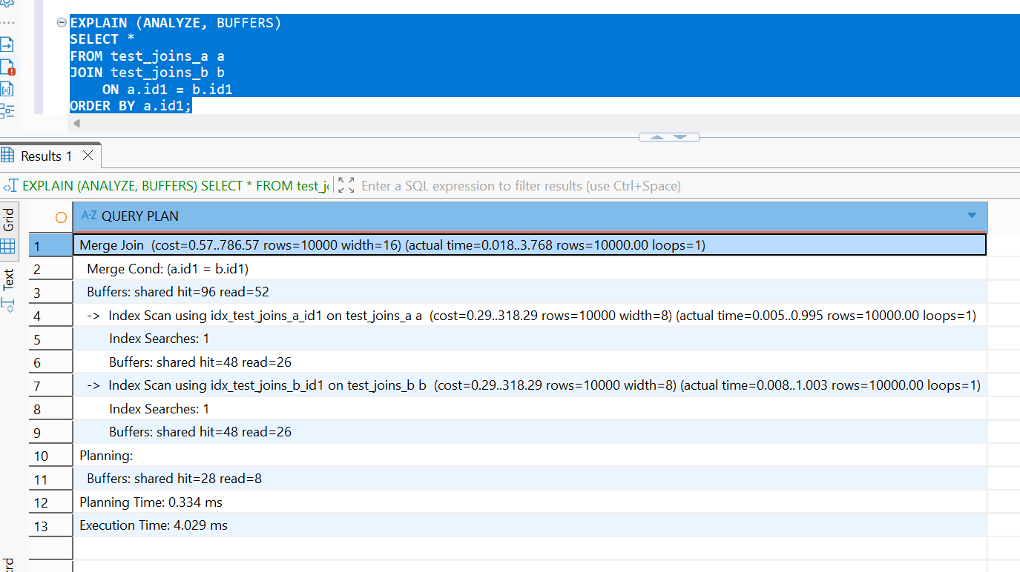
Conclusion: PostgreSQL may choose a Hash Join instead of a Merge Join. To make Merge Join -we have created indexes on the join columns.

Set enable_mergejoin to off and recheck plan. Switch on enable_mergejoin

SET enable_mergejoin = off;

EXPLAIN (ANALYZE, BUFFERS)
SELECT *
FROM test_joins_a a
JOIN test_joins_b b
ON a.id1 = b.id1
ORDER BY a.id1;

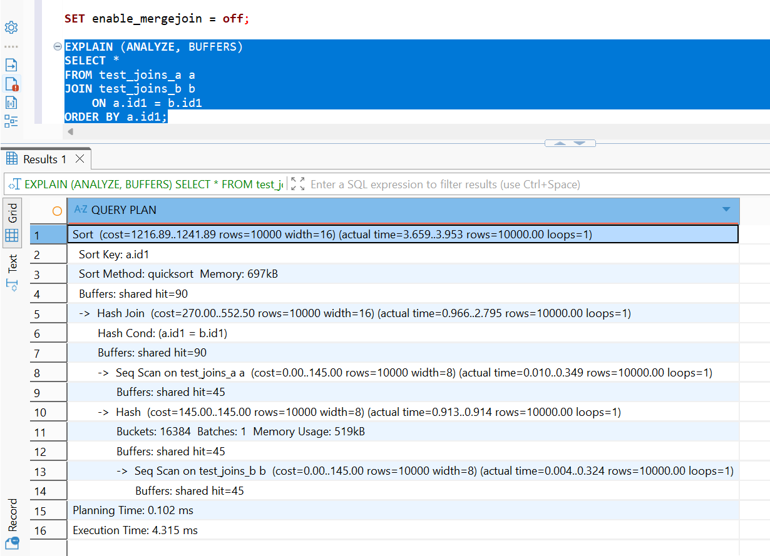

Conclusion
When Merge Join is enabled, PostgreSQL can merge the two inputs in sorted key order; after disabling it, the planner selects Hash Join and may need an additional Sort operation to satisfy ORDER BY.

TASK 4: CHANGING JOIN ORDER
DROP TABLE IF EXISTS test_joins_c;

CREATE TABLE test_joins_c
(
id1 int,
id2 int
);

INSERT INTO test_joins_c (id1, id2)
SELECT
generate_series(1, 1000000),
(random() * 10)::int;

ANALYZE test_joins_c;
ANALYZE test_joins_a;
ANALYZE test_joins_b;

EXPLAIN
SELECT c.id2
FROM test_joins_b b
JOIN test_joins_a a
ON b.id1 = a.id1
LEFT JOIN test_joins_c c
ON c.id1 = b.id1;

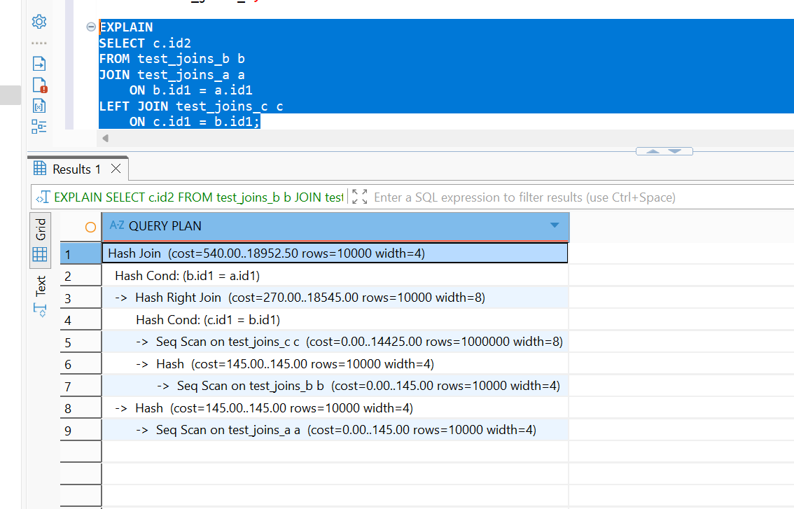

Conclusion
The execution plan shows that PostgreSQL reordered the joins. Instead of executing (test_joins_b JOIN test_joins_a) LEFT JOIN test_joins_c exactly as written, it first joined test_joins_b with test_joins_c using a Hash Right Join and then joined the result with test_joins_a using a Hash Join. The optimizer selected this order because it estimated it to have the lowest execution cost based on table statistics and row counts.

Set join_collapse_limit = 1 and recreate plan for query above. Describe changes if any. Return join_collapse_limit = 8.

SET join_collapse_limit = 1;

EXPLAIN
SELECT c.id2
FROM test_joins_b b
JOIN test_joins_a a
ON b.id1 = a.id1
LEFT JOIN test_joins_c c
ON c.id1 = b.id1;

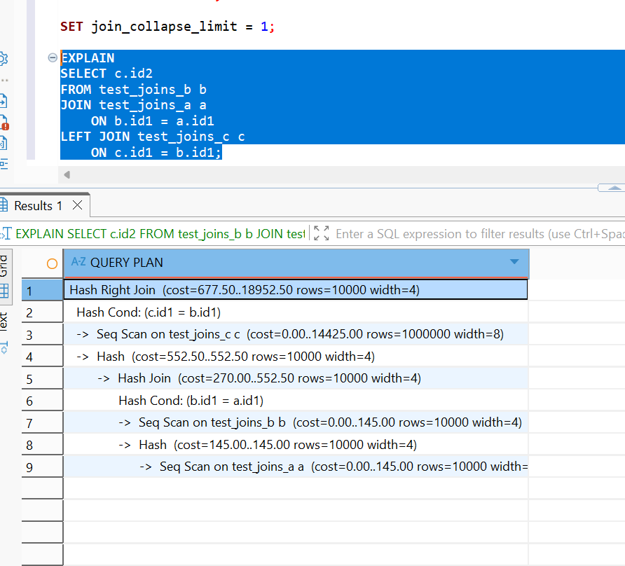
The plan shows:
- test_joins_b is joined with test_joins_a first using a Hash Join:
Hash Cond: (b.id1 = a.id1)
- The result is then joined with test_joins_c using a Hash Right Join:
Hash Cond: (c.id1 = b.id1)

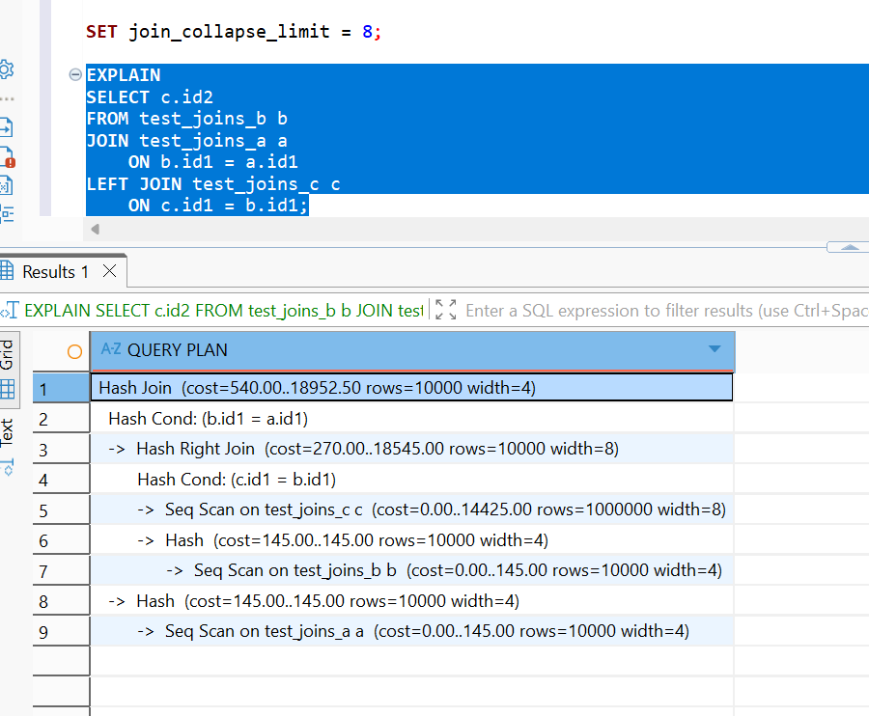
Both plans use a Hash Right Join to implement the LEFT JOIN, but join_collapse_limit = 1 preserves the written order (b JOIN a) LEFT JOIN c, while join_collapse_limit = 8 allows PostgreSQL to reorder the joins as (b LEFT JOIN c) JOIN a.
TASK 5: LATERAL JOIN

Create a query to find TOP 10 of orders by it cost for each store. So, on the output you should have 10 orders for each store (or less, depends on sample random data) with cost less than max_order_cost. Use LATERAL join.
SELECT
s.store_id,
s.store_name,
s.max_order_cost,
o.order_id,
o.order_num,
o.order_cost
FROM stores AS s
LEFT JOIN LATERAL (
SELECT
order_id,
order_num,
order_cost
FROM orders
WHERE order_cost < s.max_order_cost
ORDER BY order_cost DESC
LIMIT 10
) AS o ON TRUE
ORDER BY
s.store_id,
o.order_cost DESC;
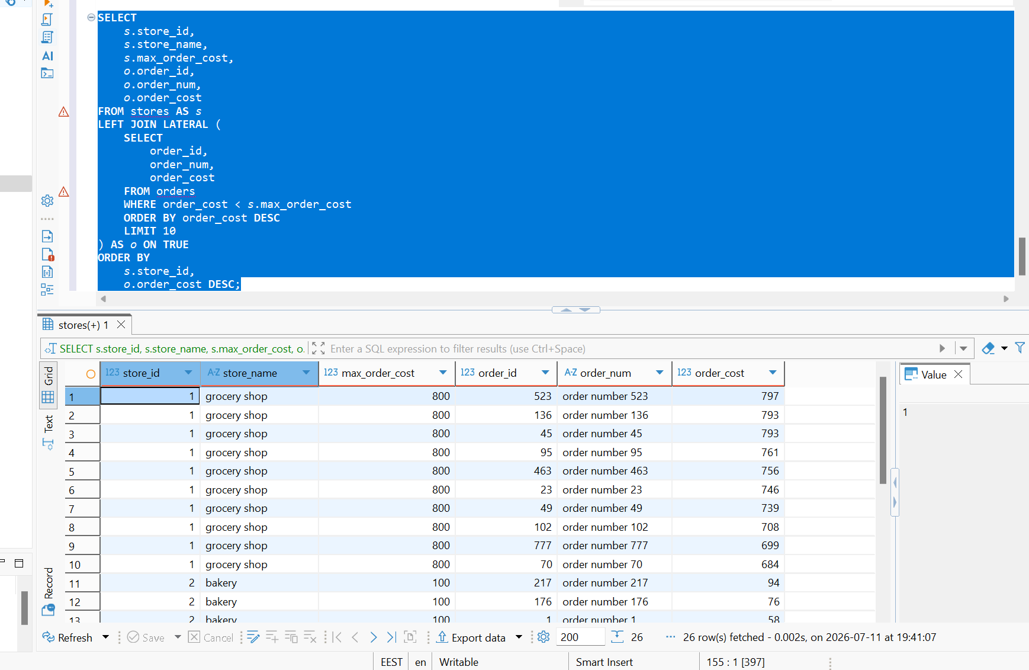
TASK 6: RECURSIVE CTE

WITH RECURSIVE emp_hierarchy AS (
SELECT
empno,
ename,
mgr,
1 AS level
FROM emp
WHERE mgr IS NULL

UNION ALL

SELECT
e.empno,
e.ename,
e.mgr,
eh.level + 1
FROM emp e
JOIN emp_hierarchy eh
ON e.mgr = eh.empno
)
SELECT
e.empno,
e.ename AS employee_name,
m.ename AS manager_name,
eh.level
FROM emp_hierarchy eh
JOIN emp e
ON e.empno = eh.empno
LEFT JOIN emp m
ON e.mgr = m.empno
ORDER BY eh.level, e.empno;
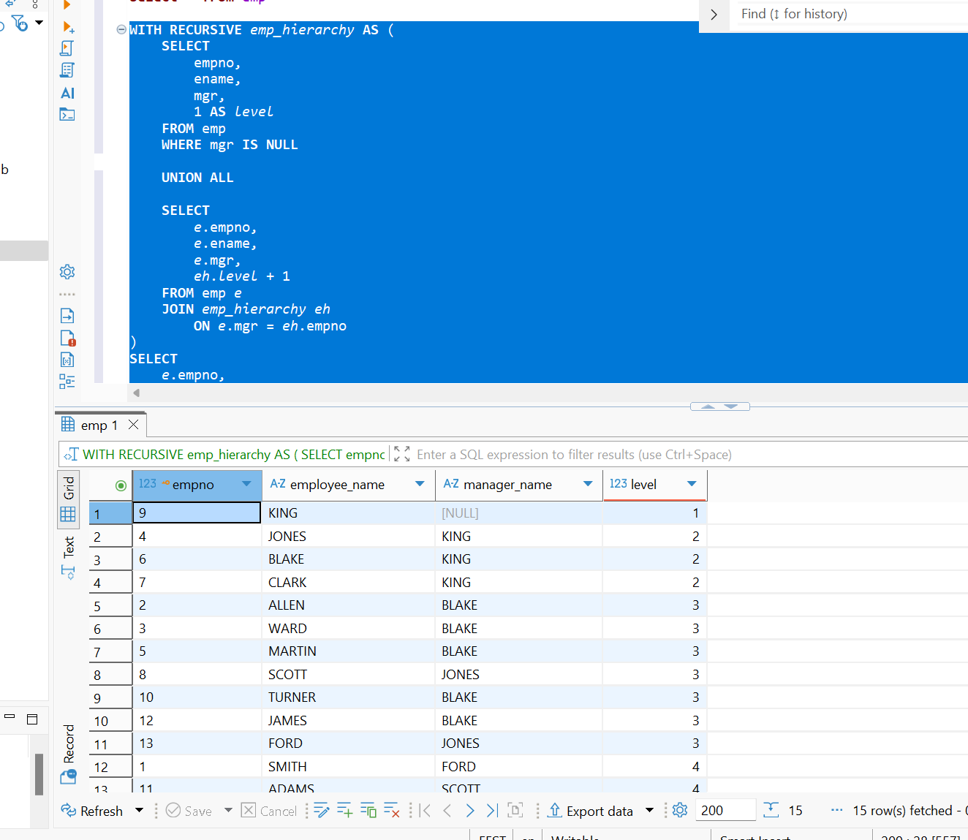
TASK 7: CHANGING DATA CTE
WITH updated_orders AS (
UPDATE orders
SET order_cost = order_cost / 2
WHERE order_cost BETWEEN 100 AND 1000
RETURNING
order_id,
order_cost,
order_num
),
logged_updates AS (
INSERT INTO order_log (
order_id,
order_cost,
order_num,
action_type
)
SELECT
order_id,
order_cost,
order_num,
'U'
FROM updated_orders
RETURNING log_id
),
deleted_orders AS (
DELETE FROM orders
WHERE order_cost < 50
RETURNING
order_id,
order_cost,
order_num
),
logged_deletes AS (
INSERT INTO order_log (
order_id,
order_cost,
order_num,
action_type
)
SELECT
order_id,
order_cost,
order_num,
'D'
FROM deleted_orders
RETURNING log_id
)
SELECT
(SELECT COUNT(*) FROM logged_updates) AS updated_rows,
(SELECT COUNT(*) FROM logged_deletes) AS deleted_rows;
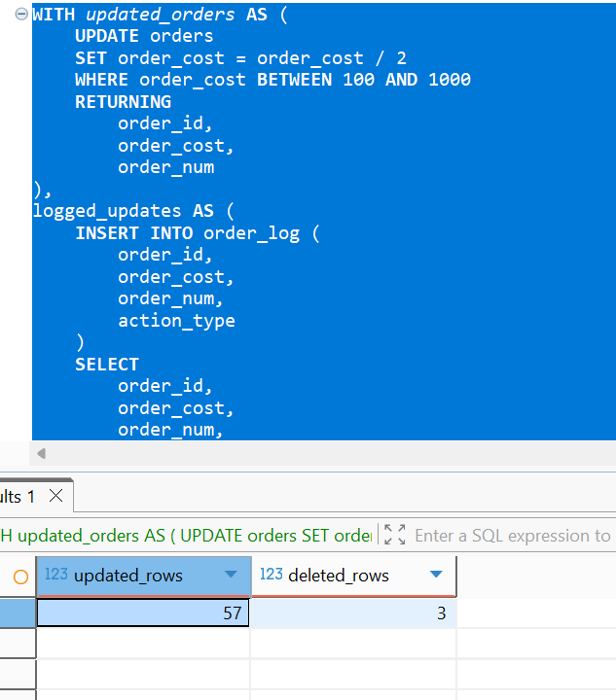

This single CTE statement:
- Divides order_cost by two for orders with costs from 100 to 1000.
- Logs the updated rows with action_type = 'U'.
- Deletes orders with costs below 50.
- Logs the deleted rows with action_type = 'D'.
- Returns the number of updated and deleted rows.
SELECT *
FROM order_log
ORDER BY log_id;

