DROP TABLE IF EXISTS sales_info CASCADE;
CREATE TABLE sales_info ( id INTEGER, category VARCHAR(1), ischeck BOOLEAN, eventdate DATE );

CREATE TABLE sales_info_2022 ( CHECK ( eventdate >= DATE '2022-01-01' AND eventdate < DATE '2023-01-01' ) ) INHERITS (sales_info);

CREATE TABLE sales_info_2023 ( CHECK ( eventdate >= DATE '2023-01-01' AND eventdate < DATE '2024-01-01' ) ) INHERITS (sales_info);
CREATE TABLE sales_info_2024 ( CHECK ( eventdate >= DATE '2024-01-01' AND eventdate < DATE '2025-01-01' ) ) INHERITS (sales_info);
CREATE TABLE sales_info_2025 ( CHECK ( eventdate >= DATE '2025-01-01' AND eventdate < DATE '2026-01-01' ) ) INHERITS (sales_info);
CREATE TABLE sales_info_2026 ( CHECK ( eventdate >= DATE '2026-01-01' AND eventdate < DATE '2027-01-01' ) ) INHERITS (sales_info);

CREATE OR REPLACE FUNCTION partition_sales_info()
RETURNS TRIGGER LANGUAGE plpgsql AS
$$ BEGIN
IF NEW.eventdate >= DATE '2022-01-01' AND NEW.eventdate < DATE '2023-01-01'
THEN INSERT INTO sales_info_2022 VALUES (NEW.*);
ELSIF NEW.eventdate >= DATE '2023-01-01' AND NEW.eventdate < DATE '2024-01-01'
THEN INSERT INTO sales_info_2023 VALUES (NEW.*);
ELSIF NEW.eventdate >= DATE '2024-01-01' AND NEW.eventdate < DATE '2025-01-01'
THEN INSERT INTO sales_info_2024 VALUES (NEW.*);
ELSIF NEW.eventdate >= DATE '2025-01-01' AND NEW.eventdate < DATE '2026-01-01'
THEN INSERT INTO sales_info_2025 VALUES (NEW.*);
ELSIF NEW.eventdate >= DATE '2026-01-01' AND NEW.eventdate < DATE '2027-01-01'
THEN INSERT INTO sales_info_2026 VALUES (NEW.*);
ELSE RAISE EXCEPTION 'Event date % is outside the available partition range', NEW.eventdate; END IF; RETURN NULL; END; $$;

DROP TRIGGER IF EXISTS partition_sales_info_trigger ON sales_info;

CREATE TRIGGER partition_sales_info_trigger
BEFORE INSERT ON sales_info
FOR EACH ROW
EXECUTE FUNCTION partition_sales_info();

INSERT INTO sales_info (id, category, ischeck, eventdate)
SELECT id, ( ARRAY['A', 'B', 'C', 'D', 'E', 'F', 'G', 'H', 'I', 'J', 'K'] )[floor(random() * 11 + 1)::INTEGER] AS category,
random() < 0.5 AS ischeck, DATE '2022-01-01' + floor( random() * (DATE '2027-01-01' - DATE '2022-01-01') )::INTEGER AS eventdate
FROM generate_series(1, 10000000) AS id;

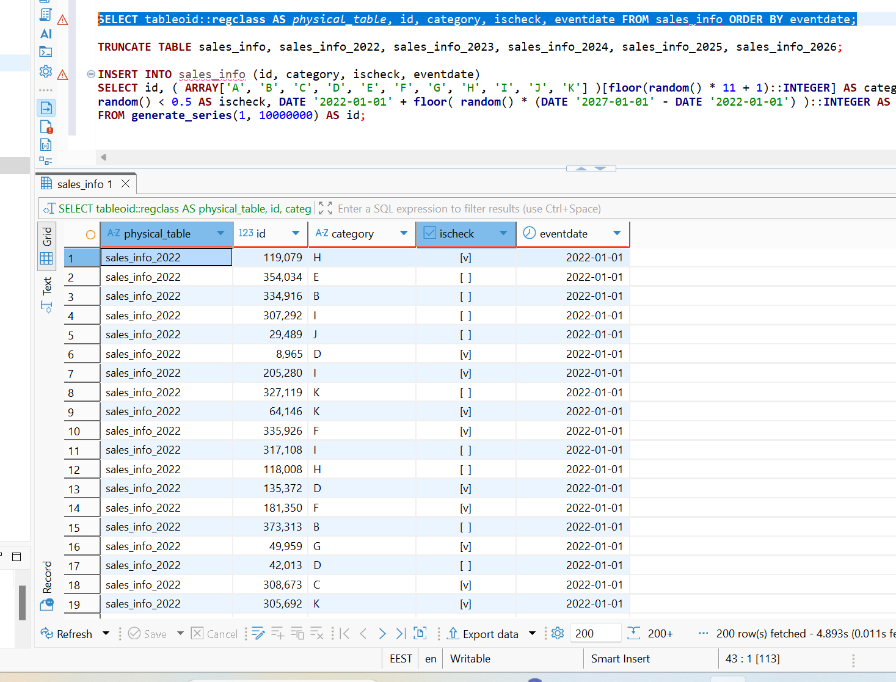
Update some rows in SALES_INFO and set another eventdate.
UPDATE sales_info
SET eventdate = eventdate + INTERVAL '1 day'
WHERE id BETWEEN 1 AND 1000 AND eventdate < DATE '2022-12-31';

6. Create table SALES_INFO_SIMPLE with the same structure as SALES_INFO but without partitioning. Insert test data from the 5th step. Compare plans of different queries:
• Select all
• Select with range of dates
• Select exact date
• Count of all rows
• Count of rows with range of dates

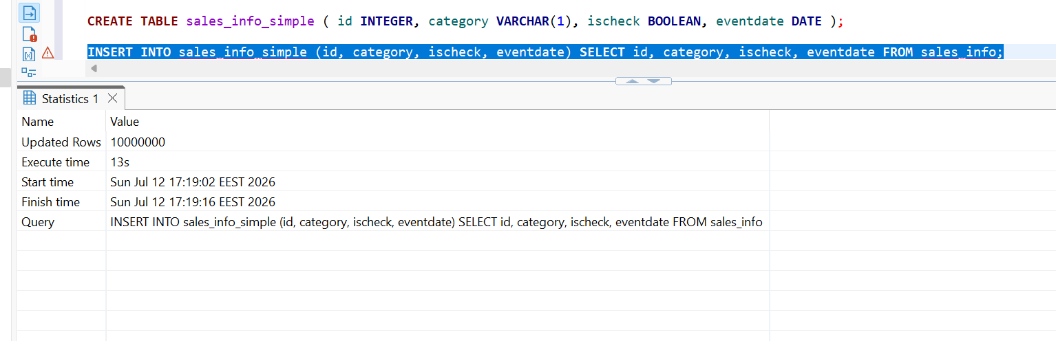
EXPLAIN (ANALYZE, BUFFERS) SELECT * FROM sales_info;
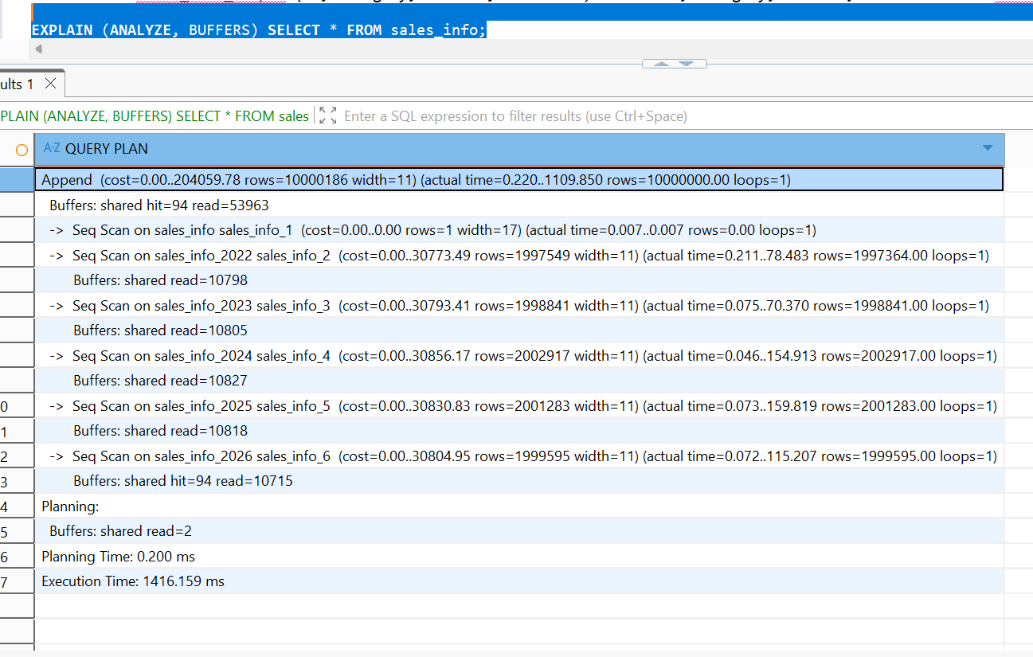
EXPLAIN (ANALYZE, BUFFERS) SELECT * FROM sales_info_simple;

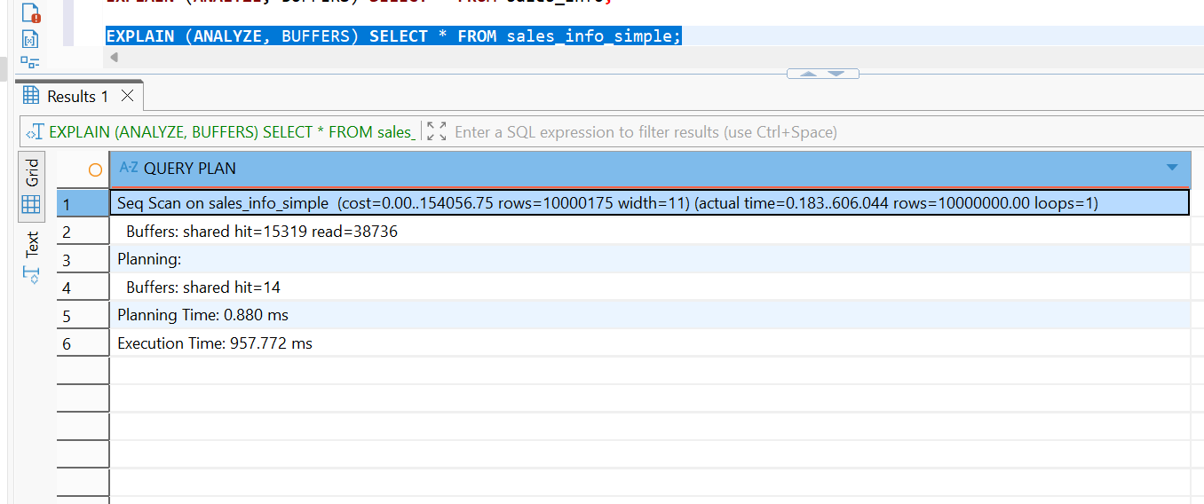
The partitioned sales_info table used an Append plan and performed a separate sequential scan on the parent table and all five yearly child tables. PostgreSQL read all partitions because the query had no WHERE condition on eventdate. The total execution time was 1416.159 ms.
The non-partitioned sales_info_simple table used a single Seq Scan over the whole table. Its execution time was 957.772 ms.

EXPLAIN (ANALYZE, BUFFERS)
SELECT * FROM sales_info WHERE eventdate >= DATE '2024-03-01' AND eventdate < DATE '2024-04-01';
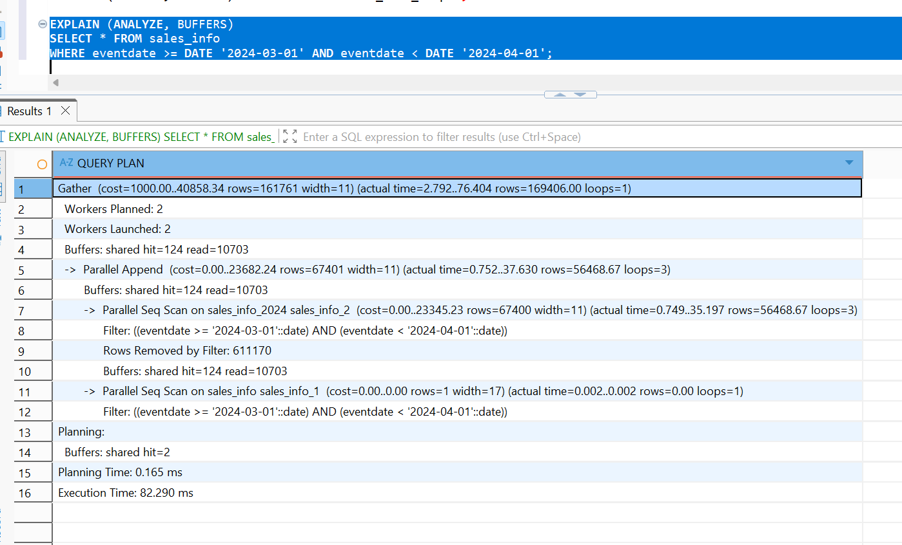
EXPLAIN (ANALYZE, BUFFERS)
SELECT * FROM sales_info_simple
WHERE eventdate >= DATE '2024-03-01' AND eventdate < DATE '2024-04-01';
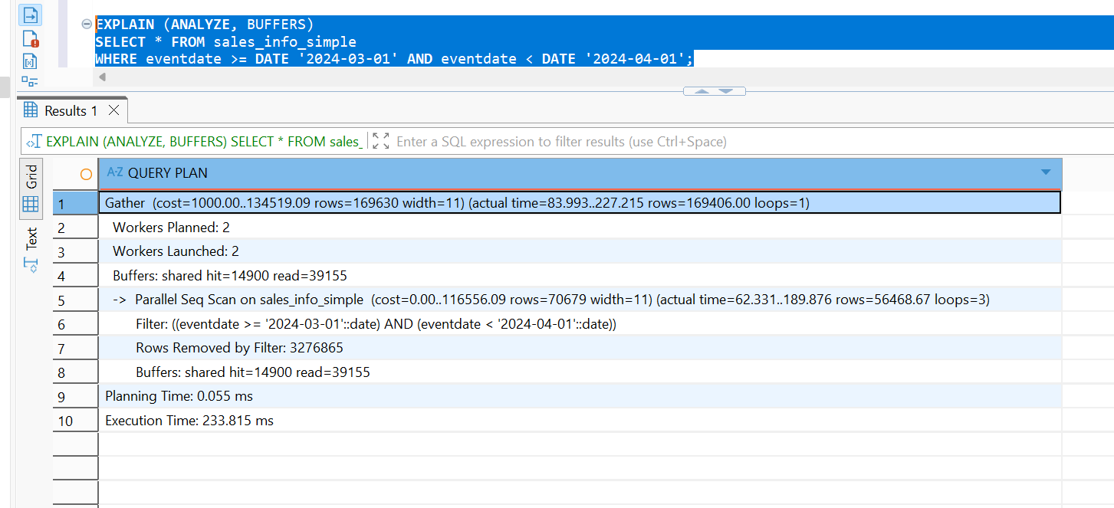
For partition table:
• PostgreSQL used Parallel Append.
• Only the sales_info_2024 partition was scanned.
• Partitions for 2022, 2023, 2025, and 2026 were excluded.
• About 169,406 rows were returned.
• Only 10,703 pages were read.
For non-partition table:
• PostgreSQL performed a Parallel Seq Scan on the entire table.
• Approximately 3,276,865 rows were examined and discarded by the filter.
• The query still returned the same 169,406 rows.
• 39,155 pages were read.

EXPLAIN (ANALYZE, BUFFERS)
SELECT * FROM sales_info
WHERE eventdate = DATE '2025-06-01';
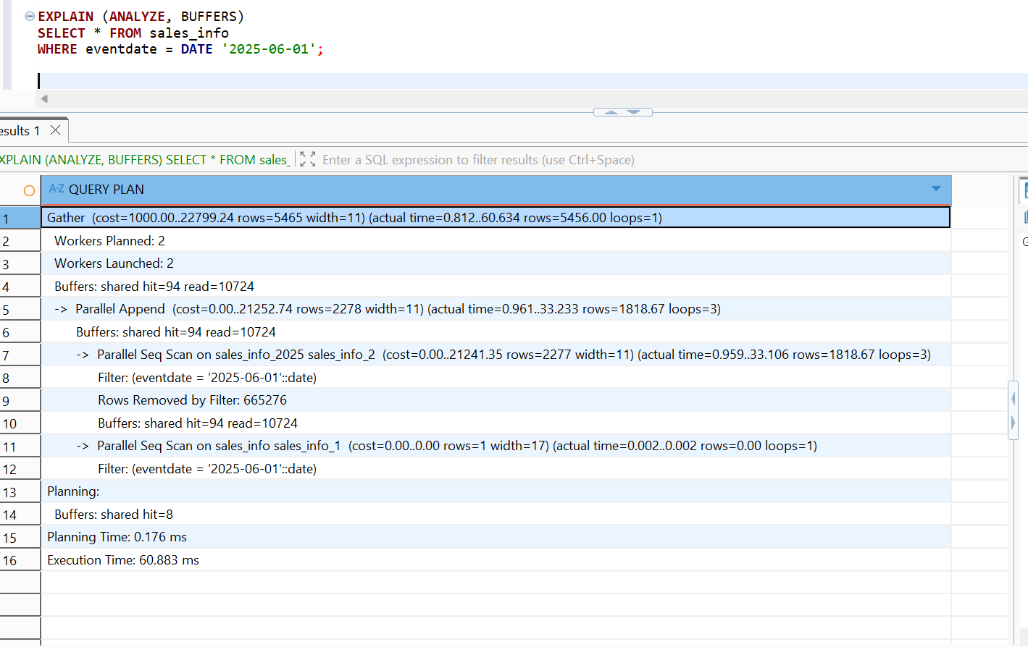
EXPLAIN (ANALYZE, BUFFERS)
SELECT * FROM sales_info_simple
WHERE eventdate = DATE '2025-06-01';
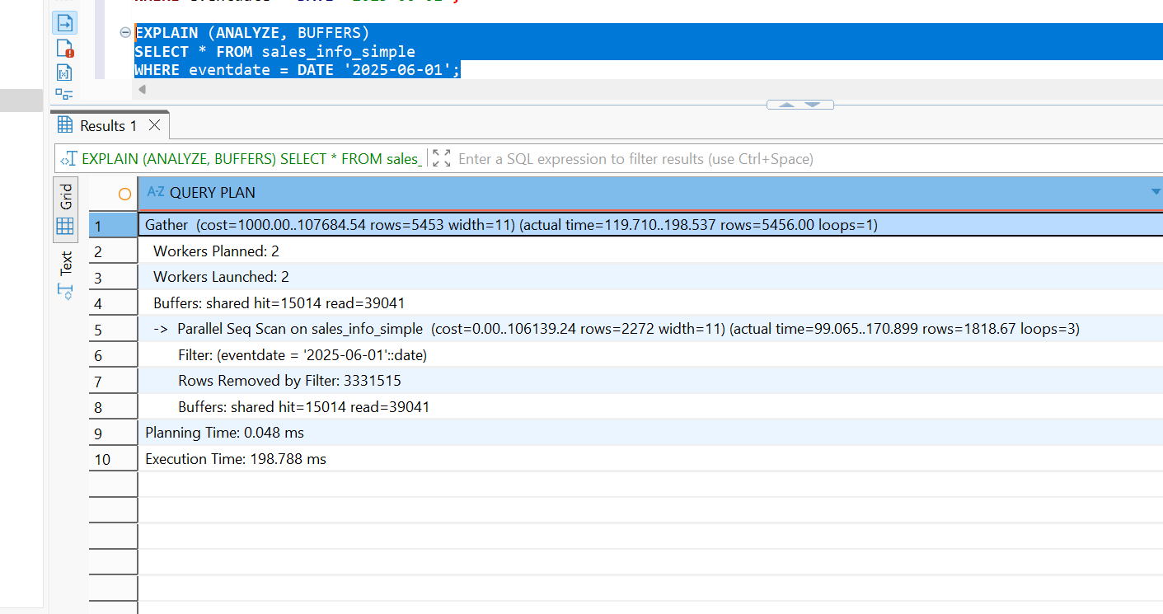
For partition table:
• PostgreSQL used Parallel Append.
• Only the sales_info_2025 partition was scanned.
• About 5,456 rows were returned.
• 665,276 rows within the 2025 partition were filtered out.
• Only 10,724 pages were read.
For non-partition:
• PostgreSQL performed a Parallel Seq Scan on the entire table.
• The same 5,456 rows were returned.
• About 3,331,515 rows were filtered out.
• 39,041 pages were read.

EXPLAIN (ANALYZE, BUFFERS)
SELECT COUNT(*) FROM sales_info;
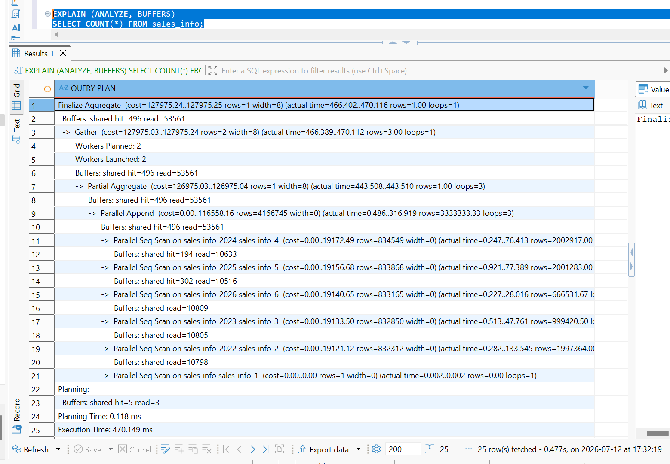
EXPLAIN (ANALYZE, BUFFERS)
SELECT COUNT(*) FROM sales_info_simple;

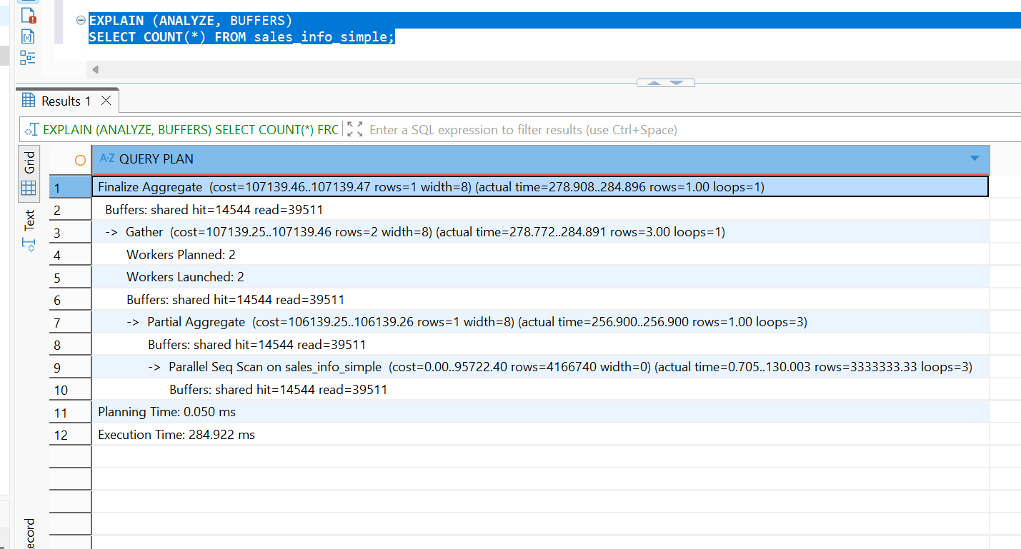
For partitioned table :
• PostgreSQL used:
- Parallel Append
- Partial Aggregate
- Gather
- Finalize Aggregate
• All yearly partitions (2022–2026) were scanned.
• Total pages read: 53,561
• Parallel workers processed each partition separately.
Non-Partitioned Table:
- PostgreSQL used:
  - Parallel Seq Scan
  - Partial Aggregate
  - Gather
  - Finalize Aggregate
- Only one table was scanned.
- Total pages read: 39,511
EXPLAIN (ANALYZE, BUFFERS)
SELECT COUNT(*) FROM sales_info
WHERE eventdate >= DATE '2023-01-01' AND eventdate < DATE '2024-01-01';
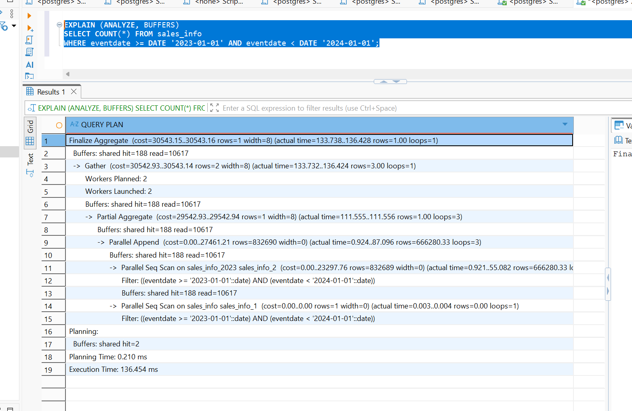
EXPLAIN (ANALYZE, BUFFERS) SELECT COUNT(*) FROM sales_info_simple
WHERE eventdate >= DATE '2023-01-01' AND eventdate < DATE '2024-01-01';
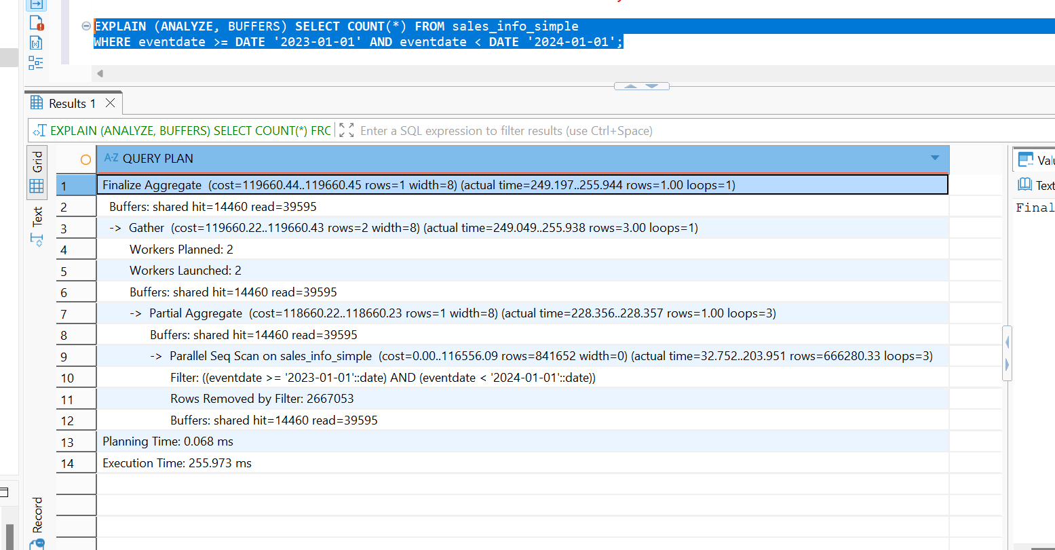
Partitioned table:
• PostgreSQL used:
- Parallel Append
- Partial Aggregate
- Gather
- Finalize Aggregate
• Only the sales_info_2023 partition was scanned.
• Other yearly partitions were excluded through partition pruning.
• 10,617 pages were read.
• Approximately 1,999,841 rows were processed.
Non- Partitioned Table:
• PostgreSQL performed a Parallel Seq Scan on the entire table.
• Approximately 2,667,053 rows were filtered out.
• 39,595 pages were read.
• The whole 10-million-row table had to be scanned.

Delete one of partition (the oldest one). Create some general table like sales_info_3000 with the same structure as sales_info and add it as new partition.

DROP TABLE sales_info_2022;
SELECT parent.relname AS parent_table, child.relname AS child_table FROM pg_inherits
JOIN pg_class parent ON pg_inherits.inhparent = parent.oid
JOIN pg_class child ON pg_inherits.inhrelid = child.oid
WHERE parent.relname = 'sales_info' ORDER BY child.relname;

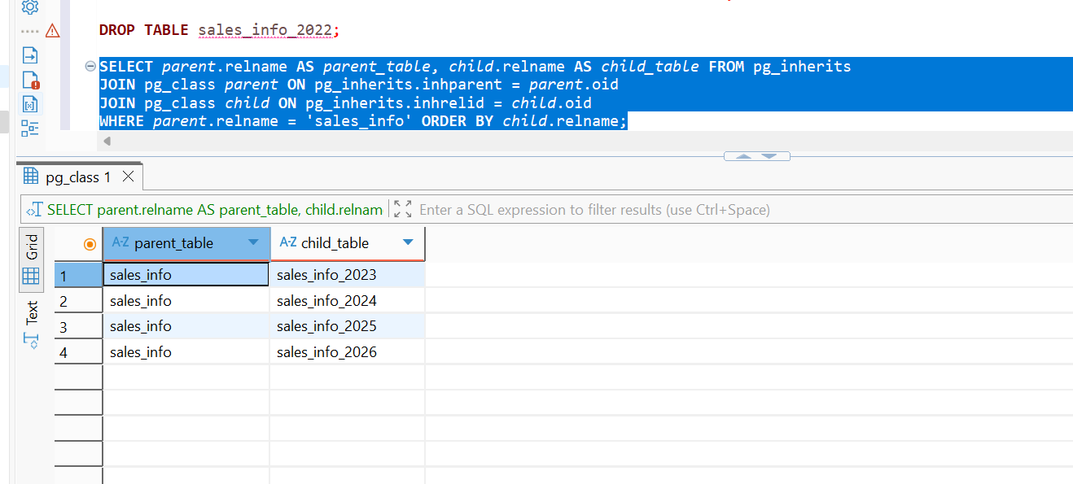
CREATE TABLE sales_info_3000 ( LIKE sales_info INCLUDING DEFAULTS );

ALTER TABLE sales_info_3000 INHERIT sales_info;

SELECT parent.relname AS parent_table, child.relname AS child_table FROM pg_inherits
JOIN pg_class parent ON pg_inherits.inhparent = parent.oid
JOIN pg_class child ON pg_inherits.inhrelid = child.oid
WHERE parent.relname = 'sales_info' ORDER BY child.relname;

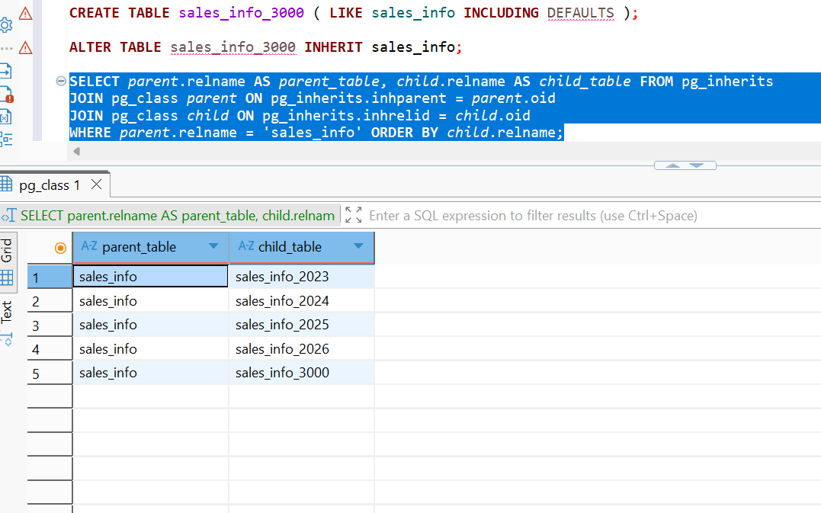

Task2
DROP TABLE IF EXISTS sales_info_dp CASCADE;

CREATE TABLE sales_info_dp
(
id INTEGER,
category VARCHAR(1),
ischeck BOOLEAN,
eventdate DATE
)
PARTITION BY RANGE (eventdate);

CREATE TABLE sales_info_dp_2022
PARTITION OF sales_info_dp
FOR VALUES FROM (DATE '2022-01-01')
TO (DATE '2023-01-01')
PARTITION BY LIST (category);

CREATE TABLE sales_info_dp_2022_ae
PARTITION OF sales_info_dp_2022
FOR VALUES IN ('A', 'B', 'C', 'D', 'E');

CREATE TABLE sales_info_dp_2022_fk
PARTITION OF sales_info_dp_2022
FOR VALUES IN ('F', 'G', 'H', 'I', 'J', 'K');

CREATE TABLE sales_info_dp_2022_default
PARTITION OF sales_info_dp_2022
DEFAULT;

CREATE TABLE sales_info_dp_2023
PARTITION OF sales_info_dp
FOR VALUES FROM (DATE '2023-01-01')
TO (DATE '2024-01-01')
PARTITION BY LIST (category);

CREATE TABLE sales_info_dp_2023_ae
PARTITION OF sales_info_dp_2023
FOR VALUES IN ('A', 'B', 'C', 'D', 'E');

CREATE TABLE sales_info_dp_2023_fk
PARTITION OF sales_info_dp_2023
FOR VALUES IN ('F', 'G', 'H', 'I', 'J', 'K');

CREATE TABLE sales_info_dp_2023_default
PARTITION OF sales_info_dp_2023
DEFAULT;

CREATE TABLE sales_info_dp_2024
PARTITION OF sales_info_dp
FOR VALUES FROM (DATE '2024-01-01')
TO (DATE '2025-01-01')
PARTITION BY LIST (category);

CREATE TABLE sales_info_dp_2024_ae
PARTITION OF sales_info_dp_2024
FOR VALUES IN ('A', 'B', 'C', 'D', 'E');

CREATE TABLE sales_info_dp_2024_fk
PARTITION OF sales_info_dp_2024
FOR VALUES IN ('F', 'G', 'H', 'I', 'J', 'K');

CREATE TABLE sales_info_dp_2024_default
PARTITION OF sales_info_dp_2024
DEFAULT;

CREATE TABLE sales_info_dp_2025
PARTITION OF sales_info_dp
FOR VALUES FROM (DATE '2025-01-01')
TO (DATE '2026-01-01')
PARTITION BY LIST (category);

CREATE TABLE sales_info_dp_2025_ae
PARTITION OF sales_info_dp_2025
FOR VALUES IN ('A', 'B', 'C', 'D', 'E');

CREATE TABLE sales_info_dp_2025_fk
PARTITION OF sales_info_dp_2025
FOR VALUES IN ('F', 'G', 'H', 'I', 'J', 'K');

CREATE TABLE sales_info_dp_2025_default
PARTITION OF sales_info_dp_2025
DEFAULT;

CREATE TABLE sales_info_dp_2026
PARTITION OF sales_info_dp
FOR VALUES FROM (DATE '2026-01-01')
TO (DATE '2027-01-01')
PARTITION BY LIST (category);

CREATE TABLE sales_info_dp_2026_ae
PARTITION OF sales_info_dp_2026
FOR VALUES IN ('A', 'B', 'C', 'D', 'E');

CREATE TABLE sales_info_dp_2026_fk
PARTITION OF sales_info_dp_2026
FOR VALUES IN ('F', 'G', 'H', 'I', 'J', 'K');

CREATE TABLE sales_info_dp_2026_default
PARTITION OF sales_info_dp_2026
DEFAULT;

SELECT
parent.relname AS parent_table,
child.relname AS child_table
FROM pg_inherits
JOIN pg_class parent
ON parent.oid = pg_inherits.inhparent
JOIN pg_class child
ON child.oid = pg_inherits.inhrelid
WHERE parent.relname LIKE 'sales_info_dp%'
ORDER BY parent.relname, child.relname;
partition hierarchy
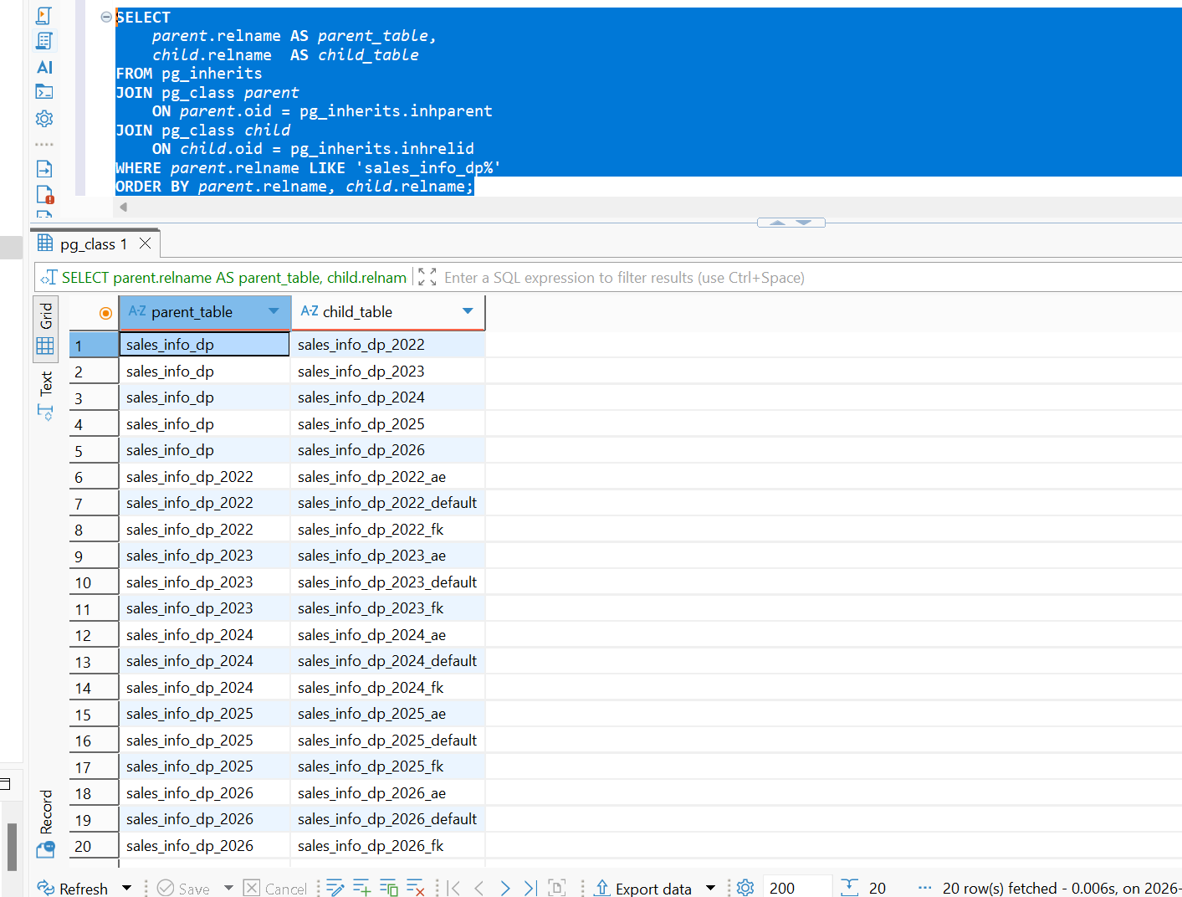
Update rows and change the category
SELECT
tableoid::regclass AS physical_partition,
id,
category,
eventdate
FROM sales_info_dp
WHERE category = 'A'
ORDER BY id
LIMIT 10;

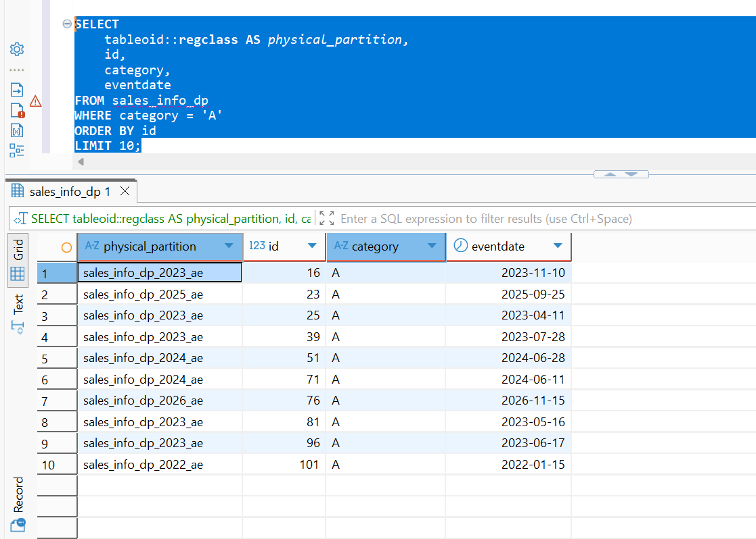
UPDATE sales_info_dp
SET category = 'H'
WHERE id IN
(
SELECT id
FROM sales_info_dp
WHERE category = 'A'
ORDER BY id
LIMIT 1000
);
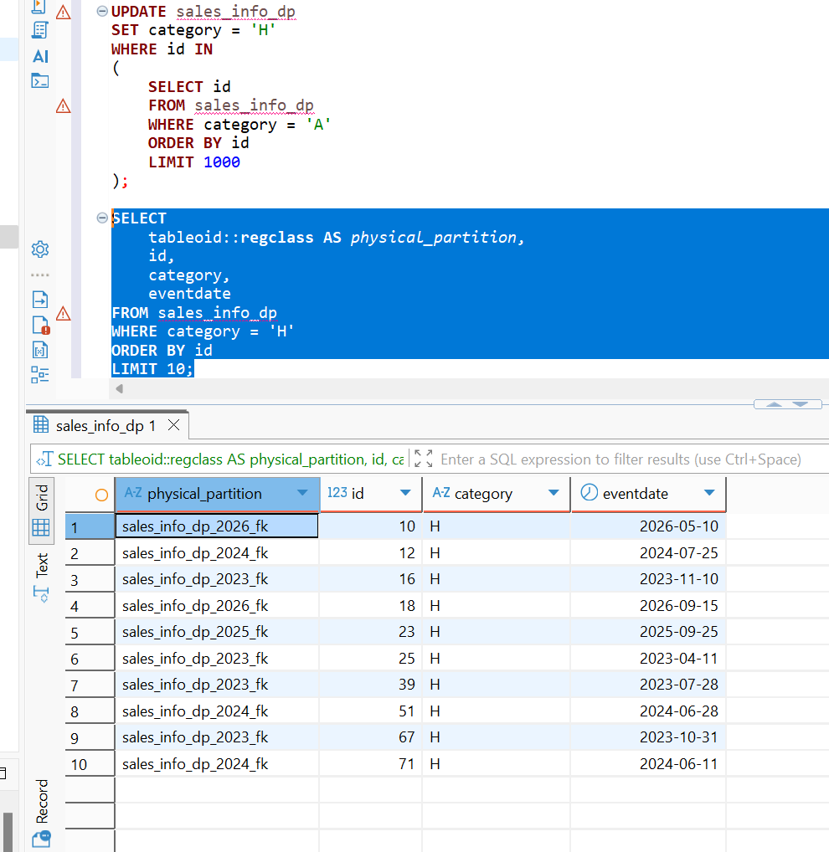
DROP TABLE IF EXISTS sales_info_simple;

CREATE TABLE sales_info_simple
(
id INTEGER,
category VARCHAR(1),
ischeck BOOLEAN,
eventdate DATE
);

INSERT INTO sales_info_simple
(id, category, ischeck, eventdate)
SELECT
id,
category,
ischeck,
eventdate
FROM sales_info_dp;

SELECT
(SELECT COUNT(*) FROM sales_info_dp) AS partitioned_rows,
(SELECT COUNT(*) FROM sales_info_simple) AS simple_rows;

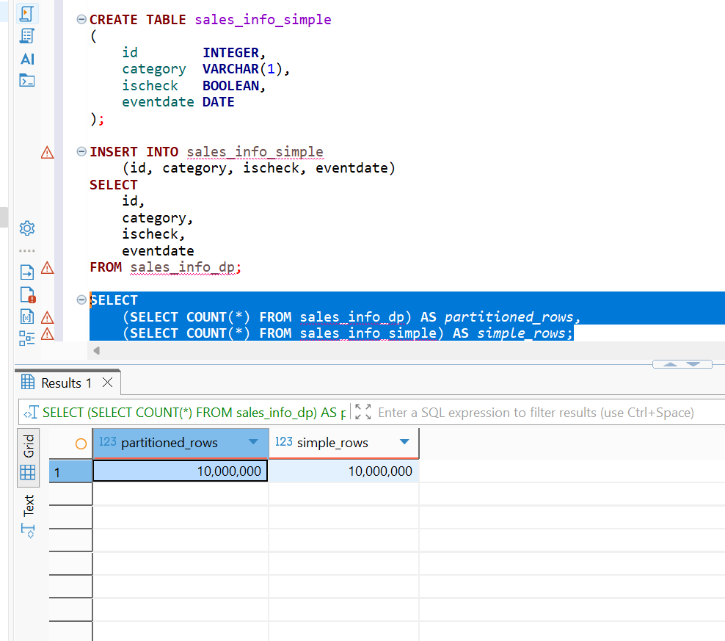
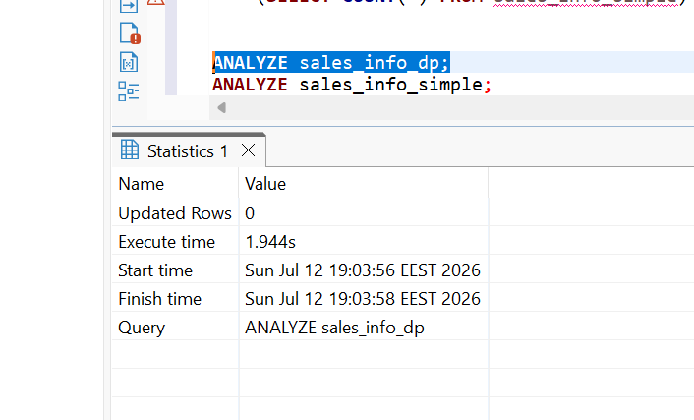
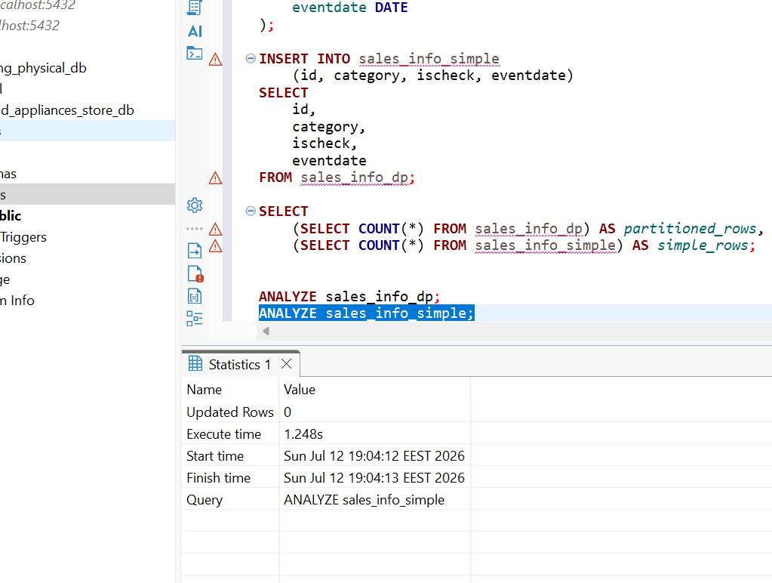

Compare plans of different queries for tables SALES_INFO_DP and SALES_INFO_SIMPLE

EXPLAIN (ANALYZE, BUFFERS) SELECT * FROM sales_info_dp;
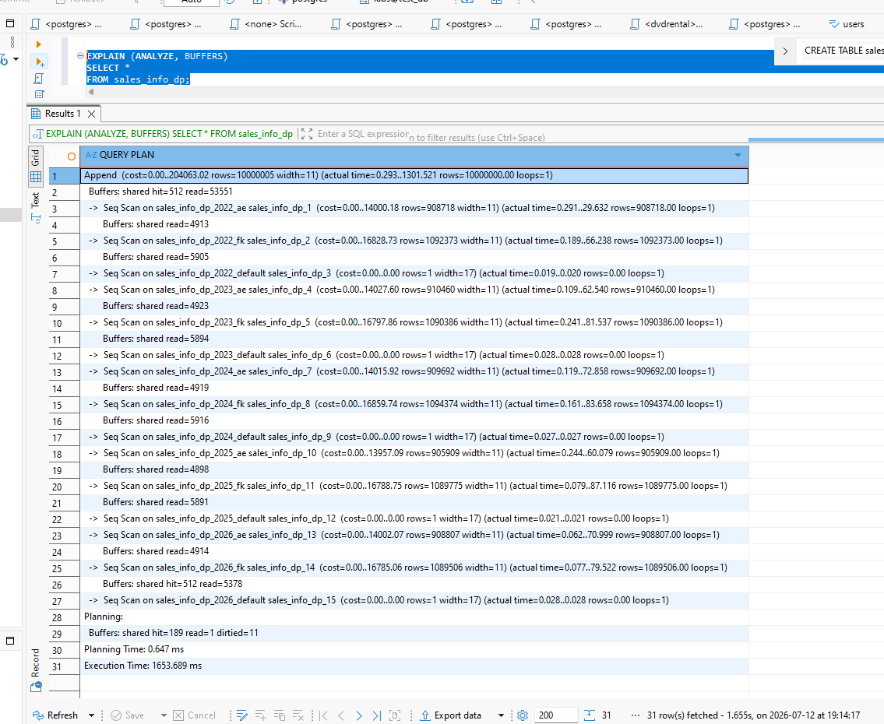
EXPLAIN (ANALYZE, BUFFERS)
SELECT *
FROM sales_info_simple;

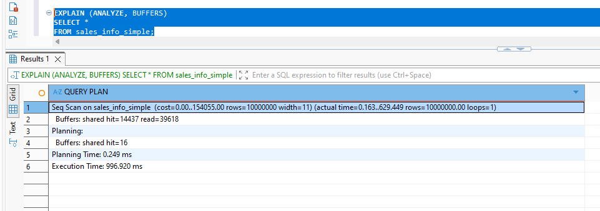
Select All Rows
• PostgreSQL used an Append operation.
• All 15 lowest-level partitions were scanned:
- 5 yearly partitions × 3 category partitions (AE, FK, DEFAULT).
• About 53,551 pages were read.
• Returned 10,000,000 rows.
• Default partitions were scanned even though they contained no rows.
Non-Partitioned Table
• PostgreSQL performed a single Seq Scan.
• About 39,618 pages were read.
• Returned 10,000,000 rows.
EXPLAIN (ANALYZE, BUFFERS)
SELECT *
FROM sales_info_dp
WHERE eventdate >= DATE '2024-03-01'
AND eventdate < DATE '2024-04-01';

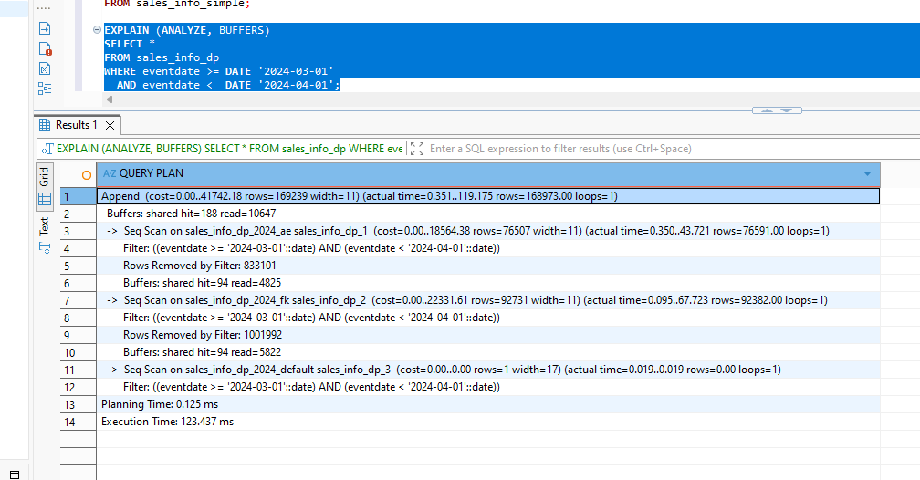
EXPLAIN (ANALYZE, BUFFERS)
SELECT *
FROM sales_info_simple
WHERE eventdate >= DATE '2024-03-01'
AND eventdate < DATE '2024-04-01';

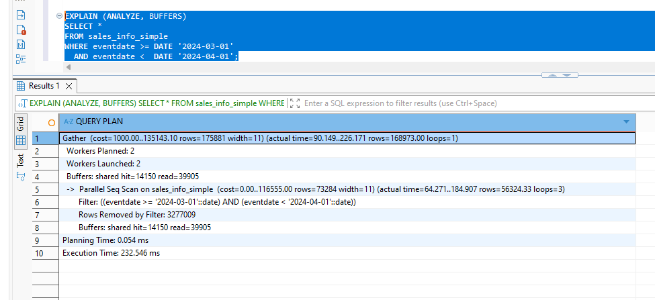
Partitioned
• PostgreSQL used partition pruning.
• Only the 2024 range partition was accessed.
• Within 2024, PostgreSQL scanned:
- sales_info_dp_2024_ae
- sales_info_dp_2024_fk
- sales_info_dp_2024_default
• Other yearly partitions (2022, 2023, 2025, 2026) were completely excluded.
• Returned 168,973 rows.
• Read 10,647 pages.
Non-Partitioned
• PostgreSQL performed a Parallel Seq Scan on the entire table.
• Returned 168,973 rows.
• Removed approximately 3.28 million rows by filter.
• Read 39,905 pages.
Select an exact date
EXPLAIN (ANALYZE, BUFFERS)
SELECT *
FROM sales_info_dp
WHERE eventdate = DATE '2025-06-01';
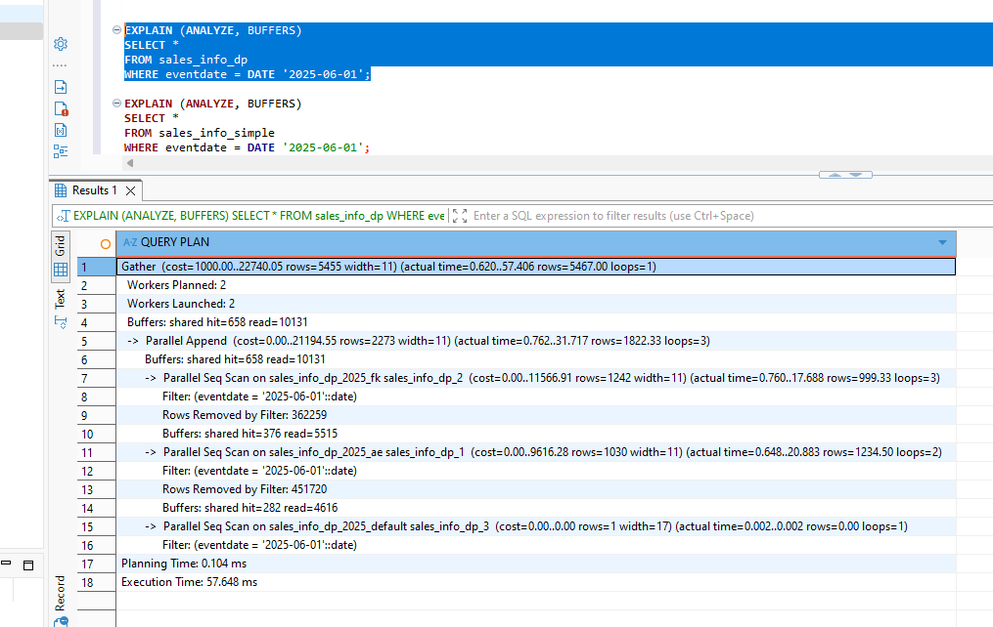
EXPLAIN (ANALYZE, BUFFERS)
SELECT *
FROM sales_info_simple
WHERE eventdate = DATE '2025-06-01';
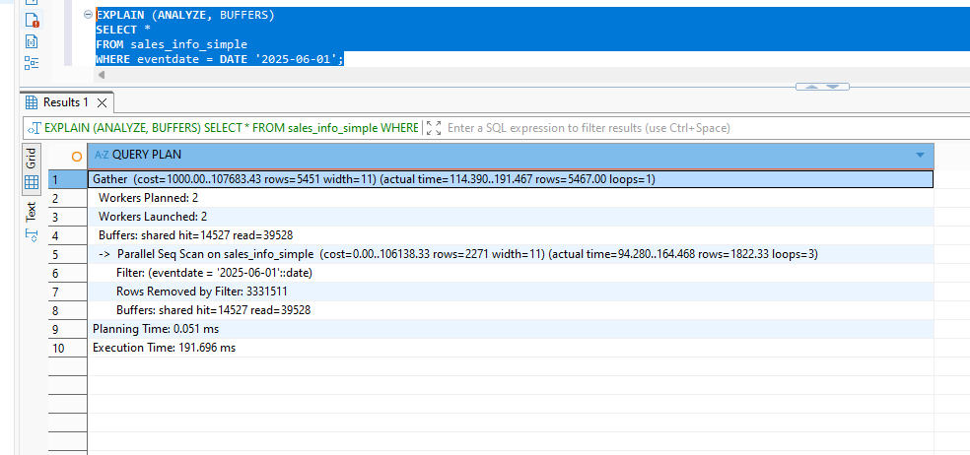

Select an exact category
EXPLAIN (ANALYZE, BUFFERS)
SELECT *
FROM sales_info_dp
WHERE category = 'A';
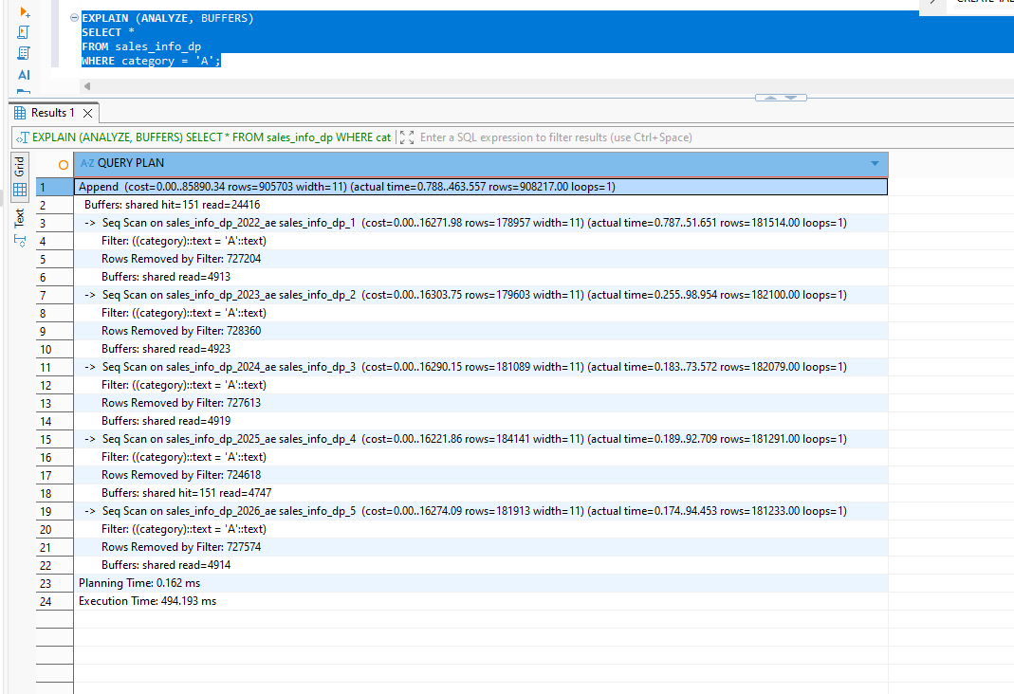
EXPLAIN (ANALYZE, BUFFERS)
SELECT *
FROM sales_info_simple
WHERE category = 'A';
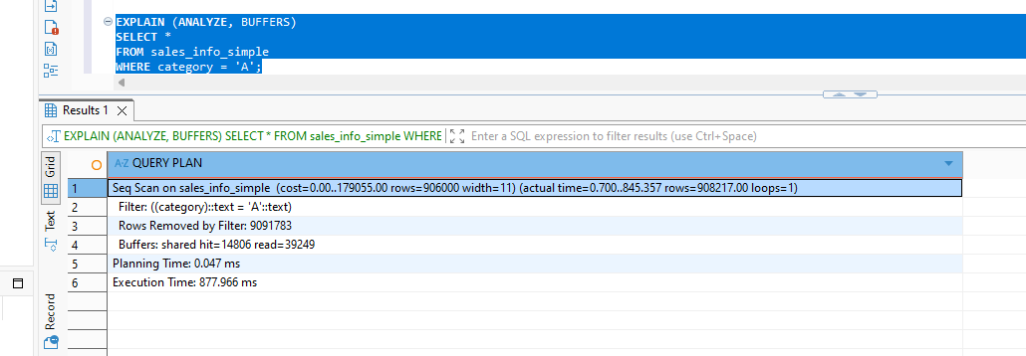
Select a list of categories
EXPLAIN (ANALYZE, BUFFERS)
SELECT *
FROM sales_info_dp
WHERE category IN ('A', 'B', 'C');
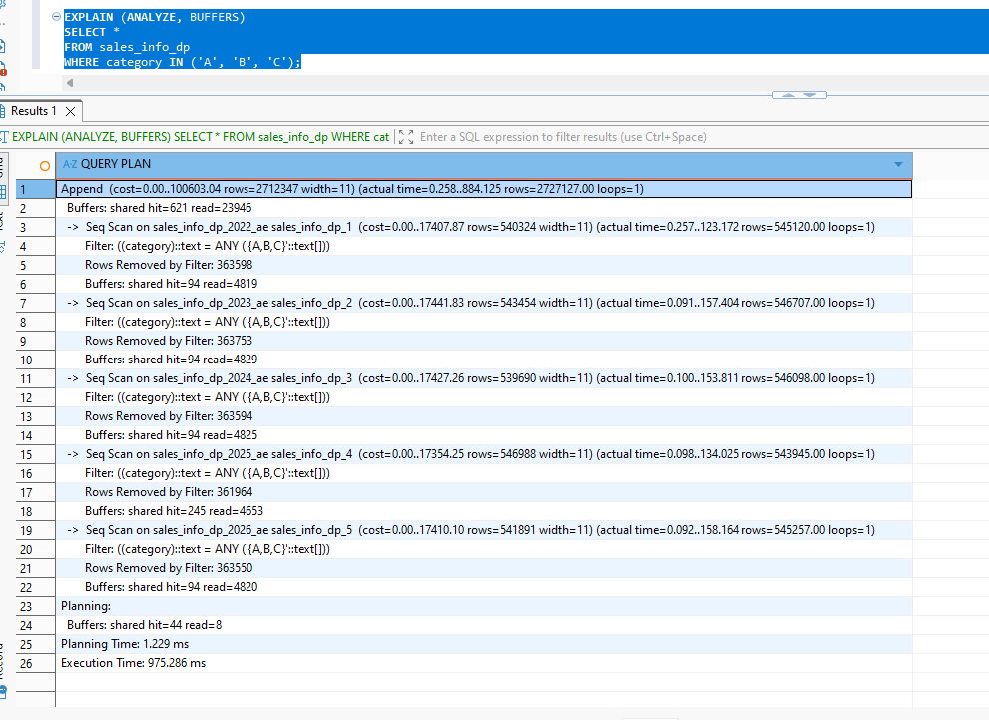
EXPLAIN (ANALYZE, BUFFERS)
SELECT *
FROM sales_info_simple
WHERE category IN ('A', 'B', 'C');

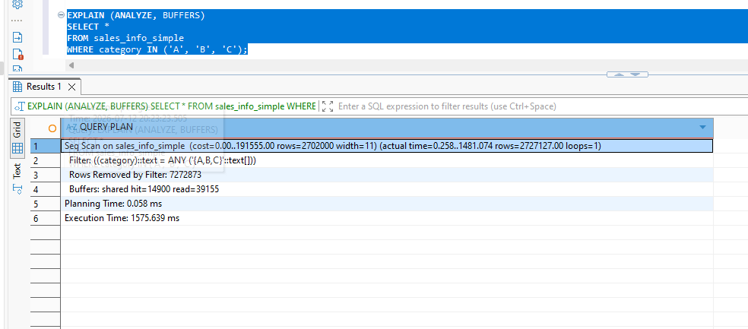
Select categories for an exact date
EXPLAIN (ANALYZE, BUFFERS)
SELECT *
FROM sales_info_dp
WHERE eventdate = DATE '2025-06-01'
AND category IN ('A', 'B', 'C');
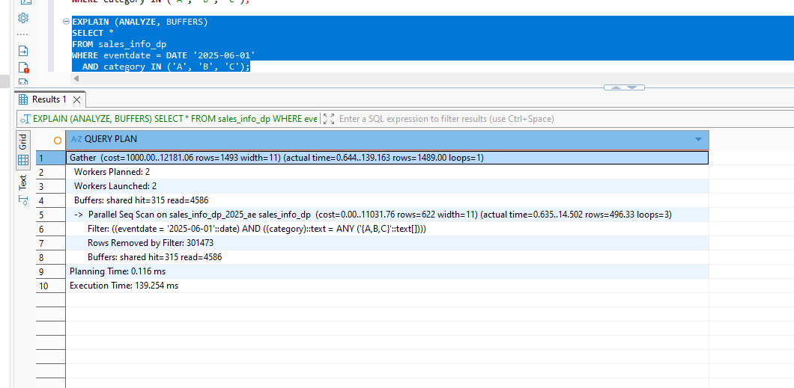
EXPLAIN (ANALYZE, BUFFERS)
SELECT *
FROM sales_info_simple
WHERE eventdate = DATE '2025-06-01'
AND category IN ('A', 'B', 'C');

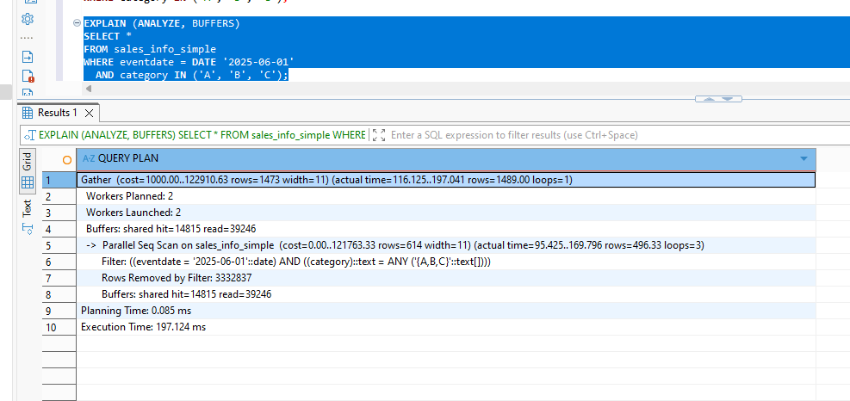
Count all rows
EXPLAIN (ANALYZE, BUFFERS)
SELECT COUNT(*)
FROM sales_info_dp;

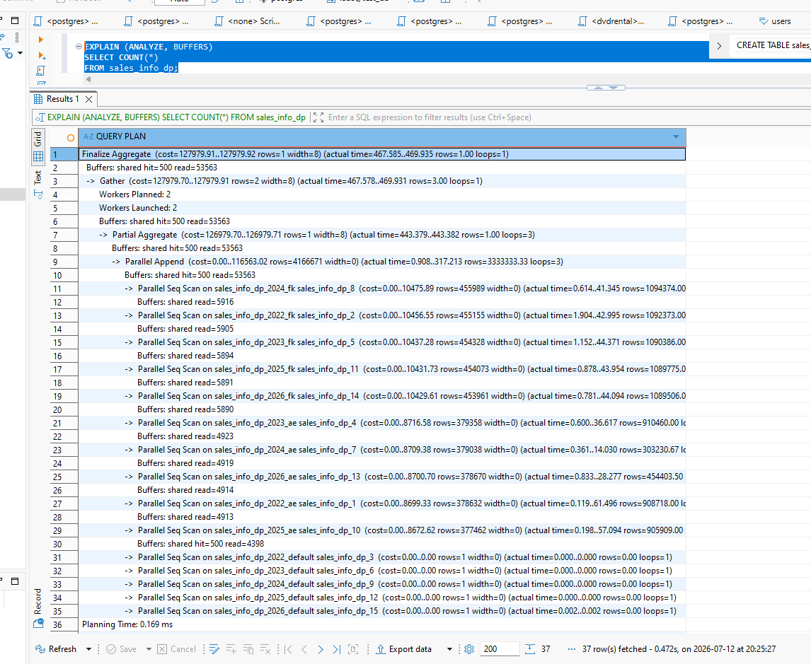
EXPLAIN (ANALYZE, BUFFERS)
SELECT COUNT(*)
FROM sales_info_simple;
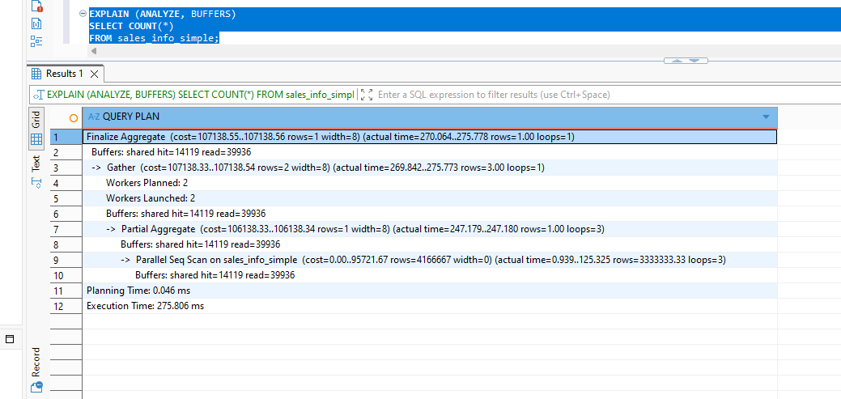
Count rows within a date range
EXPLAIN (ANALYZE, BUFFERS)
SELECT COUNT(*)
FROM sales_info_dp
WHERE eventdate >= DATE '2023-01-01'
AND eventdate < DATE '2024-01-01';

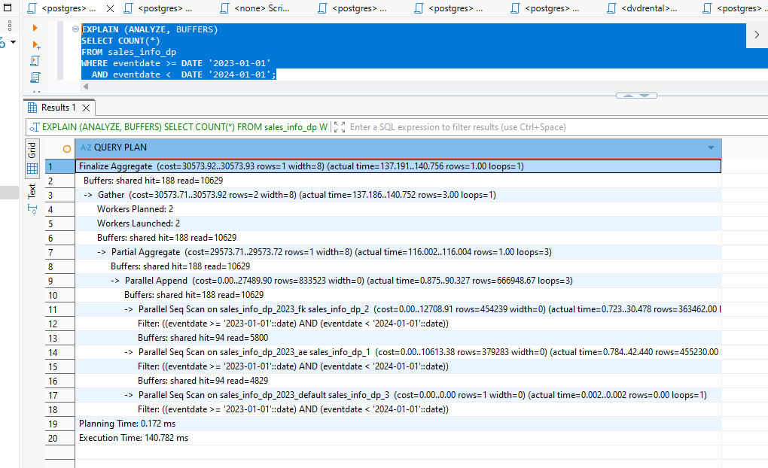
EXPLAIN (ANALYZE, BUFFERS)
SELECT COUNT(*)
FROM sales_info_simple
WHERE eventdate >= DATE '2023-01-01'
AND eventdate < DATE '2024-01-01';

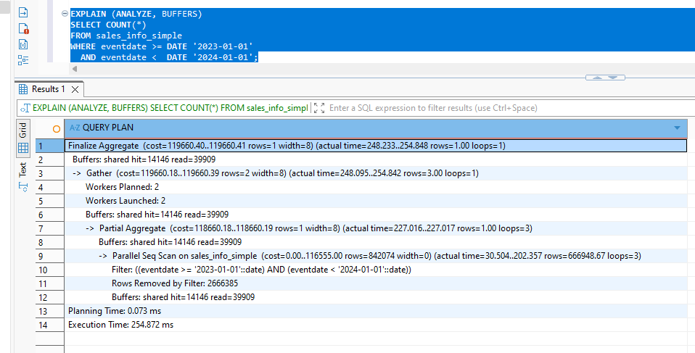

Part 6. For one of the child tables with range partition by eventdate split one list partition for two.

ALTER TABLE sales_info_dp_2022
DETACH PARTITION sales_info_dp_2022_ae;

CREATE TABLE sales_info_dp_2022_abc
PARTITION OF sales_info_dp_2022
FOR VALUES IN ('A', 'B', 'C');

CREATE TABLE sales_info_dp_2022_de
PARTITION OF sales_info_dp_2022
FOR VALUES IN ('D', 'E');

INSERT INTO sales_info_dp_2022
(id, category, ischeck, eventdate)
SELECT
id,
category,
ischeck,
eventdate
FROM sales_info_dp_2022_ae;

SELECT
tableoid::regclass AS physical_partition,
category,
COUNT(*) AS row_count
FROM sales_info_dp_2022
WHERE category IN ('A', 'B', 'C', 'D', 'E')
GROUP BY tableoid, category
ORDER BY physical_partition, category;

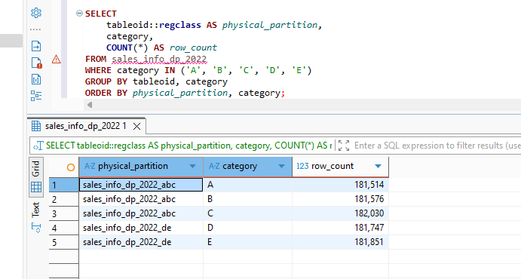
ALTER TABLE sales_info_dp_2022
DETACH PARTITION sales_info_dp_2022_abc;

ALTER TABLE sales_info_dp_2022
DETACH PARTITION sales_info_dp_2022_de;

CREATE TABLE sales_info_dp_2022_ae
PARTITION OF sales_info_dp_2022
FOR VALUES IN ('A', 'B', 'C', 'D', 'E');

INSERT INTO sales_info_dp_2022_ae
(id, category, ischeck, eventdate)
SELECT
id,
category,
ischeck,
eventdate
FROM sales_info_dp_2022_abc;

INSERT INTO sales_info_dp_2022_ae
(id, category, ischeck, eventdate)
SELECT
id,
category,
ischeck,
eventdate
FROM sales_info_dp_2022_de;

DROP TABLE sales_info_dp_2022_abc;
DROP TABLE sales_info_dp_2022_de;

SELECT
parent.relname AS parent_table,
child.relname AS child_table,
pg_get_expr(child.relpartbound, child.oid) AS partition_bound
FROM pg_inherits
JOIN pg_class parent
ON parent.oid = pg_inherits.inhparent
JOIN pg_class child
ON child.oid = pg_inherits.inhrelid
WHERE parent.relname = 'sales_info_dp_2022'
ORDER BY child.relname;

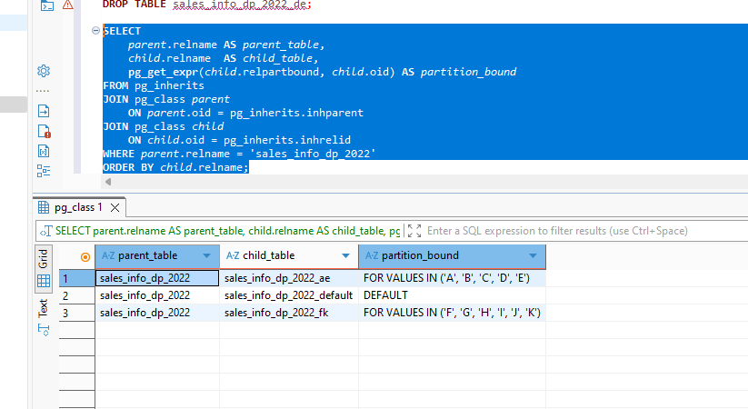

2.1 TASK 3: Use Parallel Querying
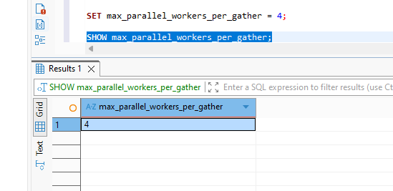

2. Analyze plans for tables SALES_INFO, SALES_INFO_DP and SALES_INFO_SIMPLE by querying
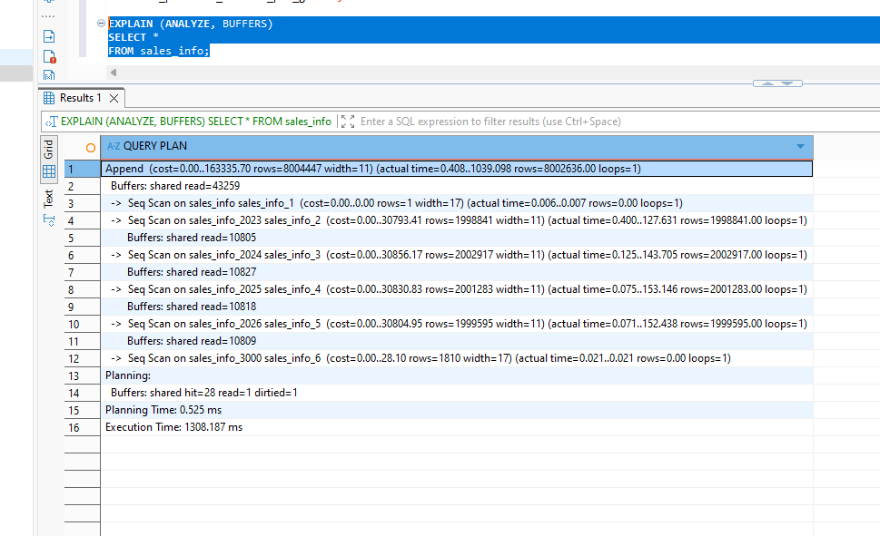
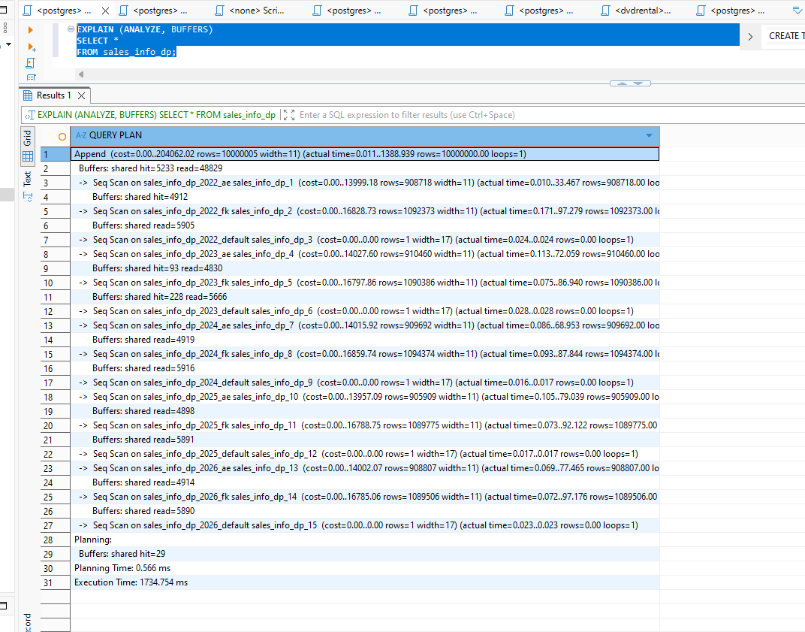
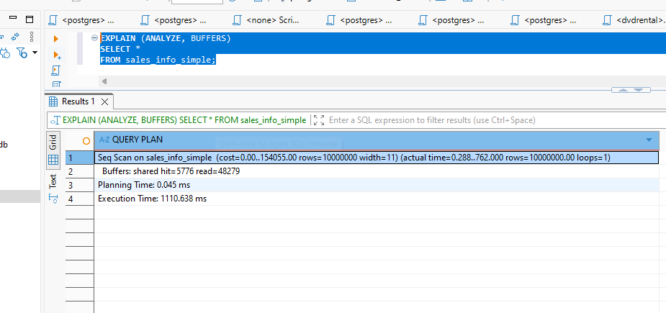
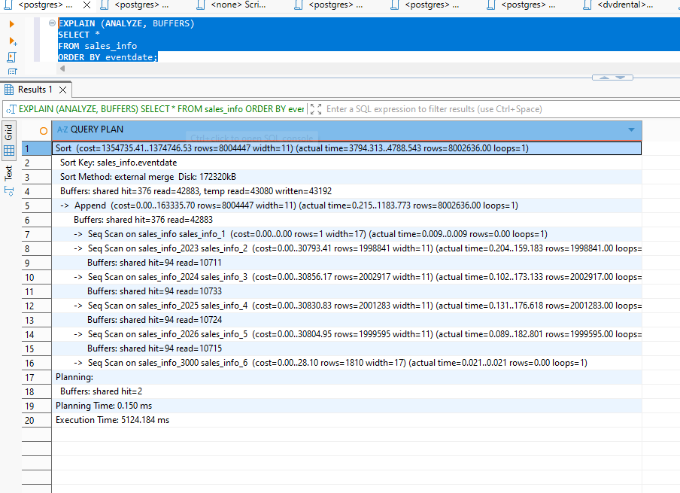
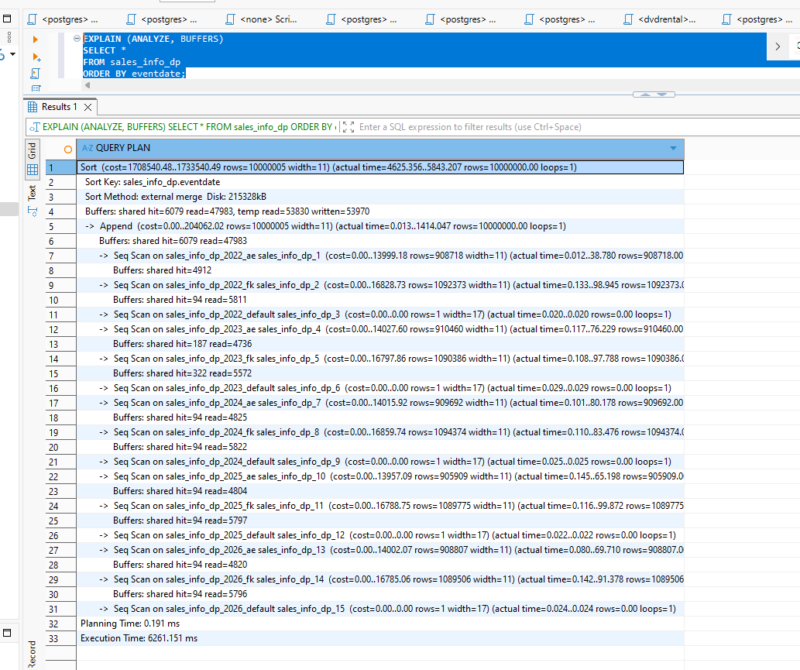
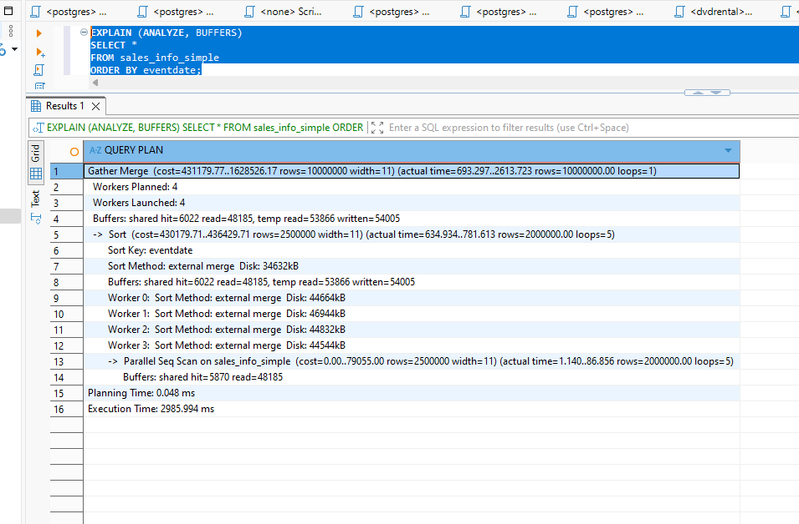
Count all rows
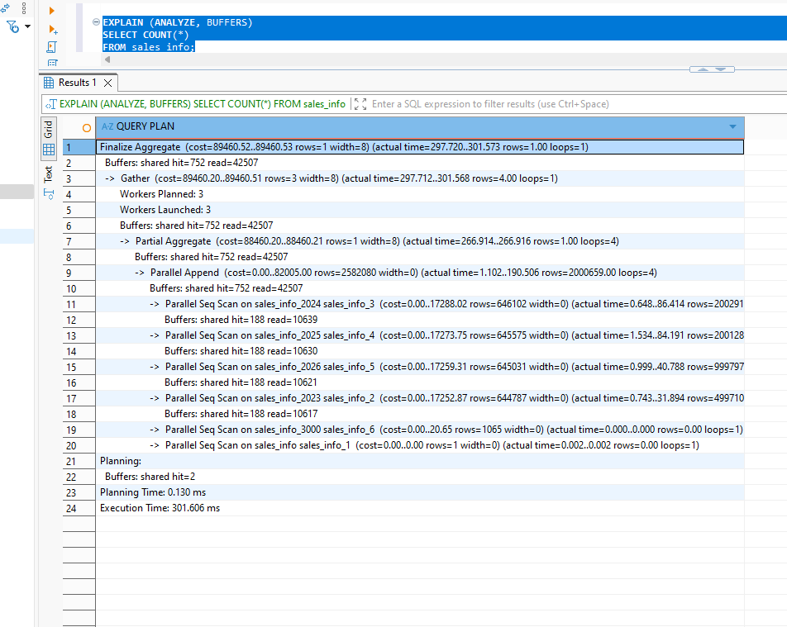
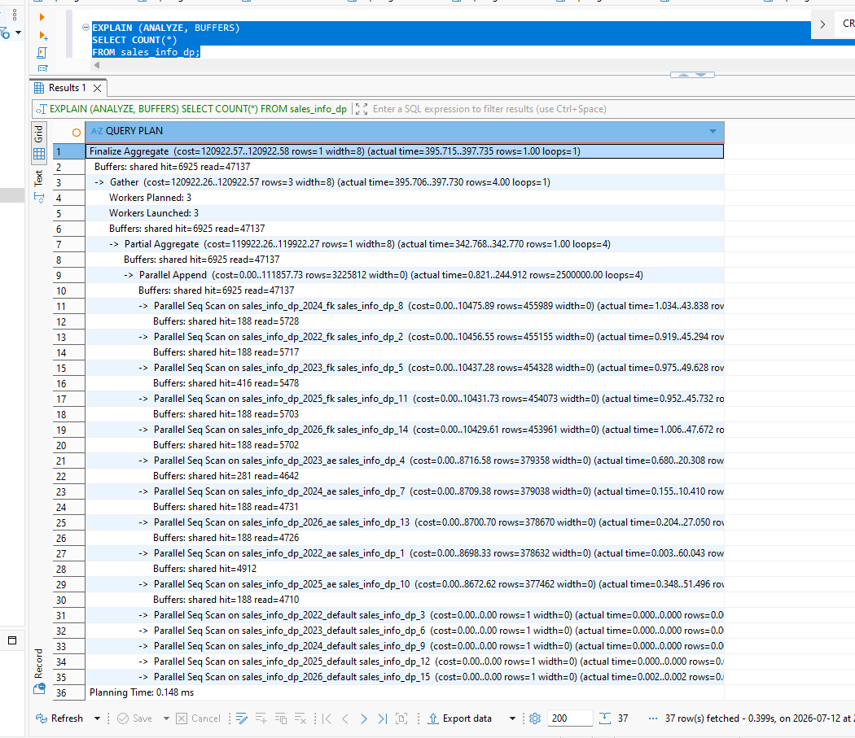
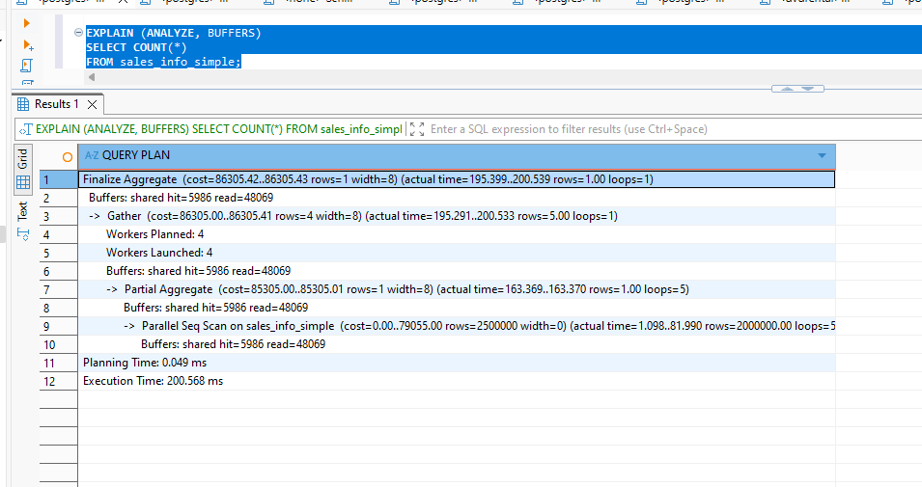
Add a range of dates
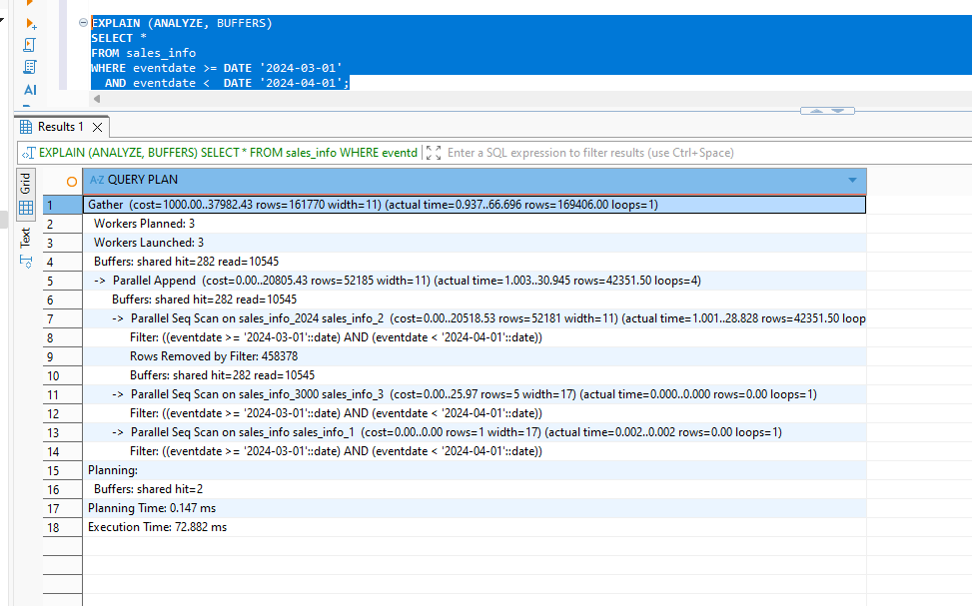
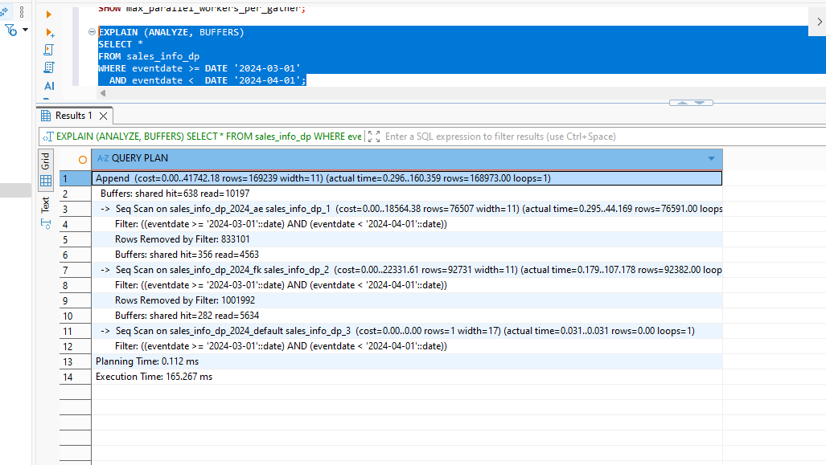
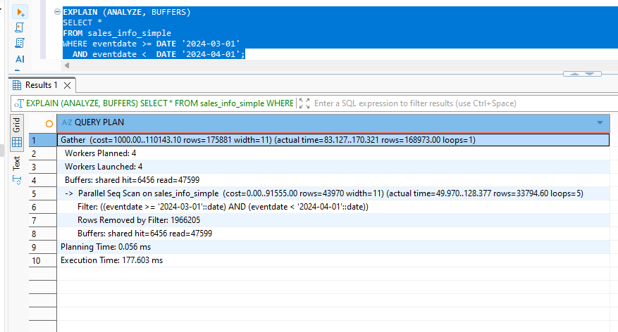
Group rows by category
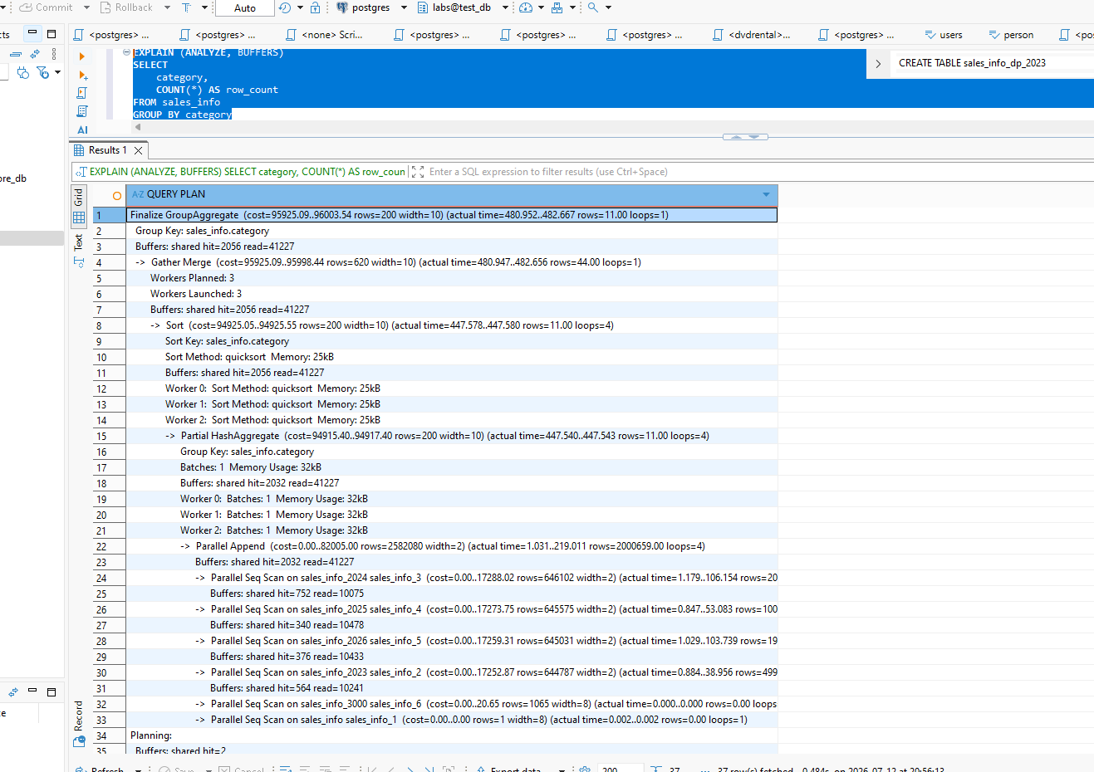
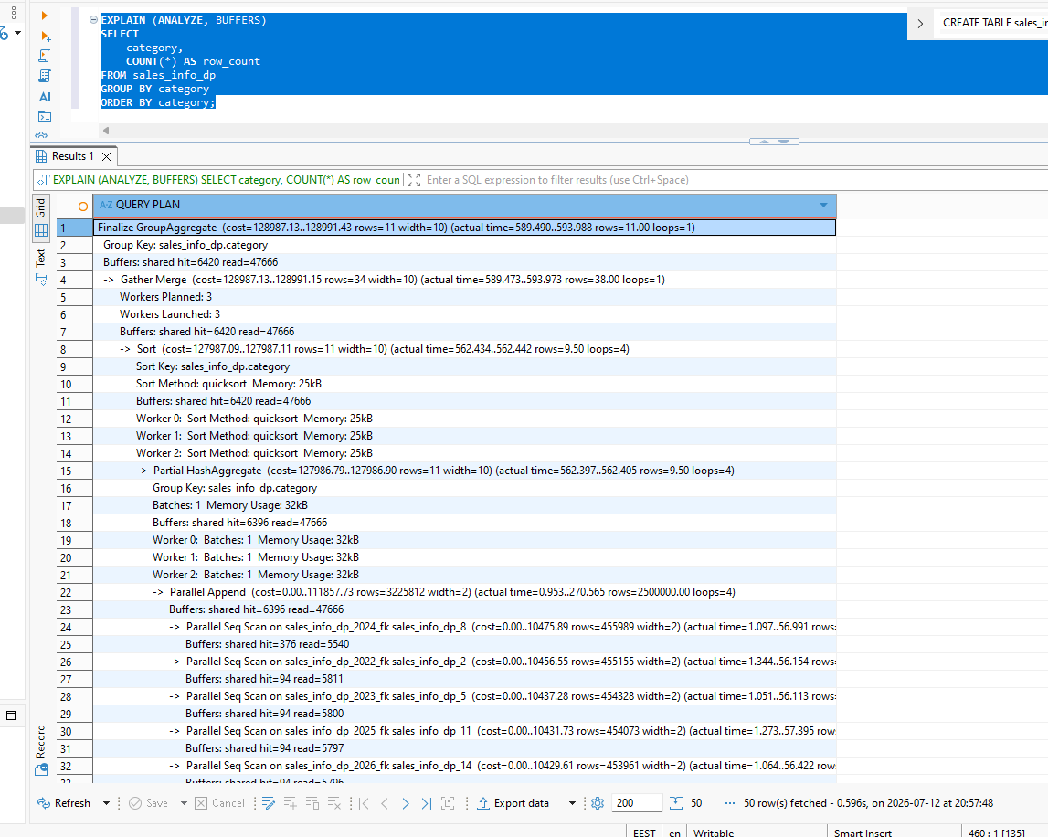
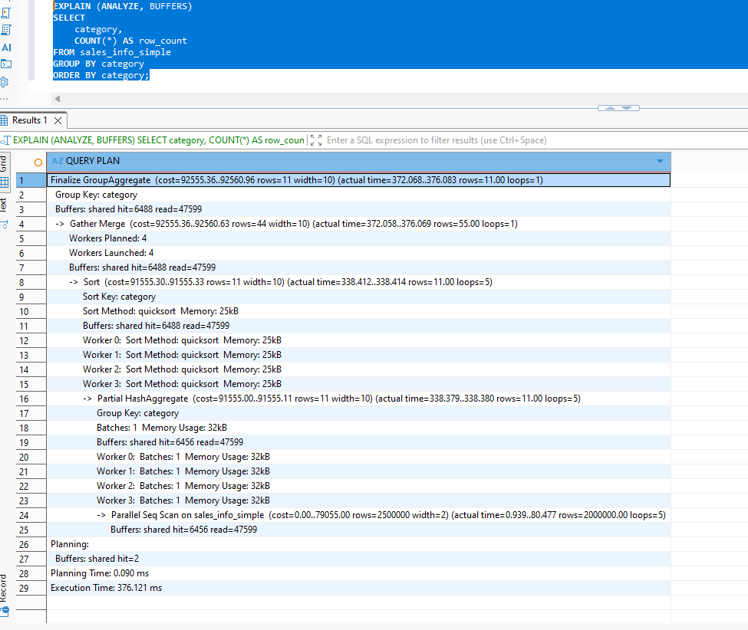
Join SALES_INFO and SALES_INFO_DP and count rows on an exact date
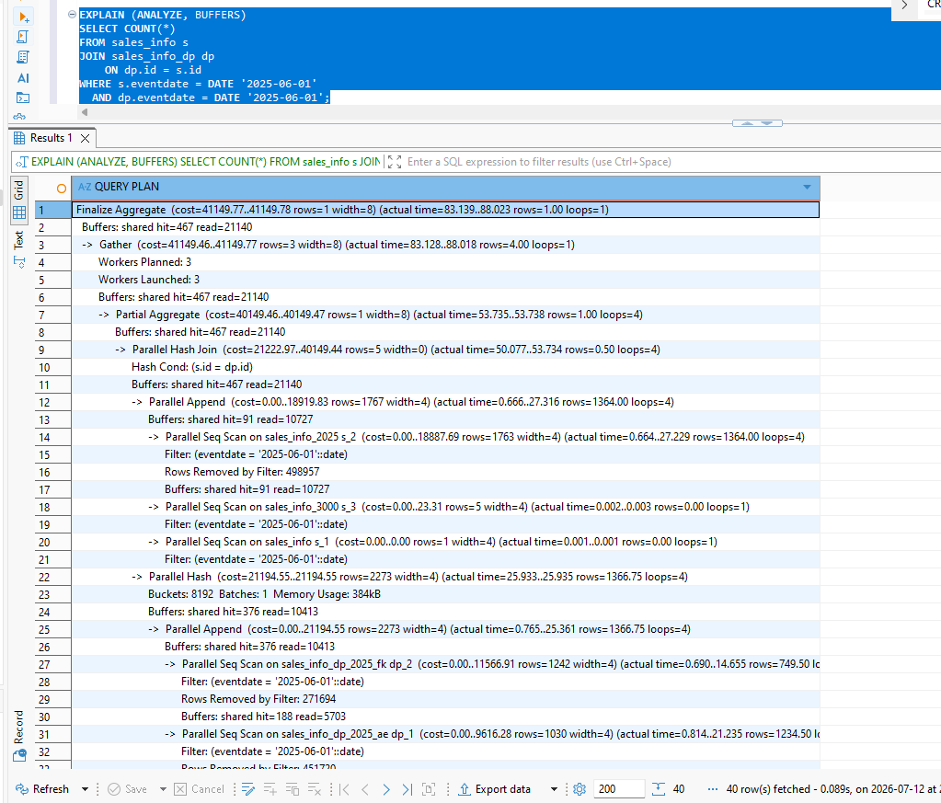

Add indexes on any of table with partitions. Check how plans are change
CREATE INDEX idx_sales_info_dp_eventdate
ON sales_info_dp (eventdate);

CREATE INDEX idx_sales_info_dp_id
ON sales_info_dp (id);

ANALYZE sales_info_dp;

SELECT
tablename,
indexname,
indexdef
FROM pg_indexes
WHERE tablename LIKE 'sales_info_dp%'
ORDER BY tablename, indexname;

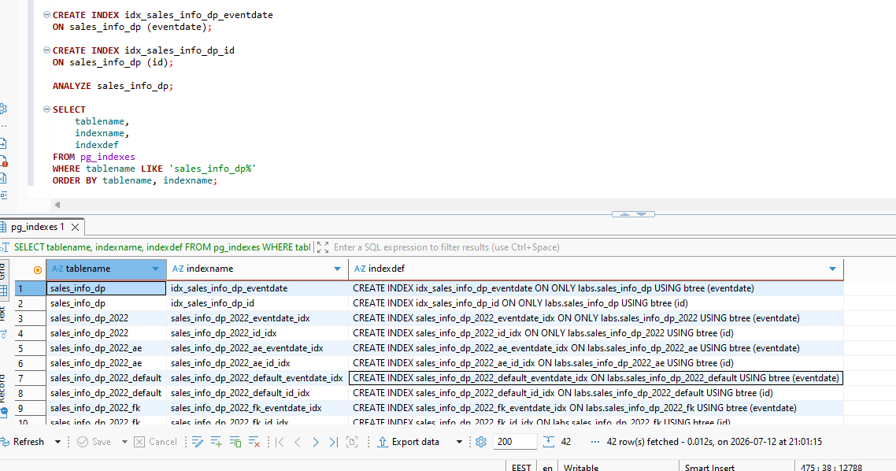
EXPLAIN (ANALYZE, BUFFERS)
SELECT *
FROM sales_info_dp
WHERE eventdate = DATE '2025-06-01';

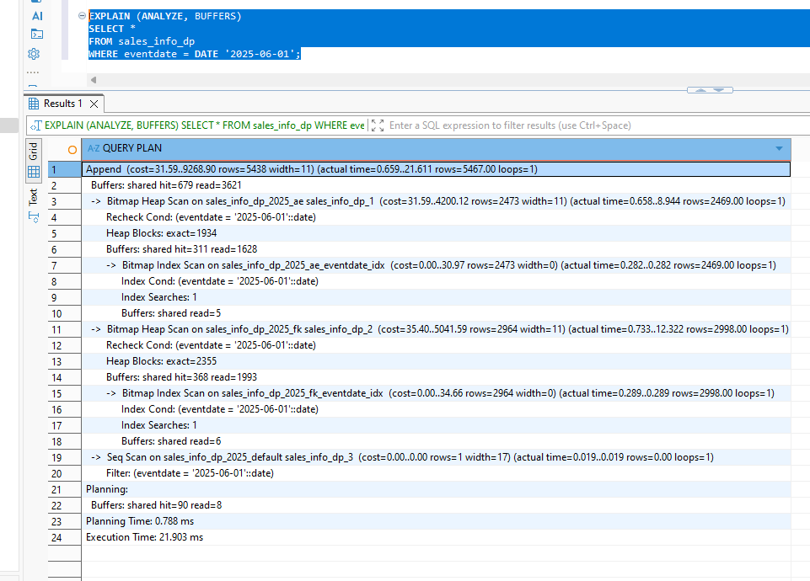
Conclusion: The yearly partitions are first pruned by date. PostgreSQL then uses the local eventdate indexes in the remaining 2025 subpartitions.
For an exact date returning many rows, PostgreSQL may prefer a Bitmap Index Scan combined with a Bitmap Heap Scan.
Date range after index
EXPLAIN (ANALYZE, BUFFERS)
SELECT *
FROM sales_info_dp
WHERE eventdate >= DATE '2024-03-01'
AND eventdate < DATE '2024-04-01';

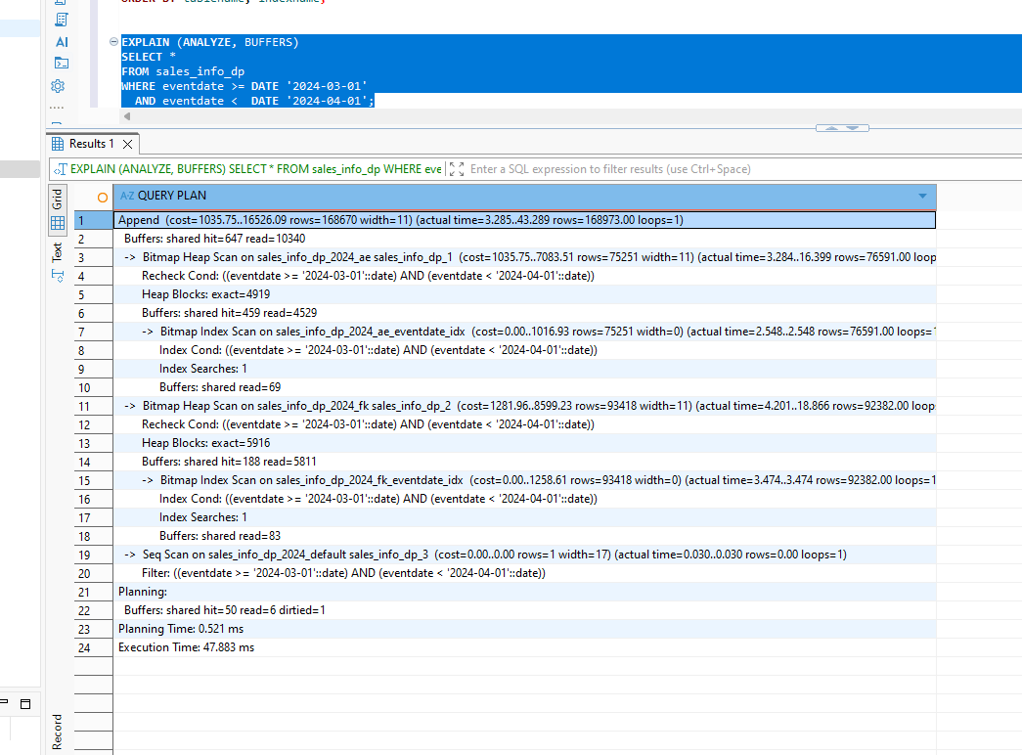
Conclusion: The date index was more useful for highly selective conditions, such as one exact date. For a wider date range returning many rows, PostgreSQL could retain a sequential scan because reading a large part of the partition sequentially was estimated to be cheaper.

Join after adding the id index
EXPLAIN (ANALYZE, BUFFERS)
SELECT COUNT(*)
FROM sales_info s
JOIN sales_info_dp dp
ON dp.id = s.id
WHERE s.eventdate = DATE '2025-06-01'
AND dp.eventdate = DATE '2025-06-01';

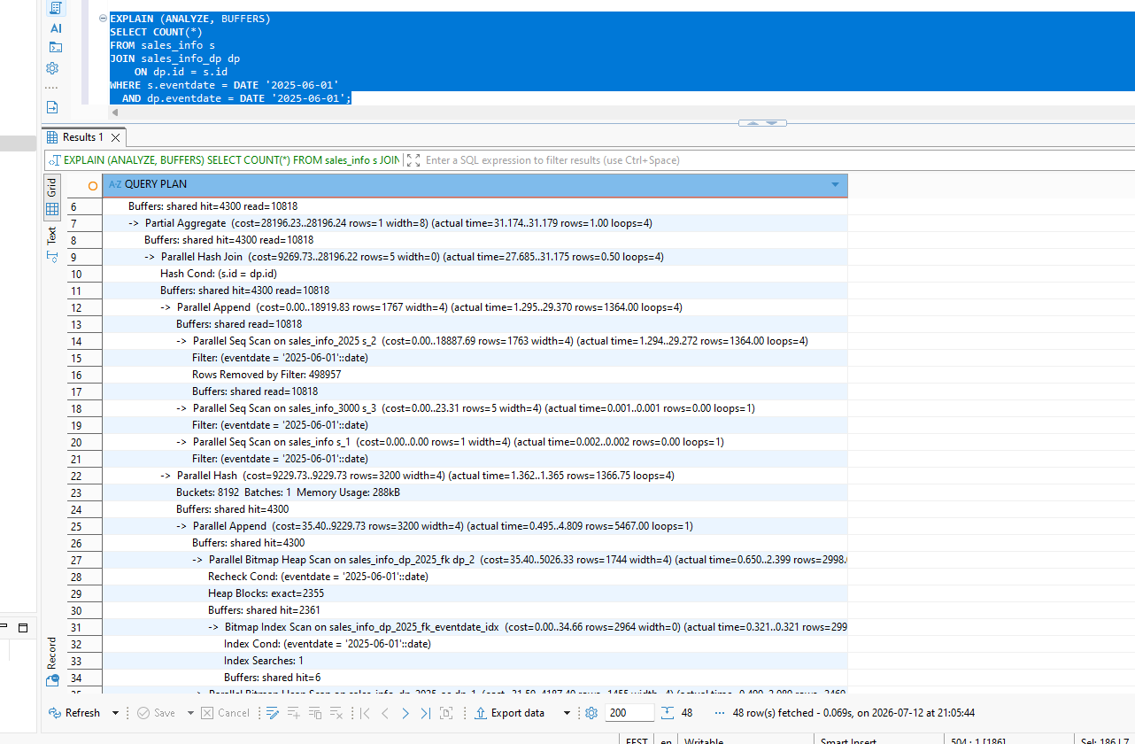

SUMMARY

Test | SALES_INFO plan | SALES_INFO_DP plan | SALES_INFO_SIMPLE plan | Main observation
Select all | Parallel Append | Parallel Append | Parallel Seq Scan | All rows scanned
Order by date | Gather Merge + Sort | Gather Merge + Sort | Gather Merge + Sort | Sorting adds major cost
Count all | Partial/Finalize Aggregate | Partial/Finalize Aggregate | Partial/Finalize Aggregate | Parallel aggregate
Date range | One year scanned | One year and its subpartitions | Full table scan | Partition pruning helps
Group by category | Partial aggregate over Append | Partial aggregate over Append | Partial aggregate over Seq Scan | All rows still processed
Join on exact date | 2025 child only | 2025 subpartitions only | Not used | Pruning plus parallel join
Exact date after index | Index/Bitmap scan possible | Index/Bitmap scan possible | — | Index helps selective search
Join after id index | Hash or indexed join | Hash or indexed join | — | Plan depends on cardinality

